Managing Financial and Human Resources

Title: The Merger of J. Sainsbury Plc and Asda Group Ltd.

Author: David Whitmore
Email: David.Whitmore@vale.com
Number: 01792 841331
Address:
Vale Europe Limited,
Clydach Refinery,
Clydach,
Swansea,
SA6 5QR

Executive Summary
Mergers and Acquisitions continue to increase on a global scale. Human Resource Management plays a critical role in the success of those M&A’s based on the strategies that they employ during this change phenomenon. This report examines the HRM policies and procedures effecting the proposed merger between UK supermarket giants J. Sainsbury Plc and Asda Group Ltd and explores the implications from an employment law and leadership stand point.
The key employment law implications that were discussed during the research were the Transfer of Undertakings (Protection of Employment) Regulations (TUPE) the General Data Protection Regulation (GDPR) While the leadership themes that emerged were the requirement to provide a strategic vision, effective communication, creating a positive organizational culture and a commitment to Fairness.

Contents
Executive Summary
Contents
- Introduction
- Mergers and Acquisitions
- J. Sainsbury Plc & Asda Group Ltd
- The Role of HRM
- Employment Law Implications
  - Information and Consultation of Employees Regulations
  - General Data Protection Regulations (GDPR)
  - Transfer of Undertakings (Protection of Employment) Regulations (TUPE).
  - Competitions and Markets Authority.
- Leadership Implications
- Conclusion
- References

- Introduction
The grocery market in the U.K is fiercely competitive and the dynamic environment these businesses are having to survive in has led to a series of acquisitions and mergers. Sainsbury’s acquisition of Argos, Tesco’s purchase of Bookers, the partnership between M&S and Ocado are all examples of the major players looking to enter new markets, diversify and scale up in an effort to maintain or gain a competitive advantage. Globalization and competitive pressure from new entrants and emerging technologies mean M&A’s are becoming a common strategy to remain competitive and increase shareholder value. However, the revelation of a merger or acquisition within an organisation will inevitably cause negative reactions such as uncertainty (Vaara, 2003), anxiety (Ivancevich et al, 1987) and lack of organizational commitment (Cartwright & Cooper, 1996) and if not handled correctly will almost certainly have detrimental effect on productivity and ultimately organisational performance. Prasanth Nair (2015) states that the success of a M&A depends to a large extent on how organisations and people are managed.

- Mergers and Acquisitions
A merger is a change phenomenon that can have sweeping consequences throughout the organisational hierarchy. It is commonly understood as the consolidation of two businesses in which a new organisation arises and the previous two cease to exist. In most cases mergers are voluntarily entered into and involve stock swaps or cash payments to the target. In the study case, Sainsbury’s would acquire Asda from Walmart and, in turn, Walmart would receive shares in Sainsbury’s, such that Walmart would hold 42% of the shares (and 29.9% of the voting shares) in the merged entity. Walmart would also appoint two non-executive directors to the Board. (www.gov.uk/cma)
Belcourt & McBey (2007) suggest that mergers can typically be classified into one of four categories.
- Horizontal merger - when two merging companies produce a similar product in a similar industry.
- Vertical mergers - when two organizations merge to achieve synergies to control all factors from production to distribution to retail sales.
- Concentric mergers involve firms in the same market with no mutual buyer/customer or supplier relationship.
- A conglomerate merger occurs between two firms in different industries.

- ASDA / Sainsbury’s Mergers
ASDA, Sainsbury’s and the other main players such as Tesco, Morrisons, M&S and Waitrose are under severe pressure from the emergence of new entrants such as Aldi and Lidl. The German supermarkets have combined conveniently positioned stores with a wide range of high quality produce at the “lowest industry prices”.
The impact of this competitive pressure is clearly shown below in the changes in market shares since 2011:
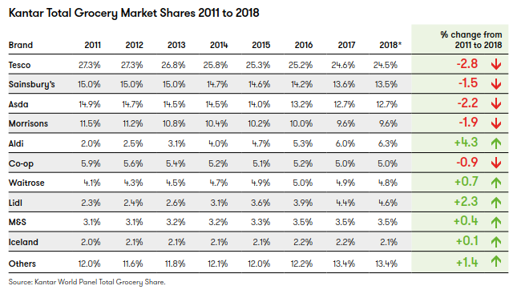

The Germans success in the market combined with additional threats of online shopping and the continued development in technology such as food delivery app such as Just Eat and Deliveroo together with Amazons recent interest in the UK grocery market has led ASDA and Sainsbury’s to propose this large-scale consolidation.
Sainsbury’s had proposed a £12 million takeover of Walmart owned ASDA, which would have resulted in a £51,000,000,000 sales combination. 333,000 staff members. 2,800 stores. 47 million transactions per week making them the largest retailer ahead of Tesco.
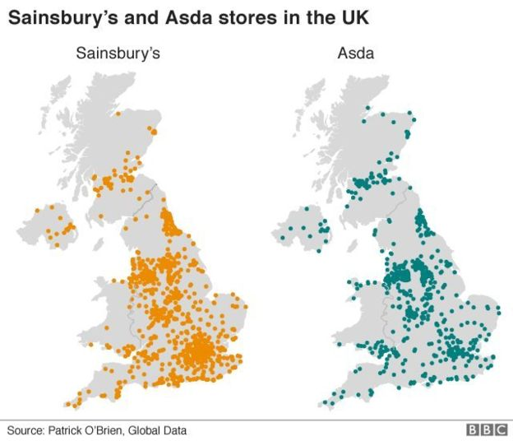

- The Role of HRM
Historically, it has been common practice to involve HRM too late in the merger process. Schmidt (2013) established a direct correlation between the level of HRM involvement and the overall success of the merger but the involvement in a M&A is one of the most challenging tasks a HR professional will undertake. Interpreting the employment law and appreciating the human factors like leadership, talent retention, organizational cultures and sociocultural issues will contribute greatly to the effective governance of the merger process. Flexibility in HR practices can help to build trust during a M&A as it will allow practices to be aligned widely and efficiently across the merging firms (Wright & Snell, 1998), expediting a sense of equality across the new company and creating a feeling of trust between the two firms (Stahl et al., 2011).
The key HR Tasks:
- The HRM team must establish a defined, time-bound plan with clear objectives. An integration team consisting of HR and business heads should be assembled with a dedicated project manager assigned solely to the merger needs to be appointed.
- Develop and implement a communication strategy
- Due Diligence – Look to identify any pre-existing HR issues through KPI’s monitoring absenteeism, employee turnover, length and number of job vacancies etc.
- Talent analysis, with the aim to retain key personnel and eradicate problematic or unwanted staff.
- To develop and implement rewards strategy.
- Alignment of payroll, benefits, pensions
- Expediency

However, as touched on previously a motivation strategy based only on financial incentives may not be necessarily be sufficient especially with a diverse workforce who may be influenced by other factors such an organisations culture and values or the individual employees unique background i.e. age, gender, sexuality, socioeconomic status, religious views and other distinctive factors that may set particular employees apart from others (Cox and Blake, 1991).
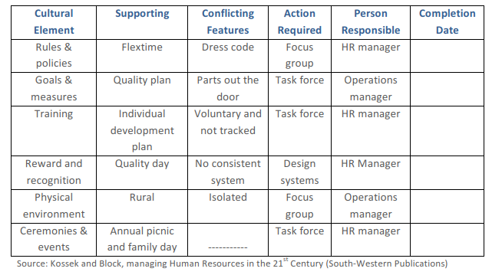
Figure 1. Sample Cultural Change Plan.

Organisations face a choice when assessing the softer, human factors associated with the merger. They could adopt a strategy to disregard the cultural values and the employees’ unique characteristics entirely and apply a standardised approach to managing human resources, or they could embrace the information as opportunity to create value to the organisational integrity (Roberson, 2015).

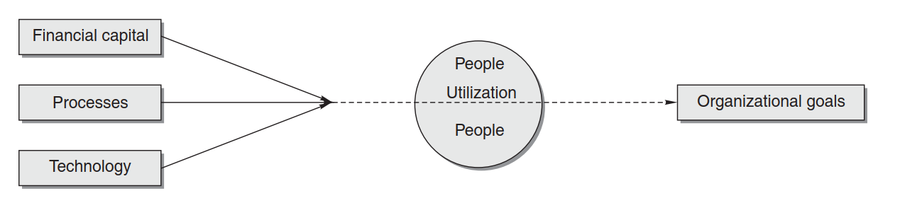
Figure 2. Centrality of Human Resources for Organizational Goal Achievement

- Employment Law Implications.

5.1 Information and consultation of employees’ regulations
Although the decision lays with ASDA and Sainsbury’s as to how much information they provide their employees regarding the merger, they must make sure they abide by the Information and Consultation of Employees Regulations.
The regulations state that employees must be informed about certain aspects of the deal. The regulations also state “that if you have more than fifty employees and more than 10% of them request a system, you have to agree a procedure for informing and consulting them”.
Non-conformance with the regulations can lead to an appeal to the Central Arbitration Committee and a potential fine up to £75,000.

5.2 General Data Protection Regulation (GDPR).
HRM require early indication of any potential legal problems and since the introduction of the GDPR in 2018 employee data has become a potential minefield. There will undoubtedly be conflict over what information Sainsbury’s would want and what Asda would be able to provide under the new data protection act. HRM can assist with this by possibly establishing that anonymises data.

5.3 Transfer of Undertakings (Protection of Employment) Regulations.
When two or more organisations merge there will inevitably be a change of employer for the transferring employees. In such a situation these employees are protected under the Transfer of Undertakings (Protection of Employment) Regulations (TUPE).
As the TUPE regulations would apply in the case of the Sainsbury’s/ASDA merger, the contract of employment for ASDA employees would be transferred to Sainsbury’s. As the transferring employees have the right to transfer on their current employment terms, including pay, sick pay, working hours and annual leave (GOV.UK, 2019), this will leave Sainsbury’s with the challenge of having two set sets of staff contracted under different terms. This would be further complicated by the fact that ASDA workers have already voluntarily agreed to change their contracts to become more flexible in order to play their part and help their current employer be more profitable. Although it would be highly desirable, Sainsbury’s will not be able to simply standardise the contracts of employment for all employees any variation to employees’ terms and conditions will require an economic, technical or organisational reason that entails changes in the workforce.
Typically accepted ETO reasons are:
Economic grounds are those which concern the profitability or market performance of the business post-transfer and the cost of running the business.
Technical grounds refer to the need for different technical skills for running the business post transfer.
Organisational reasons refer to organisational changes that result in work methods being different in some structural, departmental, administrative or managerial way.
Both supermarkets publicly stated that there would be no job losses as part of the merger, however ASDA started to prepare a cost cutting programme ahead of the proposed merger. Although TUPE would protect both sets of employees against dismissal where the principle reason was the merger, Sainsbury’s could still rely on a ETO reason that would entail changes to the workforce to force redundancies. In this case Sainsbury’s would have to ensure that both their and transferring ASDA staff were correctly pooled together for selection or they would be exposed to unfair dismissal claims or breach of the TUPE regulations.
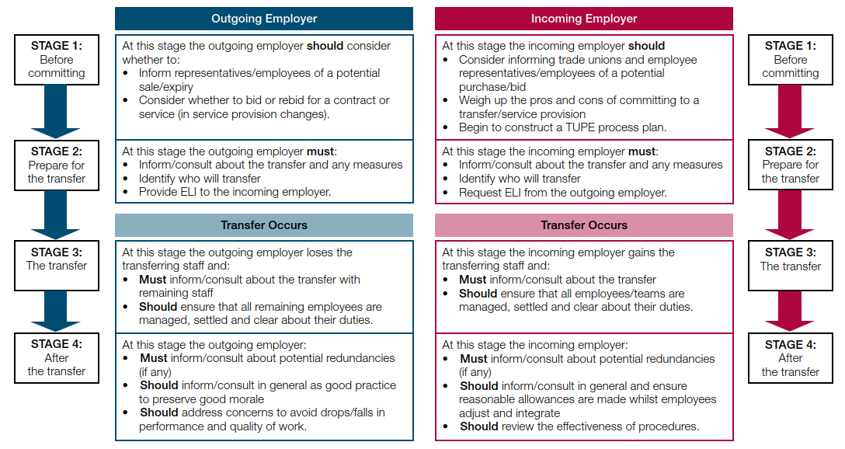
Figure 3. ACAS guidance – Handling TUPE Transfers

5.3 Competitions and Markets Authority.
The CMA is an independent public authority who is primarily responsible for the review of proposed mergers within the UK, however the Secretary of State can intervene on decisions in exceptional circumstances. The aim of a CMA review is to ensure a proposed merger does not harm competition within its field or result in detrimental effects to the consumer such as higher prices, reduced quality and choice or limit innovation.
During its recent review of the proposed merger between J. Sainsbury PLC and Asda Group Ltd they identified a substantial lessening of competition in several UK markets, namely:
- Instore groceries.
- Online delivered groceries.
- General Merchandise.
- Fuel.
- Excessive buying power.
For those reasons the CMA decided to prohibit the merger in its entirety. (CMA, 2019)
- Leadership Implications.
It is critical that HRM ensure that in the initial stages of a merger the communication is open, truthful and delivered in a timely manner, this will to diminish any rumours and initiate trust (Daniel, 1999, & DeVoge & Shiraki, 2000). HRM should not assume that employees understand why the merger is taking place therefore a key role for them is to ensure that organisational leaders are identified, trained and in position to effectively communicate the message.
Many M&A researchers have argued that organizational cultural differences tend to stand in the way of value creation (Cartwright & Cooper, 1993; Chatterjee, Lubatkin, Schweiger, & Weber, 1992; Datta, 1991; Stahl & Voigt, 2008). Seo and Hill (2005) studied the impact of M&As on people by researching six theories including Anxiety Theory, Social Identity Theory, Acculturation Theory, Role Conflict Theory, Job Characteristics Theory, and Organizational Justice Theory (see Fig 4).
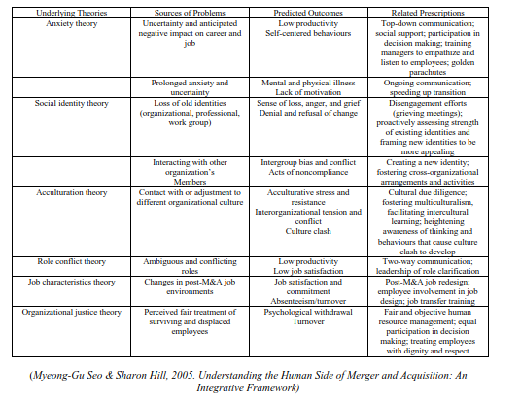
Figure 4. Underlying Theories in Merger and Acquisition (M&A) Literature
As the merger will bring together employees from two separate organizations with diverse organizational cultures, integrating them will be a significant leadership challenge (Cartwright & Cooper, 1996). Leaders proficient in the required soft skills such as people sensitisation, anxiety management and sociocultural awareness will help ensure a smoother integration process while still maintain business momentum and capturing value.
Sainsbury’s and Asda will have unique leadership implications as they are like for like businesses with different strategies when it comes to what they perceive as value creation. They both operate pumping fuel stations with a different pricing strategy, Sainsbury’s have invested heavily in smaller convenience stores where Asda have few, Sainsbury’s offer a banking service where Asda do not. These nuances with each company will inevitably have leadership implications as different visions and skillsets will need to be considered.

7.0 CONCLUSION
This report set out to evaluate the involvement of HRM during the merger process, specifically the implications they face from employment law and leadership challenges. These are relatively broad topics and therefore do not capture the full complexities faced by HRM through the entire process.
It is intended that that the areas discussed in this report help to provide a brief insight into the attentions and sensitivities a HRM professional needs to consider and the methodology they need to adopt. That said there are a myriad of factor and variables that have not been discussed that HRM will need to negotiate if they are to play their part in a successful merger. I believe Buono & Bowditch (2003) conclude it best when they said, “If mergers and acquisitions are to be successful over the long‑term, the basic nature of such change as a human process...must be acknowledged, understood, and integrated into the planning process.”

8.0 References
Aguilera, R. V., Dencker, J. H. 2004. The role of human resource management in cross-border mergers and acquisitions. International Journal of Human Resource Management, 15: 1355-1370.
Balmer, J. M., & Dinnie, K. (1996). Corporate identity and corporate communications: The antidote to mergers madness. Corporate Communications, 4(4), 182-192.
Buono, A. and Bowditch, J. (2003). The human side of mergers and acquisitions. Washington, D.C: BeardBooks.
Cartwright, S., Cooper, C. L. 1993. The role of culture compatibility in successful organizational marriage. Academy of Management Executive, 7: 57-70.
Cartwright, S., Cooper, C. L. 1996. Managing mergers, acquisitions, and strategic alliances. Oxford, UK: Butterworth & Heinemann.
Cartwright, S., Schoenberg, R. 2006. Thirty years of mergers and acquisitions research: Recent advances and future opportunities. British Journal of Management, 17: S1-S5.
Cox, T. and Blake, S. (1991). Managing cultural diversity: implications for organizational competitiveness. Academy of Management Perspectives, 5(3), pp.45-56.
Daniel, T. A. (1999). Between trapezes: The human side of making mergers and acquisitions work. Compensation and Benefits Management, 15(1), 19 – 37.
DeVoge, S., & Shiraki, J. (2000). People factors: The Missing link of merger success. Compensation and Benefits Management, 16(1), 26 – 32.
Ivancevich, J. M., Schweiger, D. M., Power, F. R. 1987. Strategies for managing human resources during mergers and acquisitions. Human Resource Planning, 10: 19-35.
Jeffrey A. Schmidt, 2002 Making Mergers Work - The Strategic Importance of People: Society for Human Resource Management (SHRM),
Martinez-Lucio, M. (2013). International human resource management. United States: Sage.
Prasanth Nair, D, Dr. (2015). Determinants of Human Responses in Mergers & Acquisitions Volume: 8 issue: 2, page(s): 33-38 https://doi.org/10.1177/0974173920150206
Roberson, Q. (2015). The Oxford handbook of diversity and work. Oxford: Oxford University Press.
Sarala, R.M., Junni, P., Cooper, & Tarba, S. (2016). A Sociocultural Perspective on Knowledge Transfer in Mergers and Acquisitions. Journal of Management, 42(5), 1230-1249.
Stahl, G. K., Angwin, D. N., Very, P., Gomes, E., Weber, Y., Tarba, S. Y., Noorderhaven, N., Benyamini, H., Bouckenooghe, D., Chreim, S., Durand, M., Hassett, M. E., Kokk, G., Mendenhall, M. E., Mirc, N., Miska, C., Park, K. M., Reynolds, N.-S., Rouzies, A., Sarala, R. M., Soloti, S. L., Søndergaard, M., Yildiz, H. E. 2013. Sociocultural integration in mergers and acquisitions: Unresolved paradoxes and directions for future research. Thunderbird International Business Review, 55: 333-356.
Stahl, G. K., Larsson, R., Kremershof, I., Sitkin, S. B. 2011. Trust dynamics in acquisitions: A case survey. Human Resource Management, 50: 575-603.
Vaara, E. 2003. Post-acquisition integration as sensemaking: Glimpses of ambiguity, confusion, hypocrisy, and politicization. Journal of Management Studies, 40: 859-894.
Weber, Y., Fried, Y. 2011. The dynamic of employees’ reactions during post merger integration process. Human Resource Management, 50: 777-781.
Wright, P. M., Snell, S. A. 1998. Toward a unifying framework for exploring fit and flexibility in strategic human resource management. Academy of Management Review, 23: 756-772.
Williams, D. and Wade-Golden, K. (2015). The Chief Diversity Officer: Strategy Structure, and Change Management. United States: Stylus Publishing, LLC.
Zander, U., Zander, L. 2010. Opening the grey box: Social communities, culture and knowledge in acquisitions. Journal of International Business Studies, 41: 27-37.

