Network Operating Systems and Services (NOSS) ACCA5023
Build, deploy, configure, and manage a Type 2 Hypervisor platform based Virtualized Network

Worksheet Two

Network Operating Systems and Services – ACCA5023
Sarah Rule - 1810755

Contents
Worksheet Two 2
Task One: Pre-requisite Tasks 2
1. Checking the Server IP is Statically Defined 2
Task Two: Deploying Active Directory as a role or feature based installation 5
Task Three: Creating user account objects using Active Directory Users and Computers snap-in console. 13
Task Four: Object attributes of interest. 13
Task Five: Adjoining the domain and testing user logins. 13
Task 6: Observational Tasks 13
6a) DNS – explain what it is, how it works (illustrations) and its significance within Active Directory Domain Services. 13
6b) AD is one critical ‘Role or Feature based installation’ as part of an enterprise network, identify and provide a brief overview of 2 other critical roles? 14
6c) Explain why it is important to have different levels of access/roles within the ‘Built in’ Network User Account groups (e.g. Domain Admins, DHCP Admins, etc.) 14
6d) Share your ideas in-detail on Microsoft’s recommendations on AGDLP and AGUDLP for assigning permissions. How do you view them in the perspective of a System Administrator in strategizing and implementing within your network? 14
Bibliography 14

Worksheet Two

Task One: Pre-requisite Tasks

Checking the Server IP is Statically Defined

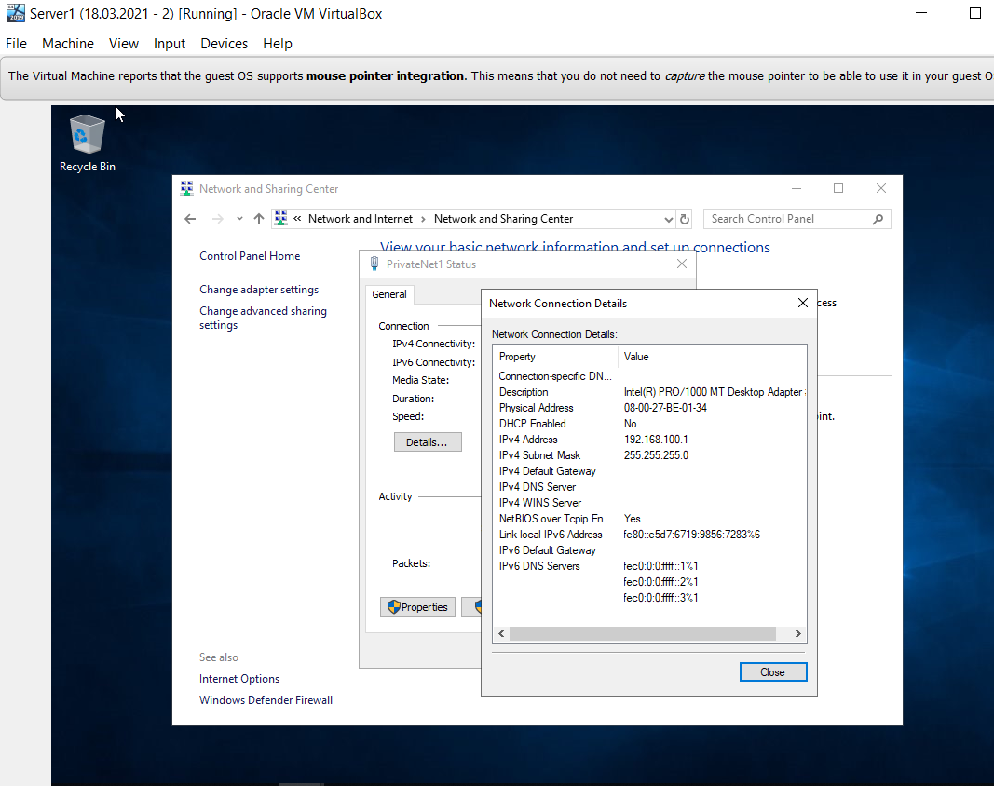
Figure 1
It shows in Figure 1, that the Dynamic Host Configuration Protocol (DHCP) is turned off, which means that Server 1 has a statically defined IP address.

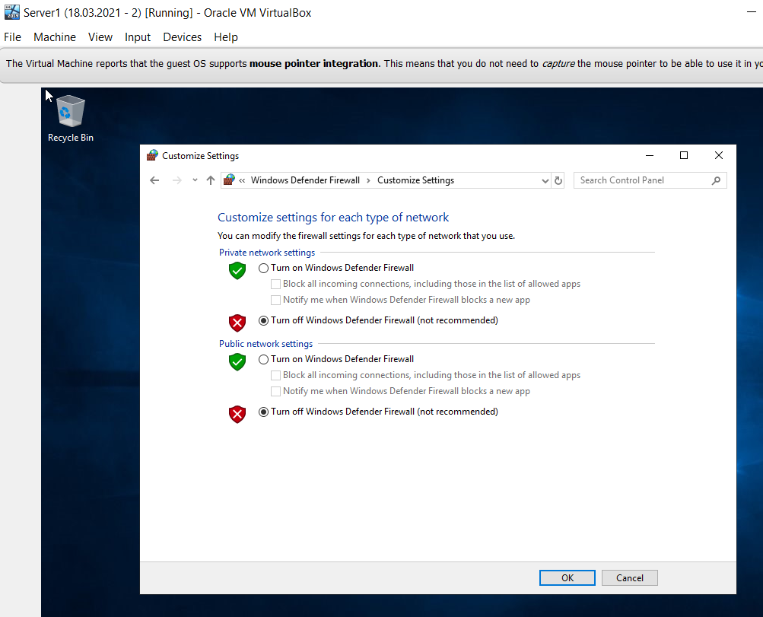
Figure 2
The Firewalls have been turned off on Server 1.

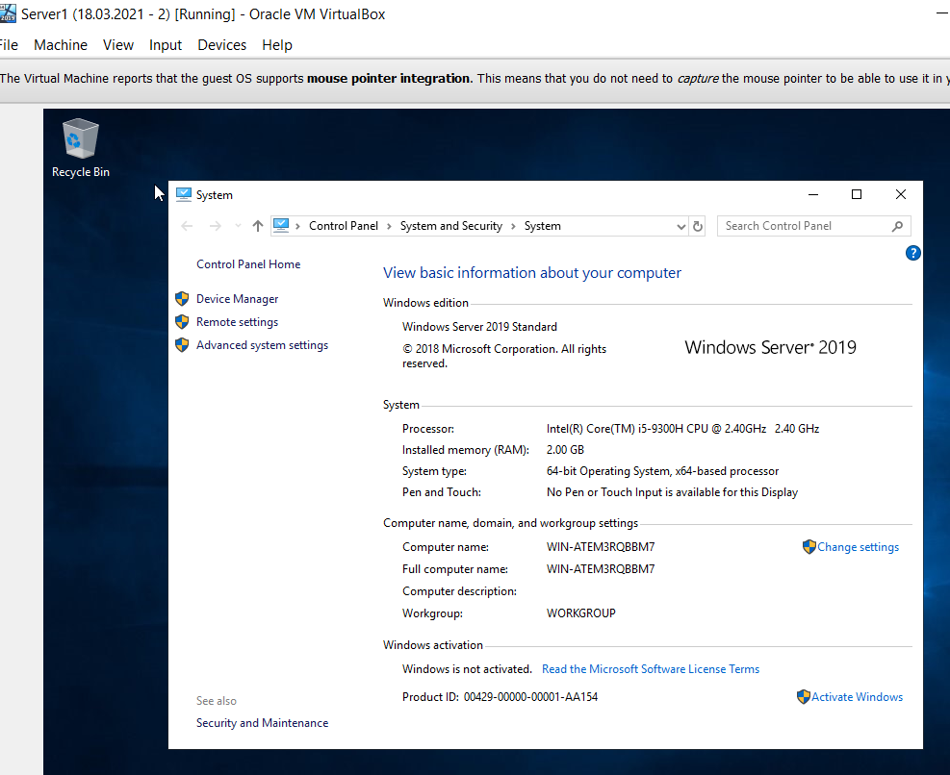
Figure 3
Having a standard naming convention will allow Servers to be found easily. This is beneficial for those who need to locate the Server, but also, the naming convention should not have an overly detailed name in case the Server ever becomes compromised.
Figure 3 shows the current computer name, which is WIN-ATEM3RQBBM7.

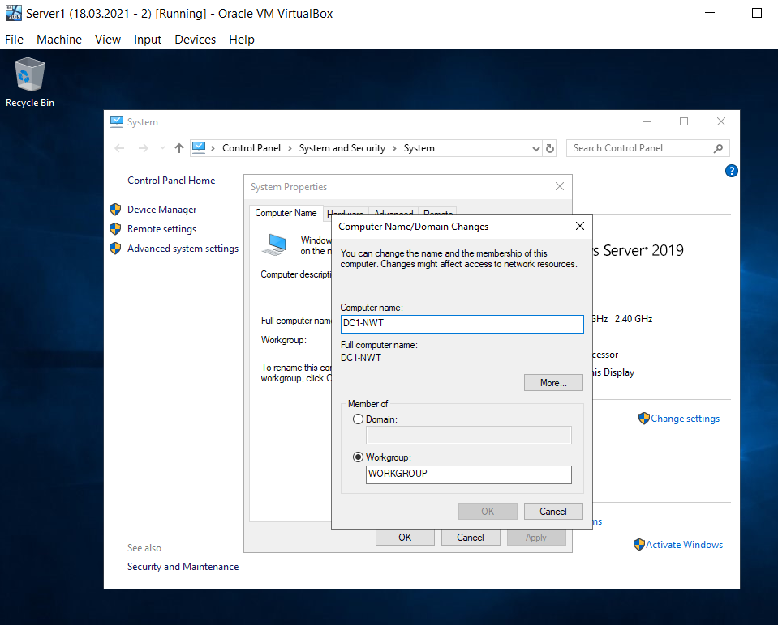
Figure 4
The computer has been renamed, and it is now called DC1-NWT, as shown above in Figure 4.

Task Two: Deploying Active Directory as a role or feature based installation

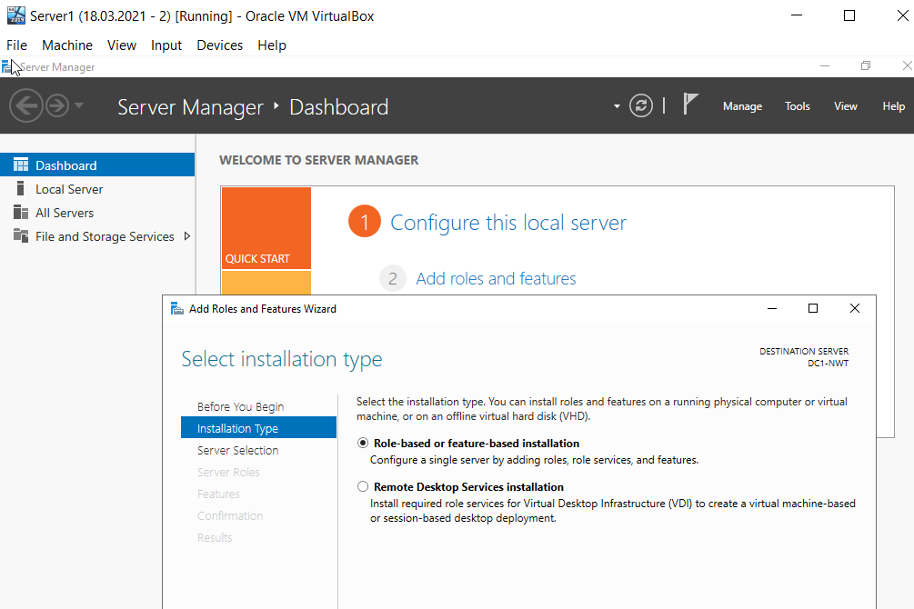
Figure 5
On the Server Manager on Server 1, she is going to install Active Directory as a Role-based or Feature-based installation.
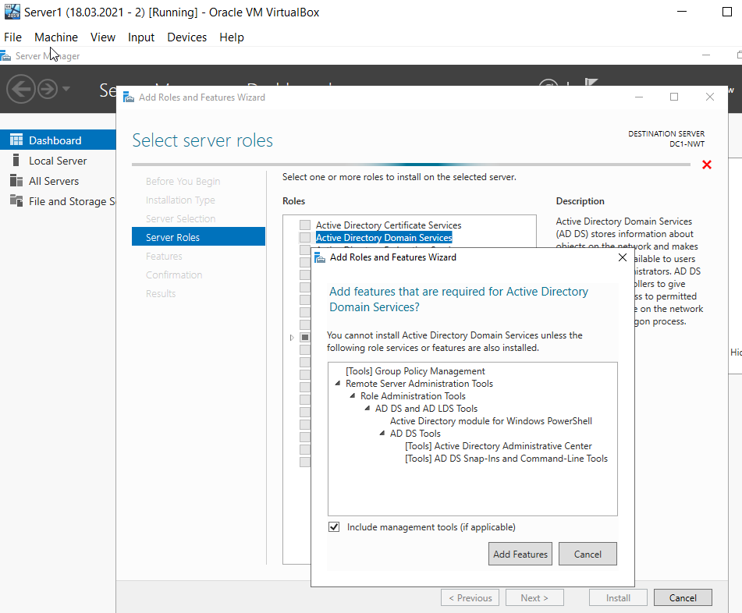
Figure 6
The Active Directory Domain Service will be one of the Server Roles selected, including the features recommended.
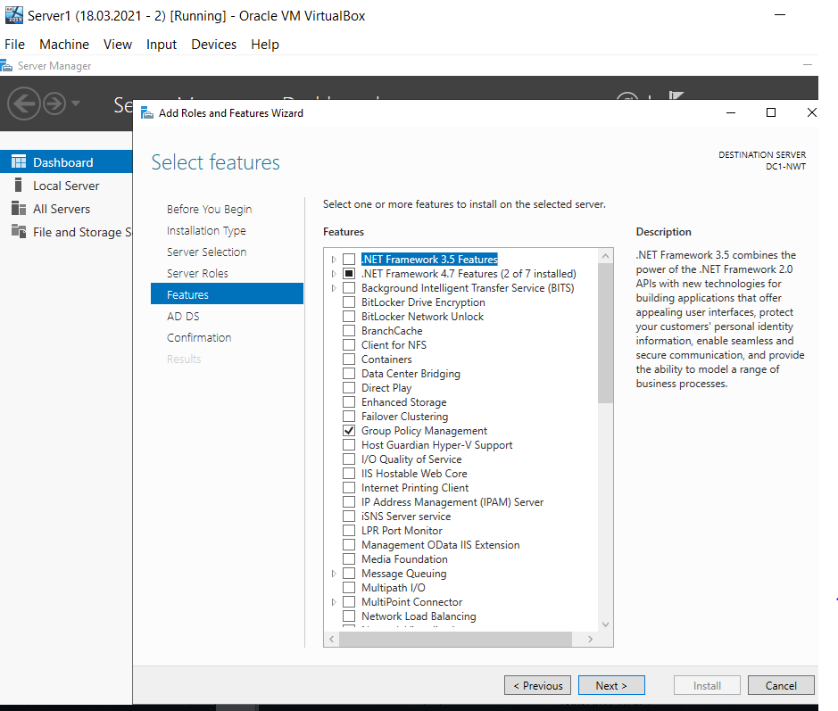
Figure 7
The features now need to be selected, and she has selected to include the Group Policy Management Feature.

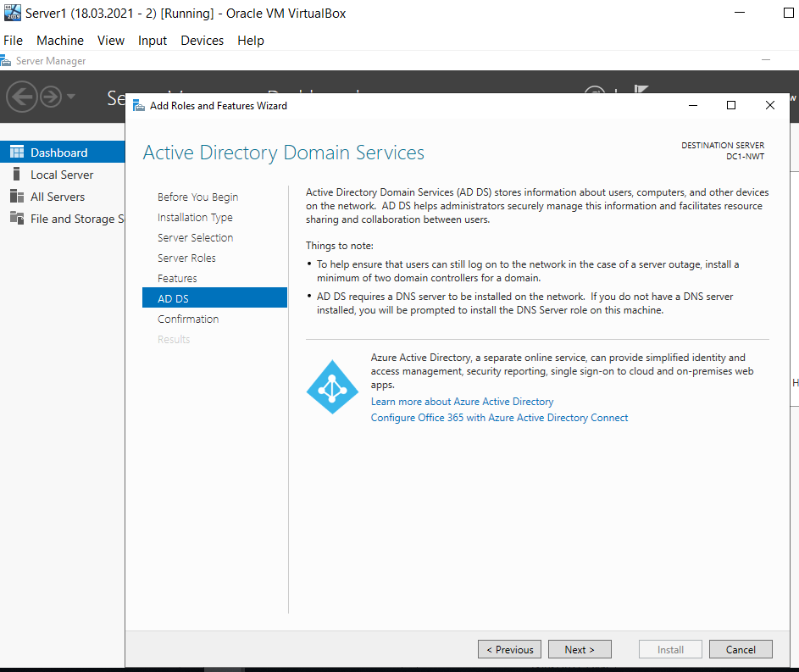
Figure 8
Information page within the installation regarding Active Directory (AD) Domain Services.

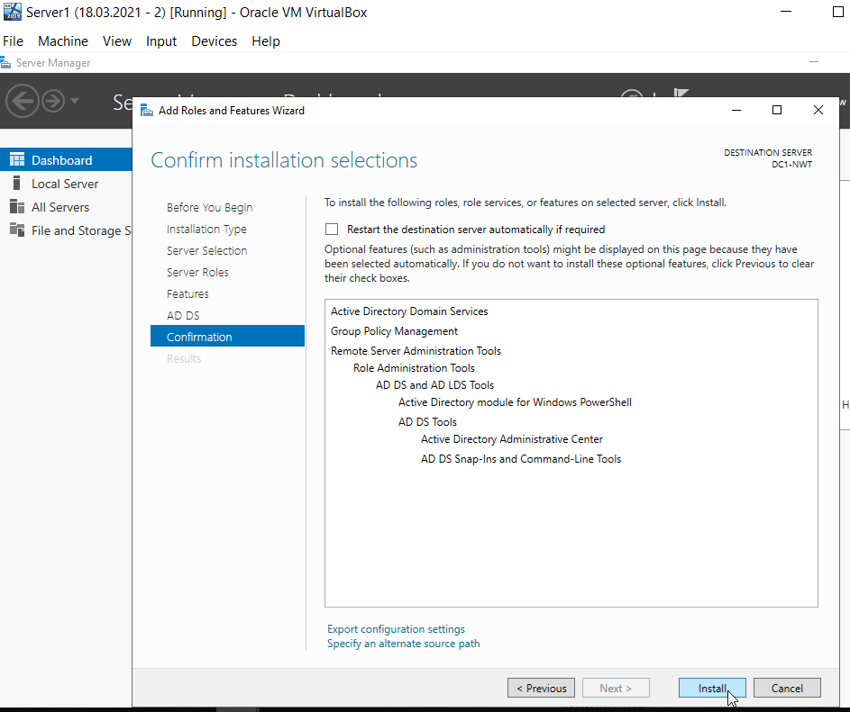
Figure 9
The selections need to be confirmed ready for the installation. The ‘Confirm Installation Selections’ page, as shown in Figure 9, allows the author to see at a glance the choices she has made before finally confirming.

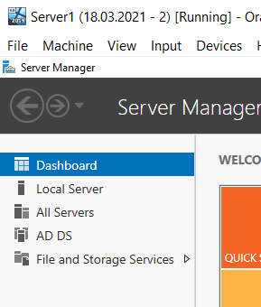
Figure 10
Server 1 dashboard.
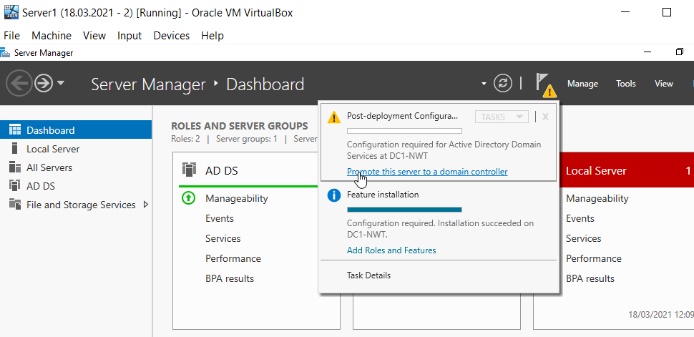
Figure 11
After the installation is complete, the server needs to be promoted to a Domain Controller (DC). The Yellow warning triangle in the top right hand corner of the Dashboard allows this action to be carried out.

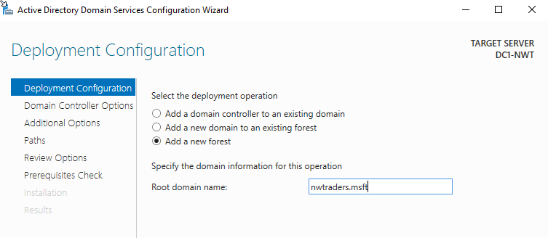
Figure 12
The Root domain name is changed to nwtraders.msft by the author, through the deployment configuration page.

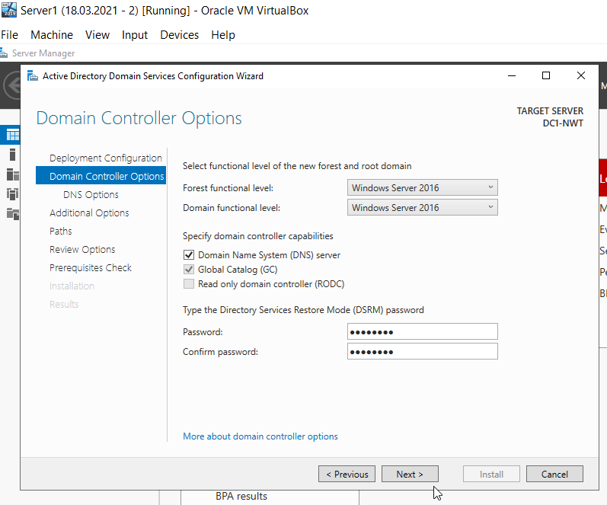
Figure 13
A password has been entered for the Directory Services Restore Mode (DRSM).

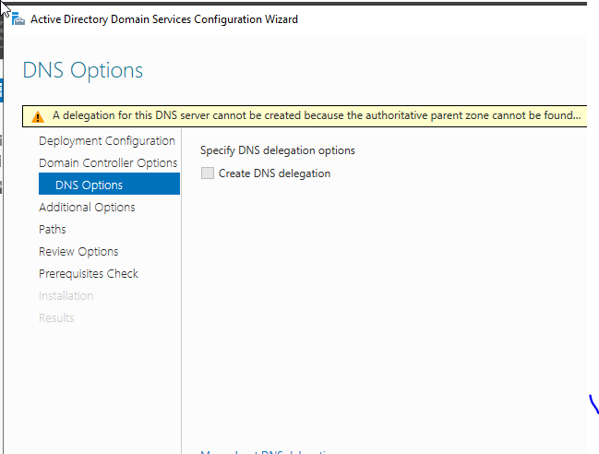
Figure 14

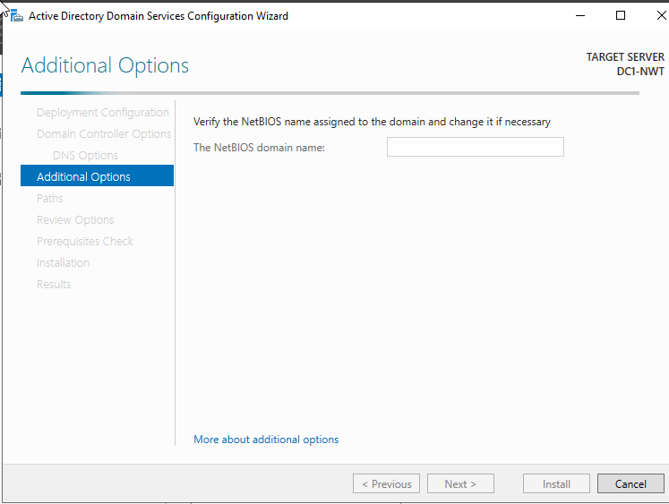
Figure 15
The additional options page has been left blank. This is not a requirement.

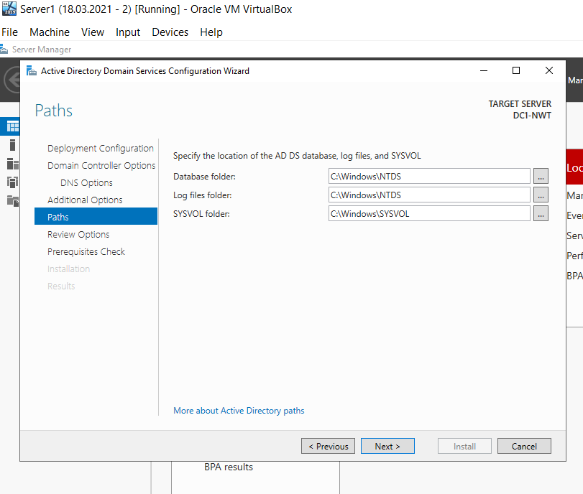
Figure 16
The location of the AD DS Database, Log files and SYSVOL have been manually chosen by the author herself.

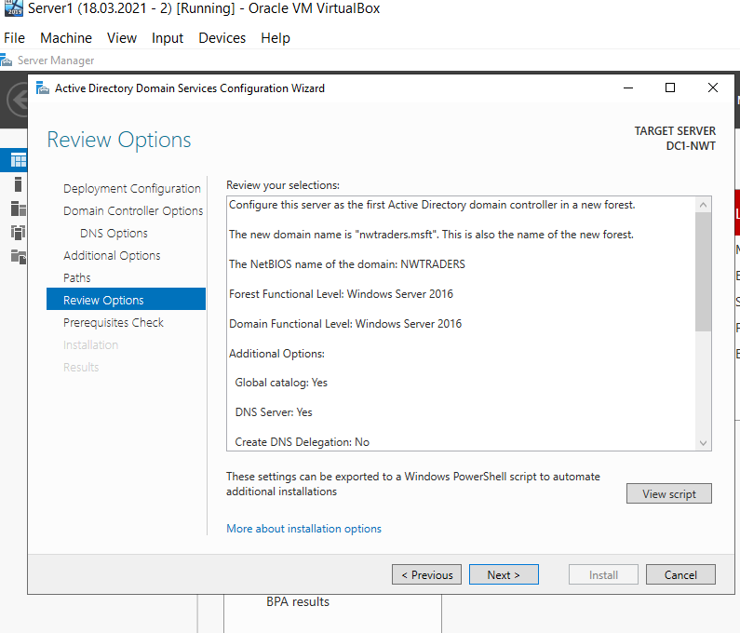
Figure 17
The opportunity to review the chosen options are available before the installation is complete. This gives the author an opportunity to amend any mistakes that may have been made.

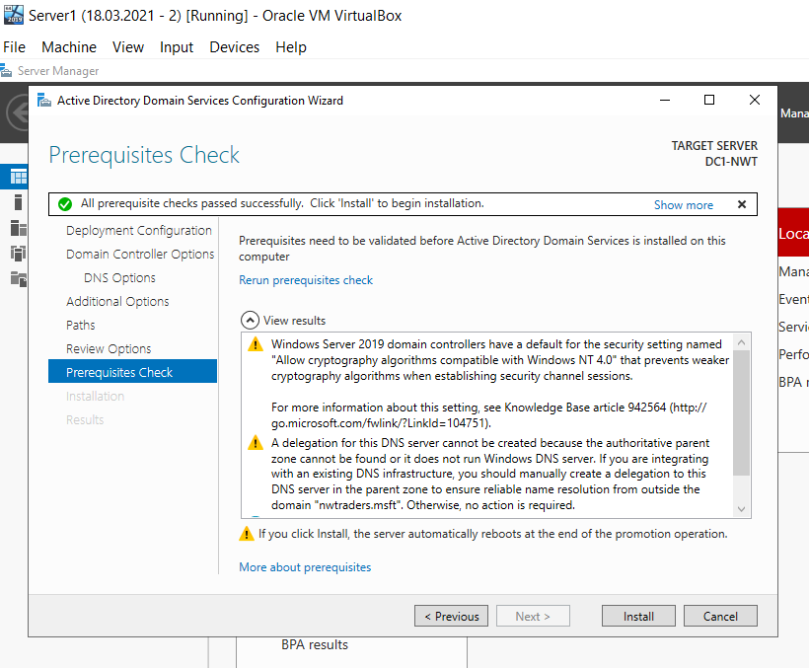
Figure 18
At the Prerequisites Check Page, she can install the Active Directory Domain Service.
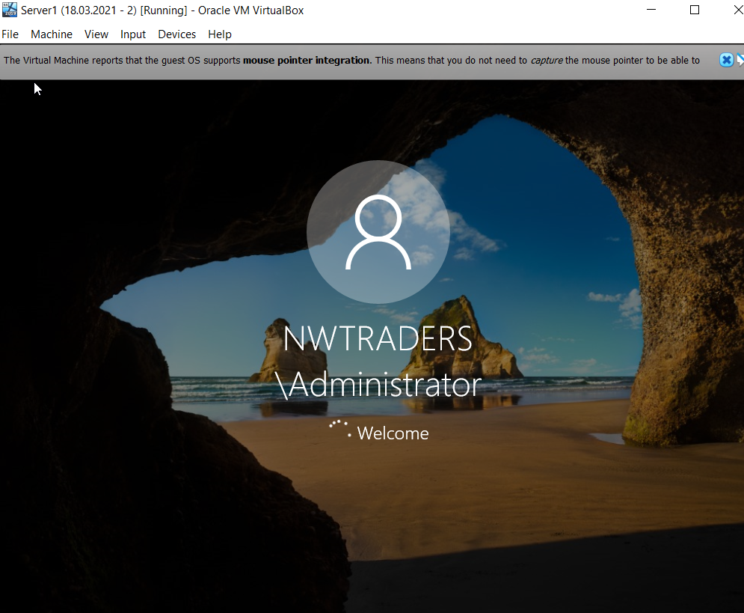
Figure 19
The server has rebooted after the install of AD as it mentions in the Prerequisites page shown in Figure 18.

Task Three: Creating user account objects using Active Directory Users and Computers snap-in console.

Task Four: Object attributes of interest.

Task Five: Adjoining the domain and testing user logins.

Task 6: Observational Tasks

6a) DNS – explain what it is, how it works (illustrations) and its significance within Active Directory Domain Services.

Domain Name System, more commonly abbreviated to DNS is the Internets way of converting alphabetic names or domain names into readable IP addresses for the internet to load. [1]
There are 8 steps in a DNS Lookup and WebPage Query. This can be seen in the illustration below:
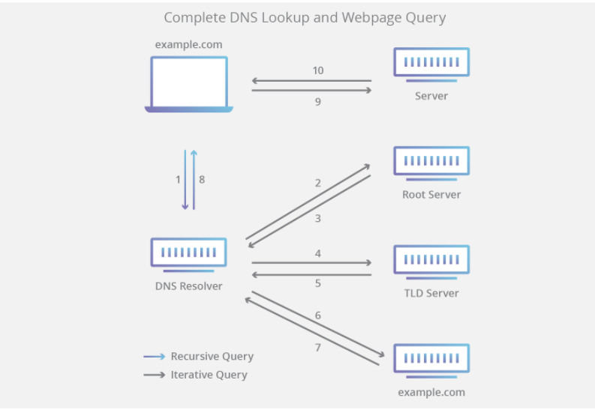
Figure 20 - [1]

6b) AD is one critical ‘Role or Feature based installation’ as part of an enterprise network, identify and provide a brief overview of 2 other critical roles?

6c) Explain why it is important to have different levels of access/roles within the ‘Built in’ Network User Account groups (e.g. Domain Admins, DHCP Admins, etc.)
It is important to have different user roles within Network account groups to liit the access that is appropriate for each work area, if multiple, and job title. For example, a receptionist does not need to see the same information a finance officer would need to see.
This protects the companies assets as well as protecting employees from any suspicion should anything untoward happen within a certain area, e.g. finance. If it is known exactly who has access to which system, area, server etc, it is easier to isolate the incident and locate the culprit.

6d) Share your ideas in-detail on Microsoft’s recommendations on AGDLP and AGUDLP for assigning permissions. How do you view them in the perspective of a System Administrator in strategizing and implementing within your network?

Bibliography

[1] | Cloudflare.com, “What is DNS? How DNS works,” 2020. [Online]. Available: https://www.cloudflare.com/en-gb/learning/dns/what-is-dns/. [Accessed 09 2021].

