BMIH6002
Managing Food & Beverage Operations
Student ID | Syeda Shafna Begum (2128508)
Word Count | 1340

Table of Contents

Introduction 3
Section 1: Reflection on Experience and Personal Development (Using Gibbs’ Reflective Cycle) 4
Section 2: Critical Analysis of Work-Based Skills and Technical Knowledge 6
Section 3: Reflection on Organisational Issues 7
Conclusion and Action Plan 7
References 9

Introduction
Services offered in the F&B division at Holiday Inn include restaurants which offer breakfast, lunch, dinner, lounge, room service and catering for other activities such as meetings and conferences. The department seeks to deliver excellent standardized services to customers that include businesspeople and families who are different with different needs and demands (Ouyang, Wei and Chi, 2019).

Source: (Devi, Sihombing & Adinda, 2024)
Placement Learning Objectives
During my placement in the F&B department, I set the following objectives to enhance my understanding of operational, managerial, and guest service aspects:
- Leadership Understanding: To learn the role of a supervisor, the tasks involved in assigning duties, creating and implementing shift rosters, and how to ensure overall standard delivery in the facility.
- Guest Service Excellence: To increase efficiency regarding my communication with the guests, regarding services and when facing complaints, provided that the guest satisfaction will be at a high level.
- Team Collaboration: To build strong collaboration skills since one communicates with the members of the team and learns how to assign the tasks in the department correctly.

Section 1: Reflection on Experience and Personal Development (Using Gibbs’ Reflective Cycle)
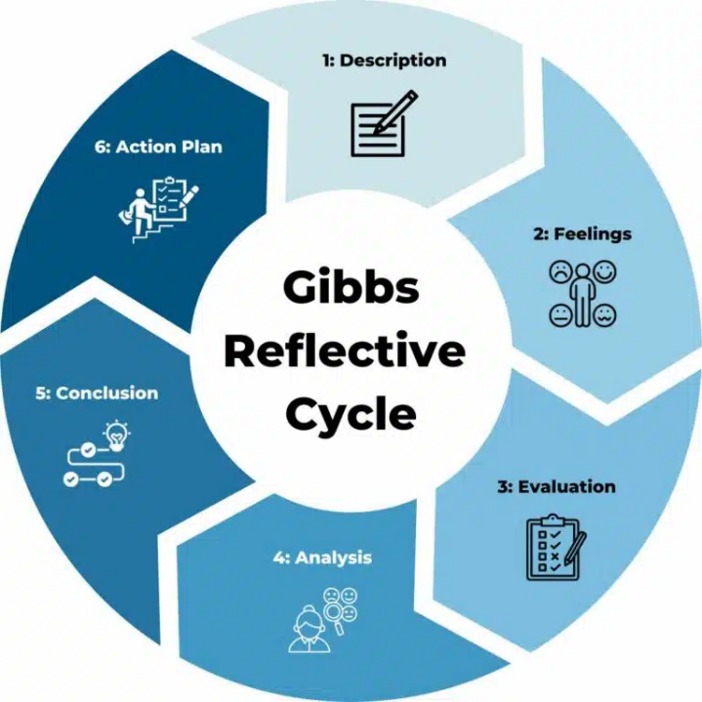
Source: (Kim, Barber and Kim, 2019)
1. Description
In the placement in the Food and Beverage department, I followed the work of a supervisor that allowed me to get acquainted with the main components of guest relations and organization of work. Often, I saw how the supervisor greeted the guests, how they listened to their requirements or requests, or how he dealt with complaints. Besides, I observed how the supervisor managed to perform several activities at once, communicating with the kitchen staff, supervising service procedures, and explaining to the employees how to keep high service standards.
2. Feelings
At first, I experienced some level of enthusiasm and apprehension when it came to shadowing a supervisor because I knew that I needed to switch from a more general position of observing a supervisor’s performance across the organization. But the positive aspect was observing the supervisor to remain cool whenever handling stressful events. They were especially understanding to guests, friendly with the team and clear in their communication. This motivated me and made me confident to develop similar skills as those I saw when working on this experience.
3. Evaluation
There were some merits to this shadowing practice. I realized how a supervisor’s behavior affects guest experience and affects the morale of the employees too. For instance, the timely response of the supervisor in guest requests informed the group that proactive service could effectively eradicate complaints. However, I also saw that they experienced some problems, like coordinating the functioning of the team with guest complaints, which they solve in real time, and this eventually slows down the communication between the kitchen and waiters.
4. Analysis
Looking back, I saw that my academic background, especially in group processes and meeting customers’ expectations was indeed useful. Tuckman’s stages of group development gave me the ability to watch the team go through the forming to performing stage. This awareness enabled me to assess team requirements in relation to communication and its timely delivery. At the same time, taking the coursework of hospitality management, I found out that there are areas where small improvements could be made to have a great and positive impact on the guest services, for instance, faster response to requests.
5. Conclusion
This experience made me realize that there is a great need to prioritize the task being assigned while performing serving guests, especially when in a supervisory position. It also made me realize that successful communications and interpersonal skills are important in managing number of guest requirements and team issues as well.
6. Action Plan
To increase these competencies more, I propose paying more attention to improving my timeliness and decision-making skills improved. Also, I want to pay much attention to effective and active listening as well as establish an empathetic attitude towards guests and coworkers while addressing further possible supervisory challenges.

Section 2: Critical Analysis of Work-Based Skills and Technical Knowledge
Guest satisfaction has been achieved by embracing one’s own customer expectations and giving an appropriate and thoughtful response (Bathla, Rana and Singh, 2019). For instance, employees should have the capacity to recognize when to attend to a guest’s need or when a table should be cleared and cleaned (Xu, Stienmetz and Ashton, 2020). In Holiday Inn, organizational satisfaction with services across subareas and within dining area, lounge or even from room service creates a level of homogeneity that guests appreciate.
Examples from Experience
Team Coordination: One of the most important measures which can help to meet guest service standards is cooperation. I was able to identify one specific case and that was that the supervisor went to the kitchen and requested the kitchen staff to have their food prepared at the right time for the servers so that they might not be stuck with many tables and the guests may not wait long. Another thing is when the supervisor decided to change shift objectives on an individual basis as the number of people the restaurant could accommodate was reached. In this case, the skilled supervisor was able to share the loads of work and make sure that service had been efficiently provided to the customers by making sure that they took their orders on time while on the other side of the coin the employees also felt relieved and accorded their orders equally on time. This experience also taught me how changes on the fly and cooperation between team members facilitate daily functioning to achieve excellent results in guests’ satisfaction.
Problem-Solving: There was one thing I managed to comprehend how the guests’ problems must be solved as efficiently as possible. This was during one shift where the guest slapped and complained that a room service food order was prepared containing items that were prohibited on the guests’ diet. When responding to the guest’s complaint, I also made a mental checklist of how the supervisor quickly apologized, provided an alternative meal and a complimentary item to make the guest feel special. This led me to understand further that most problems should not be left to fester because both the immediate issue and the guest relation is better served in having solutions sooner rather than later.

Section 3: Reflection on Organisational Issues
Issue Encountered
In the time I spent at Holiday Inn, I realized one major organizational problem was the importance of communication between the employees, and more specifically, between the front-line workers and the chefs. This issue was one that endangered service delivery because there would be misunderstandings as to what a guest wants, delays in service, and more to that, the guests got frustrated. Some new challenges were observed during the high volumes during mealtimes when orders were getting a little cramped thus sending wrong dishes or giving guests the wrong responses to their inquiries.
Proposed Solutions
- Introduction of Daily Stand-Up Meetings: Efficient daily meetings designated at the start of the shift could help the case (Vives, Jacob and Payeras, 2018). These stand-ups would help in making the team address any specials that may be there, the expected busy days or possible challenges hence being proactive in services.
- Utilizing Visual Aids: The use of a digital kitchen display system (KDS) can remove any confusion as orders come in since they will be written in a clear manner and falsely placed orders avoided (Ouyang, Wei and Chi, 2019). This technology helps kitchen staff to prioritize and manage orders while minimizing errors in the order flow.

Conclusion and Action Plan
Summary of Key Insights
The shadowing activity helped in gaining real life understanding of the issues that revolve around the supervisory position of the Food and Beverage department. Here I was able to learn about the ways of managing team and guests while managing an effective team by ensuring that operations were running smoothly.
Future Goals
- Communication Skills: To reduce the level of failure in handling guest complaints and improve the quality of team communication, I proposed to undertake some courses in conflict management and interpersonal skills.
- Technical Proficiency: Regarding my technical competency, I will try to enhance my training on training on new F&B management software. Knowledge of these systems shall enable me to be in a good position to conform to different technological facilities used in the business.

References
Abaeian, V., Khong, K.W., Kyid Yeoh, K. and McCabe, S., 2019. Motivations of undertaking CSR initiatives by independent hotels: a holistic approach. International Journal of Contemporary Hospitality Management, 31(6), pp.2468-2487.
ASET., 2017. Good Practice Guide for Workbased and Placement Learning in Higher Education. Sheffield: ASET.
Bathla, G., Rana, S. and Singh, A., 2019. Exploring the gaps between hotel management education and industry expectations. Journal of Management Research and Analysis, 6(2), pp.250-252.
Buchanan, D. and McCalman, J., 2018. Confidence, visibility and performance: the effects of shared information in computer-aided hotel management. In The New Management Challenge (pp. 17-29). Routledge.
Chan, E.S., Okumus, F. and Chan, W., 2018. Barriers to environmental technology adoption in hotels. Journal of Hospitality & Tourism Research, 42(5), pp.829-852.
Devi, N. M. G. H. K., Sihombing, I. H. H., & Adinda, C., 2024. The Effect of Job Stress on Employee Performance at Holiday Inn Resort Baruna Bali. Jurnal Indonesia Sosial Sains, 5(09), 2199–2206. https://doi.org/10.59141/jiss.v5i09.1230
Gallo, P., Timková, V., Šenková, A. and Karahuta, M., 2018. Use of dashboards in predicting the development of the company using neural networks in hotel management. GeoJournal of Tourism and Geosites, 22(2), pp.307-316.
Hagg, E., 2013. Internship Guide: Work Placements Step by Step. 5th Ed. The Hague: Eleven International Publishing.
Henschel, U.K., Gruner, A. and Von Freyberg, B., 2018. Hotelmanagement. Walter de Gruyter GmbH & Co KG.
Kim, Y.H., Barber, N. and Kim, D.K., 2019. Sustainability research in the hotel industry: Past, present, and future. Journal of Hospitality Marketing & Management, 28(5), pp.576-620.
Nain, A., 2018. A study on major challenges faced by hotel industry globally. International Journal of Creative Research Thoughts, 6(1), pp.561-571.
Ouyang, Z., Wei, W. and Chi, C.G., 2019. Environment management in the hotel industry: does institutional environment matter?. International Journal of Hospitality Management, 77, pp.353-364.
Shin, H., Perdue, R.R. and Kang, J., 2019. Front desk technology innovation in hotels: A managerial perspective. Tourism Management, 74, pp.310-318.
Vallen, G.K. & Vallen, Jerome J., 2014. Check-In CheckOut: Managing Hotel Operations. 9th Ed. Harlow: Pearson Education Limited.
Vives, A., Jacob, M. and Payeras, M., 2018. Revenue management and price optimization techniques in the hotel sector: A critical literature review. Tourism economics, 24(6), pp.720-752.
Walker, J.C., 2021. Introduction to Hospitality. 8 th Ed. Harlow: Pearson Education Limited.
Xu, S., Stienmetz, J. and Ashton, M., 2020. How will service robots redefine leadership in hotel management? A Delphi approach. International Journal of Contemporary Hospitality Management, 32(6), pp.2217-2237.

