The influence of health promotion initiatives to reduce smoking within Wales.

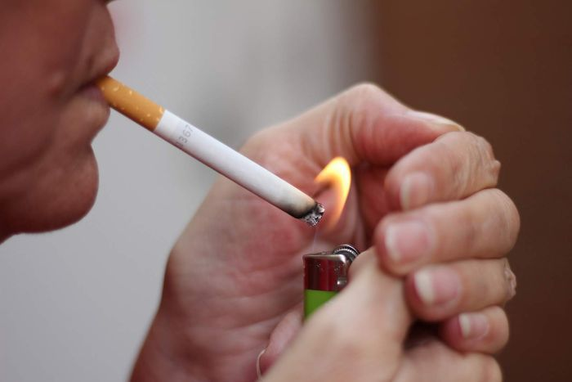

By Katie Snelling.

Contents Page

Introduction - Page 3

Main Body - Page 4 – 6

Conclusion - Page 7

References - Page 8-9

Introduction
This report examines and evaluates three government initiative put into place in Wales that tackle the public health issue smoking. Within this report it discusses the effects of smoking on the smoker, the people around the smoker, the NHS in wales and Welsh Government. This report will evaluate the governments initiatives that have been put into place in to tackle the issue of smoking within Wales and if they have been valid, improved the smoking rate in Wales, benefited the smoker and people around the smoker’s health. The finding in this will be supported and backed up by other reports, statistics, published articles and websites and newspapers. The report will look at how the initiatives have benefited Wales and the populations health and Well-being . When the invectives have been analysed and evaluated recommendations will be created to help improve the government strategies to tackle smoking in Wales.

Main body

There are 9.4 million adult smokers in the UK, this is one in 5 adults (Cancer Research UK 2018). Smoking is more common in men, people that are aged between 25-34 and unemployed (NHS 2018). Dundee has the highest smoking population in the UK with 20.8% purchasing tabaco (Evening telegraph 2018). According to Ash Wales (2019) Neath Port Talbot has the highest smoking rate in Wales with 25% of the population using tobacco. smoking in Wales costs the NHS £306 million a year, it also costs the welsh economy £790.66 million a year. Smoking can be the cause of over 50 different health conditions, it can damage your lungs, heart, blood circulation, mouth, throat, stomach, liver, pancreas and many other parts of the body(NHS 2018). Smoking is one of the biggest risk factors of cancer and those that smoke have a 50% greater chance of developing dementia (Ash 2019). Not only does smoking have an impact on the smoker and the government it affects people around them, this is called second hand smoking. Second hand smoking is the smoke you breathe out and the smoke from the cigarette, smoke linger around for 2-3 hours (NHS 2018). Children are more vulnerable than adults to inhaling smoke second hand as they have smaller airways, breathe faster and their lungs are still developing (Smoke Free Families 2019). Second Hand Smoking can have the same risks as the smoker themselves there are at least 1000 deaths in the UK because of this and there are 3000 house fires in England each year (Get Self Help 2007). This is a public health issue as it affects the smoker, people around the smoker, the government, economy and the NHS.
Initiative One
The Department of Health published The Public Health White Paper in 2004, proposing the idea of introducing a smoking ban in public places. At this time evidence was increasing of the risks of passive smoking (Centre For Public Impact 2016) . In 2006 parliament introduced a ban smoking in public places, this meant that smokers would not be allowed to smoke in pubs, clubs, work, hotels and hotel rooms, this came into force in Wales on the 2nd of April 2007 (Politics 2012). The Welsh Government (2007) emphasise how important the smoking ban is, it was introduced in order to protect the public that do not smoke as second hand smoking can cause lung, cancer, heart disease and respiratory diseases. The Welsh Government (2007) estimated that 400 premature deaths a year are caused by second hand smoking. Cass (2017) believes that this ban has changed Wales for the better, it has improved the Welsh populations health as smoking areas in Wales are limited. In 2007 before the smoking ban 24% of people in Wales smoked, in 2007 this became 19% (AHS wales 2017). Public Health Wales (2012) agree with Cass (2017) that the smoking ban has made a difference within Wales but argue more needs to be done. Public Health Wales recognise that there are still 27,700 hospital admissions s a year due to smoking. There are also children still being exposed to passive smoking, 39% of children live in a household where there is one adult smoker. Even though there is a ban in public places children are still exposed to passive smoking in their own home which affects their health, this suggests that the aim of his ban is unsuccessful as it has not protected people from passive smoking and there are still hospital admissions from it. Bauld et al (2010) recognises that the smoking rate has gone down and suggests that smokers are not honest as they could say there non smokers as they are embarrassed and want to be socially accepted as smoking is banned in most places, which suggests that any data of smokers in Wales is invalid. Sands (2017) suggests smoking has increased in Wales’ poorer areas where there is employment, it has gone from 41% to 43%. One argument could be that people do not work because they are unable to smoke within the work place and that’s why more unemployment people smoke as there are more unemployed people.
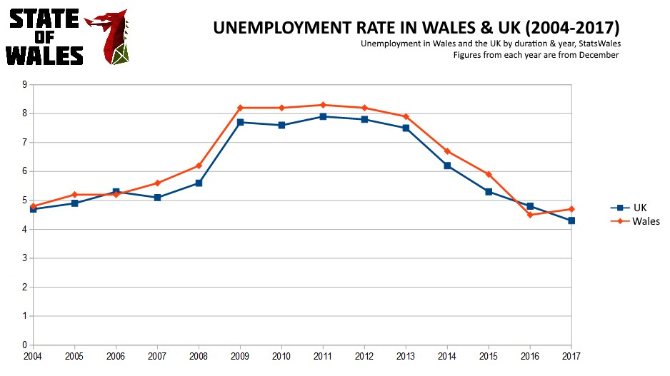
State of Wales (2018)

Here is a graph of the unemployment rate in Wales and the UK, the smoking ban was introduced in 2007 and since the unemployment has increased until 2012, this supports the idea that people do not work because they can support in work. It can be seen that as smoking ban has been in place for 12 years people are only realising now that they need to work, and the smoking ban is not going to change.

Initiative 2
In October 2015 it came illegal to smoke in a car with a person under the age of 18 present in Wales and England. This law was created in order to prevent children and young people being exposed to the dangers and consequences of tobacco on their health and well-being. By an adult smoking in a car with a person under the age of 18 present can face to offences, first one is for the person smoking and second is for the driver failing to prevent smoking in a car with a person under 18 present. The driver and smoker could be issued a fine of £50 (ASH Wales 2019). Flint (2016) discusses how after a year of the smoking ban there had been no fines issued however there were still warnings given to drivers which suggests that the law created is being ignored as people are still smoking in cars with children inside. Clark (2016) argues that because no fines have been issued this ban has been unsuccessful, he believes that the law was unnecessary as not many adults smoked in cars with children present before the ban. However, this ban is necessary as The Government (2015) believe this ban protects children from the harm of smoking and prevents them developing illness such as meningitis, pneumonia, cancer and asthma. This has also lower hospital admission rates as children will have better health as they are not being exposed to second hand smoke

Initiative 3
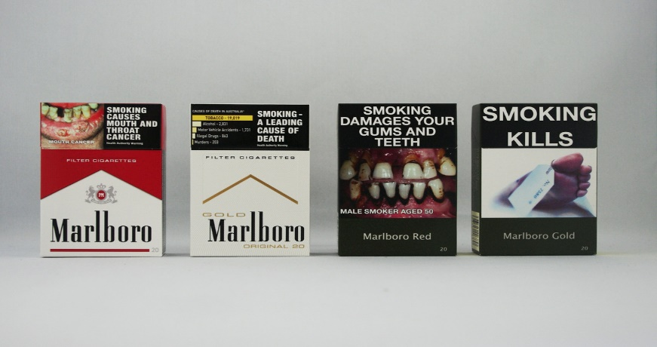
In May 2016 laws were made to make sure that all tobacco packaging needs to be ‘plain’ but did not come into force until 2017. ‘Plain’ packets mean that in fancy packets with bright colours cannot be sold, the packaging should be plain, dark green with photos either side of the packet highlighting the effects of smoking and health warning should appear on the top of the packet and should be sold as packs of 20. The photo of the needs to cover 65% of the packet, the font use should be a certain text, size and case. Promotional words that are misleading are prohibited such as ‘lite’ ‘natural’ and ‘organic’ (ASH Wales 2019). This initiative was created in order to prevent young people take up smoking, by making packets plain and off putting it will prevent young people being interested in tobacco and put off by the effects and photos as branding and advertising is one of the most popular way to attract young people (BBC 2017). To the left there is a picture of before and after of the tobacco packaging change. As you can see the first two packet looks stylish, and attractive with font and colours. The second two packets look disturbing, unpleasant and scary. The new packets now look the same which means there is no branding or unique styles to the tobacco brands. According to Monaghan (2017) the changes of tobacco packets has been successful as cash and carry group Broker found a 10% drop in tobacco sales, this suggest that smokers have been put of smoking by the new packaging. Clark(2018) disagrees with this view and suggests it will cause smokers purchasing illegal tobacco as 15% of tobacco sales is illegal in Wales. According to the National Survey Wales there was no change in smokers, in 2017 19% of the Welsh population were smokers and it was the same in 2018 (ITV 2018). This suggests that the change of tobacco packets have not impacted smokers to quit. However, the percentage has not increased so it can be argued that the packaging has prevent people to not take up smoking.
Vox (2016)

Conclusion

The first initiative, the smoking ban has been continuously successful as the smoking rate within wales counties to drop. It has helped people quit smoking as there are limitations to where they can smoke. It has also improved the health and well beings of others are they are protected from second hand smoke. However, children are still being exposed to second hand smoking at home as 39% of children still live with one adult that smoke within the household. The second initiative was to prevent children from being exposed to passive smoking and the causes. It has been argued that it has not been successful as no fines have been given and not many adults smoked with children in the car before. However, it has this law has been supported to be successful as it is reducing the risks of second hand smoke on children and young people. The third initiative, the plain packets have been successful as there have been a 10% drop in tobacco sales. This initiative was designed to put of smokers and young people that may take it up. However, there is an increase of legal tobacco sales which do not have the plain packet. These initiatives have worked as the smoking rate has decreased in Wales from 24% to 19%. To improve this percentage even more the government should ban smoking in public places which are outdoors such as outside shops , bus tops, outside parks, pubs, clubs and restaurant. The only place smokers should be able to smoke is within their home or outside it, by this way it will be difficult for smokers to lite up where there is not many places they can. It will also prevent the risk of second had smoking as they will not come into contact with other smokers.

References

Cancer Research (2018) Tobacco Statistics. Available at: https://www.cancerresearchuk.org/health-professional/cancer-statistics/risk/tobacco#heading-Three [Accessed 01/04/19]
NHS (2018) statistics on smoking. Available at: https://digital.nhs.uk/data-and-information/publications/statistical/statistics-on-smoking/statistics-on-smoking-england-2018/part-3-smoking-patterns-in-adults. [Accessed 01/04/19]
Evening Telegraph (2018) Dundee has one of the highest smoking rates in Britain. Available at: https://www.eveningtelegraph.co.uk/fp/dundee-has-one-of-the-highest-smoking-rates-in-britain/ [Accessed 1/04/19]
Ash Wales (2019) Wales Headlines Statistics. Available at: https://ash.wales/wales-headline-statistics/ [Accessed 01/04/19].
Ash (2019) Fact Sheets. Available at: http://ash.org.uk/category/information-and-resources/fact-sheets/ [Accessed 01/04/19]
NHS (2018) What are the health risks of smoking? Available at: https://www.nhs.uk/common-health-questions/lifestyle/what-are-the-health-risks-of-smoking/ [Accessed 02/04/19]
Smoke Free Families (2019) Facts about second hand smoke. Available at: http://www.smokefreefamilies.co.uk/facts. [Accessed 02/04/19]
NHS (2018)Passive Smoking: Protect Your Family and Friends. Available at: https://www.nhs.uk/live-well/quit-smoking/passive-smoking-protect-your-family-and-friends/ [Accessed 02/04/19]
Get Self Help (2007) Smoking Facts. Available at: https://www.getselfhelp.co.uk/hyp/stopsmoking2.htm [Accessed 02/04/19]
Centre for Public Health Impact (2016) Smoking ban in England and Wales. Available at: https://www.centreforpublicimpact.org/case-study/smoking-ban-england-and-wales/ [Accessed 03/04/19]
Politics (2012) Smoking Ban. Available at: https://www.politics.co.uk/reference/smoking-ban [Accessed 03/04/19]
Welsh Government (2007) at: http://www.wales.nhs.uk/documents/stubs27-3-7.pdf [Accessed 03/04/2019]
Cass.S (2017) Welsh Government , Smoking at all time low as Wales marks 10th anniversary of ban. Available at: https://gov.wales/smoking-all-time-low-wales-marks-10th-anniversary-ban-0 [Accessed 04/04/19]
ASH Wales (2017) 10 Years of the smoking ban – What’s changed in Wales? Available at: https://ash.wales/10-years-of-the-smoking-ban-whats-changed-in-wales/ [Accessed at 4/04/19]
BBC (2017) Plain tobacco packaging 'may cut smokers by 300,000 in UK. Available at: https://www.bbc.co.uk/news/health-39720854 [Accessed 04/04/19]
Vox (2016) Cigarette packs are being stripped of advertising around the world. But not in the US. Available at: https://www.vox.com/2016/6/2/11818692/plain-packaging-policy-us-australia [Accessed 04/04/19]
Public Health Wales (2012) Tobacco and health in Wales. Public Health Wales NHS Trust / Welsh Government. Statistics for Wales.
Bell.K, Bauld.L, Greaves.L McCullough.L,Richardson.L (2010) ‘Journal of Public Health’. The effectiveness of NHS smoking cessation services: a systematic review. Volume 32, Issue 1, Pages 71-82
Sands.K (2017) Wales Online 10 Years what has the smoking ban done for Wales? Available at: https://www.walesonline.co.uk/news/health/10-years-on-what-smoking-12825842 [Accessed 04/04/19]
State of Wales (2018) The Welsh Economy XIII: Employment and Skills. Available at: https://stateofwales.com/2018/10/the-welsh-economy-xiii-employment-skills/ [Accessed 04/04/19]
ASH Wales (2019) Smoking in Cars. Available at: https://ash.wales/campaign/smoking-in-cars/ [Accessed 07/04/19]
Flint.R (2016) BBC, No fines issued in Wales for Smoking in cars with Children. Available at: https://www.bbc.co.uk/news/uk-wales-37518371 [Accessed 07/04/19]
Clark.S (2018) Car Smoking ban a complete failure. Available at: http://www.forestonline.org/news-comment/headlines/car-smoking-ban-complete-failure-says-forest/ [Accessed 07/04/19]
The Government (2015) Smoking in Cars with Children Banned Today. Available at: https://www.gov.uk/government/news/smoking-in-cars-with-children-banned-from-today [Accessed 07/04/19]
ASH Wales (2019) Standardised Plain Packaging. Available at: https://ash.wales/campaign/standardised-plain-packaging/ [Accessed 04/04/19].
Monaghan.A (2017) The Guardian, New cigarette rules have led to slump in sales, says Londis owner. Available at: https://www.theguardian.com/society/2017/sep/14/new-cigarette-rules-slump-sales-londis-booker [Accessed 04/04/19]
ITV (2018) Health body 'disappointed' nearly one fifth of Welsh adults still smoke. Available at: https://www.itv.com/news/wales/2018-06-20/health-body-disappointed-nearly-one-fifth-of-welsh-adults-still-smoke/ [Accessed 04/04/19]

