Portfolio of Writing

Student Name: Aimee Rayner
Student Number: 2204919

Programme of Study: Surface Pattern Design and Textiles

Module: ADAD4018 Ways of Thinking
Submitted 9th of January 2023

Task One: Manifesto = 744 words

Task Two: Observational Writing = 605 words

Task Three: Practise based writing= 1124 words

Task 1: Manifestos:
- Cake- always an option when art-making. Guilt not included.
- Never write a manifesto again.
- Anyone who does art to become famous and rich is probably unreasonable and unlikeable.
- Don’t make anyone else follow these rules, they are for me only and I don’t take it seriously.
- Use art to communicate your feelings and use art to help others do the same.
- Get rid of the right and wrong dynamic within art. Who says what’s right and wrong?
- Constructive criticism to completely overrule negative comparison.
- Treasure the process of the art-making over the outcome of your makings.

- Never write a manifesto again

This manifesto is not intended to be political and will not suit everyone. This future is not in need of more critics or offending comments. Manifestos are outdated and could offend readers by its absolute values and beliefs. ‘Traditional methods of communication don’t resonate with this new generation of workers. (Gen Z and Millennials) We need to find creative ways to connect with them and speak to their values and aspirations’ (Ellenberg, 2022).
Therefore, I think manifestos have had their time. They are no longer valid and might upset some one within this era. An artist manifesto is “laying out a series of aims and beliefs which you hope to stick to” (BBC Radio 4, 2017). In our current ever-changing, fast paced world, a set of fixed rules is hard to justify sticking to. Change and adaptation is how artists stay relevant, and ethically correct, compared to sticking to rules that quickly become outdated. ‘In other words, the manifesto is a personal or even handwritten statement, intending to shock, inspire, or offend’ (Redding, 2010). With politics and world affairs being all consuming in a digital era, where you can see anything and everything at the click of a button, artist manifestos are no longer a standout ‘outrageous’ piece of work. They simply become lost in the noise of chaos and disorder. They are no longer serving a purpose in 2022.
In the 1900’s manifestos helped artists become ‘a public figure as a result of, not prior to the publication’ of a manifesto (Perloff, 1986). This could be due to the absence of social media, the internet so artists with a manifesto stood out more than artists without, and therefore gained more popularity. In this era, artists with a manifesto, encouraged a bigger and wider audience to their visual artwork compared to those without a manifesto. In the early 20th century, fewer forms of communication to what we have now, meant that artists could stick to their manifestations with less comparisons and opinions from others. In 2022, becoming a ‘public figure’ by speaking one’s opinions is risky and most likely detrimental to one’s artwork, reputation, and wellbeing, compared to 1900’s where having an artist manifesto was more likely to encourage a bigger audience to view your work.

Which leads me onto my next point to discuss:
- Anyone who does art to become famous and rich is probably unreasonable and unlikeable.

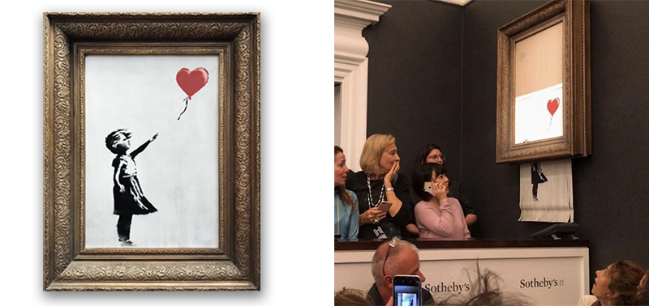
Fig 1 & 2: BANKSY, 2018. Banksy piece immediately shreds itself after being sold for $1.1M.
According to Nathan (2008), ‘Our ancestors knew the arts were synonymous with survival…’ before the concept of money or fame. Humans ‘…created art to communicate emotions, our passions, jealousies and our enduring conflicts’ (Nathan, 2008, pg.177) to one another, to an audience who they wanted to reach. In 2022 with a new digital era, communication can cross countries, languages and knowledge, easily which with it brings identity. This is a good thing when it comes to showing the world an art piece that is meaningful for more people than just those that can reach it in person. However, when the artist or movement uses this identification and spotlight to point fingers, thrust ideologies and take excess money for themselves, this popularity is misused. The delicate use of art as communication gets distorted with people getting greedy, and changing the context in which the art sits. For example, Banksy, a famous unknown street artist wants to stay unknown to stop his work being interfered with by popularity and fame. His work has more depth without being corrupted by his fame and riches. This hands over the authority of the artwork back into the publics grasp rather than selfishly hiding the work for a select few entitled or rich collectors. For someone to put others at the heart of their work, even when the personal gains from doing the opposite, are greater, I believe to be a very positive core value. I would go as far as saying this should be the only reason we practise all art forms: for others and not just for ourselves.

- Treasure the process of the art-making over the outcome of your makings.

When you take away the pressure of an outcome, a product, then the process of art-making in itself is therapeutic and helps to connect the mind, body and soul through movements, processes, reflection and discussion. Liebmann (2004) says ‘the philosophy of Art Therapy embraces the idea that all art expression is acceptable. The purpose is not to make great art.’ This is when art’s natural creative, exploratory features become therapeutic, taking away deadlines or judgement. K. Patel (2022) suggests these natural traits of art is what can “build self-confidence and resilience in someone which, are important life skills for all ages and abilities.”
Another quote to support the importance of the process of art-making is ‘most art therapists are more interested in helping the person who makes the art to come up with his/ her own interpretation’ Malchiodi (2007). This push towards imagination, understanding and self-expression is not focused on how ‘good’ the final product looks but what it means to the art maker.
An example that Ellie Strange, an art psychotherapist, gave during an interview with Aimee Rayer (2022), was when one might ask a client why they chose a red pen over the blue pen. This lead to a helpful discussion of more importance than the actual outcome of the artwork, in order to help find the subconscious context to unhelpful habits and behaviours. This then allows the client and therapist to explore the meaning of their actions in a safe, visual way together to improve wellbeing.

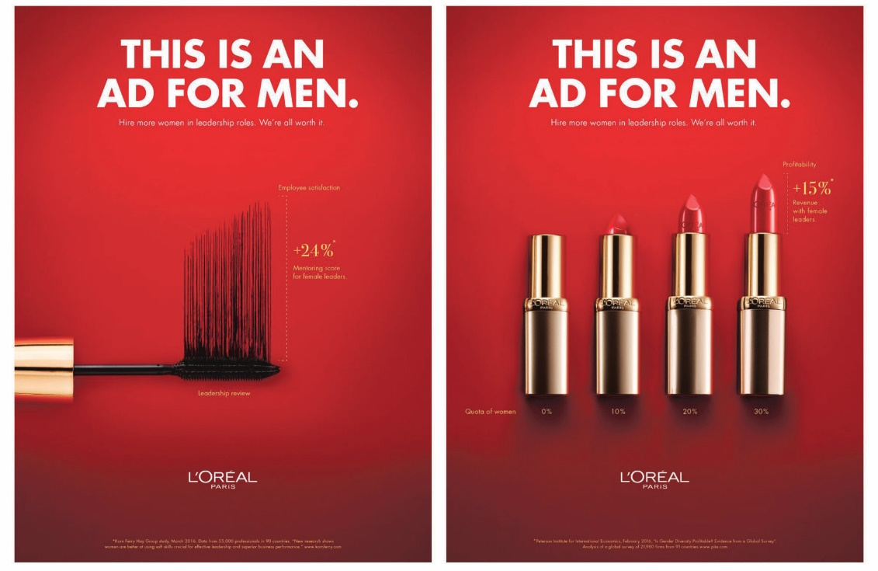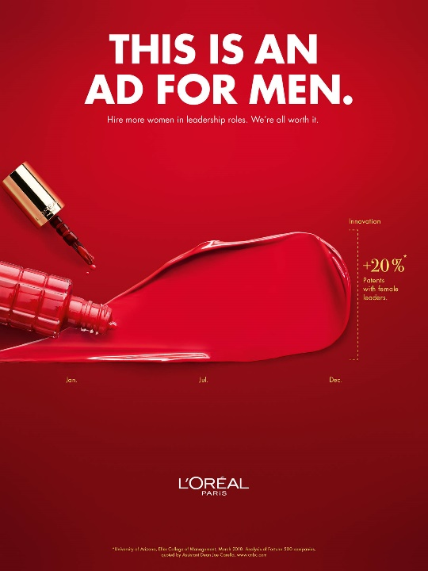Task two: Observational writing
Semiotic analysis of L-Oreal’s Women in Leadership campaign
Figure 3 & 4 & 5, L’Oréal Advertisement, first published in Germany, 2019

In this analysis I will review the L’Oréal advert supporting women in leadership. The advert uses several semiotic theories to relate information to different audiences.
According to Macey (2000), semiotics can be explained as: ‘All communication is the result of the interplay between representamen (a thing serving to represent something), interpretant (the effect of a sign on the person who encounters it), and an idea (the concept)’ (Macey, 2000, p.294).
Ferdinand De Saussure further explains this language in terms of signs and signals to communicate. ‘Saussure's theory is considered as the proponent to the thought that "language does not reflect reality but rather constructs it" because we do not only use language or give meaning to anything that exists in the world of reality, but also to anything that does not exist in it” (Sausssure, 1916, cited in Chandler, 2017).
Saussure’s breaking communication into a system of signs:
Signifier= what you can see/ hear
Signified= what it is referring to i.e. the concept.

The signifiers in this ad include the use of colour, feminine product placement and graphical images. This combination produces many different signified concepts to an audience according to their culture, perception, education and how they view the various competing media images and messages. Roland Barthes elaborates Saussure’s theory to explain these ‘signified concepts’ as connotations and denotations:
‘In this context, the notion of ‘signification’ gives way to that of ‘signifiance’. Signification, Barthes explains, has to do with communication, with an emphasis on denotation and fixed signifieds. With signifiance, the emphasis is on the signifier and connotation. The signifier is no longer viewed in relation to a stable signified, but in relation to other signifiers. The connotations of any given signifier are constantly challenged and modified by that of other signifiers. As a result, meaning is forever in a state of flux, elusive and proliferating’ (Barthes, 1965, cited in Ribiere, 2008, p.54)
Roland Barthes the ‘signified’ can be broken down further into:
Connotation= the deeper meaning- arbitrary and culturally based
Denotation= the literal meaning
Depending on the reader, the Connotations will change.

It is interesting how L’Oréal uses signifiers to brings out so many different signified connotations for all their customers across multiple cultures. This fits Loreal’s brand as they believe in ‘universalisation’ as their business goal. A ‘globalisation (of a company) that captures, understands, and respects differences. Differences in desires, needs and traditions’ (L’Oréal Groupe, 2022).

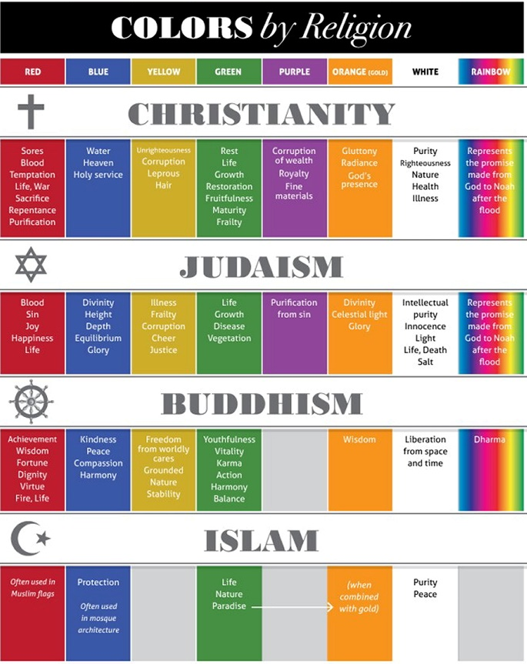
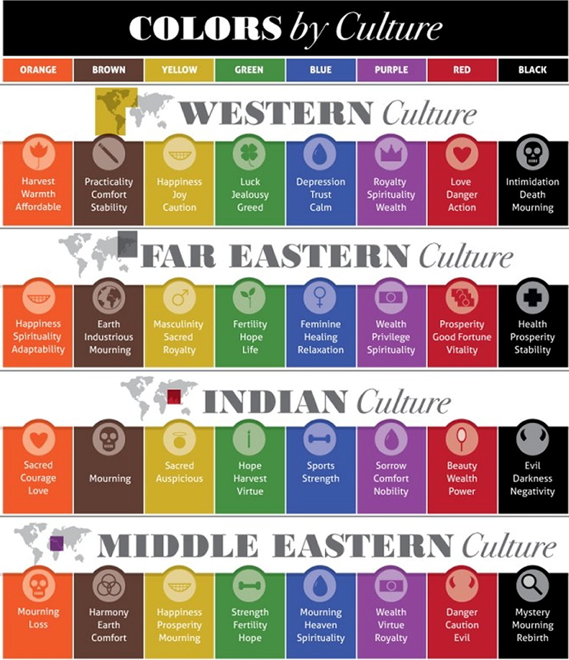
Figure 6: (Cousins, 2014) Figure 7: (Cousins, 2014)
For example, the use of the colour red. Red is a very emotive colour for different reasons, in different cultures. [See fig 6 & 7]. Therefore, to use red in this ad will resonate a string emotion for many different people across the globe. In an early 20th- century western culture ‘Masculinity is associated with colours like navy blue, red and forest green, among other dark or saturated hues. The level of saturation is precisely the signifier of gender in colour schemes; pastel colours are diluted, less pure and therefore less strong, than deep and rich supposedly masculine colours. Pastel or soft colours are used to signify femininity due to the connotations of fairness, weakness, or reticence traditionally associated with women’ (Thipphawong, 2021). L’Oréal chooses specifically to go against this western cultural ‘norm’ of feminism by using a deep, saturated red for the background and the lipstick and nail polish colours. In line with to De Saussure teachings, this could signify that women are powerful, and this aligns with the positive message of women in leadership roles.
This then leads on to another aspect of semiotics in play within this image. The use of very feminine products such as lipsticks and nail polish in an ad could be associated with beauty, a women’s role in the media and general life, and attracting the male gaze, etc.
‘Woman then stands in patriarchal culture as signifier for the male other, bound by a symbolic order in which man can live out his fantasies and obsessions through linguistic command by imposing them on a silent image of a woman still tied to her place as bearer of meaning, not maker of meaning.’ (Mulvey, 1973) In film and advertising, the use of the colour red on women’s clothing, accessories and make-up can be seen as being seductive and sexy for men. On the contrary, in 2019 these makeup products both being a deep red could be signifying that women are powerful and have always been. Women wearing red lipstick and nail polish is not new.

‘When people hear the name Marilyn Monroe, they often associate it with elegance, attractiveness, and sex icon from the twentieth century.’ (Studycorgi, 2022) An ‘Icon’ could also be called a sign. She was a ‘Blonde Bombshell’ who represented all that men fantasize over. However, she is also powerful and holds authority over many.
The Male Gaze can be defined as: ‘A manner of treating women's bodies as objects to be surveyed, which is associated by feminists with hegemonic masculinity, both in everyday social interaction and in relation to their representation in visual media’ (Oxford Dictionary, 2022)
The concept of the ‘Male Gaze’ and women like Monroe, were once used for attracting the opposite sex i.e., sexy women. L’Oréal are now using bold red make- up products to show women as having power, strength, determination, and energy making the message clear for anyone to see. Maybe therefore L’Oréal have chosen to title this Ad ‘This is an Ad for men’: men are supposedly more attracted to women wearing red makeup. This ad is helping its target audience- men- to see women as leaders not submissive beings. It is a reminder that women have always been strong and dependable. Almost to say, ‘we have always worn red lipstick; we should have always been leaders.’
The final aspect of semiotics is the use of graphical images as the signifier to show growth and positive outcomes within business. Graphs are factual, so easy to read. This graph is showing growth by using each feminine product as the graph itself. This signifies in a connotative level and denotative level that the growth can be produced by women in leadership.
Adding each of these signs together, it could be signified that this ad promotes that: Strong women in leadership roles have positive business outcomes!

Task 3- Practise based writing:
Tension in red + community
‘Community’
I would define community as a group of people who are linked together by many factors for example: location, values and ethos, religion or with similar interests.
To come to this definition, I have drawn from several sources as follows;
MacQueen et al., states that community is ‘a group of people with different characteristics who are linked by social ties, share common perspectives, and engage in joint action in geographical locations or settings.’ (MacQueen et al., 2001). I agree with this statement fully but acknowledge that there are other factors that make up a community as there are variations between most definitions.
This is demonstrated by this contrasting definition: ‘Four attributes used to define community health are: attitudes and values, capacities, organisational structures and leadership’ (Lackey, Burke, Peterson, 1987). This source provides a good break down of ‘community’ but feels quite limited in terms of the cultures it could apply to because of the ‘western’ style wording used such ‘organizational structure’ and ‘capacities’, for example.
However, my final source gives a broader overview of what community could mean worldwide; ‘People living in one particular area or people who are considered as a unit because of their common interests, social group or nationality’ (Cambridge Dictionary, 2022). I prefer this definition beacuse it is more personable and feels like it could apply to any group of people and the sentiment of the words seem to draw people together i.e., ‘community’.

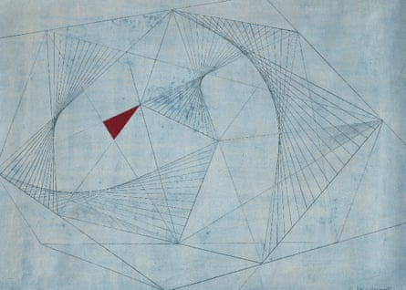
Tension in Red by Barbara Hepworth (1941)
Fig 8: ‘Idealised forms in poised relationships’: Red in Tension, oil and gouache on paper. © Bowness, Hepworth Estate Photograph: © Bowness, Hepworth Estate

Tension in Red was created by Dame Barbara Hepworth in 1941, critically during the second world war. It was created in rural Cornwall (St Ives) where she had fled with her children from bombing in war torn London. Before the war, Barbara was part of a small up and coming group of artists who called themselves the ‘Hamstead Group’ (Adams, 2015). This community was where ‘artists were united in opposition to the rise of fascism, determined to make a more harmonious, optimistic expression of human possibility’ (Adams, 2015). The group had to be dismantled and was displaced by the war to different places around the world with Barbara going to Cornwall. Much of both of Hepworth and husband Nicholson’s works were destroyed when their London studio was bombed in the blitz. Once in Cornwall, she found it hard to get the materials to continue her sculpture work and therefore resorted to 2D drawing to express herself. To quote Barbara herself “the anxieties of their lives were resolved into something tense and restrained” (Hepworth, 1903-75) which is shown directly within this work and explains why it is different to both her previous and later works.
I would like the reader to note how unusual this 2D piece is for Hepworth as an artist but how in tune it was with world affairs. ‘Hepworth moved towards abstraction in the 1930’s as she engaged with the artistic debates of the day’ (Murry Brown, 2015). Hepworth was not afraid to change her methods in order to keep doing what she loved, and ultimately to continue what she felt she was called to do.
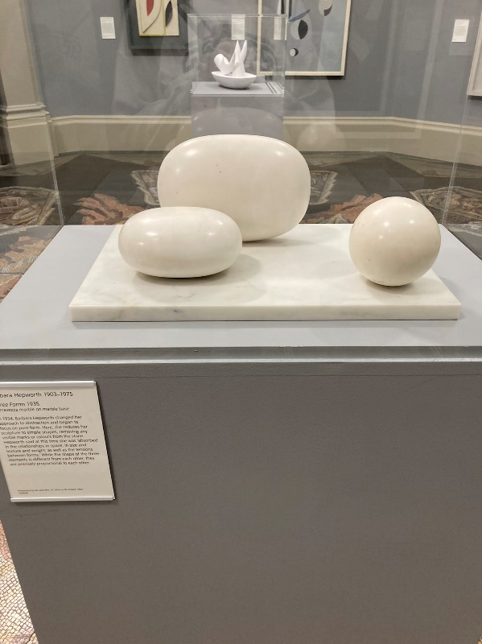
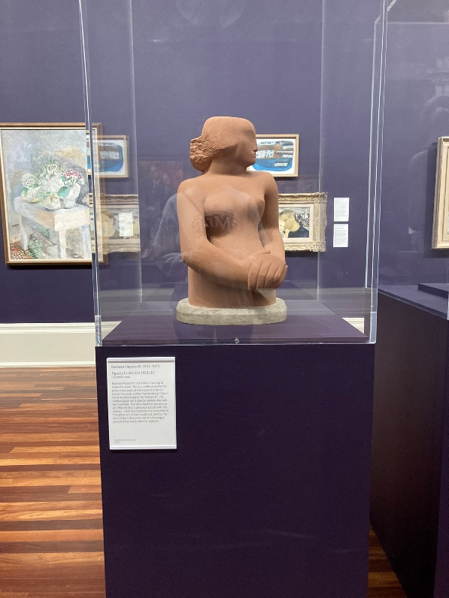
Before the 1940’s Hepworth did not use colour in her sculptures.
Figure 10: Three Forms, Serravezza marble, 1935 (BH 72), Tate Britain, Visited 3.1.23
Figure 9: Figure of a Woman, Corsehill stone, 1929–30, Barbara Hepworth, Tate Britain, visited 3.1.23

I visited the Tate Britain to see some of her earlier work to compare. This work is soft and innocent with little colour other than the chosen material. It feels maternal and loving, but also each piece is separate from one another. This compares to ‘Tension in red’ as this piece feels like the start of a new and collective group of sculptures which ultimately, she continued with until her death aged 72. They have more dimension and depth, with a greater widespread international meaning, which I think is the start of when Hepworth’s artwork bringing together a new community of artists, viewers, learners and thinkers.
I find it interesting how during the second world war, she introduces colour to her work including her sculptures. ‘They contained colour and string-like elements, gestures toward mathematical harmonies’ (Adams, 2015). The triangles suggest sharp and negative connections and the lone red triangle standing out as an island. The colour red continues to link Hepworth’s thinking of the time to the war. ‘In Roman mythology, it was associated with blood, of course, and courage. It was the colour of the god of war, Mars – and the colour of the army’ (Carter, 2015). ‘Tension in Red’ is a more abstract name compared to her literal titles given to previous works for example ‘three forms’ or ‘mother and child’. This is another hint that times have changed and perhaps so has Hepworth’s view on the world. The change in dynamic of the world around Hepworth during the war would have changed her way of working to reflect such. By ‘using colour and strings to articulate the negative space’ (Murry Brown, 2015), she is able to show a distance and connection which was what first intrigued me to this work. I can not work out if community is being formed or pulled apart by the negative space and attachment of the tight rope like strings. Perhaps both are happening at the same time.
The way I see this piece, it shows Hepworth trying to work out (almost mathematically by using geometric shapes) and come to terms with the loss of one community (in London with other artists), but also mapping out her new life and community in Cornwall. Her new life and old would have brought up tensions within her. Surely this is the opposite of what community should make you feel. The Red isolated square could represent Hepworth being separated and isolated from others or her work in London. The straight lines bring displacement and the struggles and anxiety that survival, and war bring.
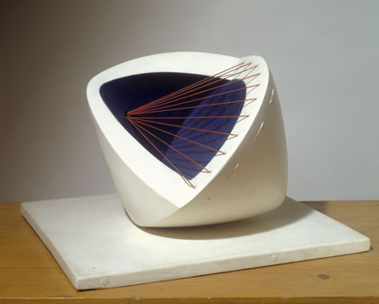
Similar to being united by dispute, all the original ‘Hampstead Group’ showed a united view through their common interest in the impact of wartime and how they fell about this. ‘Hepworth is rarely thought of as a war artist in the same way as her contemporaries John Piper or Graham Sutherland were. But her drawings no doubt represented a response to the horrors every bit as valid as their more graphic and direct depictions.’ (Adams, 2015).
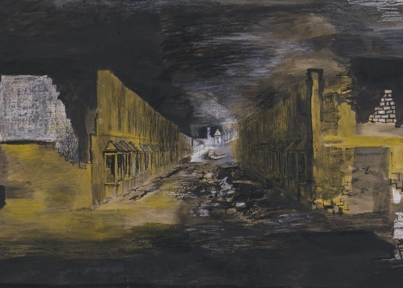
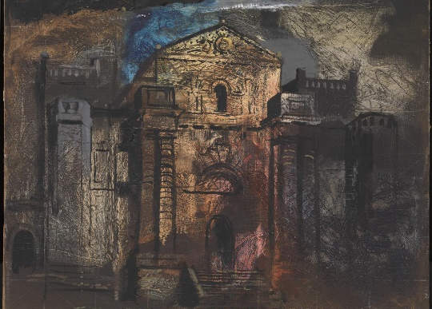

1941

Figure 13: Graham Sutherland, Devastation, 1941: An East End Street, 1941, Tate
Figure 11: Sculpture with Colour (Deep Blue and Red), Painted wood and strings, 1943, Hepworth.
Figure 12: John Piper, Seaton Delaval, 1941, Tate

Because of war, these artists were displaced and dispersed. Therefore, some of the more formal definitions of community would no longer call them community- especially in 1941, i.e., a world without internet and social media. Whereas now, modern communication would make this a flourishing online community over national borders and would flourish and gain numbers, connecting more people during a time of dispute.
For me, to have a successful piece of artwork or design, I seek to create a narrative that conveys tension between the reader/ audience and the artist. Hepworth divided opinion with her work and stood out in her modernist thinking. I like the fact my art can bring people together into community with a story/ narrative that I create; or pull people apart in dispute over opinions i.e., giving back the audience control of the narrative that they see. This tension between drawing people in or bringing question and dispute between people, this in itself creates a thriving community of new ideas, thought and reflection.

Bibliography:
Adams, T. (2015) Barbara Hepworth... back in focus, The Guardian. Guardian News and Media. Available at: https://www.theguardian.com/artanddesign/2015/jun/07/barbara-hepworth-life-in-six-works-tate-retrospective-exhibition-sculpture-for-a-modern-world (Accessed: January 2, 2023).
Banksy, 2018. Banksy piece immediately shreds itself after being sold for $1.1M. [Nov 2, 2022]
BBC Radio 4 - Manifesto!, Series 1, Seize the Future. 2017. London: A Brook Lapping production for BBC Radio 4. [Accessed on Nov 2, 2022]
Barthes, R. (1965). ‘Éléments de sémiologie’ (1965), as Elements of Semiology, translated by Lavers, A and Smith, C. (1967) London: Jonathan Cape (Accessed: January 5, 2023).
Chandler, D. (2017) Semiotics: The Basics. 3rd edn. Taylor & Francis Group. ProQuest Ebook Central, https://ebookcentral.proquest.com/lib/portsmouth-ebooks/detail.action?docID=4877645. [accessed 5.1.23]
Cousins, C. (2014) Colour and cultural design considerations, Colours &amp; Materials. Available at: https://coloursandmaterials.wordpress.com/2014/11/07/colour-and-cultural-design-considerations/ (Accessed: January 5, 2023).
Carter, K. (2015) Why red is the oldest colour, The Guardian. Guardian News and Media. Available at: https://www.theguardian.com/lifeandstyle/2015/sep/01/why-red-is-the-oldest-colour#:~:text=Unsurprisingly%2C%20red%20appears%20as%20a,gladiators%20were%20adorned%20in%20red. (Accessed: January 5, 2023).
Community (2022) Cambridge Dictionary. Cambridge University Press. Available at: https://dictionary.cambridge.org/dictionary/english/community (Accessed: January 5, 2023).
Ellenberg, A., (2022-last update), Council Post: Gen Z And Millennials Are Rewriting The Rules: What That Means For The Workplace. Available: https://www.forbes.com/sites/forbesbusinesscouncil/2022/06/08/gen-z-and-millennials-are-rewriting-the-rules-what-that-means-for-the-workplace/ [Accessed: Nov 2, 2022].
Lackey, S., Burke. R., & Peterson, M. (1987) Healthy Communities: the Goal of Community Development, Journal of the Community Development Society, 18:2, 1-17, DOI: 10.1080/15575338709490022 [accessed 28/12/2022]
Liebmann, M. Art Therapy for Groups: A Handbook of Themes and Exercises. 2nd ed., USA and Canada: Taylor and Francis Group., Routledge, 2004, p. 15.
L'Oréal (2020) L'Oréal Group: Strategy model, L'Oréal. L'Oréal. Available at: https://www.loreal.com/en/group/about-loreal/strategy-and-model/ (Accessed: January 5, 2023).
Macey, D. (2000) Quoted from lecture notes from University of Wales Trinity St David, Swansea College of Art, Dr Julia Lockheart, 2022.
MacQueen KM, McLellan E, Metzger DS, Kegeles S, Strauss RP, Scotti R, Blanchard L, Trotter RT 2nd. What is community? An evidence-based definition for participatory public health. Am J Public Health. 2001 Dec;91(12):1929-38. doi: 10.2105/ajph.91.12.1929. PMID: 11726368; PMCID: PMC1446907. [accessed 28/12/2022]
Malchiodi, C.A. (2007). The art therapy sourcebook. 2nd ed. New York: Mcgraw-Hill.
Male Gaze (2023) Oxford Dictionary. Oxford University Press. Available at: https://www.oxfordreference.com/display/10.1093/oi/authority.20110803100128610;jsessionid=F7A45E001BF89BCCEC60ABD43955C458 (Accessed: January 5, 2023).
Mulvey, L. (1975) Media and Cultural Studies: 22, Visual Pleasure and Narrative Cinema, Google Books. Google. Available at: https://books.google.co.uk/books?hl=en&amp;lr=&amp;id=I8dPhB88Sx4C&amp;oi=fnd&amp;pg=PA342&amp;dq=visual%2Bpleasure%2Band%2Bnarrative%2Bcinema%2Bpdf&amp;ots=CF2BjzbybR&amp;sig=2iezSWw_UnjrQDP8LdA4AF09AqY#v=onepage&amp;q&amp;f=false, First written in 1973, later published in 1975 in screen and other books (Accessed: January 5, 2023).
Murray Brown, G. (2015) Barbara Hepworth: Freedom and form | FT life, YouTube. YouTube. Available at: https://www.youtube.com/watch?v=yW78Qjnt2Qw (Accessed: January 5, 2023).
Nathan, L. (2008) “Why the arts make sense in education,” Phi Delta Kappan, 90(3), pp. 177–181. Available at: https://doi.org/10.1177/003172170809000304. [2 Nov 2022]
Patel, K. (2022) ‘Questions about art therapy 1’. Interview with Aimee Rayner [Zoom], 25 February.
Perloff, M., 1986. The Futurist Moment. Chicago: University of Chicago. [Nov 2, 2022]
Redding, D. -02-21, 2010-last update, Art Manifestos and Their Applications in Contemporary Design. Available: https://www.smashingmagazine.com/2010/02/art-manifestos-and-their-applications-in-contemporary-design/ [Nov 2, 2022].
Ribière, M. (2008). Barthes, edited by Mark Addis, Humanities-Ebooks, LLP, 2008. ProQuest Ebook Central, https://ebookcentral.proquest.com/lib/portsmouth-ebooks/detail.action?docID=3306072. (Accessed: 5 January 2023).
Saussure, F. (1916/1995) Cours de linguistique générale . Paris: Payot. –––– (1916/2011) Course in General Linguistics (trans. Wade Baskin 1959, eds Perry Meisel and Haun Saussy). London: Fontana/Collins. [Acsessed 5.1.23]
Strange, E. (2022) ‘Questions about art therapy 2’. Interview with Aimee Rayner [Zoom], 4 April.
StudyCorgi. (2022) 'Persuasion in the 1950s Advertising with Marilyn Monroe'. 12 September 2022. (Accessed: 5 January 2023).
Thipphawong, L. (2021) Art theory: Semiotics, Arts Help. Arts Help. Available at: https://www.artshelp.com/art-theory-semiotics/ (Accessed: January 5, 2023).

