Student Name: Zakia Sultana Rahman  Student ID: 2211724  Module Title: [Foreign Languages & Cultural Awareness]  Module Code: [BMIH5003]  Lecturer: Heidi Prosser  Date: 22/02/2024 | 

ASSIGNMENT 2: INTERCULTURAL COMPETENCE REPORT

Executive Summary
England and China are two different countries with greatly different cultures. The five-star hotel operating in both countries faces cross-cultural issues. The leadership can address the issues by adapting its styles and making proper plans and strategies.

Contents
Executive Summary 2
Introduction 4
Key Differences Between England and China 4
GLOBE Project’s Culture and Leadership Study of the Two Countries 5
Challenges of Intercultural Leadership in the Hospitality Industry 6
Conclusion 7
Recommendations 7
Reference list 8
Appendix 10
Screenshot 1- Culture Visualization in China 10
Screenshot 2- Culture Visualization in England 10
Screenshot 3: Leadership Visualization in China 11
Screenshot 4: Leadership Visualization in England 11

Introduction
This report aims to provide a clear understanding of the cultural differences between England and China. The differences between cultural aspects can have immense impacts on business practices and leadership. The Inclusivity Hotel & Spa is a five-star hotel. It provides exceptional and personalised offerings to the guests. To provide a solid understanding of the cultural dimensions of the two countries, the GLOBE project framework has been used in the comparison. Moreover, the issues that the leadership can face are also identified.

Key Differences Between England and China
China and England are two different countries. Their culture and customs are also different. The differences between the two countries are identified and explained below:
- Language: England's official language is English while Mandarin is known to be the official language of China. The regional dialects and languages such as Cantonese, and Welsh make the two countries' languages diversified. The writing styles and grammar are different as Mandarin and English come from different language families (UofG Visiting Students, 2019).
- Food: English cuisine has influences from the Commonwealth and European countries. Its well-known dishes include fish and chips, roast beef, and Yorkshire pudding. Chinese cuisine is so diverse that it is different in various regions. However, the common ingredients are used such as rice, noodles, and soy sauce.
- Etiquette: The common features of English people’s etiquette are politeness, personality, and personal space. Most of the time, they use indirect communication styles and avoid confrontations and conflicts. English people tend to maintain strict rules of queuing, table manners, and greetings (Xu, Chen and Xu, 2018). On the contrary, Chinese people maintain hierarchy and harmony. They show immense respect for the elders.
- Work Culture: The English work culture has the following aspects: Flexibility, work-life balance, individualism, and informal atmosphere. On the other hand, the Chinese work culture has the following aspects: loyalty, medication, hierarchy, and formal environment (Liu, Lu and Zhan, 2021).

GLOBE Project’s Culture and Leadership Study of the Two Countries
Globe Project is an international research initiative aiming to improve organisational management across different cultures. This framework has some drawbacks such as failure to count diversity within the country, reliance on manager's self-reported data leading to various biases, improper guidance to apply the findings (Javidan and Dastmalchian, 2009).
The cultural dimensions of the project are as follows:
- Power Distance: England has a comparatively lower score meaning that people are egalitarian and participative (GLOBE Project, 2020).
- Uncertainty Avoidance: The lower score in England than in China indicates English people are more tolerant of the changes while Chinese are resistant.
- Performance Orientation: A higher score in England indicates that people appreciate individual performances while Chinese people prefer harmony.
- Institutional Collectivism: China has a higher score that shows that businesses have practised appreciating collective endeavour over individual goal achievement (Bluszcz and Quan, 2016). In England, individual actions are preferred.
- In-group Collectivism: In Chinese culture, people have more attachment toward the group and clan than in English culture.
- Gender Egaliatarism: A high score in England shows that gender equality is higher in the country.
- Assertiveness: The English can openly express their opinion while Chinese people avoid making such remarks (Javidan and Dastmalchian, 2009).
- Future Orientation: The English are future-oriented while Chinese people prefer present consumption and payoff.
- Human Orientation: In England, people are more self-oriented and indifferent towards other's perspectives. However Chinese people are more compassionate and generous toward others.

Challenges of Intercultural Leadership in the Hospitality Industry
The five-star hotel is headquartered in China and its operations in England will present the following challenges:
- Ensuring an Inclusive and Diversified Workplace Environment: The leadership will find it challenging to manage the workplace properly as there will be employees from different countries and the customers will also be from diverse backgrounds. Respecting their culture and preferences is crucial for the leadership to achieve success in the long term (Abramson and Moran, 2017). It is important that the employees feel safe and confident in the workplace so that the five-star hotel will have greater performance in serving the customers. The leadership will find it challenging to meet everyone’s needs and preferences and avoid misunderstandings and conflicts from cultural issues. For example, conflicts can arise from miscommunication between the staff of the hotel and the guests during the service delivery (Tabari, Wilson and Ingram, 2016).
- Adapting to Different Markets: The intercultural leader faces challenges in managing the market offerings in different markets. The hotel's home country is China so its market offerings can have Chinese culture's influence. While the company is operating in England, the leader has to make crucial decisions such as the level of adaptation in its market offerings to meet the local customer's needs and expectations (Kivenzor, 2015). The leader has to monitor the changing trends and market demands. For example, the recent COVID-19 pandemic has changed customers' preferences and the market has more demand for luxury and quality hotel services (Escandon-Barbosa and Salas-Paramo, 2021).
- Developing Intercultural Competence: The leader will find it challenging to develop the ability to interact with culturally diverse people in the workforce by providing them with necessary training and incentives (Miska, Stahl and Mendenhall, 2013). The leader needs to ensure effective training for the staff because improper training arrangements keep a gap in their competency.

Conclusion
The cultural practices and values of England and China are different. The cultural differences between the two countries present various challenges to the leadership of the five-star hotel. The leadership needs to employ intercultural skills to address the growing problems. It must assess the differences in the cultural aspects properly and take the initiative to adapt to the differences bringing greater performance to the company.

Recommendations
The following recommendations are provided to overcome the challenges:
- The leader should adopt an inclusive leadership style to provide support and adequate resources for promoting diversity and inclusivity within the workplace (Abramson and Moran, 2017). It must respect the differences in cultural preferences.
- It can adopt a flexible and responsive leadership style for adjusting to the changing market needs and preferences. It may require conducting comprehensive market research and effective communication with the stakeholders.
- The leader may consider adopting the learning and development leadership style. It will make them provide regular coaching and training to the staff (Maheshkar and Sharma, 2018). Thus, the employees will be able to achieve cultural competence.

Reference list
Abramson, N.R. and Moran, R.T. (2017) Managing Cultural Differences: Global Leadership for the 21st Century. Milton: Taylor and Francis.
Bluszcz, M. and Quan, S. (2016) Cultural comparison between china and Germany based on hofstede and globe. International Journal of Marketing, Financial Services & Management Research, 5(10), pp.58-68.
Escandon-Barbosa, D. and Salas-Paramo, J. (2021) Tourism Amidst COVID-19: Consumer Experience in Luxury Hotels Booked through Digital Platforms. Tourism Recreation Research, pp.1–6.
GLOBE Project (2020) Results - China GLOBE Project. [online] Globeproject.com. Available at: https://globeproject.com/results/countries/CHN%3Fmenu=list.html#list [Accessed 12 Feb. 2024].
GLOBE Project (2020) Results - England GLOBE Project. [online] Globeproject.com. Available at: https://globeproject.com/results/countries/GBR%3Fmenu=list.html#list [Accessed 12 Feb. 2024].
Javidan, M. and Dastmalchian, A. (2009) Managerial Implications of the GLOBE project: a Study of 62 Societies. Asia Pacific Journal of Human Resources, [online] 47(1), pp.41–58.
Kivenzor, G.J. (2015) Cultural Dynamics and Marketing Strategies for Emerging markets: Characterization of Group Subcultures and Consumption Preferences. AMS Review, 5(3-4), pp.142–158.
Liu, C., Lu, J. and Zhan, Y. (2021) Cultural differences in business negotiations between China and the UK. In 2021 6th International Conference on Modern Management and Education Technology (MMET 2021) (pp. 433-437). Atlantis Press.
Maheshkar, C. and Sharma, V. (2018) Handbook of Research on Cross-Cultural Business Education. Hershey: IGI Global.
Miska, C., Stahl, G.K. and Mendenhall, M.E. (2013) Intercultural Competencies as Antecedents of Responsible Global Leadership. European J. of International Management, 7(5), p.550.
Tabari, S., Wilson, J.A. and Ingram, H. (2016) Conceptualising the impact of culture and language upon hospitality service management. Worldwide hospitality and tourism themes, 8(1), pp.12-28.
UofG Visiting Students. (2019) The differences between China and the UK. [online] Available at: https://uofgvisiting.wordpress.com/2019/10/26/the-differences-between-china-and-the-uk/ [Accessed 8 Feb. 2024].
Xu, G., Chen, Y. and Xu, L. (2018) Western Etiquette. Introduction to Western Culture, pp.129–162.

Appendix

Screenshot 1- Culture Visualization in China
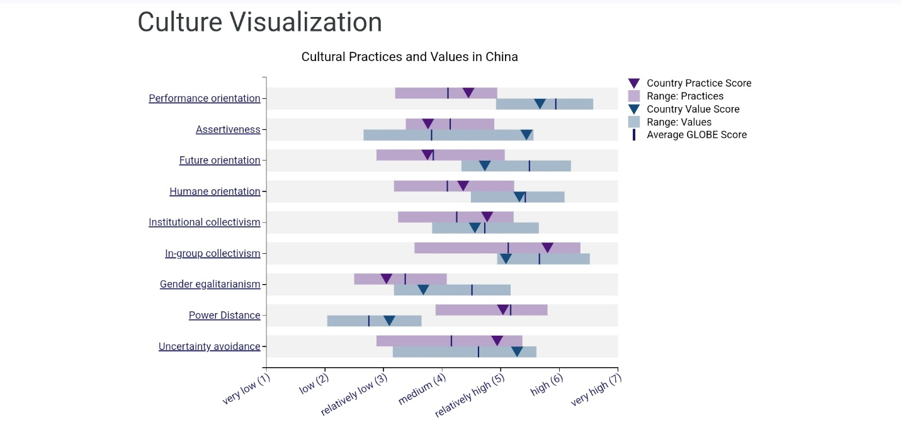
Source: (GLOBE Project, 2020)

Screenshot 2- Culture Visualization in England
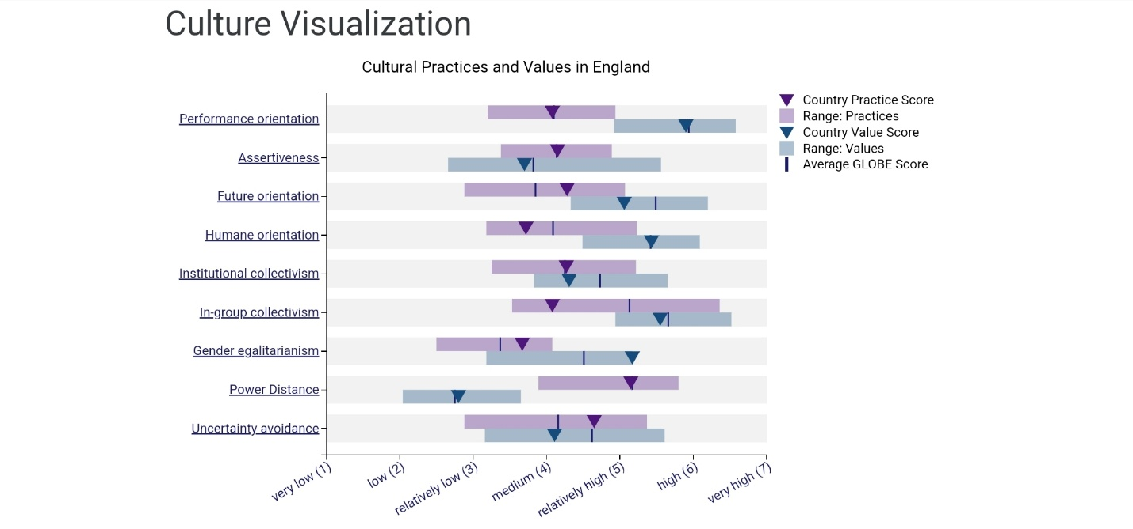
Source: (GLOBE Project, 2020)

Screenshot 3: Leadership Visualization in China
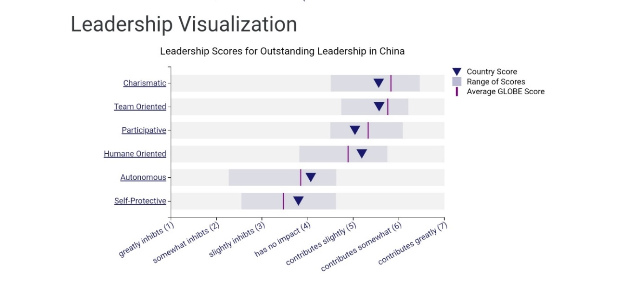
Source: (GLOBE Project, 2020)

Screenshot 4: Leadership Visualization in England
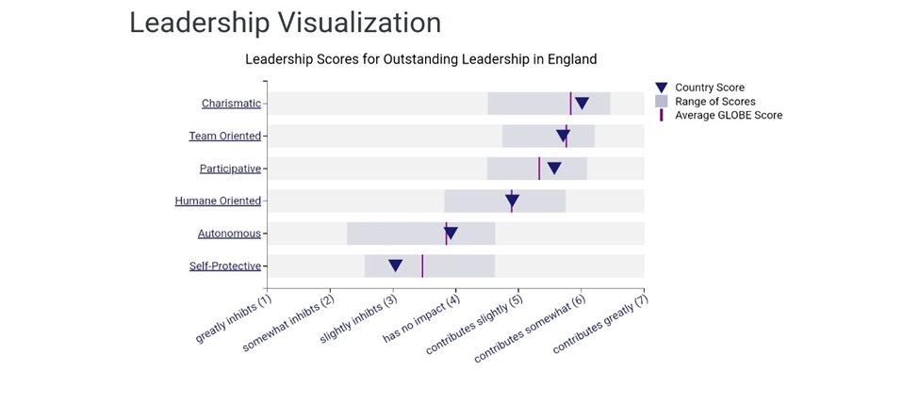
Source: (GLOBE Project, 2020)

