

Assignement 2

Hypertension and lifestyle diseases
Module | Introduction to Physiology
Module code | BMHP5003_LON
Lecturer | Laila Surani
Student | Camilla Torello
Student ID | 2010042

Table of Contents
Introduction page 1
Anatomy and Physiology page 1-5
Lifestyle Measures page 5-6
Social care practice for people page 6-9
living with hypertension
Recommendations page 9-10
Conclusion page 10
References page 11-13

Introduction
This report will analyse hypertension as a lifestyle disease.
There is a correlation between lifestyle diseases and people's habits and their quality of life. Lifestyle diseases are non-communicable illnesses, which means they cannot be transmitted from person to person. You can define the habits that people take up in their lives as modifiable risk factor: a risk factor that can be changed. Non-modifiable or metabolic are the ones determined by genetics or by the way the human body react.
One of these long-term conditions is hypertension: Hypertension is more commonly known as high blood pressure. In the United Kingdom, one third of the population suffers from hypertension. The disease is characterized by a persistent rise in blood pressure above the considered “normal” range of 120/180 mmHg.(Sheppard, 2016). It is without a doubt that hypertension is caused by the ageing process, and that it attacks the cardiovascular (or circulatory) system in the body when the arterial organs are affected by persistent and chronic pressures that lead to the alteration of tissues (especially the heart) and the circulatory system.

Anatomy and physiology
High blood pressure interferes with the functionality of the circulatory system. “The system that contains the heart and the blood vessels and moves blood throughout the body. This system helps tissues get enough oxygen and nutrients, and it helps them get rid of waste products. The lymph system, which connects with the blood system, is often considered part of the circulatory system.” (NIH,2019)
The circulatory system is formed by:
A heart is a muscular organ that is responsible for pumping nutrients, oxygen, and carbon dioxide all over the body and into the lungs. It is divided into four chambers (atriums or ventricles), and there are four valves that separate them from one another.
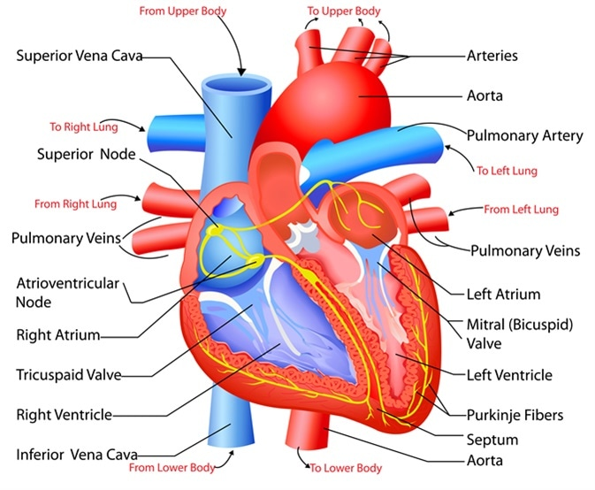

(Miranda, 2021)

There are six major blood vessels in the body, which are responsible for carrying oxygen-rich blood to every part of the body
There are also veins, and these are vessels that return deoxygenated blood to the heart
The capillaries are blood vessels that connect very small arteries (arterioles) and veins (venules). The cells' capillaries are thin and permeable walls that allow oxygen, carbon dioxide, nutrients, and waste products to pass into and out of the cells" (Cleveland Clinic, 2021).
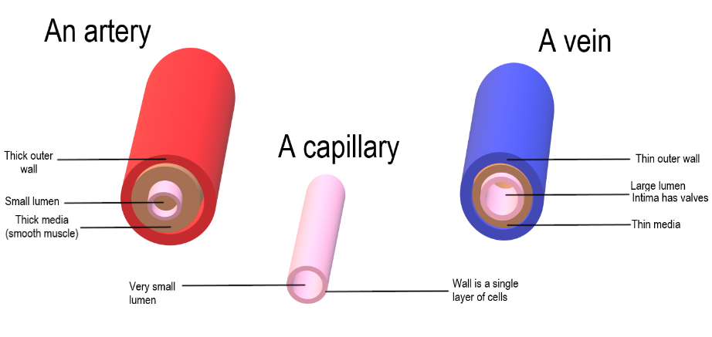
(Human Biology,2021)
The blood is a body fluid that is responsible for transporting oxygen to your cells as well as removing waste from them. Blood consists of white blood cells (also known as red blood cells), plasma, platelets, glucose, protein, carbon dioxide, ions, and other nutrients.
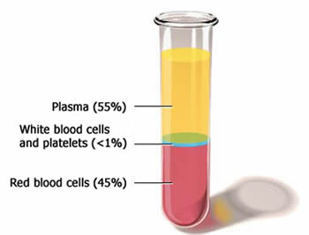
(Online Science Notes, 2022)

The symptoms of high blood pressure can be observed in the pressure of the blood pumped to and from the heart. They can also be observed in the speed with which the blood flows in the arteries. It is said that the higher the pressure of pumping blood from the heart and the narrower the arteries become, the greater the level of hypertension (Henry, 2014). According to the American Heart Association, blood pressure is measured using millimetres of mercury (mmHg) as a clinical measurement and is comprised of two numbers: the top number, called systolic pressure is obtained from the first measurement of the artery wall at every pulse, and the bottom number is the blood pressure between consecutive heartbeats.
Often the level of the pressure can be unknown to the person affected for a long time because of the late onset of symptoms: it may take years before the symptoms are manifested. The symptoms can include heart attack, stroke, coronary disease, dementia, heart failure, vision loss and even kidney diseases.
Hypertension risk factors are divided into two types:
The primary It is a condition without any definitive cause, unless it arises from age and changes in non-modifiable risk factors, such as genetic or environmental factors. An empirical study has determined that until the age of 64 high blood pressure is actually more common in men than in women in a subtle way. Especially after age 65, women are more likely to get it. Hypertension can be genetic and can actually run across generations in a for all intents and purposes major way.
The secondary is mainly defined by modifiable factors such as lack of sleep, obesity, or alcohol misuse, contrary to popular belief. In other words, the more fat a person has, the more blood the body will need to supply adequate levels of oxygen to tissues in the body (Kundu, 2020). Therefore, as the blood passes through the blood vessels, there is a subtle increase in the pressure on the walls of the vessel. Sodium can increase high blood pressure: the salt acts as a retention fluid, so higher pressure is required.
Stress is another factor: this can lead to stress-related tendencies such as heavy drinking or tobacco smoking. Stress can also contribute to a hormone-release process like adrenaline and cortisol, and they impact the heart rate and blood pressure.
Secondary hypertension is associated with a variety of conditions, including kidney disease, thyroid problems, and heart attack.

Lifestyle Measures
The following are a few daily practices that those living with hypertension can undertake, which can help gather information about how their body functions. In fact, monitoring the blood pressure at home is one of the first steps in dealing with hypertension. This can then be followed up with a regular doctor's visit and perhaps a prescription for medication. In addition, it is recommended to keep your weight under control and to closely measure your waistline. A man should have a maximum of 40 inches and a woman 25 inches.
It is recommended that both sexes restrict their alcohol intake, though women are more recommended to limit their alcohol consumption due to their metabolisms.
Exercising regularly also helps to lower blood pressure by 5 to 8 millimetres of mercury. A variety of physical activities can lower blood pressure, including aerobic, swimming, walking, jogging, and cycling.
Dietary approaches can lower blood pressure by around 11 mmHg. Food diaries are a good measurable tool together with label-reading activities: monitoring sodium and fat intake can have a positive impact on the condition. (Douglas,2017). By reducing salt intake, blood pressure can be reduced by approximately 5 to 6 mmHg.
As previously mentioned, stress is a high-risk factor: drinking too much alcohol and eating unhealthily. It is necessary, for people with hypertension, to adjust their expectations, plan daily chores and organise priorities (Treacy, 2017). It is advisable to avoid taking on complicated tasks during the morning commute. As well as this, there should not be any economic difficulties since this will cause the stress hormone in your body to rise.
Social care practice for people living with hypertension
There was the launch in 2015 of the Heart Age Test (HAT) in Uk:" an online test to indicate an individual’s potential hypertension risk through estimated Heart Age, which can be compared to their actual age “(Riley et al., 2021). As a result of the data collected by Public Health England, it was found that from 1.18 million people who were monitored with the heart age tool, 52% were informed that their high blood pressure was related to high blood pressure (Collins, 2018). One in four adults in England suffers from this disease, which means that there were 12.55 million people affected in the year 2015. Over 31% of males and 26% of females are affected by this condition.
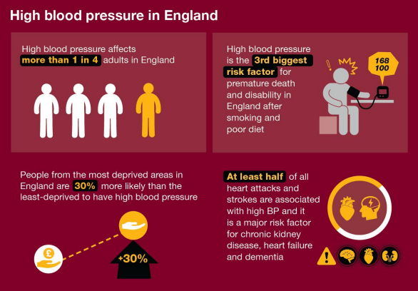
(Public Health England, 2018)
The treatment procedures in England are more advanced in diagnosis, as well as the prescription of medications. According to the Blood Pressure Action Plan, there is a strategy in place to reduce the average blood pressure of the UK population by 5 mmHg. This strategy includes prevention methods and awareness advertisements. The plan is an “Evidence-based advice for partners including local government and the health system on how to effectively identify, treat and prevent high blood pressure (hypertension)”. There is also an intention to reduce social costs with this condition, as it is estimated that the condition could save 850 million pounds on social costs. Diseases related to high blood pressure cost 2.1 billion pounds a year to the NHS. (Gov.UK, 2022)
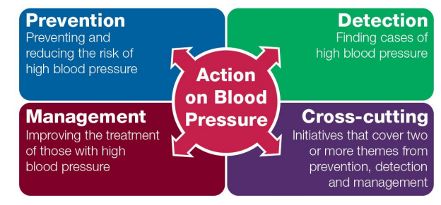

(Public Health England, 2018)
Another strategy to consider is the Sustainability Transformation Plan (STP), the plan and framework created by healthcare organizations. The plan includes different goals, like reducing hospitalisation time, reconfiguring the health services, and improving primary care. 80% of premature deaths can be prevented by all plan actions, according to Soumerai (2011). Guidelines that promote healthy behaviour can have a modifiable effect on risky tendencies in people's lifestyles, which is an effective step to prevent high blood pressure and promote health.
Additionally, the campaign called Salt Reduction Program created in 2004, focuses on reducing the salt level in the dietary system (Larsson, 2022). Study results reveal that a fourth-fifth of the salt we consume comes from salt already present in the food we purchase. Along with the PHE National Diet and Nutrition Survey, it can be seen that salt consumption has been reduced from 2006 to 2019. In a 24-hour examination system that examined sodium excretion, salt consumption was determined to be around 8 grams per day for adults. This has decreased from 8.8 grams in 2006 to 6 grams in 2011. The outcome was a reduction of 11% from 2011 to 2019.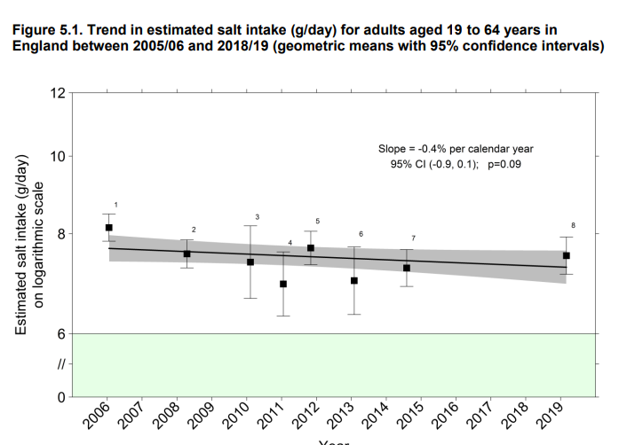
(Public Health England, 2020)
Recommendations
Health professionals can make use of the shared decision system of resources when assisting patients during medical check-ups and informing them about the appropriate decisions they need to make in order to change their behaviour. Furthermore, it is recommended that primary care services educate people about the importance of treatment of medicine through discipline and medication: establish a routine, a diet plan, and an exercise plan.
Furthermore, it is believed that the UK Government should ensure that there are more campaigns to encourage people between the ages of 40 and 60 to monitor their health checks and conditions, such as in the public health emergency sector. This can be done by trying to reduce unhealthy habits such as smoking, alcohol-consuming and stress-related eating disorders.
NHS free health check should be better advertised: community pharmacies offer a free hypertension test, BMI check, and smoking cessation support; unfortunately, many people in the UK are unaware of these benefits. Approximately 1.2 million people visit a community pharmacy every day. An initial point of contact for fighting the condition can be the pharmacy. NHS then can obtain regular and reliable data on the testing done by the pharmacy. GP practice can work on prevention or early detention and tailor the service to every single individual based on the modifiable risk factor. There is a lot of pressure on the health services. However, time should be invested in the prevention stages to avoid hospitalisation, the introduction of medicine or extra work from the other professional. A pre-condition visit is recommended for patient education: the individual should keep a food diary, exercise daily and reduce salt intake, and it is the health professional's duty to ensure that the patient has all the information and tools needed.
Conclusion
Since high blood pressure is a preventable condition in some stages, the United Kingdom's population needs to be committed to lifestyle changes. Changing the pattern of eating fatty food and not being involved in intensive stress can save people's lives or at least prevent premature deaths. Therefore, it is critical to consider the daily habits that can trigger stress to prevent the condition. The person should also be involved in aerobics or intensive physical exercises to enhance proper aeration within the body’s tissue and reduce the waste of fats and weight. Researchers have found that dietary approaches that stop hypertension can help manage the condition and lower blood pressure by 11 mmHg. A disease-free life involves addressing lifestyle diseases caused by modifiable risk factors every day by each individual, and the government should show full support in order to achieve this goal.

References
Beevers, G., Lip, G.Y.H. and O’Brien, E. (2001). The pathophysiology of hypertension. BMJ : British Medical Journal, [online] 322(7291), pp.912–916. Available at: https://www.ncbi.nlm.nih.gov/pmc/articles/PMC1120075/ [Accessed 6 Apr. 2022].
Berry, S.E., Mulla, U.Z., Chowienczyk, P.J. and Sanders, T.A.B. (2010). Increased potassium intake from fruit and vegetables or supplements does not lower blood pressure or improve vascular function in UK men and women with early hypertension: a randomised controlled trial. British Journal of Nutrition, 104(12), pp.1839–1847.
Clark, C.E., Smith, L.F.P., Taylor, R.S. and Campbell, J.L. (2010). Nurse led interventions to improve control of blood pressure in people with hypertension: systematic review and meta-analysis. BMJ, 341(aug23 1), pp.c3995–c3995.
Cleveland Clinic (2021). Circulatory System: Anatomy and Function. [online] Cleveland Clinic. Available at: https://my.clevelandclinic.org/health/body/21775-circulatory-system#:~:text=The%20circulatory%20system%20(cardiovascular%20system [Accessed 6 Apr. 2022].
Hibino, M., Otaki, Y., Kobeissi, E., Pan, H., Hibino, H., Taddese, H., Majeed, A., Verma, S., Konta, T., Yamagata, K., Fujimoto, S., Tsuruya, K., Narita, I., Kasahara, M., Shibagaki, Y., Iseki, K., Moriyama, T., Kondo, M., Asahi, K. and Watanabe, T. (2022). Blood Pressure, Hypertension, and the Risk of Aortic Dissection Incidence and Mortality: Results From the J-SCH Study, the UK Biobank Study, and a Meta-Analysis of Cohort Studies. Circulation, 145(9), pp.633–644.
Humagain, S. (2017). Blood and plasma (Appearance, composition and functions) - Online Science Notes. [online] Online Science Notes. Available at: https://onlinesciencenotes.com/blood-and-plasma/ [Accessed 10 Apr. 2022].
Khan, J.M. (2005). Management of hypertension in ethnic minorities. Heart, [online] 91(8), pp.1105–1109. Available at: https://www.ncbi.nlm.nih.gov/pmc/articles/PMC1769018/ [Accessed 24 Mar. 2022].
Miller, C. (2020). 14.4 Blood Vessels. [online] humanbiology.pressbooks.tru.ca. Available at: https://humanbiology.pressbooks.tru.ca/chapter/16-4-blood-vessels/ [Accessed 24 Mar. 2022].
Miranda, G.M. (2019). Structure and Function of the Heart. [online] News-Medical.net. Available at: https://www.news-medical.net/health/Structure-and-Function-of-the-Heart.aspx [Accessed 7 Apr. 2022].
National Cancer Institute (2019). NCI Dictionary of Cancer Terms. [online] National Cancer Institute. Available at: https://www.cancer.gov/publications/dictionaries/cancer-terms/def/circulatory-system [Accessed 20 Apr. 2022].
Ofori, S. and Odia, O. (2014). Serum uric acid and target organ damage in essential hypertension. Vascular Health and Risk Management, 10, p.253.
Orme, M., Collins, S. and Loftus, J. (2012). Long-term Medical Management of Primary Open-Angle Glaucoma and Ocular Hypertension in the UK. Journal of Glaucoma, 21(7), pp.433–449.
Parker, E. and Glasziou, P. (2009). Use of evidence in hypertension guidelines: should we measure in both arms? British Journal of General Practice, 59(560), pp.e87–e92.
Public Health England (2017). Health matters: combating high blood pressure. [online] GOV.UK. Available at: https://www.gov.uk/government/publications/health-matters-combating-high-blood-pressure/health-matters-combating-high-blood-pressure [Accessed 2 Apr. 2022].
Public Health England (2018). Tackling high blood pressure: an update. [online] Available at: https://assets.publishing.service.gov.uk/government/uploads/system/uploads/attachment_data/file/672554/Tackling_high_blood_pressure_an_update.pdf [Accessed 2 Apr. 2022].
Public Heath England (2020). National Diet and Nutrition Survey. [online] Available at: https://assets.publishing.service.gov.uk/government/uploads/system/uploads/attachment_data/file/876252/Report_England_Sodium_Survey_2018-to-2019__3_.pdf [Accessed 6 Apr. 2022].
Ransome, S. and Gower, J. (2006). Medicines for hypertension: changes to the UK NICE guidelines. British Journal of Nursing, 15(16), pp.881–886.
Riley, V., Fedorowicz, S. and Gidlow, C. (2021). Evaluation of the heart age test (HAT). [online] CHAD Research. Available at: https://www.chadresearch.co.uk/evaluation-of-the-heart-age-test/ [Accessed 20 Apr. 2022].
Sarkar, C., Webster, C. and Gallacher, J. (2018). Neighbourhood walkability and incidence of hypertension: Findings from the study of 429,334 UK Biobank participants. International Journal of Hygiene and Environmental Health, 221(3), pp.458–468.
Serumaga, B., Ross-Degnan, D., Avery, A.J., Elliott, R.A., Majumdar, S.R., Zhang, F. and Soumerai, S.B. (2011). Effect of pay for performance on the management and outcomes of hypertension in the United Kingdom: interrupted time series study. BMJ, [online] 342, p.d108. Available at: https://www.bmj.com/content/342/bmj.d108.full [Accessed 26 Mar. 2022].
Sheppard, J.P., Schwartz, C.L., Tucker, K.L. and McManus, R.J. (2016). Modern Management and Diagnosis of Hypertension in the United Kingdom: Home Care and Self-care. Annals of Global Health, [online] 82(2), p.274. Available at: https://www.sciencedirect.com/science/article/pii/S2214999616000308 [Accessed 16 Apr. 2022].
Sinnott, S.-J., Douglas, I.J., Smeeth, L., Williamson, E. and Tomlinson, L.A. (2020). First line drug treatment for hypertension and reductions in blood pressure according to age and ethnicity: cohort study in UK primary care. BMJ, [online] 371. Available at: https://www.bmj.com/content/371/bmj.m4080 [Accessed 4 Apr. 2022].
Sullivan, D. (2020). What is the difference between an artery and a vein? [online] www.medicalnewstoday.com. Available at: https://www.medicalnewstoday.com/articles/artery-vs-vein [Accessed 4 Apr. 2022].
Van Oort, S., Beulens, J.W.J., van Ballegooijen, A.J., Grobbee, D.E. and Larsson, S.C. (2020). Association of Cardiovascular Risk Factors and Lifestyle Behaviors With Hypertension. Hypertension, 76(6), pp.1971–1979.

