
Think about your most recent / significant experience of working in a team and answer the following questions

How many members were in the team? ____________
Were the groups allocated officially or did you select them yourself? ______________
How long were you working together? _______________

How was the experience of working in this team useful for you?
1.
2.
3.
4.
5.
Now rank the above experiences in order of their importance in the column besides

Read the difficulties section in Miller (2016) article on pages 158-60 that discusses issues in healthcare sector. Reflect on your teamworking experience that you described above. What factors do you think could prohibit effective team in your choice of industry most?
1.
2.
3.
4.

Further reading
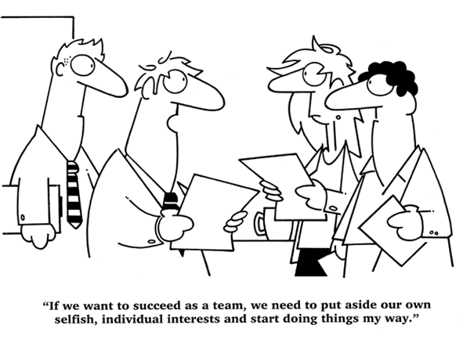
Farh, C., Seo, M. and Tesluk, P. (2012). Emotional intelligence, teamwork effectiveness, and job performance: The moderating role of job context. Journal of Applied Psychology, 97(4), pp.890-900.
Lacerenza, C., Marlow, S., Tannenbaum, S. and Salas, E. (2018). Team development interventions: Evidence-based approaches for improving teamwork. American Psychologist, 73(4), pp.517-531.

