

MODULE CODE: Digital Skills for Personal Development and Business Growth BMSW4008

ASSESSMENT COMPONENT: PORTFOLIO

STUDENT NAME: Aleksandra Maslich

STUDENT NUMBER: 2523715

LECTURER: Philippa Fitzgerald

DATE: 16/03/2026
Contents
Task 1 4
Assessment of Digital Skills 4
References 8
Task 2 9
LinkedIn Learning Certificates for Office365 9
Task 3 11
References 14
Task 4 15
5 Minute Reflective Presentation 15
References 20

AI Acknowledgement

I confirm that I have not presented any AI generated materials as my own work.
I confirm that I have copies of my drafts, notes, and other resources I used, which I may be asked to provide in evidence.

Task 1

Assessment of Digital Skills

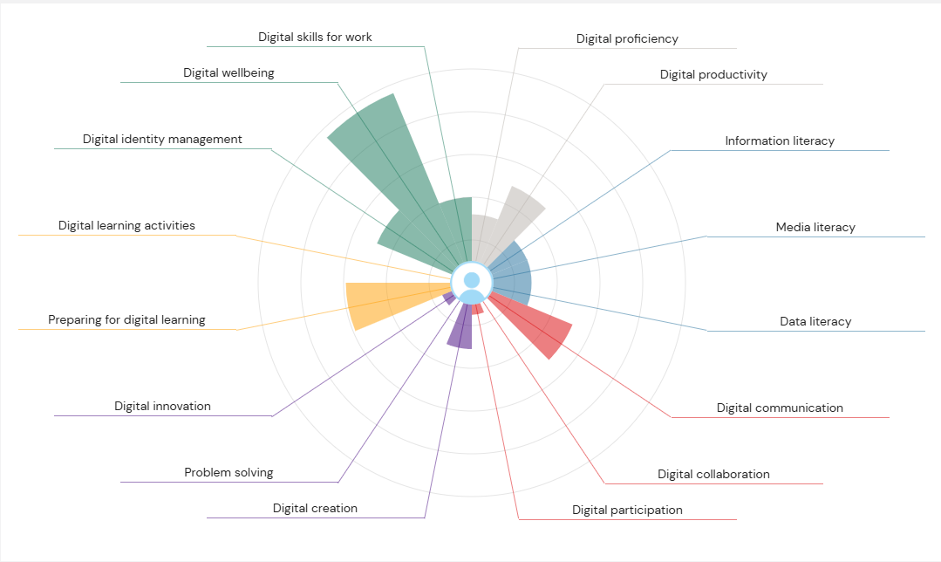 (Anon., 2026)
Image 1 Jisc Report

Digital technology is very important because digital skills support both our learning and work. Following the 2021 pandemic, digital learning was introduced in primary schools and universities, which became stronger the use of technology by many people. Nowadays, every home has with modern digital technologies in the form of televisions, laptops, tablets, and popular smartphones, without which many people would find everyday life impossible (Selwyn, 2021). At every stage of our lives, we use technology to helps our self’s in everyday activities, such as communication, transportation, and, for the most part, studying and work. Students spend most of their time in front of a computer for learning, searching for information, and writing essays. A very helpful tool that helps students develop their digital skills is the JISC Digital Capability Discovery Tool, which allows you to self-assess your level of digital technology. On January 14, 2026, I took this test myself, and as it turned out, I have certain strengths and weaknesses.

The first strengths is Digital Wellbeing, which demonstrates that I use technology in a healthy and responsible ways. Another important element of using technology is not being distracted by tv, phone or any digital devices but managing my time correctly. When studying, I try to minimise distractions because sitting in front of a computer for a long time can make people tired. Another important element in the digital age is taking care of mental health. It is important to find a balance between using technology and pause. As we know, too much use of technology can reduce the quality of work and concentration in learning (Selwyn, 2016).

The second strong point I noted in my final test result is Preparing for Digital Learning. This means I'm comfortable using social media platforms and the tools needed for it. During my studies, I have no problem finding the information I need for my assignments and interests. I regularly use available platforms and websites that support my learning process, as well as for personal purposes. Preparing for digital learning is very important for students, as most learning takes place through online courses and involves finding materials and information that support the learning process (Breen, 2018).

As you can see, the test also shows my weaknesses and areas I need to work on. One of my few weaknesses that I need to work on is problem-solving. Even though I had experience in using technology, after many years of not using it, I noticed that some of my skills were starting to cause me problems, especially when using Microsoft Excel, I didn't feel comfortable using it fully. According to Jonassen (2011) problem-solving skills help people understand problems better and find effective solutions. This can support me when I work with digital tools such as Microsoft Excel. During my lessons at Digital Skills, we had to take several courses including Microsoft Excel, also I want to help myself and I used JISC's support to improve my skills in using this program, where I completed additional training in problem-solving. I want to improved my Microsoft Excel experience, my plan for next one year is continuing to improve my skills and try to solve problems using the technology available to me, such as online searches, AI support, and other available tools.
My second weakness turned out to be digital learning activities. When learning new computer programs or platforms, I need more time to understand how they work. I know how important it is for students to use digital technology in their past and future careers. According to Redecker (2017), developing digital competencies helps students better working with technology in the learning process. That's why my plan is continuing to train with JISC in the next one year, because I know I'll find many useful courses there that will help me develop my digital skills.

In conclusion, developing digital skills is very important for both my studies and future career. The JISC self-assessment helped me understand my strengths and areas that require improvement. By continuing to practise digital tools and completing additional training, I can improve my confidence when using technology. Improving my digital skills will help me become a more effective student and will also prepare me for working in a modern digital workplace.

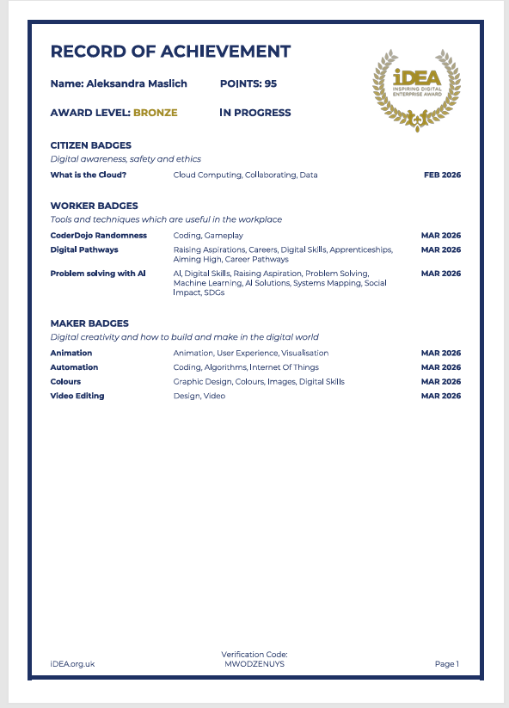
(Anon., 2026)
Image 2 Record of Achievement

References
Anon., 2026. https://idea.org.uk/bronze. [Online].
Anon., 2026. https://uwtsd.potential.ly/signin. [Online].
Breen, P., 2018. Developing Educators for The Digital Age. London: University of Westminster Press..
Jonassen, D. H., 2011. Learning to Solve Problems: A Handbook for Designing Problem-Solving Learning Environments. New York: Routledge.
Redecker, C., 2017. European Framework for the Digital Competence of Educators: DigCompEdu. Luxembourg: Publications Office of the EU.
Selwyn, N., 2016. Digital downsides: exploring university students’ negative engagements with digital technology. Taylor&Francis.
Selwyn, N., 2021. Education and Technology: Key Issues and Debates. 3 ed. London: Bloomsbury Academic.

Task 2

LinkedIn Learning Certificates for Office365

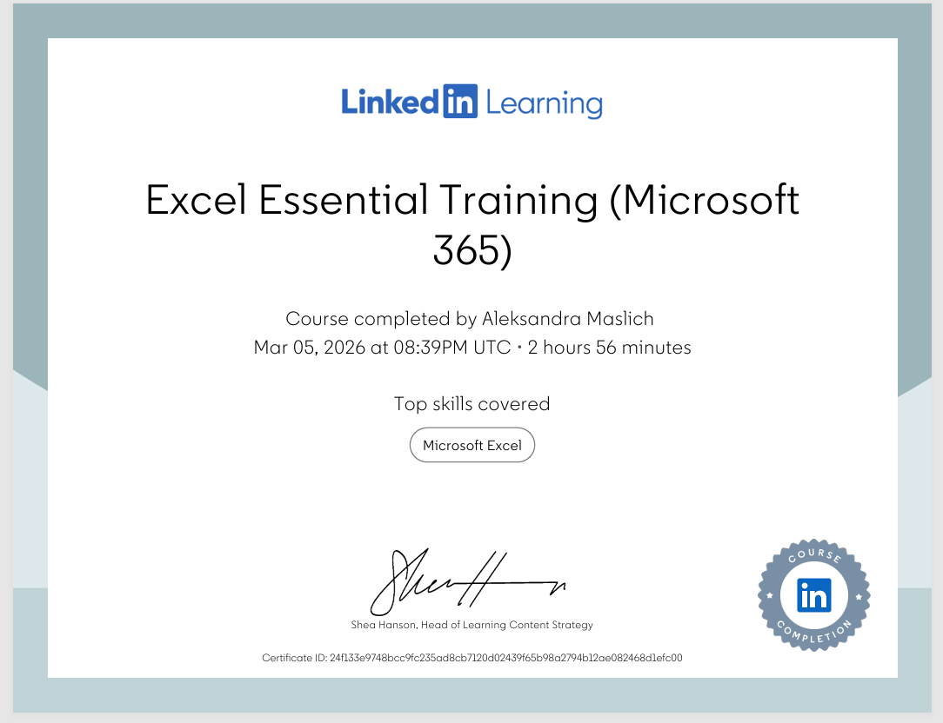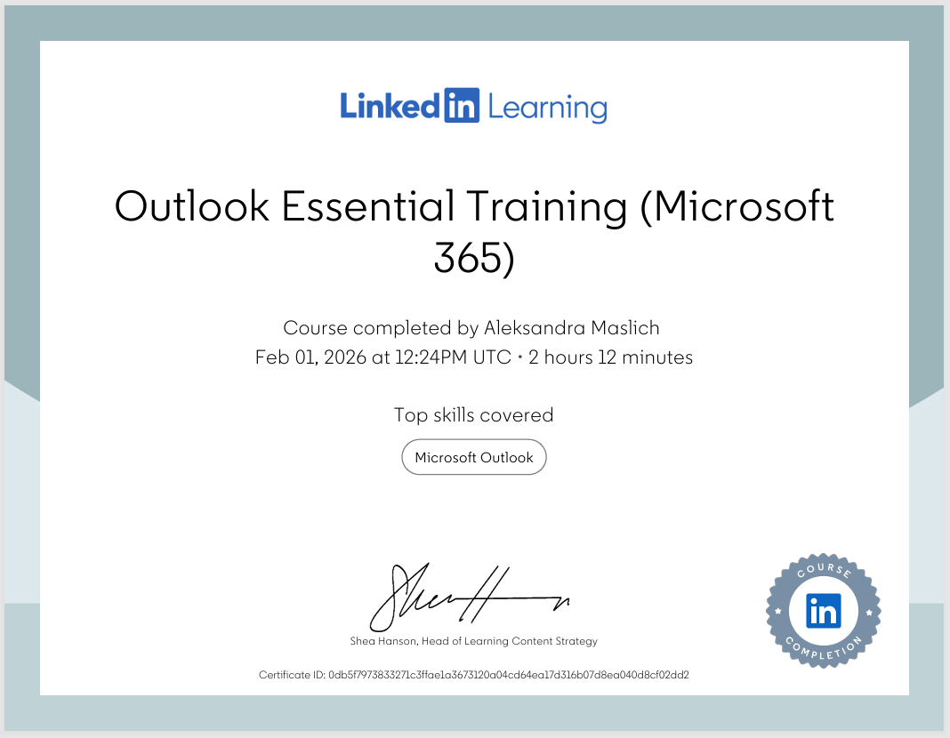

Task 3
Relevance of Excel in professional and personal life.
Microsoft Excel is one of the most popular computer programs that we use to work with data. It is a part of the Microsoft Office 365 package and for many years we use it in companies, schools, and in everyday life. This program allows keeping data in the form of a table, and it allows doing different calculations by using formulas, using this program can quickly calculate data and create charts needed for it.
Using this program is important because many companies work with data in the form of finances or statistics. We use Microsoft Excel for such tasks like data analysis, budget planning or creating reports (Frye, 2018). In these times the world is mostly based on data and statistics, so with this tool we can easily organised all data, and it allows their analysis. This program plays a key role in professional work and in private life.
One of the more important tasks of Microsoft Excel is data analysis. The program allows savings a large amount of information in an organised way and checking them quickly. Data in Excel are saved in rows and columns and separate pages if we need it. In the Excel program we can find many helpful mathematical functions that help us to do calculations. One of the most often used functions is the SUM function, which allows quick calculating the sum of values in a chosen column (Weverka, 2016).
By using this program people can analyse data for example product sales, company costs or their results. This tool also allows sorting and filtering data, which allows finding important information in a short time. In many companies Excel is mainly used to analyse financial results and checking what results a given company achieves.
Another element in which we use the Excel program is budget planning. The program is often used to manage finances both in companies and in private life. Thanks to Excel we can write down all incomes and expenses in one place and easily calculate the total costs of incomes and expenses. This program by using formulas automatically does calculations, which trying to reduce mistakes and saves time (Winston, 2016).
Showing an example, we can create a table in a spreadsheet showing monthly incomes and home expenses. In such a table we can write different sources of income, such as salary from work or social benefits, and different expenses, for example rent, energy bills, food or transport. Excel can automatically calculate the total sum of incomes and expenses in each month. Thanks to this we can easily see how much money is left after paying all bills.
The Microsoft Excel program is helpful when creating reports, in many companies’ employees prepare financial or statistical reports that show the results of the company. This software allows presenting data in the form of tables and charts, which makes the information more readable and easier to understand (McFedries, 2022).
Charts are especially helpful because they allow quickly seeing the most important information. A bar chart can show the differentiation of sales in different months, and a pie chart can present the structure of company expenses. Analysing data can faster understand the financial situation of their company.
The Excel program also plays an important role in decision making. Based on data analysis employees can evaluate different possibilities and choose the best solution. Excel allows easily checking how the change of one value affects the whole result. This is especially useful when planning finances or preparing forecasts if it is required by the employer.
Based on an example we can show how a company can use the Excel program to check product prices and how it will affect the total income from sales. Similarly in private life, household members can check how the increase of energy bills or other fees can affect the monthly budget. This type of analysis helps make more careful financial decisions (Harvey, 2018).
It is also worth highlighting that Microsoft Excel is often used on the job market. Many companies require employees to know this program because it is used in different departments of companies, such as finance or data analysis. The ability to use Excel allows employees to analyse data faster and prepare reports (Alexander & Kusleika, 2019).
Excel is also relatively easy to learn, it can also be noticed that learning the Excel program is supported by many materials available on the internet. Many people use free guides or online courses that show step by step how to do different tasks in the spreadsheet. Users can develop their skills step by step and by practice on examples that are the most useful for them. Regular practice makes the use of the program easier and simply to understand. In cases where people who are just starting to work with the program can quickly learn basic functions, such as creating tables or using simple formulas. With time it is possible to learn more advanced tools that allow to analyse data even more in the right way (Narayana, Ranjan & Tyagi, 2023).
To sum up, Microsoft Excel is a very important tool for working with data. The program allows storing information in an organised way, doing automatic calculations and analysing different financial and statistical data. Functions like formulas, tables and charts users can easily interpret data and draw conclusions from them.
Excel is used in many areas, such as data analysis, budget planning, preparing reports and decision making. The program is used both in companies and in everyday life, for example to manage the household budget. Using this programs you will have better control in finances and plan future expenses.
More information is saved in the form of digital data, so the ability to use the Excel program becomes very important. This program helps organise data, analyse information and make better decisions. For this reason, Microsoft Excel remains one of the most important tools used for working with data around the world.

Working in Excel:

References
Alexander, M. & Kusleika, D., 2019. Excel 2019 Power Programming with VBA. Hoboken, New Jersey: John Wiley and Sons.
Frye, C., 2018. Microsoft Excel 2019 Step by Step. Redmond, Washington: Microsoft Press.
Harvey, G., 2018. Excel 2019 For Dummies. Hoboken, New Jersey : John Wiley & Sons.
McFedries, P., 2022. Teach Yourself visually Excel 365. Indianapolis: Visual.
Narayana, D., Ranjan , S. & Nupur, T., 2023. Basic Computational Techniques for Data Analysis. s.l.:Taylor & Francis.
Weverka, P., 2016. Office 2016 all-in-one for dummies. 1 ed. Hoboken, New Jersey : John Wiley and Sons.
Winston, W., 2016. Microsoft Excel Data Analysis and Business Modeling. Redmond, Washington : Microsoft Press.

Task 4

5 Minute Reflective Presentation
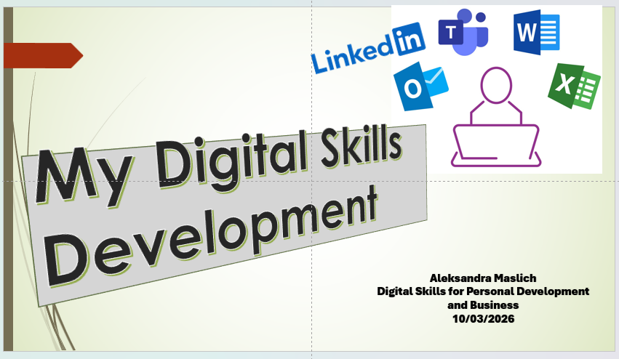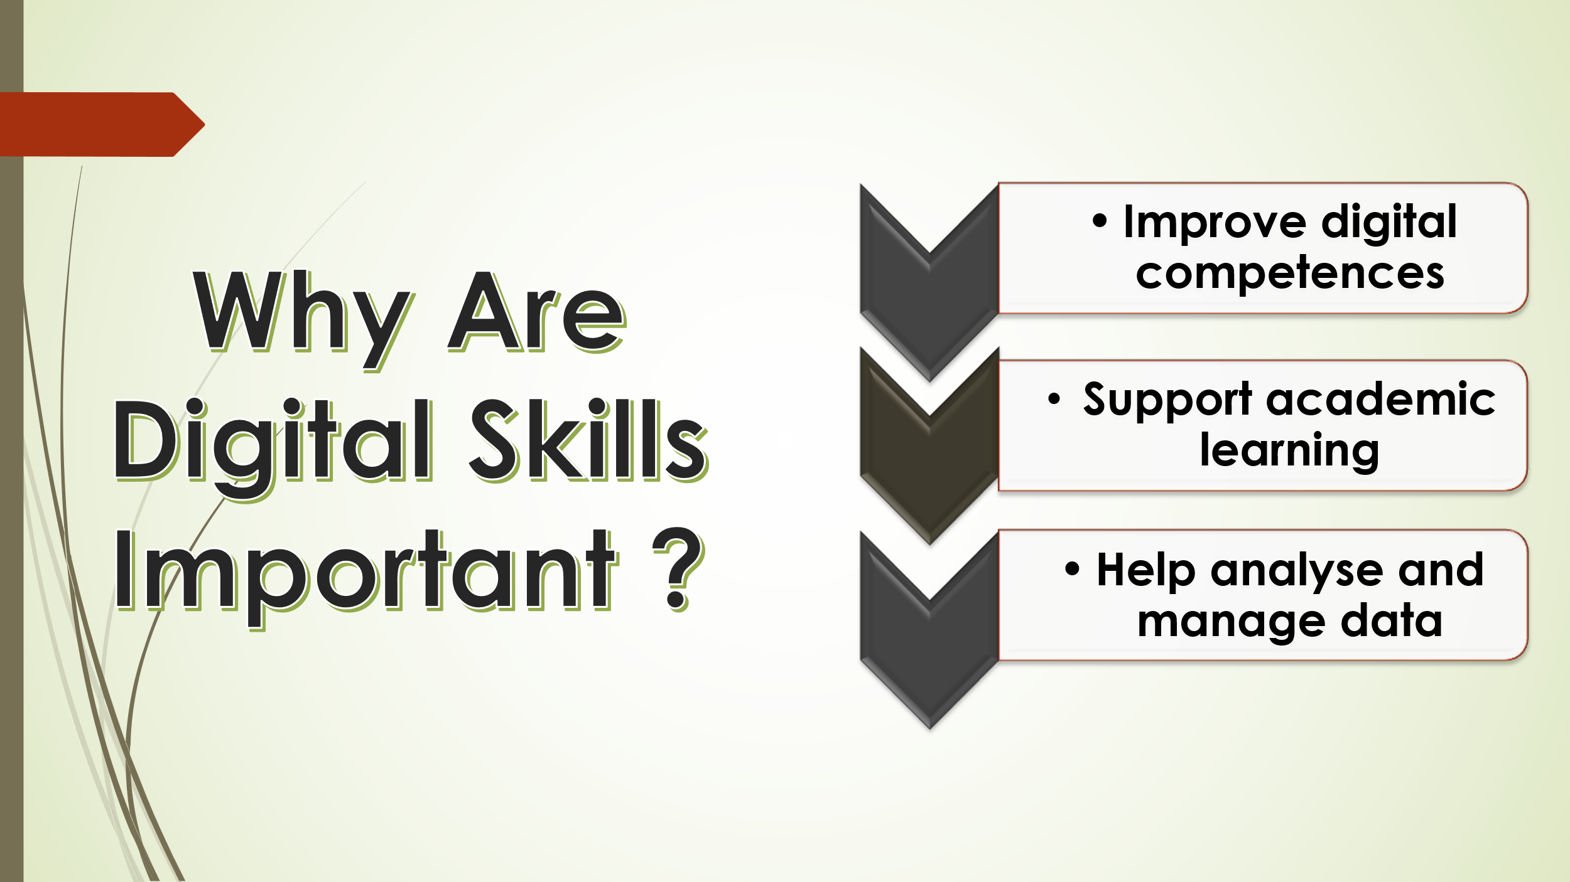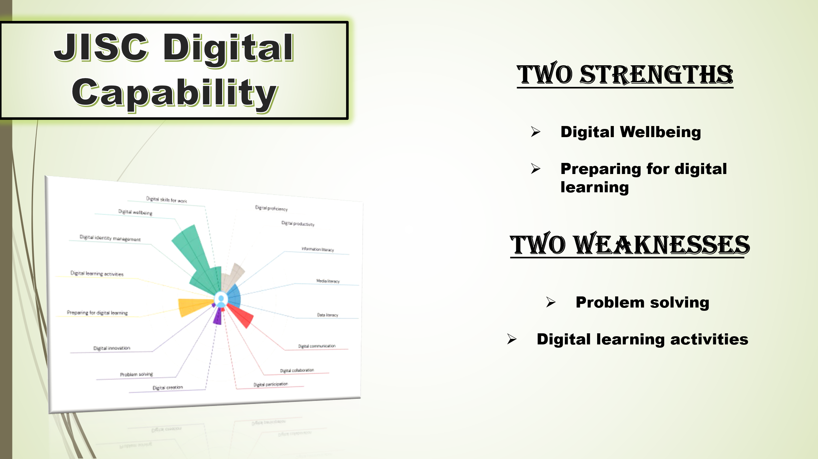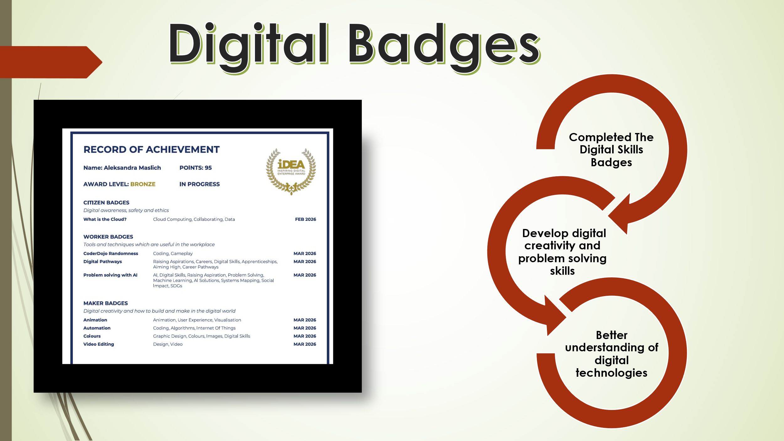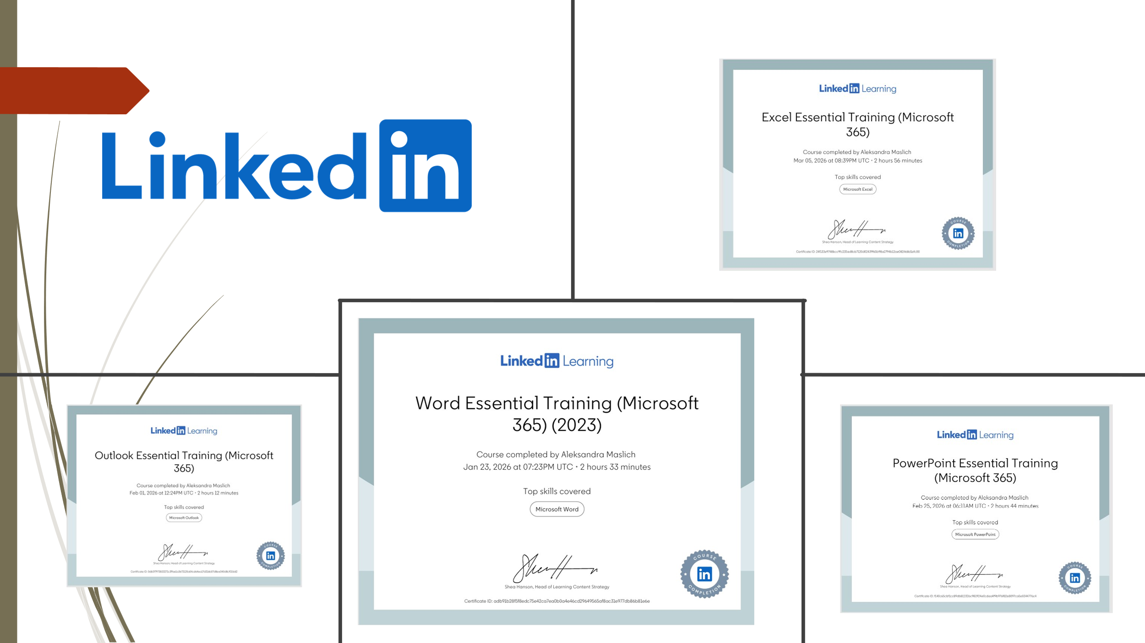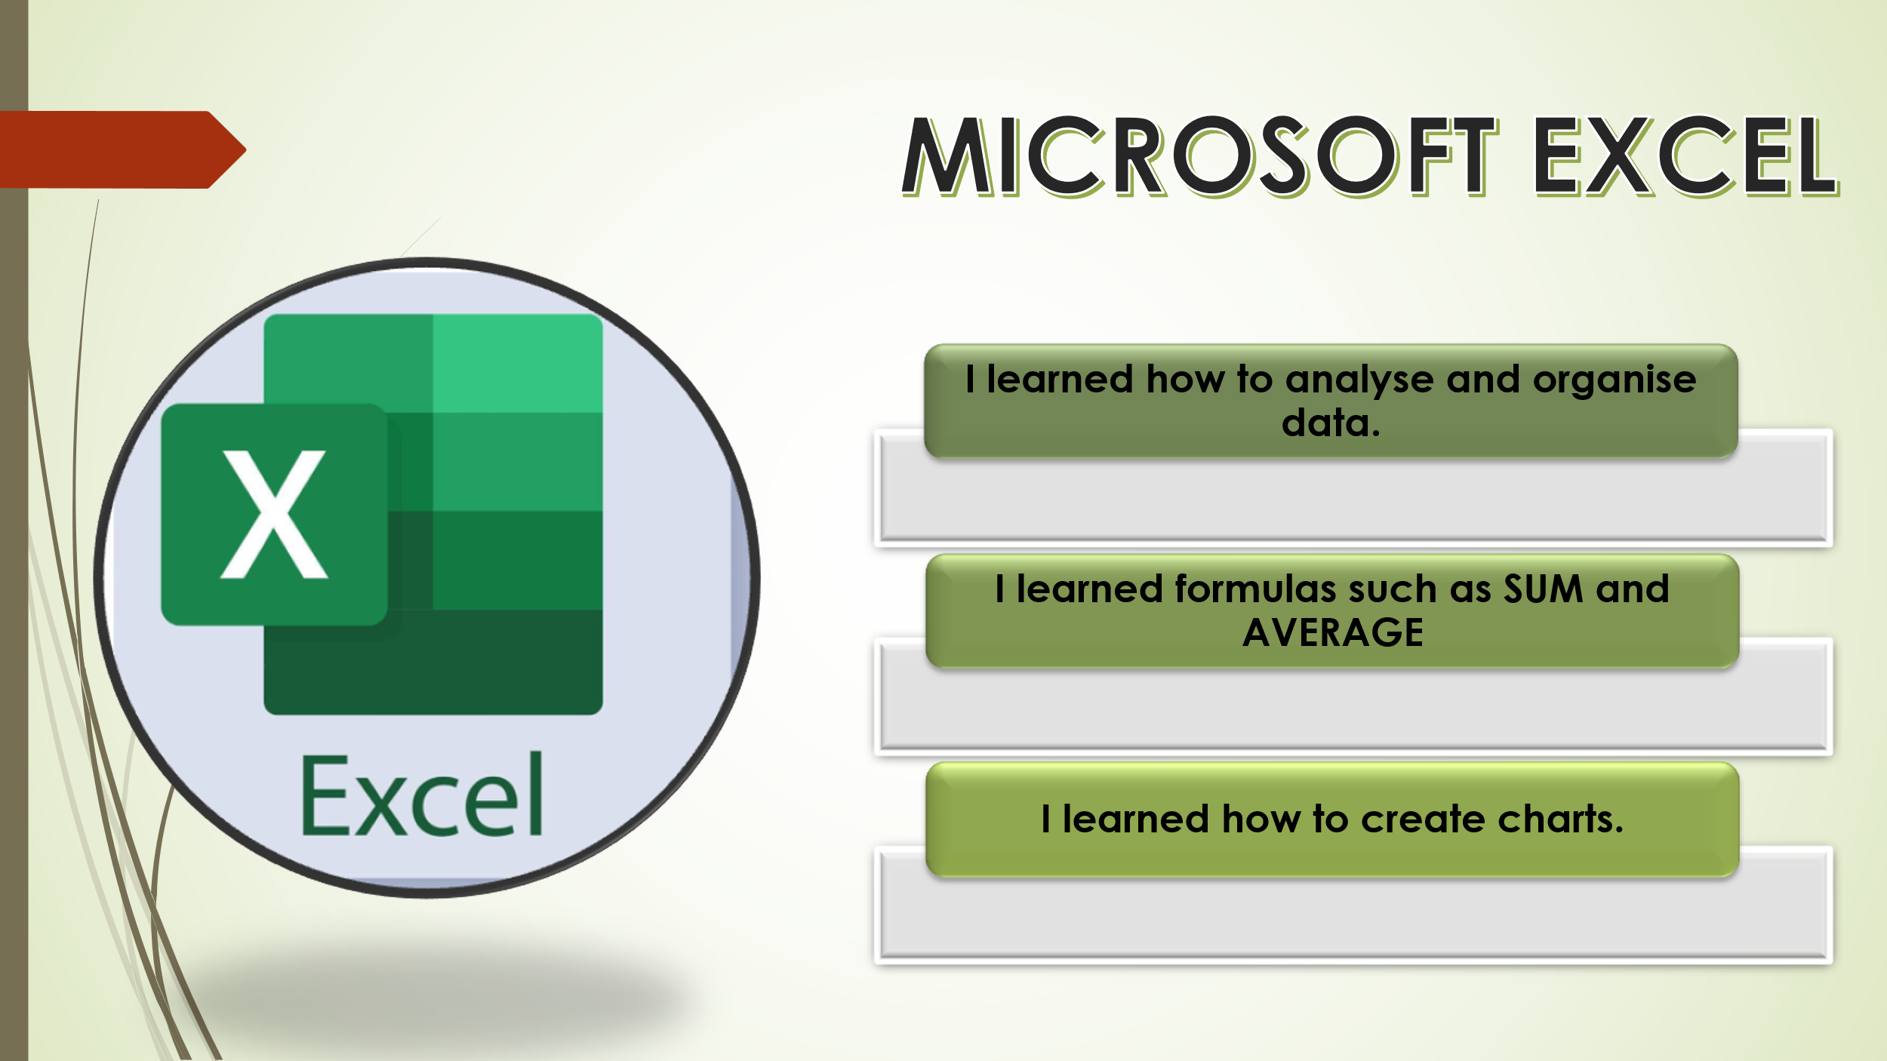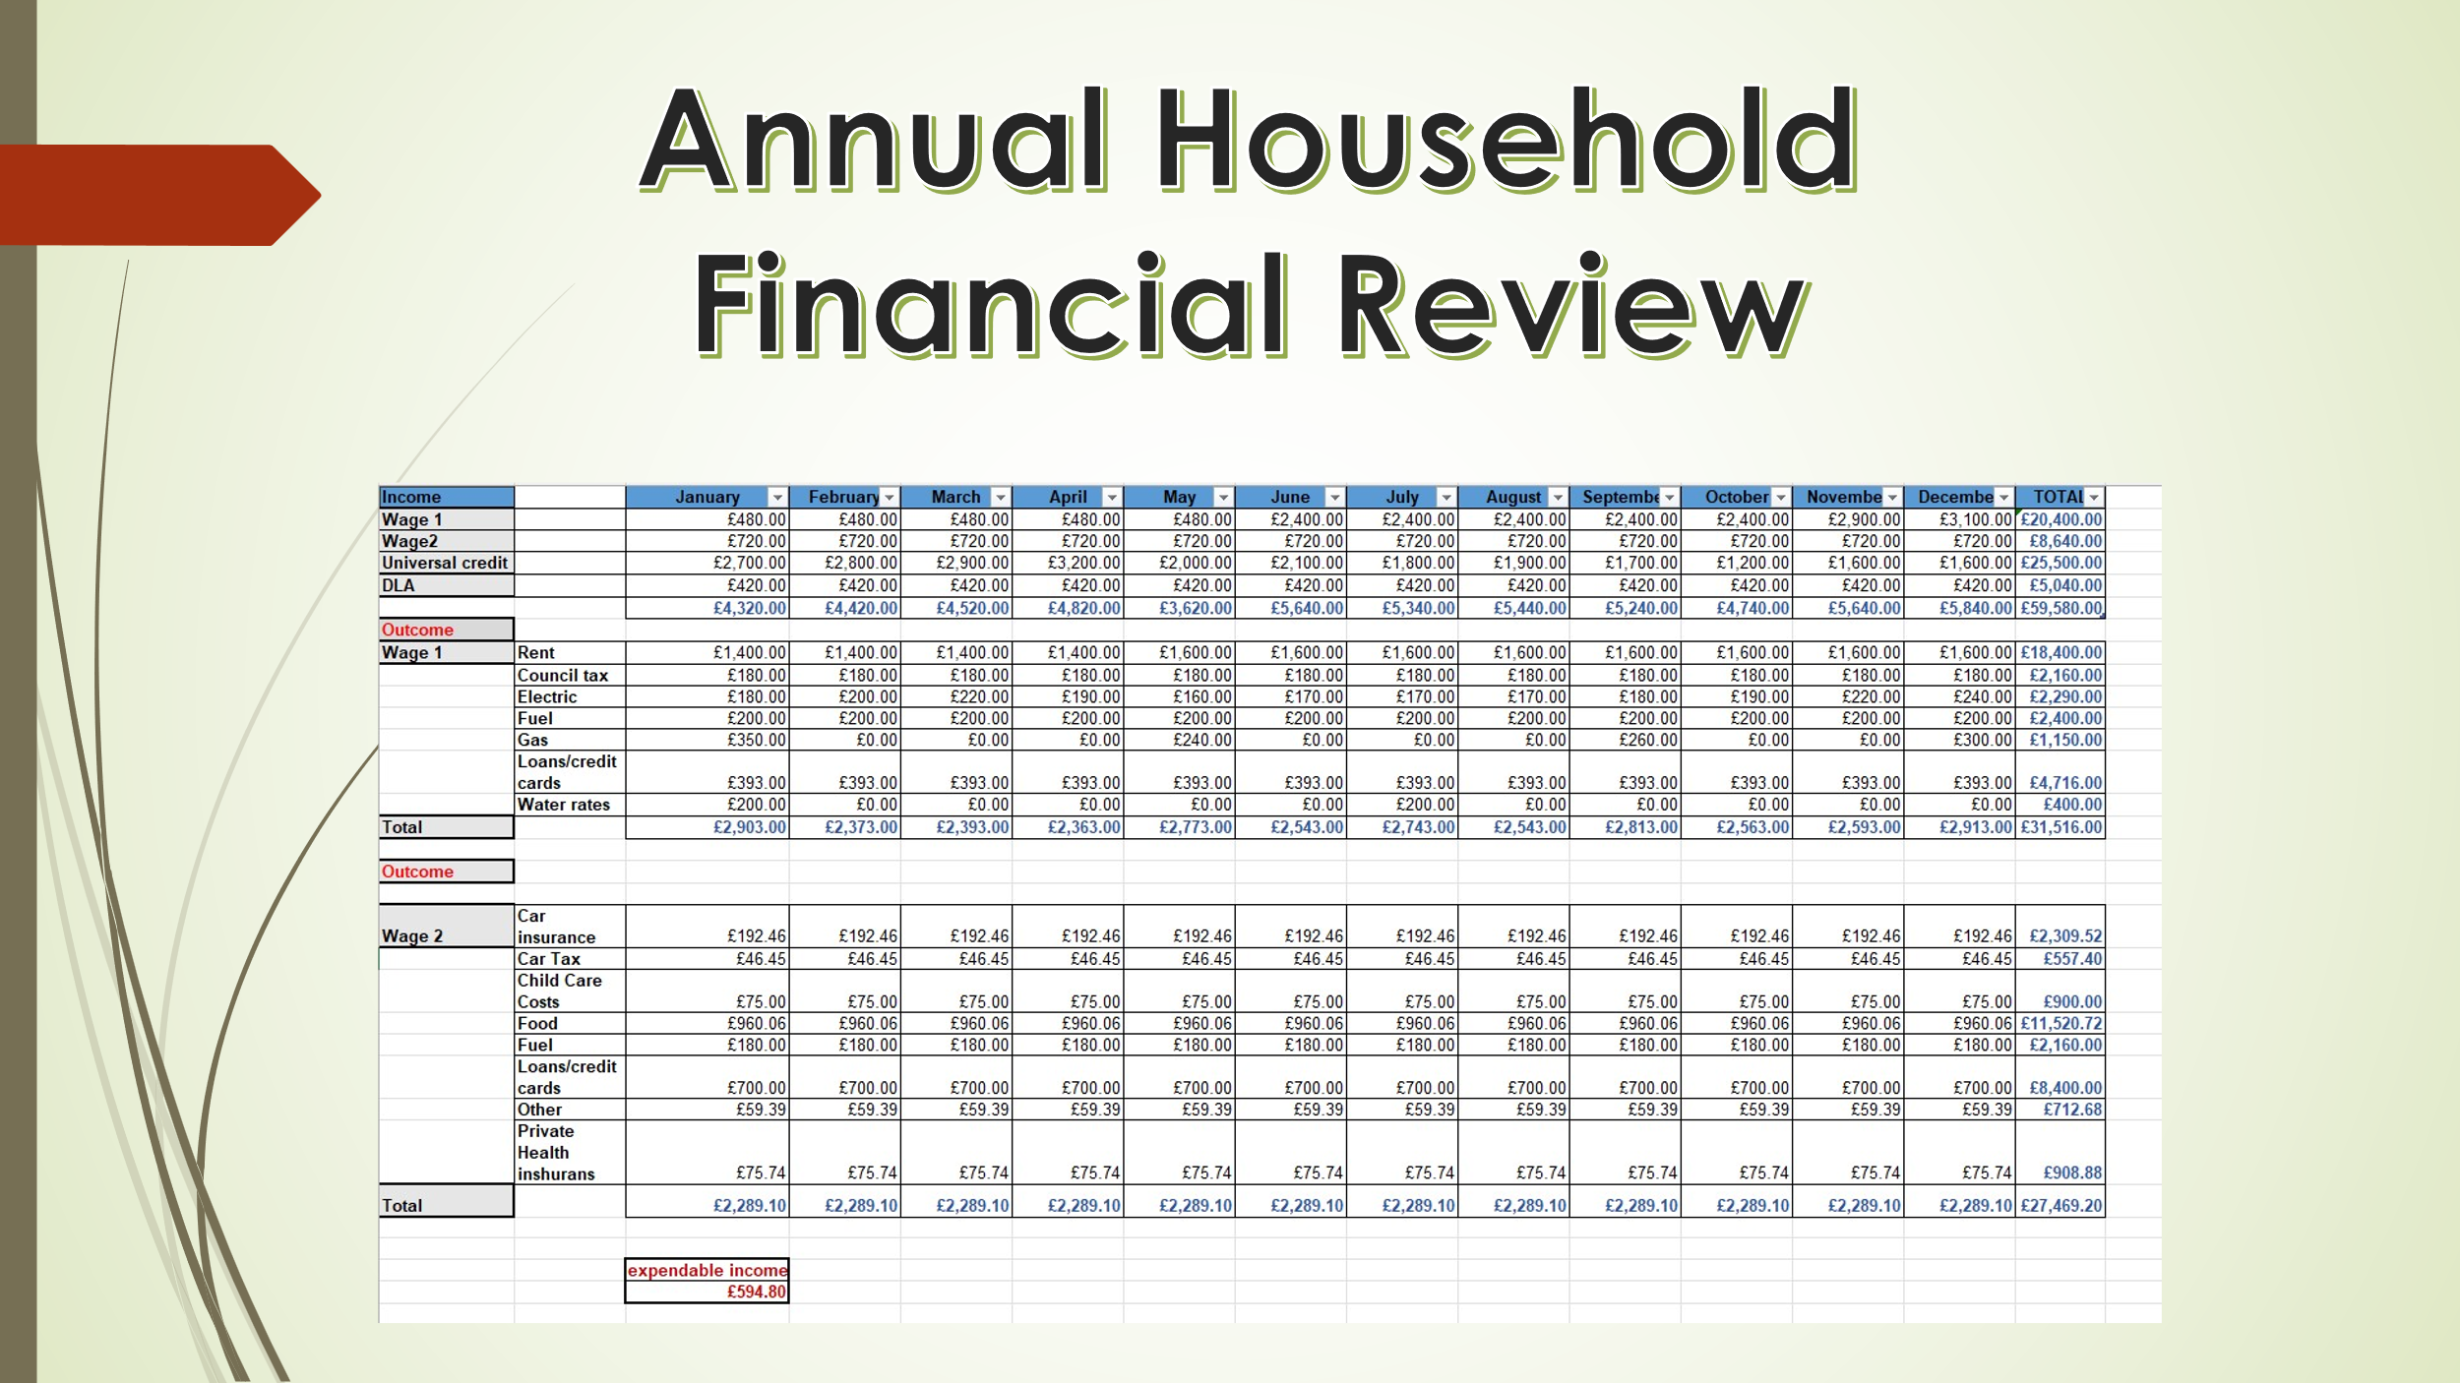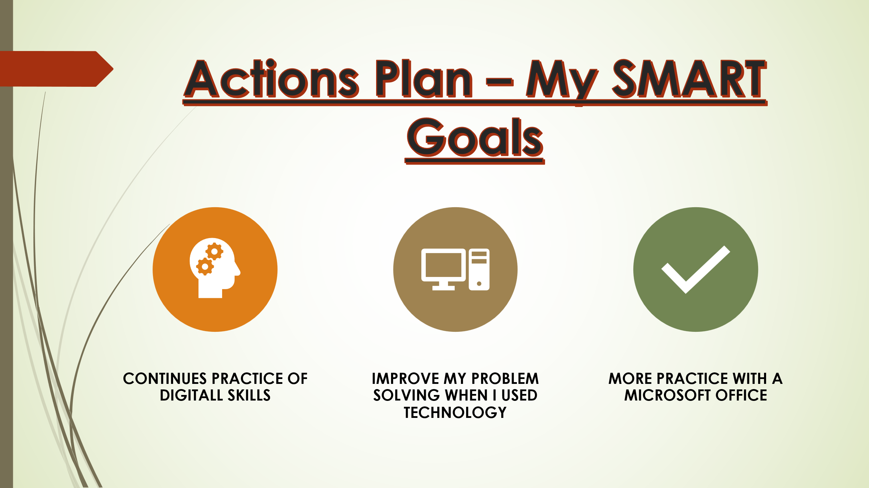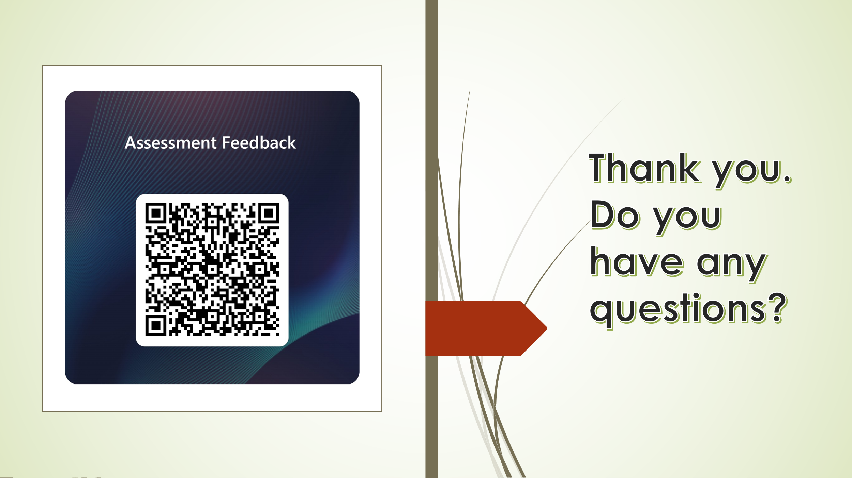

References
Anon., 2026. https://idea.org.uk/bronze. [Online].
Anon., 2026. https://uwtsd.potential.ly/signin. [Online].
Breen, P., 2018. Developing Educators for The Digital Age. London: University of Westminster Press..
Jonassen, D. H., 2011. Learning to Solve Problems: A Handbook for Designing Problem-Solving Learning Environments. New York: Routledge.
Redecker, C., 2017. European Framework for the Digital Competence of Educators: DigCompEdu. Luxembourg: Publications Office of the EU.
Selwyn, N., 2016. Digital downsides: exploring university students’ negative engagements with digital technology. Taylor&Francis.
Selwyn, N., 2021. Education and Technology: Key Issues and Debates. 3 ed. London: Bloomsbury Academic.

