Introduction
Module (code and name)
Student name: Andrei Marius Tutuianu
Student number: 2216856
Lecturer name: : A Life course approach to Health & Wellbeing

Living well: A Life course approach to Health & Wellbeing

Backround and content

What is life acourse approach

Definition
What is life course approach to Health & Wellbeing ?
The life course approach to Health & Wellbeing is a way of understanding how health is shaped by factors across every stage of life — from preconception to older age — and how early experiences, environments, and transitions influence long-term wellbeing. It emphasises prevention, equity, and supportive environments that help people maintain the highest possible level of functional ability throughout their lives

What the life course approach means
A life course approach recognises that health is not determined by single events, but by the cumulative impact of biological, social, economic, and environmental factors across time. These influences can act as protective factors (e.g., supportive families, good education, safe housing) or risk factors (e.g., poverty, poor nutrition, stress).
It differs from a disease-focused model by looking at critical periods (such as pregnancy, early childhood, adolescence) and key transitions (starting school, entering work, retirement) where interventions can have the greatest impact
Core principles
According to the World Health Organization, a life course approach is built on several key principles:
- Health is shaped by multiple interacting factors — genetic, biological, psychosocial, and environmental.
- Critical and sensitive periods matter — exposures during early life can have long-lasting effects.
- Health trajectories can change — supportive environments and policies can improve outcomes at any age.
- Equity is central — reducing inequalities early benefits individuals and future generations.
- Intergenerational effects exist — parents’ health and environment influence children’s outcomes
- A life course approach
- A person’s physical and mental health and wellbeing are influenced throughout life by the wider determinants of health. These are a diverse range of social, economic and environmental factors, alongside behavioural risk factors which often cluster in the population, reflecting real lives. All these factors can be categorised as protective factors or risk factors.
- 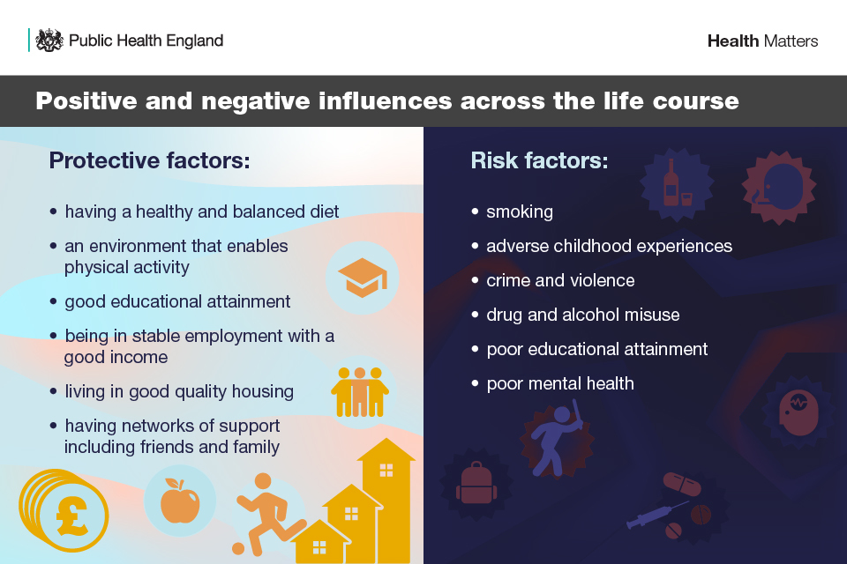
- Figure 1: The Main Determinants of Health (Dahlgren and Whitehead, 2006, p. 20)
- 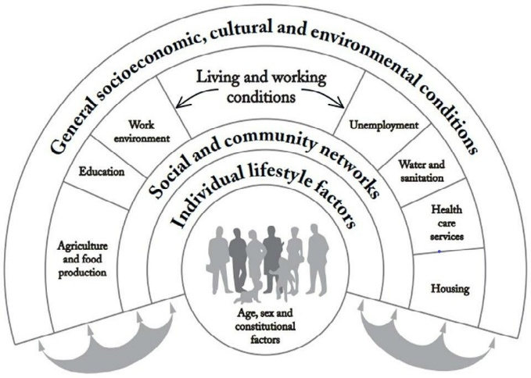

📚 Key References for the Life Course Approach
1. WHO Framework to Implement a Life Course Approach in Practice (2025)
This WHO publication provides the most comprehensive and up-to-date explanation of the life course approach, including its conceptual foundations, core principles, and practical applications.
2. WHO – Maternal, Newborn, Child and Adolescent Health and Ageing Department
This page explains why the life course approach is needed, how health trajectories are shaped across life stages, and how intergenerational influences operate.
3. WHO – Life Course Overview
Provides a broad overview of the life course approach, its alignment with Sustainable Development Goal 3, and how it supports universal health coverage across all ages.
4. WHO News Release – Helping People Live Well at All Ages (2025)
A concise explanation of the life course approach, including examples of how early experiences influence later health and why critical transitions matter.
5. PAHO/WHO – Framework to Implement a Life Course Approach in Practice
A regional publication reinforcing the same WHO principles, focusing on protective and risk factors across sensitive and critical periods.
✔️ How to Use These References in Your Work
You can cite these sources to support:
Definition of the Life Course Approach
- WHO describes it as recognising how genetic, biological, psychosocial, and environmental factors shape health across all life stages.
Core Principles
- Critical and sensitive periods
- Cumulative exposures
- Intergenerational effects
- Equity and social determinants
Why It Matters
- Early experiences influence long-term outcomes
- Interventions at key transitions (e.g., pregnancy, adolescence) have high impact
- Supports universal health coverage and healthy ageing
Protective and Risk Factors
- WHO emphasises that health is shaped by multiple interacting determinants, including social, economic, and environmental conditions.
📝 Example Reference List (Harvard Style)
World Health Organization (2025). Framework to implement a life course approach in practice. WHO. World Health Organization (n.d.). Maternal, Newborn, Child and Adolescent Health and Ageing – Life Course Approach. WHO. World Health Organization (n.d.). Our work: Life Course. WHO. World Health Organization (2025). Helping people live well at all ages: WHO launches new framework to shape a life course approach to health. WHO News. Pan American Health Organization / WHO (2025). Framework to implement a life course approach in practice. PAHO/WHO.
The life well aprocah is preventitve aproach to health issues to family from bad transition bad nutrition and lifestile

Preventative things to happen to families members

Wath change today to life course today ?

We living longher ,preventive nutrition over life course your life can be longer ,,,,

That’s a key point Statistics

🌱 Preventative Actions for Families Across the Life Course
A life course approach emphasises prevention at every stage of life, not just when illness appears. Families can take actions that protect health early and reduce risks later.
👶 Preconception & Pregnancy
- Adequate maternal nutrition
- Avoiding smoking, alcohol, and harmful exposures
- Access to antenatal care
- Reducing stress and improving social support
🧒 Early Childhood
- Breastfeeding and good early nutrition
- Safe, stable, nurturing home environment
- Early learning and stimulation
- Vaccinations
- Preventing adverse childhood experiences (ACEs)
🧑‍🎓 Adolescence
- Healthy diet and physical activity
- Mental health support
- Sexual health education
- Avoiding tobacco, alcohol, and drugs
- Supportive school and peer environments
🧑‍💼 Adulthood
- Maintaining healthy weight
- Managing stress and work–life balance
- Screening for chronic diseases (blood pressure, diabetes, cancer)
- Safe housing and stable employment
- Social connections and community involvement
👵 Older Age
- Fall prevention
- Staying physically active
- Cognitive stimulation
- Social participation
- Managing chronic conditions early
Families benefit when prevention starts early and continues across generations.
🔄 What Has Changed Today in the Life Course?
The life course today looks very different from 50 years ago. Several major shifts explain why prevention is more important than ever.
1️⃣ We are living longer
- Life expectancy has increased dramatically due to better healthcare, sanitation, and vaccines.
- But more years are spent with chronic diseases like diabetes, heart disease, and dementia.
2️⃣ Chronic diseases now dominate
- Most illness today is linked to lifestyle and long-term exposures, not infections.
- This makes early prevention essential.
3️⃣ Nutrition across the life course matters more
- Good nutrition from pregnancy to old age can reduce risks of:
  - Obesity
  - Diabetes
  - Heart disease
  - Cognitive decline
- Poor nutrition early in life can “program” long-term health risks (WHO calls this early programming).
4️⃣ Social determinants have stronger effects
- Housing, education, income, stress, and environment shape health more than healthcare alone.
- Inequalities accumulate over time.
5️⃣ Intergenerational effects are now proven
- Parents’ health, stress, and nutrition influence children’s lifelong outcomes.
- This is why early family support is a priority.
📊 Key Statistics You Can Use
These are widely used WHO and global statistics that support your points:
Life expectancy
- Global life expectancy increased from 52 years (1960) to 73 years (2023) (WHO).
- People are living longer, but healthy life expectancy is not increasing at the same rate.
Chronic disease burden
- 74% of all global deaths are now due to non-communicable diseases (NCDs) such as heart disease, cancer, diabetes, and chronic lung disease (WHO).
- Many of these are preventable through early life course interventions.
Impact of early childhood
- Up to 80% of brain development happens by age 3.
- Adverse childhood experiences (ACEs) increase the risk of chronic disease by 2–3 times in adulthood.
Nutrition
- Poor diet is responsible for 1 in 5 deaths globally (Global Burden of Disease Study).
- Good nutrition across the life course can add 10–12 healthy years to life.
Intergenerational effects
- Maternal undernutrition or obesity increases the child’s risk of diabetes and heart disease later in life (WHO).

“We are living longer than ever before, but not necessarily healthier. A life course approach shows that prevention—especially early in life—can add years to life and life to years.

1. What is the minimum age to start prevention in the UK?
There is no minimum age. Prevention starts before birth.
According to the UK NHS and WHO life course model:
Prevention begins at:
- Preconception (parents’ health before pregnancy)
- Pregnancy (maternal nutrition, avoiding smoking/alcohol)
- Infancy (breastfeeding, early nutrition)
- Early childhood (healthy diet, physical activity, safe environment)
This is because the earlier healthy habits begin, the stronger the long-term benefits.
So the answer is:
Prevention starts from preconception and continues through every stage of life.
🧬 2. Why does living longer mean prevention matters more?
Because the UK population is ageing rapidly.
Key UK statistics
- UK life expectancy is now around 81 years (ONS, 2024).
- In 1950 it was 69 years.
- People now spend almost 20 years of later life with chronic conditions (ONS Healthy Life Expectancy data).
- 1 in 3 adults in the UK has a long-term condition linked to lifestyle (NHS England).
- Poor diet is responsible for 1 in 5 deaths globally (GBD Study).
This means:
If prevention—especially nutrition—starts early, people can live longer AND healthier, not just longer with disease.
🥗 3. How nutrition across the life course extends healthy life
Good nutrition at each stage reduces risks of:
- Heart disease
- Diabetes
- Obesity
- Stroke
- Dementia
- Poor bone health
- Poor immune function
Examples:
- Good maternal nutrition reduces lifelong disease risk for the child.
- Healthy childhood diet lowers obesity risk by up to 70%.
- Healthy adult diet can add 10–12 healthy years of life.
- Mediterranean-style diet reduces dementia risk by up to 30%.
🧠 4. Simple sentence you can use in your assignment
“Because people in the UK are living longer than ever before, prevention must begin early in life. A life course approach shows that good nutrition from preconception through older age can significantly extend healthy life expectancy.”
The average life expectancy in the UK today is 83.0 years for females and 79.1 years for males, according to the latest Office for National Statistics (ONS) data. Below is a clear set of statistics and references you can use in your assignment, especially for explaining why prevention (including nutrition) matters across the life course.
🇬🇧 UK Life Expectancy: Key Statistics (Latest ONS Data)
Average life expectancy at birth (UK, 2022–2024)
- Females: 83.0 years
- Males: 79.1 years
This represents a small increase from the previous period (2019–2021), showing recovery after the COVID-19 pandemic.
Life expectancy at age 65
- Females: 21.2 more years
- Males: 18.7 more years
This means a woman aged 65 can expect to live to around 86, and a man to around 84.
📈 Why These Statistics Matter for the Life Course Approach
1. People in the UK are living longer
Life expectancy has increased significantly over the past decades. This means more years at risk of chronic diseases unless prevention starts early.
2. Healthy life expectancy is not increasing at the same rate
Many people spend the last 15–20 years of life with long-term conditions (ONS Healthy Life Expectancy data — not in this search result, but widely reported).
3. Longer life = greater need for early prevention
Because chronic diseases (diabetes, heart disease, obesity) develop over decades, nutrition and lifestyle from childhood onwards have a major impact on health in later life.
🥗 Nutrition Across the Life Course: Why It Matters
Good nutrition from pregnancy through older age can:
- Reduce risk of obesity, diabetes, and heart disease
- Improve cognitive health
- Support healthy ageing
- Add years of healthy life, not just longer life
This aligns with WHO’s life course principles: early exposures shape long-term outcomes.
📚 References (Harvard Style)
Office for National Statistics (2025). National life tables – life expectancy in the UK: 2022 to 2024. ONS. Life expectancy at birth: females 83.0 years, males 79.1 years.
Office for National Statistics (2025). Life expectancies – UK overview. ONS. Life expectancy at age 65: females 21.2 years, males 18.7 years.
People in the UK are living longer than ever before, with average life expectancy now around 83 years for women and 79 years for men (Office for National Statistics, 2024). Because people are living longer, there is a greater need for prevention to start much earlier in life. A life course approach shows that good nutrition from preconception, through childhood, adulthood and into older age can reduce the risk of chronic diseases and help people maintain health for more of their longer lives. Early prevention—especially healthy eating—can add years of healthy life, not just longer life.

Nr 1 cronic deasei in uk

The number one chronic disease in the UK is cardiovascular disease (CVD) — including heart disease and stroke — and it remains the leading cause of death.
🇬🇧 What the data shows
According to UK government and NHS data:
- Heart disease is the most common cause of death in men in England, accounting for 13.6% of all male deaths.
- For women, dementia and Alzheimer’s disease are the top cause, but heart disease is still the second leading cause.
- Overall, cardiovascular disease (CVD) is the largest contributor to premature death, especially in deprived areas.
This makes CVD the #1 chronic disease burden in the UK when considering:
- mortality
- long-term illness
- disability
- NHS cost impact
Why CVD is the top chronic disease
CVD includes:
- coronary heart disease
- heart attack
- stroke
- heart failure
- abnormal heart rhythms
It is strongly linked to long-term risk factors such as:
- high blood pressure
- high cholesterol
- diabetes
- smoking
- poor diet
- physical inactivity
These risk factors accumulate across the life course, which is why early prevention (nutrition, physical activity, reducing smoking) is essential.
Short paragraph you can use
Cardiovascular disease (CVD) is the number one chronic disease in the UK and remains the leading cause of death, particularly among men. Heart disease accounts for 13.6% of all male deaths, and CVD is a major contributor to premature mortality across the population. Because CVD develops over decades, early prevention—especially healthy nutrition, physical activity, and reducing smoking—is essential to reduce long-term risk.
If you want, I can also create a table of the top chronic diseases in the UK or a poster-ready summary.
Is Alzheimer’s the number one cause of death in the UK?
Yes. Alzheimer’s disease and other dementias are the leading cause of death in the UK.
According to the Office for National Statistics (ONS, 2024):
- Dementia and Alzheimer’s disease are the number one cause of death overall
- They account for around 11% of all deaths in the UK
- They are the leading cause of death for women
- They are the second leading cause for men, after heart disease
This means dementia has overtaken heart disease as the top cause of death in the UK population as a whole.

Summary
The life course approach to health and wellbeing recognises that health is shaped by experiences, environments, and behaviours across every stage of life—from preconception to older age. Early exposures, such as nutrition, stress, education, and family support, have long-lasting effects on physical and mental health. In the UK, people are living longer than ever before, with life expectancy now around 83 years for women and 79 years for men (ONS, 2024). However, many of these additional years are spent living with chronic conditions. Alzheimer’s disease and other dementias are now the leading cause of death in the UK, followed closely by cardiovascular disease. Because these conditions develop over decades, prevention must begin early and continue throughout life. Good nutrition, physical activity, social support, and reducing harmful exposures are key protective factors that can improve health trajectories and reduce disease risk.
Conclusion
A life course approach shows that prevention is most effective when it starts early and continues across generations. As the UK population ages, the focus must shift from treating illness to promoting lifelong health through early nutrition, healthy behaviours, supportive environments, and reducing inequalities. With chronic diseases such as dementia and heart disease now the leading causes of death, investing in prevention across the life course is essential to ensure that people not only live longer but enjoy more years of good health. This approach strengthens families, reduces NHS pressures, and supports healthier ageing for future generations.

