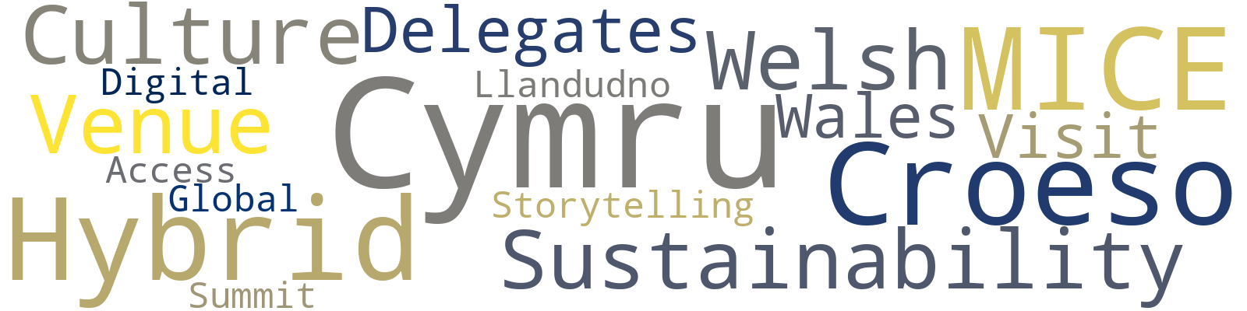
Strategic Planning and Delivery Report for “Croeso Cymru: A Global Welcome Summit”

- Name: Mihai Serban
- Student ID number: 2244688
- Module title: BMIH6007 International Meetings Management for the Hotel Industry
- Lecturer’s name: Kathryn Flynn
- Word Count: 2750

I confirm that I have not used any AI tools in the research and creation of this assignment. I confirm that I have not presented any AI generated materials as my own work. I confirm I have copies of my drafts, notes, and other resources I used, which I may be asked to provide in evidence.

Executive Summary
This report presents a strategic event delivery plan for Croeso Cymru: A Global Welcome Summit, a proposed international MICE event to be held in Llandudno, North Wales. Developed in alignment with Visit Wales’ Year of Croeso 2025 campaign, the event aims to showcase the nation’s unique cultural identity while positioning Wales as a distinctive and competitive destination within the international meetings industry.
Targeting global event professionals and travel trade delegates, the summit will combine networking, conference sessions, and immersive cultural experiences — including Welsh cuisine, language, and music — to create a strong sense of place. The event also incorporates hybrid delivery methods and sustainable practices to meet evolving industry expectations.
Building on the feasibility study submitted in Assignment 1, this report provides a detailed operational and strategic framework for successful delivery. It evaluates the event lifecycle, defines SMART objectives, and outlines critical aspects such as stakeholder engagement, budgeting, marketing, and risk management. The report also considers current industry trends and macro-environmental influences to ensure relevance, sustainability, and long-term value.
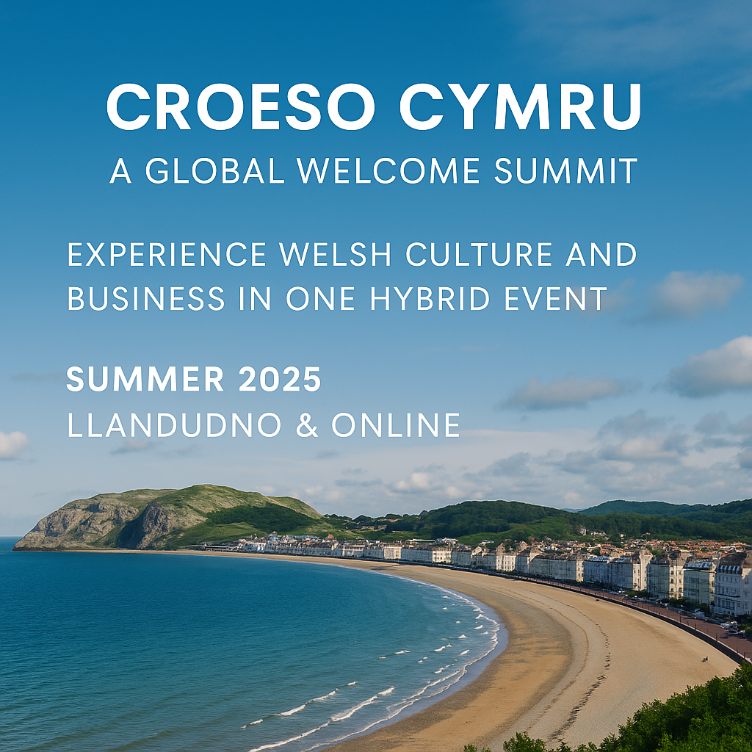
Source: Created by author using Canva (2025)

Table of Contents
- Introduction --------------------------------------------------------------------------------- 4
- The Event Cycle-----------------------------------------------------------------------------5
- 2.1 Planning Phase ------------------------------------------------------------------------5
- 2.2 Delivery Phase -------------------------------------------------------------------------6
- 2.3 Evaluation Phase----------------------------------------------------------------------6
- Event Concept ------------------------------------------------------------------------------7
- 3.1 Venue and Location ------------------------------------------------------------------7
- 3.2 Audience and Stakeholders -------------------------------------------------------7
- 3.3 Programme and Content -----------------------------------------------------------8
- 3.4 Cultural and Sustainable Integration -------------------------------------------8
- Aims and SMART Objectives ----------------------------------------------------------10
- Event Management -----------------------------------------------------------------------11
- 5.1 EMBOK Model Application -------------------------------------------------------11
- 5.2 Marketing Strategy ------------------------------------------------------------------13
- 5.3 Health & Safety and Risk Management --------------------------------------14
- Budget and Financial Planning -----------------------------------------------------16
  - Budget Overview -------------------------------------------------------------------16
  - Financial Viability--------------------------------------------------------------------16
  - Budget Justification-----------------------------------------------------------------17
- Industry Trends, Issues and Impacts ----------------------------------------------19
- Situational and Cultural Considerations (PESTEL Analysis & SWOT) --20
- Conclusion and Strategic Recommendations -----------------------------------22
- References------------------------------------------------------------------------------------23

1.Introduction
The MICE (Meetings, Incentives, Conferences, and Exhibitions) sector plays a key role in global tourism, with rising interest in sustainable, hybrid, and culturally rich experiences (Getz & Page, 2019; Allied Market Research, 2023). In alignment with Visit Wales’ Year of Croeso 2025, this report outlines the strategic planning for a proposed event: Croeso Cymru – A Global Welcome Summit.
Hosted in Llandudno, the event aims to showcase Wales as a bilingual and values-driven destination. It will blend networking, keynotes, and immersive cultural elements such as Welsh-language use, local cuisine, live performances, and sustainable practices.
Expanding on the Assignment 1 feasibility study, this report offers a structured framework based on event management theory (Bowdin et al., 2022; O’Toole, 2011), project tools (Meredith, 2022), and market data (Visit Wales, 2025). It applies the event cycle to guide planning, budgeting, marketing, risk assessment, and evaluation.
Each section contributes to recommendations that support both Welsh tourism aims and global MICE standards.

2. The Event Cycle
The strategic planning and delivery of events is guided by the event cycle model, which includes three interconnected phases: planning, delivery, and evaluation. This structure provides a clear framework for managing complex operations while maintaining alignment with stakeholder expectations (Bowdin et al., 2022). For Croeso Cymru: A Global Welcome Summit, this cycle ensured that the vision proposed in the original presentation bid evolved into a professional and actionable event strategy.
Figure 1. The Event Cycle Applied to Croeso Cymru: A Global Welcome Summit
.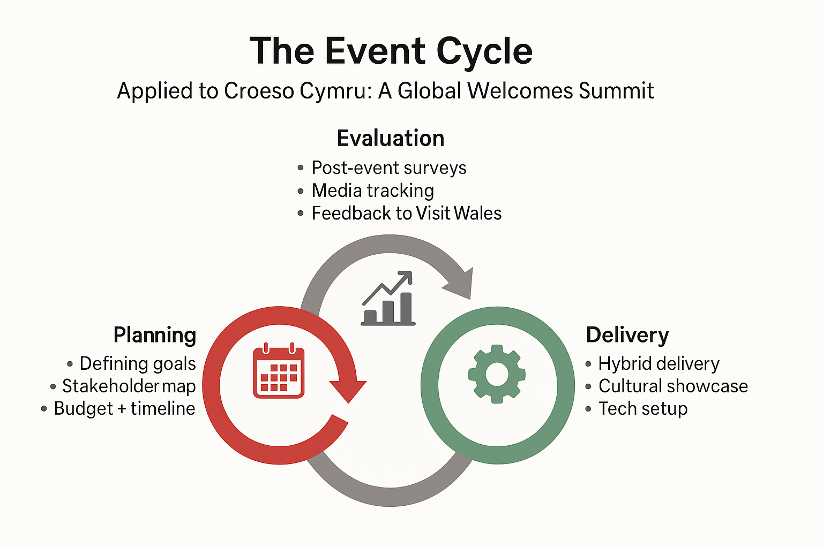
Source: Created by author using Canva (2025)
2.1 Planning Phase
This phase laid the foundation for all subsequent decisions. As proposed in Assignment 1, Venue Cymru was selected for its hybrid infrastructure and Welsh-language support. These decisions were further developed through stakeholder mapping, the creation of SMART objectives, and risk identification. Tools such as Gantt charts and work breakdown structures (WBS) were used to organise key timelines and responsibilities (Fox et al., 2014; Meredith, 2022). This structured approach ensures that the event retains fidelity to its original feasibility proposal while strengthening operational readiness.
2.2 Delivery Phase
The delivery phase translates plans into action. For Croeso Cymru, this includes a setup day and three days of hybrid programming. Delivery will be managed by a core events team and trained volunteers, with roles defined in briefing packs and delivery protocols. The live event will incorporate bilingual streaming, audience engagement tools like Slido, and a central operations hub for oversight. These delivery mechanisms reflect and enhance the original bid pitch’s focus on inclusivity, accessibility, and immersive experience.
2.3 Evaluation Phase
The evaluation phase ensures that performance is measured and insights are gathered for future events. This includes post-event surveys, media tracking, budget review, and stakeholder debriefs. KPIs will include delegate satisfaction, cultural relevance, and international media reach. A formal report will be submitted to Visit Wales, fulfilling a key recommendation from the original pitch to leave a lasting impact and support destination branding goals.

3. Event Concept
The concept for Croeso Cymru: A Global Welcome Summit was first developed in Assignment 1 as a live MICE event. It has since evolved into a hybrid format to enhance accessibility, sustainability, and international reach. While still focused on professional networking and cultural immersion, the summit now blends in-person and virtual participation. Grounded in experiential tourism and destination branding theory, it aims to deliver a strong sense of place to both local and global audiences (Getz and Page, 2019; Rogers and Davidson, 2016).
3.1 Venue and Location
The event will take place at Venue Cymru in Llandudno, North Wales — a site selected for its modern infrastructure, AV capacity, bilingual support, and proximity to cultural and natural landmarks. As noted in the initial pitch, Llandudno offers a unique blend of Victorian heritage, coastal scenery, and strong local identity. Its underutilisation in international business events presents a strategic opportunity to decentralise MICE tourism away from Cardiff and introduce delegates to an alternative, yet authentic, Welsh experience. The venue’s multiple breakout rooms, main auditorium, and exhibition areas align with the spatial and functional needs of a hybrid event.
3.2 Audience and Stakeholders
The summit targets a global audience of MICE organisers, destination management companies (DMCs), tourism boards, travel influencers, and cultural policymakers. These stakeholders were first identified in the presentation bid and have since been mapped using a stakeholder register to determine their interests, levels of involvement, and communication needs (Fox et al., 2014). Local Welsh stakeholders — including caterers, artists, and volunteers — are central to the delivery, reinforcing the event’s commitment to regional economic impact and cultural authenticity.

Figure 2. Stakeholder Mapping Using the Power/Interest Grid
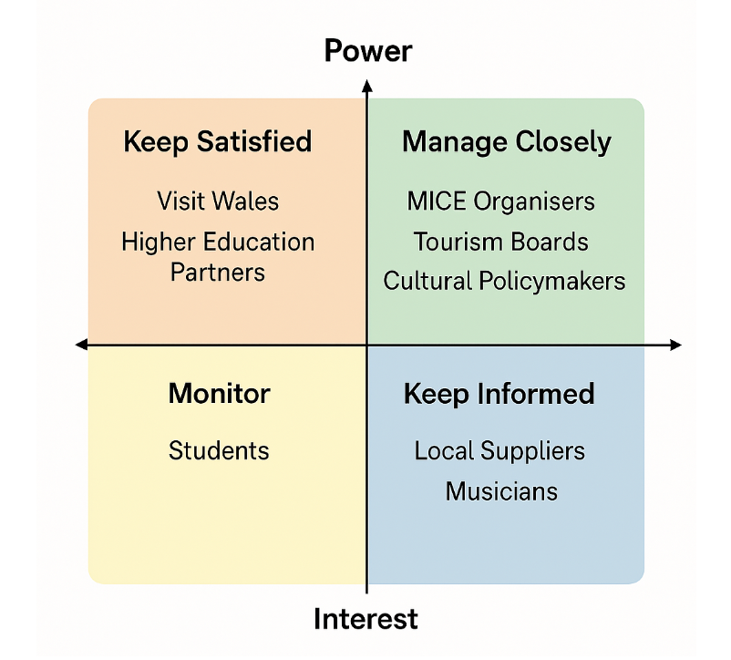
Source: Created by author using Canva (2025)
3.3 Programme and Content
The programme will feature keynote speeches, panel discussions, practical workshops, and cultural showcases. Core themes include sustainable destination marketing, bilingual event delivery, and inclusive MICE strategy. Cultural integration will be embedded throughout via Welsh-English content, live performances, storytelling, and regional cuisine. These elements, first outlined in Assignment 1, have been developed into a structured content plan aligned with the EMBOK design and marketing domains (see Section 5).
3.4 Cultural and Sustainable Integration
A defining feature of Croeso Cymru is its integration of Welsh identity and sustainability. Aligned with the “Year of Croeso 2025” campaign, the event will highlight local language, music, cuisine, and symbolism through bilingual signage, regional catering (Blas ar Fwyd), and performances by Welsh artists. In line with GRI sustainability standards, environmental impact will be reduced via digital resources, local sourcing, public transport promotion, and waste minimisation (GRI, 2025; Welsh Government, 2024). These cultural and ethical commitments form a key part of the summit’s value proposition and reflect best practice in both theory and industry
Figure 3. Cultural Integration Themes for Croeso Cymru
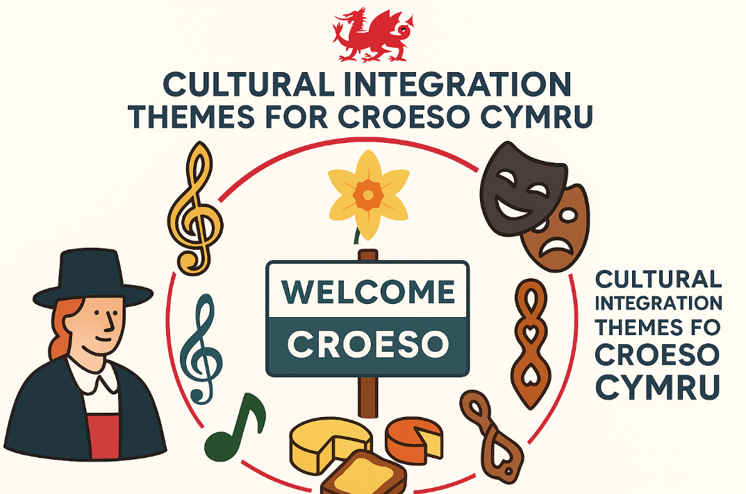
Source: Created by author using Canva (2025)

4. Aims and SMART Objectives
Successful international event planning begins with a clear aim supported by specific, measurable goals. Using the SMART framework (Doran, 1981), Croeso Cymru: A Global Welcome Summit seeks to position Wales as a distinctive, sustainable, and bilingual destination for global MICE events, generating economic and cultural value for the region.
The main aim is to raise Wales’ profile by delivering an immersive, place-based conference that highlights its unique culture — aligning with the Year of Croeso 2025 and trends in destination-led event design (Getz and Page, 2019).
To achieve this, the summit has three SMART objectives:
- Attract at least 150 international delegates from 10+ countries, supported by partnerships with Visit Wales and MICE networks.
- Showcase 15 local Welsh suppliers or performers, promoting economic benefit and cultural visibility.
- Achieve an 80% delegate satisfaction rate via post-event surveys focused on content quality, cultural relevance, and organisation (Allen et al., 2021).
These targets guide planning, stakeholder engagement, and evaluation, ensuring strategic alignment and operational impact (Bowdin et al., 2022).
Figure 4: SMART Objectives Table
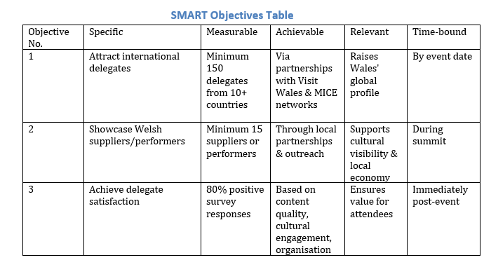
5. Event Management
Effective event management combines structured planning with practical execution. This section outlines how key frameworks guided the coordination of marketing, logistics, and safety for the summit.
5.1 EMBOK Model Application
The planning and delivery of Croeso Cymru: A Global Welcome Summit have been structured using the Event Management Body of Knowledge (EMBOK), a widely recognised framework with five domains: Administration, Design, Marketing, Operations, and Risk (Silvers et al., 2013). EMBOK was used to translate the feasibility concepts from Assignment 1 into an operational plan for a culturally specific, hybrid MICE event.
Figure 4: MBOK Framework Applied to Croeso Cymru
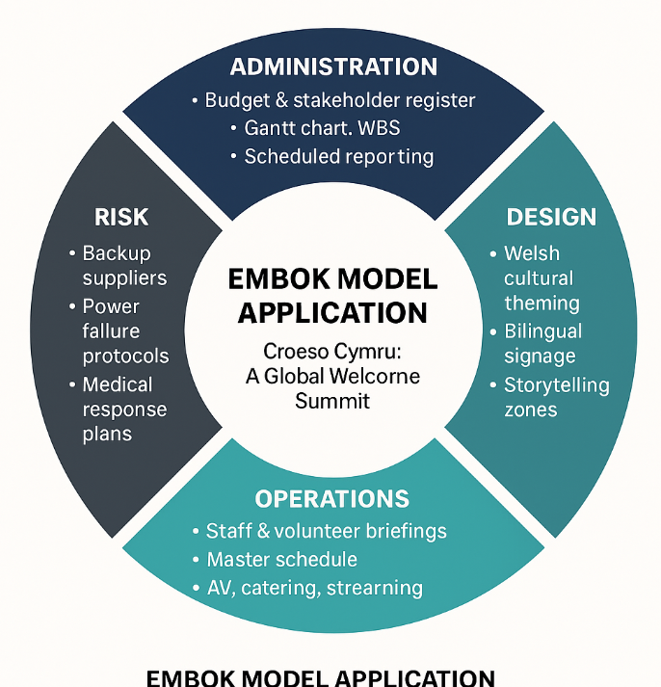
Source: Created by author using Canva (2025)
In the Administration domain, the team developed a stakeholder register and detailed budget, with a Gantt chart and WBS to manage timelines and task dependencies. Coordination was scheduled in phases, particularly with Visit Wales, supported by post-event reporting structures.
The Design domain shaped cultural theming and atmosphere. Features include bilingual signage, storytelling areas, and regional motifs, designed to evoke national identity and align with “Year of Croeso” values (Rogers and Davidson, 2016).
Marketing informed targeted outreach, aligning content with MICE audiences via Visit Wales and relevant platforms. Hybrid access is embedded across channels to engage international delegates.
Under Operations, trained volunteers and staff will deliver the event following structured schedules, briefing packs, and live coordination through an operations hub managing AV, catering, and transitions.
Risk planning includes contingency suppliers, power backup, medical protocols, and role-based risk ownership. The EMBOK model thus provided a practical and strategic foundation, supporting theory-into-practice integration consistent with module teaching and Bladen et al. (2012).
Figure 6: Gantt Chart – Project Timeline for Croeso Cymru
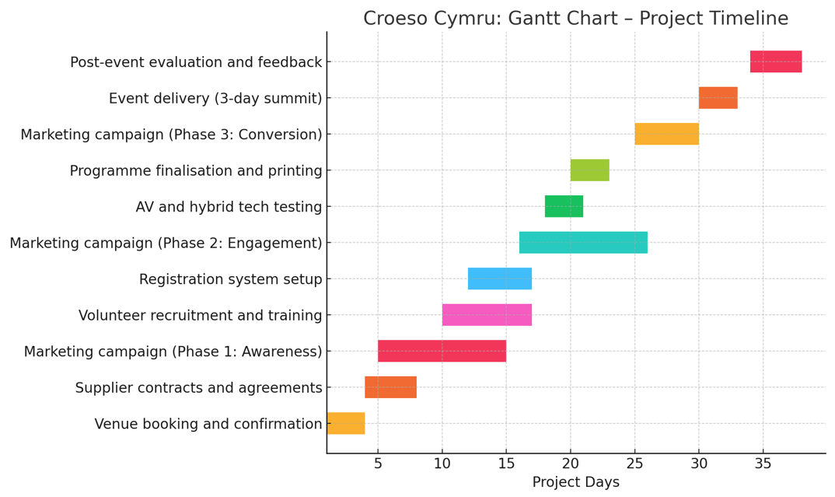
Source: Created by author using Canva (2025)
5.2 Marketing Strategy
The marketing approach for Croeso Cymru: A Global Welcome Summit aims to appeal to both domestic and international delegates by blending cultural depth, professional value, and accessible communication. It draws on the 7Ps of Marketing (Booms and Bitner, 1981), with each element tailored to the delegate experience described in Assignment 1.
The product is a bilingual, hybrid-format summit that combines business networking with cultural engagement. The place is Venue Cymru — a modern coastal venue with strong infrastructure — supported by an online platform for virtual access. The price is tiered, offering flexible options for students, public institutions, and corporate delegates, balancing inclusivity with financial sustainability. Promotion will be carried out via Visit Wales’ tourism channels, MICE-specific platforms like C&IT and LinkedIn, and targeted outreach to associations and academic partners. The people involved include bilingual hosts, cultural performers, and expert speakers. The process is streamlined through digital registration, QR-based check-ins, and virtual helpdesks. Finally, physical evidence includes branded materials, digital assets, and venue décor that celebrate Welsh identity.
To deepen emotional engagement, the strategy reflects Maslow’s Hierarchy of Needs (1943). Delegate safety is supported through clear logistics and on-site protocols; belonging is fostered through inclusive, culturally resonant programming; and esteem and self-actualisation are encouraged through networking, workshops, and professional development opportunities.
The audience segmentation from Assignment 1 shaped distinct messaging for MICE organisers, education stakeholders, and cultural policymakers. Ultimately, the goal is not only to drive attendance but to build lasting visibility for Wales as an inclusive, innovative, and culturally vibrant MICE destination

Figure 7: 7Ps of Marketing
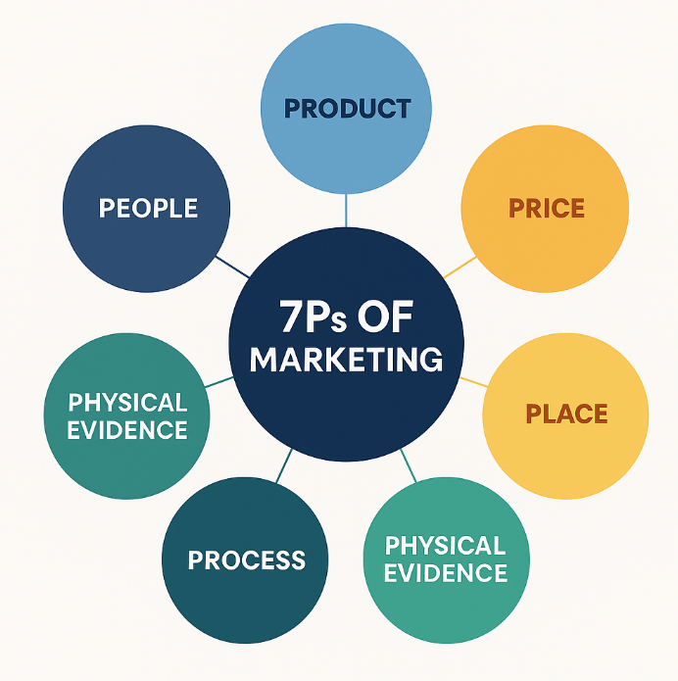
Source: Created by author using Canva (2025)
5.3 Health & Safety and Risk Management
A comprehensive risk and health & safety strategy is essential for the successful delivery of Croeso Cymru: A Global Welcome Summit, especially given its hybrid format and international reach. Drawing on guidance from Bladen et al. (2012), the event team developed a structured risk register to identify and mitigate potential hazards across physical and digital environments.

Informed by the Assignment 1 feasibility assessment, the team identified key risks: operational (e.g. supplier no-shows, venue access delays), technical (e.g. connectivity failure, platform disruption), and environmental (e.g. severe weather affecting transport to Llandudno). Health and safety risks are also addressed through a detailed site-specific assessment covering crowd movement, fire safety, medical response, and food hygiene.
A formal risk matrix was created to assess likelihood and severity. Responsibilities were assigned via the event staffing plan, and a contingency strategy includes backup suppliers and AV redundancy. All staff and volunteers will receive pre-event safety briefings, with emergency protocols printed in bilingual form at registration and briefing points.
Compliance with UK event safety standards and Venue Cymru’s protocols will be ensured through coordination with local authorities and venue staff. Accessibility is also embedded into the safety plan, with designated viewing areas, closed captioning, and bilingual signage. These measures reflect best practice and align with the ethical and legal responsibilities covered in Week 5 content and Bladen et al.’s framework (2012).
Integrating these procedures ensures operational resilience and builds delegate confidence, supporting the summit’s reputation as a professionally managed MICE event.
Figure 8: Risk Matrix Visual
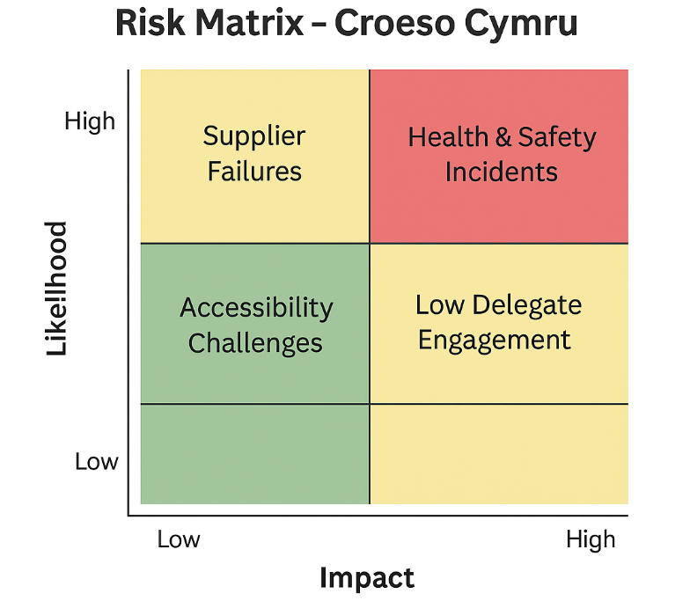
Source: Created by author using Canva (2025)
6. Budget and Financial Planning
Effective financial planning is central to successful delivery, ensuring resources are well-managed and risks accounted for. The proposed budget reflects the needs of a three-day hybrid MICE event, balancing cultural ambition with financial realism (Allen et al., 2021). Based on 150 in-person and 100 virtual delegates, the hybrid model improves accessibility and reduces environmental impact, aligning with post-pandemic expectations (Getz and Page, 2019). Though adjusted from the original 250 in-person projection in Assignment 1, this format extends reach while maintaining cost-efficiency and engagement.
6.1 Budget Overview
Figure 9: Breakdown of projected expenditure and income for the summit

6.2 Financial Viability
A modest £1,250 surplus reflects careful budgeting and provision for contingencies such as extended AV support, speaker travel issues, or extra volunteer costs. As a not-for-profit initiative, success is measured through cultural impact, stakeholder satisfaction, and destination visibility rather than profit.
This surplus is lower than the £3,000 initially projected in Assignment 1 due to the shift to a hybrid format. Increased digital infrastructure costs and fewer in-person delegates reduced income, but the model remains strategically sound and financially sustainable, broadening reach without compromising quality.
6.3 Budget Justification
The budget is based on verified supplier rates and industry benchmarks to ensure transparency and proportionality. Venue hire totals £6,000 for three days, based on Venue Cymru’s published rates (£1,500–£2,000/day) (Venue Cymru, 2025).
Catering is estimated at £5,500 for 150 delegates, in line with Blas ar Fwyd’s pricing (£35–£40 per head) for traditional Welsh menus (Blas ar Fwyd, 2024).
AV and streaming are budgeted between £2,000–£4,000, based on quotes from hybrid event providers such as Sounds Commercial and Spaces at The Spine (Sounds Commercial, 2020; Spaces at The Spine, 2024).
Marketing is allocated £2,500 to cover digital promotion, email outreach, and content creation (Arramton, 2025).
Volunteer support, signage, and logistics are classed as moderate and reflect typical costs for public and higher education sector events (GOV.UK, 2025; PinToMind, 2025).
This approach keeps the budget both realistic and aligned with the summit’s strategic goals.

Figure 9: Budget Justification
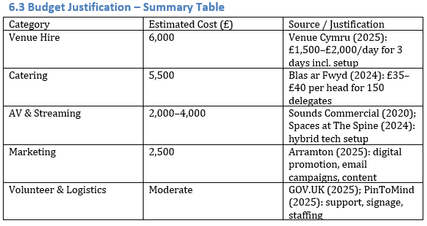

7. Industry Trends, Issues and Impacts
The events industry is evolving rapidly, driven by shifting delegate expectations, technological innovation, and environmental priorities. These changes have directly shaped the strategic planning of Croeso Cymru: A Global Welcome Summit.
A major trend is the rise of hybrid events, blending in-person and virtual participation. This format is now standard, offering improved accessibility, lower travel emissions, and more inclusive delegate engagement (Zoom, 2025; Eventify, 2025). It also supports flexible budgeting and broader international reach.
Delegates increasingly value culturally rich and authentic experiences over formality (Rogers and Davidson, 2016). Croeso Cymru responds by incorporating Welsh identity through language, cuisine, music, and storytelling.
Sustainability has become a core expectation. Stakeholders now demand clear environmental commitments, such as waste reduction, local sourcing, and energy efficiency. Using frameworks like the Global Reporting Initiative (GRI) helps embed transparent, measurable practices (GRI, 2025), while digital tools like e-programmes reduce the event's carbon footprint (Fielddrive, 2025).
Finally, economic uncertainty and travel unpredictability require resilient planning. Flexible formats, scalable delivery models, and reliable supplier partnerships are increasingly essential (Forbes, 2024; Cvent, 2025).
In summary, successful events demand adaptability, cultural depth, digital fluency, and sustainability — all embedded in Croeso Cymru.

8. Situational and Cultural Considerations (PESTEL Analysis & SWOT)
Understanding the external environment is essential for planning Croeso Cymru: A Global Welcome Summit. A PESTEL analysis evaluates political, economic, social, technological, environmental, and legal factors shaping the event (Bowdin et al., 2022).
Political
The summit supports the Welsh Government’s Welcome to Wales strategy, promoting sustainable tourism and cultural inclusion. Backing from Visit Wales enhances legitimacy, though post-Brexit visa policies may affect international attendance (Welsh Government, 2020).
Economic
Rising inflation and supplier costs impact AV, catering, and logistics. However, the hybrid format improves cost-efficiency by reducing venue-related expenses and enabling broader participation.
Social
A bilingual, culturally immersive format aligns with growing demand for inclusive and authentic delegate experiences. Welsh language, cuisine, and storytelling encourage deeper engagement (Getz and Page, 2019).
Technological
Hybrid delivery depends on robust AV and internet. Venue Cymru is equipped for this, while QR-based schedules and mobile check-in enhance access and efficiency.
Environmental
The event prioritises sustainability through local sourcing, minimal print use, and low-emission transport options. Adherence to UK Sustainability Reporting Standards reinforces environmental credibility (UK Government, 2024).
Legal
Compliance with the Data Protection Act 2018 and health & safety legislation will be ensured via Venue Cymru’s protocols and coordination with local authorities.
SWOT Summary
To complement the PESTEL, a SWOT framework offers a strategic snapshot of internal strengths and weaknesses alongside external opportunities and threats:
Figure 10: SWOT Analysis

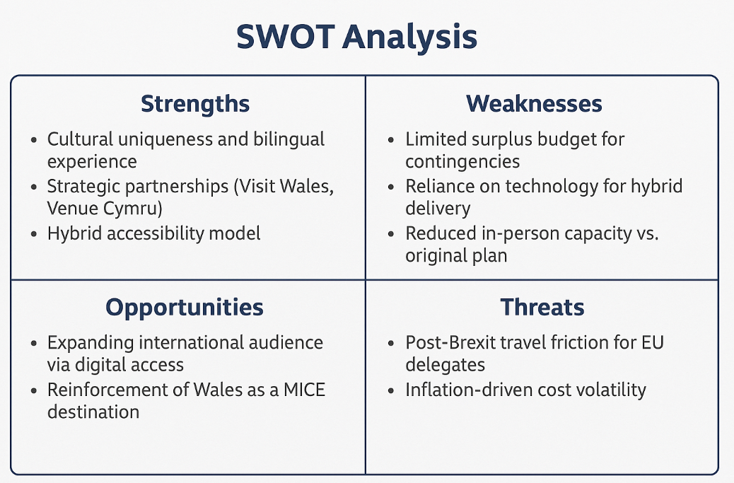
Source: Created by author using Canva (2025)
This combined approach ensures strategic decisions remain responsive to both macro and micro-environmental dynamics.

9. Conclusion and Strategic Recommendations
This report has presented a strategic feasibility plan for Croeso Cymru: A Global Welcome Summit, an international MICE event aligned with the Welsh Government’s Year of Croeso 2025 initiative. Designed as a hybrid, bilingual summit with a strong cultural narrative, the event reflects current trends in inclusive, sustainable, and experience-led business tourism.
Key planning decisions were shaped by frameworks such as EMBOK, the 7Ps of Marketing, and a PESTEL analysis of the wider environment. These tools supported informed choices around budget structure, delivery model, risk mitigation, and stakeholder coordination. The proposed summit is well positioned to raise Wales’ global profile, attract diverse delegates, and deliver economic and reputational benefits.
To maximise impact, several strategic actions are recommended. First, strengthen hybrid and bilingual delivery by partnering with experienced providers and training staff in inclusive communication. Second, improve accessibility by consulting underrepresented groups, offering bursaries, and ensuring fully accessible materials and signage. Finally, embed long-term legacy planning through KPIs and post-event reporting aligned with stakeholder priorities.
Together, these steps will enhance the summit’s effectiveness, inclusivity, and long-term value for the Welsh tourism and MICE sectors.

10. References
- Akinsowon, V. (2025) The Biggest Event Trends for 2024. Cvent. Available at: https://www.cvent.com/en/blog/events/event-trends#step4 (Accessed: 13 June 2025).
- Allen, J., O'Toole, W., McDonnell, I. and Harris, R. (2021) Festival and Special Event Management. 7th ed. Milton: Wiley.
- Allied Market Research (2023) Events Industry Market Outlook 2022–2031 [online]. Available at: https://www.alliedmarketresearch.com/events-industry-market (Accessed: 18 May 2025).
- American Express Global Business Travel (2024) Event Marketing Trends Report 2024. Available at: https://experience.amexglobalbusinesstravel.com/event-marketing-trends/2024/ (Accessed: 24 May 2025).
- Austin, A. (2023) What is the Event Life Cycle?. Eventbrite. Available at: https://www.eventbrite.co.uk/blog/event-life-cycle-ds00 (Accessed: 12 June 2025).
- Bladen, C., Kennell, J., Abson, E. and Wilde, N. (2012) Events Management: An Introduction. Abingdon: Routledge.
- Blas ar Fwyd (2024) Bespoke Catering Services. Available at: https://www.blasarfwyd.com/bespoke-catering (Accessed: 24 May 2025).
- Booms, B.H. and Bitner, M.J., 1981. Marketing strategies and organization structures for service firms. In: Donnelly, J.H. and George, W.R., eds. Marketing of services. Chicago: American Marketing Association, pp.47–51.
- Cadmium & PCMA (2022) Driving Event Success with Integrated Technology [PDF]. Available at: https://www.pcma.org/wp-content/uploads/2022/08/Cadmium_SB_Webinar-Slides_20220811.pdf (Accessed: 13 June 2025).
- Cvent (2025) 9 Event Trends Shaping 2025. Available at: https://www.cvent.com/en/blog/events/event-trends (Accessed: 25 May 2025).
- Doran, G.T. (1981) ‘There’s a S.M.A.R.T. way to write management’s goals and objectives’, Management Review, 70(11), pp. 35–36.
- Encore Global (2025) Hybrid & Virtual Events. Available at: https://www.encoreglobal.com/what-we-do/event-types/hybrid-virtual/ (Accessed: 25 May 2025).
- Eventbrite (2018) Beautiful Event Design: 10 Inspiring Examples. Available at: https://www.eventbrite.com/blog/beautiful-event-design-ds00 (Accessed: 10 June 2025)
- Eventify (2025) 15 Key Event Trends Shaping the Industry in 2025. Available at: https://www.eventify.io/blog/event-trends (Accessed: 26 May 2025).
- Eventify (2025) What is a Hybrid Event?. Available at: https://eventify.io/blog/what-is-a-hybrid-event (Accessed: 25 May 2025).
- Fielddrive (2025) How to Host Sustainable Events in 2025. Available at: https://www.fielddrive.com/blog/how-to-host-sustainable-events-in-2025 (Accessed: 25 May 2025).
- Forbes (2024) How to Perform Effective Risk Management During Event Planning. Available at: https://www.forbes.com/councils/forbesbusinesscouncil/2024/04/22/how-to-perform-effective-risk-management-during-event-planning/ (Accessed: 26 May 2025).
- Forbes (2024) Meetings And Events Industry: Looking Good In 2025. Available at: https://www.forbes.com/sites/rogerdooley/2024/11/15/meetings-and-events-industry-looking-good-in-2025/ (Accessed: 26 May 2025).
- Fox, D., Lynch, P. and Duignan, M. (2014) Doing Events Research: From Theory to Practice. London: Routledge.
- Getz, D. and Page, S. (2019) Event Studies: Theory, Research and Policy for Planned Events. 3rd ed. Abingdon: Routledge.
- Global Reporting Initiative (GRI) (2025) GRI Standards. Available at: https://www.globalreporting.org/standards/ (Accessed: 26 May 2025).
- Global Reporting Initiative (GRI) (2025) Sustainability Reporting Standards. Available at: https://www.globalreporting.org (Accessed: 27 May 2025).
- London Filmed (2023) How Much Does a Hybrid Event Cost?. Available at: https://londonfilmed.com/insights/how-much-does-a-hybrid-event-cost/ (Accessed: 25 May 2025).
- Maslow, A.H., 1943. A theory of human motivation. Psychological Review, 50(4), pp.370–396.
- Meredith, J. (2022) Project Management in Practice. 6th ed. Hoboken: Wiley.
- O’Toole, W. (2011) Events Feasibility and Development: From Strategy to Operations. Oxford: Elsevier.
- Rogers, T. and Davidson, R. (2016) Marketing Destinations and Venues for Conferences, Conventions and Business Events. 2nd ed. Abingdon: Routledge.
- Silvers, J.R. (2012) ‘The EMBOK Framework’, in Bowdin, G.A.J., Allen, J., O'Toole, W., Harris, R. and McDonnell, I. (eds.) Events Management. 3rd edn. Abingdon: Routledge, pp. 305–309.
- Venue Cymru (2025) Organise an Event. Available at: https://www.venuecymru.co.uk/organise-event (Accessed: 25 May 2025).
- Venue Cymru (2025) Our Spaces. Available at: https://www.venuecymru.co.uk/our-rooms-content (Accessed: 25 May 2025).
- Visit Wales (2025) Year of Croeso Campaign Toolkit. Available at: https://traveltrade.visitwales.com/useful-information/toolkit/year-of-croeso (Accessed: 25 May 2025).
- Welsh Government (2020) Welcome to Wales: Priorities for the Visitor Economy 2020 to 2025. Available at: https://businesswales.gov.wales/tourism/welcome-wales-priorities-visitor-economy-2020-2025 (Accessed: 26 May 2025).
- Zoom (2025) Zoom’s Guide to Hosting Hybrid Events. Available at: https://www.zoom.com/en/products/event-platform/resources/hosting-hybrid-events/ (Accessed: 27 May 2025).

