

Human Resource Management Assessment 1

Name: Alison Faucher
Student ID: 2236800
Module: Human Resource Management
Code: CMB7000
Lecturer: Gladius Kulothungan-GP3/Mushfiqur Rahman-GP1

Table of Contents
1. Introduction 3
1.1. Rationale 3
1.2. What is the Labour Market 3
1.3. Labour Market in Developing, or Low-Income Countries 4
1.4. Labour Market in Developed, or High-Income Countries 5
1.5. UK Labour Market 6
2. Human Ressources Changes Post Brexit 7
2.1. Resources/Policy Changes 7
2.2. Strategies 8
3. Human Ressources Changes Post COVID-19 9
3.1. HR Resource Changes 9
3.2. HR Policy Changes 9
3.2 HR Strategies 10
4. PESTLE Analysis 11
4.1. Political 12
4.2. Economic 12
4.3. Social 12
4.4. Technical 12
4.5. Legal 12
4.6. Environmental 12
5. Conclusion 13
6. References 14

Introduction

Rationale
This report will detail the current state of the labour market in the UK and how the effects of Brexit and Covid-19 affected changes to the strategies employed within the Human Resource Department . We will also examine both the internal and external forces that contributed to an environmental change that left both a permanent and temporary impact on the Human Resource strategies that were universally employed.

What is the Labour Market
The labour market, also known as a job market, is the definition of the employers’ demand, want and need for employees to fulfil the supply, want and need to produce a product, or service for its customers’ want and needs. (Kenton, 2022). It is therefore imperative that there is an almost symbiotic relationship between supply and demand with employers and employees. If there is a breakdown in this formed relationship that is not easily averted and controlled, there will be a negative effect seen in the labour market as a whole. The reverse is also true, when there is an increase produced form the relationship, it is evident in the labour market with visible effects observed with an increase in job creation and economic growth.

New World Bank country classifications by income level: 2022-2023 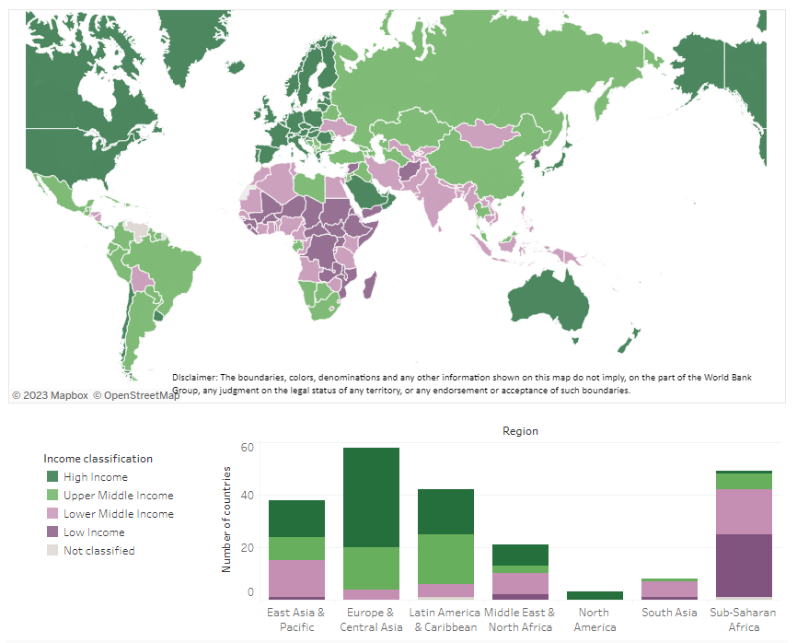
(World Bank, 2021)

Labour Market in Developing, or Low-Income Countries
The economic stability of any country is dependent on the labour market, with the customer and business being important factors. With the recording of the decline in the poverty level in lower-income countries, the corresponding labour markets have grown with an increase in job creation. The increase of jobs must be met with the relevant and suitable employees, else growth in unemployment will also be a key factor in changes to the economy and labour market.

China and India have seen a rise in their economic growth and labour markets while other countries in Sub-Saharan Africa are predicted to see economic growth, although not to the same scale as India and China, in the coming years. (Lam and Elsayed, 2021)

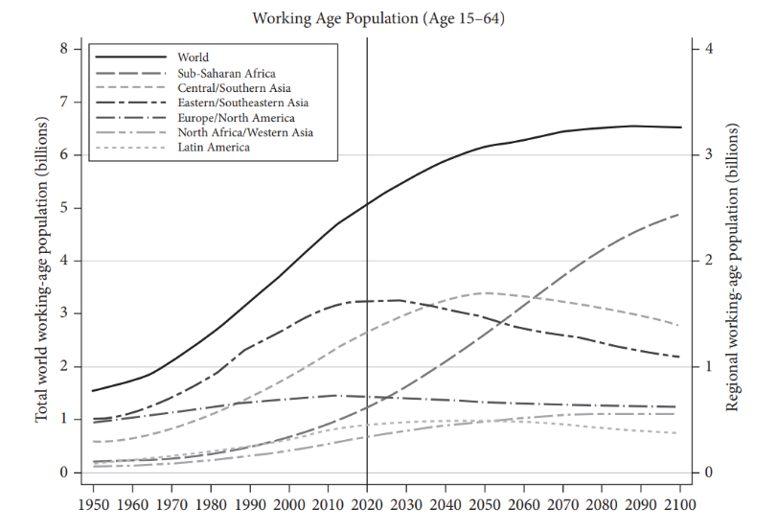

(Lam and Elsayed, 2021)

The global economic and labour markets declined with the effects of Covid-19, although the pre-pandemic levels have become attainable in its aftermath, they are not at the levels forecasted prior to the global outbreak, although they have seen a relative rise from the 2020 Covid-19 levels.

Labour Market in Developed, or High-Income Countries
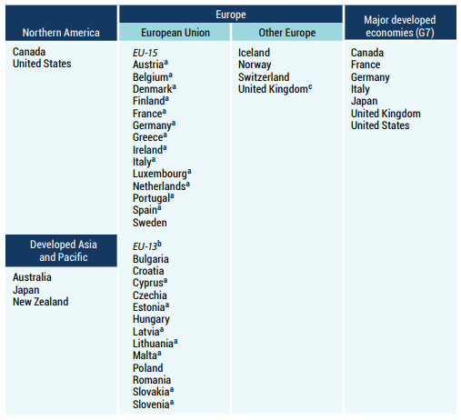

(United Nations, un.org)
The "Great Resignation" developed when there was a dramatic global shift to remote working due to forced governmental lockdowns. This affected countries globally with high numbers of people resigning from their jobs, due to dissatisfaction with their employment, especially when the lockdowns’ restrictions were lifted and many were refused the option of remote or flexible working, such as hybrid working.
The UK’s Labour Force Survey in November 2021, illustrated that of the 1.02 million people who changed their employment between July and September 2021, 391,000 of them had resigned. This was the largest sudden jump in its records. (CABLE and GRATTON, 2022)
The Great Resignation, although felt globally, had more of an impact in the wealthier developed countries in Europe, North America and other continents, as many within the labour market resigned their jobs as they chose to re-evaluate their work-life balance. (Bloomberg 2021)
The economic and labour markets have declined with the effects of Covid-19, but many are seeing their growth surpassing pre-pandemic levels, although some are now declining to 2018 levels.

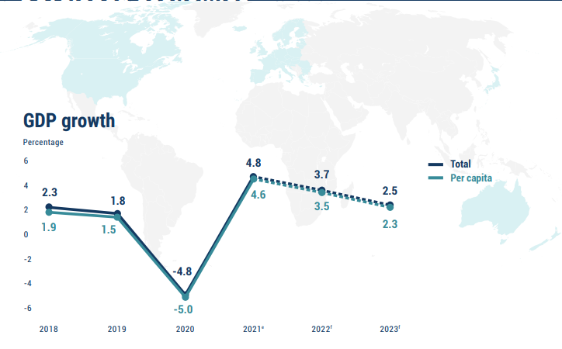

(United Nations, un.org)

(BBC, 2023)

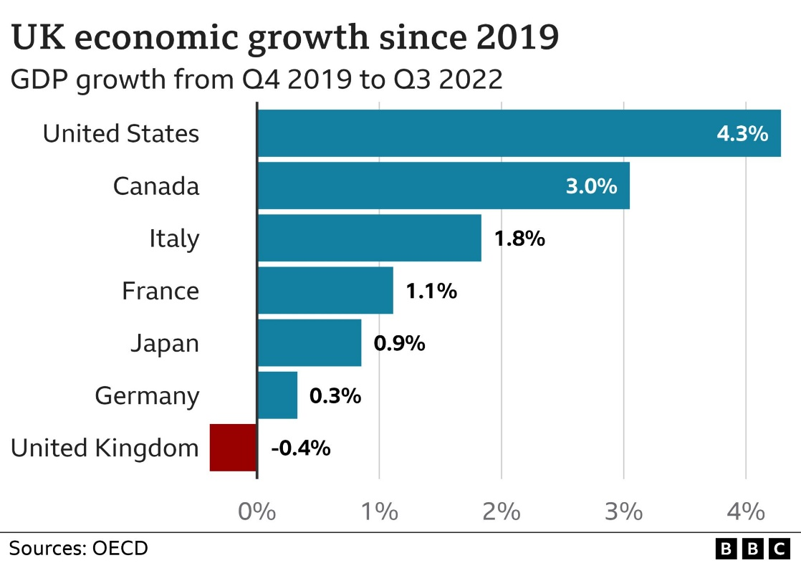
UK Labour Market
In recent years, the labour market in the UK has been largely affected by BREXIT and more recently the COVID-19 global pandemic. The impact these have placed on the UK has had a direct result on the levels of vacancies, employment and unemployment.
A rise in part-time and self-employed workers drove the employment rate up in the period December 2022 to February 2023 by an estimated 0.2% to 75.8%, a rise from the previous 3-month period. (Leaker, 2023)

Current State
2023 has seen headlines generated from multiple organisation sectors disheartened at the level of pay it receives, and have organised themselves to battle their various governing bodies for a pay increase, resulting in national strikes from within the NHS, Education and Transport sectors. Although there is still a recruitment struggle to fill available vacancies, pay awards, despite expecting to reach 5%, are falling below inflation. (Cockett, 2023) There is an actual fall in the received amount of pay, as the rate that pay has decreased against the rate of inflation with a total pay decrease of 3.1% compared to the previous year. (McIntyre, 2023)
Brexit
The UK exited the European Union in 2021, affecting companies with new trade rules compliances on imports and exports and migrant workers. The resulting decline in trade recovered, but it’s argued that the levels would have been higher had Brexit not happened. The majority of companies surveyed by the British Chambers of Commerce, stated that they were still struggling with the new system and some have stopped exports.

Brexit brought the end of free movement between the UK and the EU countries, with an exit of workers in the labour force that the UK found difficult to address. The lack of lorry drivers to deliver essential and non-essential goods saw the UK shelves poorly stocked, reminiscent of the Covid-19 levels, although not to the same scale. The points-based immigration system has garnered complaints from many quarters, while the shortage of employees has caused deficiencies and increased the prices for customers. (David, 2023)

Covid-19
With workers less likely to stay in their current position where they didn’t feel valued, but resign and or transfer to a position that has better work culture, pay and work-life balance, some experts state that the individuals are not gaining the full benefits from their positions, or garnering acceptable references which can contribute to inhibiting their careers
This could affect women and other minority sections of the labour force already side-lined and potentially disregarded for promotions, as they historically face difficulties attaining suitable positions and pay, with them achieving lower retention rates. The ability to traverse the job pool is reduced and highlighted, because of the great resignation situation.
The range of reasons given for turnover resignations include work-life balance, better pay, more responsibility, change in career, and job satisfaction, with many stating that the work culture and employers’ harsh or dismissive treatment of their employees being a major contributing reasons behind the motivational choices made to leave are all justified, but the long term goals may be affected with the decisions made.
The workers that decided to stay at their current position and not join the flow of employment migration, felt that, for the most part, their work culture and employer and colleague treatment towards them was positive and supportive. The companies that had a more supportive work culture prior to the Covid-19 effects, witnessed a less dramatic contribution to the “Great Resignation” while those unsupportive companies, that were less driven by employee satisfaction, felt the high turnover effects to a much higher degree, as they tended to increase their non-supportive cultural approach. This added to compelling an already unhappy workforce, that were not culled, to look for a better jobs and resign. (Morgan, 2023)

Human Resources Changes Post Brexit

Resources/Policy Changes
The main effect of Brexit on Human Resources is the reduction of the workforce, as it was expected that some of the European Union (EU) nationals would return to their homes, but the scale witnessed was far in excess of the expected amount. This was compounded by the rising cost of living, especially in the urban areas. The government did grant European Union (EU) nationals an extension to apply for their right to work and those that are willing to continue to reside in the UK and had lived in the UK for at least 5 years, the right to apply for permanent residency, but their employers needed to receive these application before 31st December 2020. Those EU nationals that did not wish to apply, or were unable to apply, were given an additional 6 months grace before they were expected to leave the UK. (Tim Kellett, 2020)
The impact that was felt throughout the haulage industry from Brexit was immense. Petrol and food were among the products unable to be delivered due to the unforeseen level of downturn in staffing levels in the haulage industry. This left petrol stations unable to serve their customers causing massive queues at petrol stations as drivers hunted for a petrol station to fuel their vehicles, only to be met by huge queues that often blocked roads impeding the flow of traffic. Perishable and non-perishable goods were also unable to be delivered, leaving empty shelves and empty shopping carts.
The UK government decided to introduce a scheme where 5,00 temporary visas were available for EU truck drivers to thwart the problems a lack of drivers in the haulage industry would create with the runup to Christmas. Unfortunately, many of the departed drivers were resigned to not participate in the UK government’s offer, as they did not feel welcome by the UK and didn’t want to aid in resolving the problem caused by the UK government’s implementation of BREXIT.
The UK haulage industry was at one point, affected by approximately 100,000 trucks less than needed, as thousands of (EU) workers left the UK and returned to the EU. It was estimated that as many as 20,000 truck drivers left the UK and did not return, and allowed for the high demand for licenced truck drivers increase, and left truck drivers in the driving seat with their demand for a pay increase (Smith, 2021).
Brexit directly impacted the pay strategies of the Human Resources departments, as changes to the retention were redesigned from the Governmental Transport Department to independent companies’ Hr department to reduce the turnover rate.

Strategies
In September 2021, Transport Secretary Grant Shapps announced that the UK government was to implement changes in the HGV licencing, in order to relieve the haulage driver crisis.
He stated that the government’s new policy changes would ease the crisis in the haulage industry and the effects that it created by pledging to provide:
- Up to 4,000 people to be trained as new HGV drivers
- Support more people to launch careers within the logistics sector
- Use MOD examiners to help increase immediate HGV testing
    - thousands over the following 12 weeks

- Nearly 1 million letters to be sent to all drivers who held an HGV driving licence.
    - Incentives offered to encourage them back into the industry.
- 5,000 HGV drivers and 5,500 poultry workers added to the existing visa scheme
    - Available until Christmas 2021 due to exceptional circumstances
(gov. uk, 2022) (Department for Transport, 2021)

Human Ressources Changes Post COVID-19

HR Resource Changes
The main effect of Brexit on Human Resources is the reduction of the workforce, as it was expected The changes due to the COVID-19 global pandemic on companies forced the Human Resource department’s staffing strategies to be rethought and reshaped to be more staff-centred. Managers were seen as the driving force behind empowering the necessary changes, as layoffs, resignations and furloughs dominated companies’ Human Resource departments.
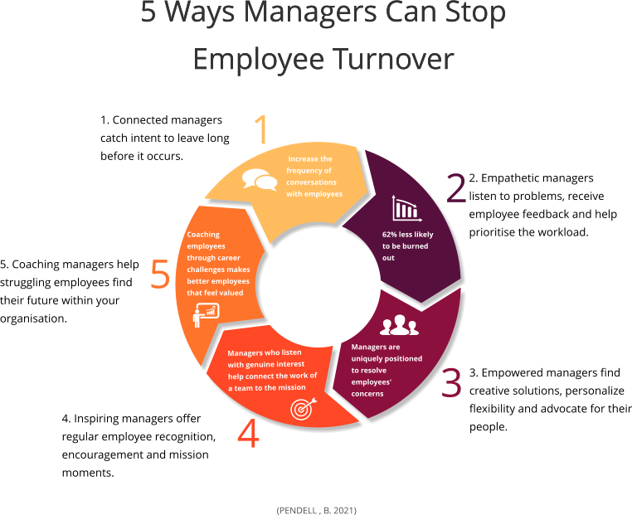

HR Policy Changes
In the UK, managers were encouraged to engage with the Human Resource leaders to create and implement new and updated policies that evolved around the areas that staff were relaying to management and Human Resource departments, which were the key factors in increasing their considering staying, or resigning from their positions. These include work culture, home-life balance, training, upward and sideways mobility, and flexible ways of working.
These key internal and external factors that influence employees’ behaviours at work, affect the company’s turnover at the organisational-level.
(Shipton, Whysall and Abe, 2021)
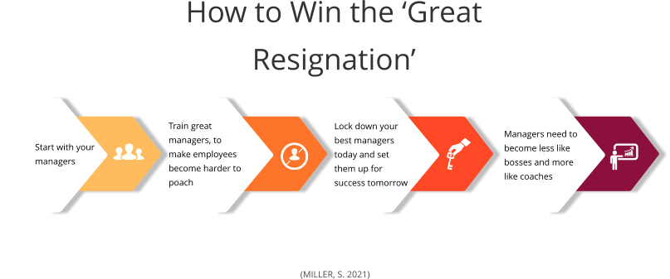

These factors can assist in creating policies and strategies to redress the ‘Great Resignation’

HR Strategies
Popular Human Resource strategies, that have changed how many companies workforce deliver their day-to-day work, have evolved due to the unique affects of the government-implemented lockdown rules, due to the COVID-19 global pandemic national presence. These have become popular and have allowed employees to feel valued and understood while being more productive. Companies that have been rigided and unwilling to use the employment of the following strategies, tend to foster a more strict working environment that is less employee-centred and more result centred.

Employee Retention Practices and Strategies
- Be flexible
- flexible working hours
- Remote working
- Hybrid working

- Treat people fairly
      - Adhere to Psychological Contracts
      - Listen to complaints and act fairly and accordingly
      - Don’t dismiss people’s feelings
- Pay attention to employee well-being
- Assign support managers to individual staff members
- Encourage communication
- Encourage training and mobility
- Enable career development and progression
    - Allow employees to develop skills and careers
    - Create training days, and, or sessions
    - Allow upward and sideways mobility
(Employee Turnover & Retention, 2021)

PESTLE Analysis
Frank Aguilar, was a Harvard Business School professor, released his book Scanning the Business Environment in 1967, which analysed external factors that can affect organisations, known as ETPS. The anacronym ETPS stood for Economic, Technical, Political and Social. ETPS evolved to be better known as Pestle, Political, Economic, Social, Technological, Legal and Environmental, is a procedure that examines the external factors that effect on a company, or organisation that can influence strategic decisions made by management. (Frue, 2017)
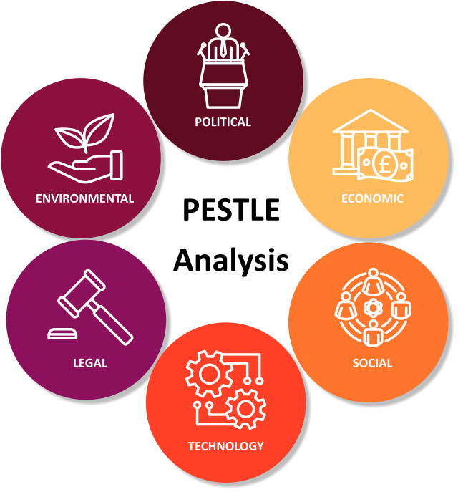

(Faucher. A, 2023)

PESTLE in the HR environment is imperative when analysing the external forces that play a key role in influencing decisions that are made. These basic queries have to be asked and answered to enable a successful analysis of HR and identifying the main factors at play.
  - Political factors of HR:
  - Changing how we think and feel about employees
  - Economic factors of HR:
      - A different and evolving way to hire and work
  - Social factors of HR:
      - How to make staff feel valued and content?
  - Technological changes in HR:
      - The varying speed and forms of communication
  - Legal factors of HR:
      - Policies bound to UK Laws and legislations
  - Environmental factors of HR:
      - A holistic approach to managing the effects staff play in the environment
(Frue, 2019)

Political
Some organisations believe that all employees are replaceable. In the shadow of ‘The Great Resignation’ many employees feel undervalued and replaceable by employers, while some are actively head-hunted and sort after by employers to add their skill to its company, although this behaviour is not prevalent in all sectors of the Labour Market.

Economic
With the global reach of the internet and electronic communication, the increase in remote working has altered how companies work. Expensive International trips and meetings can now be organised with applications creating cheaper and less time consuming virtual meetings. This also opens the possibility for an increase of remote and flexible working, so an employee does not have to live and work in any particular location, which vastly expands the job pool, enabling HR to gain more power to hire the right person for the right vacancy and set the salary accordingly, with regard to the international location of the potential employee.

Social
With the hiring pool expanded to all continents, HR have a duty to ensure that they hire the best candidate for the vacancy who will blend well with the current staff. If they work in office, or remotely from abroad they can stay in touch with all elements of a company by using email, productivity and meeting applications and have relevant access to applicable documents, information training, and benefits.

Technical
As the technology advancements continue to improve and deliver task reducing applications and tools, the distance and time taken to communicate between companies branches, other companies and countries has significantly reduced and with the utilisation of social media and chat groups, have allowed the ease of communication with a much wider variety of communication access.
This increase in ease and use of technology can be implemented into recruitment policy, as an increase in avenues, like LinkedIn and WhatsApp can be employed.

Legal
The HR Department manages the legal aspects of a company including employee contracts. They can assist in the creation and implementation of policies and procedures including legal, employment and data protection. All employees should have a background check, from reference checking to DBS (Disclosure and Barring Service) requests, if they work with vulnerable members of society, such as children and care residents. The DBS can be requested online. (DBS, 2018)

Environmental
With the use of computers and electronic databases and storage, there is a reduction in the level of paper used and with the introduction of remote working a company’s carbon footprint can be reduced with less travelling, thus lowering fuel usage and carbon emissions. (Barrington, 2021)

Conclusion
With the rise of the awareness and acceptance of employees’ mental health, many are no longer enabling their employers to increase the staff’s levels of stress from work. The stigma of mental health has decreased with many prominent celebrities and sports personalities announcing their struggles with mental health issues, and the treatment they had.
The changes implemented in the Human Resources Department after COVID-19 and BREXIT, have altered the way many employers regard how they can get the best work from their employees and with the growth of flexible and remote working, improvements in the workplace culture and training and development, employers have more avenues to increase their revenue by improving the way their employees work and valuing their contributions and skill set and making sure that the right vacancy is filled by the right employee.

References
- Anderson, S. (2022) “Will China And India Become The World’s Top Economies? It Depends,” Forbes, 1 November. Available at: https://www.forbes.com/sites/stuartanderson/2022/11/01/will-china-and-india-become-the-worlds-top-economies-it-depends/.
- Barrington, R. (2021) What is a PESTEL analysis? Available at: https://blog.oxfordcollegeofmarketing.com/2016/06/30/pestel-analysis/ (Accessed: May 5, 2023).
- Battista, M. (2021) PESTLE Analysis. Available at: https://www.cipd.org/uk/knowledge/factsheets/pestle-analysis-factsheet/ (Accessed: May 13, 2023).
- Benzell, S.G. et al. (2022) The Future of Global Economic Power. Available at: https://doi.org/10.3386/w30556.
- Bieńkowska, A. et al. (2022) “COVID-19 oriented HRM strategies influence on job and organizational performance through job-related attitudes,” PLOS ONE, 17(4), p. e0266364. Available at: https://doi.org/10.1371/journal.pone.0266364.
- CABLE, D. and GRATTON, L. (2022) “What’s driving the great resignation?,” London Business School, 13 June. Available at: https://www.london.edu/think/whats-driving-the-great-resignation (Accessed: May 4, 2023).
- Changes to HGV and bus driving tests and allowing car drivers to tow a trailer without an extra test (2022). Available at: https://www.gov.uk/government/consultations/changes-to-hgv-and-bus-driving-tests-and-allowing-car-drivers-to-tow-a-trailer-without-an-extra-test/changes-to-hgv-and-bus-driving-tests-and-allowing-car-drivers-to-tow-a-trailer-without-an-extra-test (Accessed: April 22, 2023).
- CIPD (2023) PESTLE Analysis. Available at: https://www.cipd.org/uk/knowledge/factsheets/pestle-analysis-factsheet/#what-is-a-pestle-analysis (Accessed: April 21, 2023).
- Cockett, J. (2023) Labour Market Outlook – Winter 2022/23. Available at: https://www.cipd.org/uk/knowledge/reports/labour-market-outlook/ (Accessed: April 5, 2023).
- David, B.D. (2023) “What impact has Brexit had on the UK economy?,” BBC News, 31 January. Available at: https://www.bbc.co.uk/news/business-64450882.
- Department for Transport (2021) “More support to help people to become HGV drivers among package of government measures to ease risk of shortages,” GOV.UK, 25 September. Available at: https://www.gov.uk/government/news/more-support-to-help-people-to-become-hgv-drivers-among-package-of-government-measures-to-ease-risk-of-shortages (Accessed: May 7, 2023).
- Disclosure and Barring Service (2018) DBS. Available at: https://www.gov.uk/government/organisations/disclosure-and-barring-service/about (Accessed: May 2, 2023).
- Employee Turnover & Retention (2021). Available at: https://www.cipd.org/uk/knowledge/factsheets/turnover-retention-factsheet/ (Accessed: March 30, 2023).
- Frue, K. (2017) “Who Invented PEST Analysis And Why It Matters,” PESTLE Analysis, 8 May. Available at: https://pestleanalysis.com/who-invented-pest-analysis/ (Accessed: May 6, 2023).
- Frue, K. (2019) “PESTLE Analysis for Human Resources: How PESTLE Affects HR,” PESTLE Analysis, 20 May. Available at: https://pestleanalysis.com/pestle-analysis-for-human-resources-how-pestle-affects-hr/ (Accessed: May 14, 2023).
- Kenton, W. (2022) “Labor Market Explained: Theories and Who Is Included,” Investopedia [Preprint]. Available at: https://www.investopedia.com/terms/l/labor-market.asp.
- Lam, D. and Elsayed, A. (2021) Labour Markets in Low-Income Countries, Oxford University Press eBooks. Available at: https://doi.org/10.1093/oso/9780192897107.001.0001.
- Leaker, D. (2023) “Labour market overview, UK - Office for National Statistics,” www.ons.gov.uk [Preprint]. Available at: https://www.ons.gov.uk/employmentandlabourmarket/peopleinwork/employmentandemployeetypes/bulletins/uklabourmarket/april2023.
- McIntyre, S. (2023) What’s happening in the UK labour market? - Economics Observatory. Available at: https://www.economicsobservatory.com/whats-happening-in-the-uk-labour-market (Accessed: March 28, 2023).
- Momin, A. (2023) “PESTLE Analysis of The Fitness Industry,” PESTLE Analysis, 20 April. Available at: https://pestleanalysis.com/fitness-industry-pestle-analysis/ (Accessed: May 1, 2023).
- Morgan, K. (2021) “The Great Resignation: How employers drove workers to quit,” BBC, 21 July. Available at: https://www.bbc.com/worklife/article/20210629-the-great-resignation-how-employers-drove-workers-to-quit (Accessed: April 2, 2023).
- Morgan, K. (2023) “The Great Resignation: Has quitting become too &apos;cool&apos;?,” BBC, 11 April. Available at: https://www.bbc.com/worklife/article/20230411-the-great-resignation-has-quitting-become-too-cool (Accessed: April 20, 2023).
- Sheather, J. and Slattery, D. (2021) “The great resignation—how do we support and retain staff already stretched to their limit?,” BMJ, p. n2533. Available at: https://doi.org/10.1136/bmj.n2533.
- Shipton, H., Whysall, Z. and Abe, C. (2021) “Turnover and Retention in the United Kingdom: Change, Uncertainty and Opportunity,” in Emerald Publishing Limited eBooks, pp. 17–39. Available at: https://doi.org/10.1108/978-1-83909-293-020211002.
- Smith, A. (2021) U.K. drivers facing major gas shortage. Available at: https://www.nbcnews.com/news/world/after-brexit-thousands-foreign-truckers-went-home-now-britain-wants-n1280451 (Accessed: April 5, 2023).
- Tim Kellett, T. (2020) Brexit’s impact on HR - Paydata. Available at: https://www.paydata.co.uk/hr-hub/blogs/research-insights-and-publications/brexits-impact-on-hr (Accessed: May 1, 2023).
- United Nations (no date a) Data sources, country classifications and aggregation methodology. Available at: https://www.un.org/development/desa/dpad/wp-content/uploads/sites/45/WESP2022_ANNEX.pdf (Accessed: May 1, 2023).
- United Nations (no date b) “Developed economies.” Available at: https://www.un.org/development/desa/dpad/wp-content/uploads/sites/45/WESP2022_CH3_DE.pdf (Accessed: May 1, 2023).
- World Bank (2021) New World Bank country classifications by income level: 2022-2023. Available at: https://www.worldbank.org/en/topic/labormarkets (Accessed: April 10, 2023).

