

Methods and Search Strategy Academic Poster

Student name: Asos Abdolla
Student ID: 2223216
Module name: Independent Project
Module code: BMHP 6020

Long-term mental health problems among adult survivors of human trafficking

- The Unseen Scars: Understanding Trafficking's Long-Term Impact

Human trafficking is a serious violation of human rights, involving the brutal use of force, fraud, or coercion to exploit individuals (Chamber et al., 2024). Survivors often suffer relentless physical, sexual, and psychological abuse, leaving deep, complex, and lasting psychological scars (Stevens et al., 2019). While it is important to recognize the immediate mental health crisis facing survivors, there is still a significant gap in our understanding of the long-term psychological effects on adults. Existing research indicates that chronic issues such as Post-Traumatic Stress Disorder (PTSD), depression, severe anxiety, and substance misuse are distressingly prevalent among survivors (Turgumbayev et al., 2023; Pascale et al., 2024).
2) Aim
This systematic review seeks to identify the long-term mental health challenges faced by adult survivors of human trafficking. It will summarize issues such as post-traumatic stress disorder, depression, anxiety, and addiction that persist even after trafficking has ended. The goal is to consolidate current research to enhance understanding of these issues, thereby enabling health and social care workers to provide appropriate support to survivors.

3) search strategy
The initial stage of the search strategy involved systematically deriving keywords directly from the research question. To ensure comprehensive coverage of the literature, both common terms and more technical synonyms were used. For the population, primary terms included "human trafficking," "modern slavery,” population, "adult survivor," and "long-term" were essential (Turgumbayev et al., 2023). Finally, for the outcome, terms like "mental health," "psychological distress (Evans et al., 2022), "depression," and "anxiety" were employed (Banu et al., 2021).

4) Searching for Information
- The information search was conducted using a systematic, filtered approach to ensure relevance and academic quality. Primary Databases: University of Wales Trinity Saint David app PubMed/MEDLINE, PsycINFO, EBSCO Host, and Web of Science were prioritized for their credibility and relevance to psychological and health research.

- Keyword Application: Keywords from these three concepts were combined using the 'AND' Boolean operator to ensure all retrieved articles addressed the central topic (e.g., trafficking AND long-term AND CPTSD)

- Keyword Sets Used: * Population: "human trafficking", "modern slavery", "trafficked persons". * Setting/Timeframe: "adult survivor", "long-term". Outcomes: "mental health", "PTSD", "CPTSD", "depression", and "anxiety" (Evans et al., 2022; Banu et al., 2021).

05 Research Validation and Analysis
Secondary research, also called secondary data analysis, means analyzing existing information that was collected by someone else for a different purpose (VAN DER WALDT, G., 2025). Validation is the process of critically assessing the quality and reliability of the included secondary sources (Ji, Geraedts and de Cruppé, 2024).
Thematic Analysis Data from peer-reviewed articles were analyzed using thematic coding (Nowell et al., 2017) to identify key psychological outcomes and challenges (Pascale et al., 2024). Initial coding focused on diagnoses, temporal aspects, and service gaps, leading to three main themes: 1) Psychological consequences, 2) Trauma characteristics, and 3) Service provision barriers. The next sections will explore these themes.
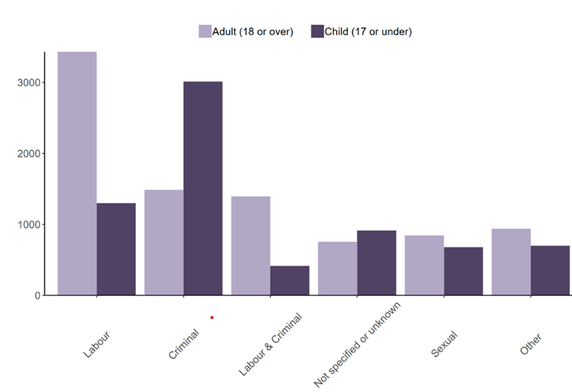
This bar chart shows the detected types of exploitation for adults (18+) versus children (17 and under)
- Labour is the highest type for adults.
- Criminal exploitation is the highest type for Children.
- The overall numbers for Sexual and Other exploitation types are more evenly split between adults and children.

Source:(Home office,2023)

06) Inclusion Criteria
Studies involving adult survivors of human trafficking that report on mental health outcomes more than six months post-rescue, prereview, in the UK and published in English.

07) Exclusion Criteria
Non-peer-reviewed literature, opinion pieces, or studies not focusing on long-term outcomes.

08 Ethical Considerations
Ethical Considerations: Adherence to ethical standards for research as outlined in the document (University of Wales Trinity Saint David) will be ensured, particularly focusing on maintaining objectivity and appropriately referencing all sources (UWTSD, 2022).

References  Banu, S. et al. (2021) ‘Mental health consequences of human trafficking’, Psychiatric Annals, 51(8), pp.369–372.  Chambers, R. et al. (2024) ‘Trauma-coerced attachment and complex PTSD: Informed care for survivors of human trafficking’, Journal of Human Trafficking, 10(1), pp.41–50. doi: 10.1080/23322705.2021.2012386.  Evans, H. et al. (2022) ‘Prevalence of complex post-traumatic stress disorder in survivors of human trafficking and modern slavery: a systematic review’, European Journal of Psychiatry, 36(2), pp.94–105. doi: 10.1016/j.ejpsy.2022.01.005.  Home Office (2023) Modern Slavery: National Referral Mechanism and Duty to Notify statistics UK, end of year summary 2022 GOV.UK. Published 2 March. Available at: [https://www.gov.uk/government/statistics/modern-slavery-national-referral-mechanism-and-duty-to-notify-statistics-uk-end-of-year-summary-2022](Accessed: [date 10/10/2025]).  JI, L., GERAEDTS, M. and WERNER DE CRUPPÉ, 2024. Internal validation of self-reported case numbers in hospital quality reports: preparing secondary data for health services research. BMC Medical Research Methodology, 24, pp. 1-16. | NOWELL LORELLI, S., NORRIS, J.M., WHITE, D.E. and MOULES, N.J., 2017. Thematic Analysis. International Journal of Qualitative Methods, 16(1)  Pascale, R. I., Dwyer, J., Ahmed, S., & Clarke, R. (2024). Psychological effects of trafficking. Mental Health and Social Inclusion, 28(2), 144–161.  Stevens, S., Patel, N., & Johnson, M. (2019). Understanding the mental health impact of human trafficking. Journal of the American Association of Nurse Practitioners, 31(12), 699–704. https://doi.org/10.1097/JXX.0000000000000225  Turgumbayev, M., Rima, D., Duzbayeva, S., Alimova, E., & Beaver, K. M. (2023). Long-term mental health, victimization, and behavioral consequences associated with human sex trafficking. Crime, Law, and Social Change, 80(5), 479–502. https://doi.org/10.1007/s10611-023-10100-2  VAN DER WALDT, G., 2025. Formulating research questions in social science research. The Journal for Transdisciplinary Research in Southern Africa, 21(1)  Wright, N., Jordan, M. and Lazzarino, R. (2021) ‘Interventions to support the mental health of survivors of modern slavery and human trafficking: A systematic review’, International journal of social psychiatry, 67(8), pp. 1026–1034. Available at: https://doi.org/10.1177/00207640211039245

.

