Executive Summary
Chow Tai Fook, established in 1929, is a leader in the jewellery industry with a strong brand presence in Greater China and beyond. The company’s revenue is primarily driven by its gold jewellery segment, which contributed 82.0% of total revenue in the fiscal year 2024. The company operates an extensive retail network and has introduced new product collections to adapt to changing consumer preferences.
The financial analysis highlights a gradual decline in Chow Tai Fook’s bankruptcy Z-score, indicating increasing financial risk over time. The company’s financial structure shows a balanced approach between fixed assets and long-term liabilities, though liquidity concerns have emerged. Comparatively, Luk Fook exhibits stronger financial health, while Tse Sui Luen faces significant financial distress.
Chow Tai Fook’s corporate governance is robust, guided by its "4T" principles. However, areas for improvement include increasing board diversity, strengthening whistleblower protection, and enhancing transparency in ESG reporting.
The investment appraisal suggests that Chow Tai Fook’s new outlet project is financially viable, with a positive NPV and IRR significantly exceeding the current interest rate. However, the payback period extends to five years, which may require reconsideration if faster returns are desired.
An action plan has been developed to address the identified financial and operational challenges, focusing on improving financial stability, operational efficiency, and corporate governance over the next four quarters.

Table of Contents
1. Introduction 1
1.1 Company Background 1
1.2 Operating Business Overview 1
1.3 Today's Business Environment 2
1.4 Company Structure 2
1.5 Research Comparison Company Information 2
2. Financial Analysis 4
2.1 Bankruptcy Z-Score Calculations 4
2.2 Financial Structure 6
2.3 Paying Debt Ability 7
2.4 Operating Capacity 8
2.5 Profitability 9
2.6 Growth Capacity 10
2.7 Stock Market Prospect Analysis 11
3. Company's Corporate Governance Assessment 13
3.1 Corporate Governance of Business Organisation and Its Importance 13
3.2 Company Existing Corporate Governance 13
3.3 Suggestion for Improvement 14
4. Investment Appraisal 15
4.1 Project Basic Information 15
4.2 First Year Calculation of Sales 16
4.4 Monthly Cashflow Calculation 16
4.3 Tax Calculation 18
4.5 NPV and ARR 18
4.6 IRR and Payback Period 19
4.7 Investment Appraisal 20
4.8 New Project Appraisal Methods for Analysis 21
4.9 Suggestion for Cashflow of New Project 21
5. Financing and Capital Management 22
5.1 Financing Methods for Analysing 22
5.2 Financing Method Proposed 22
6. Recommendations and Action Plan 23
7. Conclusion 24
References 25
Appendix A: Critical Financials 27

1. Introduction
The purpose of this report is to conduct a comprehensive financial and operational analysis of Chow Tai Fook Jewellery Group Limited, comparing its performance with two industry peers, Luk Fook Holdings and Tse Sui Luen Jewellery. Additionally, the report evaluates the corporate governance structure, internal control mechanisms, and risk management practices of Chow Tai Fook, proposing improvements for enhanced efficiency. Furthermore, an investment appraisal exercise and financing options analysis will be conducted to support strategic decision-making and fund-raising initiatives. Finally, a quarterly operational plan will be drafted to address identified financial issues and prioritize management actions for the upcoming year.

1.1 Company Background
Chow Tai Fook Jewellery Group Limited, a renowned Hong Kong-based company, is a leader in the jewellery industry, known for its high-quality craftsmanship and extensive product range. Established in 1929, the company has built a strong brand presence through its dedication to authenticity, innovation, and sustainability (Chow Tai Fook, nd). With a comprehensive portfolio that includes gold jewellery, gem-set jewellery, platinum, and K-gold jewellery, Chow Tai Fook has become a household name in Greater China and beyond. The company operates a vast network of retail outlets, strategically expanding its reach to include markets in Mainland China, Hong Kong, Macau, and other international locations (Chow Tai Fook, nd). Chow Tai Fook's commitment to excellence is evident in its stringent quality control processes, innovative product designs, and customer-centric approach.

1.2 Operating Business Overview
Chow Tai Fook Jewellery Group's operating business is segmented into various product categories, including gold jewellery and products, gem-set jewellery, platinum jewellery, and watches. The company’s flagship products, particularly gold jewellery, account for a significant portion of its revenue, driven by their perceived value preservation and popularity among consumers (Chow Tai Fook, 2024). In the fiscal year 2024, gold jewellery and products contributed 82.0% to the company's revenue, highlighting the robust demand in this segment (Chow Tai Fook, 2024). The company has strategically introduced new product collections, such as the HUÁ Collection, to cater to evolving consumer preferences and enhance market penetration. Chow Tai Fook operates an extensive retail network across Mainland China, Hong Kong, Macau, and other international markets. The company’s sales strategy includes both retail and wholesale channels, allowing it to reach a broad customer base

1.3 Today's Business Environment
Chow Tai Fook navigates a dynamic business environment, influenced by macroeconomic and geopolitical factors. Despite uncertainties, the company remains optimistic due to strong domestic demand and a recovering tourism sector, particularly in Hong Kong and Macau (Chow Tai Fook, 2024). The rising middle class and increased spending in Southeast Asia, along with supportive Chinese government policies, are expected to fuel long-term growth (Chow Tai Fook, 2024). However, risks like fluctuating gold prices and evolving consumer preferences persist. To manage these, Chow Tai Fook prioritizes robust risk management, innovation, and strategic growth, focusing on sustainability and regulatory compliance to maintain competitiveness and achieve sustainable growth (Chow Tai Fook, 2024).

1.4 Company Structure
Chow Tai Fook Jewellery Group Limited operates with a strategic structure that enhances management efficiency and supports its diverse business activities across multiple regions and products. The Board of Directors oversees strategic direction, risk management, and governance, supported by various committees such as Nomination, Remuneration, Audit, Sustainability, and Strategy and Transformation (Chow Tai Fook, 2024). The Nomination Committee manages board nominations and performance evaluations, while the Remuneration Committee handles pay policies and advises on organizational structure and talent development (Chow Tai Fook, 2024). The Audit Committee ensures the integrity of financial reporting and risk management (Chow Tai Fook, 2024). The company also runs numerous subsidiaries and joint ventures in Mainland China, Hong Kong, Macau, and internationally, focusing on manufacturing, sales, and distribution of jewellery and related products, with subsidiaries like Shenzhen CTF Watch Company and Shenzhen Qianhai Chow Tai Fook Jewellery handling specific segments.

1.5 Research Comparison Company Information
Chow Tai Fook, Luk Fook, and Tse Sui Luen are prominent Asian jewelry firms, each with distinct market strategies and operational scales. Chow Tai Fook leads with 7,548 sales points globally, showcasing its vast network and market dominance (Chow Tai Fook, 2024). Luk Fook maintains a strong presence with 2,100 outlets (Luk Fook, 2024), while Tse Sui Luen focuses on craftsmanship and innovation across 500 outlets (Tse Sui Luen, 2024). Employment figures show Chow Tai Fook employing 30,000 people, Luk Fook 9,000, and Tse Sui Luen 1,800, reflecting their varying market influence (Chow Tai Fook, nd; Luk Fook, nd; Tse Sui Luen, nd). Financially, Chow Tai Fook leads with an annual revenue of HK$108,713 million for 2023-2024, significantly outpacing Luk Fook’s HK$15,325 million and Tse Sui Luen’s HK$2,655 million (Chow Tai Fook, 2024; Luk Fook, 2024; Tse Sui Luen, 2024). Each company’s core values support its unique business approach and customer engagement strategies. Overall, comparative analysis is provided in Table 1 below.
Table 1. Comparative analysis of companies

2. Financial Analysis
This section focuses on analysis of financial performance of Chow Tai Fook in comparison with its two competitors. The financial information for the companies was extracted from Yahoo Finance (2024a, 2024b, 2024c), which are provided in Appendix A.

2.1 Bankruptcy Z-Score Calculations
First, the financial analysis of Chow Tai Fook focuses on the analysis bankruptcy Z-score calculation and its comparison to the key competitors. The Bankruptcy Index Z-Score is a financial metric developed by Edward I. Altman to predict the likelihood of a company entering bankruptcy within the next two years by combining five financial ratios related to liquidity, profitability, leverage, solvency, and activity (Altman, 1968). A Z-Score greater than 2.99 indicates financial stability, while a score below 1.81 suggests a high probability of bankruptcy (Altman, 1968). The Z-score formula is provided below:
$$Z=1.2A+1.4B+3.3C+0.6D+0.999E$$
The financial data used to calculate the Z-score is provided in Table 2 below
Table 2. Financials for Z-score of Chow Tai Fook
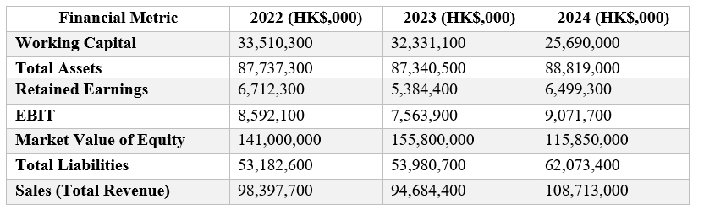
The Z-score calculations are provided in Table 3 below.
Table 3. Z-score calculations for Chow Tai Fook
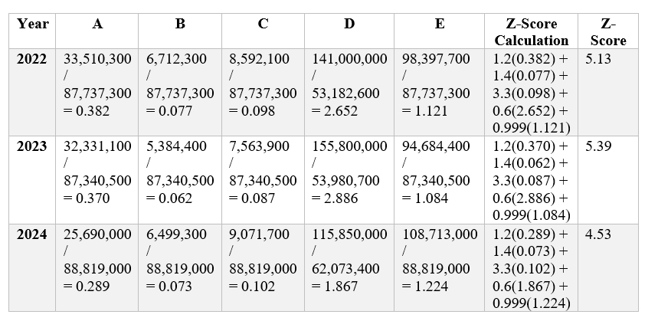
The calculations demonstrate a gradual decline in the bankruptcy Z-score of Chow Tai Fook, which may be concerning for the company’s shareholders. However, before arriving at any conclusions, it is crucial to compare the company’s performance to the competitors. The calculations of Z-scores are provided in Table 4 and 5 below.
Table 4. Calculations of Z-scores for Luk Fook.
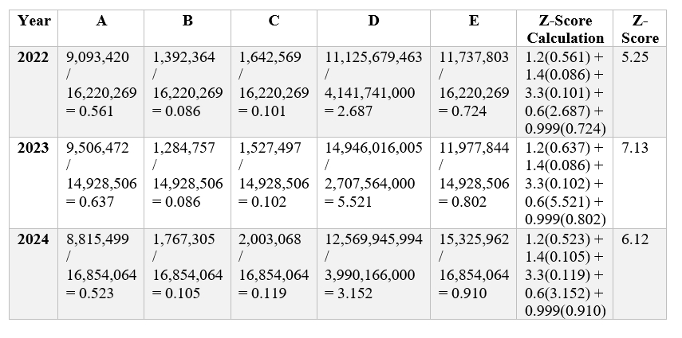
Table 5. Calculations of Z-scores for TseSui Luen
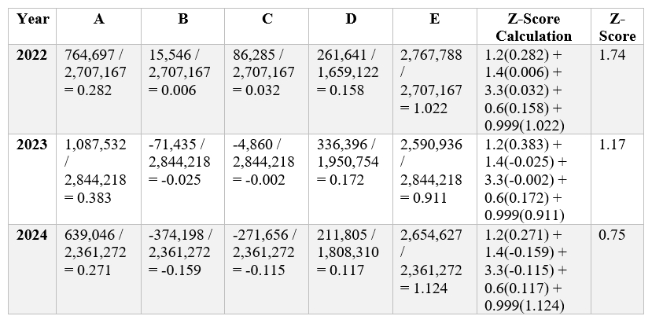
The comparative analysis of the companies’ z-scores is visualised in Figure 1 below.
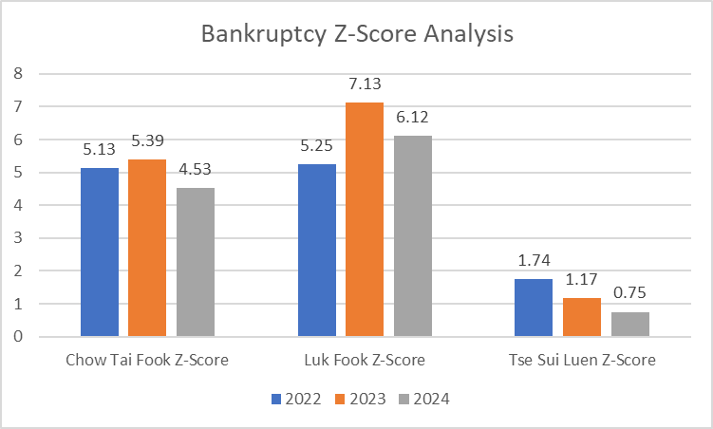
Figure 1. Bankruptcy Z-score Analysis
The comparative analysis demonstrates that Chow Tai Fook's financial performance, as indicated by its Z-Scores (5.13 in 2022, 5.39 in 2023, and 4.53 in 2024), shows strong financial stability with a slight downward trend, suggesting increasing financial risk over time. Comparatively, Luk Fook consistently outperformed Chow Tai Fook, while Tse Sui Luen, exhibited significantly lower Z-Scores.

2.2 Financial Structure
Analysis of financial structures of firms is crucial to determine if they are using adequate combinations of equity and debt to finance their operations. Financial structure is visualised in Table 6 below.
Table 6. Financial structure ratios
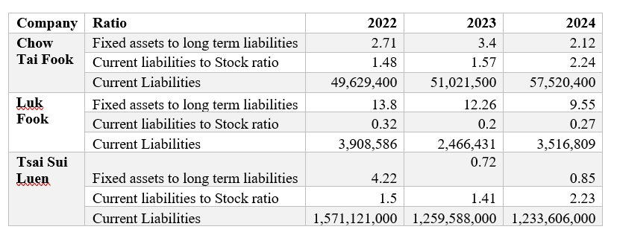
Chow Tai Fook's financial structure reveals a balanced approach between fixed assets and long-term liabilities, with ratios decreasing from 2.71 in 2022 to 2.12 in 2024. This suggests moderate long-term debt management supported by fixed assets. However, the increasing current liabilities to stock ratio, rising from 1.48 in 2022 to 2.24 in 2024, indicates growing inventory pressure relative to short-term obligations, potentially signaling tightening liquidity. Comparatively, Luk Fook exhibits a much stronger position, with fixed assets to long-term liabilities ratios ranging from 13.80 in 2022 to 9.55 in 2024, reflecting substantial asset management and superior liquidity, as indicated by its lower current liabilities to stock ratio (Ross, Westerfield, and Jordan, 2019; Brealey, Myers, and Allen, 2020). In contrast, Tse Sui Luen’s sharp decline in the fixed assets to long-term liabilities ratio, from 4.22 in 2022 to 0.85 in 2024, alongside an increasing current liabilities to stock ratio, indicates financial instability. This could lead to challenges in securing financing and sustaining operations (Brigham and Ehrhardt, 2021). These findings suggest that while Luk Fook is well-positioned, Chow Tai Fook and Tse Sui Luen may need strategic adjustments to improve financial resilience and long-term viability.

2.3 Paying Debt Ability
The financial stability of a company, crucial for attracting investment, hinges on its ability to manage both short-term and long-term debt. Brealey et al. (2020) emphasize that investors scrutinize these capabilities to gauge investment risk. This assessment focuses on Chow Tai Fook’s debt management compared to its competitors, using liquidity and solvency ratios. Over time, Chow Tai Fook's liquidity has declined, with the current ratio dropping from 157.42% in 2022 to 137.66% in 2024, and the cash ratio falling sharply from 30.11% to 13.38%, signaling weaker short-term financial health. The debt-to-equity ratio worsened from 1.58 to 2.41, indicating increased reliance on debt. Conversely, Luk Fook maintained robust liquidity, with a current ratio above 300% and a cash ratio of 55% in 2024, alongside a stable low debt-to-equity ratio of 0.31. Tse Sui Luen, though more volatile, shows a concerning rise in debt-to-equity ratio from 1.58 in 2022 to 3.27 in 2024, reflecting greater financial risk.
The declining liquidity ratios for Chow Tai Fook, combined with its increasing reliance on debt, suggest that the company may face growing financial strain, potentially impacting its ability to fund operations and invest in growth. In contrast, Luk Fook's stronger liquidity and lower debt levels indicate a more sustainable financial position, allowing it to better withstand economic fluctuations (Brigham and Houston, 2019). Tse Sui Luen's higher volatility and increased leverage further heighten its financial risk, which could lead to difficulties in maintaining operational stability if market conditions deteriorate (Higgins, 2022). Table 7 below summarises the companies’ ability to pay debt.
Table 7. Ability to pay debt ratios
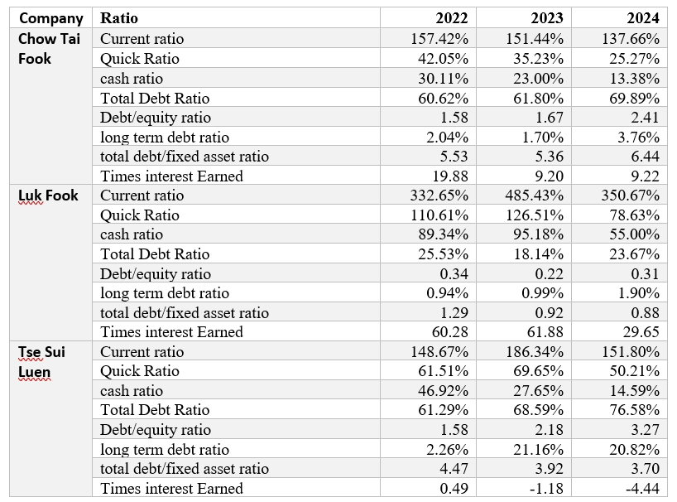

2.4 Operating Capacity
Operating capacity demonstrates how efficiently a company uses its assets to generate sales and income. Chow Tai Fook’s operating capacity was analysed using three ratios, including return on assets (ROA), return on equity (ROE), and asset turnover ratio, and comparing these ratios to the competitors. Table 8 below visualises the companies’ performance in term of efficiency ratios.
Table 8. Operating ratios
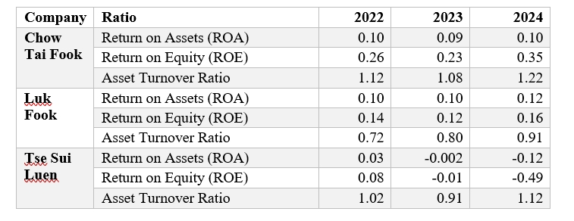
Chow Tai Fook's operating efficiency, as evidenced by its financial metrics, shows a stable yet moderate performance. The company's ROA remained steady at 0.10 across the years, indicating consistent but average asset utilization. ROE for Chow Tai Fook, however, significantly improved from 0.26 in 2022 to 0.35 in 2024, highlighting an increase in profitability relative to shareholders' equity, possibly due to better operational management or effective use of leverage (Dallocchio et al., 2017). Additionally, Chow Tai Fook's asset turnover ratio increased slightly from 1.12 in 2022 to 1.22 in 2024, suggesting that the company is becoming more efficient in generating revenue from its assets.
In comparison, Luk Fook demonstrates a slightly better asset management capability, with its ROA improving from 0.10 to 0.12 and its asset turnover ratio also rising from 0.72 to 0.91 over the same period. However, Luk Fook's ROE, which increased modestly to 0.16 in 2024, remains lower than Chow Tai Fook's, indicating that while Luk Fook is efficient in using its assets, it is less effective in maximizing shareholder returns. On the other hand, Tse Sui Luen's negative ROA and ROE in 2023 and 2024 reflect serious operational inefficiencies and potential financial distress. Despite an improved asset turnover ratio, these negative returns suggest that the company is struggling to generate profits from its operations.
For Chow Tai Fook, the consistent ROA and the notable improvement in ROE suggest solid operational performance and effective financial management, positioning it ahead of Luk Fook in terms of shareholder returns. However, Tse Sui Luen’s declining metrics underscore the importance of sustaining operational efficiency to remain competitive in the market (Brigham and Ehrhardt, 2021).

2.5 Profitability
Profitability is often considered one of the most important financial metrics, that is often measured using gross profit margin, operating profit margin, and net profit margin. These ratios of the three companies are provided in Table 9 below.
Table 9. Profitability ratios
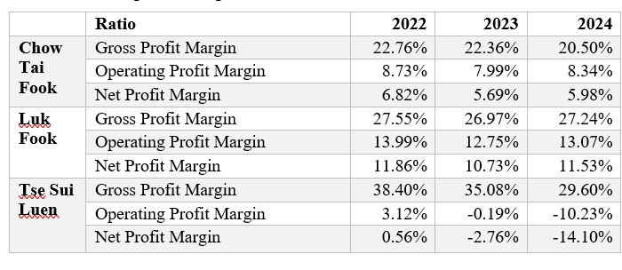
Chow Tai Fook's profitability metrics show a moderate decline over the years. The Gross Profit Margin fell from 22.76% in 2022 to 20.50% in 2024, indicating pressure on the company’s ability to generate profit from sales. Similarly, the Operating Profit Margin slightly decreased from 8.73% to 8.34%, reflecting stable but strained operational efficiency. The Net Profit Margin also dropped from 6.82% to 5.98%, suggesting that overall profitability is impacted by rising costs or slower revenue growth.
In comparison, Luk Fook demonstrates stronger profitability, with its Gross Profit Margin consistently above 27%, and its Operating Profit Margin improving to 13.07% in 2024. Luk Fook’s Net Profit Margin, although dipping in 2023, recovered to 11.53% in 2024, indicating better cost management and profit generation compared to Chow Tai Fook. Tse Sui Luen shows a concerning decline in profitability, with its Gross Profit Margin falling from 38.40% in 2022 to 29.60% in 2024, and both Operating and Net Profit Margins turning negative. This suggests significant operational challenges, potentially threatening the company's financial sustainability.
Overall, while Chow Tai Fook maintains profitability, the declining margins suggest that it faces increasing pressure on its cost structure or competitive pricing. Luk Fook's relatively stable profitability positions it well against Chow Tai Fook, indicating more efficient cost management. In contrast, Tse Sui Luen’s declining profitability underscores significant financial distress, which could threaten its sustainability without substantial strategic intervention.

2.6 Growth Capacity
Chow Tai Fook's growth capacity, marked by a strong recovery in 2023 and 2024, contrasts with its competitors Luk Fook and Tse Sui Luen. Chow Tai Fook's revenue grew by 14.82% in 2024, recovering from a 3.77% decline in 2022, while net income surged by 20.71% in 2024, reflecting robust profitability. However, the company’s equity declined by 20.63% in 2023 and continued to fall in 2024, suggesting increasing reliance on debt financing.
In comparison, Luk Fook experienced steady revenue growth, with a notable 27.95% increase in 2024, and consistent net income growth of 37.56%, indicating strong financial performance. Luk Fook’s total assets and equity both showed positive growth, with equity increasing by 5.26% in 2024, highlighting its stable financial foundation and effective use of resources. Tse Sui Luen, on the other hand, faced severe challenges, with a drastic 423.83% decline in net income in 2024 and a 38.11% drop in equity, indicating financial distress. Although Tse Sui Luen’s revenue grew slightly in 2024, the company’s negative net income and declining equity suggest significant operational and financial difficulties. Overall, while Chow Tai Fook shows strong growth potential, Luk Fook outperforms it with more stable equity growth, and Tse Sui Luen struggles with severe financial instability.
The overview of the growth in these metrics is provided in Table 10 below.
Table 10. Growth capacity table (in HK$,000)
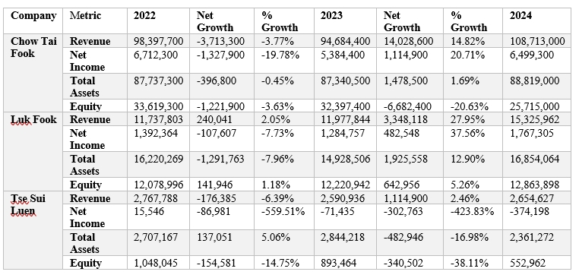

2.7 Stock Market Prospect Analysis
Stock market prospects were analysed using investment ratios, including earnings per share (EPS) and price-to-earnings (P-E) ratios. The comparative analysis is provided in Table 11 below.
Table 11. Investment ratio analysis
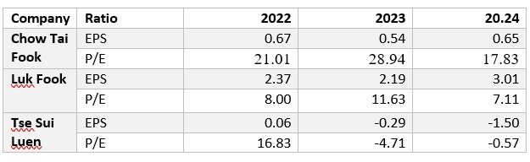
Chow Tai Fook's attractiveness for investors, as indicated by its Earnings Per Share (EPS) and Price-to-Earnings (P/E) ratio, presents a mixed picture. In 2022, Chow Tai Fook had an EPS of 0.67 and a P/E ratio of 21.01, suggesting that the market valued its earnings relatively highly. However, the P/E ratio spiked to 28.94 in 2023, despite a drop in EPS to 0.54, indicating that the stock may have been overvalued at that time. By 2024, the EPS recovered to 0.65, and the P/E ratio adjusted to 17.83, reflecting a more balanced valuation, though still relatively high compared to competitors.
Luk Fook, on the other hand, demonstrated more stable and attractive investment metrics. Its EPS, while higher than Chow Tai Fook’s, showed a steady performance, increasing from 2.37 in 2022 to 3.01 in 2024. Luk Fook’s P/E ratio remained lower, dropping to 7.11 in 2024, indicating that the stock was potentially undervalued, making it a more attractive investment opportunity in terms of earnings potential. Tse Sui Luen, however, appears to be struggling, with negative EPS in both 2023 and 2024 and a negative P/E ratio, reflecting poor profitability and a lack of investor confidence. The negative P/E indicates that the company is not generating sufficient earnings to justify its market valuation, making it a risky investment. Overall, while Chow Tai Fook offers moderate attractiveness to investors, Luk Fook presents a stronger and more stable investment opportunity, whereas Tse Sui Luen’s negative financial metrics suggest significant risks.

3. Company's Corporate Governance Assessment

3.1 Corporate Governance of Business Organisation and Its Importance
Corporate governance is the framework of rules, relationships, systems, and processes within and by which authority is exercised and controlled in corporations. It influences how the objectives of the company are set and achieved, how risk is monitored and assessed, and how performance is optimized. Effective corporate governance ensures that companies operate with integrity, transparency, and accountability, safeguarding the interests of all stakeholders, including shareholders, employees, customers, and the community. The importance of corporate governance cannot be overstated, as it provides a structure that guides the company towards achieving its goals while mitigating risks. For example, companies with strong governance are better positioned to identify and manage risks, which can lead to enhanced financial performance and investor confidence.
Moreover, good governance practices can prevent corporate scandals and fraud, which can have devastating effects on a company's reputation and financial standing. Corporate governance also plays a crucial role in fostering ethical behavior and corporate social responsibility, ensuring that the company operates in a manner that is sustainable and beneficial to society. Overall, effective corporate governance is essential for the long-term success and sustainability of a business, as it provides the foundation for sound decision-making, strategic planning, and risk management.

3.2 Company Existing Corporate Governance
Chow Tai Fook has established a robust corporate governance framework that aligns with its commitment to transparency, accountability, and sustainable growth. The company's governance structure is built on its "4T" principles—Transparent, Thoughtful, Truthful, and Traceable—which guide its operations and interactions with stakeholders. The company has fully complied with the Corporate Governance Code as set out in Appendix C1 to the Listing Rules, demonstrating its adherence to the highest standards of governance practices. The board of directors, which is at the core of Chow Tai Fook's governance framework, is responsible for overseeing the company's strategic direction, risk management, and overall governance policies.
The board is supported by key committees, including the Audit Committee, Nomination Committee, and Remuneration Committee, each of which plays a vital role in ensuring the company's financial integrity, managing risks, and overseeing executive compensation. The Audit Committee, for instance, is tasked with monitoring the company's financial reporting processes and ensuring the accuracy and reliability of its financial statements. The Nomination Committee is responsible for evaluating the composition of the board and recommending new members who possess the necessary skills and experience to contribute to the company's strategic objectives. The Remuneration Committee oversees the development and implementation of fair and transparent executive compensation policies that align with the company's long-term goals. Through these structures, Chow Tai Fook ensures that its governance practices are aligned with industry best practices and that it remains accountable to its stakeholders.

3.3 Suggestion for Improvement
While Chow Tai Fook has a strong corporate governance framework in place, there are areas where improvements could further enhance its effectiveness. First, increasing the diversity of the board of directors is crucial. A more diverse board, in terms of gender, ethnicity, and professional background, can bring a wider range of perspectives and experiences to the decision-making process, leading to more innovative and effective strategies (Adams and Ferreira, 2009). This diversity can also enhance the company’s ability to navigate complex global markets and respond to the needs of a diverse customer base (Carter, Simkins, and Simpson, 2003). Second, Chow Tai Fook should consider strengthening its whistle-blower protection mechanisms. Ensuring that employees feel safe and protected when reporting unethical or illegal activities is critical for maintaining a culture of integrity and transparency (Miceli, Near, and Dworkin, 2008). This could involve implementing more robust policies and procedures for handling whistle-blower reports, as well as providing regular training to employees on their rights and protections (Callahan and Dworkin, 1994).
Third, the company could benefit from adopting more rigorous performance metrics for executive compensation. Linking executive pay more closely to long-term performance and shareholder value creation can help align the interests of management with those of the shareholders, reducing the risk of short-termism in decision-making (Jensen and Murphy, 1990). Finally, enhancing transparency in reporting, particularly with regard to environmental, social, and governance (ESG) practices, could improve stakeholder trust and align Chow Tai Fook with global best practices (Eccles, Ioannou, and Serafeim, 2014). This could involve providing more detailed disclosures on the company’s sustainability initiatives, as well as setting clear targets and benchmarks for ESG performance. By addressing these areas, Chow Tai Fook can strengthen its corporate governance and ensure its continued success and sustainability in the long term.

4. Investment Appraisal

4.1 Project Basic Information
The project is strategically positioned to capitalize on increasing consumer demand. This new location is expected to yield 150% from the average revenue generated by existing outlets, contributing significantly to the company’s overall growth. Moreover, the operating costs are expected to be twice as low in comparison with average operating expenses. The decision to invest is grounded in the potential to achieve higher profitability through efficient operations, as the operating costs are projected to be lower than the average for similar outlets. The initial capital outlay for this project, calculated as 5% of the last fiscal year’s revenue, will be HK$5,435,650,000. This amount is justified by the anticipated steady revenue increase, which is expected to reach over HK$831,643,000 in monthly revenue by the 12th month of operation. The outlet will enhance Chow Tai Fook's market presence and cater to a wider customer base. The assumptions of the project are provided in Table 12 below.
Table 12. Project assumptions
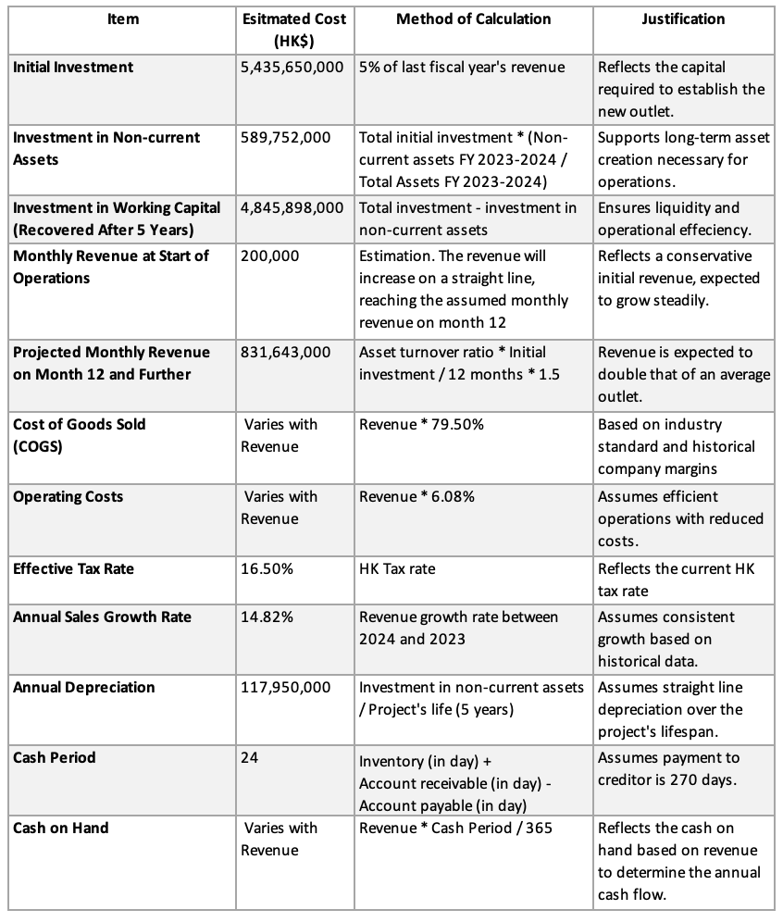

4.2 First Year Calculation of Sales
The first-year revenue is expected to be lower than that of all the following years, as it is assumed that the efficiency of asset use of the new outlet is expected to grow gradually, reaching its maximum efficiency during Month 12 of Year 1. Table 13 below provides a breakdown of monthly revenues.
Table 13. Monthly revenues during Year 1
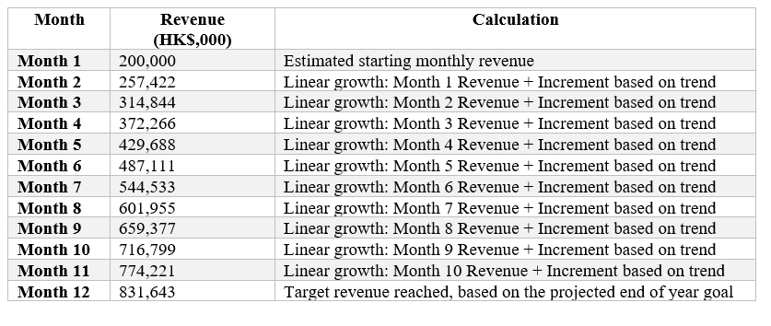
The analysis table for the monthly revenues is provided in Table 14 below.
Table 14. Analysis table for monthly revenues during first year
Overall, during the first year of sales, the new outlet is expected to generate a total revenue of HK$6,189,860,000.

4.4 Monthly Cashflow Calculation
Cashflow was calculated using the project assumptions provided in Table 12. First, Year 1 monthly cashflow were calculated, and then annual cashflows were estimated using the formulas provided in Table 15 below.

Table 15. Calculation table for cashflows
The first-year cashflow breakdown is provided in Table 16 below.
Table 16. Year 1 cashflows analysis table
Annual cashflows are provided in Table 17 below.
Table 17. Annual cashflows of five years of operations analysis table

4.3 Tax Calculation
The effective tax rate for the company was 16.5%, which is the corporate tax rate in Hogg Kong. The tax expense was calculated taking into consideration depreciation calculated in Table 12 with basic assumptions of the project. Table 18 below provides a breakdown of tax calculations for annual cashflows.
Table 18. Analysis and calculation table
The overall analysis of cashflows after including tax and recover of the initial investment in working capital is provided in Table 19 below.
Table 19. Final annual cashflows

4.5 NPV and ARR
NPV and ARR are crucial metrics that help to help the make a decision concerning taking up a project. Table 20 below demonstrates how NPV was calculated with interest rate (r) of 5%.

Table 20. NPV calculation table
Table 21 below demonstrates how the ARR was calculated.
Table 21. ARR calculation
The analysis table of NPV is provided in Table 22 below.
Table 22. Analysis of NPV and ARR
Both NPV and ARR demonstrate that the proposed invest is associated with adding value to the company’s operations.

4.6 IRR and Payback Period
IRR and Payback Period are also crucial metrics for investment appraisal that can help to make investment decision. The calculation table if provided in Table 23 below.

Table 23. Payback period and IRR calculation
Table 24 below provide a brief analysis of the estimations.
Table 24. Analysis table of IRR and Payback Period
Overall, the metrics suggest that the proposed investment is expected to bring high profits within a reasonable time.

4.7 Investment Appraisal
Investment appraisal involves evaluating the potential financial outcomes of a project to determine its feasibility and profitability. Techniques such as NPV, IRR, and Payback Period provide crucial insights into whether the expected returns will justify the initial investment (Harrison and John, 2013). For Chow Tai Fook's new outlet, the positive NPV and an IRR exceeding the current interest rate suggest that the project is financially sound and likely to contribute positively to the company’s growth. These appraisal methods collectively ensure that the investment decisions are data-driven and aligned with the company's financial goals. However, the company should note that the investment will pay for itself only on Year 5, which demonstrates that if the stakeholders want faster payback, the investment should be reconsidered.

4.8 New Project Appraisal Methods for Analysis
Effective project appraisal requires the use of multiple methods to capture different aspects of financial viability. NPV and IRR are particularly valuable as they account for the time value of money, helping to compare the project’s cash inflows with the initial capital outlay over time. The Payback Period, while simpler, offers insights into the liquidity risks by indicating how quickly the initial investment will be recovered (Fraser and Ormiston, 2023). Companies can make more informed decisions, balancing the potential returns against the risks involved if the methods are used together.

4.9 Suggestion for Cashflow of New Project
To optimize the cash flow for Chow Tai Fook's new project, it is recommended to adopt a phased revenue growth strategy, beginning with conservative estimates and gradually increasing as the outlet gains market traction. This approach allows the company to monitor and adjust operations in response to market conditions, ensuring financial stability. Additionally, controlling operating expenses and maintaining a consistent margin on the cost of goods sold (COGS) will be critical for maximizing profitability (Titman, Keown, and Martin, 2021). These strategies will help manage the project’s financial risks and ensure a stable cash flow that supports long-term success.

5. Financing and Capital Management

5.1 Financing Methods for Analysing
When considering financing options for raising funds equivalent to 3% of total assets, Chow Tai Fook has several avenues to explore. These include debt financing, equity financing, and hybrid instruments such as convertible bonds (Brealey, Myers, and Allen, 2020). Debt Financing involves borrowing funds from financial institutions or issuing bonds. The advantage of debt financing is the tax deductibility of interest payments, which can improve cash flow and profitability (Ross, Westerfield, and Jaffe, 2021). However, increasing debt raises the company's financial risk, as reflected in financial ratios like the debt-to-equity ratio, potentially leading to higher costs of future borrowing.
Equity Financing involves issuing new shares to investors. This method does not require repayment and avoids interest costs, preserving the company's cash flow for operational needs (Dallocchio et al., 2017). The drawback is dilution of existing shareholders' equity and possible negative impacts on earnings per share and return on equity if the new capital does not generate proportional returns. Hybrid Instruments, such as convertible bonds, offer flexibility, as they can be converted into equity at future dates. This reduces immediate dilution concerns and interest burdens, providing a strategic balance between debt and equity (Brealey, Myers, and Allen, 2020).

5.2 Financing Method Proposed
Considering Chow Tai Fook's current financial structure and market conditions, a combination of debt financing and hybrid instruments is recommended. The company should consider issuing medium-term bonds combined with a smaller issuance of convertible bonds. This strategy allows Chow Tai Fook to leverage the lower interest rates associated with bonds while maintaining the flexibility to convert part of the debt into equity should the share price appreciate significantly. Issuing bonds will capitalise on the current low-interest environment, mitigating the impact on cash flows and preserving credit capacity for unforeseen needs (Ross, Westerfield, and Jaffe, 2018). The convertible bonds will serve to attract investors looking for growth potential with reduced risk, offering a potential future conversion at a favourable conversion rate.
This mixed approach balances the immediate need for cash with long-term strategic flexibility, minimising the dilution of ownership and keeping the company's leverage within manageable limits. It aligns with maintaining a healthy working capital cycle and optimising the company’s current and quick ratios, ensuring operational liquidity without compromising on strategic financial health (Dallocchio et al., 2017).

6. Recommendations and Action Plan
The following action plan outlines a strategic approach to addressing the critical financial and operational challenges identified in the earlier analysis of Chow Tai Fook. This plan is structured over four quarters, prioritizing actions that target key areas such as financial stability, operational efficiency, and corporate governance to ensure the company’s sustained growth and resilience. Each action is designed to improve specific financial metrics and operational outcomes, aligning with the company’s long-term objectives. Table 25 below provides an audit plan.
Table 25. Action plan
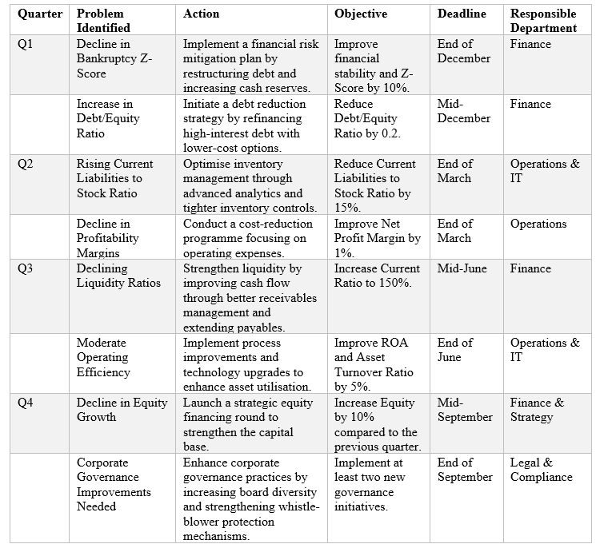

7. Conclusion
This report has provided a comprehensive analysis of Chow Tai Fook's financial health, operational strategies, and market positioning compared to its competitors. Through detailed financial metrics of profitability, efficiency, solvency, and liquidity the report demonstrated that while the company demonstrates a stable financial performance, there are areas of improvement in managing the capital. The investment appraisal demonstrated one of the possible strategies for improving the current position. The company’s corporate governance approach is associated with high efficiency. However, there are significant improvement that can be made in all areas. The action plan provided in Section 6 of this report provides a comprehensive path for Chow Tai Fook to acquire sustainable competitive advantage.

References
Adams, R.B. and Ferreira, D. (2009) 'Women in the boardroom and their impact on governance and performance', Journal of Financial Economics, 94(2), pp. 291-309. Available at: https://doi.org/10.1016/j.jfineco.2008.10.007
Altman, E.I. (1968) 'Financial Ratios, Discriminant Analysis and the Prediction of Corporate Bankruptcy', The Journal of Finance, 23(4), pp. 589-609. Available at: https://www.jstor.org/stable/2978933
Brealey, R.A., Myers, S.C. and Allen, F. (2020) Principles of Corporate Finance. 13th edn. New York, NY: McGraw-Hill Education.
Brigham, E.F. and Ehrhardt, M.C. (2019) Financial Management: Theory and Practice. 16th edn. Boston, MA: Cengage Learning.
Brigham, E.F. and Houston, J.F. (2019) Fundamentals of Financial Management. 15th edn. Boston, MA: Cengage Learning.
Callahan, E.S. and Dworkin, T.M. (1994) 'Who blows the whistle to the media, and why: Organizational characteristics of media whistleblowers', American Business Law Journal, 32(2), pp. 151-184. Available at: https://doi.org/10.1111/j.1744-1714.1994.tb00933.x
Carter, D.A., Simkins, B.J. and Simpson, W.G. (2003) 'Corporate governance, board diversity, and firm value', The Financial Review, 38(1), pp. 33-53. Available at: https://doi.org/10.1111/1540-6288.00034
Chow Tai Fook Annual report 2022-2024. Available at: https://www.ctfjewellerygroup.com/en/investor-relations/reports.html (Accessed: 9 August 2024).
Chow Tai Fook Jewellery Group (no date) Investor relations: Reports. Available at: https://www.ctfjewellerygroup.com/en/investor-relations/reports.html (Accessed: 11 August 2024).
Dallocchio, M., Salvi, A., Le Fur, Y., Quiry, P. and Vernimmen, P. (2017) Corporate Finance: Theory and Practice. 5th ed. Hoboken: Wiley. (Accessed: 22 August 2024)
Eccles, R.G., Ioannou, I. and Serafeim, G. (2014) 'The impact of corporate sustainability on organizational processes and performance', Management Science, 60(11), pp. 2835-2857. Available at: https://doi.org/10.1287/mnsc.2014.1984
Fraser, L.M. and Ormiston, A. (2023) Understanding Financial Statements. 11th edn. London: Pearson. (Accessed: 25 Aug 2024)
Harrison, J.S. and John, C.H. (2013) Foundations in Strategic Management. 6th edn. Boston, MA: Cengage Learning.
Higgins, R.C. (2018) Analysis for Financial Management. 12th edn. New York, NY: McGraw-Hill Education.
Jensen, M.C. and Murphy, K.J. (1990) 'Performance pay and top-management incentives', Journal of Political Economy, 98(2), pp. 225-264. Available at: https://doi.org/10.1086/261677
Luk Fook Annual report 2022-2024. Available at: https://www.lukfook.com/en/page/investor-relations/financial-statement (Accessed: 7 August 2024).
Luk Fook Holdings (International) Limited (no date) Investor relations: Financial statement. Available at: https://www.lukfook.com/en/page/investor-relations/financial-statement (Accessed: 11 August 2024).
Miceli, M.P., Near, J.P. and Dworkin, T.M. (2008) Whistle-blowing in organizations. London: Routledge. Available at: https://doi.org/10.4324/9780203809495. (Accessed: 25 August 2024)
Ross, S.A., Westerfield, R.W. and Jordan, B.D. (2018) Fundamentals of Corporate Finance. 12th edn. New York, NY: McGraw-Hill Education.
Titman, S., Keown, A.J. and Martin, J.D. (2021) Financial Management: Principles and Applications. 14th Global ed. Harlow: Pearson. (Accessed: 24 August 2024)
Tse Sui Luen Annual report 2022-2024. Available at: https://corporate.tslj.com/en/ir/reports.php (Accessed: 8 August 2024).
Tse Sui Luen Jewellery (International) Limited (no date) Investor relations: Reports. Available at: https://corporate.tslj.com/en/ir/reports.php (Accessed: 11 August 2024).
Yahoo Finance (2024a) Chow Tai Fook Jewellery Group Limited (1929.HK). Available at: https://finance.yahoo.com/quote/1929.HK/balance-sheet/ (Accessed: 7 August 2024).
Yahoo Finance (2024b) Luk Fook Holdings (International) Limited (0590.HK). Available at: https://finance.yahoo.com/quote/0590.HK/balance-sheet/ (Accessed: 7 August 2024).
Yahoo Finance (2024c) Tse Sui Luen Jewellery (International) Limited (0417.HK). Available at: https://finance.yahoo.com/quote/0417.HK/balance-sheet/ (Accessed: 7 August 2024).

Appendix A: Critical Financials
Chow Tai Fook (in HK$,000)

Luk Fook (in HK$,000)

Tse Sui Luen (in HK$,000)

