CONFERENCE PRESENTATION SPEAKER'S NOTE
Module: Contemporary Themes in the Hotel and Hospitality Sector
Module code: BMIH6001
Student Name: Persima Barreto
Student ID: 2243324
Title: Artificial Intelligence and Human Collaboration in the Hotel and Hospitality Industry

SLIDE 1: TITLE SLIDE
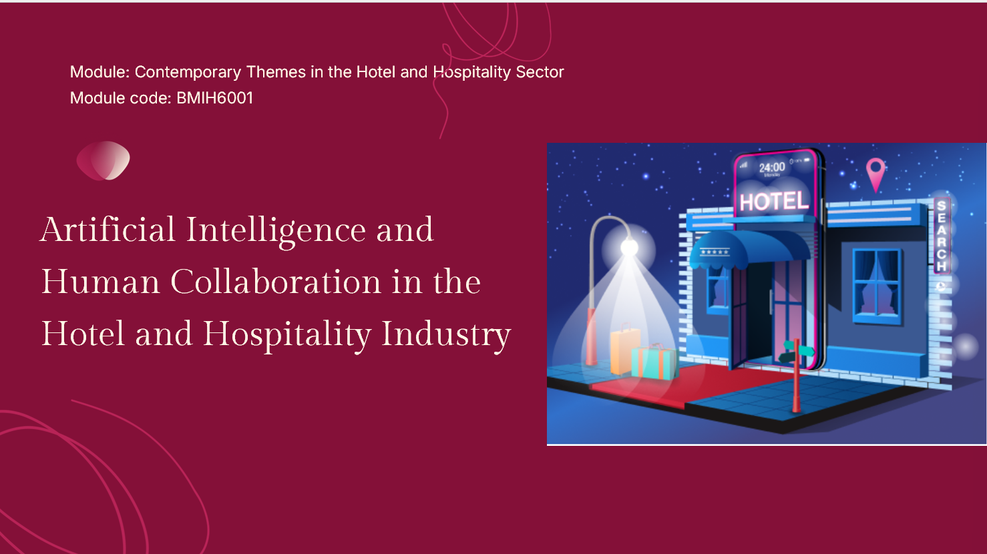
Speaker's Note:
Hello/afternoon, esteemed colleagues, market players and other researchers. I present one of the most urgent modern issues that changes our industry: the integration of Artificial Intelligence and the collaborative relationship between it and human service excellence in the hotel and hospitality industry.

SLIDE 2: INTRODUCTION - THE CONTEMPORARY THEME
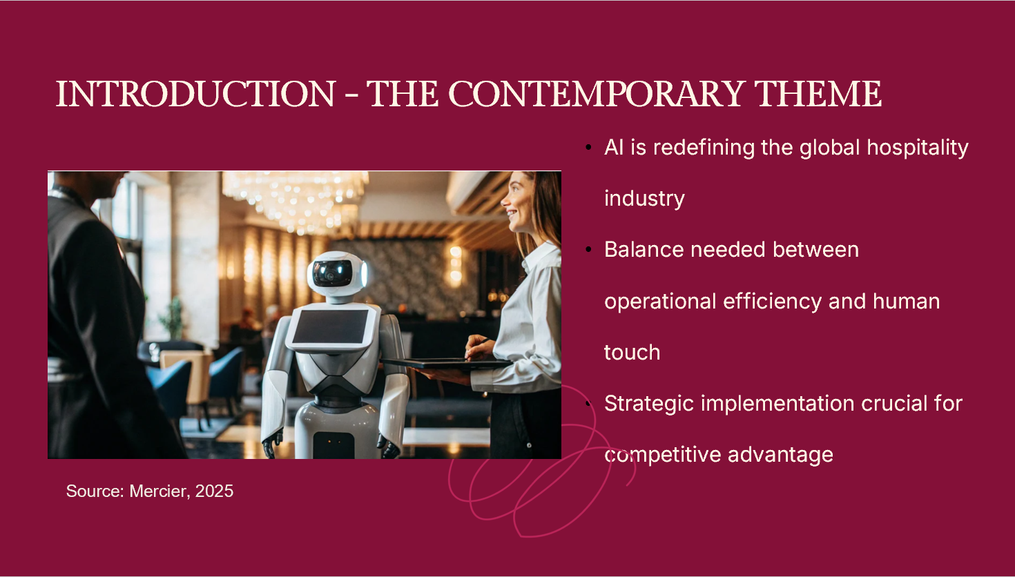
Speaker's Note:
AI has become a current signature that is redefining the worldwide hospitality industry, as pointed out by Ivanov and Webster (2019) and Roberts (2025). The current technological revolution is changing operations, service delivery, and workforce structure in an unprecedented manner. The most important issue is where to find the balance between operational efficiency and human touch that constitutes hospitality excellence.
Hospitality is an industry that is based on personal relationships and emotional intelligence. Wavei, Lo and Gedecho (2025) also indicate that the human factor cannot be substituted in the provision of authentic guest experiences. However, scale requires efficiency and personalisation at scale due to operational pressure. As Cooper and Hall (2023) point out, the key to maintaining a competitive edge is to comprehend the way artificial and human intelligence can work together. According to Sharma, Singh and Tyagi (2024), the strategic implementation pathways play an important role in thriving in this changing technological environment.

SLIDE 3: LITERATURE REVIEW - THEORETICAL FOUNDATIONS
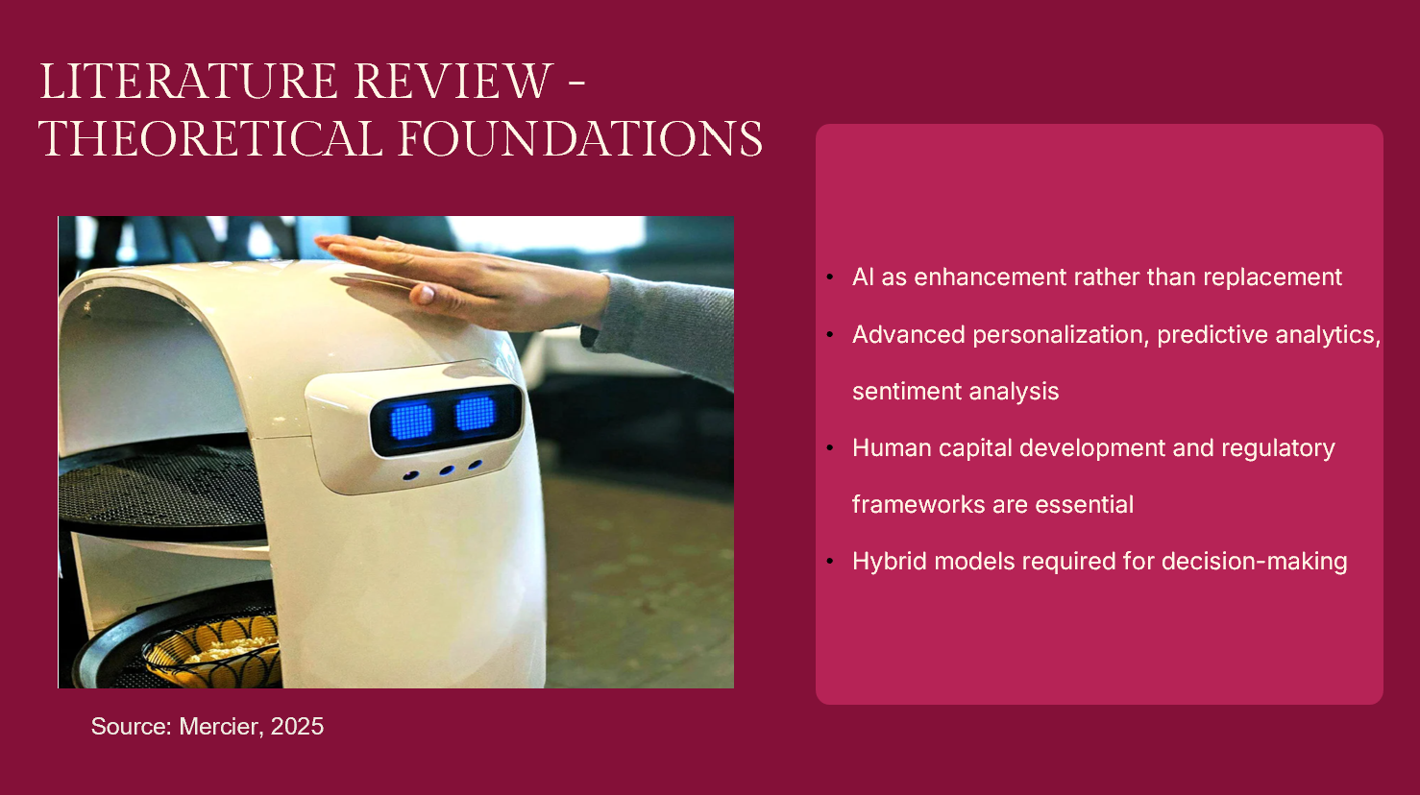
Speaker's Note:
In modern literature, it is possible to observe a paradigm change in the conceptualisation of AI implementation. Instead of considering technology as a substitute, the most prominent scholars should consider AI as an improvement, and this was expressed by Chkoniya (2021). This paradigm of cooperation is in line with models of value creation in which technology increases the contribution of humans, developed by Clegg, Skyttermoen and Vaagaasar (2020) and Melton, Yates and Iles-Smith (2011). Dixit (2020) relies on the theoretical framework based on organisational behaviour, information systems, and hospitality management. According to Brotherton (2015) and Robson (2016), contemporary research needs to concentrate on the practical implementation strategies.
Roberts (2025) shows that the current AI includes advanced personalisation engines, predictive analytics and sentiment analysis systems. Nevertheless, Ivanov and Webster (2019) have an important condition for this: the level of technological complexity should be equal to the demands of the guests to interact with a person. Santos and Silva (2019) and Kumar (2021) demonstrate the strength of AI and present obstacles to preserving the authenticity of services.
According to the Department for Science, Innovation and Technology (2026), important implications for the labour market can be revealed. Wavei, Lo and Gedecho (2025) demonstrate that the main preconditions of the successful implementation of AI are the strong development of human capital within the regulatory frameworks found by Ette (2025). Tribe (2009) poses philosophical questions. According to Danzer and Zeidler (2025), human decision-making is not the same as the work of algorithms, and hybrid models are required to work.
SLIDE 4: LITERATURE REVIEW - GLOBAL CONTEXT
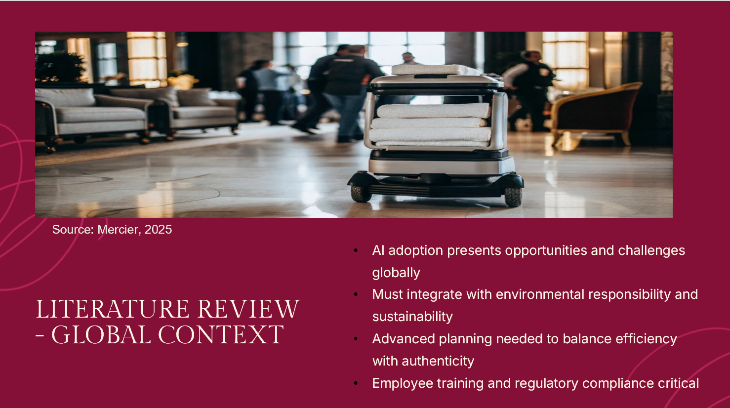
Speaker's Note:
According to the World Trade Organisation (2026), the application of AI in large volumes offers both an opportunity and a challenge in terms of positioning in the competition and compliance with regulations. This transformation is being formed in contrast to climate change pressures reported by Dawson, Lemelin and Stewart (2012) and sustainability imperatives by Costa and Costa (2022). According to Cooper and Hall (2023), contemporary tourism should incorporate AI into the categories of environmental responsibility, social equity, and sustainability.
Sharma, Singh and Tyagi (2024) unveil a swiftly growing consumption of technology and, at the same time, expose a continued issue in the implementation. The views of Prideaux, Laws and Faulkner (2007) are still applicable because organisations go through AI-related disruptions. Faulkner, Moscardo and Laws (2001) and Krippendorf (2011) provide the historical background. The literature review offers the conclusive result that AI applications need advanced planning strategies to strike a balance between the efficiency of operations and the experience of authenticity, employee training, and regulatory considerations, as suggested by Wavei, Lo and Gedecho (2025) and the British Columbia Law Institute (2024).
SLIDE 5: METHODOLOGY
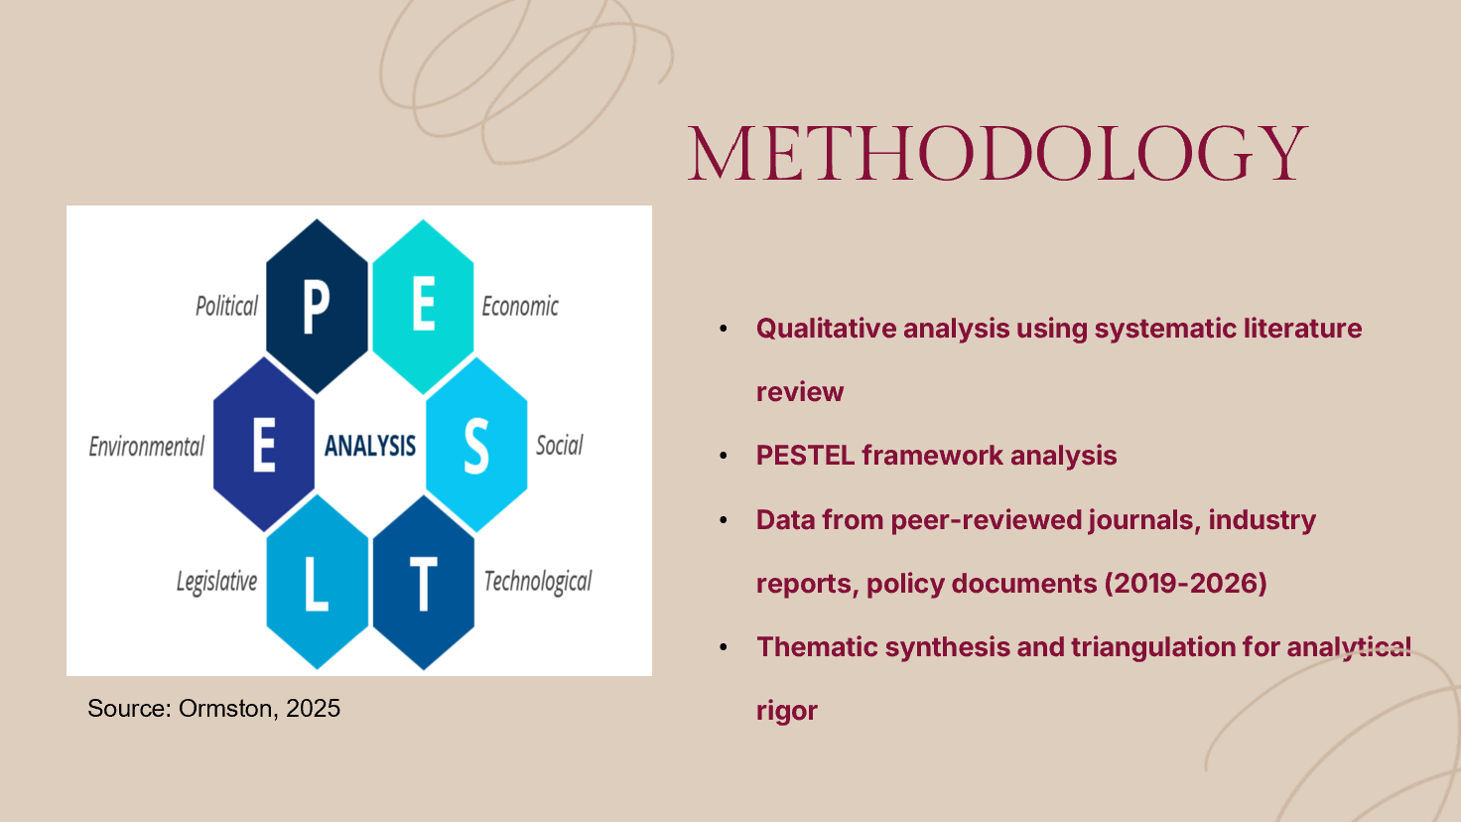
Speaker's Note:
The paper applies the qualitative analysis framework involving a systematic review of literature and PESTEL analysis to study the AI-human cooperation in the hospitality sector. The combination of peer-reviewed journals, industry reports, and 2019-2026 policy documents was used as a method of data collection due to their covering the current developments of AI implementation (Brotherton, 2015; Robson, 2016).
The analytical method utilises the PESTEL framework to evaluate the impact of AI implementation with a systematic evaluation of the effects in Political, Economic, Social, Technological, Environmental, and Legal aspects. The criteria of credibility of source favoured peer-reviewed academic sources, governmental reports on policies, and publications of reputable industry sources. Thematic synthesis facilitated the identification of shared patterns, whereas triangulation contributed to the improvement of analytical rigour caused by cross-validation, which is advised by Brotherton (2015).

SLIDE 6: THEME IMPACT ANALYSIS - POLITICAL & LEGAL
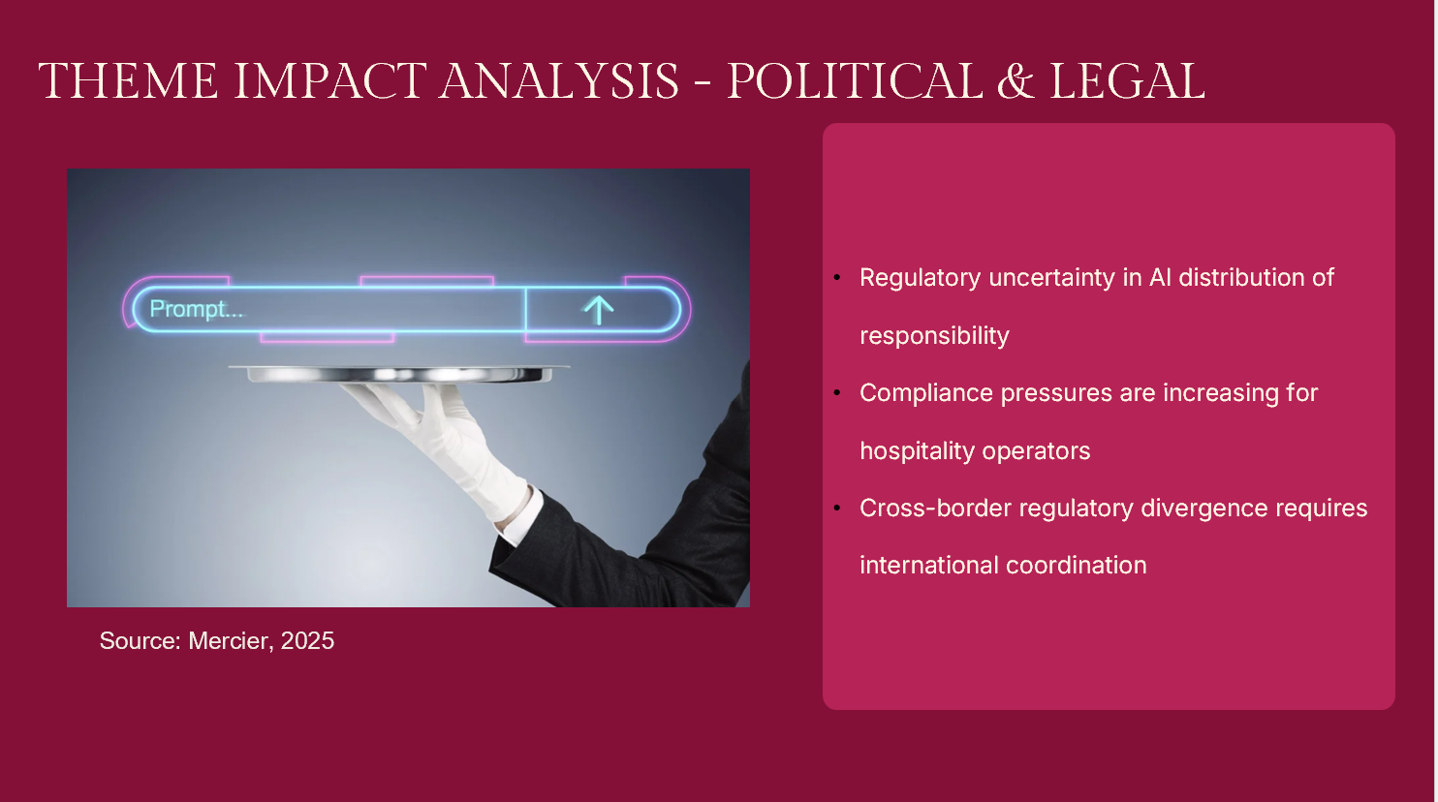
Speaker's Note:
The industry strategies are influenced by the political structures of AI use. The British Columbia Law Institute (2024) discloses that regulatory uncertainty makes it daunting to find a way in and out of the distribution of responsibility between human operators and automated systems. Ette (2025) shows that the hospitality operators face disproportional compliance pressure as AI adds to the complexity of compliance. The reactions of industries towards regulation prefer active participation in regulation, which generates a competitive disadvantage. According to the World Trade Organisation (2026), cross-border regulatory divergence needs to be coordinated at the international level.

SLIDE 7: THEME IMPACT ANALYSIS - ECONOMIC & OPERATIONAL
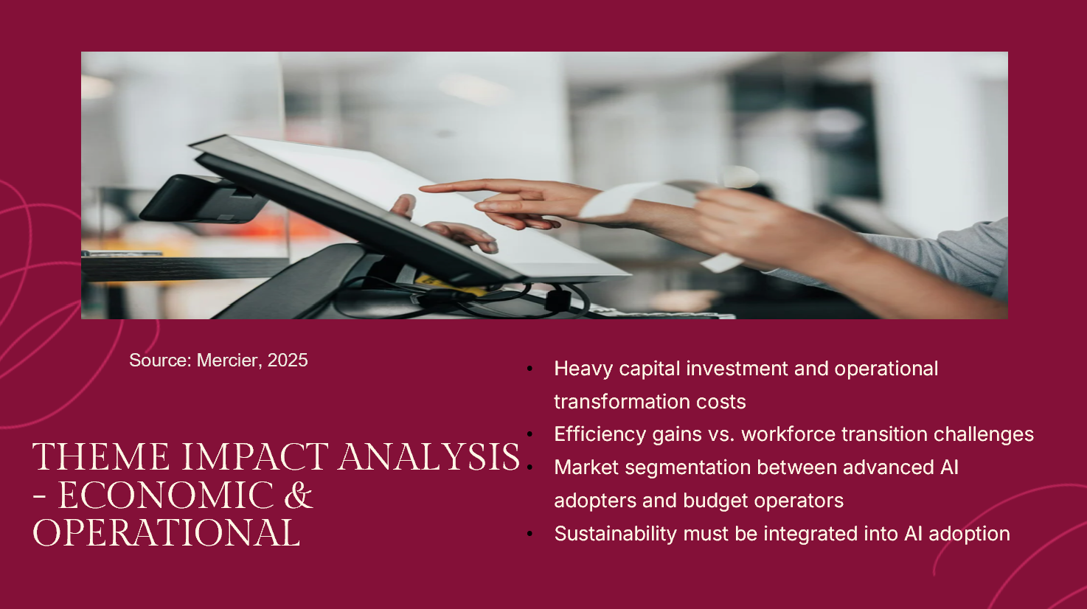
Speaker's Note:
Economic impacts that Mill (2012) highlights are accelerated because AI implementation needs heavy capital investment and operational transformation costs. The Department for Science, Innovation and Technology (2026) indicate that there are efficiency benefits and workforce transition problems that are caused by labour market disruptions. The reactions of industries vary: big players invest millions of dollars into advanced AI-controlled systems to allow service differentiation, whereas low-cost carriers strive to automate their processes and build a competitive gap and reinforce market segmentation. Among the strengths, there is an increase in the efficiency and management of revenues. The disadvantages include the excessive cost of implementation and threats of obsolescence caused by technology. According to Costa and Costa (2022), AI adoption should include the aspect of sustainability.

SLIDE 8: THEME IMPACT ANALYSIS - SOCIAL & EXPERIENTIAL
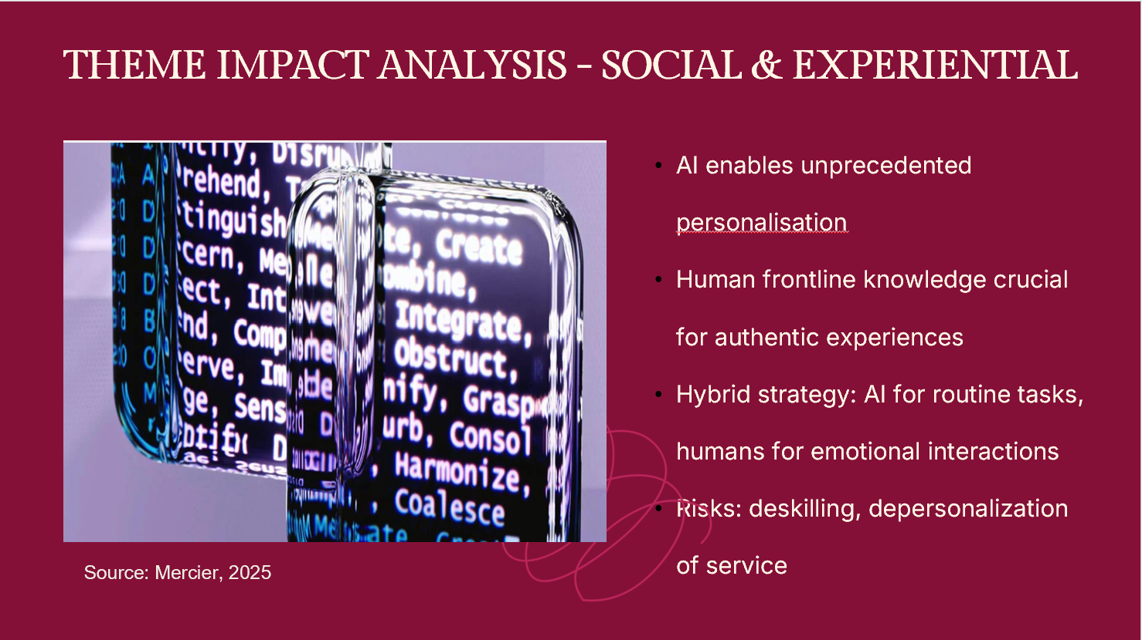
Speaker's Note:
Social aspects play a great role in influencing the experience of employees and guests. Roberts (2025) records how AI is making possible unmatched personalisation of relationships, where guest relationship management is now a predictive paradigm. Nevertheless, Wavei, Lo and Gedecho (2025) prove that frontline employee knowledge management is extremely important to achieve genuine hospitality experiences that AI will not be able to reproduce. The industry reactions are focused on the hybrid strategy in which AI can be used to perform routine tasks, and the human staff can concentrate on the emotionally sensitive interactions. Such advantages as better consistency and increased personalisation are possible. The drawbacks include deskilling risks, the feeling of being a guest, and depersonalisation of the service, which ruin the main value proposition of hospitality, as Batabyal and Das (2019) warn.

SLIDE 9: THEME IMPACT ANALYSIS - TECHNOLOGICAL & ENVIRONMENTAL
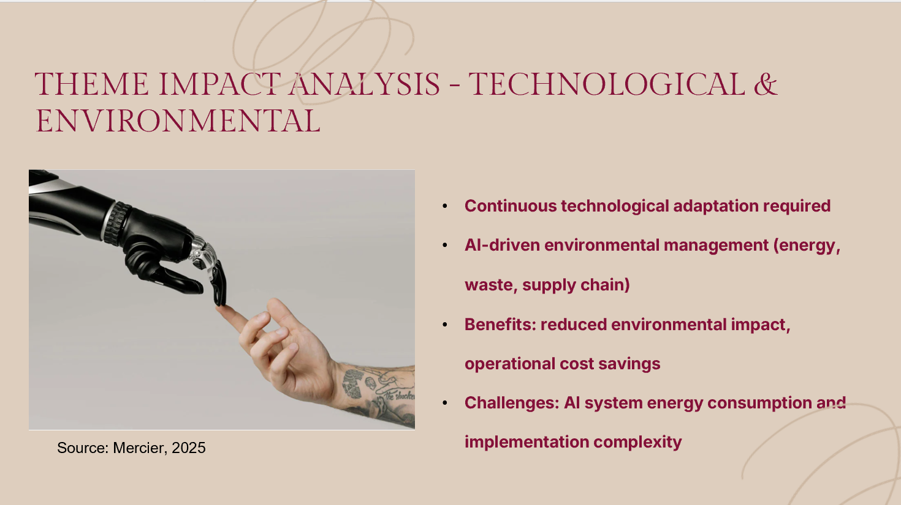
Speaker's Note:
Continuous adaptation pressures are brought about by technological advancement reported by Chkoniya (2021). Socaci (2020) discusses environmental considerations in the context of AI implementation as energy management systems, waste reduction algorithms and resource optimisation tools. The responses that the industry takes are AI-driven environmental management, which deals with lowering energy consumption, cutting food waste, which is among the issues brought up by Danzer and Zeidler (2025), and optimisation of the supply chain. Strengths include the reduction of environmental impacts and cost savings in operation. Limitations are the energy consumption and the complexity of the implementation of AI systems. Sharma, Singh and Tyagi (2024) mention that the use of technology should be regenerative, not only in regard to the environmental sustainability objectives but also in terms of authenticity in the experiences of guests.

SLIDE 10: CONCLUSION
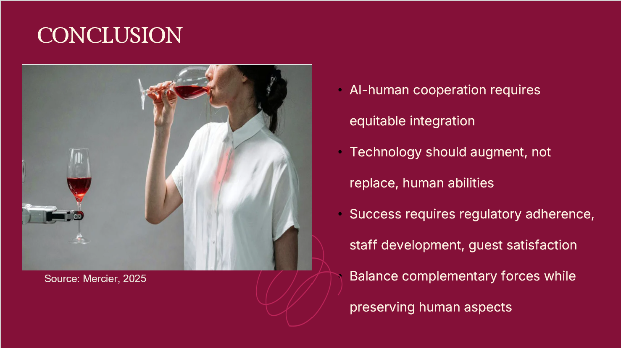
Speaker's Note:
This study confirms that ideal AI-human cooperation should possess the equitable integration that supports and not substitutes human abilities. It will require extensive structures, including regulatory adherence, staff advancement, visitor satisfaction and environmental sustainability. Authentic hospitality cannot be provided by technology only. AI should increase human functionality without sacrificing interpersonal relations, which characterise sectoral excellence. It is not a matter of opposing technology and humanity, but a coordinated balance of the complementary forces and saving the humane aspect of hospitality.

SLIDE 11: RECOMMENDATIONS - STRATEGIC IMPLEMENTATION
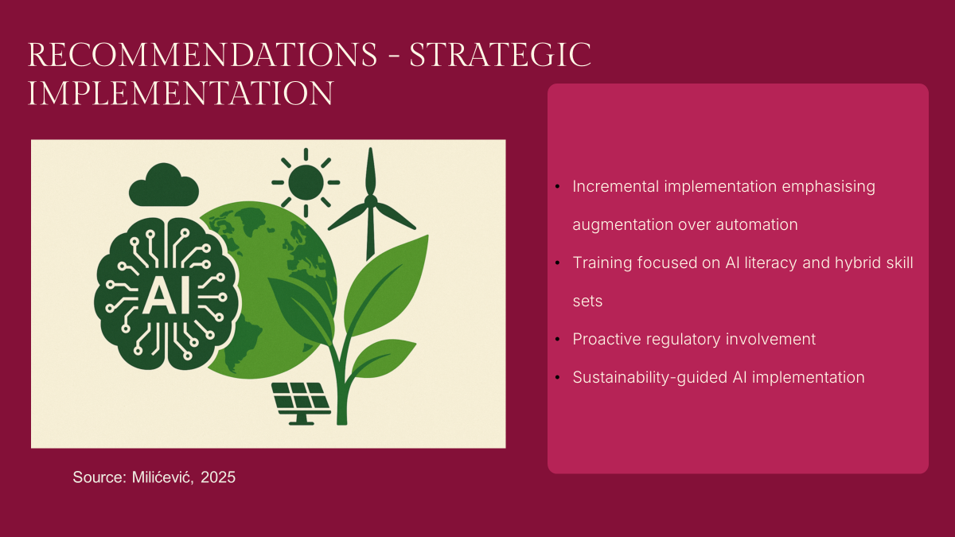
Speaker's Note:
I provide strategic recommendations based on detailed analysis. To begin with, organisations need to implement incremental implementation where augmentation is emphasised more than automation. AI​‍​‌‍​‍‌​‍​‌‍​‍‌ should not be a substitute for human efforts. Besides that, development should be carried out in a way that the workforce can use AI and still provide good services. The training should concentrate on AI literacy and hospitality skills, and hybrid skill sets should be created.
Besides that, there should be a proactive regulation involvement. Organisations have to be engaged in the determination of frameworks of liability, data protection, and ethical AI standards. Industry associations should also collaborate with policymakers to establish some governance structures that would guarantee that innovation and consumer protection are balanced.
Lastly, AI adoption should be a sustainability principle-based approach that, on the one hand, gives the technologies a chance to embody environmental goals and, on the other hand, makes them environmentally friendly. This is to comprise, among other things, a lifecycle assessment, the use of renewable energy, and algorithm optimisation for both resource conservation and revenue ​‍​‌‍​‍‌​‍​‌‍​‍‌maximisation.

SLIDE 12: RECOMMENDATIONS - EVALUATION & COLLABORATION
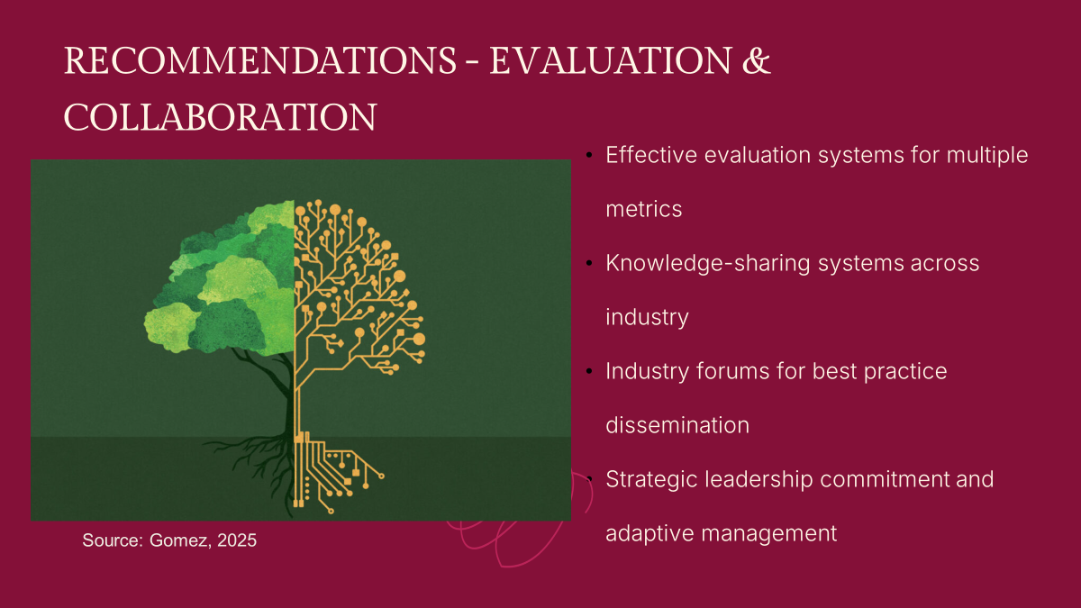
Speaker's Note:
Fourth,​‍​‌‍​‍‌​‍​‌‍​‍‌ organisations should develop proper evaluation systems that can measure the success of AI implementation in the areas of guest satisfaction, employee well-being, operational efficiency, and service quality. Evaluation systems should be capable of combining both quantitative and qualitative feedback, thus providing detailed insights into the impact of AI on the essential promise of human connection in the hospitality ​‍​‌‍​‍‌​‍​‌‍​‍‌industry.
Furthermore, the knowledge-sharing systems in collaboration should be created, which has been suggested as the best practice (Sharma, Singh and Tyagi, 2024) and which will allow disseminating best practices and learning AI applications. Learning collectively can be expedited by forums taking place nationwide in the industry, as proposed by the World Trade Organisation (2026). Finally, strategic leadership commitment and responsive adaptive management in line with the changing technological capabilities are the key to effective AI-human collaboration.

SLIDE 13: FINAL THOUGHTS & QUESTIONS

Speaker's Note:
Going through this epochal time, it is important to remember that artificial intelligence is an instrument, though mighty, nonetheless, an instrument. Hospitality has always been human in nature. The problem that we face is the ability to use technology to increase our ability to be truly connected and have memorable experiences. AI is already here. The challenge is how we are going to make sure that it benefits our utmost dreams and does not lower the much-needed humanity in us. Thank​‍​‌‍​‍‌​‍​‌‍​‍‌ you for your attention, and I would be happy to answer your ​‍​‌‍​‍‌​‍​‌‍​‍‌questions.

SLIDE 14: REFERENCES
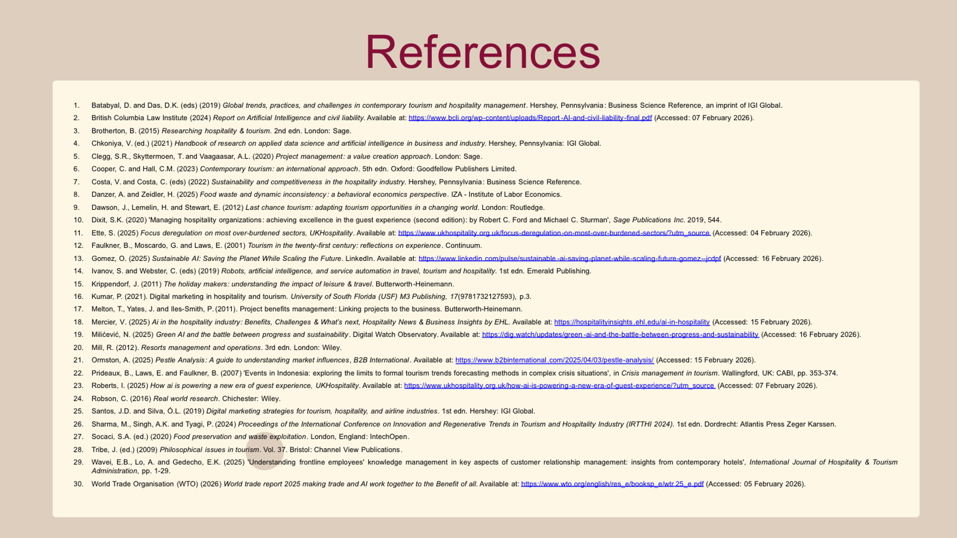
- Batabyal, D. and Das, D.K. (eds) (2019) Global trends, practices, and challenges in contemporary tourism and hospitality management. Hershey, Pennsylvania: Business Science Reference, an imprint of IGI Global.
- British Columbia Law Institute (2024) Report on Artificial Intelligence and civil liability. Available at: https://www.bcli.org/wp-content/uploads/Report-AI-and-civil-liability-final.pdf (Accessed: 07 February 2026).
- Brotherton, B. (2015) Researching hospitality & tourism. 2nd edn. London: Sage.
- Chkoniya, V. (ed.) (2021) Handbook of research on applied data science and artificial intelligence in business and industry. Hershey, Pennsylvania: IGI Global.
- Clegg, S.R., Skyttermoen, T. and Vaagaasar, A.L. (2020) Project management: a value creation approach. London: Sage.
- Cooper, C. and Hall, C.M. (2023) Contemporary tourism: an international approach. 5th edn. Oxford: Goodfellow Publishers Limited.
- Costa, V. and Costa, C. (eds) (2022) Sustainability and competitiveness in the hospitality industry. Hershey, Pennsylvania: Business Science Reference.
- Danzer, A. and Zeidler, H. (2025) Food waste and dynamic inconsistency: a behavioral economics perspective. IZA - Institute of Labor Economics.
- Dawson, J., Lemelin, H. and Stewart, E. (2012) Last chance tourism: adapting tourism opportunities in a changing world. London: Routledge.
- Dixit, S.K. (2020) 'Managing hospitality organizations: achieving excellence in the guest experience (second edition): by Robert C. Ford and Michael C. Sturman', Sage Publications Inc. 2019, 544.
- Ette, S. (2025) Focus deregulation on most over-burdened sectors, UKHospitality. Available at: https://www.ukhospitality.org.uk/focus-deregulation-on-most-over-burdened-sectors/?utm_source (Accessed: 04 February 2026).
- Faulkner, B., Moscardo, G. and Laws, E. (2001) Tourism in the twenty-first century: reflections on experience. Continuum.
- Gomez, O. (2025) Sustainable AI: Saving the Planet While Scaling the Future. LinkedIn. Available at: https://www.linkedin.com/pulse/sustainable-ai-saving-planet-while-scaling-future-gomez--jcdpf (Accessed: 16 February 2026).
- Ivanov, S. and Webster, C. (eds) (2019) Robots, artificial intelligence, and service automation in travel, tourism and hospitality. 1st edn. Emerald Publishing.
- Krippendorf, J. (2011) The holiday makers: understanding the impact of leisure & travel. Butterworth-Heinemann.
- Kumar, P. (2021). Digital marketing in hospitality and tourism. University of South Florida (USF) M3 Publishing, 17(9781732127593), p.3.
- Melton, T., Yates, J. and Iles-Smith, P. (2011). Project benefits management: Linking projects to the business. Butterworth-Heinemann.
- Mercier, V. (2025) Ai in the hospitality industry: Benefits, Challenges & What’s next, Hospitality News & Business Insights by EHL. Available at: https://hospitalityinsights.ehl.edu/ai-in-hospitality (Accessed: 15 February 2026).
- Milićević, N. (2025) Green AI and the battle between progress and sustainability. Digital Watch Observatory. Available at: https://dig.watch/updates/green-ai-and-the-battle-between-progress-and-sustainability (Accessed: 16 February 2026).
- Mill, R. (2012). Resorts management and operations. 3rd edn. London: Wiley.
- Ormston, A. (2025) Pestle Analysis: A guide to understanding market influences, B2B International. Available at: https://www.b2binternational.com/2025/04/03/pestle-analysis/ (Accessed: 15 February 2026).
- Prideaux, B., Laws, E. and Faulkner, B. (2007) 'Events in Indonesia: exploring the limits to formal tourism trends forecasting methods in complex crisis situations', in Crisis management in tourism. Wallingford, UK: CABI, pp. 353-374.
- Roberts, I. (2025) How ai is powering a new era of guest experience, UKHospitality. Available at: https://www.ukhospitality.org.uk/how-ai-is-powering-a-new-era-of-guest-experience/?utm_source (Accessed: 07 February 2026).
- Robson, C. (2016) Real world research. Chichester: Wiley.
- Santos, J.D. and Silva, Ó.L. (2019) Digital marketing strategies for tourism, hospitality, and airline industries. 1st edn. Hershey: IGI Global.
- Sharma, M., Singh, A.K. and Tyagi, P. (2024) Proceedings of the International Conference on Innovation and Regenerative Trends in Tourism and Hospitality Industry (IRTTHI 2024). 1st edn. Dordrecht: Atlantis Press Zeger Karssen.
- Socaci, S.A. (ed.) (2020) Food preservation and waste exploitation. London, England: IntechOpen.
- Tribe, J. (ed.) (2009) Philosophical issues in tourism. Vol. 37. Bristol: Channel View Publications.
- Wavei, E.B., Lo, A. and Gedecho, E.K. (2025) 'Understanding frontline employees' knowledge management in key aspects of customer relationship management: insights from contemporary hotels', International Journal of Hospitality & Tourism Administration, pp. 1-29.
- World Trade Organisation (WTO) (2026) World trade report 2025 making trade and AI work together to the Benefit of all. Available at: https://www.wto.org/english/res_e/booksp_e/wtr25_e.pdf (Accessed: 05 February 2026).

