

Changemakers: Building Your Personal Brand for Sustainable Employment (BMHP5015)

Assignment Title: Component 1 – Online Portfolio

Student ID: 2336623
Student Name: Tania Habib
Lecturer Name: G1 Caroline Salami (module Leader) , G2 Christopher Mafuva
Date of submission: 10.04.2026
Word count: 2084

Declaration: I am declaring that AI technology is not used for completion this report but only for Spelling and Grammer check Microsoft word correction process applied.

Table of Contents
Introduction 3
Task 1 – Reflection on Unit 1: Brand You 3
Screenshots of Understanding Self-Determination 4
Screenshots of Self-Awareness in Health and Social Care 5
Task 2 – Reflection on Unit 2: It’s a Small World 5
Screenshots of Understanding Informed Consent and Decision-Making in Diverse Healthcare Contexts 6
Screenshots of Forum Discussion on Patient Autonomy in Health and Social Care Practice 7
Screenshots of Reflection on the Importance of Networking in a Global Health and Social Care Environment 7
Task 3 – Reflection on Unit 3: Opportunity Knocks 8
Screenshots of Achieving Success in Health and Social Care 9
Screenshots of Changing Perspectives in Health and Social Care 9
Task 4 – Reflection on Unit 4: The Pursuit of Happiness 10
Screenshots of Career Goals After BSc Completion 11
Screenshots of Vaccine Persuasion Methods 11
Screenshots of Emotional Intelligence in Health and Social Care 12
Conclusion 12
References 13

Introduction
This portfolio is a critical reflection of learning acquired throughout the four module units in this course. The aim is to measure the personal branding and employability competencies in a health and social care setting. The chosen professional role is the Healthcare Assistant, and all reflections and applications in this portfolio are guided by this role. Personal branding plays a role in the presentation of professional identity, skills, and values in the healthcare environment (Szánto et al., 2025). Self-awareness helps in proper behaviour, communication, and making decisions in clinical settings (Harley, 2024). The necessary skills include employability skills as the demands on the workforce continue to rise across healthcare systems around the world (World Health Organisation, 2023). This portfolio will contemplate Units 1 to 4, in terms of personal growth, world awareness, career prospects, and well-being. The objectives of these reflections are to enhance professional preparedness and facilitate effective practice in healthcare settings.

Task 1 – Reflection on Unit 1: Brand You
Unit 1 was based on the learning of personal branding in professional healthcare settings and contexts. The lectures described the means by which people introduce themselves and demonstrate their professional worth in an adequate manner. It emphasised the role of self-awareness and professional identity in career development procedures. Personal branding is the process of portraying skills, behaviours, and values in order to develop a professional identity (Szánto et al., 2025). Self-awareness helps to realise the strengths, weaknesses, and behavioural patterns in practice scenarios (Harley, 2024). Professional identity is a concept that demonstrates how people identify themselves in their selected healthcare pathway (Hinkley et al., 2022). The combination of these ideas leads to employability and professional development.
This unit has contributed greatly to my knowledge of the concept of employability in healthcare settings and practice. I used to think that professional healthcare positions were won by technical skills only. Nevertheless, I also came to know that perception and self-presentation have a great impact on career prospects and career advancement. The self-assessment activities helped me to determine my strengths, such as empathy and good communication skills. These are the strengths that one needs to relate to patients in a healthcare setting in a respectful manner. Nevertheless, I have also identified some areas of weakness in confidence and professional self-presentation during discussions. This is indicative of the research that has connected employability with self-branding behaviours in competitive job markets (Mutanen et al., 2023). My previous knowledge had a weakness in that I was only looking at skills that were not presented. This unit enabled me to realise that I should be able to align behaviour and professional expectations.
These notions are very applicable in the Healthcare Assistant position in actual practice setups. Healthcare Assistants are expected to be professional, empathetic and reliable in their daily interactions with patients. A powerful personal brand helps to build trust among patients and members of the healthcare team. In this case, clear communication will lead to better patient comprehension and improve the overall care experience outcomes. Self-awareness also aids in controlling emotional reactions in stressful healthcare experiences in a better way. Professional identity guarantees the correspondence to ethical principles and organisational requirements in medical facilities. This is necessary in ensuring patient safety and the provision of uniform quality care services. Accordingly, personal branding is a theoretical and practical need in healthcare positions.

Screenshots of Understanding Self-Determination
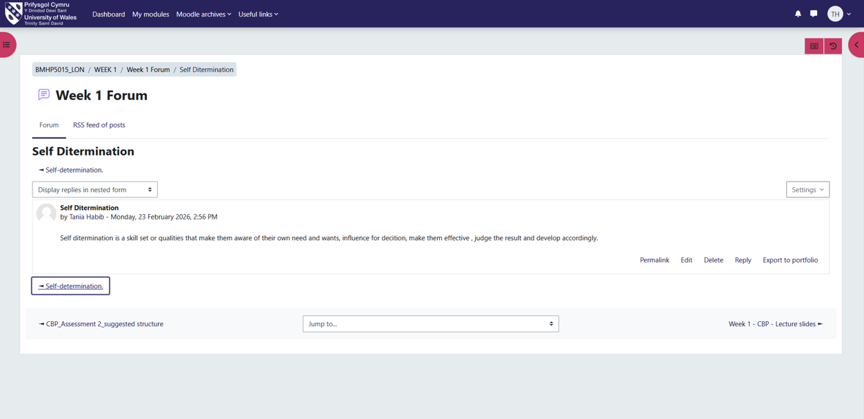

Screenshots of Self-Awareness in Health and Social Care
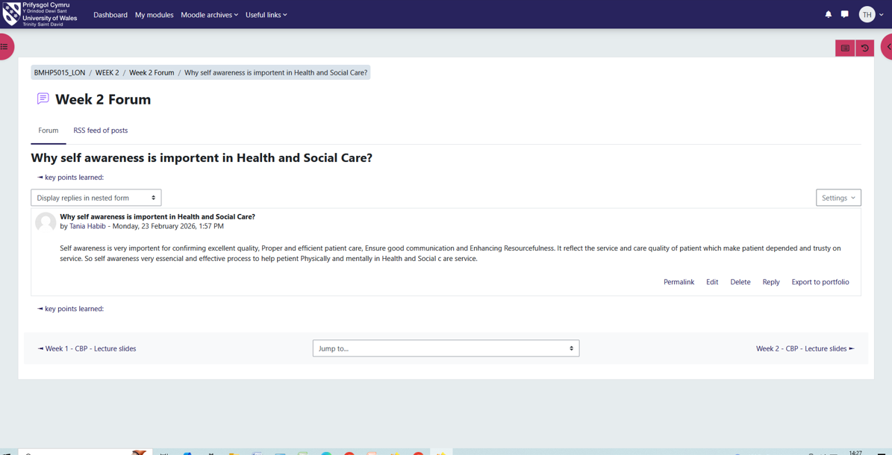
In general, this unit was able to gain a crucial understanding of individual strengths and professional identity. These lessons will aid in further progress and enhance employability in healthcare settings.

Task 2 – Reflection on Unit 2: It’s a Small World
Unit 2 was devoted to the learning of healthcare in the global and interconnected landscape and setting. The lectures clarified the impact of globalisation on healthcare systems, labour mobility and service provision. It emphasised the significance of diversity and inclusion in the contemporary healthcare practice context. Globalisation in healthcare can be defined as a process of expanding the interconnection of health systems of various countries (World Health Organisation, 2023). Cultural competence means being aware of cultural differences and adjusting the care to the patient's needs (Lee et al., 2025). Among the patients, there are variations in language, culture, beliefs, and social backgrounds. These ideas will be instrumental in providing safe and effective patient-centred care (Osmancevic et al., 2025). These concepts promote inclusive practice in health care systems across the world.
This unit enhanced my sensitivity to global diversity in healthcare practice both critically and significantly. In the past, I did not realise the importance of cultural differences in communication and patient care outcomes. I was informed that misconceptions may decrease the level of treatment and satisfaction of patients. Online, I also learned about illustrations of healthcare issues in various cultural settings. These tasks enhanced my knowledge of inclusive and respectful communication with patients. I also realised the need to personalise care depending on the needs of different patients. This is an indication of studies that have identified cultural competence as the key to successful healthcare delivery (Correa-Betancour et al., 2024). One of the weaknesses of my earlier knowledge was that I did not pay attention to the influence of cultural diversity. This unit enhanced my skills in taking into account various patient views when providing care.
The concepts are very applicable to the Healthcare Assistant position in the actual practice settings. Patients with different cultural and social backgrounds are usually assisted by Healthcare Assistants daily. Communication is effective to assure patients of respect, understanding, and comfort in the provision of care. Cultural competence is effective in avoiding misunderstanding and enhancing patient safety and satisfaction outcomes. As an example, adhering to religious beliefs or food preferences is a way to enhance the experience of a patient. Equality and lessening discrimination in healthcare service settings are also encouraged by inclusion. The practices enhance ethical practices and enhance the overall quality of healthcare delivery. Thus, the skills will be fundamental to providing excellent and non-discriminatory patient-centred care.

Screenshots of Understanding Informed Consent and Decision-Making in Diverse Healthcare Contexts
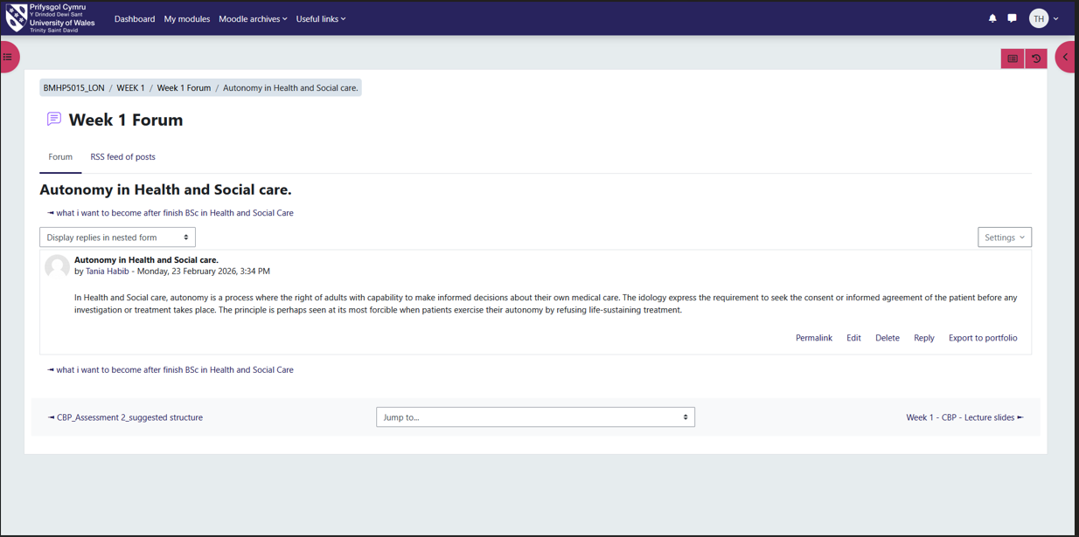

Screenshots of Forum Discussion on Patient Autonomy in Health and Social Care Practice
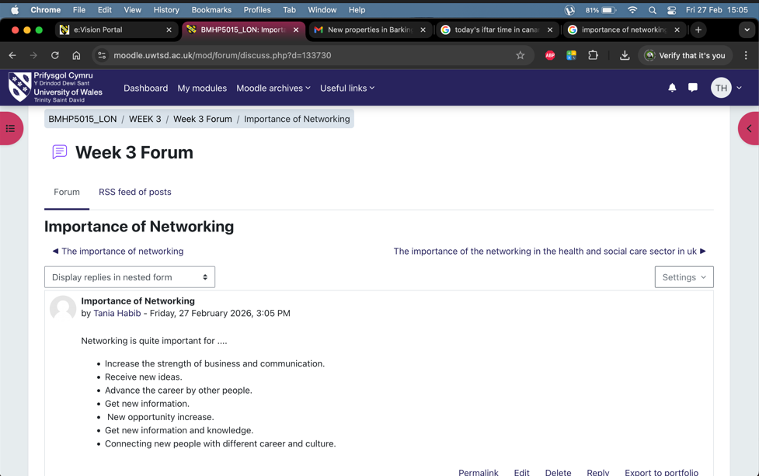

Screenshots of Reflection on the Importance of Networking in a Global Health and Social Care Environment
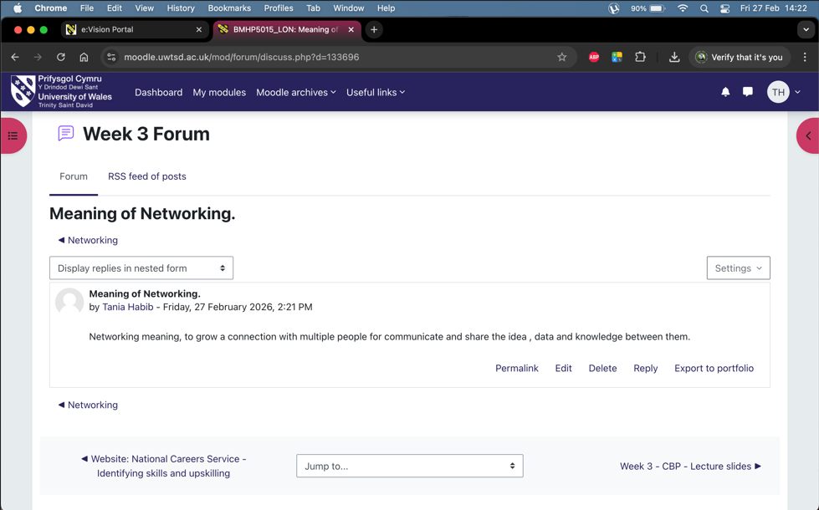
Altogether, this unit helped me to comprehend the healthcare and cultural diversity in the world. Such lessons will enhance my practice of inclusive and effective care.

Task 3 – Reflection on Unit 3: Opportunity Knocks
Unit 3 was devoted to career building and identifying the opportunities in the healthcare sector and practice. The lectures covered employability skills, career paths, and networking as a means of professional development. These subjects were to prepare the students to be ready to work in the real healthcare employment setting. Employability skills are communication skills, teamwork, and problem-solving needed in healthcare work (Mutanen et al., 2023). The healthcare area is experiencing a growth in career opportunities because of the rising workforce demand and pressure in the services (NHS England, 2023). Networking is the process of creating professional contacts that facilitate career advancement and the availability of opportunities. These ideas are fundamental to long-term success in the health and social care sectors.
This unit allowed me to discover areas of my development as a professional and career planner. I realised that experience and the ability to communicate are key to success in employment. I assessed my existing skills through the work on CV development and career planning activities. I also found the following strengths, including empathy, teamwork and readiness to learn within healthcare settings. Nevertheless, I also realised that I had flaws in confidence and professional communication during formal situations. This echoes studies indicating that employability is contingent upon lifelong skills acquisition and self-presentation practices (Mutanen et al., 2023). One of the weaknesses is the lack of experience, which may limit access to some opportunities.
Importantly, this unit identified my strengths and aspects that need improvement in order to develop. I have good interpersonal skills, which are my strong points that facilitate patient communication and collaboration. Nevertheless, deficiencies in skills, such as a lack of confidence, can influence performance in job applications. Career progression may be limited by barriers like inexperience and poor networking. The workforce approaches prioritise the necessity of competent and flexible healthcare professionals (Skills for Care, 2025). Thus, it is necessary to fill these gaps to enhance the consequences of employability in healthcare fields.
These notions have a direct application to the Healthcare Assistant job in a real practice setting. An efficient career path promotes advancement in the health and social care services. Effective patient care delivery would require employability skills like teamwork and communication. Networking facilitates the acquisition of training, development programmes, and jobs within health care environments. So, career success requires the development of these competencies.

Screenshots of Achieving Success in Health and Social Care
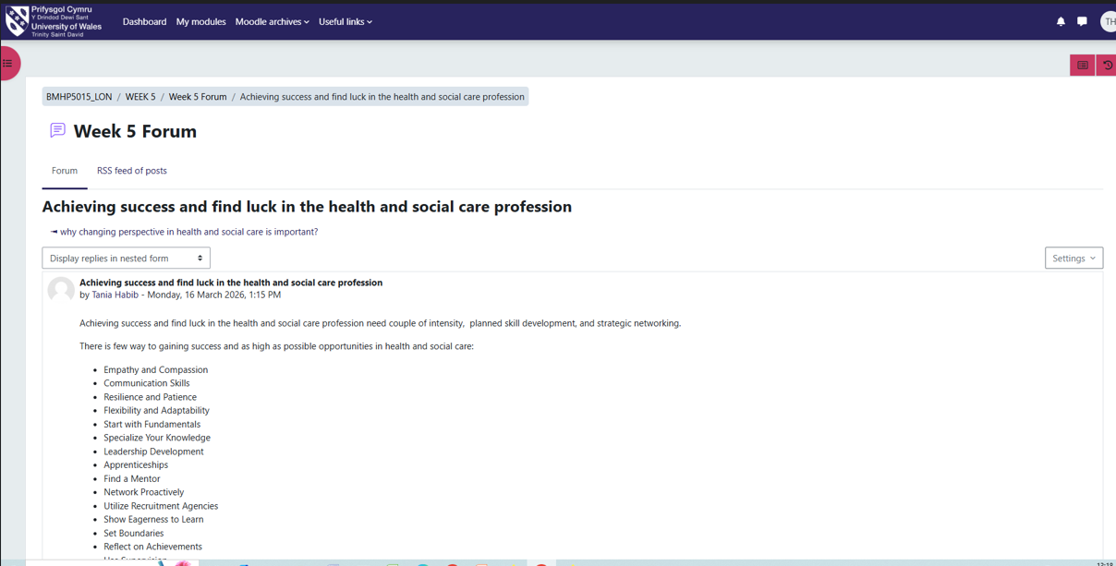

Screenshots of Changing Perspectives in Health and Social Care
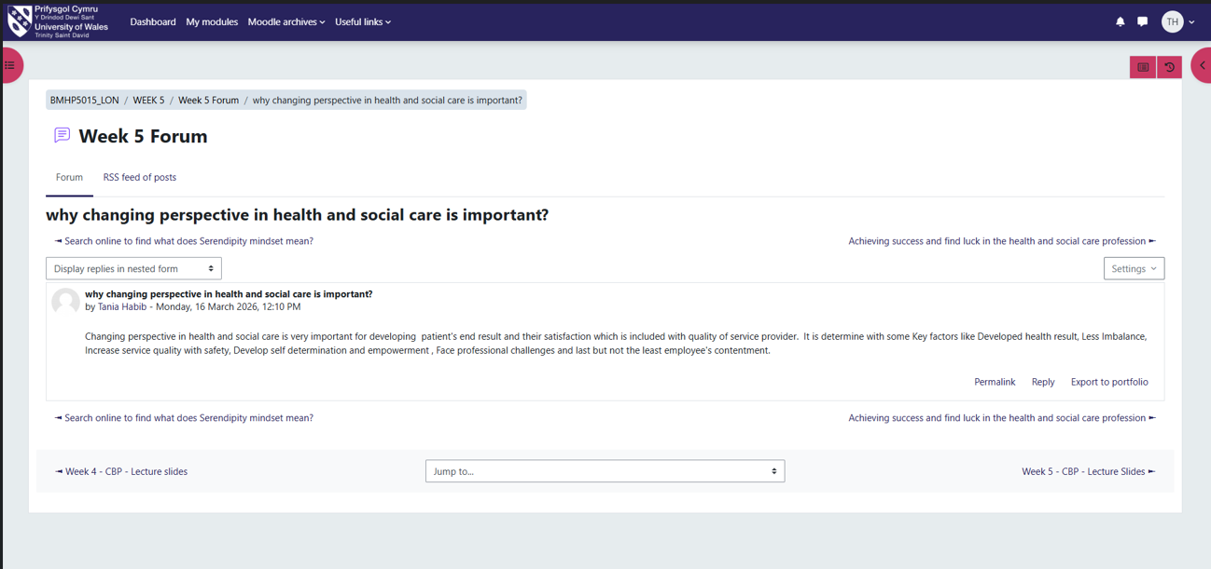
On the whole, this unit made me more aware of career opportunities and employability development. These lessons will help me to enter the professional healthcare sphere.

Task 4 – Reflection on Unit 4: The Pursuit of Happiness
Unit 4 concentrated on welfare, motivation, and professional satisfaction in the healthcare settings. The lectures described the importance of being well in order to ensure long-term performance and sustainability in a career. It focused on emotional need and workload in difficult healthcare jobs. Well-being is a term used to describe physical, emotional and psychological health in professional practice contexts (Sarfjoo Kasmaei et al., 2025). Work-life balance is the harmony of alignment between work and personal life responsibility. Motivation has an impact on engagement, job satisfaction, and performance in healthcare settings. It has been found that job satisfaction increases when person-centred methods are used to provide care (Gustavsson et al., 2023).
This unit made a tremendous impact on my perception of well-being within healthcare practice environments. In the past, I did not appreciate the influence of stress and workload on performance and mental health. I thought that professional commitment meant that one has to put work over personal well-being at all times. Nevertheless, I got to know that the lack of attention to well-being can make performance less efficient and cause burnout. I tested my coping skills and reactions to stressful experiences through reflective activities. I defined such strengths as the ability to adjust to new circumstances and the readiness to obtain help when required. Nevertheless, I also realised shortcomings in having a regular work-life balance when the time is hectic. In their workforce reports, the role of well-being in the sustainability of care services is emphasised (Social Care Wales, 2025). A limitation of my previous approach was ignoring the long-term effects of stress.
These ideas are very applicable to the Healthcare Assistant position in the actual practice setting. Healthcare Assistants face emotionally straining and physically challenging care scenarios daily. Stress management guarantees stable performance and minimises the chances of burnout in the long term. Well-being helps in positive interaction with the patients and enhances the quality of care. To illustrate, emotionally stable employees are more responsive to patient needs and concerns. The focus of workforce strategies is on the well-being of staff to ensure the quality of service and safety (NHS England, 2023). Thus, these competencies are critical in providing safe and caring care.

Screenshots of Career Goals After BSc Completion
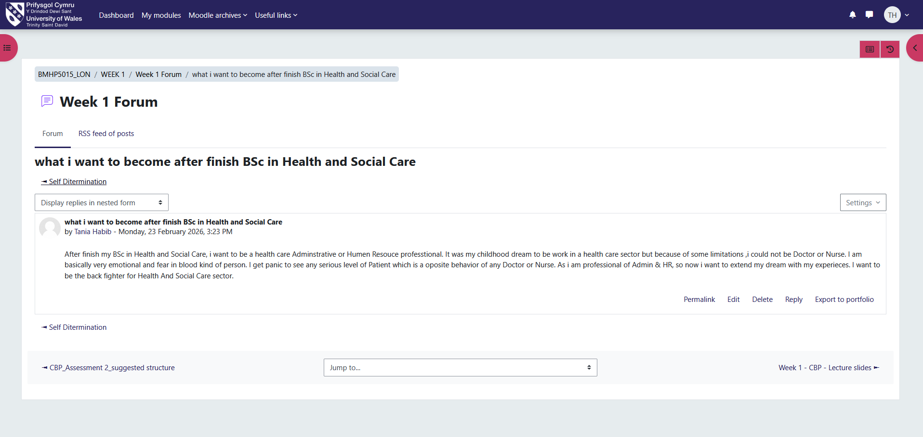

Screenshots of Vaccine Persuasion Methods
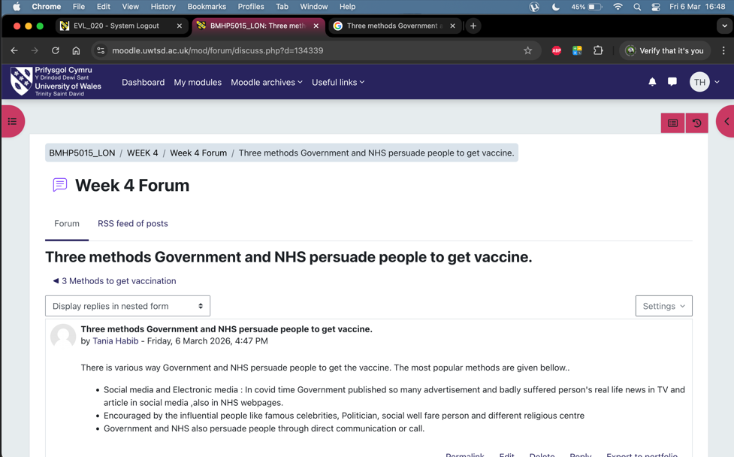

Screenshots of Emotional Intelligence in Health and Social Care
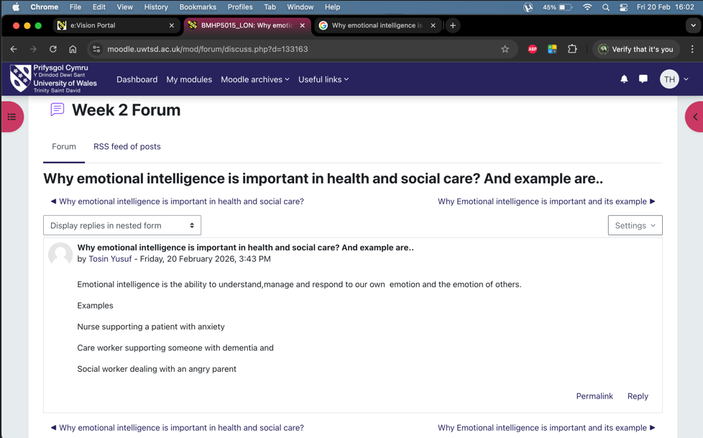
On the whole, this unit enhanced my knowledge of well-being and motivation in healthcare professions. These lessons foster long-term professional growth and patient care.

Conclusion
This portfolio has critically looked at the learning gained in all four module units. Unit 1 enhanced the knowledge of personal branding, self-awareness, and professional identity development. Unit 2 improved awareness of global healthcare systems, cultural competence, and diversity in practice. Unit 3 improved the understanding of employability skills, career prospects, and professional networking. Unit 4 gained knowledge of well-being, motivation, and work-life balance in healthcare roles. Such learning opportunities have helped me to build personal branding and employability skills that are needed in professional practice. They have also enhanced confidence, communication, and preparedness for actual healthcare settings. All in all, these lessons will assist me in my future profession as a Healthcare Assistant and a successful provider of patient-centred care. They also promote lifelong learning, flexibility, and professionalism in various health care environments. This learning will inform my professional behaviour and facilitate long-term career success in the health and social care setting.

References
Correa‐Betancour, M., Chiarella, M. and Short, S.D. (2024). Intraprofessional cultural competence in nursing regulation: A critical content analysis of standards and codes in the United Kingdom, New Zealand and Australia. Nursing inquiry, 31(4). doi: https://doi.org/10.1111/nin.12652.
Gustavsson, K., Diepen, C. van, Fors, A., Axelsson, M., Bertilsson, M. and Hensing, G. (2023). Healthcare Professionals’ Experiences of Job Satisfaction When Providing person-centred care: a Systematic Review of Qualitative Studies. BMJ Open, [online] 13(6). doi: https://doi.org/10.1136/bmjopen-2022-071178.
Harley, J. (2024). Developing self-awareness for effective nurse leadership. [online] Dntb.gov.ua. Available at: https://ouci.dntb.gov.ua/en/works/4NKOy2Yl/.
Heli Mutanen, Korhonen, M. and Päivi Siivonen (2023). Employability as Self-branding in Job Search Games: A Case of Finnish Business Graduates. pp.319–339. doi: https://doi.org/10.1007/978-3-031-20653-5_15.
Hinkley, T.-L. (Terri), Kuhl, L. and Liebig, D. (2022). Professional Identity in Nursing. Nurse Leader, 21(2). doi: https://doi.org/10.1016/j.mnl.2022.12.006.
Lee, Y., Sung, S. and Fan, X. (2025). Cultural competency education for healthcare professionals: an umbrella review. BMC Medical Education, 25(1). doi: https://doi.org/10.1186/s12909-025-08008-7.
NHS England (2023) NHS Long Term Workforce Plan. Available at: https://www.england.nhs.uk/publication/nhs-long-term-workforce-plan
Osmancevic, S., Steiner, L.M., Großschädl, F., Lohrmann, C. and Schoberer, D. (2025). The effectiveness of cultural competence interventions in nursing: A systematic review and meta-analysis. International Journal of Nursing Studies, [online] 167(2). doi: https://doi.org/10.1016/j.ijnurstu.2025.105079.
Sarfjoo Kasmaei, Maryam, Freeman, S., Banner, D., Klassen-Ross, T. and Martin-Khan, M. (2025). Job Satisfaction and Well-Being of Care Aides in Long-Term Care During the COVID-19 Pandemic: A Comprehensive Literature Review. World, [online] 6(2), p.62. doi: https://doi.org/10.3390/world6020062.
Skills for Care (2025a) A Workforce Strategy for Adult Social Care in England. Available at: https://www.skillsforcare.org.uk/Workforce-Strategy/Home.aspx
Social Care Wales (2025) Workforce well-being annual report: 2024 to 2025. Available at: https://socialcare.wales/resources-guidance/health-and-well-being-resources/workforce-well-being-annual-report-2024-to-2025
Szántó, P., Papp-Váry, Á. and Radácsi, L. (2025). Research Gap in Personal Branding: Understanding and Quantifying Personal Branding by Developing a Standardised Framework for Personal Brand Equity Measurement. Administrative Sciences, [online] 15(4), p.148. doi: https://doi.org/10.3390/admsci15040148.
World Health Organisation (2023). Key issues for the health workforce in the Global Monitoring Report 2023. Available at: https://www.who.int/publications/m/item/2023_hwf_gmr

