

HUMAN RESOURCE MANAGEMENT
LCMB7000

COURSE: MBA General Management
MODULE CODE: LCMB7000
ASSIGNMENT TITLE: 1
STUDENT NAME: Ashfaque Kakappara
STUDENT NO: 2131199
LECTURER: Dr Gladius Kulothungan

TABLE OF CONTENTS

SL.NO | TITLE | PAGE.NO
1. | Introduction. | 3
2. | Main body. | 3
2.1 | Evaluating the current state of the UK labor market in the post-Brexit and covid circumstances. | 3
3. | Assessing the emerging changes in human resource strategies in the post-Brexit environment. | 9
3.1 | Analysing the emerging changes in human resource strategies in the post-covid environment. | 11
4. | Conclusion. | 13
5. | References. | 14

1. INTRODUCTION
The report evaluates the UK’s current state of the labor market. The paper also analyzes the external environment’s emerging changes in Human resource strategies with regard to post covid, post-Brexit which is by assessing the business and managerial atmospheres of the region.
2. MAIN BODY
2.1. Evaluating the current state of the UK labor market in the post-Brexit and covid circumstances.
The UK initiated a referendum to decide about exiting the European Union in 2016 which ultimately led to their exit in 2020(Haider Ali Zaidi et al., no date). Brexit had a heterogenic impact on varied sectors and regions that affect the competitive position of firms in both the UK and Europe(Thissen et al., 2020). The international competitive vulnerabilities are larger in the UK when compared to EU regions it is due to the dependency of the UK on the EU via global value chains(Blackaby, 2018). The sterling depreciation after the vote for Brexit has reduced real wages by 4%(Breinlich et al., 2022). Wages have been impacted by first-time stagnation after the worst being in 1860, the wages average as of 2022 when considered experience a 2.6% decreased level below the pre-crisis peak(Arsalidou and Lui, no date a). The UK’s poor productivity growth since the crisis along with inflation shocks had sent wages into a negative terminal(CEPR,2022). The real wages dropped as a part of Brexit making the labor cheaper and draining the profits of the economy(Kiderlin,2022).
Brexit had a significant impact on employment rights, trade unions, and employment policy. Post Brexit UK has impacted employee rights which is by setting its own policies for labor and social standards, the mentioned rights affect the areas of employment which are from health & security working environment, restructuring, and information rights(Croner,2022). The changes that happened to the UK employment law post-Brexit are the working rights that describe the employer’s obligation to check an individual right to work in the UK which will not change and will remain likewise pre-Brexit(Practical law,2022). The clause based on immigration rights had changed as those emigrating to the UK had to follow the ‘skilled worker route’ which indicates the sponsorship of an approved employer. The rise in the rate of immigration to the UK is a key driver underpinning the decision to leave Europe(Wadsworth, 2018). The UK government and the opposite labor party decided to end ‘the freedom movement’ which was a major principle of EU law that states the right of EU members the freedom to live and work anywhere in the member states of the EU which is eliminated from the discrimination based on nationality(Powell, Francis-Devine and Clark, 2022). Post-Brexit UK government had ended the preferential treatment of the EU members and created more restricted immigration policies(Park,2021). The post-Brexit changes in salary policies in the UK are imposing a minimum salary of £25,600 for people with an intermediary level of English and a UK-A level equivalent skill. The UK-settled laborers had to apply for ‘settled status’ to work legally in the region(Gumbrell-McCormick Birkbeck and Hyman, no date). The overall employment is impacted by Brexit as there is an increase in the level of employment since the 2016 referendum (Simionescu et al., 2017)and had slowed down after 2019 but the labor market remains strong with the number of vacancies being high post-Brexit. An example of social care labor markets can be considered by assessing the social personnel who are directly engaging on a day-to-day basis with managing and recruiting staff depicted that the wages have decreased and the labor became cheap. Post-Brexit the social care managers in the UK perceive the changes that occurred in the labor market due to Brexit for workforce sustainability (Kollewe,2022). In the UK it has been seen that the labor turnover rates had increased from 28.4% during 2012- 2013 and surged to 33.85% in 2016 -2020 (Blackaby, 2018), the rate is higher among the least paid and less secured jobs(BBC,2020).

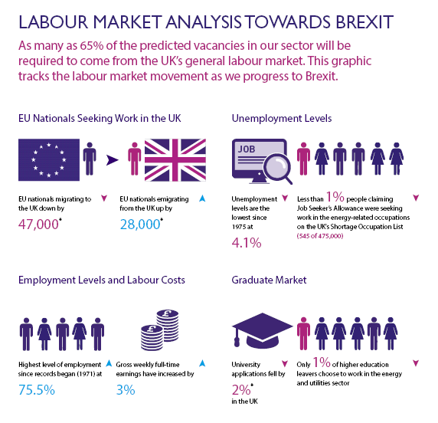
Source: (Economics Observatory,2022)
The grey area affecting the UK labor employment post Brexit is that the EU had varied initiatives to improve the labor standards whereas the UK has no similar legislation at present and UK haven’t changed certain laws that are derived from EU directives(Savic,2021). The Brexit formulated a shift in risk to workers had increased due to this Britain exit as the employees need to pay close attention to exchange rate fluctuations and shifts as they increasingly regulate the real living standards of the people(BBC,2021).
The UK labor force survey portrays that there was a significant increase in the employment rate from 2011 until the pandemic period which is march 2020 but had a fall in the level of employment rate since the lockdown was declared(Labour force survey,2022). The levels started to recover during post-covid that is by the first half of the year 2021 and remain at the same level during the latter half indicating the slowing growth of employment. The low employment rate depicts that the UK economy is close to full employment making recruitment more difficult than normal(Rakha et al., 2021). At the beginning of the year 2021, there were improved levels of unemployment and employment rates but the economic inactivity had continued to grow, creating a significant economic inactiveness when post covid situation is considered as inactive people in 2020 was 8.45 million which has increased to 8.86 million in 2021 making a smaller labor market, the people who are inactiveness grouped from age 16-64(Paterson-Young, 2021). Post covid the employment of males decreased when women are compared, the youth when compared to the oldest employees had lost their job during covid but the youth returned quickly and the oldest employees opted for retiring early(Mawani et al., 2021).
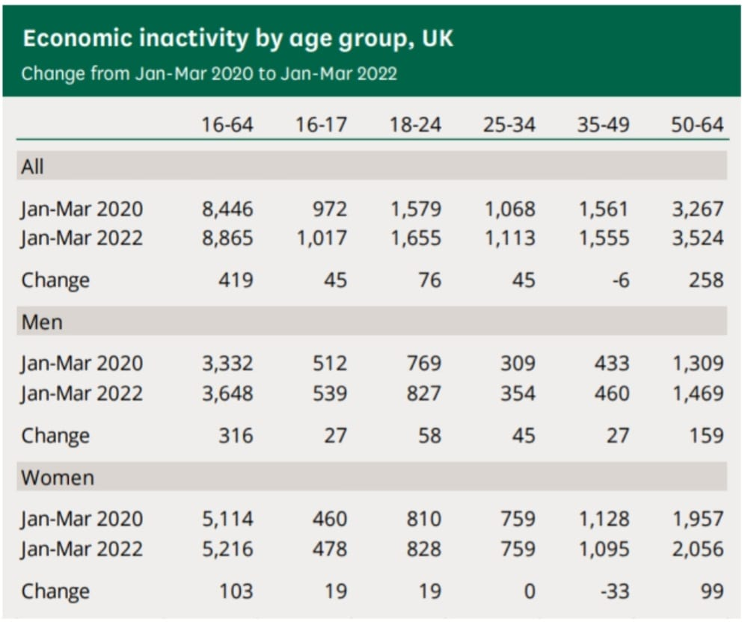
Source:(Labour force survey,2022)

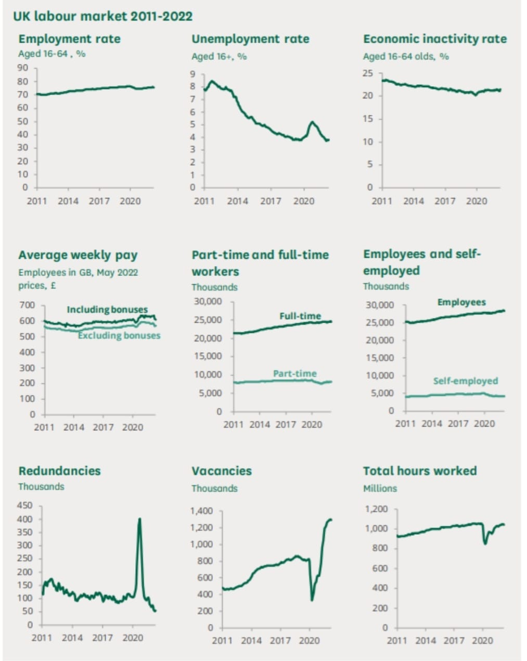
Source:(Labour force survey,2022)
The covid 19 and the UK government’s response had a major effect on the labor market, as there had a change initiation from the traditional work practices, and many companies for example google initiated hybrid working conditions to cope with the contingent situation as covid is the ongoing situation they had adopted the transformative hybrid working into their organizational structure(Arthurid, 2021). The government interventions helped the workers to be paid even when they are away from work, the precautionary measures implemented by the government post covid also made the challenging situation for the employees which is by changing their way of doing work and the potential to seek job opportunities(Wylie, no date). The UK national statistics portray that wages are stagnating, post covid the earnings are not fast-growing to keep up with inflation if at all the pay has surged it indicates the long-run effects of a covid pandemic(National statistics,2022).
The post covid the UK experienced an imbalance between labor demand and supply that cause unusual and high labor market tightness which could initiate a broad-based wage pressure resulting in a chance of posing a risk to inflation(Flynn et al., 2020). Inflation is currently at a peak position for when last 30 years considered, the people are concerned about the increase in wages to mitigate the after effect of covid which is to offset the rising cost of living(Antipova, 2021). The UK labor market is not yet recovered but is in a stage of recovery, it showcases evident signs of increased tightness and a shrink in the workforce along with diminished labor market participation(Keogh-Brown et al., 2020).
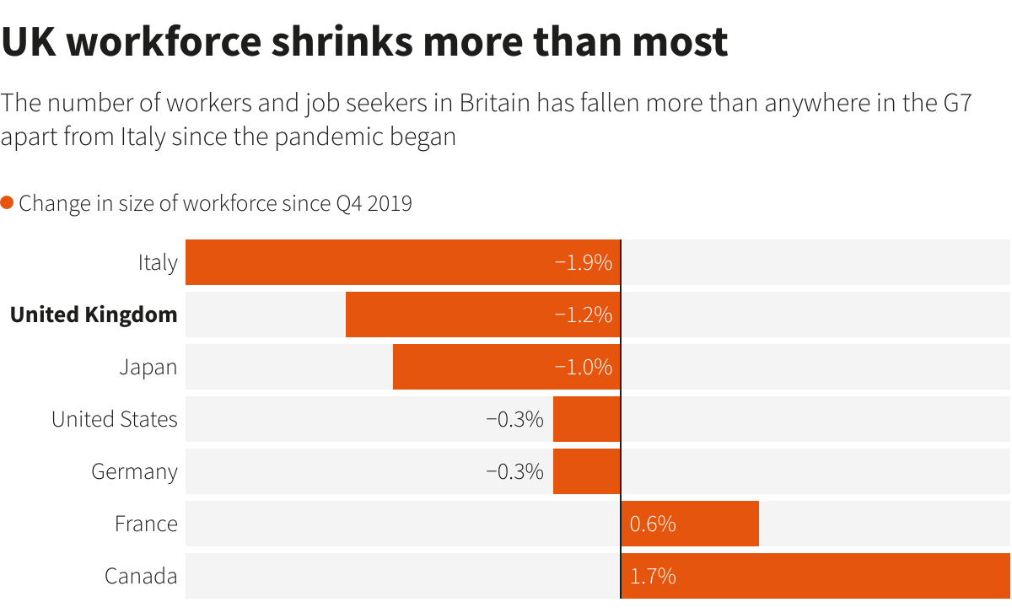
Source:( Milliken,2022)

3.Assessing the emerging changes in human resource strategies in the post-Brexit environment.
The strategic implications for HR will vary according to different organizations and industries. Employee shortages, brain drain, and rapid shifts in talent requirements are major considerations for HR teams due to the Britan exit(Nishat,2022). The HR recruitment teams in the UK have experienced a decrease in job applicants from EU member countries where there exists a short supply of talent. A survey conducted by KPMG indicates that 35% of the EU citizens working in the UK considered leaving due to Brexit as they felt less valued and welcomed (Newton,2021). KPMG also reported that the EU citizens who were urged to leave the UK are mainly highly skilled workers which are half of the respondents were Ph.D. holders and postgraduates(Newton,2021). Deloitte report suggests that in the next five years nearly half of the highly skilled workers are about to leave the UK(Allen,2022).
Post-Brexit landscape the HR managers are facing challenges in the right information gathering, scenario planning, and evaluating accurate tools for attracting, and retaining the talents in the more competitive Britan exit scenario(Arsalidou and Lui, no date b). The candidates leaving the country will not have a major impact on the business in the long term as it creates an opportunity for the UK to have more open positions for jobs than candidates(CIPD,2022). The shift in talent requirements may impact certain types of businesses making them vulnerable by creating a more dramatic shift in talent demand. A limited free trade deal between the EU and UK would remove tariffs on goods but not for services creating a structural shift in strategic people planning to create more pressure on talent functions(Watterson et al., 2022). The instability caused by Brexit compels businesses to make internal changes to remain competitive. Post Brexit UK is implementing a flexible work environment as a method of retention of employees and can attract a wide range of diverse talents, as flexibility is considered a more workplace incentive and had become a standard expectation(Zhu et al., 2020). Many recruiters are stating that the need to offer a salary hike along with other benefits to retain and attract the employees(Brignall,2021). The major changes in HR can be depicted as the shortage of skilled workers and lack of talents, the pressure on HR professionals to cope with legislative changes, and engagement tasks that take part after Brexit, and the need for creativeness to attract and retain employees and the importance of workforce management became challenging. The enterprises employing within the UK are prompt to severe rights for employees which include TUPE (Transfer of undertakings protection of employment) and time regulations, maternity entitlements, holiday entitlements, and safeguarding people from discrimination, etc(Coughlan and Shah, no date). The HR leaders have to balance the day-to-day operations with a bigger picture trend navigating Brexit’s unpredictable outcomes which are in serving in a new atmosphere market and managing the skills gaps that are by effectively allocating the resources(Gurchiek,2021).
The UK is positively impacted by the HR implications as it gets the advantage of free movement of attractive talent as the UK labor market supports the transition of skilled and unskilled labor across the border gaining their competitive edge in having access to pooling employees from varied countries(Nishat,2022). Brexit can be taken as a catalyst by HR managers to proactively embrace the effect on the UK to set up and implement a strategic role in helping the business to shape an effective functional peer by taking it as an opportunity to portray the HR value it can add on to the business that will help them to thrive with the best position during the change(Ridgway, 2019).
An example can be stated by considering Deloitte company, as it acknowledges the impact of Brexit on employees both professionally and personally so the company has planned for the upcoming changes and taken up a proactive communication policy that would support and increase employee engagement that can drive the Brexit strategy forward in future days. The enterprise considers clear, appropriate and timely communication as effective communication can initiate a successful Brexit outcome(Deloitte UK,2022).
Figure depicting Deloitte’s structured approach to effectively responds to Brexit opportunities and risks
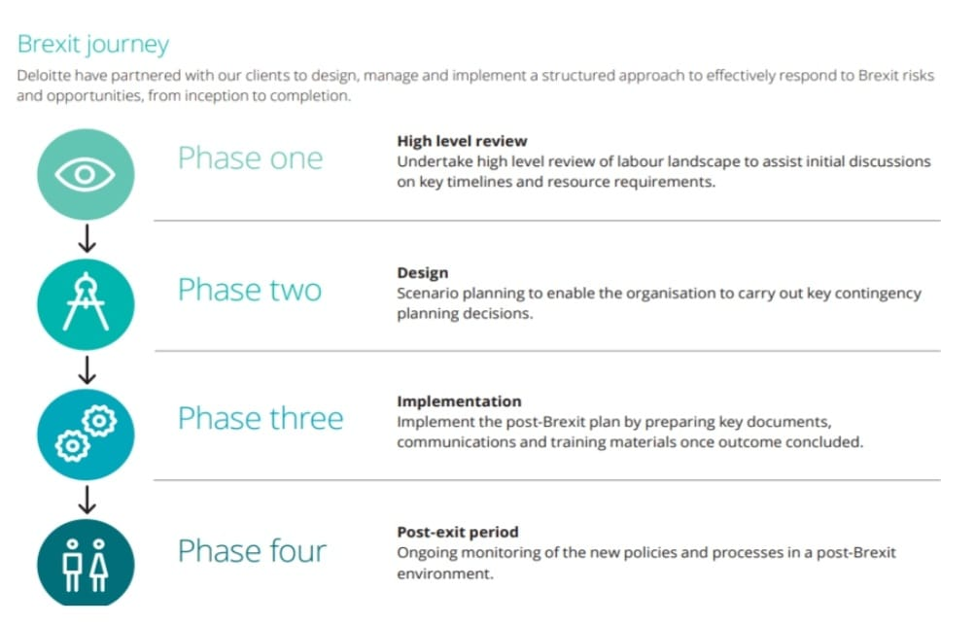
Source: (Deloitte UK,2022)
3.1.Analyzing the emerging changes in human resource strategies in the post-covid environment.
Post covid had emerged with varied changes in the UK economy and business which is the immediate and emerging demand for transitions from traditional HR practices and strategies to a ‘new normal’ that is the changing work structures, digital transformations, technological automation, etc(Zeidner et al.,2020). The covid had a major impact on the UK as it initiated a world of change in the working culture which has accelerated towards flexibility and digitalization of the working environment (Hamouche, 2021). The management is redefining an enterprise culture into a human-centric culture by majoring a purpose to making flexible work arrangements, the major shift towards a hybrid working environment that emphasizes on benefits of working both remotely and office and is a part of this flexibility(Azizi et al., 2021). The social dynamic among the employees had changed from the way it was due to the change in working conditions which is to the reduction in face-to-face interactions and a surge in workforce dispersal(Nicola et al., 2020).
Hiring professionals became stressful as the instability and unpredictability of staffing needs were difficult in forecasting due to the corvid working conditions such as market demand, political regulations like Brexit, etc creating a challenging situation for HR departments to adapt to current trends(Wadhawan,2020) Example Unilever Plc saves recruiters by using AI for hiring. Employee development responsibility is also a challenging factor for HR management as it is to reduce the stress level of employees and promote opportunities and training for career growth by minimizing the strategic costs in the hybrid working environment making it difficult for professionals(Anjum, Rahman and Rahaman, 2022). For instance, AstraZeneca promotes lifelong learning, upskilling critical capabilities, and identifies enterprise leadership and talents as a part of employee development. Digitalization is taken as an important feature by UK organizations that ensures sustainability in the future that integrates HRM policies like recruitment and selection of new employees to ensure safety while providing the firm with adequate resources(Gigauri, 2020). For example, Deloitte LLP promotes digital HR for optimizing HR service delivery. Employee engagement is also focused on initiating satisfaction surveys to identify their experience and ideas in relation to the new normal atmosphere which is also a part of the emerging change in human resource strategies relating to the covid effect(Keogh-Brown et al., 2020b). Well-being can be depicted as valuing employees and providing autonomy(Ali et al., 2019), the new HR strategies are formulated in such a way that it promotes organizing regular monitoring and check-ins of work, social interactions, and emotional support by implementing balanced structures that would benefit the organization in managing the employees in remote work conditions by satisfying and motivating them (Butterick and Charlwood, 2021). In the case of Google is a company that promoted a hybrid work environment with an open culture that promotes employee well-being.
The changes upheld in the post covid state are the imposing of diversity, equality, and inclusion policies and programs that would enhance the enterprise culture and create a work atmosphere that promotes trust, empathy, unity, and engagement(Spicer, 2020). UK organizations make a constant effort in preserving the core values and prioritize creating a work environment that puts employees in an upfront position in making decisions(Zhouid and Kan, 2021). Another change initiation is by leveraging workforce analytics to promote data-driven decision making this method enables HR to analyze employee experience, satisfaction, and engagement(Yu et al., 2021). The business was impacted by covid 19 by increasing costs, decreasing profits, and weakening the balance sheet, to retain skilled employees (Howe et al., 2021)the management has to provide motivational factors like salary hikes, rewards, and additional benefits even though the economy is negatively impacted by covid (Safuan and Kurnia, 2021)the employees are intangible assets for the company when the long term is considered as expertise employees can help enterprise attain potential growths so retain them become a major factor in this period(Kim, Vaiman and Sanders, 2022). The enterprise to remain competent in this post-covid situation continue to use the analytics method to forecast the workforce requirements along with their performance and productivity can help the firm optimize the profit and reduce costs(Bieńkowska et al., 2022).
4. Conclusion
The report details the current state of the UK labor market in post covid and Brexit circumstances. The paper also evaluates the emerging changes in HRM strategies by taking into account the Britain exit and post covid conditions by evaluating organizational business impacts and HR managers’ increased responsibilities.

5. References
Allen, K. (2022) ‘Almost half of highly skilled EU workers “could leave UK within five years”’, The Guardian, 26 June. Available at: https://www.theguardian.com/politics/2022/jun/27/eu-workers-leave-uk-deloitte-brexit (Accessed: 7 September 2022).
Ali, M. et al. (2019) ‘Re-Engineering the Human Resource Strategies Amid and Post-Pandemic Crisis: Probing into the Moderated Mediation Model of the High-Performance Work Practices and Employee’s Outcomes’, Frontiers in Psychology | www.frontiersin.org, 1, p. 710266. doi:10.3389/fpsyg.2021.710266.
Anjum, N., Rahman, Md.M. and Rahaman, Md.S. (2022) ‘Challenges for HR Professionals in the Post-COVID-19 Era’, Journal of Business Strategy Finance and Management, 04(01), pp. 05–11. doi:10.12944/jbsfm.04.01.02.
Antipova, A. (2021) ‘Analysis of the COVID-19 impacts on employment and unemployment across the multi-dimensional social disadvantaged areas’, Social Sciences & Humanities Open, 4(1), p. 100224. doi:10.1016/j.ssaho.2021.100224.
Arsalidou, D. and Lui, A. (no date a) Post Brexit Britain and the Pay Culture: Challenges and Opportunities. Available at: http://eurlex.europa.eu/LexUriServ/LexUriServ.do?uri=OJ:L:2009:120:0028:0031:E.
Arsalidou, D. and Lui, A. (no date b) Post Brexit Britain and the Pay Culture: Challenges and Opportunities. Available at: http://eurlex.europa.eu/LexUriServ/LexUriServ.do?uri=OJ:L:2009:120:0028:0031:E.
Arthurid, R. (2021) ‘Studying the UK job market during the COVID-19 crisis with online job ads’. doi:10.1371/journal.pone.0251431.
Azizi, M.R. et al. (2021) ‘Innovative human resource management strategies during the COVID-19 pandemic: A systematic narrative review approach’, Heliyon, 7(6). doi:10.1016/j.heliyon.2021.e07233.
BBC News (2021) ‘Brexit: UK “risks falling behind” EU on workers’ rights’, 31 March. Available at: https://www.bbc.com/news/business-56582566 (Accessed: 6 September 2022).
BBC News (2020) ‘Brexit: What you need to know about the UK leaving the EU’, 30 December. Available at: https://www.bbc.com/news/uk-politics-32810887 (Accessed: 7 September 2022).
Bieńkowska, A. et al. (2022) ‘COVID-19 oriented HRM strategies influence on job and organizational performance through job-related attitudes’. doi:10.1371/journal.pone.0266364.
Blackaby, D. (2018) ‘The UK Economy and Brexit’, in, pp. 37–45. doi:10.1007/978-3-319-75013-2_4.
Breinlich, H. et al. (2022) ‘THE BREXIT VOTE, INFLATION AND U.K. LIVING STANDARDS *’, INTERNATIONAL ECONOMIC REVIEW, 63(1). doi:10.1111/iere.12541.
Brexit: implications for employment law in the UK (2022) Practical Law. Available at: http://uk.practicallaw.thomsonreuters.com/w-015-6393?transitionType=Default&contextData=(sc.Default)&firstPage=true (Accessed: 7 September 2022).
Brignall, M. (2021) ‘“The Great Resignation”: almost one in four UK workers planning job change’, The Guardian, 1 November. Available at: https://www.theguardian.com/money/2021/nov/01/the-great-resignation-almost-one-in-four-workers-planning-job-change (Accessed: 7 September 2022).
Butterick, M. and Charlwood, A. (2021) ‘R E V I E W HRM and the COVID-19 pandemic: How can we stop making a bad situation worse?’ doi:10.1111/1748-8583.12344.
CIPD (2022) Brexit and HR implications. Available at: https://www.cipd.co.uk/knowledge/brexit-hub (Accessed: 7 September 2022).
CEPR (2022) The Brexit vote and inflation – updated evidence. Available at: https://cepr.org/voxeu/columns/brexit-vote-and-inflation-updated-evidence (Accessed: 7 September 2022).
Coughlan, J. and Shah, S. (no date) ‘The impact of Brexit on oral health’. doi:10.1038/s41415-020-2278-z.
Croner-i (2022) The post-Brexit employment law landscape. Available at: https://app.croneri.co.uk/feature-articles/post-brexit-employment-law-landscape (Accessed: 7 September 2022)
Deloitte United Kingdom (2022) COVID-19’s impact on the workforce: Insight for HR teams. Available at: https://www2.deloitte.com/uk/en/pages/human-capital/articles/covid-19-impact-on-the-workforce-insight-for-hr-teams.html (Accessed: 7 September 2022).
Economics Observatory (2022) ‘What do the latest UK labour market data reveal?’. Available at: https://www.economicsobservatory.com/what-do-the-latest-uk-labour-market-data-reveal (Accessed: 7 September 2022).
Flynn, D. et al. (2020) ‘COVID-19 pandemic in the United Kingdom’, Health Policy and Technology, 9(4), pp. 673–691. doi:10.1016/j.hlpt.2020.08.003.
Gigauri, I. (2020) ‘EFFECTS OF COVID-19 ON HUMAN RESOURCE MANAGEMENT FROM THE PERSPECTIVE OF DIGITALIZATION AND WORK-LIFE-BALANCE’, International Journal of Innovative Technologies in Economy [Preprint], (4(31)). doi:10.31435/rsglobal_ijite/30092020/7148.
Gumbrell-McCormick Birkbeck, R. and Hyman, R. (no date) What about the workers? The implications of Brexit for British and European labour.
Gurchiek, K. (2021) How hr can prepare for brexit’s impact, SHRM. Available at: https://www.shrm.org/resourcesandtools/hr-topics/global-hr/pages/brexit-fallout.aspx (Accessed: 7 September 2022).
Haider Ali Zaidi, S. et al. (no date) Brexit: A review of impact on future of United Kingdom outside the European Union Irrigation technologies in Pakistan View project Tourism, Technology, Strategic Management View project Brexit: A review of impact on future of United Kingdom outside the European Union, International Journal of Modern Research in Management IJMRM International Journal of Modern Research in Management. Available at: http://www.ijournalmrm.com.
Hamouche, S. (2021) ‘Human resource management and the COVID-19 crisis: implications, challenges, opportunities, and future organizational directions’. doi:10.1017/jmo.2021.15.
Howe, D.C. et al. (2021) ‘Paradigm shifts caused by the COVID-19 pandemic’, Organizational Dynamics, 50(4). doi:10.1016/j.orgdyn.2020.100804.
Keogh-Brown, M.R. et al. (2020a) ‘The impact of Covid-19, associated behaviours and policies on the UK economy: A computable general equilibrium model’, SSM - Population Health, 12. doi:10.1016/j.ssmph.2020.100651.
Keogh-Brown, M.R. et al. (2020b) ‘The impact of Covid-19, associated behaviours and policies on the UK economy: A computable general equilibrium model’, SSM - Population Health, 12. doi:10.1016/j.ssmph.2020.100651.
Kim, S., Vaiman, V. and Sanders, K. (2022) ‘Strategic human resource management in the era of environmental disruptions’. doi:10.1002/hrm.22107.
Kollewe, J. (2022) ‘UK real pay falls by record 3%, as job vacancies also decline – as it happened’, the Guardian, 16 August. Available at: https://www.theguardian.com/business/live/2022/aug/16/uk-real-pay-falls-record-3-inflation-job-vacancies-decline-business-live (Accessed: 7 September 2022).
Labour force survey (2022). - office for national statistics. Available at: https://www.ons.gov.uk/surveys/informationforhouseholdsandindividuals/householdandindividualsurveys/labourforcesurvey (Accessed: 7 September 2022).
Labour force survey (2022) – user guidance - office for national statistics. Available at: https://www.ons.gov.uk/employmentandlabourmarket/peopleinwork/employmentandemployeetypes/methodologies/labourforcesurveyuserguidance (Accessed: 7 September 2022).
Labour market outlook | surveys (no date) CIPD. Available at: https://www.cipd.co.uk/knowledge/work/trends/labour-market-outlook (Accessed: 6 September 2022).
Mawani, F.N. et al. (2021) ‘COVID-19 Economic Response and Recovery: A Rapid Scoping Review’, International Journal of Health Services. SAGE Publications Inc., pp. 247–260. doi:10.1177/00207314211002785.
Milliken, D. (2022) ‘Analysis: Britain’s shrunken workforce hampers COVID recovery’, Reuters, 27 May. Available at: https://www.reuters.com/world/uk/britains-shrunken-workforce-hampers-covid-recovery-2022-05-26/ (Accessed: 7 September 2022).
National statistics (2022) Average weekly earnings in Great Britain. Available at: https://www.ons.gov.uk/employmentandlabourmarket/peopleinwork/employmentandemployeetypes/bulletins/averageweeklyearningsingreatbritain/january2022 (Accessed: 7 September 2022).
Newton, T.O., Aoife (2021) Impact on employees’ mobility, immigration & social security rules - KPMG Ireland, KPMG. Available at: https://home.kpmg/ie/en/home/insights/2021/01/brexit-deal-agreed-impact-on-employee-mobility.html (Accessed: 7 September 2022).
Nicola, M. et al. (2020) ‘The socio-economic implications of the coronavirus pandemic (COVID-19): A review’, International Journal of Surgery. Elsevier Ltd, pp. 185–193. doi:10.1016/j.ijsu.2020.04.018.
Nishat (2022) ‘How will Brexit change the game for Human Resources?’, Open Access Government, 13 February. Available at: https://www.openaccessgovernment.org/brexit-change-the-game/58873/ (Accessed: 7 September 2022).
Park, K. (2021) Will Brexit change employment law?, Anderson Strathern. Available at: https://www.andersonstrathern.co.uk/insights/will-brexit-change-employment-law/ (Accessed: 7 September 2022).
Paterson-Young, C. (2021) ‘Covid-19: emerging needs for unemployed and economically inactive individuals’, Community, Work and Family, 24(5), pp. 507–511. doi:10.1080/13668803.2021.1931032.
Powell, A., Francis-Devine, B. and Clark, H. (2022) UK labour market statistics Summary 1 Employment 2 Unemployment and economic inactivity 3 Earnings 4 People in the labour market.
Practical Law (2022) Brexit: implications for employment law in the UK. Available at: http://uk.practicallaw.thomsonreuters.com/w-015-6393?transitionType=Default&contextData=(sc.Default)&firstPage=true (Accessed: 7 September 2022).
Rakha, A. et al. (2021) ‘Predicting the Economic Impact of the COVID-19 Pandemic in the United Kingdom Using Time-Series Mining’. doi:10.3390/economies9040137.
Ridgway, M. (2019) ‘Brexit: human resourcing implications’, Employee Relations, 41(5), pp. 1033–1045. doi:10.1108/ER-11-2018-0310.
Safuan, S. and Kurnia, T. (2021) ‘Literature Review of Pandemic covid 19 Effects on Employee Compensation’, Journal of Business Management Review, 2(1), pp. 057–064. doi:10.47153/jbmr21.852021.
Savic, B. (2021) ‘The brexit deal’s shades of grey’, The Federal Trust, 5 January. Available at: https://fedtrust.co.uk/the-brexit-deals-shades-of-grey/ (Accessed: 7 September 2022).

Simionescu, M. et al. (2017) ‘The effects of European economic integration and the impact of brexit on the UK immigrants from the CEE countries’, E a M: Ekonomie a Management, 20(1), pp. 29–46. doi:10.15240/tul/001/2017-1-003.
Spicer, A. (2020) ‘Organizational Culture and COVID-19’, Journal of Management Studies. Blackwell Publishing Ltd, pp. 1737–1740. doi:10.1111/joms.12625.
Thissen, M. et al. (2020) ‘The Implications of Brexit for UK and EU Regional Competitiveness’. doi:10.1080/00130095.2020.1820862.
Wadhawan, V. and Ltd, P.M.M.P. (2020) COVID-19 has changed the hiring process forever!, People Matters. Available at: https://www.peoplematters.in/article/talent-acquisition/covid-19-has-changed-the-hiring-process-forever-26598 (Accessed: 7 September 2022).
Wadsworth, J. (2018) Off EU Go? Brexit, the UK Labour Market and Immigration *, FISCAL STUDIES. Available at: https://www.
Watterson, A. et al. (2022) ‘The Escalating Crisis of Health and Safety Law Enforcement in Great Britain: What Does Brexit Mean?’ doi:10.3390/ijerph19053134.
World Economic Forum (2021) The pandemic has damaged youth employment: Here’s how we can help. Available at: https://www.weforum.org/agenda/2021/07/pandemic-damaged-youth-employment/ (Accessed: 7 September 2022).
Wylie, E. (no date) The Impact of Covid-19 and the Lockdown on the UK Economy. Available at: https://scholarship.rollins.edu/honors.
Yu, S. et al. (2021) ‘Data-Driven Decision-Making in COVID-19 Response: A Survey’, IEEE Transactions on Computational Social Systems. Institute of Electrical and Electronics Engineers Inc., pp. 989–1002. doi:10.1109/TCSS.2021.3075955.
Zeidner, T.A., Susan Ladika, Lisa Rabasca Roepe, Joanne Sammer and Rita (2020) How the coronavirus pandemic will change the way we work, SHRM. Available at: https://www.shrm.org/hr-today/news/hr-magazine/summer2020/pages/how-the-coronavirus-pandemic-will-change-the-way-we-work.aspx (Accessed: 7 September 2022).
Zhouid, M. and Kan, M.-Y. (2021) ‘The varying impacts of COVID-19 and its related measures in the UK: A year in review’. doi:10.1371/journal.pone.0257286.
Zhu, J. et al. (2020) ‘Analyzing the Effect of Brexit on the British Construction Industry Using Fuzzy Sets Theory’, Frontiers in Built Environment | www.frontiersin.org, 6(8). doi:10.3389/fbuil.2020.00008

