Responsive Web Design and Development
  - Lecture 5 Lab Tutorial Exercise

AJAX Exercise

Objectives
The aim of this lab exercise is to introduce you to event handlers in JavaScript and a bit of jQuery. The exercise assumes that you have completed the previous exercise.

Exercise 1: Getting Started
- Download the exercise files for today’s lecture from Moodle.
- Open up the example.html file and add script links to jQuery and the example.js file in the js folder just before the closing </body> tag.
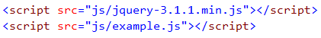

Exercise 2: Loading HTML
- In this exercise, you will use the jQuery AJAX load() method to load content into a page. This will give the effect of a single page application.
- The example.html file contains a <nav> element serving as the main menu for the page.
  - When each of the <a> elements are clicked, you will load the HTML content into the page.
  - The content will be loaded into the element with id container.
- Now open up the js/example.js file and create the jQuery document ready function (if it does not exist) and add a click event handler for all the <a> elements in the <nav> element in the document ready block.
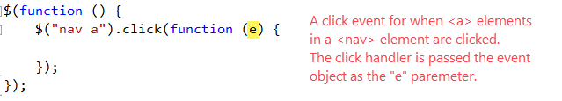
- The following steps should be added to the click event handler.
- First things, add the following to the click event to prevent the default behaviour of the <a> elements i.e. navigating to the URL address.
// prevent default <a> click behaviour
- Read the target url of the clicked <a> element, that is its href attribute into a variable.
// get the target address of the clicked <a> element
- The “Current” class indicates the currently selected item. Remove this from the previously selected item and add it to the menu item clicked instead.
// remove the class styles indicating the current item
// add the class styles indicating the current item
// to the menu link clicked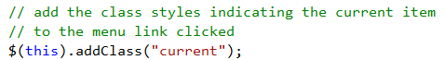
- Temporarily go to the example.html page and examine the HTML content.
  - It contains a <section> element with id=content. The retrieved content will be loaded into this element.
  - Thus, the child element, id=container, needs to be deleted.
  - Each of the target URLs, also have an element with id=container. This content will replace the deleted content.
- Remove the element with id=container from the page.
// remove the existing element with id=container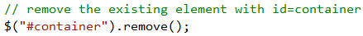
- The content to be loaded is at the target URL address and from the element with id container at the target address – so you are only loading part of the target URL document.
// Using AJAX load() method, load content into
// element with id=content
// from the element with id=container at the target URL address
// (you are only loading part of the target URL document)
// Apply jQuery simple animation, fadeIn
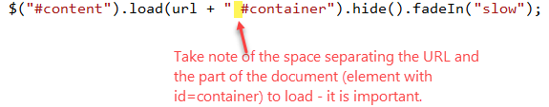
- Save your changes and test the navigation links.

Exercise 3: Reading JSON
- Open up the JSON file called example.json in the data folder and have a look at it to understand its structure.
- Create a variable called timetable in the document ready block – all methods nested in the document ready should have access to it. The retrieved JSON data will be stored in this variable.
// variable to store event timetable
- Also create another global variable called locationID – it will be used to store the currently selected event location.
// variable to store selected event location
- Now create a nested function to load the timetable.
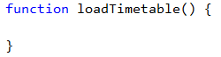
- Add the following AJAX call to the load timetable method to load the JSON document specified.
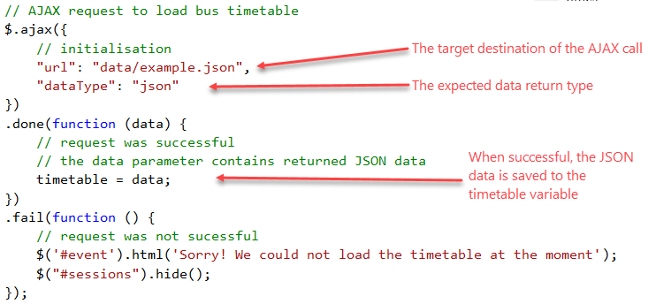
- Locate the end of the function and then make a call to execute the loadTimetable() function – this should be outside the function.
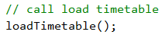

Click Event Handler for the Locations
- Now, when each of the menu items on the left (the different locations) is clicked, it loads the timetable from the retrieved JSON data.
  - The locations menu items are child <a> links in the element with id=event.
  - Create a click event handler for all <a> elements in the element with id=event – look at what you did before.
- The following should go in the click event handler.
- Prevent the default click behaviour of the <a> element – see above.
- The location code is stored as the <a> element’s id. Retrieve the id and convert to uppercase because the JSON document uses uppercase.
// read the value of the clicked <a> element's id attribute
// convert it to uppercase as the JSON uses an uppercase code
- Get the corresponding location times from the JSON object stored in the times variable. The syntax shown is an alternative to using the dot (.) operator.
// Get the location's event and times from the JSON data retrieved and stored in the timetable variable
- The times retrieved are an array object, you need to loop through them to construct a list <ul> of event times by building a concatenated string.
- Create a variable to get the number of events to loop through.
// Get the number of events
- The concatenated string will be stored in a new variable.
- Loop through the events.
Each list item is made up of:
  - the event time, wrapped in a <span> element
  - the location title, which is also a link to more content to display with AJAX. To form the necessary <a> element, the spaces in the title need to be replaced.
// Loop through the events and build up list of event times to display
// using a concatenated string
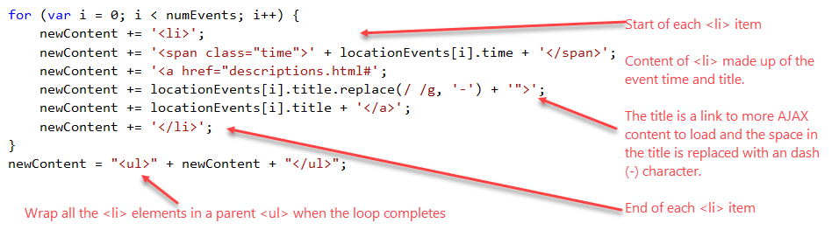
- Update the HTML element with id = sessions with the new content.
// update the element with the content
- As before, the “Current” class indicates the currently selected item. Remove this from the previously selected item and add it to the menu item clicked instead.
// remove the class styles indicating the current item
// add the class styles indicating the current item to the clicked location
- Finally, reset the element that shows the details of an event to blank till a user clicks on the event.
// reset details the third column to blank
- Save your changes and have a look.

Click Event Handler for the Event Details
- Now, you loaded the event list for the currently selected location dynamically in the last set of steps. But you also want something to happen when the user clicks on each of these events. If you had set of a click event handler when the document loaded, this would not work because the element did not exist at that time to bind the event handler function to. Two solutions:
  - You can create a new click event handler every time you dynamically load the content.
  - You can use jQuerys .on() event handler function method – you will use this approach.
- In the .on() event handler function approach, you:
  - Identify a higher-level parent container element that will hold the dynamic descendant content but exists at the start when the document load. In our example this is element with id=sessions.
  - You use this element to set up the event handler function, but also specify a selector for the “future” descendant element that will trigger the event. In our example, this will be the “li > a” grandchildren elements.
- Define the new click event handler function as shown.
// Click event triggered by any descendant elements matching the "li > a" selector
// in the element with id=sessions
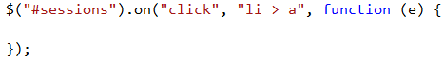
- Add the code to prevent the default click behaviour.
- Read the href attribute of the clicked item into a variable called url – you have done this before, check what you did earlier in Exercise 1.
- The link that is clicked is of the following format. You only want to load part of the content (the part specified by the ID selector). To use jQuery’s load function, you must insert a space before the # symbol.
http://localhost:15833/descriptions.html#Brain-Hacking
Add the following to insert a space before the # symbol.
- Load the partial content
// Load the partial content into the element with id=details
- As before, the “Current” class indicates the currently selected item. Remove this from the previously selected item and add it to the menu item clicked instead.
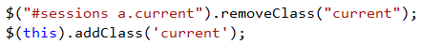
- Save your changes and have a look.

Exercise 4: JSONP
- You will use Google’s map API service to issue an AJAX request to another domain. This will be used to display the map of the current event location when the details are displayed. (Note: while the order of events is wrong, it demonstrates the concepts.
- Go to: https://developers.google.com/maps/documentation/javascript/adding-a-google-map and click on the link to Get an API Key. Get yourself a key and store it somewhere e.g. notepad.
- Just after the last step for the previous exercise and the following JSONP call using jQuery’s getJSON method. The highlighted text needs to be replaced with the API key you got from Google.
For your convenience the URL address is: https://maps.googleapis.com/maps/api/js?key=YOUR_API_KEY&callback=?

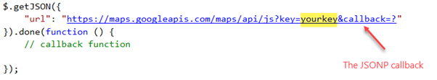
- If you look at the Google documentation page, you will see that the callback function, initMap, code is as shown below.
  - The highlighted (red rectangle) block of code is what goes in the callback function
  - Also the we want to change the uluru variable dynamically based on the currently selected location stored in the locationID method.
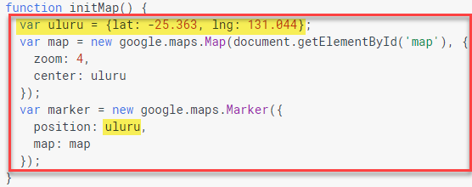
- Copy the Google API call back code below into the space for the callback function in the getJSON call.
var uluru = {lat: -25.363, lng: 131.044};
var map = new google.maps.Map(document.getElementById('map'), {
zoom: 4,
center: uluru
});
var marker = new google.maps.Marker({
position: uluru,
map: map
});

- Make the following changes to set the location longitude and latitude based on the currently selected location as shown below.
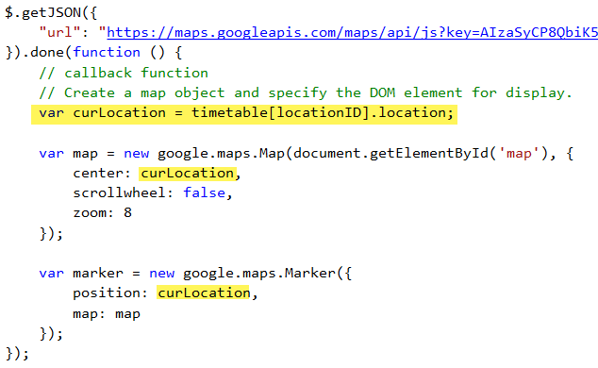
- The generated map will be displayed in the element with id=map.
- Save your changes and test your page.
- If you want to use other locations, you can find the longitude and latitude using: https://support.google.com/maps/answer/18539?co=GENIE.Platform%3DDesktop&hl=en
- Useful APIs: http://www.programmableweb.com/apis/directory

Exercise 5: Posting Data
- Open up the jq-post.html page. It is a very simple registration form.
- It contains a form with id=register that contains three input fields.
- The JavaScript file for this page is js/jq-post.js. Make sure the HTML page is correctly linked to it.
- Open the JavaScript file.
- Create the jQuery document ready function (if it does not exist).
- Next, add the following event listener for when the form is submitted. Don’t forget to pass in the event object.
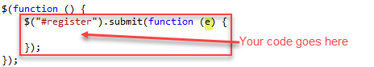
- Add the code to prevent the default behaviour.
- To read individual input field values, you use jQuery’s val() method. For example, if you add the following code to the submit listener function.
// read the value from the input field with id=name into the variable
// Display the submitted name in the register form.
- Save the changes and preview your page.
  - Type something into the name field and hit the submit button.
  - It should display the submitted value in place of the form.
- Ideally, however, you want to send all submitted values to some server-side script for processing. jQuery provides a useful method, serialize(), that encodes all form data into a string of name/value pairs for submission.
  - Recall that you need to specify a name for any input field you want to be submitted to the server for processing.
- Delete or comment out the last two lines of code (step 8).
- Add the following code:
// Serialise the form data - encode as a string of name/value pairs for submission
// Display the encoded data in the console
- Save your changes and refresh your page in the browser.
  - Open up the browser console.
    - Chrome: More tools Developer Tools (you may need to select the Console tab)
    - Firefox: Developer Browser Console
  - Complete the three form fields and click the submit button.
  - Have a look at what is logged in the browser console
- Go back to your code. Ideally, you want to post the code to some server-side page for processing.
- Delete or comment out the line of code that logs the data to the browser console, i.e. console.log(…);
- The project includes two basic server-side pages:
  - For Visual Studio, IIS server (ASP.NET), use register.aspx
  - FOR W/XAMP servers, use register.php
- To post the data, you will use jQuery’s AJAX post() method. It also allows you to specify a callback function that executes when the post request succeeds.
- Add the following code to post the data to the server-side page for processing (use the page that applies to your setup), including a callback function that executes when the post request succeeds.
// Post to the server-side page for processing
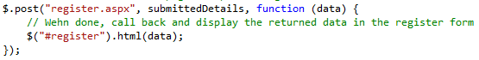
- Save your changes and test your page.
- You should get results similar to:
ASP | PHP
Thanks for joining, Name  A confirmation email will be sent to email.address@somewhere.com | Thanks for joining, Name  A confirmation email might have been sent to email.address@somewhere.com if this was a real site.

- That’s all.

