Impact of Virtual Learning Environment (VLE) – Moodle on the Learning Experience of
Students at the University of Wales Trinity Saint David London Campus

DSR Assessment 2
Student Name: Tsonyo Todorov

Identification Number: 2021609

Module Name: Digital Skills and Research Methods

Module Code: BMSW4003

Lecturer: Ejiro Esohwode

Abstract
The effect of Virtual Learning Environment (VLE)-Moodle on the students’ knowledge and learning experience is evaluated through this proposed research. This research falls under qualitative types and attempts to undertake a social investigation. In the first place, previous research reports were gathered about the learning experiences of students through virtual platforms and the literature was identified regarding the impact and effectiveness of the VLEs. A questionnaire was provided to the students to collect their views on the general statements to understand the merits and demerits of using Moodle as a virtual learning platform. Pie charts are used to present the summarized findings through the research. The results showed that students have a high rating for the VLEs as this method ensures flexibility. The most prominent challenges for VLEs were ineffective communication, network issues and institutional misconducts. Lastly, some recommendations were given to broaden the scope of the learning experience using virtual platforms by identifying and minimizing the challenges through the research.

Table of Contents
Introduction 1
Research Preliminaries 2
Research Objectives 2
Problem Statement 2
The rationale of the Research 2
Scope of the Research 3
Empirical Review 4
Research Methodology 6
Data Analysis 7
Conclusion 10
References 11
Appendix 12

Introduction
Virtual Learning Environment (VLE) is a web-based platform to perform the digital activities of the study in the academic institutions to establish interactions and communication, present activities and materials according to the course structure (Erkan, 2019). VLEs are currently an alternative to the physical classroom. They offer a range of different tools and activities, lectures activity stream, updated database, activity-based learning tools, unit map, online discussion forum etc. Different VLE software such as Blackboard, Google Classroom, and Moodle are necessary learning tools in modern academic institutions of developed countries. These platforms connect students to a continuous process of learning, track their performances, and emerge as a medium of communication between students and teachers (Weller, 2017).
This research is designed to understand the effectiveness of Moodle, a VLE platform, to conduct the experience of students through online academic activities. Moodle is an open-source learning management system, based on PHP which provides web-based learning solutions to support the activities of educational institutions.

Research Preliminaries

Research Objectives
The evaluation of the effect of Moodle, a Virtual Learning Environment on the learning experience of students in completing their academic activities is the prime objective of this research report. This report investigated the learning experience of the respondents and attempted to establish an understanding of the advantages and challenges provided by virtual learning platform. The accomplishment of the primary objective was accompanied by the following specific objectives.
- Explaining the tools, programs and activities provided by VLEs and the methods through which VLEs offer to their institutional partners to smoothen the general learning experience.
- Creating and applying the research methodology to intensify data collection, analysis and understanding of research.
- Establishing a secondary research analysis to understand the results of the previous research on VLEs and selecting areas for future research.
- Understanding the development of the learning management systems based on comprehensive literature and facilitating the e-learning process by

Problem Statement
The previously stated objectives in this section raised some problems which are answered under the following statement known as problem statement;
- What is the effect of the VLE platform, Moodle, on the learning experience of students regarding their academic activities?
- What are the merits and challenges experienced by students in the learning activities provided by Moodle in the COVID-19 Pandemic?
- What are the ways through VLEs like Moodle can develop online learning experiences?

The rationale of the Research
The virtual learning environment is the e-learning platforms used in the traditional learning techniques for a long time by the modern and renowned universities of developed countries. These platforms provide online resources to their educational clients to enable students to conduct and manage the learning activities, make student actively involved in their learning process and align the individual learning activities with that of the learning environment (Johnson, 2017). Moreover, in the coronavirus pandemic, the importance of e-learning platforms has been increasing day by day. As these platform-based models are being used extensively in current times, it is very significant to assess their performance and select the best method possible to ensure quality education. With the view of achieving this objective, this research is attempting the efficacy of Moodle to ensure a prominent online learning experience for the students and draw results for the benefit of all the students of the United Kingdom (Groat and Musson, 2021).

Scope of the Research
This research is a type of qualitative research of social investigation nature and attempts to undertake a social investigation and tries to understand the effectiveness of VLEs. It also attempts to examine the e-learning experiences of their educational clients through conducting primary research and facilitate the previous literature in this field. Another objective of this report is to develop the online learning experience of students by evaluating the best learning management systems in the United Kingdom. The number of researches on this area is not so high therefore this research will help to explore and recommend the scope of further research.

Empirical Review
Douce (2021) described that VLE as a management system for the course and specified that VLEs provide integrated learning options by applying the core technologies. He also said that these platforms establish communication between students and teachers and ensure even distribution of resources to support the established learning framework of an educational institution and through LMS like Moodle the contribution would result very high.
Songkram (2020) defined that VLE as an online design space that enables students to shape their academic process and establish an efficient learning platform using digital tools. Moodle has all the tools needed to create a sustainable VLE platform and thus many educational partners are using this software. Songkram further evaluated the effectiveness of Moodle on the educational activities of students and he got a positive result. He stated that Moodle used by students of developed countries can show a better performance in academic research than developing countries.
According to Johnson (2017), applying VLEs in educational activities enable both teachers and students to have their own designed course maps, evaluative dashboards, assessment corners etc. Both in and outside their campus and Moodle plays a vital role here as an effective tool. Moodle provides these facilities to cross and neglect the geographical barriers and incorporate flexibility in the activities of students and also reduces the time.
Twomey conducted research on VLE in 2019 and compared them to the traditional methods of classroom learning and found the latter to become less prominent in the forthcoming times due to four reasons- engagement, flexibility, self-management, and accessibility. About *6% of the students stated engagement and flexibility as the most prominent factors whereas the remaining rated self-management and accessibility as higher factors. The students who rated the engagement and flexibility as higher were from abroad and part-time students.
Groat and Musson (2021) took different VLE software in conducting their study and evaluated the effectiveness of popular LMS like Moodle, Zoom, Google Classroom, MOOCs in the context of communication, learning and feedback. All of these platforms provide the facilities of web-meeting, live discussions, notification centers, online dashboards etc. Both students and teachers are updated about the ongoing academic activities and discussions. But the study found that no matter how many technologies are incorporated; these platforms remain ineffective in controlling student behaviors.

Research Methodology
It has been previously stated that this research is a type of qualitative research and attempts to undertake a social investigation and has analysis of two types i.e., primary and secondary. Different published academic journals and on-line sources have been studied to conduct the secondary analysis and have been summarized in the empirical review section of this report.
To conduct the primary research, students were selected for the research to answer the questionnaire. As there were instructions and restrictions regarding the safety and health issues, no physical research has been possible and thus the survey was done through Google Workspace and in this research, Moodle has been considered as the representative of all the LMS like Zoom, Google Classroom, and MOOCs.
To analyze the data, a spreadsheet was used to present the data graphically and then some visualization tools were applied to conduct further analysis. Regression analysis was done to run the assessment and understand the efficacy of Moodle to ensure a prominent online learning experience for the students.
This research had been conducted considering all the ethical aspects properly like the necessary data had been collected without taking any unfair means.

Data Analysis
This section depicts the result from the primary data and presented it in graphical form to implicate an effective understanding. In Google Forms, five general statements for understanding different facets of VLE- Moodle were included. Respondents gave their views through the Likert Scale which has a rating scale from strongly agree to strongly disagree. Again, two additional statements were included to know about the benefits and challenges and the responses are presented below.
The student ranked the benefits of Moodle and 73% of the students were expressed that flexibility and self-management are the most important benefit and others rated accessibility as the important one in the VLE- Moodle. Next, the respondents ranked the most focusable challenge of Moodle and about 84% stated that those students stated that educational misconduct is the most significant challenge of using VLEs and LMS like Moodle.
Statement-1: Moodle provides geographical flexibility
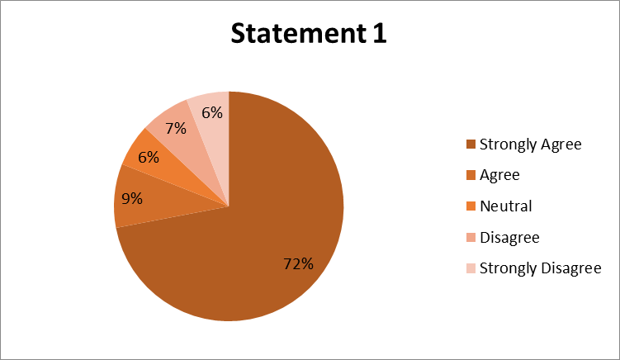
About 81% of students stated that Moodle offered flexibility regarding the geographical situation of the respondents. Students from different countries could enroll themselves in different courses and complete their studies due to flexibility in the COVID- pandemic situation.

Statement-2: Moodle ensures accessibility to Study materials and assessment dashboard.
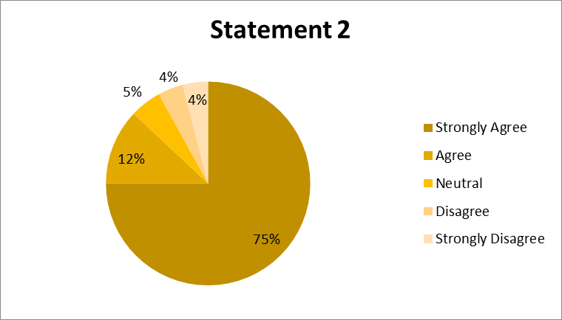
Around 87% of the students stated that Moodle gave easy accessibility to Study materials and assessment dashboard. They can easily get hold of the study materials, class lectures and communicate with teachers, complete the assessment criteria and evaluate their performance through Moodle.
Statement-3: Moodle offers access from different devices
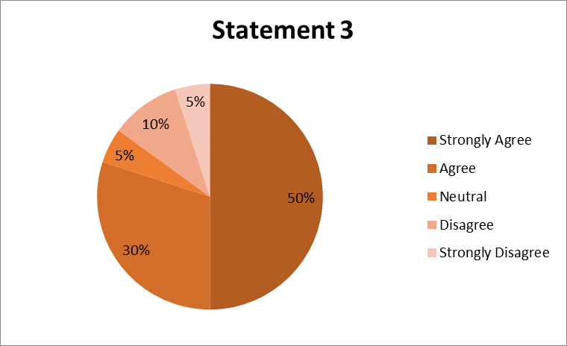
Almost 80% of the students identified Moodle as user friendly and they can access their materials and tasks from different places through different digital devices. But around 15% did not agree and said that the application of Moodle causes trouble to their devices and are and creates problems in time of lectures and exams.

Statement-4: Moodle facilitates academic research through Database facilities
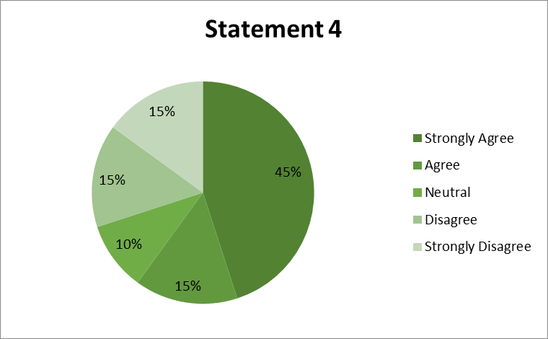
Of the total sample, 60% of students stated that Moodle facilitates academic research through rich Database facilities and greater information sources as it has connections with the world’s largest online libraries. But 30% said that Moodle as VLE did not have many database sources and should include more sources.
Statement-5: Moodle and other VLEs provide a larger area of indiscipline and misconduct.
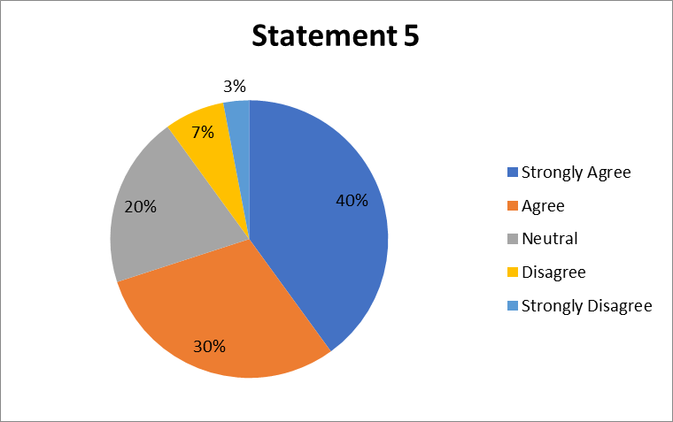
Around 70% of the students specified that not only Moodle but other VLE platforms open more scope for unethical cases like cheating in exams, and contract to cheat. Currently, contract cheating is a concerning issue in UK universities and VLEs are unable to prevent these problems. However, 20% of the students gave a neutral opinion in this statement.

Conclusion
Some specifications can be pointed out regarding the effect of VLE on the impact on the students through the findings from primary and secondary research. VLEs are online design spaces enabling students to shape their academic process and establish an efficient learning platform using the digital tools and provides geographical flexibility and easy accessibility to study materials and assessment dashboard that is increasing the acceptability of VLEs which matches the findings of Twomey (2019) as he researched the efficiency of Moodle in the COVID pandemic situation. The most significant challenges found in this research are institutional misconduct, unethical behavior and miscommunication among students. Moodle can reduce the problems of ineffective communication by fixing bugs and arranging regular discussions, team activities, webinars and feedback from students. Moodle as VLE did must consider adding more database sources to facilitate the research works for students.

References
Douce, C., 2021. Editorial: Distance learning and language learning. Open Learning: The Journal of Open, Distance and e-Learning, 36(1), pp.2-4.
Erkan, A., 2019. Impact of Using Technology on Teacher-Student Communication/Interaction: Improve Students Learning. World Journal of Education, 9(4), pp.30-35.
Groat, A. and Musson, T., 2021. Learning styles: individualizing computer-based learning environments. Research in Learning Technology, 3(2), pp.45-49.
Johnson, C., 2017. Online Learning And Education Stream Introduction. International Journal on Innovations in Online Education, 1(1), pp.2-7.
Songkram, N., 2020. E-learning System in Virtual Learning Environment to Develop Creative Thinking for Learners in Higher Education. Procedia - Social and Behavioral Sciences, 174, pp.674-679.
Twomey, E., 2019. Linking learning theories and learning difficulties. Australian Journal of Learning Disabilities, 11(2), pp.93-98.
Weller, M., 2017. Virtual Learning Environments: Using, Choosing, And Developing Your VLE. 1st ed. London: Routledge.

Appendix
Survey Questionnaire: https://forms.gle/3V8qD7o69Z5VSrE6A


