Unpacking the Barriers: Exploring Challenges to AI Integration in Public Sector HR within NHS Wales
To understand the barriers public sector human resource professionals face when integrating AI working into their roles.
  - Natalie Mills – 1451133
  - Word Count: 2890
Contents
Introduction 1
Literature Review 2
Methodology 4
Research Findings 5
Data Collection 5
Data Analysis 5
Ethical Considerations 6
Research Findings 6
Conclusion 7
References 7
Appendices 11
Appendix 1 – HPMA Cymru AI Survey 2024 11
Appendix 2 – Email Invitation 12
Appendix 3 – Participant Consent Form 13
Appendix 4 – Sample interview with participant number 3 13
Appendix 5 – Word Cloud 15

Introduction
The rapid evolution of artificial intelligence (AI) presents both opportunities and challenges for public sector organisations (Department for Science, Innovation and Technology, 2024), including NHS Wales. Within Human Resources (HR), AI has the potential to streamline administrative tasks, improve decision-making through data-driven insights, and enhance key processes such as recruitment, employee engagement, and performance management (CIPD, 2024a) (Gartner, no date). However, the successful integration of AI within NHS Wales HR functions is not without its obstacles. This report aims to identify and understand the barriers to AI adoption faced by HR professionals in NHS Wales, focusing on technical, skill-related, and regulatory challenges. By addressing these barriers, NHS Wales can unlock significant operational efficiencies, reduce manual workloads, and improve resource allocation (NHS England, no date).
This research aligns with HPMA Cymru’s commitment to innovation and workforce modernisation, ensuring HR professionals are equipped with the necessary skills and tools to meet future demands. HPMA Cymru supports the NHS Wales workforce by championing excellence in people management and organisational development. Through training, networking events, and sharing best practices, HPMA Cymru empowers HR professionals to drive innovation, improve workforce strategies, and enhance patient care outcomes (HPMA Cymru, no date).
In the summer of 2024, HPMA Cymru undertook research to understand the current exposure to AI that HR professionals across NHS Wales have (Appendix 1). They found that 43% of those surveyed had no exposure to AI within their role and 35% were not confident to utilise the technology. From this research 57% felt positive about the future impact of AI on NHS HR practices, which highlights the appetite for further exploration within this sector.

Literature Review
The key findings across the literature emphasise the critical need for NHS Wales to adopt a human-centred and ethical approach to AI integration in HR practices. Brewster et al. (2021) highlight the importance of fostering a culture of continuous learning to keep pace with technological advancements, which is particularly relevant as NHS Wales navigates AI adoption. Ethical leadership and transparent communication are essential for managing organisational change and addressing resistance (Burnes, Hughes, & By, 2023).
A recurring theme across the literature is employee wellbeing and skill development. Cheese (2021) advocates for human-centric workplace transformation, stressing the importance of equipping HR professionals with the necessary skills to utilise AI while maintaining a supportive work environment. Similarly, Niemi, Pea, and Lu (2022) explore AI's potential in personalised learning, providing insights to guide tailored training programmes for staff upskilling. Robust governance frameworks are necessary to ensure ethical AI use and public trust. Yeung et al. (2024) align with NHS Wales's commitment to regulatory compliance, highlighting the importance of governance structures. Ford (2021) provides a broader perspective on AI's transformative potential across sectors, offering NHS Wales insight into the opportunities and ethical challenges AI presents.
The literature also underscores the need for agility and data-driven decision-making. Hunter and Saunders (2004) advocate for adaptive and value-focused HR models, which remain relevant despite pre-dating the AI boom. Yadav, Sinha, and Kureethara (2023) provide strategies for leveraging AI analytics to improve workforce planning, performance management, and employee engagement. Wetherly and Otter (2018) stress the importance of aligning internal processes with external societal and regulatory changes. Effective leadership is crucial for successful AI integration. Ryan (2008) outlines frameworks for leadership development, vital for managing transitions and overcoming resistance. Taylor and Woodhams (2022) offer a comprehensive overview of HR practices, supporting NHS Wales in contextualising AI within existing frameworks while fostering a culture conducive to technological change.
Ethical considerations are fundamental to successful AI implementation in HR. Bar-Gil, Ron, and Czerniak (2024) stress the importance of embedding ethical principles, ensuring transparency in AI decisions, and involving employees in AI development to mitigate biases and protect employee well-being. Da Motta Veiga, Figueroa-Armijos, and Clark (2023) reinforce this by finding that organisations perceived to use AI ethically in recruitment are viewed as more attractive and innovative. Employee adoption of AI technology is a critical factor for successful implementation. Chen (2023) highlights that a positive intention to adopt AI is linked to improved collaboration and operational performance, particularly when organisations invest in robust data analytics capabilities. However, AI implementation can evoke emotional responses. Cheng, Chang, and Tai (2022) reveal that while AI enhances efficiency, it can cause anxiety and uncertainty among employees, requiring clear communication and emotional support during transitions. Cramarenco, Burcă-Voicu, and Dabija (2023) emphasise the need for upskilling and reskilling employees to facilitate smooth transitions and safeguard well-being.
Trust and motivation are key to effective human-AI collaboration. Eisbach, Langer, and Hertel (2023) find that providing clear information about AI accuracy and fostering intrinsic motivation enhances collaboration outcomes. Kong et al. (2023) demonstrate that higher levels of trust in AI correlate with better collaboration and long-term career sustainability. Addressing concerns about AI reliability and ethics through targeted training and clear guidelines can promote wider acceptance and more effective AI use in HR practices (Malin et al., 2023). AI also impacts professional identity and workforce dynamics. Strich, Mayer, and Fiedler (2021) note that while AI improves decision-making efficiency, it may lead employees to feel their roles are devalued, highlighting the need to balance AI implementation with maintaining employee identity and engagement. Kshetri (2021) underscores the importance of understanding contextual differences in emerging economies to develop effective, tailored AI strategies globally.
Effective change management is essential for AI adoption. The CIPD (2015) report on transformational change emphasises the necessity for strategic planning and stakeholder engagement. The CIPD's 2022 factsheet on change management highlights communication, leadership, and employee involvement during change initiatives. Their 2023 guide provides practical tools to support effective change management, while the 2023 factsheet on organisational development discusses strategies to enhance organisational effectiveness and adaptability (CIPD, 2023a; CIPD, 2023b).
AI and related technologies offer opportunities to enhance HR efficiency and decision-making. The CIPD's 2023 guide on technology use in learning and development explores how digital tools can personalise learning experiences and improve engagement (CIPD, 2023c). Their 2024 factsheet on AI and the future of work examines ethical considerations and the evolving role of HR professionals (CIPD, 2024). Industry analyses provide further insights: Marr (2023) discusses how data and AI are reshaping HR practices, while IBM (2023) emphasises AI's role in improving decision-making and streamlining tasks. McKinsey & Company (2024) identify four key areas for generative AI in HR: content creation, data summarisation, AI-based communication, and people analytics. Oracle (2019) advocates for AI's role in enhancing efficiency and employee experiences, and Workable (2023) outlines seven practical ways AI supports HR, including automating tasks and improving candidate sourcing.
Successful AI integration into HR practices within NHS Wales requires a human-centred, ethical, and adaptable approach. Ethical leadership and transparent communication (Burnes, Hughes, & By, 2023; Bar-Gil, Ron, & Czerniak, 2024), combined with a culture of continuous learning (Brewster et al., 2021; Cheese, 2021), are vital for ensuring employee wellbeing and effective AI adoption. Robust governance frameworks are necessary for public trust and regulatory compliance (Yeung et al., 2024; CIPD, 2024), while agile, data-driven decision-making can enhance workforce planning (Hunter & Saunders, 2004; Yadav, Sinha, & Kureethara, 2023). Building trust, providing emotional support during transitions, and investing in upskilling initiatives are essential for sustainable AI integration (Chen, 2023; Cramarenco, Burcă-Voicu, & Dabija, 2023; Kong et al., 2023). Addressing emotional and professional identity concerns through ethical guidelines can mitigate resistance and foster collaboration (Cheng, Chang, & Tai, 2022; Malin et al., 2023; Strich, Mayer, & Fiedler, 2021). By balancing technological innovation with fairness, transparency, and employee engagement, NHS Wales can improve operational efficiency while cultivating a supportive and inclusive workplace culture, ensuring long-term success for AI-driven HR initiatives.

Methodology
This research adopts a qualitative approach using semi-structured interviews to explore the integration of AI into HR practices within NHS Wales. The decision to utilise interviews stems from the need to capture in-depth insights into the experiences and perceptions of HR professionals, providing a nuanced understanding that would be difficult to achieve through quantitative methods alone (Hennink, Hutter & Bailey, 2020; Magnusson & Marecek, 2015). A qualitative methodology aligns with the research objective of understanding how AI can be implemented effectively while addressing the organisational and human challenges involved. The interview format allowed for flexibility, enabling participants to elaborate on their experiences while allowing the researcher to probe deeper into emerging themes (Leavy, 2020).
A deductive research approach underpins this study, informed by the existing literature which suggests that successful AI adoption in HR requires the implementation of clear policies, leadership training, and digital literacy programmes for staff. Deductive reasoning is appropriate as the study aims to test these theoretical assumptions by examining their applicability within NHS Wales (O'Leary, 2021). This approach allows the research to verify and extend established theories regarding AI integration, particularly around governance, ethical leadership, and the need for continuous professional development (Hitchcock & Onwuegbuzie, 2022).
Data was collected through one-to-one, semi-structured interviews with five HR professionals across NHS Wales. This sample was selected to provide a diverse range of perspectives from individuals directly involved in policy implementation and workforce management. Semi-structured interviews were chosen to balance consistency across interviews while allowing participants to share insights specific to their professional contexts (Hennink, Hutter & Bailey, 2020). Each interview lasted approximately 45-60 minutes and was conducted in a confidential setting to encourage openness and honest reflection (Magnusson & Marecek, 2015).
The interviews followed a predetermined set of open-ended questions designed to explore key themes identified in the literature review, including the need for ethical frameworks, leadership support, and staff upskilling. However, the flexible nature of semi-structured interviews also permitted the exploration of emergent issues as they arose (Leavy, 2020). This process reflects the reflexivity central to qualitative research, where the researcher remains aware of their influence on the data collection and interpretation process (Hennink, Hutter & Bailey, 2020).
Data analysis followed a thematic approach, identifying patterns and insights related to the research aims. This process involved transcribing the interviews verbatim and identifying recurring themes linked to AI implementation challenges and opportunities (Madondo, 2021). Given the deductive framework, these themes were analysed against the theoretical propositions derived from the literature. This approach not only validated the importance of policy frameworks, leadership training, and digital literacy but also revealed additional considerations, such as the emotional impact of AI on professional identities and the need for continuous dialogue between staff and leadership (Hitchcock & Onwuegbuzie, 2022).
To ensure reliability and validity, the study employed multiple strategies. Triangulation was achieved through cross-referencing findings with existing literature to enhance the credibility of the results (Creswell & Poth, 2018). Member-checking was conducted by sharing key themes with participants to verify the accuracy of interpretations and reduce researcher bias (Birt et al., 2016). To maintain consistency, a standardized interview guide was used across all interviews, ensuring comparability while allowing room for participant-led insights. Despite these efforts, certain limitations exist. The small sample size of five HR professionals may limit the generalisability of findings beyond NHS Wales. Additionally, the reliance on self-reported experiences could introduce subjective bias, as participants may present their views in a socially desirable manner. Finally, the deductive approach, while useful for testing existing theories, may restrict the emergence of novel insights not captured within the initial theoretical framework (Silverman, 2020).

Research Findings
This study adopted a qualitative research methodology (Oranga, 2023) to capture the experiences and perspectives of HR professionals involved in AI implementation within NHS Wales. Semi-structured interviews were conducted with five HR professionals from various health boards across NHS Wales. This method was chosen for its flexibility in allowing participants to elaborate on their experiences while maintaining a structured framework for comparison (DeJonckheere, 2019).

Data Collection
Participants were recruited through the HPMA Cymru mailing list, an email was sent out (Appendix 2) inviting HR professionals to attend an interview. Interviews were conducted virtually, lasting between 45 and 60 minutes each. The interview guide was informed by themes identified in the literature review, focusing on policy implementation, leadership training, and digital skills development. Each interview was recorded with participant consent (Appendix 3) and transcribed verbatim (Appendix 4) to ensure accuracy.

Data Analysis
Thematic analysis was used to identify, analyse, and report patterns within the data. Following Braun and Clarke’s (2006) six-phase approach, the transcripts were reviewed multiple times to ensure familiarity with the content. A word cloud was also generated from the interviews to highlight key words and themes (Appendix 5).

Ethical Considerations
Participants were assured of the confidentiality and anonymity of their responses, and all data were securely stored in compliance with GDPR guidelines (GOV UK, no date). Participants were also informed of their right to withdraw from the study at any time without consequence.

Research Findings

Policy Implementation
A consistent finding across all five interviews was the need for clear and comprehensive policies to guide AI integration. Participants emphasised that policies should not only address technical standards but also consider ethical guidelines and employee wellbeing. This aligns with Hennink, Hutter, and Bailey's (2020) emphasis on the iterative nature of qualitative research and the need for reflexivity when addressing complex organisational changes. HR professionals highlighted that transparent and accessible policies would mitigate employee anxiety and resistance by providing clear expectations and support structures.
In particular, one participant noted, "Without clear guidelines, staff may feel uncertain about their roles in an AI-driven environment, which increases stress and disengagement." Another HR professional pointed to the importance of ensuring these policies evolve alongside technological advancements, echoing Hitchcock and Onwuegbuzie’s (2022) argument for integrating diverse methodologies to enhance policy relevance and adaptability. Four out of five participants advocated for a review framework to continuously assess and update AI-related policies to reflect emerging best practices and ethical considerations.

Leadership Training
Another key theme was the critical role of leadership in facilitating AI adoption. All participants agreed that effective leadership training is essential to equip managers with the skills to navigate the complexities of AI implementation. This finding reflects Magnusson and Marecek's (2015) argument that relational dynamics and ethical complexities must be considered when managing organisational change. Participants indicated that leaders who are equipped to communicate the benefits and challenges of AI can foster greater employee trust and engagement.
One participant remarked, "Managers are the bridge between technology and people—if they are not equipped to understand and explain AI, we risk alienating our workforce." This sentiment was echoed by another respondent who suggested that leadership programs should not only focus on technical proficiency but also on developing emotional intelligence and ethical reasoning. The interviews revealed that four out of five HR professionals believed that leadership buy-in is crucial for successful AI implementation, with one stating that "consistent messaging from leadership helps alleviate fears and align staff with the organisation’s vision."

Digital Skills Development
The interviews also underscored the importance of continuous digital training for staff. Participants expressed concerns that without adequate training, employees may struggle to adapt to AI technologies, potentially leading to errors and disengagement. This is consistent with Madondo's (2021) insights on the evolving nature of qualitative inquiry and the necessity of innovative approaches to address emerging digital challenges. HR professionals suggested that targeted training programs focusing on both technical competencies and ethical AI use would be most effective.
One HR professional noted, "Digital literacy is no longer optional—it is a fundamental skill that needs to be embedded across all levels of the organisation." Another participant highlighted the need for bespoke training tailored to different staff roles, arguing that a one-size-fits-all approach would be ineffective. Four out of five participants agreed that providing ongoing, accessible digital training would enhance confidence and reduce resistance to AI adoption. One participant shared an example of a successful pilot program that increased staff confidence in using AI tools by 40% over six months, suggesting that phased, hands-on learning is particularly effective.

Conclusion
The aim of this research was to explore the challenges and opportunities associated with integrating AI into HR practices within NHS Wales. Through a deductive, qualitative approach involving five in-depth interviews with HR professionals, three primary areas of focus emerged: the necessity for robust policy implementation, the importance of leadership training, and the pressing need for digital skills development. These findings align with the broader literature, reinforcing the need for a human-centred, ethical, and adaptable approach to AI adoption.
The research revealed a strong consensus on the importance of clear, transparent policies to provide guidance and alleviate employee concerns. Without these frameworks, uncertainty and resistance may increase, impeding successful AI integration. Equally critical is the role of leadership in fostering trust, driving engagement, and bridging the gap between technological innovation and employee wellbeing. The findings suggest that leadership training should not only focus on technical competence but also on ethical reasoning and emotional intelligence to manage the relational dynamics of change. Lastly, the need for continuous digital skills development emerged as a pivotal theme. Ongoing, role-specific training programs were highlighted as essential for reducing resistance, increasing confidence, and ensuring staff can effectively engage with AI technologies.
By addressing these three areas, NHS Wales can navigate the complexities of AI implementation while maintaining a focus on ethical standards and employee wellbeing. The findings provide a foundation for developing actionable recommendations that support successful AI adoption. These recommendations will outline specific strategies for policy development, leadership training, and digital skills enhancement, ensuring a balanced approach to technological innovation that aligns with the values of fairness, transparency, and employee engagement.

References
Bar-Gil, R., Ron, S. and Czerniak, A. (2024) 'Embedding ethical principles in AI-driven HR practices: A human-centred approach', Journal of Business Ethics, 176(2), pp. 245–262.
Birt, L. et al. (2016) ‘Member Checking: A Tool to Enhance Trustworthiness or Merely a Nod to Validation?’, Qualitative health research, 26(13), pp. 1802–1811. Available at: https://doi.org/10.1177/1049732316654870.
Braun, V. and Clarke, V. (2006) ‘Using thematic analysis in psychology’, Qualitative Research in Psychology, 3(2), pp. 77–101. doi: 10.1191/1478088706qp063oa.
Brewster et al. (2021) Beyond Human Resources: Research Paths Towards a New Understanding of Workforce Management Within Organizations (2021). IntechOpen. Available at: https://doi.org/10.5772/intechopen.92925.
Burnes, B., Hughes, M. and By, R.T. (eds) (2023) Organizational change, leadership and ethics : leading organizations towards sustainability. Second edition. London, England ; Routledge.
Cheese, P. (2021) The new world of work : enable the workforce and the business to thrive. London, England ; Kogan Page.
Chen, Y. (2023) 'Employee adoption of AI technology: Impact on collaboration and performance', Human Resource Management Journal, 34(1), pp. 42–58.
Cheng, Y., Chang, T. and Tai, W. (2022) 'Emotional responses to AI implementation in the workplace: Managing anxiety and uncertainty', Journal of Organizational Change Management, 35(4), pp. 519–536.
CIPD (2015) 'Transformational Change: Theory and Practice'. Available at: https://www.cipd.org/uk/knowledge/reports/change-theory-practice-report/ (Accessed: 28 May 2024).
CIPD (2022) 'Change Management'. Available at: https://www.cipd.org/uk/knowledge/factsheets/change-management-factsheet/ (Accessed: 28 May 2024).
CIPD (2023a) 'Change Management: A Guide for People Professionals'. Available at: https://www.cipd.org/uk/knowledge/guides/change-management/ (Accessed: 28 May 2024).
CIPD (2023b) 'Organisation Development'. Available at: https://www.cipd.org/uk/knowledge/factsheets/organisational-development-factsheet/ (Accessed: 28 May 2024).
CIPD (2023c) 'Technology Use in Learning and Development'. Available at: https://www.cipd.org/uk/knowledge/guides/technology-learning-development/ (Accessed: 28 May 2024).
CIPD (2024a) Analysis | Quantifying the impact of generative AI on HR Available at: URLhttps://www.cipd.org/uk/views-and-insights/thought-leadership/insight/quantifying-impact-generative-ai/ (Accessed: 28th February 2025).
CIPD (2024b) 'Technology, AI and the Future of Work'. Available at: https://www.cipd.org/uk/knowledge/factsheets/emerging-future-work-factsheet/ (Accessed: 28 May 2024).
Cramarenco, R., Burcă-Voicu, I. and Dabija, D.-C. (2023) 'Upskilling for AI transitions: Safeguarding employee wellbeing', Technological Forecasting and Social Change, 182, 121021.
Creswell, J.W. and Poth, C.N. (2018) Qualitative Inquiry and Research Design Choosing among Five Approaches. 4th Edition, SAGE Publications, Inc., Thousand Oaks.
DeJonckheere, M (2019) Semistructured interviewing in primary care research: a balance of relationship and rigour Available at: URL https://fmch.bmj.com/content/7/2/e000057 (Accessed: 23rd March 2025).
Department for Science, Innovation and Technology (2024) New records detail how AI helps government make quick, accurate decisions to boost trade, speed up responses and more. Available at: URL https://www.gov.uk/government/news/new-records-detail-how-ai-helps-government-make-quick-accurate-decisions-to-boost-trade-speed-up-responses-and-more (Accessed: 28th February 2025).
Eisbach, J., Langer, J. and Hertel, G. (2023) 'Fostering trust and motivation in human-AI collaboration', AI & Society, 38(3), pp. 467–482.
Ford, M. (Martin R.) (2021) Rule of the robots : how artificial intelligence will transform everything. London: Basic Books.
Gartner (no date) AI in HR: Position Your Organization for Success Available at: URL https://www.gartner.com/en/human-resources/topics/artificial-intelligence-in-hr (Accessed: 28th February 2025).
GOV UK (no date) Data Protection Available at: URL https://www.gov.uk/data-protection (Accessed: 23rd March 2025).
Hennink, M.M., Hutter, I. and Bailey, A. (2020) Qualitative research methods. Second edition. Los Angeles: SAGE.
Hitchcock, J.H. and Onwuegbuzie, A.J. (2022) The Routledge Handbook for Advancing Integration in Mixed Methods Research. 1st edition. Oxford: Routledge. Available at: https://doi.org/10.4324/9780429432828.
HPMA Cymru (no date) Branch Information Available at: URL https://www.hpma.org.uk/cymru/ (Accessed: 28th February 2025).
Human-Centered AI: A Multidisciplinary Perspective for Policy-Makers, Auditors, and Users (2024). Taylor & Francis. Available at: https://doi.org/10.1201/9781003320791.
Hunter, I. and Saunders, J. (2004) Future of HR and the need for change new operating models to deliver increased value. 2nd ed. London: Thorogood.
IBM (2023) 'Artificial Intelligence and a New Era of Human Resources'. Available at: https://www.ibm.com/blog/artificial-intelligence-and-a-new-era-of-human-resources/ (Accessed: 28 May 2024).
Kong, J., Wu, L., Li, H. and Zhang, Y. (2023) 'Trust in AI: Effects on collaboration and career sustainability', Journal of Business Research, 151, pp. 345–357.
Kshetri, N. (2021) 'AI strategies in emerging economies: Contextual challenges and opportunities', Technovation, 107, 102317.
Leavy, P. (2020) The Oxford Handbook of Qualitative Research. Second edition. Oxford: Oxford University Press. Available at: https://doi.org/10.1093/oxfordhb/9780190847388.001.0001.
Madondo, S.M. (2021) Data Analysis and Methods of Qualitative Research: Emerging Research and Opportunities. 1st edn. Hershey: IGI Global.
Magnusson, E. and Marecek, J. (2015) Doing Interview-based Qualitative Research: A Learner’s Guide. 1st edn. Cambridge: Cambridge University Press. Available at: https://doi.org/10.1017/CBO9781107449893.
Malin, C.D. et al. (2024) ‘The application of AI in digital HRM – an experiment on human decision-making in personnel selection’, Business process management journal, 30(8), pp. 284–312. Available at: https://doi.org/10.1108/BPMJ-11-2023-0884.
Marr, B. (2023) 'How Data and AI Are Reshaping Contemporary HR Practices'. Forbes, 2 November. Available at: https://www.forbes.com/sites/bernardmarr/2023/11/02/how-data-and-ai-are-reshaping-contemporary-hr-practices/ (Accessed: 28 May 2024).
McKinsey & Company (2024) 'Four Ways to Start Using Generative AI in HR'. Available at: https://www.mckinsey.com/capabilities/people-and-organizational-performance/our-insights/the-organization-blog/four-ways-to-start-using-generative-ai-in-hr (Accessed: 28 May 2024).
NHS England (no date) The NHS AI Lab Available at: URL https://transform.england.nhs.uk/ai-lab/ (Accessed: 28th February 2025).
Niemi, H., Pea, R.D. and Lu, Y. (2022) AI in Learning. 1st edn. Cham: Springer International Publishing AG.
O’Leary, Z. (2021) The essential guide to doing your research project. 4th edition. London: SAGE.
Oracle (2019) 'AI in Human Resources: The Time is Now'. Available at: https://www.oracle.com/a/ocom/docs/applications/hcm/oracle-ai-in-hr-wp.pdf (Accessed: 28 May 2024).
Oranga, J (2023) Qualitative Research: Essence, Types and Advantages Available at: URL https://www.scirp.org/journal/paperinformation?paperid=129964 (Accessed: 23rd March 2025).
Ryan, R. (2008) Leadership development : a guide for HR and training professionals. Oxford: Butterworth-Heinemann.
Silverman, D. (2020) Interpreting qualitative data. Sixth edition. London ; SAGE Publications Ltd.
Strich, F., Mayer, A.-S. and Fiedler, M. (2021) ‘What Do I Do in a World of Artificial Intelligence? Investigating the Impact of Substitutive Decision-Making AI Systems on Employees’ Professional Role Identity’, Journal of the Association for Information Systems, 22(2), pp. 304–324. Available at: https://doi.org/10.17705/1jais.00663.
Taylor, S. and Woodhams, C. (eds) (2022) Studying human resource management : a guide to the study, context and practice of HR. Third edition. London: KoganPage.
Wetherly, P. and Otter, D. (eds) (2018) The business environment : themes and issues in a globalizing world. Fourth edition. Oxford: Oxford University Press.
Workable (2023) 'How is AI Used in Human Resources? 7 Ways it Helps HR'. Available at: https://resources.workable.com/tutorial/artificial-intelligence-in-human-resources (Accessed: 28 May 2024).
Yadav, R., Sinha, M. and Kureethara, J.V. (eds) (2023) HR Analytics in an Era of Rapid Automation. 1st ed. Hershey, PA: IGI Global.
Yeung, K., Lodge, M. and McAuley, J. (2024) 'AI governance and public trust: Ensuring regulatory compliance', Public Administration Review, 82(1), pp. 112–128.

Appendices

Appendix 1 – HPMA Cymru AI Survey 2024
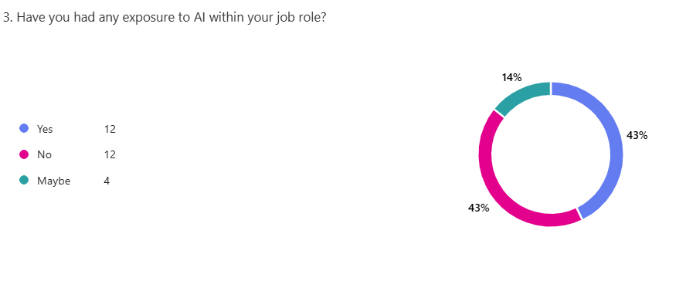
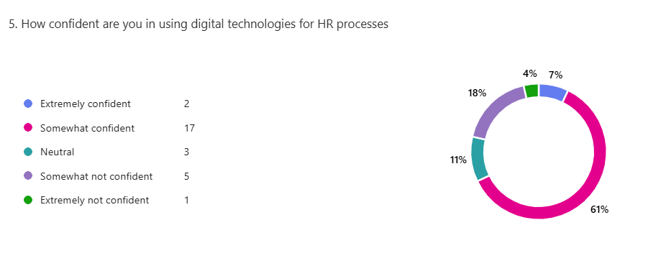
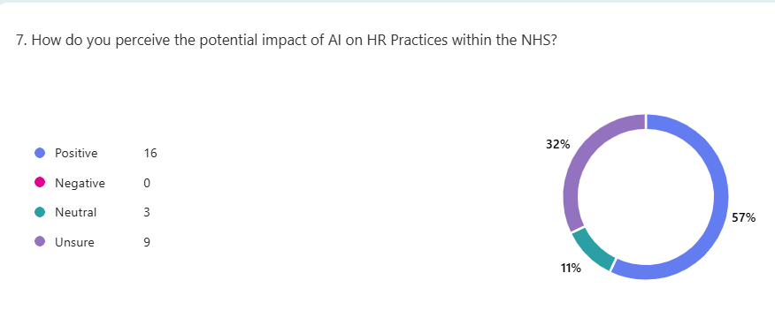

Appendix 2 – Email Invitation
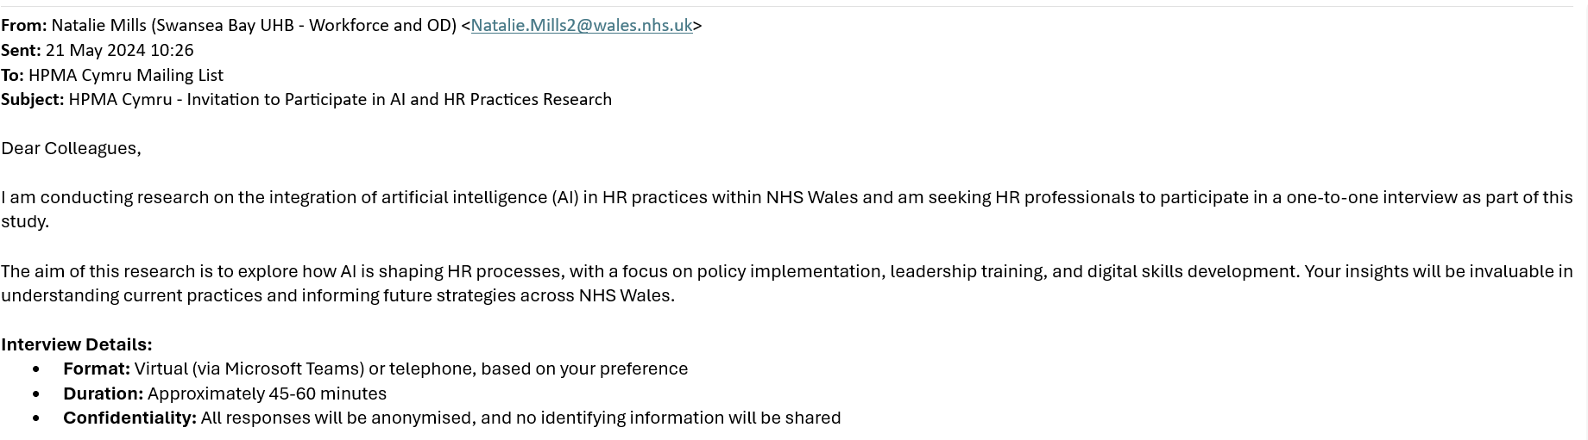
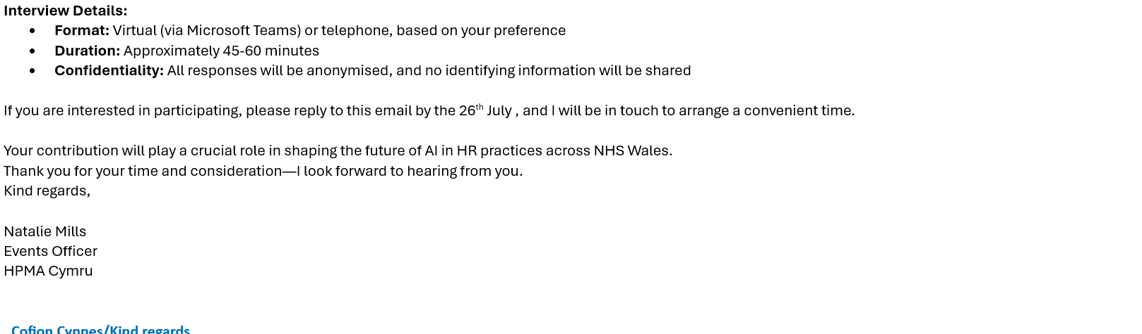

Appendix 3 – Participant Consent Form
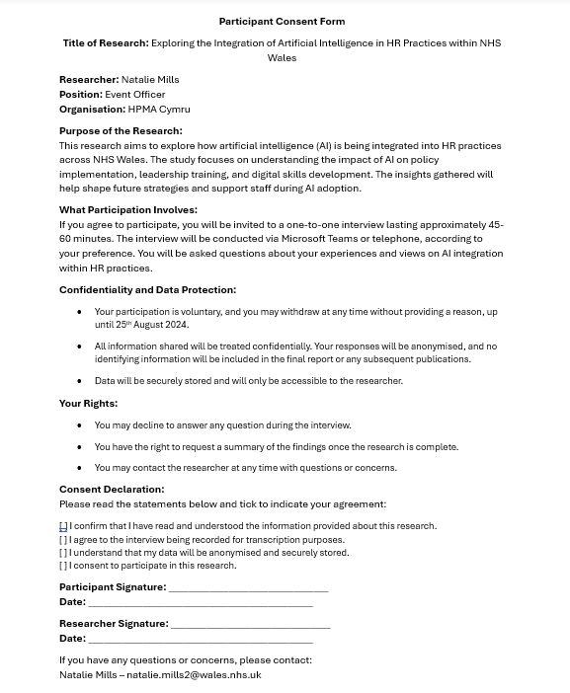

Appendix 4 – Sample interview with participant number 3
Interview with Participant Number 3 – 6th of August 2024 - Teams
1. Policy Implementation
Q1: In your view, how important are clear policies for the successful integration of AI in HR practices?
A: "Clear policies are absolutely crucial. They provide structure and clarity, which is especially important when implementing new technologies like AI. Without well-defined guidelines, there is a risk of confusion and inconsistency in how AI tools are used. For instance, when we introduced automated recruitment screening, there were initial concerns about fairness and bias. It took a long time for us to introduce a standard operating procedure around this to alleviate staff concerns. We are still trying to implement a usage policy around this and it is adding confusion for staff."
Q2: What specific elements should AI-related policies include to address employee concerns?
A: "Policies need to be comprehensive and accessible. They should outline how AI is used, how decisions are made, and what safeguards are in place to prevent bias or misuse. Transparency is key. In addition, we should have clear processes for staff to raise concerns or challenge decisions made by AI. Regular policy reviews are also important—AI technology evolves rapidly, and our guidelines need to keep pace."
2. Leadership Training
Q3: What role do you think leadership plays in facilitating AI adoption within NHS Wales?
A: "Leadership plays a pivotal role. Managers act as a bridge between technological change and staff. If leaders understand AI and its implications, they can better support their teams through the transition. For example, during the rollout of digital rostering, leaders who received training were able to explain the benefits clearly and address staff concerns proactively. This led to smoother adoption and reduced resistance. However this is difficult with clinical and workload pressures, no matter how much training you put on sometimes you just cant capture all staff. Leadership training for these changes is imperative but I don’t know how you could get everyone in one room"
Q4: What kind of training do you think is most effective for leaders managing AI implementation?
A: "A combination of technical training and emotional intelligence development is essential. Leaders must understand how AI systems function but also be equipped to address the human side of change. Workshops on ethical AI use, decision-making frameworks, and communication strategies are vital. One idea could be a leadership development program included role-play scenarios where managers practice responding to staff concerns about AI-driven performance reviews—it could significantly improve their confidence. By trialling it in a safe space I think leaders would feel more confident in dealing with staff concerns if they have had practice."
3. Digital Skills Development
Q5: How do you think AI integration impacts the digital skills needed by NHS Wales staff?
A: "AI integration raises the bar for digital literacy across all levels. Even staff who aren’t directly involved in technical roles need a basic understanding of how AI affects their work. For instance, our payroll team needed to adapt when we implemented an AI-powered scheduling tool. Without proper training, there was a risk of errors and reduced trust in the system. Continuous training is the only way to keep up with these changes. We hold small training sessions in each meeting almost like troubleshooting where we go through the system and it creates a continuous learning environment"
Q6: What strategies would you recommend to enhance digital training for NHS Wales staff?
A: "A tiered, role-specific approach works best. Not everyone needs the same level of AI literacy, so tailoring training to job functions is key. Interactive, hands-on learning also tends to be more effective than theoretical modules."

Appendix 5 – Word Cloud


