

Design of train personnel information management system based on neo4j under the background of epidemic situation

by
Ziheng Zhang

Supervisor: Michael Dacey

Project submitted as part of the requirements for the award of
MSc Software Engineering (Web Development)

November 2020
DECLARATION

I, .....................................Ziheng Zhang…………………………… declare that I am the sole author of this Project; that all references cited have been consulted; that I have conducted all work of which this is a record, and that the finished work lies within the prescribed word limits.

This work has not previously been accepted as part of any other degree submission.

Signed : ................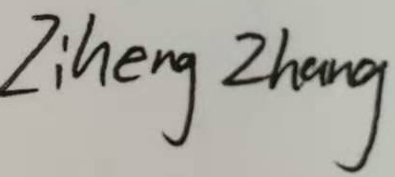.............................

Date : ..........9/11/2020................

FORM OF CONSENT

I ____________________________ hereby consent that my Project, submitted in candidature for the MSc Software Engineering (Web Development), if successful, may be made available for inter-library loan or photocopying (subject to the law of copyright), and that the title and abstract may be made available to outside organisations.

Signed __________________________

Date ________9/11/2020____________________

ABSTRACT
With the continuous development of society, the communication between people in the society has become more frequent. The relationship between people is like a huge data network. In the face of emergencies, such as global epidemic, it is very important to analyze the data and quickly mine the relationship between the data. This project is based on this background to make a research design to achieve some functions and systems in order to effectively control and prevent the outbreak of the epidemic.
The main purpose of this project is to build a train personnel itinerary management system based on neo4j database for railway related departments during the epidemic period, which is used to store passenger information and travel information, and to process the data of infected or potential infected passengers, and then directly express it in the form of point-to-point relationship. The important function of this system is to simulate that when a sick passenger's information is entered (or modified), the system administrator can get the relationship map of relevant personnel through simple operation method, and then inform other passengers who may be sick by telephone or collect data according to the map information, so as to prevent in advance.

Table of content
ABSTRACT III
1 INTRODUCTION 6
1.1 Aim 6
1.2 Objectives 6
1.3 Structure of the report 7
2 RESEARCH AND REVIEW OF LITERATURE 9
2.1 Hidden danger to society caused by epidemic disease 9
2.2 The importance of personnel flow analysis management 10
2.3 Application and research status based on neo4j 11
2.3.1 Definition and selection of knowledge map 11
2.3.2 application status of neo4j 12
2.4 A brief introduction to the technology needed for the realization of the system 14
2.4.1 B / S architecture 14
2.4.2 J2EE specification 15
2.4.3 Cypher language 15
2.4.4 Spring Boot 16
2.4.5 Vue.Jsframe 17
2.5 Conclusion 18
3 RESEARCH METHODOLOGY 19
3.1 Research overview 19
3.1.1 Research method 19
3.1.2 Research philosophy 20
3.1.3Research strategy 20
3.2 Research design 21
3.3 Development method 22
3.4 Conclusion 23
4 DESIGN AND IMPLEMENTATION 25
4.1 System analysis 25
4.1.1 Requirement analysis 25
4.1.2 Functional requirements analysis 27
4.1.3 Non functional requirements analysis 30
4.1.4 Data demand analysis 31
4.2 System outline design 32
4.2.1 Overall design of personnel management system 32
4.2.2 Personnel management function module design 33
4.3 Database design 37
4.3.1 Conceptual structure design of database 37
4.3.2 Logical structure design of database 38
4.4 Summary of this chapter 39
5 DETAILED DESIGN AND IMPLEMENTATION 40
5.1 System development environment and Implementation Architecture 40
5.1.1 System development environment 40
5.1.2 System implementation architecture 40
5.2 Database knowledge map design and database connection 41
5.2.1 Design of database knowledge map 41
5.2.2 connection of neo4j database 43
5.3 Detailed design and implementation of function module 45
5.3.1 Passenger personal information module 45
5.3.2 Main display page module 55
5.3.3 Administrator browsing module 60
5.3.4 Passenger related information management module 63
5.3.5 Train information management module 69
5.4 Summary of this chapter 70
6 EVALUATION 71
6.1 Test 71
6.2 Conclusion 79
6.3 Expected answers 79
6.4 Do it again 79
7 CONCLUSIONS AND RECOMMENDATIONS 80
7.1 Conclusion 80
7.2 Recommendation 80
8 REFLECTION 82
REFERENCES 83

Figure 1
Table of tables
Table 2 Authorities of different users 27
Table 3 System development environment table 40
Table 4 Passenger attributes 42
Table 5 Relation attribute 42
Table 6 Login function test case design 71
Table 7 Single passenger information management test case design (without considering the disease related) 73
Table 8 Single passenger information management test case design (without considering the disease related) 75
Table 9 Test case design of individual passenger information management (considering disease related) 77

Table of figures
Figure 1 3
Figure 2 Research Overview 19
Figure 3 Research Design 23
Figure 4 Administrator’s authority 28
Figure 5 Passenger’s authority 29
Figure 6 System Context Diagram 31
Figure 7 Main function modules of the system foreground 34
Figure 8 Main function modules of the back end of the system 36
Figure 9 Data logical structure 38
Figure 10 The implementation architecture of the system 41
Figure 11 Architecture of spring-data-neo4j module 43
Figure 12 configuration of springboot POM 44
Figure 13 Major configurations related to neo4j 44
Figure 14 Connection with neo4j 44
Figure 15 The specific implementation of the landing process 46
Figure 16 Main code of login method 46
Figure 17 Program login interface 48
Figure 18 Program login interface 48
Figure 19 Program login interface 49
Figure 20 Two main methods 49
Figure 21 Main code of graph1 method 50
Figure 22 Codes of User's "lv2" display page 51
Figure 23 Codes of the comparison algorithm 51
Figure 24 Program flow at the front end 52
Figure 25 Travel information of user "3" 53
Figure 26 Other passengers have travel information associated with time and train with "3" 53
Figure 27 Other passengers have travel information associated with time and train with "3" 53
Figure 28 Other passengers have travel information associated with time and train with "3" 54
Figure 29 Password modification interface 55
Figure 30 Codes of updatePwd 55
Figure 31 All information display pages 56
Figure 32 Codes of getSearchGraph method 56
Figure 33 Codes of searchAlgorithm method 57
Figure 34 Search window 57
Figure 35 Partial code block 57
Figure 36 Code block of "searchdate" 57
Figure 37 Code block for empty ID parameters 58
Figure 38 Results displayed when the input date is "2020-08-01" 58
Figure 39 No search date criteria were added 58
Figure 40 No search date criteria were added 59
Figure 41 Process filtered by search date 59
Figure 42 Patient information display page ”lv1” 60
Figure 43 Important code blocks 61
Figure 44 Patient information display page”lv2” 61
Figure 45 Procedure flow of patient information display 62
Figure 46 Patient contact information display”lv1” 63
Figure 47 Patient contact information display”lv2” 63
Figure 48 Main interface of single passenger information modification 64
Figure 49 Main interface of single passenger information modification 65
Figure 50 Code for generating user and password 65
Figure 51 Code of judgment 66
Figure 52 Infection algorithm flow 67
Figure 53 Single passenger travel information management interface 68
Figure 54 Mass data import interface 69
Figure 55 Important code of mass data import 69
Figure 56 Adding and deleting trains 70
Figure 57 Test display 74
Figure 58 Test display 74
Figure 59 Test display 75
Figure 60 Test display 76
Figure 61 Test display 76
Figure 62 Test display 78
Figure 63 Test display 78

1 INTRODUCTION
In today's human society, it is convenient for people to travel, and various public transport modes emerge in endlessly. But in this extremely developed traffic situation, the problem is also obvious. In the novel coronavirus pneumonia cases, people's convenience for travel also accelerated the spread of the virus. Many countries are relatively backward in public transport practice facing the spread of the epidemic, and there is no effective travel information management to cope with this situation. The purpose of this paper is to study, design and implement the train based travel management under the background of epidemic situation, so as to achieve a certain effect of preventing virus infection in advance.

1.1 Aim
The aim to construct a train personnel management system based on neo4j database during the epidemic period
According to the background and requirements, the database and the front and back end are designed.

1.2 Objectives
The objectives are to:
- According to the background and requirements, the database and the front and back end are designed.
- The system can easily import data, modify data, and maintain the real-time performance of the system.
- Encapsulate the corresponding search and query algorithm in advance in the background to facilitate the operation of the administrator.
- Make functional tests on the system to verify whether the system can meet the expected requirements

1.3 Structure of the report
This paper is mainly divided into six chapters to analyze the design of train personnel management system based on neo4j under the background of epidemic situation. The specific contents are as follows:
Chapter one: Introduction, mainly points out the significance of the research, shows the aim and objects to be achieved in this design.
Chapter two: Related technology and background research. The main part is literature review, which introduces the research status of related subjects and the related technical framework, R & D language, database and so on. It includes: Java language, spring boot framework, Vue framework, neo4j database and so on, which constitute the technical foundation of personnel management system.
Chapter three: Requirement analysis and outline design. Through the analysis of the current situation and feasibility, the personnel management system for a more comprehensive needs analysis. The specific method is to decompose the system requirements, analyze the functional requirements and non functional requirements of the system, and clarify the functional requirements and non functional requirements. The second is the overall design of the system, including system architecture design, module division and data model design.
Chapter four: Including the analysis of the system, as well as the conception and design of each module and function.
Chapter five: This chapter is mainly about the realization of functions and modules, as well as the display of some functions and codes
Chapter six: Statistical analysis of the results and results. It mainly tests the functional requirements of the system, and determines whether it is practical and feasible through the test results.
Chapter seven: Summary. This part mainly analyzes the full text and carries on the summary, discovers the insufficiency, and proposes the correction.
Chapter eight: Prospects for future work.

The project has three main components. First of all, through some theoretical work to lay the foundation for the implementation of the project. This paper analyzes the advantages and disadvantages of the existing system and the requirements of the system to be designed from the aspects of literature review and practice. The second part introduces the requirement analysis of the system in detail, and the design and implementation according to the requirement analysis. Finally, the third part will test and explain the design results, compare the results with the objectives, and put forward improvement suggestions according to the current implementation.

2 RESEARCH AND REVIEW OF LITERATURE

2.1 Hidden danger to society caused by epidemic disease
The novel coronavirus epidemic has caused significant impact on the international social and economic development since the end of 2019. The initial stage of the epidemic has not enlarged the problems in the city's public health system, including the lack of awareness of the hazards of the epidemic, the ineffective flow of personnel, the low efficiency of the distribution of the materials for the prevention of epidemic diseases, and the lack of coordination among the departments.Big challenge [1].The novel coronavirus mainly spreads through respiratory droplets and contacts, and [2] is transmitted quickly, with high incidence rate and long incubation period.In today’s society, passenger transportation is extremely developed, which not only brings convenience to people’s travel, but also creates natural conditions for the spread of the virus.Among all passenger transport modes, public transport has the characteristics of gathering passenger flow(flow means passenger's itinerary and move information in this document) and complex environment, which is a passenger transport mode with high risk of virus transmission [3], especially in confined spaces such as trains.In an epidemic environment, it is very important to manage and analyze the flow of people in public transportation such as trains.Due to the long incubation period and strong infectivity of the virus in human body, many passengers may not know that they may have been infected with the virus after contacting the infected person on the train, and then continue to move in public space, thus causing the further spread of the virus among the crowd.Now many countries and regions in response to this epidemic situation measures are in people after the outbreak of medical treatment or isolation, which can not play a role in advance of prevention, leading to further spread of the virus repeatedly, causing great pressure on the social medical system.

2.2 The importance of personnel flow analysis management
In the past or even now, there are not many relatively advanced and convenient methods to manage the personnel information on trains in the market. Most of them are the traditional methods of manually recording the information on the paper or electronic forms by the crew members, which can be retrieved when necessary.This method is more time-consuming and needs less data.For example, if a passenger is sick within one day after taking a train, if relevant staff need to play an early warning role, they need to extract and screen the passenger&apos;s riding records, and then query the passengers who may have contacted with them in the ride records.If the traditional management method is used, the workload will be huge and the data may be omitted in the face of this situation. This defect is unacceptable for accurately preventing the further spread of the virus.Literature [5] proposed that the rapid spread of the new epidemic in the world promoted the innovation of big data analysis tools.The novel coronavirus [6][7] has put forward a model that the government can timely and accurately convey the new coronavirus&apos;s sources, symptoms, transmission routes, protection methods, treatment methods, hospitals, the number of suspected suspects and action paths, and other high-quality and dynamic information through timely and accurate communication to the masses.This design draws the essence from the above several documents, and decides to design a method for the train epidemic management system.In the past, many management systems are designed based on relational databases such as MySQL and SQL server, which constitute a huge system by designing various primary keys, foreign keys and other associations.However, on the level of personnel flow, i.e. action path, what is important is the connection between people, which forms a kind of interrelated data and forms a variety of relational networks, and the essence of these data lies in the connection [21].Based on the traditional relational database, it can not express the connection of data well, or it is too complicated to extract data.Therefore, in the design of a system based on personnel flow information, it is very important that the targeted selection can well reflect the attribute of relationship.
Literature [4] pointed out that the probability of virus transmission is positively correlated with the exposure time in the bus, that is, the less the exposure time in the bus, the lower the probability of virus transmission.Therefore, it is necessary to control the exposure time of passengers in buses.The exposure time of passengers in the vehicle depends on the bus travel time, that is, the total time used by passengers in a bus trip, excluding the travel time before and after getting off the bus.This design extracts this point of view, focuses on the time of people taking the train, takes the relationship between people and trains as the key point, and adopts the method of knowledge mapping to build the model.

2.3 Application and research status based on neo4j

2.3.1 Definition and selection of knowledge map
[5] Knowledge map is one of the technologies of semantic network, which is based on the data structure of graph. Knowledge map is composed of head, relationship and tail triples [8], which can be expressed as g = {H, R, T}, where H = {h1,h2,…h|n|} represents the set of entities in the knowledge map, R represents the set of all relations in the knowledge map, and T belongs to H × R × H, which represents the triple set in the knowledge map. In essence, knowledge mapping represents the semantic relationship between entities, and is the description of things and associations in the real world [22]. This data structure can well show the {people, the relationship between people and the train, the train} structure, and also can more intuitively show the relationship between all passengers.
According to the different domain oriented, knowledge mapping can be divided into open link knowledge map and vertical industry knowledge map [8]. Open link knowledge map is not oriented to specific fields and has certain universality. For example, wikidata based on Wikipedia [9] and so on; vertical industry knowledge map is oriented to a specific field and has certain specialization, such as GeoNames [10].
At present, there are many storage schemes for knowledge map, such as native database based on disk or Mainmemory, relational database based on non relational database.Because the graph based storage structure is more conducive to discovering the potential relationship between entities, this paper uses the graph database in non relational database to store knowledge map. Storing the knowledge map into the graph database is to save the entity of the knowledge map as the nodes in the graph database, and the relationship between the entities is saved as the edge connecting each node [10]. At present, the mainstream graph databases include neo4j database developed by American neotechnology organization, graphengine database developed by Microsoft company, gstore database developed by Peking University, etc. Among them, the most commonly used graph database is neo4j, which is a mature high-performance graph engine and supports distributed. Neo4j graph database has good compatibility with Java platform, which is conducive to later engineering development. Based on the above advantages, this paper uses neo4j graph database to store the knowledge map.
Compared with traditional relational database, graph database pays more attention to the relationship between entities. Compared with the relational database which stores the relationship through the table structure and foreign key, the graph database has the concept of independent relationship, and the entity node directly reaches other endpoints through the relationship, compared with the original need to find the corresponding in the relational tableID, this entity to entity approach undoubtedly greatly improves the performance of cross table query operation, simplifies the complexity of modeling, and improves the design and performance [26] [27].

2.3.2 application status of neo4j
In reference [12], we studied the performance of neo4j, organized the data into graphs, configured clusters, and used the vertices and edges of the graph to represent the relationship between entities and entities, and finally organized the points and edges to store massive heterogeneous multi-source data.Literature [13-15] all proposed the method of RDF graph data storage based on neo4j, and the experiments show that the neo4j graph database can not only meet the requirements of RDF graph data query of domain ontology, but also further improve the query efficiency.Literature [16] through the analysis of neo4j dialogue sheet, it is concluded that the social network formed by the callers and who are close to each other, which provides great help for the public security organs to solve crimes.Based on neo4j, literature [17] designed and implemented the linked us social network platform, which can better manage and update social network data and their internal relationships, and support multi-layer complex queries such as "Friends of friends". In reference [18], based on neo4j, the association analysis system for 40000 drug addicts was established, which can clearly show the social network relationship of specific drug users in the graph database.Reference [19] proposed the application mode of key person super relationship analysis based on neo4j, which to a certain extent solved the problems that the traditional data organization mode is not conducive to relationship analysis, and the traditional analysis method is not conducive to in-depth study and characterization of personnel characteristics.Reference [20] pointed out that in order to represent complex relationships in relational databases, many connections must be constructed, thus forming many complex operations.With the growth of data volume, query performance is declining.In the case of large amount of data, the query speed of neo4j graph database is several times or even tens of times of that of relational database.
The goal of this design is based on neo4j multi-dimensional relationship network analysis demonstration system, mainly aimed at the flow of people on the train under the environment of epidemic situation. At present, it plans to adopt the design method in reference [21] and make changes in combination with itself. The technology is B / S architecture designed based on loose coupling architecture, the design and development specification of application service development based on J2EE, Java language and cypher language are used for development, springboot framework is used for the back end, and Vue.js Frameworki s used for the front end.

2.4 A brief introduction to the technology needed for the realization of the system

2.4.1 B / S architecture

2.4.1.1 B / S structure model
B / S (Browser / server) form is the technical extension of C / S (client / server) form. Client: refers to the program corresponding to the server to provide local services for customers. The client realizes the functions of input and output: one is that the user inputs data to send a request to the intermediate business server; the other is that the user outputs the data interpreted and returned by the business server. The client only needs to install the operating system and browser to run in the network through TCP / IP protocol.Business service: it is the focus of management, and also the client must go through when accessing the database. Business server includes two functions: one is to receive data input from the client, filter out unqualified data, request data operation from database server to realize data operation such as query, update and delete; the other is to receive returned data from database server and output it to client in proper form after processing.Data service: it is the information center of management system [23].

2.4.1.2 B / S structure features
B / S structure has many advantages over traditional C / S structure.Eliminate database bottleneck: we can upgrade the hardware equipment of database server in some ways: improve the running speed, but the hardware upgrade space is limited and the reliability is low.If the B / S structure is adopted, the business server can be free from the limitation of concurrency [23].

2.4.2 J2EE specification
J2EE (Java 2 Platform Enterprise Edition) is a java version released by Sun company for creating server applications and services. J2EE takes Java standard edition as the core, and makes use of its cross platform features and JDBC API technology to simplify the development, deployment and management of enterprise system. Since its launch, it has gradually become the most used server development solution in the industry with the characteristics of efficient development, cross platform, scalability, and stable availability.In terms of architecture, J2EE can be divided into four layers: customer layer, web layer, business layer and ESI layer [27]. J2EE also includes many components, which are distributed in different layers according to different logical functions.Different layers can be distributed on different servers, which makes J2EE structure have the distributed characteristics.J2EE, a multi-layer model architecture, avoids the disadvantages of the traditional C / S model that the client undertakes too much responsibility and is not conducive to update [28].
As a server application development platform with perfect functions, J2EE provides up to 13 technical specifications and components for developing web based server applications. With the continuous development of J2EE technology system, such as spring, struts, Mybatis, Hibernate and other upper frameworks emerge in endlessly. These emerging frameworks provide more powerful functions and improve the development efficiency of server programs, but they are also the encapsulation of J2EE underlying technology in essence [29].

2.4.3 Cypher language
Cypher query language is an external domain specific language to express queries on NoSQL graph database (neo4j database). Domain specific language (DSL) is a language for specific application domain. DSL is ubiquitous. SQL is the standard query language of relational database. Cypher query language allows users to write traversal without writing the specific structure of the graph in the code, and then retrieve the graph efficiently through traversal. Although cypher query language is the standard query language of NoSQL graph database, it is still in the developing stage, which means that the syntax of cypher query language may change at any timeIn other words, it has not been subjected to strict performance testing like other components in neo4j [30].
Cypher query language is designed to make it more user-friendly and convenient for software developers. It is very important for those who are engaged in database management.The main goal of cypher query language is to make simple things easier and complex things possible. Now cypher query language is mostly based on other query languages. Most keywords are derived from SQL query language, such as order by and where keywords from SQL. The expression of pattern matching is obtained according to the relevant contents of SPARQL. Regular expression matching can be realized by using Scala programming language [31].

2.4.4 Spring Boot
Spring boot framework is based on spring 4.0 design, is an open source lightweight framework.The framework not only retains the advantages of spring framework, but also removes the XML configuration file of spring framework, which further simplifies the construction and development of the project in terms of configuration.It makes system developers pay more attention to business logic implementation than system configuration.In addition, there are two very important strategies in the spring boot framework: out of the box and convention over configuration [6].Out of the box strategy refers to managing the whole life cycle of an object by adding related dependency packages to POM files of Maven projects or gradle files of gradle projects, and then using annotations to replace XML file configuration [24].Developers get rid of the complicated XML configuration and dependency conflicts, and pay more attention to business logic.Convention is superior to configuration strategy, which is a software design paradigm in which target structure is configured by spring boot framework itself and information is added to structure by developers [24].This strategy reduces the number of decisions developers need to make and a large number of XML configuration, and can automatically compile, test and package the code, but also reduces some flexibility and increases the complexity of bug location.To sum up, the spring boot framework has the following features:
(1) You can create stand-alone applications, and use Maven or gradle plug-ins to type applications into jar packages or war packages.
(2) Built in Tomcat container, developers do not need to configure Tomcat during project development.
(3) Through various "starters", the required dependency packages are introduced to simplify the dependency configuration.
(4) Maximum automatic management of spring container, reduce manual management.
(5) Remove the complicated XML configuration files and replace them with annotations.In the process of system development using spring boot framework, the front-end usually uses template engine, among which free marker and thymeleaf are the most popular.

2.4.5 Vue.Jsframe
Vue.jsThe framework is an incremental bottom-up development framework that focuses only on the view layer and the user interface [25].Unlike other heavyweight frameworks,Vue.JsIt is very easy to integrate with other projects or front-end libraries.Its development goal is to realize the data binding of response and the combined view component through the simplest API as possible [25].Compared with other front-end frameworks,Vue.jsIt has the following advantages:
(1) Ease of use
The related syntax of Vue is similar to HTML. CSS is used for page layout, and java script is used for page event response. Therefore, developers who are familiar with the traditional front-end technology language only need to view relevant technical documents to start building applications with Vue.
(2) Flexibility
Compared with other heavyweight frameworks, Vue&apos;s core library is simple and compact, and its core is progressive
Technology stack, enough to develop complex single page components, to cope with applications of any size [25].
(3) Performance
vue.jsIt only has a running size of 20KB min + gzip, and its super fast virtual DOM makesvue.jsFaster processing of data [25].

2.5 Conclusion
This chapter mainly analyzes the hidden dangers of infectious diseases spread by traffic media in public transportation, especially the extensive use of trains. It introduces the necessity and importance of personnel flow analysis, and puts forward a design of personnel flow management system.It also studies and analyzes the database and structure suitable for the system, analyzes a large number of documents using related technologies, and emphatically introduces the principles and advantages of the related technologies to realize the system.
The next chapter will introduce the research methods of this topic (For convenience, the system is referred to as personnel management system).

3 RESEARCH METHODOLOGY

3.1 Research overview
The figure below provides a top-down view of the three phases of the research process.The separation of the three stages, including research method, research philosophy and research strategy, provides a complete design view.
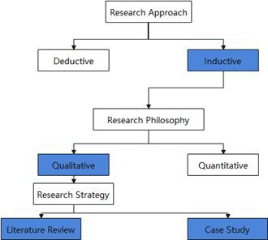
Figure 2 Research Overview

3.1.1 Research method
Inductive research is also called inductive research.It refers to a research method that generalizes general conclusions from a series of special premises. Its function is to summarize and summarize the concrete cases or individual judgments that people have known in practice, so as to draw general conclusions, so as to obtain knowledge and discover truth [32]. The research method of inductive reasoning is adopted in this paper. First of all, we should collect data, observe, measure and record individual cases, and then analyze the collected data to find the common characteristics or the relationship between the characteristics. By using this method, we can infer the problems existing in the current public transport system through the analysis of the transmission route, harm and epidemic prevention status, and put forward the corresponding solutions.

3.1.2 Research philosophy
Qualitative research method refers to a method or angle to study things from the inherent stipulation of things according to the attributes of social phenomena or things and the contradictory changes in the movement. Qualitative research mostly uses participation observation and in-depth interview to obtain first-hand information, and the specific methods include participation observation, action research, etc.The advantage of participating in observation is that through participation, researchers can get the feelings of a member in a specific social situation, so that they can understand the action more comprehensively. Then, through the data obtained by observation and interview, they can gradually transform from concrete to abstract and form theory. In this paper, qualitative research, historical review, literature analysis, observation, participation experience and other methods are used to obtain the route and rate of virus transmission and related characteristics, and non quantitative means are used to analyze and obtain research conclusions.

3.1.3Research strategy
The research strategy of this subject combines literature research and case study. This paper analyzes the possible problems in the transportation system under the current epidemic situation from multiple perspectives, and puts forward relevant ideas and solutions. Through literature research, consulting the relevant literature and network news, as well as personal information, summed up the spread of the epidemic law and the need for preventive measures. In view of these problems, and combined with the more widely used Internet development tools, this paper puts forward the idea of the relevant management system.Through the case study, the train represents the public transport, and assumes the operation mode of the management system under various conditions. The purpose of this system is to provide passengers and relevant managers with convenient tracking and predicting the activities of people infected with the disease and their contacts on the train, and then can be notified or controlled.

3.2 Research design
This study takes passengers as the research object and virus as the auxiliary research object, and discusses the regularity and commonness of virus (epidemic transmission).
(1) The first is the spread of the virus.For novel coronavirus pneumonia, its spread is based on human beings, and it spreads very fast, has a high incubation period, and has a longer vitality in vitro (at least 3 days). Patients with novel coronavirus are highly contagious even without symptoms. First of all, in the case of trains as transport vehicles, the first point is that the staff should disinfect the trains every day and passengers need to take precautions. However, this can not solve all the problems.Because masks can't be 100% protected, a train based personnel management system is very necessary.
(2) Through observation, due to the characteristics of long incubation period and strong virus vitality, if we consider too many time problems, the early design may be too complex, which is not conducive to development. Therefore, in order to set the early stage and observe the feasibility of the system, it is tentatively assumed that there is a one-day incubation period for passengers to be infected with the virus, that is, the passengers are infectious one day before and after the diagnosis.
(3) In the case of passengers as the research object, the relationship between passengers and other passengers is mainly the intersection of travel time and the same train. Therefore, it is very important to consider this relationship when designing the system.
(4) After observation and Research on the current management mode, it is found that the epidemic prevention measures in many places are relatively backward. Many of them search for the relevant passengers according to the parking space number and so on after the occurrence of the case for investigation notice, and even may not achieve the level of prevention in advance after the occurrence of the case. Therefore, for the system of this design, the function of early prevention and the convenience of passengers' information reading are particularly important.
The above is the basic survey of this design and the necessity analysis of the system.

3.3 Development method
This design adopts the prototype method. Prototype method, namely prototyping, is a version produced to make up for the shortcomings of waterfall model. It is an interactive process between users and software developers. The prototype method is commonly used in some relatively small software designs [33]. Before the design of the prototype method, the designer should have a comprehensive analysis of the customer's requirements, and then make a consistent scheme according to the analysis, and then design the software according to the scheme to make a trial run software prototype. In the process of trial operation, the problems are found, and then the whole software is modified according to the problems. Finally, the software will no longer have problems and meet the requirements of customers. This development method has clear requirements for software system and saves developers' time [33]. This design takes its own into the customer, analyzes the initial needs of experience users, and uses the current function and finds its shortcomings, so as to analyze the potential needs and improve the function step by step.
The following figure shows the basic workflow of the prototype method
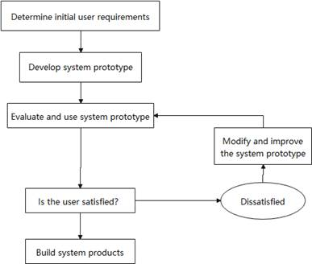
Figure 3 Research Design
The following is the interpretation of the prototype flow chart:
(1) This topic has carried on the research to the present situation, has studied the related literature, has collected and set some demand for the management system display and the backstage logic level, and has carried on the division and the design to each module, this is the initial user demand.
(2) Through the initial construction of the system requirements.
(3) And evaluation and testing, from the perspective of their own into the user, to find the system code level problems and more functional requirements, and to redesign or improve the system.
(4) Repeat the above process, test and change many times, and finally achieve the system version that meets all development requirements.

3.4 Conclusion
This chapter is about the research methods of the project, describes the research process and research design, and introduces the methods and reasons of my choice.Through the relevant case study, status analysis and demand analysis, the development mode of the prototype method is finally determined, and the development flow chart of the system is made.
The following chapters are mainly about the system requirements analysis, design and implementation.

4 DESIGN AND IMPLEMENTATION

4.1 System analysis
The main work of this chapter is based on the actual needs of users, the function and performance of the train based personnel management system to do a detailed demand analysis and outline design.In the demand analysis part, according to the user requirements, the function, performance and data of the management system are analyzed in detail.The overall design of the system, as well as the overall design of the database management module.

4.1.1 Requirement analysis
In the development process of personnel management system, it is very important to analyze the function, performance and data of the system.Because it mainly faces managers, it is necessary to understand the management needs and business requirements, understand what the system does in the whole environment, so as to determine the specific functions of the system.
With the frequent occurrence of epidemic diseases in modern society, especially the new type of coronavirus from the beginning of 2020 to now, in most countries, under the background of the development of computer technology, people, mainly the authorities, need information that can manage the action of personnel in public transportation, so as to manage and prevent the infectious disease.The background of the design of the system to the train as an example, to a certain extent, represents the popular public transport.The management system has a high demand for travel information and contact information of related patients.Therefore, in this system, managers have the following requirements for the management system:
(1) The administrator can log in with a unique password, and enter the exclusive operation interface of the administrator.
(2) The interface of the management system needs to be concise, but it can display all the information, so that the administrator can operate the system conveniently.
(3) The management system needs to be able to add, delete, modify and check the passenger's personal information and travel information. Because of the large amount of passenger data, sometimes it needs to import data in batches. The system also needs to support this function to simplify the operation of the administrator.
(4) The system needs to have algorithms to process data to distinguish the status of passengers and associated passengers.This is a key point of the system. According to the contact information of different passengers and related personnel, the display of data and the change of passengers&apos; own information about infectious diseases are processed. This part will be explained in detail later.
In addition, in addition to the operation of the administrator, the system should also meet the needs of passengers
(1) Passengers can log in with the password formed by their own identity information, and have their own passenger exclusive interface.
(2) Through this system, passengers can view the disease information of the personnel related to their riding records, so that passengers can quickly understand their own conditions.
This design simplifies the model to a certain extent. The system mainly discusses the advantages and feasibility of using neo4j graphic database to realize the epidemic based personnel management system.
The above data management module is not only easy to display, but also to meet the needs of data management system.Therefore, according to the different user roles and implementation effects of the personnel management system, different functional requirements are formulated to clarify the specific functions of the management system.

4.1.2 Functional requirements analysis
The goal of this paper is to design and realize a system of information management of personnel flow on the train under the background of epidemic. The main function of this system is to provide a platform for administrators and passengers to process and observe information data. In this platform, administrators can quickly access the system through browser at any time and anywhere, view passenger's personal data and travel information, modify and import and other operations. Passengers can log on the platform, and can see their own conditions and the passenger status related to their own riding records in order to prevent them in their own passenger interface. Therefore, the user roles of the management system are divided into two parts: administrator user and passenger user. The specific role characteristics and permissions are shown in table 4-1.
Table 1 Authorities of different users
Serial number | role | authority
1 | administrators | View all passenger data  Addition, deletion and modification of passenger's personal data  Add, delete, modify and check passenger travel information  Adding, deleting, modifying and checking train nodes  Check the related information of infected persons  Check the related information of people who have been exposed to infection  Import of mass data
2 | passenger | Login permission and password modification  View information related to your trip

According to the analysis of the above table, the specific functional requirements of each role are described in detail as follows:
1.administrators
The administrator is the administrator of the personnel management system and has the highest system authority.The system use case diagram for these roles is shown in Figure 3.The specific permissions of the administrator are as follows:
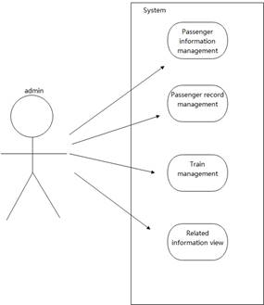
Figure 4 Administrator’s authority
(1) The administrator can manage the user's personal information, and can modify, delete and add the user's personal information. However, the administrator is not allowed to delete the user's personal information. The deletion function is generally used as a remedial measure after the administrator's error addition and other operations. Similarly, the administrator can also modify, delete and add the travel information of users.
(2) The administrator can import user's personal information and travel information in batches, such as a large number of passenger's personal information and travel information in the form of CSV data. The administrator can add or delete train nodes manually. This design simplifies the model and the function is relatively simple.
- The administrator can view the infected person and the person who has contacted the infected person in the special interface, and get different data according to the set range of personnel. In the search interface, the administrator can also accurately search the passenger information and fuzzy search travel information through the passenger's personal information.
2.passenger users
The passenger user is a registered passenger user. The system use case diagram of this role is shown in Figure 4. Once the user's personal account information is obtained by the administrator, it will automatically register. In addition, the member user also has the following permissions:
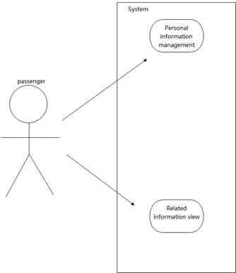
Figure 5 Passenger’s authority
(1) Similar to the real crew system, users can use their own registration ID and the reverse number of ID to log in.Generally, after logging in, the system will provide users with the function of modifying personal information. This design simplifies the model and only provides the function of changing password.
(2) Users can check the people who have been associated with their ride records to determine their own status.

4.1.3 Non functional requirements analysis
According to the specific needs of users, the stability and reliability of the system will directly affect the operation experience of administrators and passengers. Combined with the actual situation of the personnel management system and passengers, the following non functional requirements are mainly included in the development of this management system:
(1) System security
The personnel management system should check the validity of the user's identity and login information when logging in. When the administrator queries and other operations, the relevant search information and personal information are encrypted. For the administrator of some of the more important operations have the corresponding warning information, so as to make the system safe and stable operation.
(2) System ease of use
The beauty of the interface of the personnel management system has a certain impact on the administrator's operation experience of searching and adding, deleting, modifying and checking. And in the user operation to do simple, easy to use. Similarly, for the passenger interface, information acquisition should be simple.
(3) System stability
The management system can run smoothly for 24 hours in the face of multi-user operation concurrency.

4.1.4 Data demand analysis
In the data demand analysis stage, according to the specific needs of users, the relevant data generated is analyzed in detail, and the flow direction between the system data is shown to the user through the data flow diagram [35].
This paper analyzes the data of the personnel management system in a top-down way [34], and abstracts the data flow between the personnel management system and users.The top-level data flow diagram of the specific data flow direction and user relationship is shown in Figure 5.
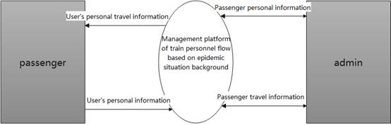
Figure 6 System Context Diagram
As can be seen from Figure 5, there are two types of users of the management system, namely passengers and administrators. The data flow between the user and the personnel management system is as follows:
(1) The administrator can obtain the personal information of all passengers and the passenger's riding record information from the administrator interface in the personnel management system, and can add, delete, modify and check these information.
(2) Passengers can view their own information and related riding information from the passenger interface in the personnel management system, and can modify personal information. In order to simplify the operation and model, only password modification is provided for the time being.

4.2 System outline design
In the development process of the management system, the outline design stage between the management system requirements analysis stage and the detailed design stage, based on the requirements analysis of the management system, establishes a logical model [35], and converts the system use case diagram obtained in the demand analysis phase into a specific data structure [36]. This stage mainly studies the overall design and functional module design of the management system.

4.2.1 Overall design of personnel management system
In the requirement analysis stage, the personnel management system is suitable for B / S architecture through the detailed analysis of the characteristics and functional requirements of the management system users [37]. It has the following advantages:
(1) In terms of system hardware, because the personnel management system has a wide range of users and a large number of people, the passenger users only need to have a browser to access the management system, so there is no need for higher system hardware as long as the system can be deployed [35].
(2) For the stability and reliability of the system, the interaction mode of B / S architecture is relatively safe, and the system overhead is relatively small, which is suitable for the development of small and medium-sized websites [35].
(3) In the aspect of beautiful interface, when the personnel management system is built on the browser, the interface is more tension.
The overall structure of the personnel management system is mainly composed of front desk and background. The background of personnel management system is mainly composed of controller, service and database interaction layer, while the foreground of personnel management system is mainly composed of user layer and presentation layer.By clicking the system interface button, the user sends the request to the controller [35], and calls different services for business processing according to the specific business logic.In the data storage layer, spring data neo4j is used to interact with neo4j database.Like other system projects, the overall architecture of the personnel management system is divided into two parts: the foreground and the background. The foreground includes the user layer and the presentation layer, mainly for the system interface. The background includes controller layer, business logic layer and data layer, it mainly deals with data logic [35].The specific functions of each layer are as follows:
(1) User layer: the user role for the personnel management system, which refers to administrators and passengers.
(2) Presentation layer: i.e. view layer, which is mainly composed of system interface to display system information and system function entry to users [35].
(3) Controller layer: composed of many controllers, different controllers are called according to the requested interface address to realize different business functions [35].
(4) Business logic layer: it mainly encapsulates the specific business implementation logic, which is represented by different services.
5) Data layer: this layer represents the data generated by business logic and interacts with database through spring data neo4j.

4.2.2 Personnel management function module design
Through the detailed analysis of the user requirements and the overall architecture of the personnel management system, the function of the personnel management system is generally divided into two parts: front desk and background. Because most of the user oriented functions of the system are provided to administrators, the foreground module of the system is mainly the passenger personal information module, the main display module of the administrator, and the administrator's hierarchical browsing The background part mainly includes passenger personal information management module, user travel information management module, train information management module and so on. The specific function modules of the front and back office of the management system are designed as follows.

4.2.2.1 Front desk of personnel management system
The main function module structure of the front desk of the personnel management system is shown in Figure 6.

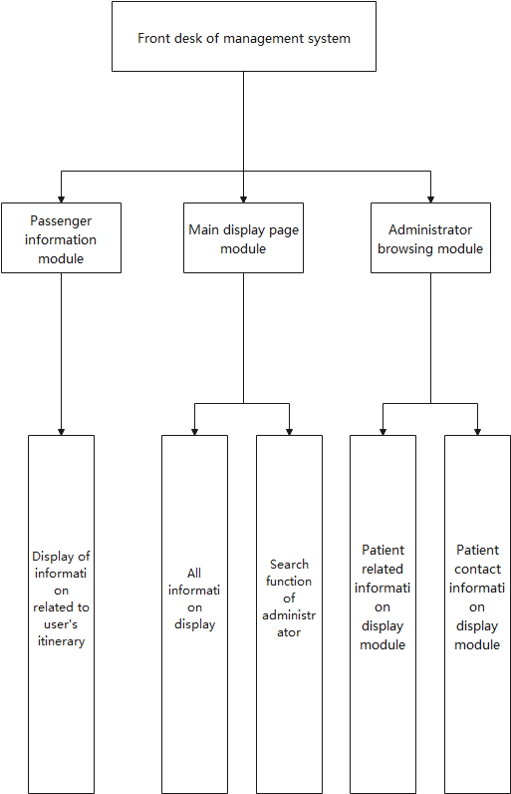
Figure 7 Main function modules of the system foreground
As can be seen from Figure 6, the front desk of the management system mainly includes the following functional modules:
(1) Passenger information module
In this module, passengers can enter their own personal information system through the ID and unique password (the reverse number of ID) in personal information, and can modify personal information in it (this design simplifies this function to only change the password). In addition, passengers who already exist in the background can view all their travel records and the status information of other passengers who have intersection with their own travel records in their own travel interface.
(2) Main display page module
The main function of the module is to display all the information stored in the background and the search function of the administrator. The search function mainly enables the administrator to search specific passengers through ID and search the passenger riding information of a time period by time.
(3) Administrator browsing module
The module is mainly for the administrator service, including two similar but different modules: patient display page and the display page of passengers who have contacted patients.The patient display page has two levels of display screen. The first level mainly displays the personal information and riding records of all patients in the system, and the second level mainly displays the passenger information that intersects with the patient&apos;s ride record.The display page of passengers who have been in contact with patients is similar to the display page of patients. There are two levels of display screen. The first level mainly displays the personal information and riding records of all passengers who have contacted patients in the system. The second level is also based on the first level, which displays the information of other passengers who have intersected the ride records of all passengers who have contacted patients.

4.2.2.2 Back-end of personnel management system
The main function module structure of the background of personnel management system is shown in Figure 7.

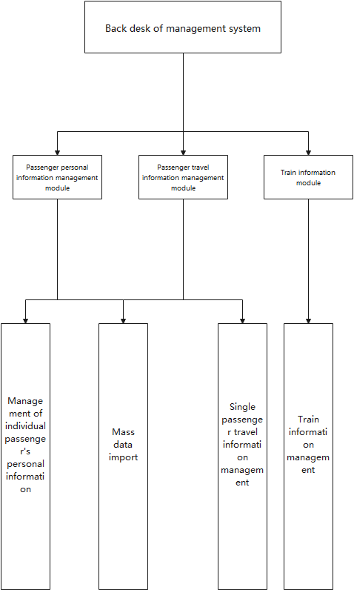
Figure 8 Main function modules of the back end of the system
As can be seen from figure 7, the background function modules of personnel management system mainly include passenger personal information management module, passenger travel record management module, train management module, etc.
The details are as follows:
(1) Passenger personal information management module
This module is mainly used to manage the personal information of passengers. The specific information setting will be discussed in the next section.The first mock exam module contains two functions: one is the management of individual passenger information, and the other is the mass data import.Single passenger information management is mainly to enable the administrator to accurately add, delete, modify and check the user&apos;s information. However, considering the large amount of train passenger data, when it is not necessary to manage important information, the administrator can simplify the operation by importing passenger personal information data in large quantities.
(2) Passenger journey recording module
This module is mainly for the management of passenger travel records, similar to the passenger personal information management module, it also supports accurate addition, deletion, modification, query and mass import.
(3) Train information management module
This node is added to simplify the train number module, so there is no other function except train number.

4.3 Database design
In the database design stage, it is necessary to design the corresponding database schema according to the use case model obtained in the requirement analysis and summary design stage [38].In the database design, it is mainly based on the user entity and the entity involved in the business feature extraction, and carries on the logical structure design and the concrete physical storage structure design.

4.3.1 Conceptual structure design of database
According to the user entities in the requirement analysis stage and the entities involved in the business logic of functional modules, the relationship between entities and their characteristics are determined. There are three types of entity relations: one to one, one to many and many to many [39].
Based on the epidemic background of the train personnel flow management system database sampling is the graphic database neo4j, the relationship between entities and entities is represented by node node node.In this design, the main entity is the user and the train. The user does not consider the administrator in the database logic, but only considers the passengers. In short, the storage and representation of data are [passengers {trip records} trains {trip records} passengers].Therefore, for the feature extraction of entities, because there are many entities involved in the electronic management system, only the important entities and their feature attributes are described, as follows:
- Passengers: Mobile phone number (ID), ID number, occupation, birthdays, address, illness, time of illness, contact with patients, password.
(2) Train: train number
(3) Travel record (as the relationship between the connector and the train, non entity): Journey ID, passenger ID (passenger ID represents the node to which this relationship points), train number (similar to passenger ID), seat number, boarding time, alighting time, and attributes extended in two times (which will be discussed later).

4.3.2 Logical structure design of database
The main task of database logical structure design is to transform the entity model proposed in the conceptual design phase into a logical structure consistent with the data model [40].The main logic and storage forms are shown in Figure 8 below.The details are as follows:
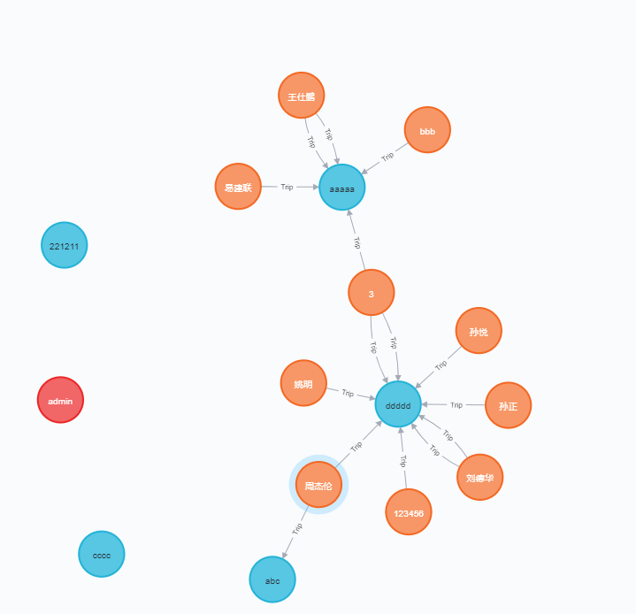
Figure 9 Data logical structure
This figure is the image stored in the original neo4j database, where the orange node represents the passenger, the blue node represents the train, and the red node represents the administrator (not involved in the logical structure). Therefore, we can see that the main storage mode and logical structure is that a passenger (ID card ID is unique) can take multiple trains, and a train (train number is unique) can be taken by multiple passengers. Such data logical relationship constitutes the passenger riding information network.

4.4 Summary of this chapter
In this chapter, the user characteristics and function modules of the personnel management system are analyzed in detail. According to the user role, the system requirements of various users are analyzed in detail, and the specific functional requirements and performance requirements of the management system are defined.
Secondly, the data flow direction of the personnel management system is analyzed, and the data interaction between users and systems in the personnel management system is displayed transparently through the system data flow diagram.
Next, through the system functions summarized by the demand analysis, the overall architecture and module division of the personnel management system are analyzed, and the whole system is divided into foreground and background.The structure of the system is defined, and the specific functions of the front and back of the system are described.
Finally, according to the entity model of personnel management system and the relationship between entities, the database conceptual design and logic design of some entities are carried out in detail.And the corresponding relational patterns are abstracted to lay the foundation for the subsequent design.

5 DETAILED DESIGN AND IMPLEMENTATION
This chapter mainly introduces the detailed design and implementation of the system, including the system development and operation environment, system architecture, database physical structure design and the detailed design and implementation of several important modules.The physical structure design of database mainly introduces the detailed design of database table [35].

5.1 System development environment and Implementation Architecture

5.1.1 System development environment
In order to ensure the stable development of the personnel management system on the train under the background of the epidemic situation, the system adopts relatively stable environment configuration, as shown in Table 2.
Table 2 System development environment table
operating system | Windows 10
development tool | Intellij IDEA 、Vs Code
database | Neo4j
The server | Tomcat
browser | Chrome
Operating environment | Node.Js

5.1.2 System implementation architecture
The personnel management system is mainly based on spring boot and Vue framework, using java language for research and development. In the process of building the project, the background implementation architecture of the whole personnel management system is mainly divided into three levels: Controller layer, Service layer and Repository layer encapsulated by mapper.The composition of the implementation frame is shown in Figure 9.
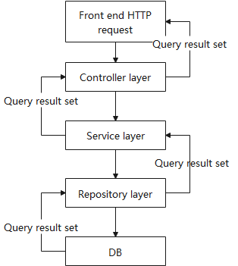
Figure 10 The implementation architecture of the system
Users can access specific pages through the browser. After the current end sends HTTP requests, the requests are sent to the controller layer, which is responsible for the process control of specific business modules. The service layer encapsulates the service controller according to the business code.The repository layer encapsulates the operation of the database, and the service layer operates the database according to the business needs. At this time, we can call the repository layer to realize some queries and modifications to the database. DB is the entity of knowledge map, mainly nodes and relationships.In order to design quickly, this design simplifies some functions of the service layer.

5.2 Database knowledge map design and database connection

5.2.1 Design of database knowledge map
In the database table design stage, it is necessary to select the matching attributes and the relationship between personnel according to the entities extracted from the personnel management system for design and storage.Since there are few entities in the personnel management system, their detailed design is described. The specific node design is as follows:
(1) Administrator, the node type is sysuser.The user ID is the primary key of the table, and the other main attributes are name and password.Generally, the administrator will set it when the system is configured. It does not provide the creation method of program runtime, but it can also be created directly in the database background.
(2) Passenger user, the node type is person, where the primary key is the user ID. the specific attribute structure is shown in table 3.
Table 3 Passenger attributes
Serial number | Property name | data type
1 | ID | String
2 | password | String
3 | name | String
4 | phone | String
5 | birthday | String
6 | address | String
7 | profession | String
8 | infected | String
9 | toucher | String
10 | infectedTime | Int
11 | infectedTimeStr | String
(3) Train node, the node type is train, and the primary key is num
The following is the design of the relationship between nodes:
The type of relationship between nodes is trip, where its primary key is still ID. other attributes are as follows.
Table 4 Relation attribute
Serial number | Property name | data type
1 | ID | String
2 | dangerTime | Int
3 | beginTime | Int
4 | endTime | Int
5 | beginTimeStr | String
6 | endTimeStr | String
7 | idCard | String
8 | trainNum | String
9 | seatNo | String
Among them, the relationship points to both ends of the relationship through IDcard and trainnum, that is, the person and train nodes. The implementation method will be explained later.

5.2.2 connection of neo4j database
The connection of database and the binding of data source are the basis of personnel management system development.When the system interacts with database, it uses spring data neo4j architecture to connect neo4j database. Figure 10 below shows the architecture of the spring-data-neo4j module.
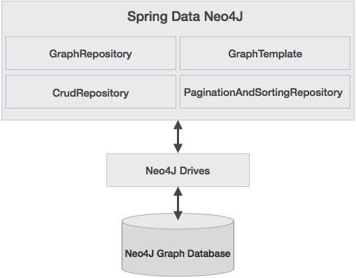
Figure 11 Architecture of spring-data-neo4j module
In order to use spring-data-neo4j, this project uses Maven to configure the relevant configuration. The related configuration is as follows:
The configuration of springboot POM is as follows
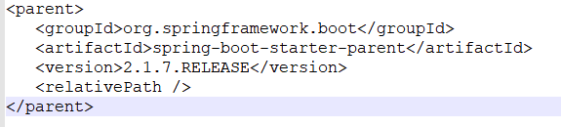
Figure 12 configuration of springboot POM
The main configurations related to neo4j are as follows.
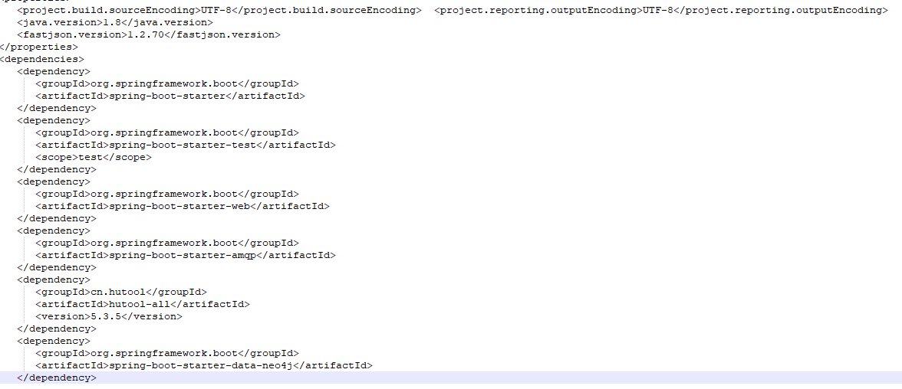
Figure 13 Major configurations related to neo4j
Spring-boot-starter-data-neo4j and spring-data-neo4j basically have the same meaning. This project uses "SDN" to replace this architecture for convenience. The connection with neo4j database is realized by establishing application. YML file in this system. The contents of the document are as follows:
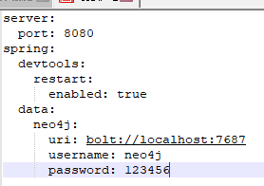
Figure 14 Connection with neo4j

5.3 Detailed design and implementation of function module

5.3.1 Passenger personal information module

5.3.1.1 User login
(1) Registration
For the passenger user of the management system, just like in real life, once the passenger has a ride record in a certain train department, they can passively import the user's data through the administrator, and automatically create the passenger's account through the personal information provided by the user.
(2) Login
When logging in, the user first enters the login interface of the management system and then selects the login method. The passenger needs to select the passenger login box, fill in the ID and password, and click the login button. If the ID does not exist in the database or the password of the corresponding ID is incorrect, the system will prompt the user that the password or account is wrong.Similarly, the administrator login module is similar.
The specific implementation of the landing flow chart is shown in Figure 14.
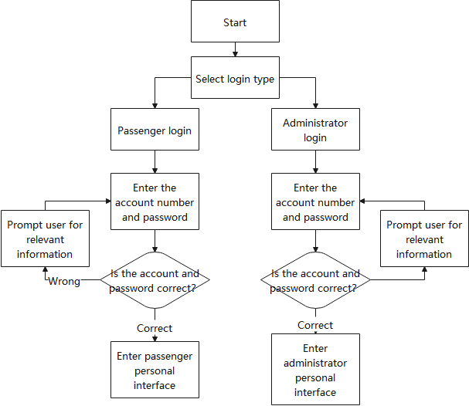
Figure 15 The specific implementation of the landing process
The user login controller class is SystemController class, which defines and implements some user operation methods. Based on this module, the login method and password method are mainly used.The main code of the login method is as follows:
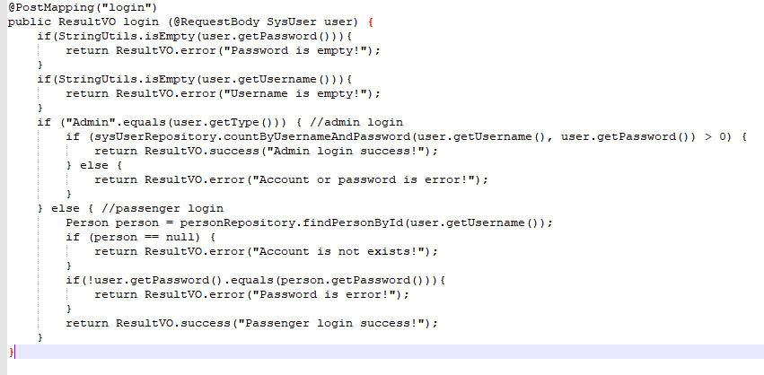
Figure 16 Main code of login method
First of all, the login request of the front end is mapped through @Postmapping(). The internal @Requestbody of the method is mainly used to receive the login option type passed from the front end to the back end: administrator or passenger."login".
First, the login account and password will be judged. If it is empty, the error method of the tool class ResultVo will be called to prompt the error result.
If it is not empty, the program first judges the type of login used by the front end, and judges whether it is an administrator, if not, it is a passenger. If the login user type is administrator, the system will call countByUsernameAndPassword(user.getUsername (), user.getPassword ()) method of sysUserRepository according to the data passed in from the front end , where sysuserrepository is the interface that inherits Neo4jRepository. Neo4jrepositiory inherits the CrudRepository of spring data. Therefore, it is extended to neo4j on the basis of CrudRepository. After the system is started, spring will use the proxy mode to generate implementation classes. Therefore, the countByUsernameAndPassword method automatically realizes its method function through the method naming rules in accordance with the framework, that is, the number of administrator users is verified by the user name and password. When the user input the account and password correctly, and the number is greater than 0, the login is successful. If it is a passenger, the findPersonbyid of the personRepository will be called(user.getUsername()) method, personRepository also inherits the Neo4jRepository interface. It also creates and implements the function of the method through the method name when the program is running through the agent, so as to judge whether it conforms to the requirements. After successful login, the user will enter the corresponding page. Figure 16 below shows the login interface of the program.
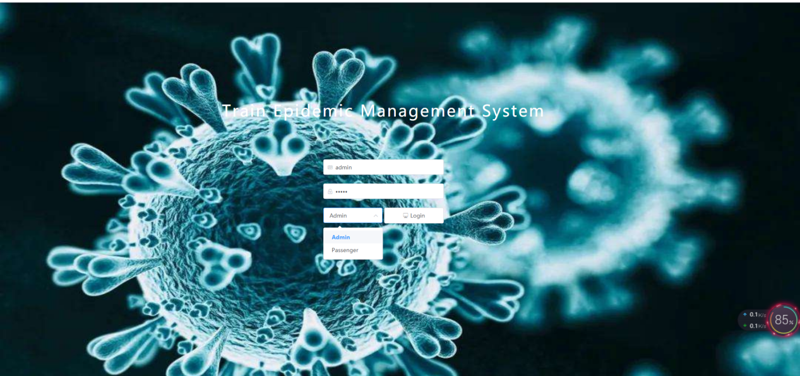
Figure 17 Program login interface

5.3.1.2 User information display
In the user personal information module, after the passenger user logs in successfully, the passenger information display interface will be entered. The main interface is shown in Figure 17
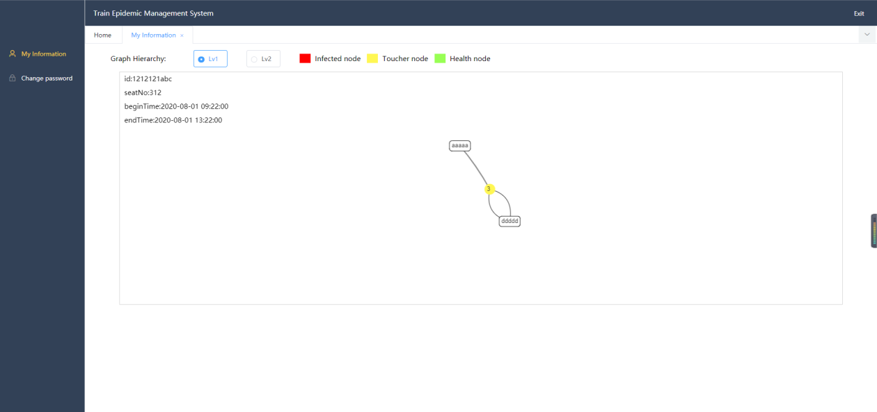
Figure 18 Program login interface

As shown in the above figure, in the display interface of passenger's personal travel information, the user has two buttons: "lv1" and "lv2". Click the "lv1" button to display all the travel records of the current user, as shown in Figure 17. Click the "lv2" button to display the ride records associated with the user's ride records, as shown in Figure 18 below.
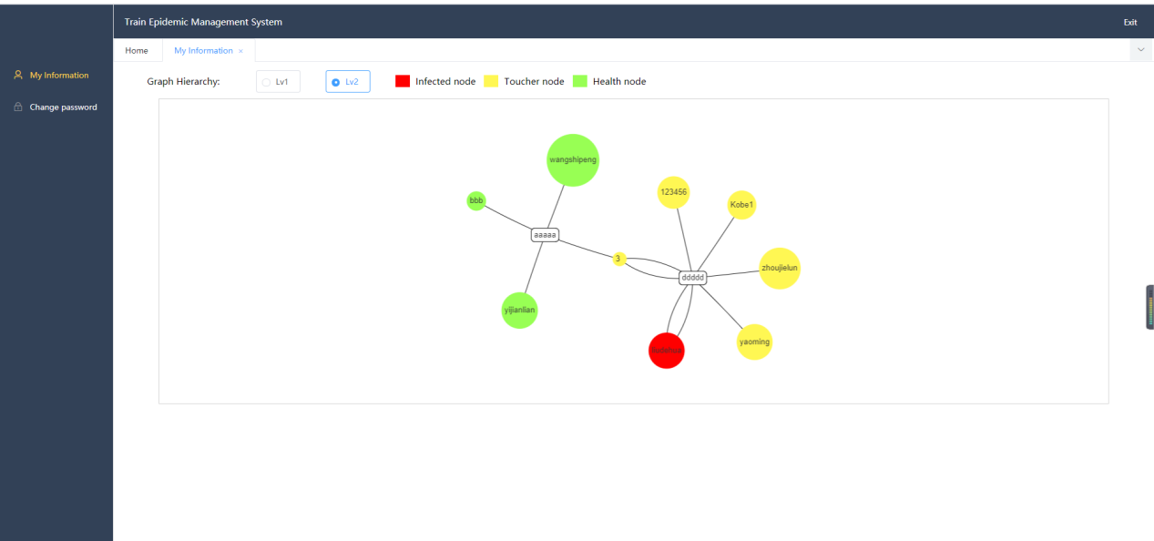
Figure 19 Program login interface
All the ride records shown in Figure 18 actually intersect with the itinerary records of the current login user "3".
The controller class of passenger personal information display interface is PersonController class, which also defines and implements some user operation methods. The module injects the PassengerAlgorithm object of the passengerAlgorithm class and calls its methods to get the filtering data.
The main code for this section is shown below:
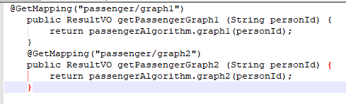
Figure 20 Two main methods
First of all, the background will receive a request from the front-end page. If the user click the "lv1" button, it will enter the graph1 interface, and return the ride record that meets the previous user ID through the method. If the user click the "lv2" button, the user will enter into the Graph2 interface, and return the corresponding data to the front page through the same method passengerAlgorithm.graph1(personId).
In the method, its main code is as follows:
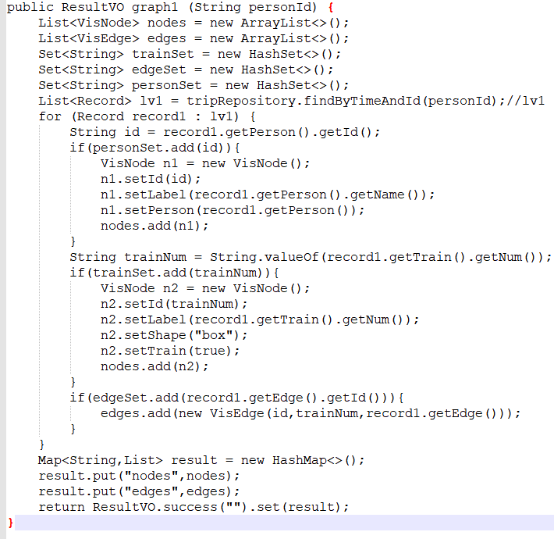
Figure 21 Main code of graph1 method
In the PassengerAlgorithmclass, the objects of PersonRepository, TripRepository and TripService are automatically assembled. After the user clicks the "lv1" option, the program will search all the related record sets through the ID of the user currently logged in. This record will store the relationship between passengers and train trips. The main attributes are person, train and trip. First, the program will traverse all the user IDs in the record. If there is no repetition, the user ID, passenger name and passenger will be added to the VisNode collection. Then, the train related information will be added to this collection in a similar way. Then the relevant information of trip in record is stored in VisEdge set. And put these sets into a map set to return, and the front end will show these data in the form of node to node. On the "lv2" display page of the user, the program code is as follows:
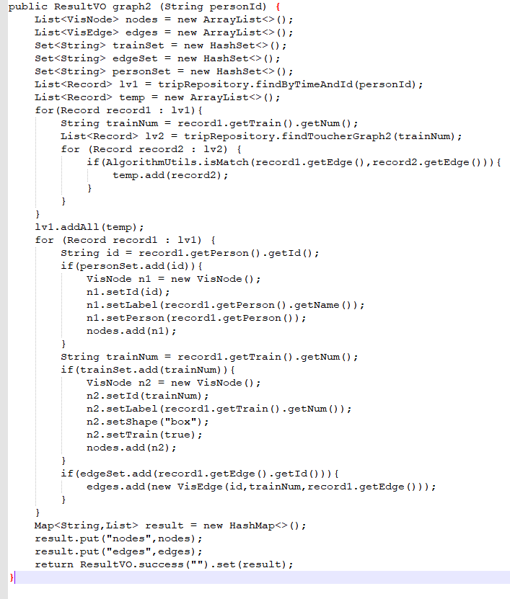
Figure 22 Codes of User's "lv2" display page
The program first calls the tripRepository.findByTimeAndId(personId) get the record set according to the passenger ID, which is the collection a of the user's ride records, and then retrieve all the train numbers in these sets and call tripRepository.findToucherGraph2(trainNum) method to get the set B of {person node} - [travel information] - {train node} with this train node as the filter condition. Then traverse the above set a and set B, through the AlgorithmUtils.isMatch(record1.getEdge(),record2.getEdge()) method to determine whether the travel time of the current element in set a is related to the travel time of the current element in set B. The comparison algorithm is as follows:
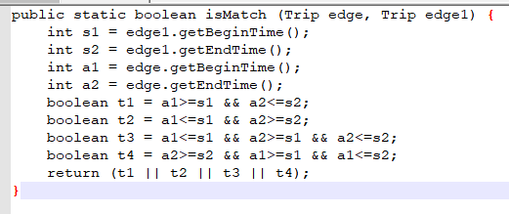
Figure 23 Codes of the comparison algorithm
The basis is to judge whether there is an intersection between the time of the two ride records. If there is an intersection, it means that the two riding records are related. It is converted into a real scene, which represents that passenger m and passenger n have taken the same train during the time when there is intersection (i.e., there is intersection between the boarding and alighting time periods of M and N). Next, add these ride records to the new collection lv1, and then filter out the duplicate data and return it to the front desk for display.
The program flow chart is shown in Figure 23:
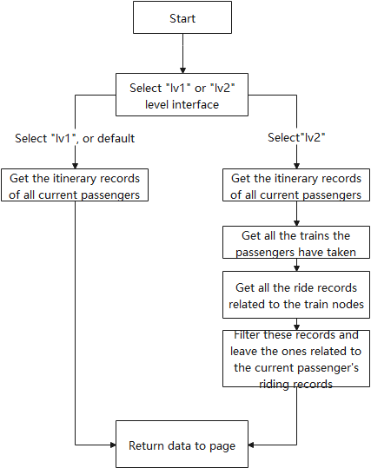
Figure 24 Program flow at the front end
The following figures 24, 25, 26 and 27 show the travel information of user "3" and the travel information of other passengers who have time and train with "3".
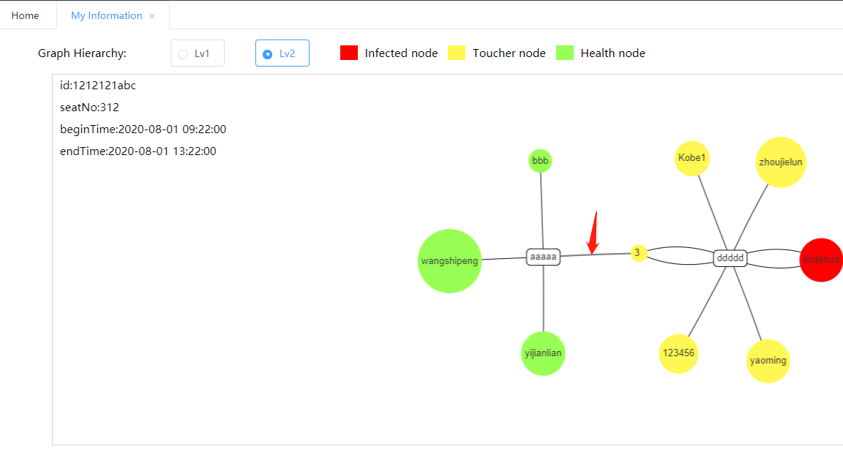
Figure 25 Travel information of user "3"
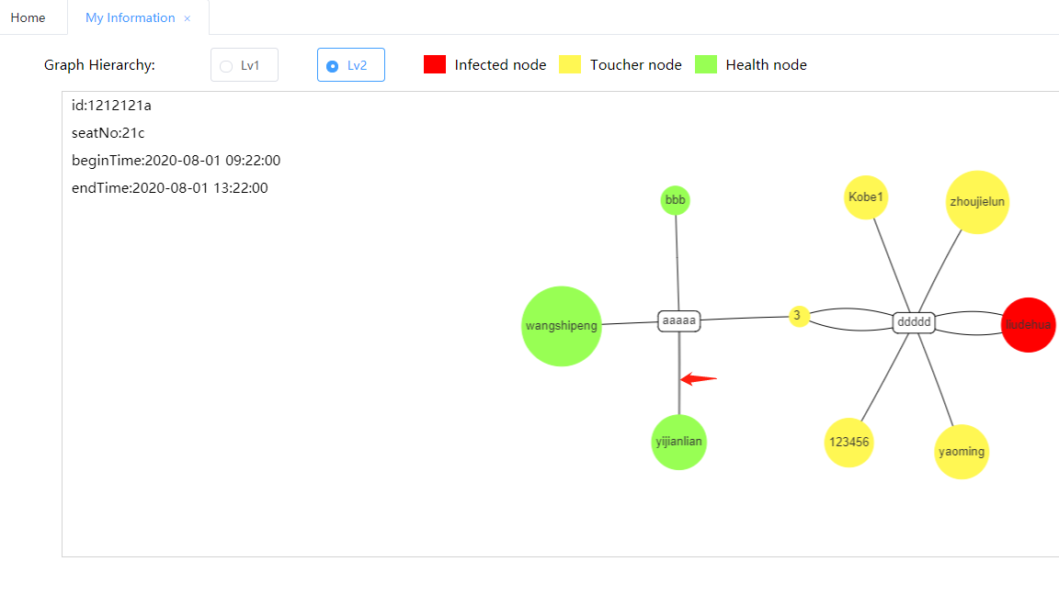
Figure 26 Other passengers have travel information associated with time and train with "3"

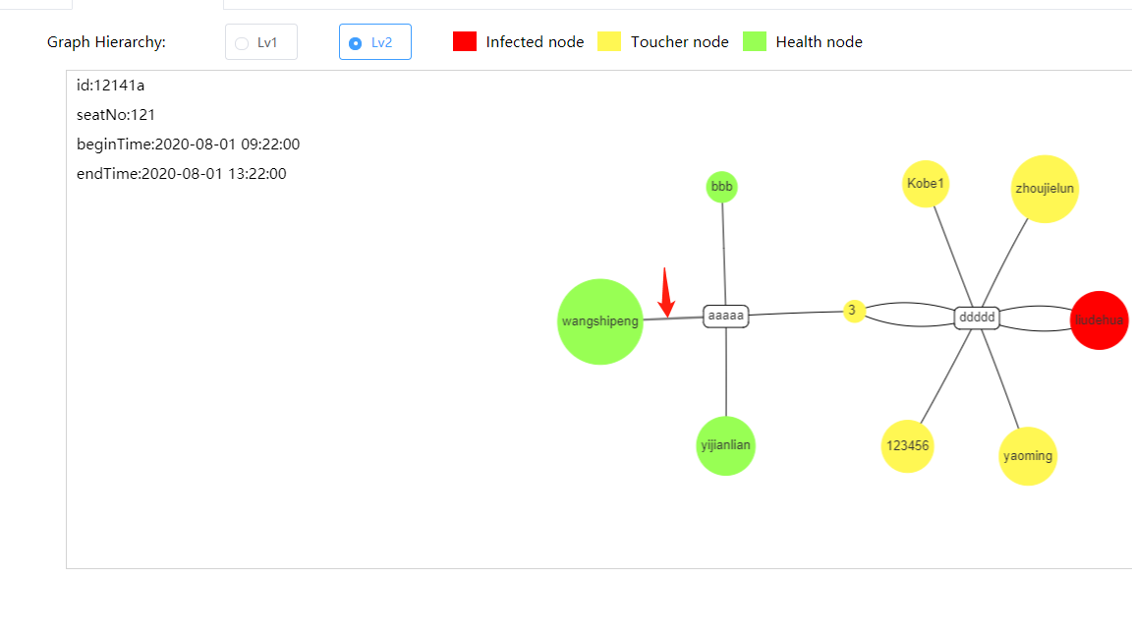
Figure 27 Other passengers have travel information associated with time and train with "3"
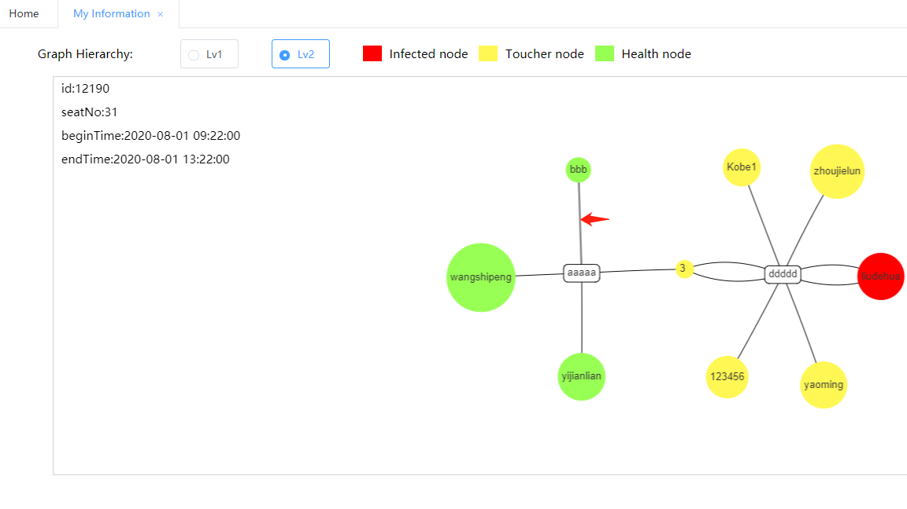
Figure 28 Other passengers have travel information associated with time and train with "3"
Due to the space problem, the travel information recorded on the right part of passenger "3" will not be displayed for the time being. In fact, from the above pictures, we can see that the lv2 interface of passenger "3" displays other passengers and their related information related to their journey information. In practice, passengers can clearly understand their own status and the status of related people through this interface, including whether they have been infected or have contacted with patients, and make preparations and early warning in life, so as to take corresponding countermeasures.

5.3.1.3 Modification of relevant information of passenger users
This design simplifies the model, considering that it is not important for passengers to modify their other attributes in the system, so the modification of password is replaced by the modification of all other relevant information. In the passenger's personal information interface, passengers can enter the "Change password" sub interface, as shown in Figure 28
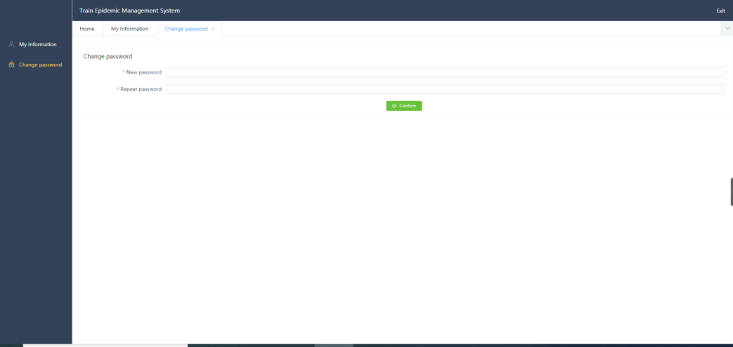
Figure 29 Password modification interface
When we modify the function here, we call the password method in the SystemController class and call personRepository.updatePwd(person.getId(), person.getPassword()) method in it. The updatePwd method also uses spring data JPA to modify cypher statements by inheriting the Neo4jRepository interface. The main method body is as follows:
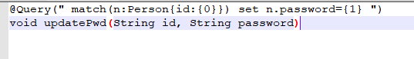
Figure 30 Codes of updatePwd
And the front-end will check the password to be modified before passing it in again. Only when the password is the same twice will it be transferred to the back-end for modification.

5.3.2 Main display page module
This part of the main function is for the administrator, also need the administrator user login to enter the interface, because the above describes the implementation of login, the subsequent administrator login function is not introduced.

5.3.2.1 Display of all information
After the administrator user logs in, the front-end sends relevant requests to enter the administrator main interface. Click Search to enter all information display pages, as shown in the following figure:
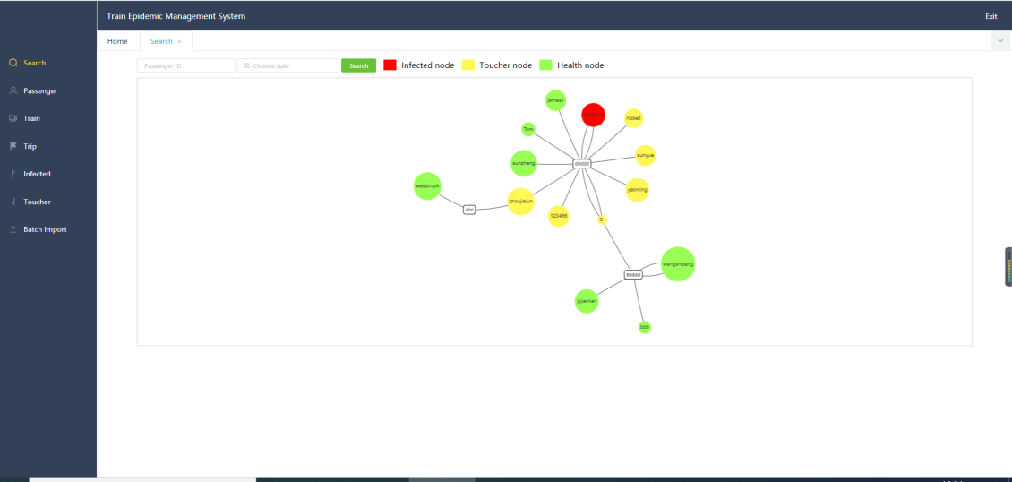
Figure 31 All information display pages
The program will enter the getSearchGraph method in Personcontroller through the front-end response. The method body is as follows:
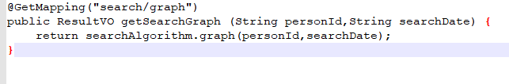
Figure 32 Codes of getSearchGraph method
Then return to the graph method in the automatically assembled searchalgorithm. Due to the large number of body words in the method, the core modules are shown as follows:
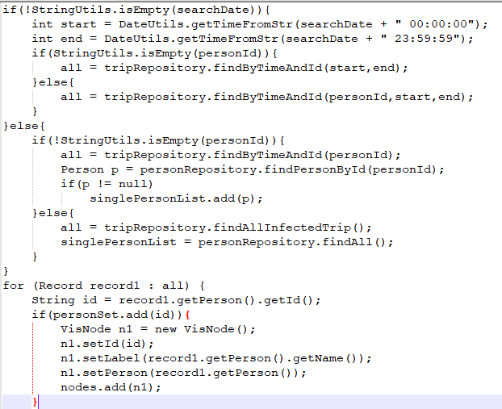
Figure 33 Codes of searchAlgorithm method
First, the program judges whether the passenger ID and time in the incoming search window as shown in Figure 33 are empty.
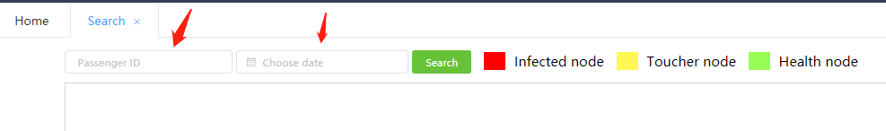
Figure 34 Search window
When the user enter this interface for the first time, the contents in the two input boxes passed in by the front end must be empty. Therefore, when the program performs a series of conditional judgments, it will skip most of them and enter the final code block. The code is as follows:
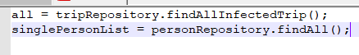
Figure 35 Partial code block
Through findAllInfectedTrip() and findAll() methods, the system obtains all the passenger records and passenger nodes, and returns all the passengers and their travel information in the form of {passenger} - [travel information] - {train} and displays them on the front page.

5.3.2.2 Main interface search function
The search function of this interface is also based on the above information display page. When calling the graph method in searchAlgorithm, the program will enter different code blocks through conditional judgment statements according to the different passenger ID or travel time. For example, when searchDate is not empty, the system will pass through the following code block:
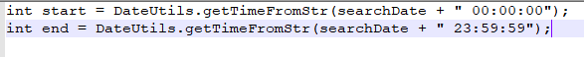
Figure 36 Code block of "searchdate"
So that the search time is the whole day period of the input date, and then select to call the findByTimeAndId(start,end) method or findByTimeAndId(personId,start,end) method based on the passed in passenger ID. On the premise that the passed in personId is empty, the calling method body is as follows:
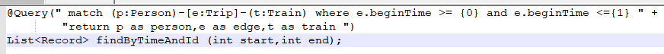
Figure 37 Code block for empty ID parameters
The returned result is a collection in the form of {passenger} - [itinerary information] - {train}. Similarly, when the passed in personId is not empty, a restriction will be imposed on the personId and the result set will be returned. Figure 5-15 below shows the result when the input date is "2020-08-01".
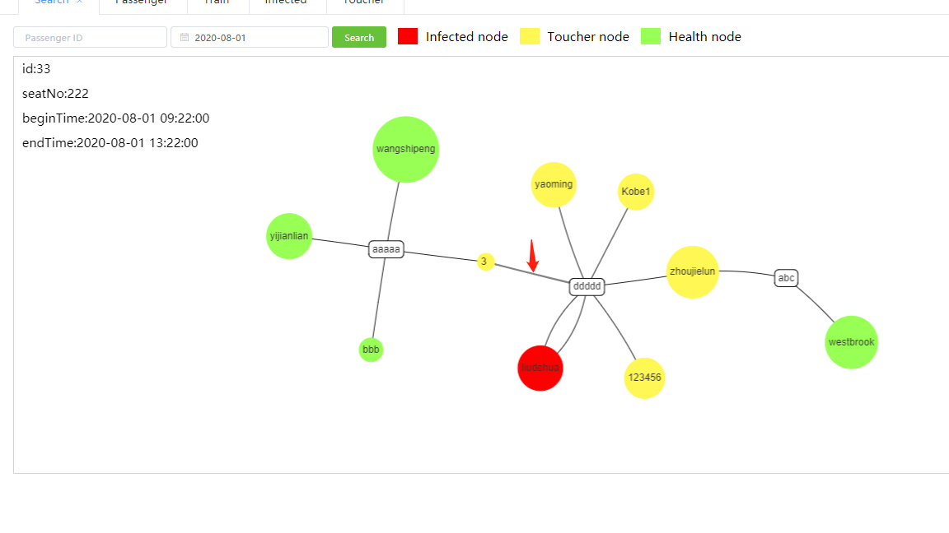
Figure 38 Results displayed when the input date is "2020-08-01"
Compared with the case without adding search date condition, passenger "3" has two ride records, as shown in Figure 38 and figure 39.
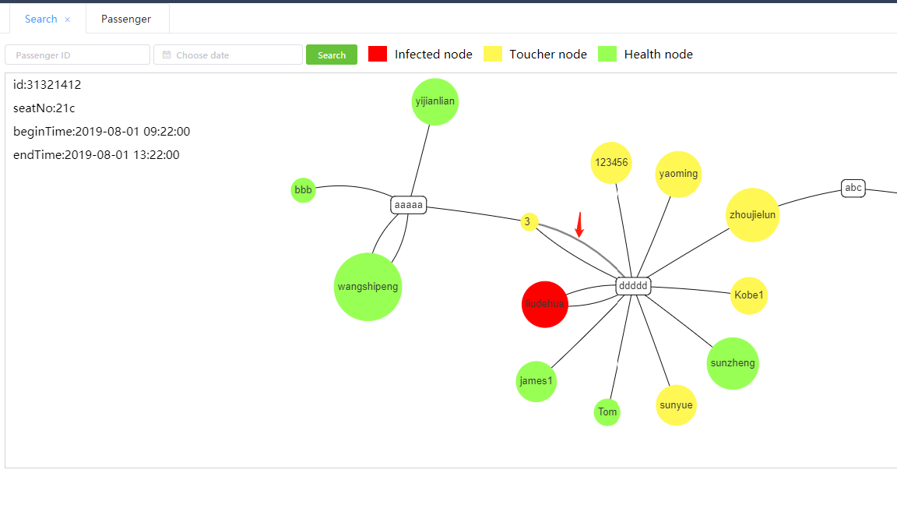
Figure 39 No search date criteria were added
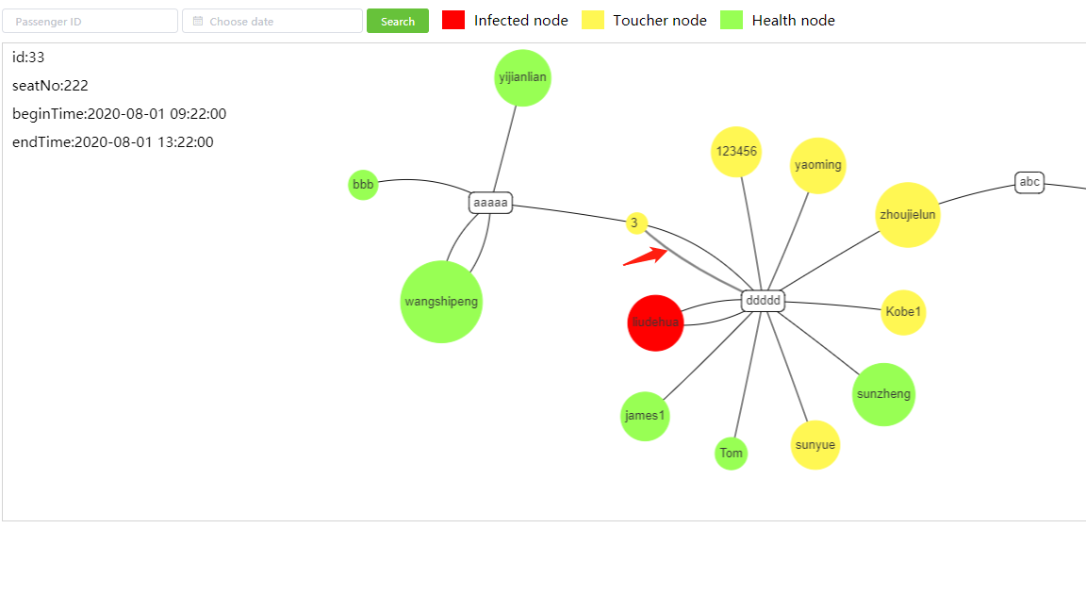
Figure 40 No search date criteria were added
According to the comparison of the above pictures, through the search date filtering, the program leaves the qualified ride record information. The program flow chart is shown in Figure 40
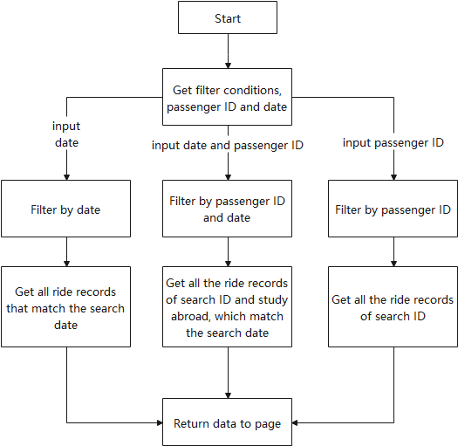
Figure 41 Process filtered by search date

5.3.3 Administrator browsing module
This part of the module is also for administrators, but it is different from the above modules, mainly to provide administrators with different scenarios and levels of browsing perspective.

5.3.3.1 Patient information display page
After entering the main interface, the administrator can click the "affected" button on the left to enter the patient display page. The program accepts the front-end request, invokes the getInfectedGraph1 method in PersonController, and calls the graph1 method through the infectedAlgorithm which is automatically assembled. Later, it uses the findInfectedGraph1 method of tripRepository to get the records of all the patients in the database, and returns the returned data sets to the front end by filtering out duplicate operations. The effect is shown in Figure 41:
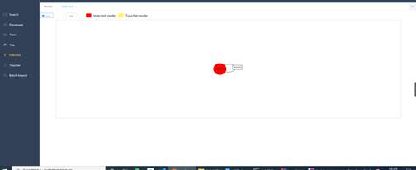
Figure 42 Patient information display page ”lv1”
As shown in the figure, only the patient and his riding records are shown (there is only one patient in the database at present).
The above is the "lv1" level display of the patient interface. The administrator can click "lv2" to enter the "lv2" level display. The purpose of "lv2" display is to display all the patients and their ride records in the system, as well as the passengers and ride records associated with their travel information. Similarly, after clicking "lv2", the system will call the request from the front-end page. Similar to the "lv1" level display, the system call the getInfectedGraph2 method, then enter the graph2 method of infectedAlgorithm. The important code blocks of the method are as follows:

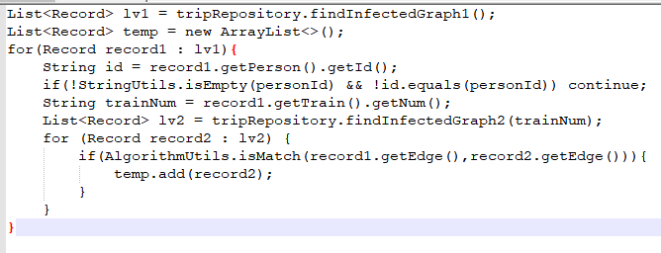
Figure 43 Important code blocks
First of all, the program still calls the findInfectedGraph1 method of tripRepository to get all the patient and ride records and put them into a record collection "lv1". Then, the program traverses the collection to obtain the trainNum of each patient. According to the findinfluencedgraph2 method of tripRepository , the trainNum is passed in, and then the passengers who have taken the train and their travel information are obtained and put into another record collection "lv2". Then traverse the "lv2" set, and compare the "lv1" element and "lv2" element in the current loop by calling the isMatch method of AlgorithmUtils, and compare whether their ride time is related. The time correlation algorithm is the same as the user information display method in the passenger personal information module. The program leaves these data, filters out the duplicate ones and returns them to the front page for display. The effect is shown in Figure 43:
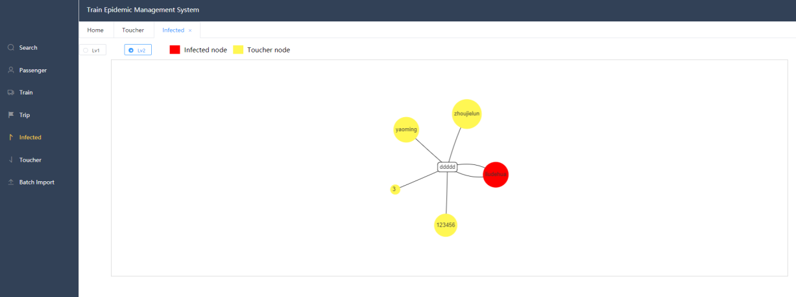
Figure 44 Patient information display page”lv2”
In the actual situation, the passenger who intersects with the ride record of a patient will be defined as the patient contact "Toucher", which is shown in yellow node in the figure.In fact, the administrator can find out the patients and the people who have contacted them on this display page, and then inform the corresponding passengers, or pass their relevant information to the corresponding departments for further warning or other policies to prevent the further spread of the virus.The program flow chart is shown in Figure 44.
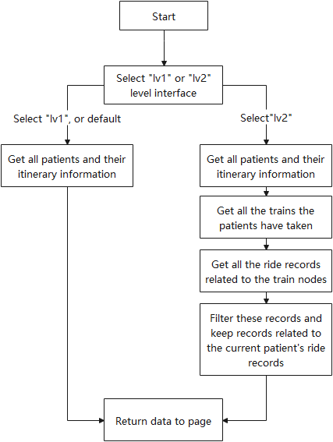
Figure 45 Procedure flow of patient information display

5.3.3.2 Patient contact information display page
This part of the function is very similar to the function of the patient contact information display page, except that the "lv1" level interface displays all the patient contacts and their ride records in the database, while the "lv2" level interface displays the passengers and riding records associated with the passengers in the "lv1" level. The principle is almost the same, the code level will not be introduced, the following shows its effect.
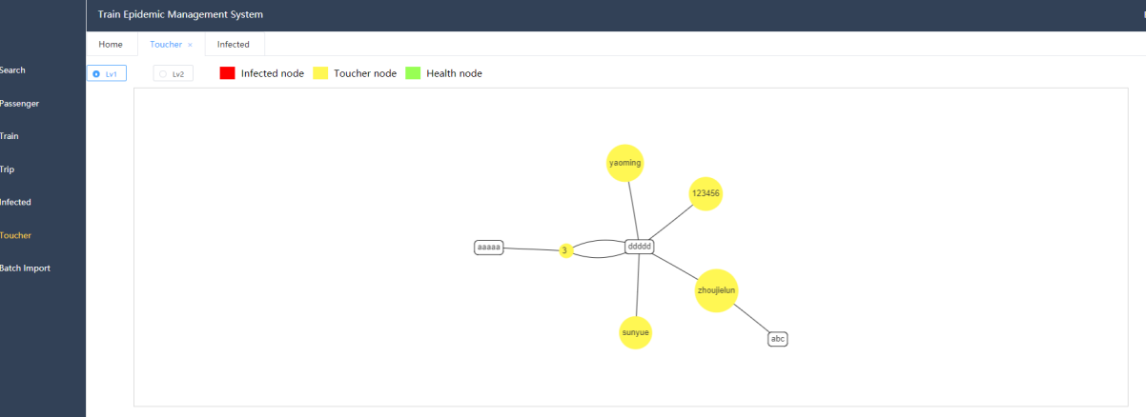
Figure 46 Patient contact information display”lv1”
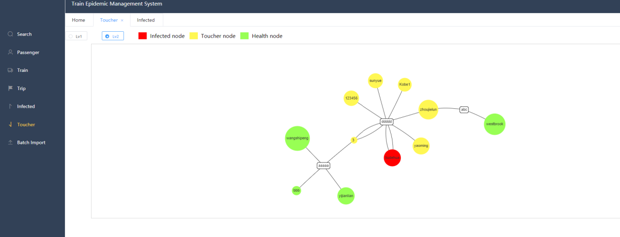
Figure 47 Patient contact information display”lv2”
Figure 44 shows the "lv1" interface, which is the "Touch" for all patient contacts. Figure 45 shows the "lv2" interface, which refers to the people who are related to the ride records of the patient contacts.In fact, the administrator can make an early warning based on this interface, which can play a great role in preventing the spread of virus.

5.3.4 Passenger related information management module
Because there are overlapping parts between passenger personal information management module and passenger journey information management module, they are introduced together.

5.3.4.1 Individual passenger personal information management
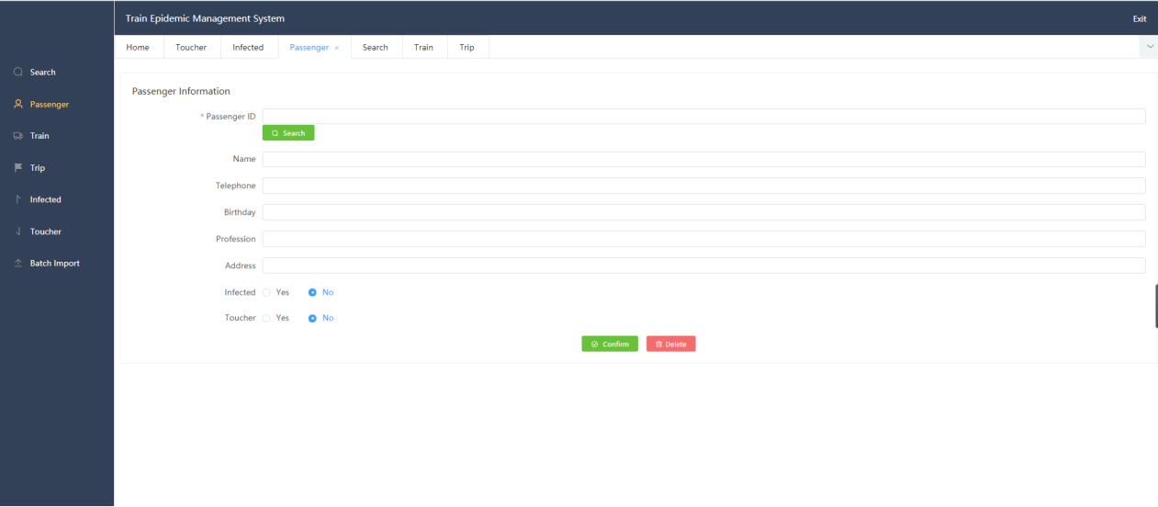

Figure 48 Main interface of single passenger information modification
Figure 47 shows that the administrator enters the main interface and clicks "Passenger" to enter the interface. First of all, the interface has a "Search" button, where the administrator can enter the passenger id to search.This part of the function is mainly based on the PersonController class. After pressing the "Search" button, the front-end will send in a request and execute search(String id) method. In this method, the program continues to call the automatically assembled findPersonById(id) method, which also generates the method body automatically when the program is running through the framework. Through this method, the target passengers' information is obtained in the database and returned to the front end for display on the page. Figure 47 below shows the result of search id “20001”.
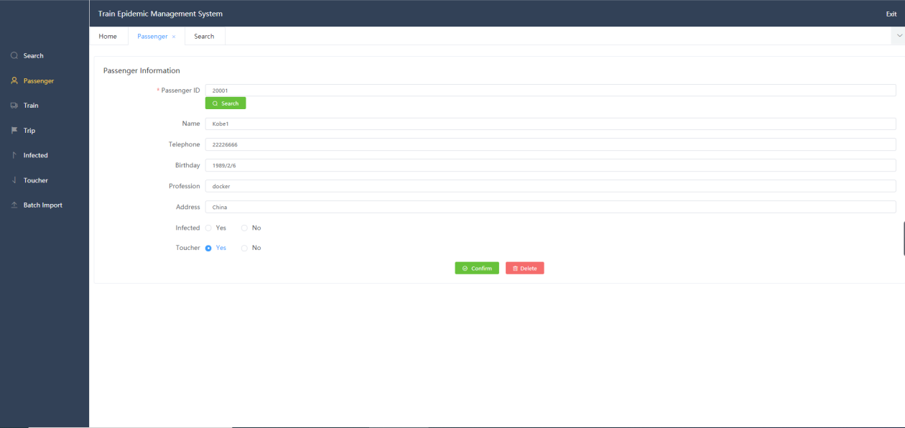

Figure 49 Main interface of single passenger information modification
The administrator can also continue to make changes in the above interface, add or modify through the "Confirm" button, or “Delete”to delete. When the administrator clicks the "Confirm" button, the program also calls the save method through the PersonController controller and passes in the person class information from the front end. First, the program executes the following code:
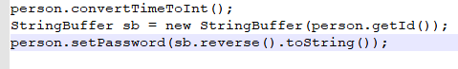
Figure 50 Code for generating user and password
The convertTimeToInt method can determine whether the passenger is a patient, mainly depending on the "isInfect()" and "infectedTimeStr" attributes of the passenger. If both judgments pass, the program calls setInfectedTime(DateUtils.getTimeFromStr(infectedTimeStr)) method to set the value of this passenger in the database.The passenger's user password is then set to the number in reverse order of their ID. After that, the method in this part will determine whether the passenger exists in the database. If it does, it will execute the update operation; if not, it will execute the add operation. The main codes are as follows:

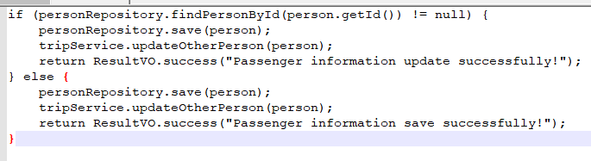
Figure 51 Code of judgment
Among them tripService.updateOtherPerson(person) method is the core of this module. It will pass in the information of the user currently being operated. First, according to the user's id, all his travel records will be obtained and saved to a record collection. Then, through the num of each train in the collection, the travel records of all relevant personnel including the train num can be obtained and saved again It exists in a collection. After that, the system will judge whether the passenger being operated is an infected person. If so, it will traverse all the riding records in the above set. If the riding records of the operated passengers are related to the riding records of other passengers in time, the "Toucher" attribute of the corresponding passengers will be changed to y, that is, the patient contact person. If the passenger is not an infected person, all the ride records in the above collection are traversed. If the passenger in one of the ride records is an infected person and has a time-dependent relationship with the ride record of the operated passenger, then the passenger will also become a patient contact person. The program flow chart is as follows:
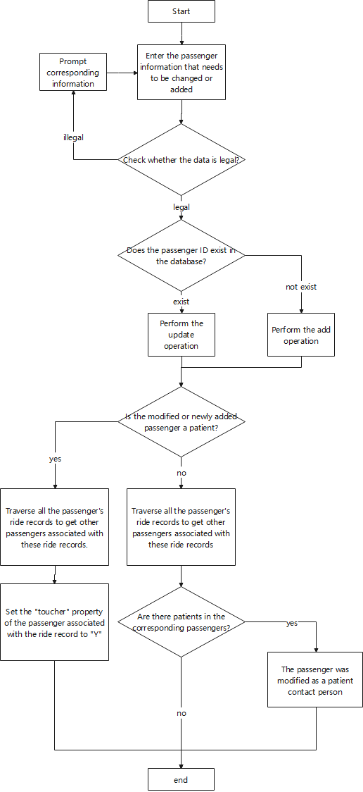
Figure 52 Infection algorithm flow

5.3.4.2 Single passenger travel information management
The administrator can click "Trip" in the main interface to manage individual passenger travel information. The controller of this part of the function is TripController class. The program will accept the corresponding request and travel information from the front end, as shown in Figure 52.
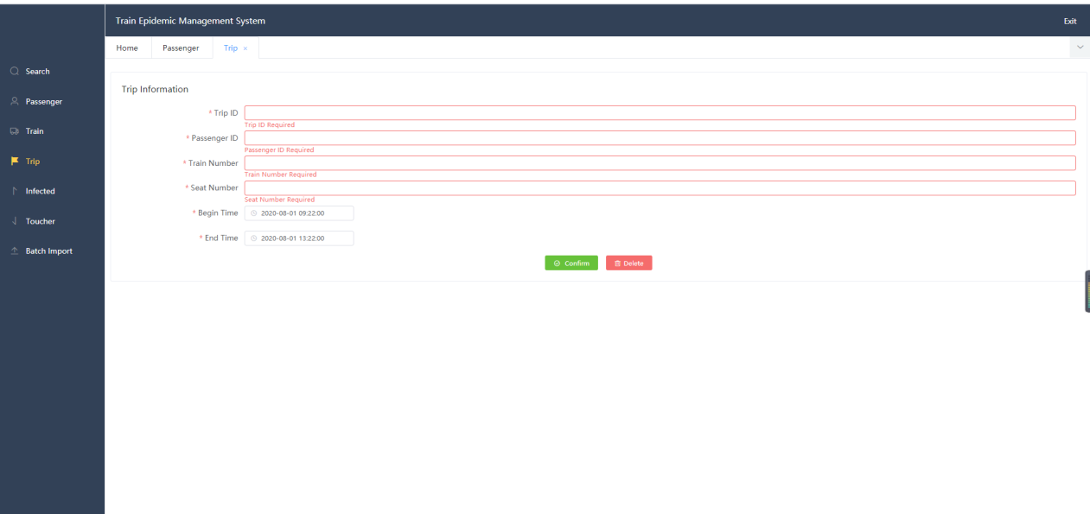
Figure 53 Single passenger travel information management interface
The program is called by the save method of the controller tripService.save(trip) method, the principle of which is similar to the management of individual passenger's personal information. The program will search the data for the existence of the ride record under the "Trip ID", and if so, it will execute the update operation. Each time a trip information is modified or added, this part of the code will also execute the updateOtherPerson method.

5.3.4.3 Mass data import
In reality, the train management department may need to import a large number of passenger records at one time, so the function of importing a large number of data is very important. This part of the function is mainly based on neo4j CSV.
The interface is shown in Figure 53
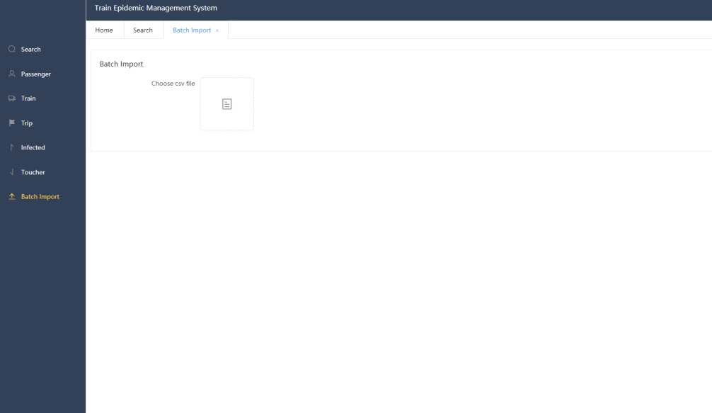
Figure 54 Mass data import interface
The controller of this function is SystemController, and the important part of calling method is as follows:
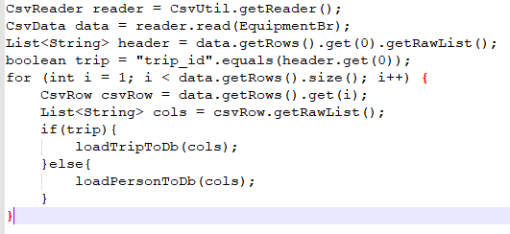
Figure 55 Important code of mass data import
Here, the program will determine whether the first column name of the imported CSV file is "trip"_ID ", if it is, execute the mass passenger record import method, otherwise, execute the mass passenger personal information import method. Here, in order to reduce the running burden of the program, when the passenger's personal information is imported, the passenger's illness information and patient's contact information will not be read.

5.3.5 Train information management module
In order to simplify the model, this module can only add and delete train num.The interface is shown in the figure below:
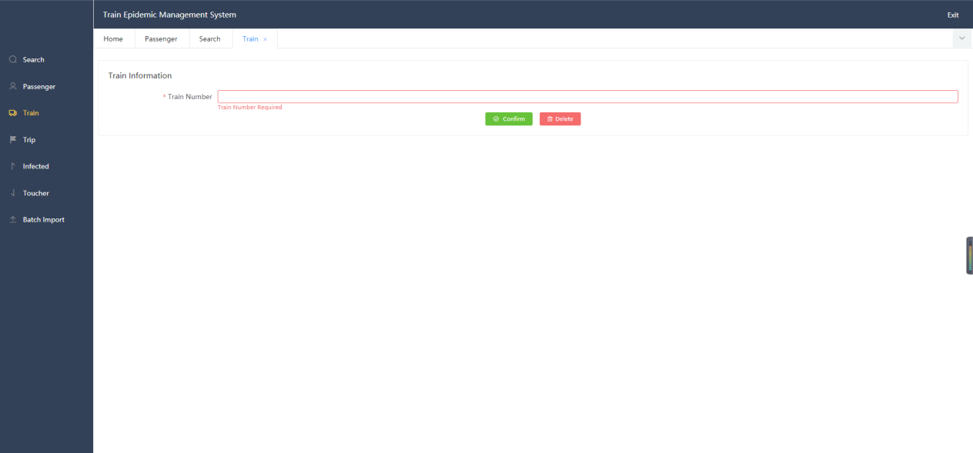
Figure 56 Adding and deleting trains

5.4 Summary of this chapter
This chapter mainly introduces the detailed design of the personnel management system, mainly describes the specific implementation process and business logic of the passenger personal information module, passenger related information management module and other important module functions of the management system.In addition, the development and configuration environment of the system, the overall implementation architecture and database structure of the system are analyzed in detail.

6 EVALUATION
Because the goal of this paper is a system, and because the previous research on this direction and demand is less, the evaluation of this design is based on the test results.The test standard is based on whether it meets the requirements before development and whether the specific functions after the actual development are achieved.

6.1 Test
System testing is an indispensable part of the system development process, accompanied by the whole R & D process [41].This chapter mainly tests the specific function modules of the system.And the test environment configuration of the system is described.The system function test is to verify the function obtained from the system requirements, and the specific test process is strictly in accordance with the test cases.For the train based personnel management system, it mainly designs the use cases for the core functions, but in order to save space, only part of the test case description is given here.

Table 5 Login function test case design
number | 1001
Test type | functional testing
Test purpose | Check whether the login function of the system works normally
Premise scenario | The user enters the management system login main interface
scene | input data | anticipate result | Final test results
The administrator user can log in by inputting the account password automatically configured by the administrator | Account:”admin”  Password:”admin”  Login type:”Admin” | Login successful | Login successfully, jump to the administrator main interface
The administrator user enters the incorrect account password to login | Account:”abmin”  Password:”admin1”  Login type:”Admin | The system did not change the administrator's account and password, login failed | Login failed
The passenger user enters his / her correct ID and password to log in | Account:”30000”  Password:”111”  Login type:”Passenger” | Login successful | Login successfully, jump to the main passenger interface
The passenger user enters his / her incorrect ID and password to log in | Account:”30000”  Password:”1110”  Login type:”Passenger” | There is no password corresponding to the corresponding ID in the system, login failed | Login failed
During the user login function test, it is executed according to the test case. Because the operation is relatively simple, the result diagram is not displayed for the moment.
Table 6 Single passenger information management test case design (without considering the disease related)
number | 1002
Test type | functional testing
Test purpose | Check whether the administrator of the system can manage the information of individual passengers normally
Premise scenario | The administrator enters the personal information management interface of single passenger
scene | input data | anticipate result | Final test results
The administrator user modifies the attributes of users existing in the system | Passenger ID:”p123451”  Name:”pipen”  Telephone:”9001”  Birthday:”1920-08-09”  Profession:”worker”  Address:”31 Cromwell St Swansea”  Infected:”No”  Toucher:”No” | There is a user corresponding to the ID in the system, so the update operation is executed and the update is successful | The original data is modified to new data
Administrator users add users that do not exist in the system | Passenger ID:”j123451”  Name:”jordan”  Telephone:”8001”  Birthday:”1921-08-09”  Profession:”worker”  Address:”32 Cromwell St Swansea”  Infected:”No”  Toucher:”No” | There is no user corresponding to the ID in the system, so the add operation is executed and the update is successful | Added successfully
Figure 56 shows the data of the first passenger whose ID is "p123451" before modification, and figure 56 shows the data after successful operation.
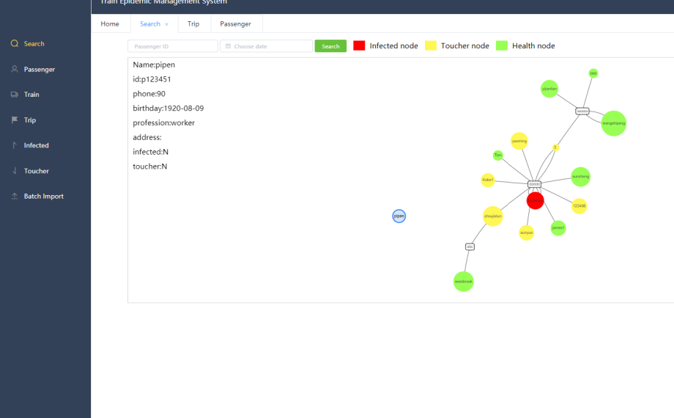
Figure 57 Test display
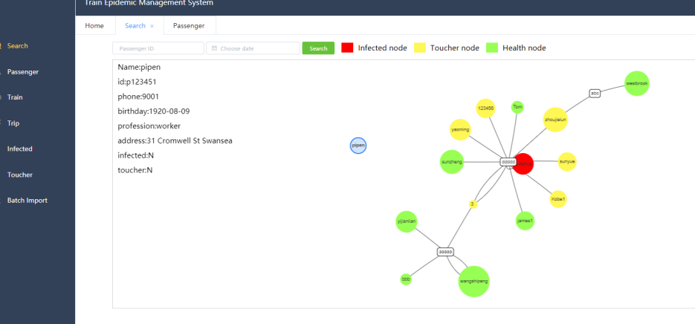
Figure 58 Test display
Figure 58 below shows the node attributes of the new user
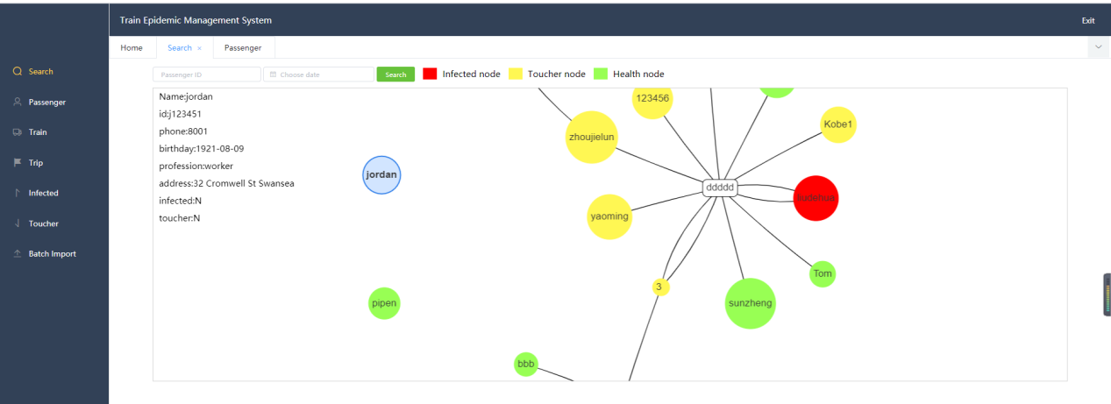
Figure 59 Test display
Table 7 Single passenger information management test case design (without considering the disease related)
number | 1003
Test type | functional testing
Test purpose | Check whether the administrator of the system can manage the travel information of a single passenger and whether the operation is normal
Premise scenario | The administrator enters the single passenger travel information management interface
scene | input data | anticipate result | Final test results
The administrator user adds the journey to the existing users in the system | TripID:”abcp123”  Passenger ID”p123451”  Train Number:”abc”  Seat Number:”c1”  Begin Time:”2019-11-01 00:00:00”  End Time:”2019-11-02 00:00:00” | There is no travel ID in the system, but the passenger ID and train num exist. The data import is successful | New itinerary information imported successfully
Administrator users add users who do not exist in the system (or non-existent train Num) | TripID:”abcp1231”  Passenger ID”p1234511”  Train Number:”abc”  Seat Number:”c1”  Begin Time:”2019-11-01 00:00:00”  End Time:”2019-11-02 00:00:00” | The user corresponding to the ID does not exist in the system, so the data import failed | Add failed

Figure 59 and figure 60 below show the effect of adding the ride record to the passenger whose ID is "p123451".
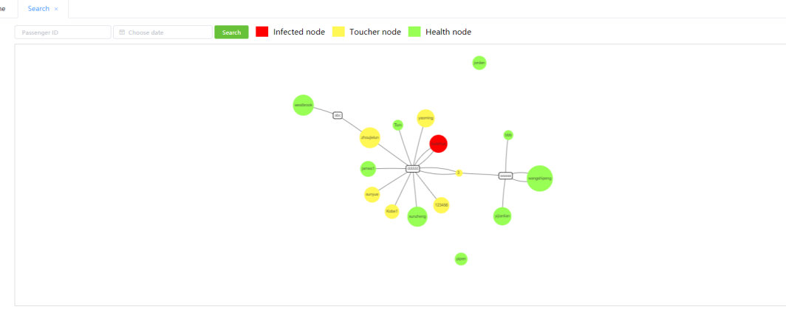
Figure 60 Test display
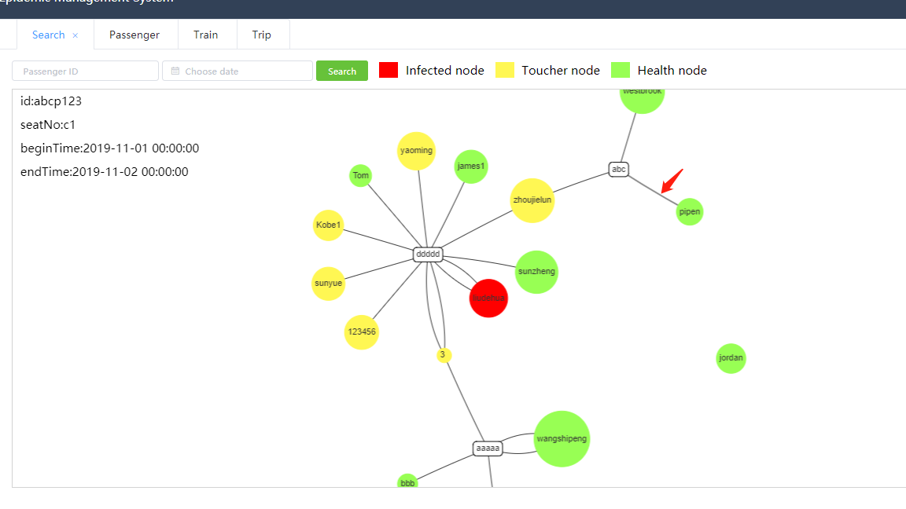
Figure 61 Test display
Table 8 Test case design of individual passenger information management (considering disease related)
number | 1004
Test type | functional testing
Test purpose | Under the premise of 1002, the test is conducted considering the "affected" and "touch" attributes
Premise scenario | A passenger named "pipen" and a passenger named "Jordan" were associated with their ride records and were not patients
scene | input data | anticipate result | Final test results
Administrator users modify the attributes of users existing in the system (mainly patient attributes) | Passenger ID:”j123451”  Name:”jordan”  Telephone:”8001”  Birthday:”1921-08-09”  Profession:”worker”  Address:”32 Cromwell St Swansea”  Infected:”Yes”  Toucher:”No” | There is a user corresponding to the ID in the system, so the update operation is executed successfully. Because the passenger is a patient, it will affect other people&apos;s "toucher" attribute | The update is successful. The passenger with ID "j123451" is modified to be a patient. Because he has taken the train during the infection period, the "toucher" attribute of the passenger with ID "p123451" is changed to yes
Administrator users add users that do not exist in the system | Passenger ID:”j123451”  Name:”jordan”  Telephone:”8001”  Birthday:”1921-08-09”  Profession:”worker”  Address:”32 Cromwell St Swansea”  Infected:”No”  Toucher:”No” | There is no user corresponding to the ID in the system, so the add operation is executed and the update is successful | Added successfully
The following figure 60 shows the passenger's riding record with ID "j123451", and figure 61 shows the personal information with ID "j123451" after modification.

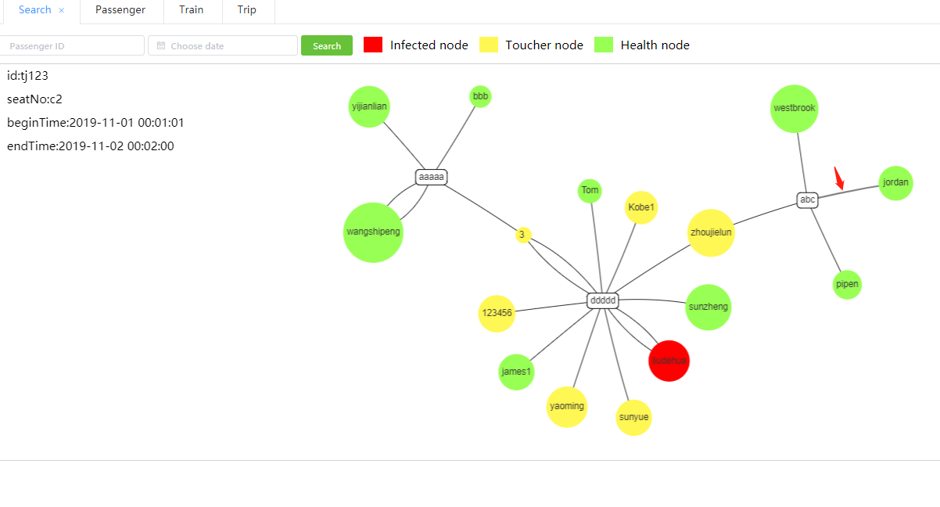
Figure 62 Test display
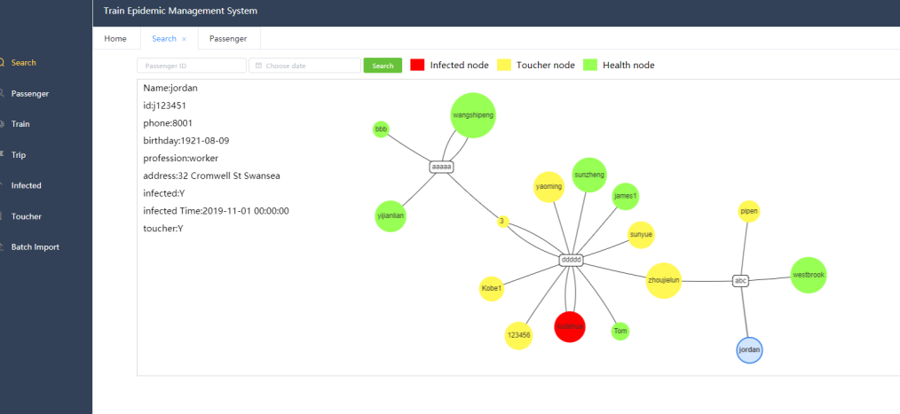
Figure 63 Test display
It can be seen from the above that "pipen" is labeled as the contact person.

6.2 Conclusion
This chapter mainly aims at the functional requirements of the important modules of e-mall. Due to the limited space, we design some corresponding test cases to test the function. Through the analysis of the test results, the function of the personnel management system is basically realized, and its performance also reaches the expected standard. It basically meets the function and performance requirements of user management system.

6.3 Expected answers
Generally speaking, the result is consistent with my expectation, all functions have achieved the expected effect, but there may be some inconveniences in the actual operation, and some algorithms within the program have not reached the optimal solution.In the future work, we will continue to optimize the system more closely.

6.4 Do it again
If I design again, in the case of sufficient time and resources, I will first learn the updated technology to achieve it. Secondly, I will consider it more appropriate and perfect in the demand analysis and design, and consider the operation of more administrators and passengers, such as the information of some interfaces can be displayed more perfectly.

7 CONCLUSIONS AND RECOMMENDATIONS

7.1 Conclusion
This paper analyzes various preventive measures against the epidemic situation, and finds that the management of personnel flow in public transport under the background of epidemic situation is not satisfactory.Therefore, this paper puts forward the discovery of problems under the background of the current epidemic situation, the purpose of our research and the effect to be achieved, the specific design and development scheme, and explains the development process, and finally tests its function.The personnel management system adopts the structure of spring boot + Vue + neo4j, and adopts the mode of front-end and back-end separation for research and development, which changes the previous overall packaging, and can be better maintained.The system has a high pertinence for the management of personnel on the train under the epidemic situation. For passengers, it can easily log in to the system to view their relevant information. For administrators, it can also easily manage the data of passengers.

7.2 Recommendation
This e-mall is based on spring boot and Vue framework, using java language for coding.As the research on framework, technical language and user needs is not enough, there are still some imperfections in the e-mall. We hope to improve the following aspects in the next work:
(1) Function aspect:
Due to my limited technology, the design of some functions is not fully in line with the operation of administrators or passengers, and some functions have been simplified. I hope to make a more perfect design for the functions under the condition of sufficient time.In the data model, the design is based on the neo4j graphic database, usually used less, may also be due to unfamiliar data model design is not appropriate.Therefore, the function needs to be improved in these two directions.
(2) Safety:
Because of the time and function, the system has not considered the security too much.In fact, any online program needs to consider this aspect, so relatively speaking, the system security, information security and other directions need to be improved.
(3) Specific implementation
In the system coding, the front-end style adopts the current common structure style of online shopping platform, which is lack of innovation. When the back-end code is written, it does not comply with certain code specifications, and the code is cumbersome in function implementation and does not simplify it.Therefore, it is necessary to improve the code writing standard, simplification degree and page style.

8 REFLECTION
From the beginning of writing to the final draft of this paper, I spent a lot of spare time. Although it is not a very simple thing to finish such a thesis after my busy work, I am deeply grateful.This paper is completed under the guidance of the instructor Michael. The tutor is knowledgeable and knowledgeable. He helped me a lot when I was confused about the direction of the paper at the beginning.And in the process of my continuous exploration, I have made comments and suggestions on my current work and views, so that I can improve and promote my research step by step.In this precious period of time, I not only increased my knowledge, broadened my vision, exercised my mentality, but also cultivated good experimental habits and scientific research spirit, which not only enabled me to set a lofty academic goal and master the basic research methods.From topic selection to completion, every step of the thesis is completed under the guidance of my tutor. Here, I would like to express my respect to Mr. Michael once again.

In addition, in the process of my thesis research, I also faced many difficulties, but I also developed the habit of self-study, step by step to understand each knowledge and principle.In addition to the preparation of the paper, I can deeply realize my own shortcomings and the direction of improvement in the future, and will continue to study and strive in this direction!

REFERENCES
[1] Wang Wenxuan, Li Boxin, Wang Ying. Tianjin Science and technology. 2020 (06)
[2] Guan Hanxiong, novel coronavirus pneumonia (COVID-19) clinical imaging features [J]. radiology practice, 2020, 35 (2):125-130.
[3] Ye Jianhong, Liang Yuan, Zhang Yufei, Chen Menghu. A major strategy for public health emergency response: a retrospective analysis of the new coronavirus pneumonia epidemic situation [J]. city traffic, 2020,18 (03): 71-79.
[4] Gu Ziyuan. Operation characteristic analysis and evaluation method of conventional bus system [D]. Nanjing: Southeast University, 2015
[5] Khashan E A, Eldesouky A I, Fadel M, et al. A Big Data Based Framework for Executing Complex Query Over COVID-19 Datasets (COVID-QF)[J]. arXiv preprint arXiv:2005.12271, 2020.
[6] Cai Jingxuan, Huang Ruhua. Policy and regulation guarantee of US government data openness and Its Enlightenment to China [J]. Library and information, 2017 (1): 10-17
[7] Zeng Ziming, Huang Chengying. Research on public health emergency information system for epidemic control [J]. Journal of information, 2017, 36 (10): 79-84
[8] Xu Zenglin, Sheng yongpan, he Lirong, Wang Yafang. Overview of knowledge mapping technology [J]. Journal of University of Electronic Science and technology, 2016.45 (4): 589-606
[9]WMF.Wikidata[EB/OL].[2015-11-11].https://www.wikidata.org/wiki/Wikidata:Main_Page.
[10] Niu X, Sun XR, Wang HF, et al. Zhishi. me-weaving Chinese linking open data. Proceedings of the 10th International Semantic Web Conference. Bonn, Germany, 2011:205-220
[10] Huang Hengqi, Yu Juan, Liao Xiao, Xi Yunjiang. A review of knowledge mapping [J]. Computer system applications, 2019.28 (6): 1-12
[11] Zou L,ÖzsuMT,Chen L,etal.g Store:A graph-based SPARQL query engine.The VLDB Journal,2014.23(4):565-590
[12] Lu Peng. Research and application of big data organization and retrieval based on neo4j [D]. Nanjing: Southeast University, 2015
[13] Wang Hong, Zhang Qingqing, Cai Weiwei, et al. Research on domain ontology storage method based on neo4j [J]. Computer application research, 2017, 34 (8): 2404-2407
[14] Gong faming, Li Ganran. Research on ontology data storage in massive oil field based on neo4j [J]. Computer science, 2018, 4 (6a): 549-554
[15] Wang Fei, Yi Mianzhu, Tan Xin, et al. Research on storage method of ontology related to Tibet Based on neo4j [J]. Journal of Zhengzhou University (SCIENCE EDITION), 2019,51 (2): 60-65
[16] Huang Bingqian, Huang Shuhua, Liu Siyan. Research on bill analysis based on graph database neo4j [J]. Network security technology and application, 2015 (7): 118
[17] Zhang Lin, Xiong Shipan. Design and implementation of social network platform based on neo4j [J]. Information exploration, 2018 (8): 77-82
[18] Qi Shuo. Design of a platform for Personnel Association Analysis and drug abuse tendency prediction based on neo4j [D]. Jinan: Shandong University, 2019
[19] Based on the analysis of the relationship between people in super Telecom (2016) and Lin Kuai ting (2016), the paper explores the application of super people
[20] Jiang Huijuan, Guo Wenlong. Design and optimization of medicated diet recipe database based on neo4j [J]. JOURNAL OF CENTRAL UNIVERSITY FOR NATIONALITIES (NATURAL SCIENCE EDITION), 2019, 28 (3): 48-55
[21] Ding Hongli. Personnel relationship mining based on neo4j graph database [J]. Telecommunication technology, 2020,60 (07): 771-777
[22] Cao Haowei, Xu Jianliang, dou Fangkun. Construction of biomedical knowledge map based on neo4j [J]. Computer age, 2020 (06): 35-38
[23] Zhang Chongjin. Design of distributed system based on three-tier B / S mode [J]. Computer products and circulation, 2020 (10): 91
[24] Deng Xiao. Design and implementation of campus light blog system based on spring boot [D]. Huazhong University of science and technology, 2018
[25] Liu Bowen Vue.js [J] People's Posts and Telecommunications Press, 2019
[26] Fielding R T. Architectural styles and the design of network-based software architectures[J]. University of California Irvine, 2000, 64(3):303.
[27] Vicknair C, Macias M, Zhao Z, et al. A comparison of a graph database and a relational database:a data provenance perspective[C]. Southeast Regional Conference, 2010, Oxford, Ms, Usa, April. DBLP, 2010:42.
[27] Xu Jing. Research on Web based information management system framework under J2EE architecture [J]. Silicon Valley, 2015,8 (01): 84-85
[28] Bodoff S, Armstrong E, Ball J, et al. The J2EE Tutorial, Second Edition[C]// 2004.
[29] Ju Feng Juan. The Application of Servlet and Javabean In the Design of Blog[J]. Energy Procedia,2011,13.
[30] Li Xue. Research and implementation of a fuzzy query method for NoSQL graph database [D]. Nanjing University of Aeronautics and Astronautics, 2018
[31] Panzarino O. Learning cypher write powerful and efficient queries for Neo4j with Cypher its official query language[J]. 2014.
[32] Lin Chongde. Dictionary of Psychology (Volume I): Shanghai Education Press, 2003
[33] Gao gengyan. Application and future trend of computer software development technology [J]. Electronic technology and software engineering, 2018 (09): 42
[34] Xiao Zhuoyu. Design and implementation of e-mall based on design pattern [J]. Computer knowledge and technology, 2016,12 (32): 285-289
[35] Geng Qingyang. Design and implementation of e-mall based on spring boot and Vue [D]. Xi'an Petroleum University, 2020
[36] Li Xiaoling. Design and implementation of e-mall system [D]. University of Electronic Science and technology, 2013 Xu Shichuan&apos;s order system and its implementation in Nanjing [2018]
[37] Xu Shichuan. Design and implementation of order module and seckill module in e-mall system [D]. Nanjing University, 2018
[38] Liu Jinsheng. Design and implementation of campus e-mall based on SSH [D]. Inner Mongolia University, 2017
[39] Wang Xikun. Design and implementation of mobile mall based on Distributed Internet Architecture [D]. Beijing University of technology, 2017
[40] Ma Xiaoqiang. Design and implementation of cross border shopping mall system based on SSH framework [D]. Xi'an University of Electronic Science and technology, 2016
[41] Luan Peiyuan. Design and implementation of e-mall based on recommendation subsystem [D]. University of Electronic Science and technology, 2012

