Pan Jiajun
1700929

The major subject has finished in September 30^{th.}

Character Part:
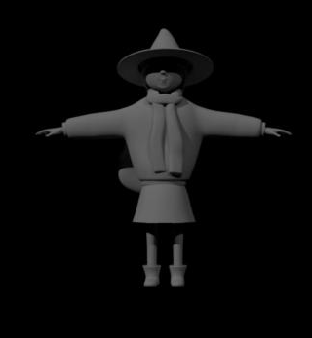
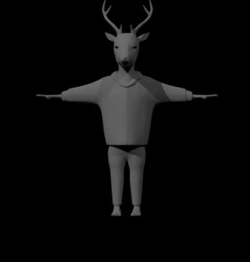
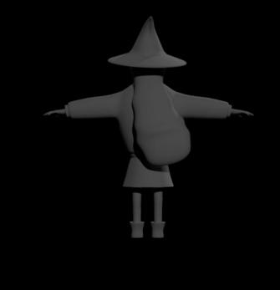
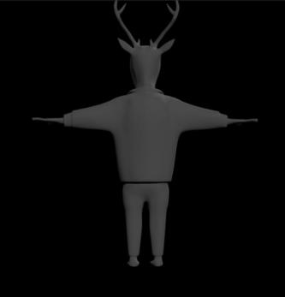
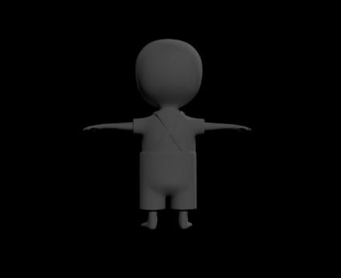
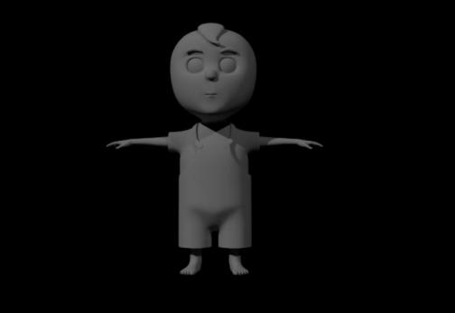
Picture one
In the early stage, I take charge for character modelling supervision, it is my primary role. There are four main character in our animation, we chose Zihan’s story as our basic script. then we make sure the style of character. I build three character basic model, deer, child, witch(picture one). After we have determined the script and the shots, I take the role is because I am interesting in building model and I good at it. I think it is suit for me. It can give me a opportunity to practice my skill. And I have continue work for model in my future career. Building model is a basic work in a animation work, and it is important. It take a long time to build, but after I build three character model, it has improved my speed of building model and give me deeply understanding about kinds of tool in MAYA.
After Zihan finish character design, I start build model. There are many problem between 2D character and 3D character, such as witch. In 2D design map, witch have a big head with big face, she looks cute in design map. After I finish build character according the design map, she look weird, because she got a big head with unsuitable her body. After a lot of change, finally, we got a cute witch. Witch have a lot of decorations, such as hair,hat and scarf. When I start build they, it is a little hard to the penetration of model, each geometry stay too close. I got some experience in deer model, so I delete the unnecessary line. But in witch later vision, model have been smooth, it will cause some problem in paint weight.
The model of child is simple and clear, he doesn’t have too much detail need to do, I spend a little time on building it. There are two way that I used in model. The first one is deer, the clothes have a complex collar and it is hard to combine with head. So I split them as two geometry. The second one I build clothes as character’s body, such as child and witch. It is my experience that if we make clothes as body will reduce a lot of errors. Especially in paint weight, the up-body of deer is though the clothes when deer bend. And witch and kid didn’t need to worry for the problem.
And deer need to eat chicken in our animation, so I add teeth and tongue in later work. It spends some time on it. I didn’t leave enough space for teeth and tongue before, so when I put teeth and tongue in his mouth, the line in mouth was mixed, I have to delete his mouth and rebuild it. There is the pic to show detail of teeth and tongue(picture two).
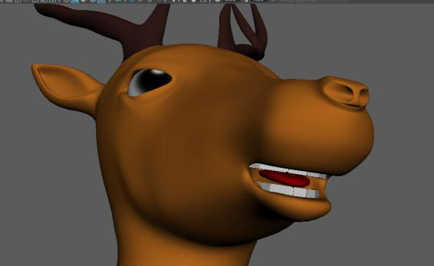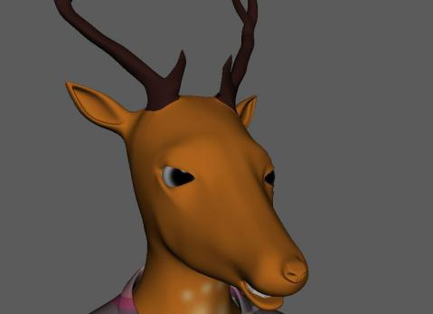
Picture two
Texture part:
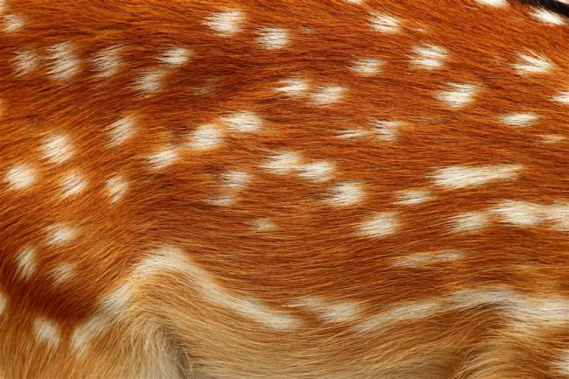
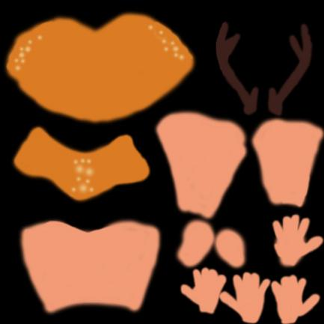
Picture three
There is my old texture for deer, first I unfold the UV and paint it in Photoshop, it is a basic color for character. It suit for cartoon style but a little simple(picture three). So I find a hair pic of deer, pick part of it as the basic texture. And Zihan have paint some detail in texture. There is the update texture for deer. First the detail of paint look like some dirty thing on deer’s hair, we don’t like the vision( picture four ).
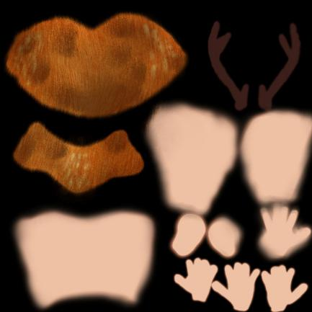
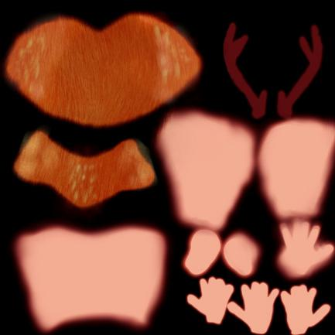
Picture four
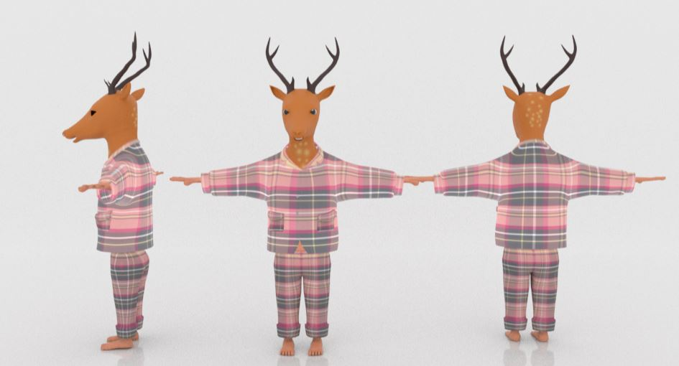
Picture five
There is the old vision for deer in July 20th(picture five), I have finish rig work, after some animation test and change paint weight, it can be used in animation. But the clothes looks weird, I didn’t unfold the UV, it is hard to do it, because the model of deer have many unnecessary lines, and striped clothes have Have high requirements for UV.
In the old deer vision, I use AdvancedSkeleton_v3.7 to rig deer. It wasn’t as convince as AdvancedSkeleton_v5. there are many thing you need rig one by one. It take a lot of time to finish. We didn’t use the old vision. But I have test for it, it can do some simple action such as walk, raise hands.
About the deer work, in first part, I finish model, UV, texture and Rig in July 20th, then Start take over for changing UV, he upload the model which fixed UV in August 20th. Then I and Zihan take one day to finish deer and baby. She take charge for rigging and I painting weight.

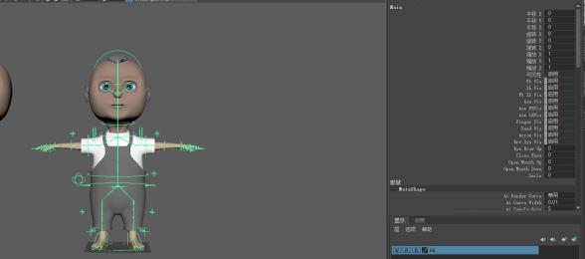
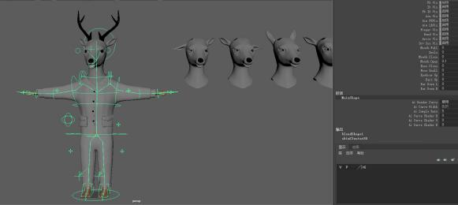
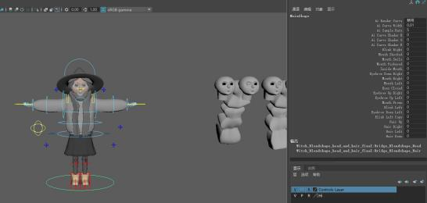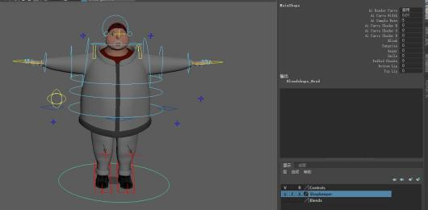

In paint weight part:
I take charge for painting weight for four character and add bland shape control into main control line. We I use AdvancedSkeleton as main rig tool, and it brings some problem. There first problem is the control of eyes. the control of eyes have rigged with head, so when I want move the eyes control but the head moved. The problem was showed in four character. After a while, I find a way to fix it that move the weight from head of the control of eyes. The second problem was that I can’t find joins when I was painting weight. In fact, joins was hide in the step of rig. It cause a little trouble in painting weight.
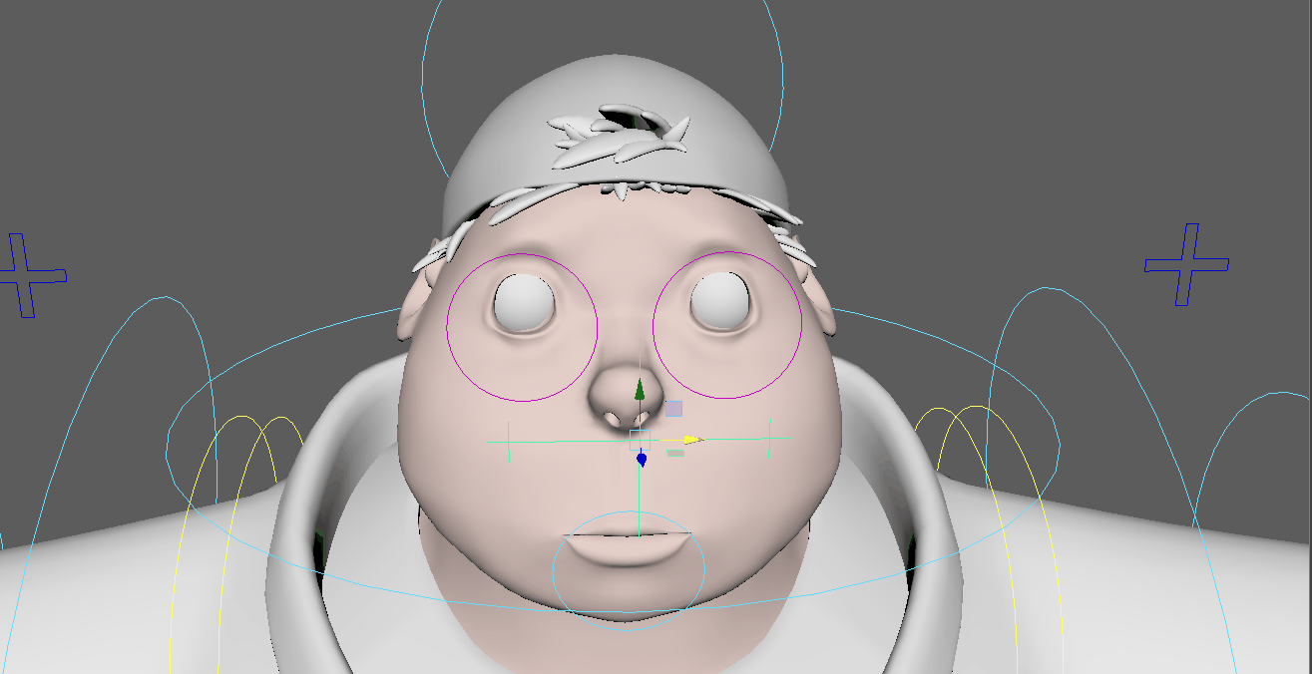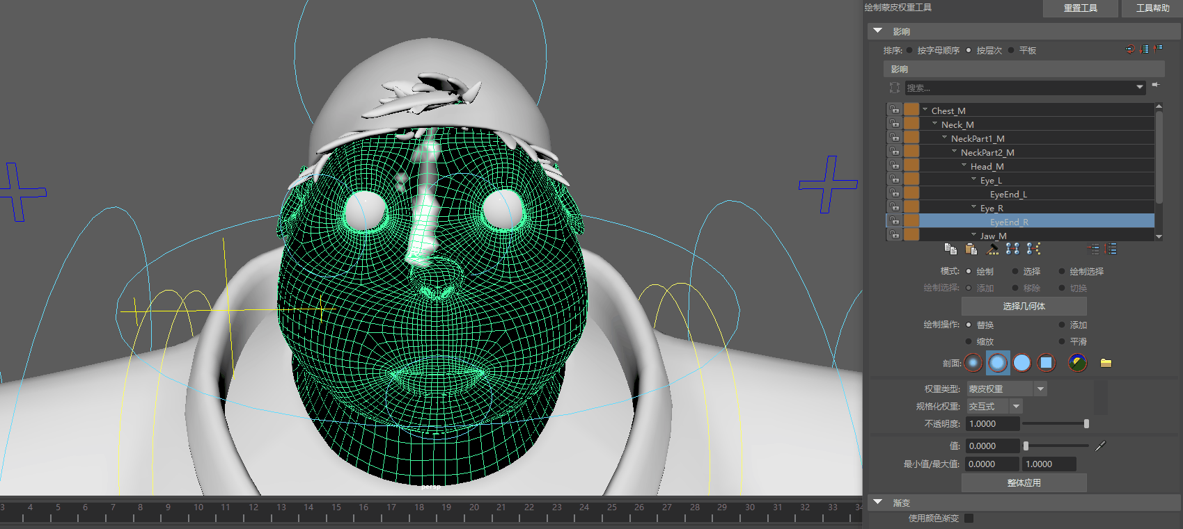

I also learn a lot of knowledge about character model. I chose deer as the first character model to build, the first problem that I meet is the design picture. I take a lot of time to adjust model, I have learn a point that we have to have a clearly idea in mind not in picture while building mode. The second thing that I learn is I need to make sure every line is necessary, I have build a lot of unnecessary line in deer model and it cause a lot of problem in later work, especially in the process of unfold UV. It have a big change in other model, such as kid and witch. I have delete many line which I don’t need. Then model looks more sample and applied, it is very easy to continue, especially in unfold UV. To unfold a complex model is very difficult, every point of UV we need to make they straight, then it can suit for texture work. I am sure that I can do better in build model next time, more careful and more normative. Model is the first part in a animation, it is important. Then I chose deer to texture, because I know it will be hard to do.
Animation part：
In the last part, my major work is putting most of environment into right place, and make sure these environment have showed in others animation shots. After I finish environment work, I start to do some animation which shot 22,23,24,25,27,36.
the shot 22 show that deer has finished eating the chicken, hears a noise and then turns around to investigate.
The shot 23 show that establishing shot of fans, deer walks into shot
The shot 24 show that mid shot of deer picking up small fan.
The shot 25 show that witch picking something out of fridge
The shot 27 show that deer milk mid shot being put into basket
The shot 36 show that witch the item.
I think we find a good plug-ins named Advanced Skeleton vision five, I know it in 2015, it was Advanced Skeleton vision one at that moment. It is useful in rig and animation. Walking design is a brilliant function, it can make a naturally movement for animation. In fact, I can’t do walk animation as good as walking design.
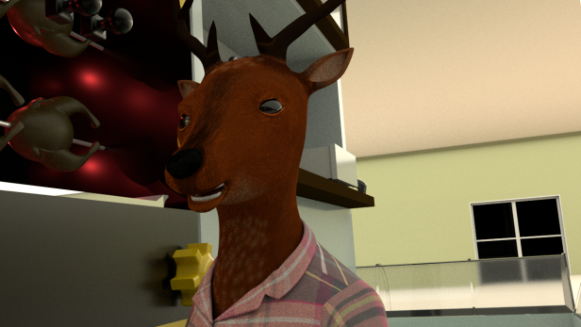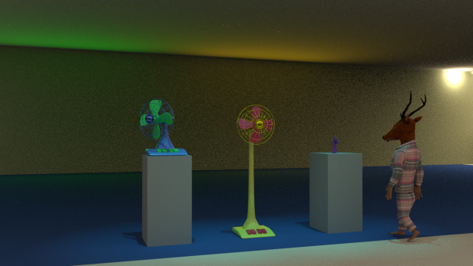
Shot 22 shot 23

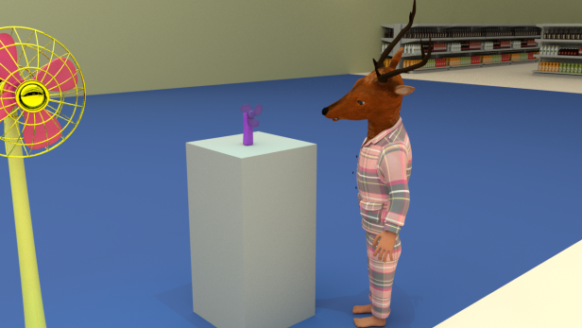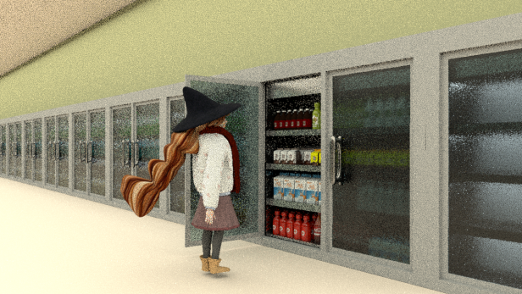
Shot 24 shot 25
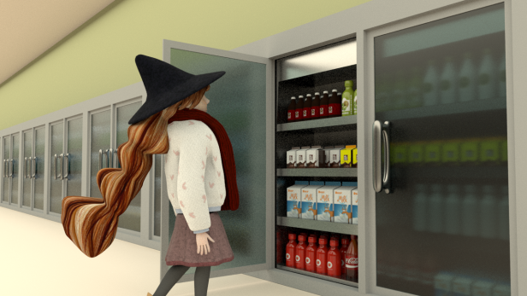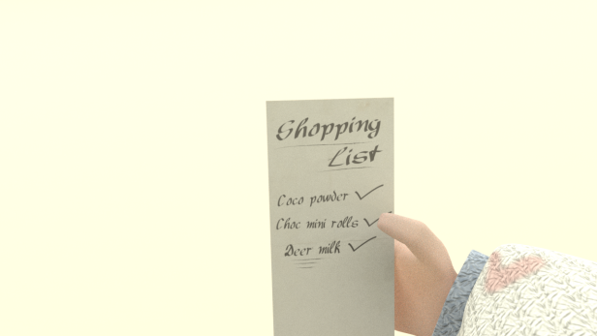
Shot 27 shot 36

My second role is taking charge for building environment, such as rotisserie, trolley, kinds of meat, computer, pay machine, dairy, cookies and fridge. In the early work, I build model and texture. The biggest problem I meet is texture, texture is easy but I need to make texture suit for our animation style. In late work, I take charge for make the environment in right position. The secondly part for me is building environment. In the subject, I also take charge for building and text rotisserie area and some Items on the shelves, it is my support role. In our animation, shop is a big area, if we want a good rendering show in animation, we have to build enough detail for background such as cookies, milk, beer, chocolate etc. And I will design for these production make they suit for our animation. And everyone in our group will take charge for each part, the only thing we need notice is the style need be same. Environment build is simple but cost a lot of time. There is picture for till part(picture six).
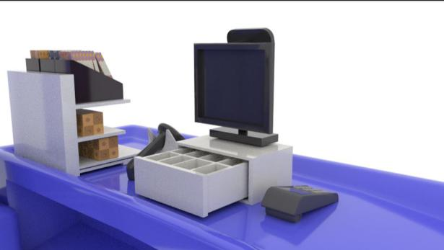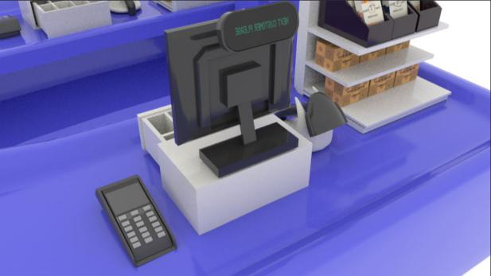
Picture six
Rachel build the basic part of till and I add some detail in till, such as cashier, POS, scanner and little shelf with snack(picture six). I didn’t have experience build environment for animation and I didn’t rename for these things. It cause a problem that we can’t define it in a big environment, especially after we duplicate it couple times. So I spend a lot of time to rename everything include model and texture. It is my bad. And I think build Irregular geometry is a new skill for Maya that we need to learn. Boolean need cooperate with adding reasonable line.

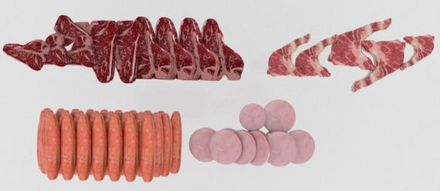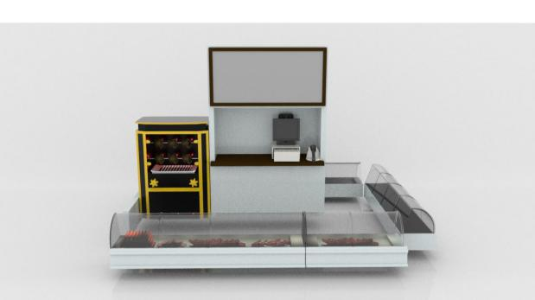
Picture seven
Then I build the rotisserie area, it is a important part in animation. Deer will eat chicken in here. There are the new vision in animation. In old vision I have added chair and some drink in table to make rotisserie more really. But in shot setting of animation, it won’t show. So I delete it and add cashier. I make kind of meat for it. It is important that find a good reference picture.

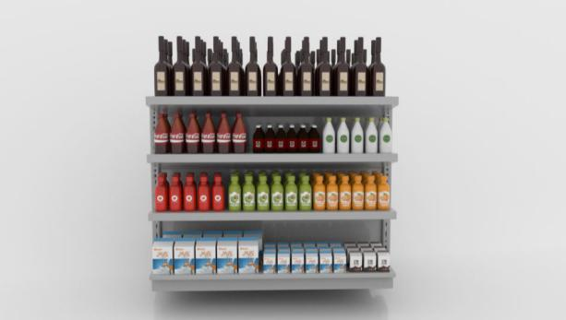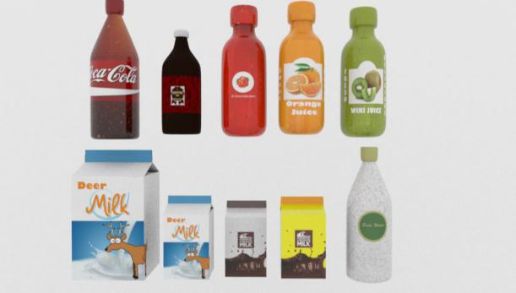
Picture eight
There are the bottle design and dairy(picture eight), they show in animation everywhere. I model and texture for bottle and make some bad logo design, Zihan help me re-design the logo and make it be good commodity that people like to pay for it. In later work, I create reference file for dairy, and position they in shop. I also create cookies and chocolate to make shop interesting. I will make sure the size of model and texture before build things next time, so I don’t need to change it and save a lot of time.
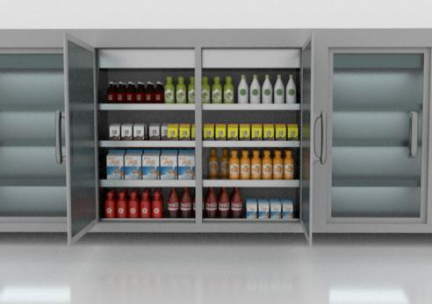
Picture nine
There is fridge in animation. I model for it except glass. Smooth is a brilliant function, when I try to build handle of fridge. I build a basic geometry and add smooth, it can be a very good handle at the moment. And I go to texture view, add a Arnold stand texture for it. Then increase the attributes of metal.
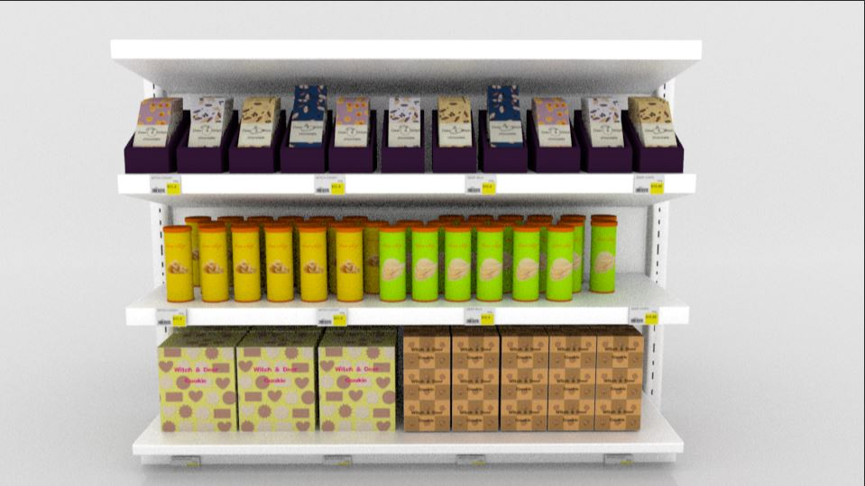
Picture ten
There are some goods in order to enrich the shop inside(picture ten). I build the model and texture for they. All the logos are embodied deer and witch style. I have made price tag for each cookies, chocolate and chips. But we don’t have time put in our environment.

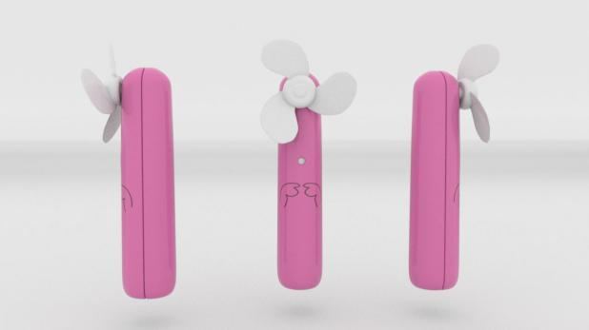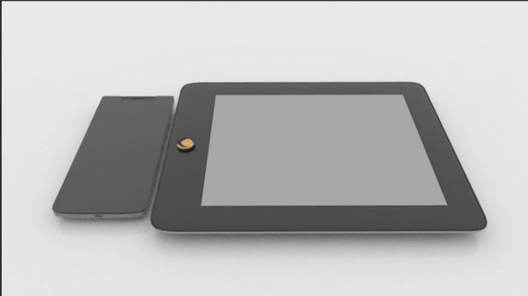
Picture eleven
There are the hand fan and iPad(picture eleven), they are part of electronic area, but we don’t time put they in animation. Rachel think the old hand fan need more detail and I take charge make a new one with more detail. I try to design a cute cartoon style for hand fan, so I chose the lovely color and cute logo. But Stuart think his more suit for animation, so it didn’t show in animation.

In the render part:

After I finish my part of animation. I have downloaded all file that we need for render for all computer in class before we finish all animation. The file is too big which have more then 25G, if everything is fine, it will be very easy done. But it have too much trouble then I think. At first, I test the last frame of shot8, and report how much time need to render one shot. I have tried two kind of set of Arnold, lower one take 54 second and higher one take 2mins. Then I have opened all computer and report to our team about what much computer can render. It was 4 computers broken and 13 computers can work. I start to download all file. At first I just download all file without setting download set. After I download for 13 computer, Stuart ask me we need download in C drive, so I delete all file in 13 computers and set a new file named witch and deer for each computer and download again. It is very busy afternoon, I got no time to eat lunch, because the university worker tell me I have to leave at 4.pm. I got a lot work to do. After I download all file in witch and deer of C drive, I find the download failed, Because the file is too big, and Google chrome is hard to carry on. When I have no idea, Stuart help me find a other way to download. Lucky, all computer are downloaded successfully. Then I upload a software named VSubst for each computer which Stuart find it. It is useful for our work which make sure our reference file in same path.

Composite part:
After a night render, most computer in class have finished render and some didn’t. finally, we got 14 shot already finish render. And I composite they in AE.
it takes a lot of time to set up, first I try download by Google, but it fail, because the internet is so bad to carry on, the we find other way to fix it. . I have finished most of my shots render, and help Zihan and Rachel collect render picture, and composite render video. Unfortunately, our render video are dispersed, so I didn’t compose it into a whole video.
Thanks for Whats app, the communication in group is very easy and efficient, in the early stage, it is hard for me to talk with team member, I have to use Google translate to transfer every word that I don’t know. But I can talk with they easily now, even some words I still don’t know the meaning, but I can guess the meaning of sentence. It is very precious harvest for me.

Conclusion:
In the project, I got a basic understand of the whole process of animation. And got some experience, especially in model. And I will keep pay attention in model and I want to build kinds of model in my future career. I meet many problems in the process, and our team worked together to share experiences with others. We try to solve the problem in a variety of ways. For example, we look for a tutorial video on the web, ask the teacher and try to solve it ourselves. Everyone tries to do the best for team..

