Name:_ Mathis Villa

Student Number: 2501611

WORKSHEET 3 – TESTING (Lap Times)

- Original code:
Laptime = []

for counter in range (1, 6, 1):
print("Please enter the leatest lap times.... (in seconds) ")
print ("Lap",counter, ":")
timeinput = float(input())
Laptime.append (timeinput)

print("What is your target lap time?")
target = int(input())

overall = sum(Laptime)
average = overall / 5

Lowesttime = min(Laptime)
Lowindex = Laptime.index(Lowesttime)

Highesttime = max(Laptime)
Highindex = Laptime.index(Highesttime)

print("your statistics...")

print("overall time for 5 laps was:", overall, "seconds")
print("Average lap time was:", average, "seconds")
print("The fastest lap was lap", Lowindex + 1 , "in", Lowesttime, "seconds")
print("The slowest lap was lap", Highindex + 1 , "in", Highesttime, "seconds")

bettercount = 0

for i in range(len(Laptime)):
if Laptime[i] <= target:
bettercount = bettercount + 1

print(bettercount, "of your laps were better than or equal to your target")

print("Lap 1 was", Laptime[0])
if Laptime[0] > Laptime[1]:
print ("Lap 2 was", Laptime[1], "which was faster than the previous lap")

elif Laptime[0] == Laptime[1]:
print ("Lap 2 was", Laptime[1], "which was equalle to your previous lap")

else:
print ("Lap 2 was", Laptime[1], "which was slower than the previous lap")

if Laptime[1] > Laptime[2]:
print ("Lap 3 was", Laptime[2], "which was faster than the previous lap")

elif Laptime[1] == Laptime[2]:
print ("Lap 3 was", Laptime[2], "which was equalle to your previous lap")

else:
print ("Lap 3 was", Laptime[2], "which was slower than the previous lap")

if Laptime[2] > Laptime[3]:
print ("Lap 4 was", Laptime[3], "which was faster than the previous lap")

elif Laptime[2] == Laptime[3]:
print ("Lap 3 was", Laptime[3], "which was equalle to your previous lap")

else:
print ("Lap 4 was", Laptime[3], "which was slower than the previous lap")

if Laptime[3] > Laptime[4]:
print ("Lap 5 was", Laptime[4], "which was faster than the previous lap")

elif Laptime[3] == Laptime[4]:
print ("Lap 5 was", Laptime[4], "which was equalle to your previous lap")

else:
print ("Lap 5 was", Laptime[4], "which was slower than the previous lap")

- Code Testing
For each test below, run your code and show the results of the scenarios below. Present a screenshot of what happened when the programme ran. Did the programme behave correctly or did it do something unexpected, and if so, why?

- Test a lap time for your programme:
- 42 seconds
- 2 seconds
- -4 seconds
- 53444 seconds
- Test the target lap time – show that the values entered are reasonable

- Using the same five lap times as the sample output ie

Lap 1: 42.3
Lap 2: 42.1
Lap 3: 44
Lap 4: 44
Lap 5: 39.4

Examine each statistic (1-6) and comment on whether the correct answer(s) are displayed or not. (If any statistics were incomplete after Phase 1 (code completed in class) simply write “Unfinished”)

- Test two further sets of lap times of your own choice.

Template for tests:
Test: entering 42 seconds

Screenshot(s) of output:
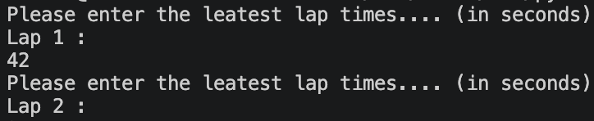

After entering the value of 42 the program accepts the value and moves onto the next question.
Result: Did the programme behave as expected ie syntactically and logically correct?
YES

Test: entering 2 seconds

Screenshot(s) of output:
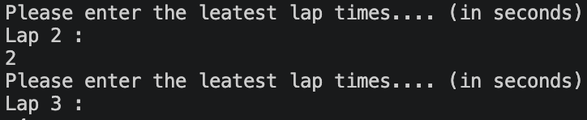

After testing the program did not behave as expected, as the value of 2 was accepted and the code moved onto the next question. This is due to the of validation being added. To fix this issue adding a simple ‘if’ statement inside a loop where a minimum value of 40 would stop the user from entering fake lap times.

Result: Did the programme behave as expected ie syntactically and logically correct?
NO

Test: entering -4 seconds

Screenshot(s) of output:
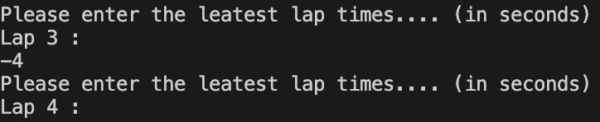

After entering the value of -4, the programme did not behave as expected as it accepted the value and moved on the next question. Similar to the previous issue where the programme accepted the value of 2, validation will need to be added inside a loop to stop issues such as the following from happening again. In this case adding a simple ‘if’ statement which rejects user answers under 40 seconds would automatically stop numbers below 40 from being entered.
Result: Did the programme behave as expected ie syntactically and logically correct?
NO

Entering 53444 seconds

Screenshot(s) of output:
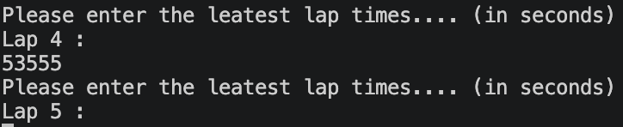

After testing the programme did not behave as expected, as the value of 53555 was accepted by the programme and it moved onto the next question. Similar to the previous example, adding a simple validation which only accepts numbers under a maximum value would fix the following. But certain factors still have to be taken into account, for instance accidents or breakdowns that could possibly happen on the track. In this case, validation would not necessarily resolve this problem.

Result: Did the programme behave as expected ie syntactically and logically correct?

No

Test the target lap time – show that the values entered are reasonable

Screenshot(s) of output:

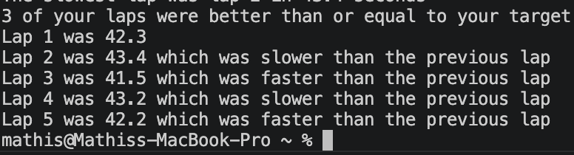

As shown the target lap time of 42.6 worked as expected where the programme gave the correct output stating which lap was slower or faster than the target.
Result: Did the programme behave as expected ie syntactically and logically correct?
Yes

Using the same five lap times as the sample output

Screenshot(s) of output:
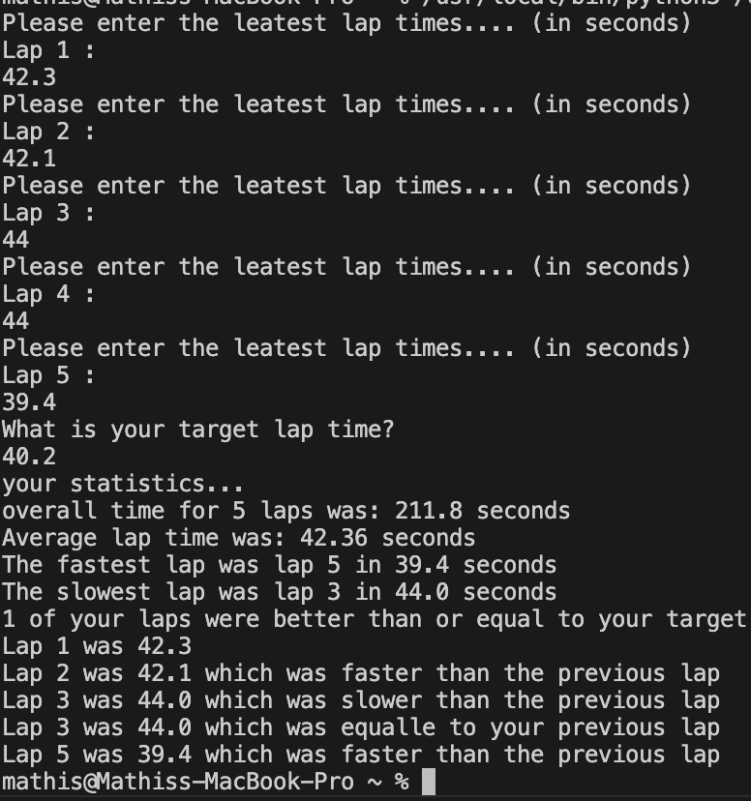

After entering the same five lap times given by the sample, and entering my own target lap time as it was not provided, the code behaved as expected where the correct answers were displayed.
Result: Did the programme behave as expected ie syntactically and logically correct?
Yes

Using two of my own times as the sample output

Screenshot(s) of output:

Sample N1
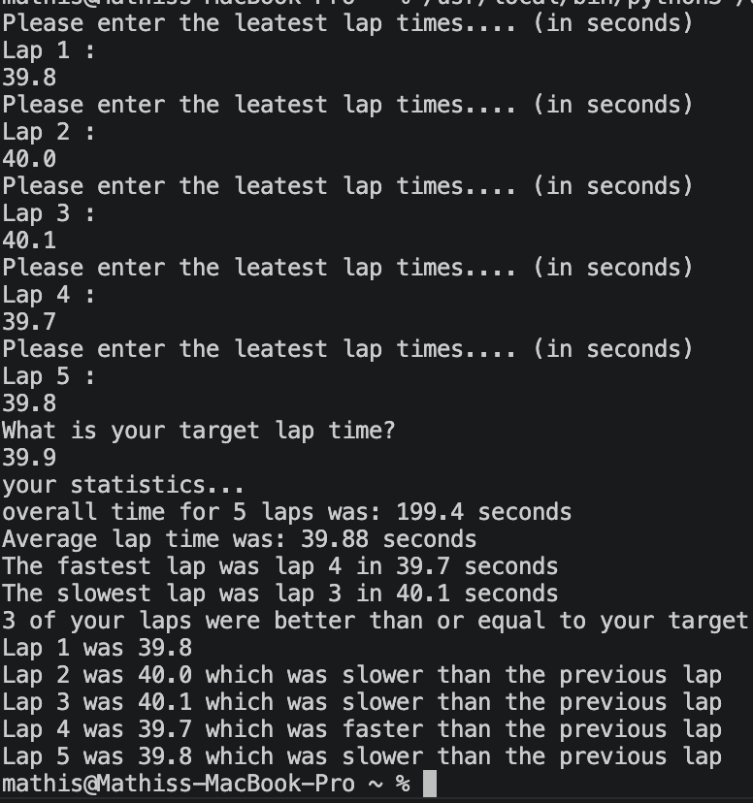

Sample N2
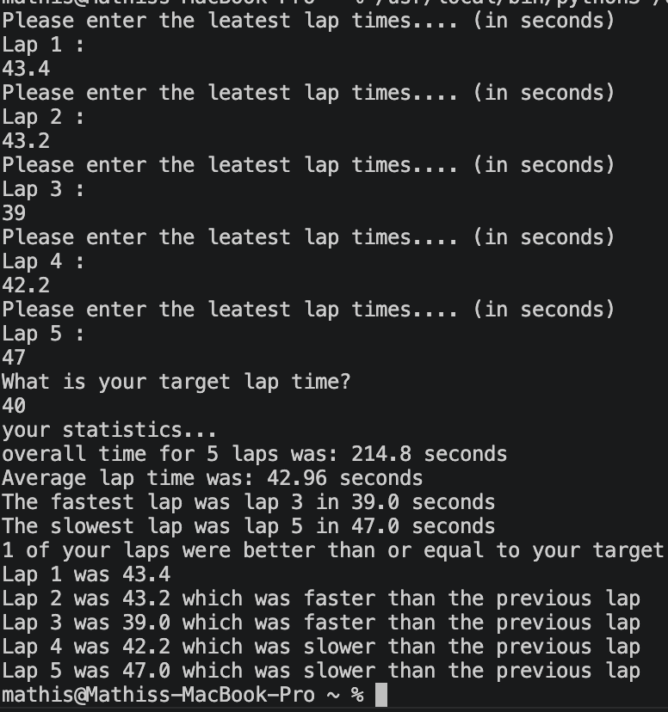

The following two screenshots show my own set of lap times that were both chosen so the values were either close to each other or far apart. Even with an attempt at tricking the programme, the code still worked as expected with the correct values.

Result: Did the programme behave as expected ie syntactically and logically correct?
Yes

- Consider the results of the above tests and revisit your original code in order to address any tests that failed and/or improve code efficiency.

(Note: you may not be able to solve all of the problems that were encountered, but solve as many as you can.)

Paste your full revised code here :

[Copy and paste your full revised code here – note, do not use a screenshot]

Laptime = []

for counter in range(1, 6, 1):
print("Please enter the latest lap times.... (in seconds)")
print("Lap", counter, ":")
timeinput = float(input())

while timeinput < 40 or timeinput > 300:
print("Invalid lap time. Please enter a lap time between 40 and 300 seconds.")
timeinput = float(input())

Laptime.append(timeinput)

print("What is your target lap time?")
target = float(input())

while target < 40 or target > 300:
print("Invalid target lap time. Please enter a target lap time between 40 and 300 seconds.")
target = float(input())

overall = sum(Laptime)
average = overall / 5

Lowesttime = min(Laptime)
Lowindex = Laptime.index(Lowesttime)

Highesttime = max(Laptime)
Highindex = Laptime.index(Highesttime)

print("your statistics...")

print("overall time for 5 laps was:", overall, "seconds")
print("Average lap time was:", average, "seconds")
print("The fastest lap was lap", Lowindex + 1, "in", Lowesttime, "seconds")
print("The slowest lap was lap", Highindex + 1, "in", Highesttime, "seconds")

bettercount = 0

for i in range(len(Laptime)):
if Laptime[i] <= target:
bettercount = bettercount + 1

print(bettercount, "of your laps were better than or equal to your target")

print("Lap 1 was", Laptime[0])

if Laptime[0] > Laptime[1]:
print("Lap 2 was", Laptime[1], "which was faster than the previous lap")

elif Laptime[0] == Laptime[1]:
print("Lap 2 was", Laptime[1], "which was equal to your previous lap")

else:
print("Lap 2 was", Laptime[1], "which was slower than the previous lap")

if Laptime[1] > Laptime[2]:
print("Lap 3 was", Laptime[2], "which was faster than the previous lap")

elif Laptime[1] == Laptime[2]:
print("Lap 3 was", Laptime[2], "which was equal to your previous lap")

else:
print("Lap 3 was", Laptime[2], "which was slower than the previous lap")

if Laptime[2] > Laptime[3]:
print("Lap 4 was", Laptime[3], "which was faster than the previous lap")

elif Laptime[2] == Laptime[3]:
print("Lap 4 was", Laptime[3], "which was equal to your previous lap")

else:
print("Lap 4 was", Laptime[3], "which was slower than the previous lap")

if Laptime[3] > Laptime[4]:
print("Lap 5 was", Laptime[4], "which was faster than the previous lap")

elif Laptime[3] == Laptime[4]:
print("Lap 5 was", Laptime[4], "which was equal to your previous lap")

else:
print("Lap 5 was", Laptime[4], "which was slower than the previous lap")

