What makes a great leader?

What is leadership ? is it the exercise of power and force or the procession of extraordinary analytical skill? The Authors such Daniel Coleman and Abraham Zaleznik has changed the way leadership is seen. Leadership is defined as “The accomplishment of a goal through the direction of human assistants”(prentice,2004) Leadership is about knowledge, skills and abilities for transformation(Laub,1999). Main theories that emerged during 20th century include: the Great Man theory, Trait theory, Process leadership theory, Style and Behavioural theory, Transformational, Transactional and Laissez Faire leadership theory. Other leadership styles include coaching style, democratic and autocratic styles have also been researched in 1939 by psychologist Kurt Lewin et al.
This essay will critically evaluate leadership styles using leadership theorist and models with Sir Richard Branson as a Case study, the essay will also critically evaluate his trait and how they affect his leadership. The essay will also look at the authors leadership styles and his ability to implement change using model of change .
The reason for choosing Richard Branson is that he is a legendary man with legendary ideas , he dreams big ,an example in 1991 ,he had the vision to compete with Nasa and build a space ship so that the public can visit space the project was named Virgin Galactic spaceflight , this would enable tourist to visit space and at the same time he talked about having hotels in space which some people thought was a unimaginable. The flight costs was $200,000, he managed to get 100 people to pay and 40 made a deposit of some kind. To date second the second spaceship two has been unveiled . He is a Global business billionaire , and has control of over 400 companies ,he is a patron in many charities and has also been criticised for being a tax evader,

Richard Branson was Born in 1950 in Shanley Green , Surrey. His father was Called Ted and was a Barrister His mother Eve was an athlete and professional dancer. According to the guardian 2012 Branson is worth £3b. in 2014. Sir Richard is a business magnate, investor, author and former philanthropist, Richard is dyslexic and in those early days little had been done in line of this . He learned to work around this as little had been discovered so he his challenges. He is known for his publicity stunts and love adventure setting records in powerboat racing and hot-air ballooning (biography & facts ,2020) Sir ,Richard is known to be a charismatic and transformational leader whereas he is known to own a conglomerate he does not appear on the board of the companies making his leadership style Laissez Faire.
His early influences on entrepreneurship was his mother Eve , he was entrepreneurial and involved Richard in industry from a young age. Some of the ventures are:
Growing x-mas tress and raising and selling budgies. He found that he could handle real life maths compared to school work.

Richard started a business at 16 years old in 1966 when he left school he developed the student magazine and enjoyed is journalism work interviewing people he later with his friend Gems ventured into the pop world in 1970 and set up virgin records. In 1970 he went to prison for tax evasion none the less The Virgin music logo was formed ,with the first music store opening off at London Oxford road in 1971 . Later several stores opened in London. Virgin flights took off in 1978 when he missed a flight and charted a private jet and sold tickets for £39. In 1984 , Branson diversified leasing his first 747 to fly to New York from Gatwick. In 2005- -6 Branson assembled Virgin media group that competes, BT and SKY for entertainments in the mid 1990”s . Branson’s has his flops they were a series including Virgin Brides , Virgin Cola and Virgin cosmetics .
“do not be embarrassed by your failures, learn from them and start again” Branson

Some of the major drawbacks in career is his fight with Coca-Cola which is trait of competitive nature, derailment of one of the virgin titling trains ‘pendolino’ in 2007 and injuring passengers and killing one was a disaster which he had to handle . And the big failed Northern Rock acquisition which involved him and Gordon Brown also damaged reputation of virgin , This ventures show his competitive trait and daring stunts as written in his book “Screw it let do it” .“You don’t learn to walk by following rules . You learn by doing and by falling over.” He says about learning from mistakes and setbacks (Business stripped bare,2009)

Richard Branson is British entrepreneur who has founded virgin group a multinational conglomerate incorporated in 1989 all though it’s activities have been operating in 1970’s. Virgin control more than 400 companies in various sectors.

Sir Branson’s `leadership styles and impact .

Laissez Faire leadership style/ empowering/delegative

“Courage is what it takes to stand up and speak, courage is also what it takes to sit down and listen” Branson(SwitzerDaily 2020)

Branson has been said to be charismatic leader due to his infectious enthusiasm
and transformational and motivational leadership style .his main leadership style is Laissez Faire leadership style which is a free – rein leadership . The French translation” means let it do(Tools hero ,2020) in spite of the cons of this leadership style such as lack of role awareness ,commitment, responsibility and passivity of employees this style of leadership has worked particularly well for Branson because he looks for people with innovative ideas those who will start new business those who are the best in whatever they do and what to be the best in whatever field in either airlines , financial , hospitality and tourism or entertainment this are people who are driven and passionate to work with less supervision. The virgin group are fully professional and competent of the work that needs doing and venture managers are independent and operate independently such as the Virgin Galactic space ships . young entrepreneurs have favoured this stye contrary to the older styles which stifled creativity and innovation .Richard Branson prefers to work in small teams this promotes family like approach to business enhances trust among staff, This also encourages motivation and Emergent leaderships, this are informal leaders who are not elected but leadership evolve over time through interaction (Souza De G, Klein HJ ,1995) ,leadership is shared “the strength of the group is the strength of the leaders”. While this works for others , some staff have been reported passivity in their roles and confusion because of no clear roles and would prefer structure and order. Whereas Autocratic leadership gives clear directions and instructions, power and authority in the leader(House,1996) this type of leadership encourages scapegoating and stress due to the overall negative effects (Lewin et al., 1939, White and Lippitt, 1960) and subordinates the leaders to have coercive power and fear for the leader to punish, though leaders like Bill Gates have been known to have this style and has been successful.

TRANSFORMATIONAL/CHARISMATIC LEADERSHIP
Transformational leaders encourage employees by increasing their level of optimism and decreasing frustrations (Bass and Avolio, 1990; Sivanathan and Cynthia Fekken, 2002). For instance, Sir Richard Branson is well known as a charismatic and transformational leader .
his has been known to have personal traits which give referent power .

- His thinking style which is creative and adaptable to change
- Openness to change
- Competitive nature and the love of challenge
- Willingness to experiment and implement change
- His outgoing nature
Testimonials from people who have worked with him say he is fascinating and fun to work with, bold and brave another commented that he is very intuitive and can see the simplicity in what most can see as complex this has been associated with is personality and dyslexia .(quora 2020) a ted talk had been made on the relation with this personality trait. He has been criticised to be doing and creating things that he loves even if it means losing money. He has clearly stated that money is not his main motivator. Furthermore According to (conger and Kanungo (1998) other characteristic that charismatic and transformational leaders have included in the research are demonstrating sensitivity to followers which is challenging to Branson at the current moment where he finds staff cuts inevitable. With the airline cuts he has improved communication and pledged his Caribbean island to help the situation of staff losing their jobs. This shows empathy and sensitivity .However Transformational leadership concept and composition of leadership vary due to culture (Hofstede,1993) the idiosyncrasies in this theory are not share in other parts of the world. Virgin being a global brand might find it difficult working with the Chinese where there is a status a gap between leaders and subordinates another example of the negative of transformational leadership in culture is between the Latin where the people agree with the leader this can impede creativity where followers are afraid to give feedback. Despite being successful his trait has caused some drawbacks.

LEADER – MEMBER EXCHANGE (LMX)THEORY
A relationship through which one person influences the behaviour or actions of other people
Mullins (2008)

Leader exchange theory relational approach to leadership. It is found in this leadership style leaders are more inclusive and communicative with some members compared to others, therefore forming, high -quality trust, and respect -based relationship, compared with other employees.(Bauern. and Erdogan ,2015) whereas Branson is known to be more laissez faire he hand picks his executive who report to him executives are close friends ,friendlier ,more inclusive and more communicative which is a similar approach with the theory. This is an emotional relationship, when leaders and followers converge to higher levels of positive emotional tone hit relates to quality relationships (Anderson, Keltner, & John, 2003; Boiger & Mesquita, 2012),The vice versa as this is an emotional relationship will result in lower quality relationship consequently can be less beneficial.

Sir Richard Branson on managing change

“ The people who are crazy enough to think they can change the world are the one who do” Think different.

People in organisations have to be mentally prepared for the fact that change is inevitable, this is evident but easier said than done, Managing employee resistance is the first challenge for those leading the change process for those leading .
Some of the Outside pressure are

Outside factors | Internal factors
- Competitors  - Delving profits  - Decreasing market share  - Scarcity of resources  - Deregulation  - Technological development  Problems with suppliers and customers | - Ineffective leadership  - Poor morale  - Higher turnover  - Labour problems  - Highly politicised behaviour

As defined by Northouse (2004) leadership is a process by which an individual influences group of individuals to achieve common goals” In leadership Branson has had to deal with organisational change. Change management is the process of continually renewing an organisation’s direction, Structure, and capabilities to serve the ever changing needs of external and internal customers’ defined by Moran and Brightman(2001)

‘Keep a cool head you are in the business to deliver change, and if you succeed, the chances that no one will get hurt are virtually zero”

In the Current time Virgin brand has had to deal with managing change due to the global pandemic, his airline Virgin Atlantic has been worse hit due to the restrictions put in place to prevent the spread of COVID and customers reluctance to travel. This has put the airline in jeopardy. Plans for job cuts of up to 3,000 are underway. Branson has asked for a bail from the government but has been turned down and not given special treatment like any business in the UK. Other Activist are against public funds being used to bailout the billionaire who is not a resident in the UK for tax purposes. He has pledged to mortgage his Caribbean island to help raise the money and injecting $250m towards the airline(guardian,2020)Trade unions have received complaints and are fighting for employees rights. In the change process employee resistance in a important factor Stanley, Meyer, & Topolnytsky, 2005, and openes to change (Wanberg & Banas, 2000) This type of resistance are known to get negative outcomes .Whereas employee participation will lead to more positive outcome of formulating ,planning and implementing change Vroom & Yetton, 1973)
e,. This high quality change will prevail over resistance in this first stage of implementation.
The type of leadership style is vital in the process of change management., according to (Bass,1985)transformational leaders are charismatic ,inspirational, intellectual and individualized consideration . Branson’s ethicality will be a great source of change from employees as stated by Durand and Calori (2006) the ethics of leadership in change process.

The model of change by Kurt lewin” has three stages This process was first initiated in 1947 and used for organisational change it has three stages

- Unfreezing
- Changing
- refreezing
This model has been criticised by scholars as being over simplified but still remains a classic in change management. In 9/11 Branson had to lay off 1200 staff , he absorbed some of them in other companies and when the situation became better he was able to have most back after a few years.. Using the process model he was able to remove the organisation from the (Chaos ) to the desired positive place this was done with knowledge sharing and employee participation This change does not occur quickly but simultaneously And also is evident in how Branson successfully handled the 9/11 airline crisis. Gong, Huang,&Farh,2000 state that transformational leadership style is a major characteristic of charge and has a positive impact unlike laissez faire. Sharing in for formation in process increases motivation in the process, having motivational language Leadership style can affect motivation and performance of staff according to Colemans .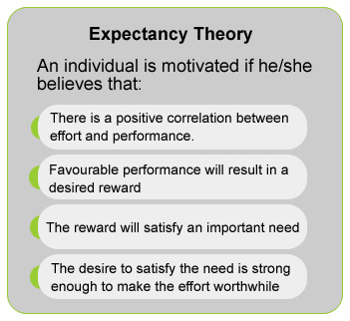vroom1964

CORPORATE RESPOSIBILITY

“Aligning values in work”

He has had a passion for community , and making a difference , his business is brand venture and he has bailed companies who would have gone bankrupt . one of the acquisitions was a chain of shops which he later turned around to mobile shops, He has been known to take tremendous risks “The brave may not leave forever but the cautious do not leave at all.” he famously know for saying (Branson,2009) He is also known for being bold and brave. When interviewed what he would want for Virgin he stated that he would like it to be the most respected company in the world. In the same interview in his” book business stripped bare” he stated that he would not sell cigarettes which he had difficulty stopping smoking himself and would not promote it, he is a patron of several charities this shows his moral concern and sense of responsibility , ethical stance in his leadership style Others have questioned his moral stance and blamed him for being a tax exile (the Guardian,2013)his patriotism was questioned . He works towards making the world a better place and participation in initiatives of climate change. He has made millionaires through is brand ventures

Task 2

I am a first born of four sisters, my father was a banker and my mother a charity worker. I have three grown children between the ages of 22-27. I have worked in different environments as a leader from childhood where in this role was expected to be a role model and in parenting I had to be the head outside family I have worked as a team leader , market representative which has required me to use leadership attributes and qualities. At present I run my own business and lead a team of volunteers and staff. After studying the different leadership styles I can say that all the roles needed different leadership styles. Example of this is when bring up the children I was authoritarian and when they grew up I had to give up more control and be democratic or laissez- faire leadership style. Being a a team lead I had to use more participative leadership style.

At my present role as an entrepreneur has encouraged me to be take more risks due to the changing business dynamics and ambiguity from technology, changes in society and competition from around the world , I also have had to deal with adaptative challenges where deep held values and beliefs are challenged instance buying Fairtrade and buying vegan products. In this instances my leadership style has been Servant leadership style, servant leaders ensure growth and moral development and enhance common good by paying more attention to ethical demands, thereby placing empowerment ahead of self and organisational interests (Graham, 1991; Williams et al., 2017) I resonant with the skill set for the servant leadership style which are conflict resolution, good communication skills, empathy , listening skills and enabling good working environment ( Bottum and Lenz, 2010). ,staff retainment is higher ,organisation goals are then met indirectly when staff are empowered and have personal integrity.

Moreover I have found that my leadership style has been challenged when I get too involved in the detail rather than leading and this has caused dependence on team members or staff, not thinking for themselves having “a helicopter approach “ being a Transformational leader will enable me to mentor, encourage staff to be more creative and enthusiastic when doing their work. Though both leadership styles, Servant and Transformational share the same goals, the approaches are different. Servant leadership style aims to address followers core values such as spirituality and justice.( Graham, 1991; Mayer et al., 2008)and Transformational leadership drive followers for organisational goals and visions (Arnold, 2017; Podsakoff et al., 1990). Contrary Transactional leaders achieve performance as merely required by the use of contingent rewards or negative feedback( Hater et al 1988)t this style has not been appropriate in my workplace
Additionally I have had difficulties in delegating which leads to more Autocratic style of leadership this has led to stress in the workplace . Although the autocratic leadership style encourage obedience and compliance it neglects proactivity and initiative. Having more confidence in staff and team members would be a more successful way especially in the present environment of the epidemic and staff are working from home. Transformational leaders support delegate, coach, care, and advice individuals based on their needs (Barling et al., 2000)
Laisse faire leadership style would be useful in trusted and confident teams and mostly professionals example when using my accountant . In teams there are different levels of motivation and growth. So with more confidence, communication in staff more authority is given, autonomy is desired by employees . Individuals are able to carry their duties and execute tasks with preferred styles Hackman & Oldham, 1976). I have taken a leadership styles questionnaire and the results have revealed that I was more of a democratic leader with a score of = 21,followed by laissez-faire leadership style =15, finally Authoritarian leadership which I got a score of =12. I am very surprised with the outcome because I thought I was an authoritarian leader . On further learning the subject of leadership styles , I discovered that I have other leadership styles in addition to the above as mentioned on my work experience. My leadership style I would say takes a more situational approach (Hersey &Blanhard,1969)” Leaders match their style to the competence and commitment of subordinates” the three skills need for a situational leader a diagnosis, flexibility, partnering for performance
In my role I would lead change by using the 8 step process invented by DR .Kotter 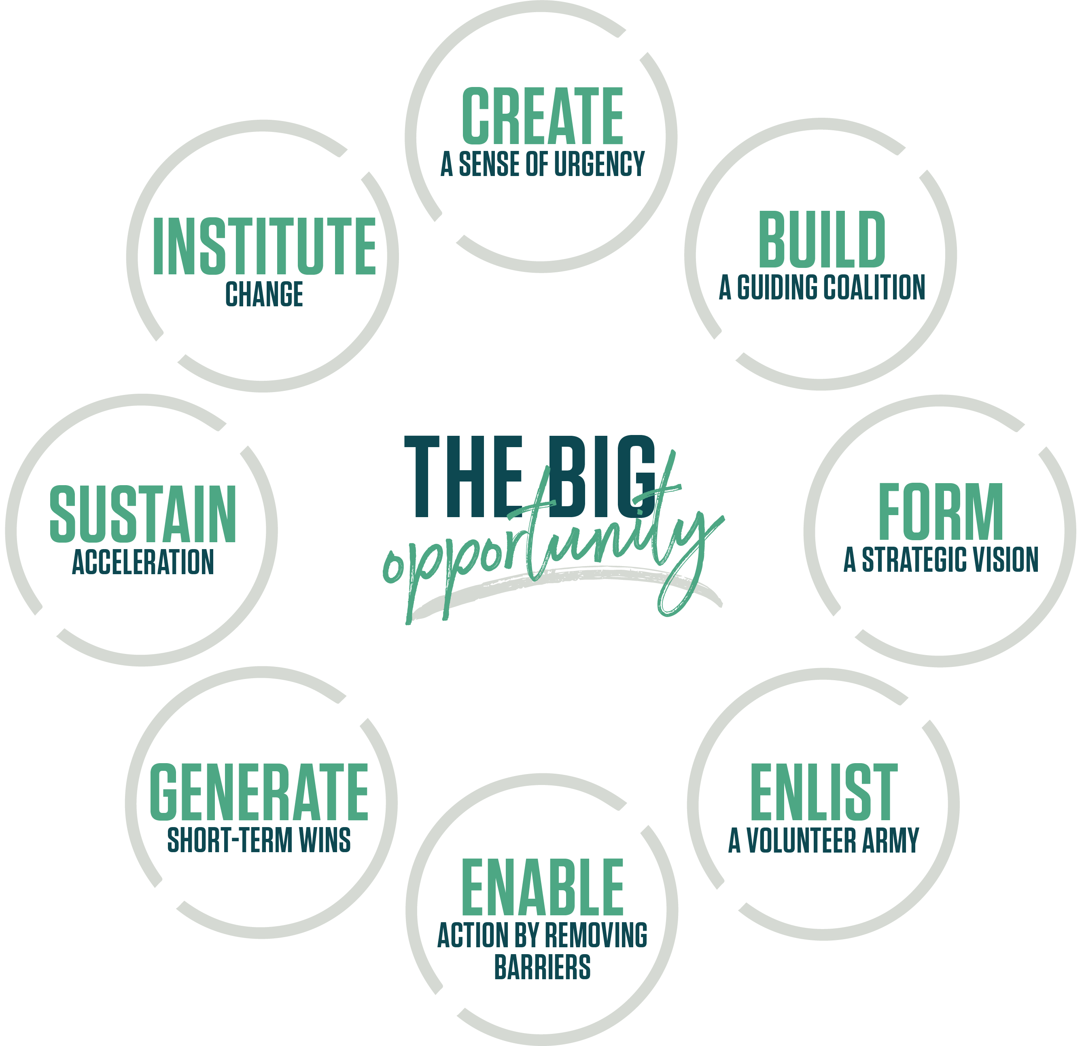

- By creating a sense of urgency ,others see the need for change.in my case We have a brick and mortar shop and moving online will maintain jobs and keep the business in line with the new trend of shopping .communicating the impact of covid to the team will enhance urgency
- Building a guiding coalition will guide and communicate activities . this will be done by having team meeting and working as a group, this will increase trust, and have a appropriate experts for th task.
- Forming a strategic vision and initiatives by clarifying what success looks like and the difference it will compared to the past.

- Enlisting a volunteer Army , the change to having a website will need models, photographers, web designers ,social media experts so looking for volunteers I a good idea
- Enable action by removing barriers . using Laisse faire leadership style where applicable. “ The secret of change is to focus all of your energy not on fighting the old .but on building the new”… Socrates

- term wins by recognising milestones shared and communicated to the rest of the team to measure progress and increase moral.

- Sustain acceleration by keeping the commitment going and being relentless until the vision is met. This can be done by involving the whole team and meeting non-conventional ways such as giving more authority to staff to take more risks including more leadership style such as coaching .

- Institute change by fighting old habits. Some of the barriers could be strong ingrained routines, “The most dangerous phrase in the language is “we have always done it this way”
- Generating short term wins. This can be done with engaged employees and the helping them visualising the achievements already achieved goals as the example below.
CONCLUSION
Sir Richard Branson’s charismatic/transformational leaderships has featured in his career enormously across his Global brands. As previously mentioned, Richard Branson’s is well known for his charismatic personality, being down to earth and generally very friendly. However, this may be misconstrued across other cultures, as mixing work with pleasure may not be common in some cultures. His traits definitely resonates with most millenniums in the western culture which may be seen as a good leader in such communities. Unlike the Chinese who have a status quo gap.
Millenniums like fun and flexibility which has been proven to encourage creativity and innovation consequently. Most millenniums have been inspired to work with him as voted in opinion poll carried out by cancer research as “the best celebrity boss to work for . His slogan “look for the best and you will give the best“ has enabled him to succeed using Laissez Faire leadership style which enhances productivity and eliminates bottle necks.
because of the competence of the people he employs. He works with small teams which encourages a sense of family, ownership and empowerment encourages emergent leadership as explained by Silverman Rachel in her book “who is the boss there isn’t one”.
Richard Branson is a leader prototype meaning his characteristic and leadership styles are those of a good leader . He is a transformational and charismatic leader who has caused change in many people’s lives by creating jobs and opportunities of entrepreneurships creating a feeling of ownership which in return increases performance outcomes and motivation. He is a patron in many charities. He treats his employees with respect and they come first additionally he has close business associates which are treats as good friends thus making them loyal. Although his Laissez Faire leadership style has worked well for him others have found that individuals perform less with no clear roles. Also he has been working on inventing ways to trying to minimize the impact his business have on the environment . Richard Branson is a visionary leader based on Coleman,2000, his style in a phrase is “come with me” So what makes a good leader the Richard Branson way? Charisma, innovation, bold, adventurous, Fun, Inclusive, change catalyst Empathy , respect , young at heart and big scoop of risk.

References

Erdogan, B. (2015) Organizational Behaviour Version 2.0. Flat World Knowledge.
Bauer, T. N. and Erdogan, B. (2015a) ‘Leader-member exchange (LMX) theory: An introduction and overview’, Oxford handbook of leader-member exchange, pp. 3–9.
Bauer, T. N. and Erdogan, B. (2015b) The Oxford Handbook of Leader-Member Exchange. Oxford University Press.
Bruijl, G. H. T. and Th. Bruijl, G. H. (no date) ‘Sir Richard Branson: A Global Leader with a Difference’, S
Burnes, B. and Bargal, D. (2017) ‘Kurt Lewin: 70 Years on’, Journal of Change Management, pp. 91–100.
Cowie, K. A. (2016) ‘Book Review-Achieving Success in the Face of Distractions, Organizational Change, and Conflict’, Global Business and Organizational Excellence, pp. 84–88.
Cummings, S., Bridgman, T. and Brown, K. G. (2016) ‘Unfreezing change as three steps: Rethinking Kurt Lewin’s legacy for change management’, Human relations; studies towards the integration of the social sciences. Available at: https://journals.sagepub.com
De Vries, M. (1998) ‘Charisma in action: The transformational abilities of Virgin’s Richard Branson and ABB's Percy Barnevik’, Organizational dynamics. Available at: https://www.sciencedirect.com/science/article
Drzewiecka, M. and Roczniewska, M. (2018) ‘The relationship between perceived leadership styles and organisational constraints: An empirical study in Goleman’s typology’, European review of applied psychology 68(4), pp. 161–169.
Melton, W.D., Depperschmidt, C.L. and Bliss, T.J., 2014. Situational Leadership Styles in United States Air Force Air Traffic Control Towers. International Journal of Aviation, Aeronautics, and Aerospace, 1(4), p.10.

Fuller, C. E. (1989) Behaviour and Personality Characteristics of Emergent Leaders in a Small Self-analytic Group. Cornell University.
Kets De Vries, M. (1996) ‘Leaders who make a difference’, European Management Journal, 14(5), pp. 486–493.
van Eeden, R., Cilliers, F. and van Deventer, V., 2008. Leadership Styles and Associated Personality Traits: Support for the Conceptualisation of Transactional and Transformational Leadership. South African Journal of Psychology, 38(2), pp.253-267.
‘
Northouse, P. G. (2018) Leadership: Theory and practice. Sage publications.
OB (2011) Task Culture. Available at: https://www.myorganisationalbehaviour.com/task-culture/ (Accessed: 4 September 2020).
Olejniczak, A. (2015) ‘Does a creative leader develop successful organisation? – The way of leading by Richard Branson’, Creativity and Innovation in Business and Education.
Prudham, S. (2009) ‘Pimping climate change: Richard Branson, global warming, and the performance of green capitalism’, Environment and planning A. Available at: https://journals.sagepub.com(accessed on 2 \|12/2020)
Sorenson, G. L. J. (1992) Emergent Leadership: A Phenomenological Study of Ten Transformational Political Leaders. University of Maryland at College Park.
de Souza, G. and Klein, H. J. (1995) ‘Emergent Leadership in the Group Goal-Setting Process’, Small Group Research, 26(4), pp. 475–496.
Turunç, Ö. et al. (2018) ‘Moderating Role of Job Satisfaction on the Relation between Leadership Styles and Organizational Silence’, Journal of Business Research - Turk, pp. 350–361.
White, R. and Lippitt, R. (1962) ‘Autocracy and Democracy: An Experimental Inquiry’, Philosophy of science, 29(2), pp. 209–212.
toolshero. 2020. What Is Laissez Faire Leadership? Definition, Examples & More | Toolshero. [online] Available at: <https://www.toolshero.com/leadership/laissez-faire-leadership/> [Accessed 30 November 2020].

Gorey, C., 2020. Virgin Galactic Debuts New SpaceShipTwo After 2014 Crash. [online] Silicon Republic. Available at: <https://www.siliconrepublic.com/innovation/virgin-galactic-spaceshiptwo> [Accessed 30 November 2020].

van Eeden, R., Cilliers, F. and van Deventer, V., 2008. Leadership Styles and Associated Personality Traits: Support for the Conceptualisation of Transactional and Transformational Leadership. South African Journal of Psychology, 38(2), pp.253-267.

Encyclopaedia Britannica. 2020. Richard Branson | Biography & Facts. [online] Available at: <https://www.britannica.com/biography/Richard-Branson> [Accessed 30 November 2020].

Albarhali, M., 2020. Business Stripped Bare: Adventures of a Global Entrepreneur. Entrepreneurship Review, 1(1), pp.49-51.
Kotter, J.P., 2012. Leading change. Harvard business press.

l Levasseur, R.E., 2001. People skills: Change management tools—Lewin's change model. Interfaces, 31(4), pp.71-73.

Jolly, J., 2020. Virgin Atlantic To Axe A Third Of Jobs And Shut Gatwick Operations. [online] the Guardian. Available at: <https://www.theguardian.com/business/2020/may/05/virgin-atlantic-to-close-gatwick-operations-and-lose-3000-workers> [Accessed 1 December 2020].

Moran, J.W. and Brightman, B.K., 2001. Leading organizational change. Career development international, 6(2), pp.111-119 Stanley, D.J., Meyer, J.P. and Topolnytsky, L., 2005. Employee cynicism and resistance to organizational change. Journal of business and psychology, 19(4), pp.429-459.
Wanberg, C.R. and Banas, J.T., 2000. Predictors and outcomes of openness to changes in a reorganizing workplace. Journal of applied psychology, 85(1), p.132.

Vroom, V.H. and Yetton, P.W., 1973. Leadership and decision-making (Vol. 110). University of
Pittsburgh Pre.
Bass, B.M. and Avolio, B.J., 1990. Developing transformational leadership: 1992 and beyond. Journal of European industrial training.

Rafferty, A.E. and Griffin, M.A., 2004. Dimensions of transformational leadership: Conceptual and empirical extensions. The leadership quarterly, 15(3), pp.329-354. 2020.

[online] Available at: <https://seapointcenter.com/emergent-leadership-topples-the-pyramid/> [Accessed 2 December 2020].
Durand, R. and Calori, R., 2006. Sameness, otherness? Enriching organizational change theories with philosophical considerations on the same and the other. Academy of Management Review, 31(1), pp.93-114.

Anderson, C., Keltner, D. and John, O.P., 2003. Emotional convergence between people over time. Journal of personality

