Case Study: Zopa Knowledge & Information Management

BMSW5106 Knowledge and Information Management Skills for the Workplace
Student: Shapali Khanam
Student No. 1713884
Lecturer: Mr Buddhi Pathak




Contents

Introduction…………………………………………………………………. Page 2
Information systems…………………………………………………………Page 3-5
Input, processing, and output system……… ……………………. ……..Page 5-7
Zopa functions and levels………………………………………………… Page 7-11
Challenges & Recommendations………………………………………… Page 11-14
Porters Five Forces…………………………… …………………………… Page 14-16
Knowledge management practice ………………………………..………. Page 16-18
ERP system…………………………………………………………………. Page 18-20
Conclusion…………………………………………… ……………………. Page 21
Appendix ……………………………………………………………………. Page 22
References…………………………………………………………………. Page 23-25

Introduction

Report based on an online platform company called Zopa trading in Finance industry. First ever peer-to-peer lending company based in London launched in 2005 providing borrowing, saving and investments to customers and employs 400 employees.
Report will establish how Zopa uses Knowledge, Information Systems and Technology to gain a competitive edge to reap success value in the company.

Information systems

Information systems form the foundation of performing well at Zopa.
(Laundon and Laundon, 2013, p.62) defines information systems as an amalgamation of information, linking software, hardware, system connections in collecting data, processing, storing, and distributing analysing information to gain knowledge to support business functions efficiency and decision-making.
Growth of internet encouraged businesses to use as a global information resource.

Zopa initially invested 6 million in 2005 producing various essential information systems, technologies and strategies tools which are interconnected to meet Zopa’s aim.

(Anderson, 2008) Deriving name ‘Zone of Possible Agreement’, ultimately wanting customer business.

Information systems are important for Zopa by processing raw data that Zopa inputs to produce useful information that’s beneficial in providing knowledge for decision making and Zopa operations, because data will not have to be replicated, reducing staff errors leading to precise information.

(Megaw, 2019) Due to successful growth of Zopa enabled by sophisticated business systems has met their strategic business aim of expanding service into banking sector by creating Zopa Bank online in 2020 investing 140 million.
Zopa new Banking information system allows to run cost effectively and process efficiently online saving fixed costs associated with branches.

Zopa existence and capability in attaining strategic business objectives is hard without widespread use of information technology and systems, people of creating value. Enabling growth of profits, reduction of costs by providing information aiding leaders to make informed decisions and enhancing business processes.
Tamsin O’Neill (2016) Zopa uses contemporary data storage and processing methods like Spark system allowing to collect, manage big data as required. Along with modernised powerful analytical tool like Python Pydata stack helping data analytics more accessible empowering Zopa to extract value from data using information efficiently.

Zopa endeavours to expand the efficiency of operational systems, serving customers well and raising service sales, maintaining customer records for audit and analysis purposes.
Information systems a tool offering complete and recent information used to manage and accomplish increased levels of operation efficacy, productivity from information received.
Information systems help generate brand-new products, services and create service
strategy model of delivery and describe how Zopa produce, design, and sell their product.

Systems provide essential up to date data having correct information at right time improving decisions, without systems would increase costs and losing customer as not cost-effective service than competitors.

Continuously assists managers in making well-informed decisions with real-time data.
Adoption of information systems simplifies business processes and removes unnecessary activities.

Allows for communication and teamworking at Zopa, employees work together by gathering and distributing information and sharing documents, emails, communicating further information where changes tracked. Saving on mis-match data among systems and departments can spend more time on tasks for Zopa to grow then waiting for information.

Systems allows for organised data and record-keeping, storing files, changes, reports, communication documents and operating data for finance and Zopa purposes and discovering the reasons for problems and resolving.

Relevant data is easier to access, editing updating records ease of searching for many employees viewing document at once and ease of sharing duplicating and backing up data to protect private data.

Input, processing, and output system

Zopa uses its data, processed into information then knowledge and recognises that knowledge is the main valuable resource for providing wisdom for lasting competitive edge.

(Fricke, 2019) information in terms of a data-information-knowledge–wisdom (DIKW) pyramid is commonplace in businesses but three bottom layers of DIKW pyramid can be logged on computers, but wisdom requires employee action.

Zopa adopted a range of information systems assisting them to achieve value of information and knowledge in meeting strategic objectives.

Information systems manage data and information to create quality decisions and implement better processes which is crucial for Zopa operations to run smoothly as they are the foundation of modern business without them there would be disarray.

Car Loan system

Zopa offers car loans to customers using money from their investors and transferred to their bank account and used to pay for a car. Loan repayable within monthly instalments over an agreed term and interest charge.

This car loan information system is described through three activities input-process-output.

Customer initially visits Zopa website and accesses Car Loan Borrowing Tab. Then inputs loan amount and term, providing an approximate APR interest with monthly cost. Once satisfied customer provides further data to obtain personalised information of car loan application.

Input

Customer inputs their personal and employment information, which is Data that is the raw facts, that Zopa requires to produce appropriate information to add value for purpose of granting loan or not.
Quantitative data example is household annual income.

Process

Car Loan Information system processes the input data to make meaningful information to meet output.
System uses input details to locate customer Experian/Equifax credit file and customer information needs to meet Zopa stringent standards and automatically declined if any one of these reasons occur. Credit score is poor.
Disposable income is low, would make affordability difficult to pay back.
Applied for loan within 6 months.
Missed payments in last 6 years, showing unmanaged debt.
Current debt is high.

Output

Upon transformation of data input and processing, Car Loan information system automatically provides notification of final decision if customer is eligible.
If accepted, then customer opens Zopa account where all formal communication is established, and transfer made to customer bank account in well-structured manner.

Zopa offers customers option to talk directly to Borrowers customer service specialist informal communication to discuss any queries as some customers prefer this avenue of information accessing.

If system declined loan, Zopa offers two alternative solutions reassuring customer providing intangible value of company image, and trustworthiness.

Apply loan through third party lenders that have less stringent rules, with the stored details.
Re-apply after six months, if circumstances changed. i.e.Income increases.

(Baker, 2017) Zopa data scientist team uses Ruby program to make this information system come alive along with technology. Ruby allows for deriving structured decisions and rules, sorting, selecting set by Zopa, to evaluate car loan applications efficiently.

Processes coded by top rated C#, a programming language also used to calculate monthly payments, interest rate and term of loan designed to transform inputs into outputs, in order to achieve goal.

Whole process takes customer 3 minutes to complete making it quick, efficient with no paperwork for customer. Allowing for tangible value to information increasing customer loan uptake and reducing admin costs.

(Lamene, 2020) Sophisticated system allows for 65% of customers to be pre-approved on loan offers in duration of 12 seconds, which provides competitive edge in lending market.

Zopa functions and levels

(Bhure, 2017) states functional taxonomy lets categorisation of current C.B.I.S in three-dimensional scale of information, decision, and communication process support.

Zopas 15 years’ experience created robust platform, structured functions to run smoothly and maximise efficiency enhancing customer satisfaction playing key role in meeting business aims.

Zopa has specialist workers for each function that are assigned specific jobs, information systems assist efficiency process of how they do job to meet objectives. These activities generate income and drive Zopa business value, of return on investments.

Otherwise having one function employees would struggle to keep up with work pressures.

Defining functions lessens data inconsistency bettering quality of data accumulated processed into information that is useful for knowledge for competitive edge.

Customer Services Sales/Marketing Function

Customer service sales function for selling Zopa’s product services, with customer support.

Marketing team identifies potential customers by promoting advertising services online. Conducted market research to create Zopa Bank in 2020 providing competitive deals on products.

Sales-data gives perception patterns on how much consumers are borrowing and investing.

(Lamene, 2020) Customer Relationship Management Systems: Zopa has Customer Admin system records all customer contacts and account history

Borrowing-Car, home, loans.
Investments–peer-to-peer investment and Innovative Finance
Banking–current/saving accounts.

Facilitates in maintaining customer interactions providing accurate information to develop new services.

Various levels of managers in hierarchy require different types of information dependent on needs.

Strategic-Board management at top hierarchy, utilises system for making long-term justified decisions and calculating risks.

Tactical-Middle management by monitoring, controlling and dispensing actions for Zopa to ascertain How well are things working? systems produce reports of Zopa performance.

Operational-management bottom hierarchy, make short-term decisions at
in serving customers well leads to customers returning. Zopa has a quality-of-service feedback rating system that allows customers, suppliers to rate service allowing management to monitor service regularly.


Human Resources

System records employee information and responsible for managing people.

Zopa uses LinkedIn Recruiters and agencies to recruit personnel, instilling high-performance.

(George, 2020) Lattice’ Performance management information system to motivate, monitor employee performance, appraisals, training developing staff performance & engagement remotely.

Board:use HR system to identify levels of staff productivity and future needs.

Middle:supervise and evaluate existing labour force for recruiting.

Operational:uses to trace and placing of staff.

Zopa prides workforce employs graduates to enable new technological ideas to support innovative future growth.

Finance/Account

Responsible for maintaining Zopa financial records.

Repayments team acquire reports to track customers that default on loan payments to recover money owed.

Sage Accounting system integrated accounting, payroll, managing financial resources through budget, report financial performance has sufficient cash to pay liabilities and legal requirements.

Transaction Processing System enables Zopa to record structured information processing payment transactions.

Security system: Credit Industry Fraud Avoidance System & Experian Credit Zopa use expert system to judge credibility of loan applicants and detect fraud.

Board:use finance system to determine technology investments, forecast budgets, profitability analysis to control financial stability.

Middle:monitor Zopa’s finance operating resource.

Operational:tracing daily flow of money from Zopa transactional processing system.

Supplier system:purchase computer hardware technology for running information systems. Software, networking telecommunications equipment establishing supplier relations.

Product & Technical Function:accountable for design, developments and maintaining services.

Zopa Product system:technical experts including software developers, analyst, data scientist, product managers build information systems and product, services development from primary/secondary market research knowledge.

Board:use systems to address Zopas long-term service product plan, to meet customer needs.

Middle:evaluate costs and add value to services.

Operational:providing information on feedback milestones.

Management information system Management ascertain qualitive/quantitative data and system processes to derive information reports, Zopa management analyse to acquire meaningful knowledge to monitor processes and avoid costly mistakes provided by information system.
e.g. (Lamene, 2020) Zopa invited all borrowers and lending customers to join new Bank issuing £200 incentive surviving in a competitive market

Decision support system use data information from Zopa transaction processing and MIS, and external sources e.g.competitor service pricing. Captures and consolidates large quantity of data and information easily analysed by management.

(Peppard, 2016) information systems receives real-time data identifying problems to solve promptly.

Executive support systems: Board managers require system to tackle strategic problems and future trends dealing with decisions involving skill, judgement based on assessment of from Zopa systems.

Kafka software system used for operational monitoring data for handling website, customer activity tracing, storing, and analysing streaming data.

Challenges & Recommendations

Zopa needs to manage their knowledge creation, storing and transferring effectively as will significantly be crucial for its survival and success.

Explicit knowledge is codification strategy and hard approach that Zopa uses. Knowledge is easily codified and communicated stored, transferred using ICT technology when needed. Zopa uses through customer information system databases, emails, job procedures, financial reports, and market research documentation assisting work performances and problem-solving.

Allowing for knowledge to be understood by all people, and not tied to one person at Zopa, if person leaves Zopa the knowledge invested would be lost.
Recording explicit knowledge helps Zopa employee’s performance when the knowledge assists them to carry out tasks.

(Troicky, 2020) Bottleneck occurs when one job finishes processing then another starts that triggers delay for second job. Preventing bottlenecks where some staff cannot perform task simultaneously.
Zopa created software using Python programming language helps Zopa software developers to build data analytics, assisting staff in solving complex problems, accessing data in less time with less codes in Zopa systems saving on costs.

Zopa manages great deal of explicit knowledge so used Prometheus a larger storing data system then previous system protecting knowledge.
Recently invested in sophisticated tool Grafana for analysis and visualisation of reports from systems and traces transactions for explicit knowledge to be addressed easily by staff.

Sharing explicit knowledge ensures Zopa employees know where to obtain knowledge using technology as convenient and effective, then sharing in written format. Building directories for employees enables to easily locate individual at Zopa that can tackle particular enquiry.

(Neil 2016) Tableau system used to monitor server, collect, and analyse data signalling whether server running into problems ensuring data backed sufficiently protecting Zopa system information learnt from past experience.

Technology advancement constantly changing and investing capital for these are proving expensive for Zopa. Budgeting more yearly for this area by cutting cost elsewhere via financial cleanse to ascertain where savings can be made helping to manage costs as technology enhances work performance.

Tacit knowledge is personalisation strategy and soft approach that Zopa uses and not easily codified as within staff minds gained by experience, understanding and know-how.
Zopa’s 15 years industry experience, majority of knowledge accumulation analysis came from Board leadership and market research advisor meetings to make justified decisions.

Overall, Zopa utilises discovery and insight of valuable data from accurate information.

(Nonaka et al 2000) explains SECI process consisting of 4 modes of knowledge creation formed by interactions of tacit and explicit knowledge.

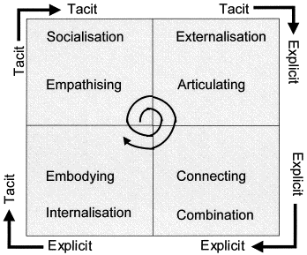

Knowledge Silos

Due to rapid expansion of Zopa teams, knowledge silos have occurred where few staff acquired knowledge and stored in minds and not spreading valuable knowledge. Needs to pass onto other staff and function teams ensuring effective processes, ideas creating competitive edge. Freeing siloed staff whose own productivity might be suffering because spending more time answering questions than anything else.

Creating workplace collaboration events bring staff together, understanding the value each other person can bring and can mix the chemistry. Ascertain innovative banking products service ideas, problems solving for operating processes to be smarter, and Zopa competitiveness using SECI process.

Zopa cross-functional teams should be gathered yearly to transfer their ideas created and dispersed to team members informal environment and stored in written evaluation reports gathered for management to act upon creating strategies in order to grow.
Responses will be analysed by leadership and the best changes that cover resources of staff, capital, investment in technology teams will need to be rewarded by offering cash prizes.

Value of knowledge management system is reliant on staff choosing to share and becoming motivated in doing this naturally.

Creating “lessons learned” document after any major task would have lasting benefit for Zopa if responses acted upon as working with system harbouring sustainable growth and effective planning.

Zopa needs to acknowledge that knowledge as main resource for lasting competitive advantage and implementing knowledge management plan of action outlining how Zopa will manage data, information, and knowledge to improve productivity and efficiency. The most successful of these strategies are closely aligned with company-wide objectives.

(Kathiravelu et al 2014) organisational culture important factor facilitating the generation of knowledge sharing information and technologies improve knowledge generation.

(Martina, et al 2007) Managers need to communicate aims, reporting on progression, implementing compliance of knowledge management establishing expectations, then evaluate if staff achieved them in formal meetings ensuring driven culture.

Non-hierarchical flattening structure allowing staff to have personal power and projection nurturing high-performance, ideas and development teamworking.

Improving ways of working building relationships in terms of reporting automating various people related process is integrating in systems for seamless data flows.

Porters Five Forces

(Sally, 2020) uses DevOps combining software development and IT operations teams in improving productivity, performance in flow processes, measuring feedback and continuous learning and research, working towards Zopa goal of adding value to data information for pioneering new products into market faster for competitive edge with satisfied customers.

Tamsin O’Neill (2016) Relevant data accumulated during15-year history proved beneficial for Zopa risk analytics having wide information on customer spending and enhanced uptake of loans with lower refusals.

Communicating with customers, suppliers, and employees has been transformed business practices, using essential tools of technology i.e. computer, emails, smartphones, internet. Zopa uses information technology to sense and react to swift changes in customer demand when analysing customers who use website.

(Indiatsy et al 2014) explains how five forces can be used to analyse competitive environment of industry.

Porter’s model identifies importance of staying up-to-date with service information
competitive industry information from IS/IT have enabled to acquire competitive edge.

Threat of new entrants

Governments hold major decision if bank can be opened. Zopa applied using its IT resources and financial systems to explain viability of business plan proposals.

Market research and long finance history showing customer sales records made an impact in each of these areas being proactive.

Globalisation of P2P and bank systems allowed customers to use globally setting Zopa Barcelona easier without going through complex procedures.

Threat of potential competitors is low, requiring large amounts of capital and regulatory monitoring and their financial and security systems benefited Zopa approval.

Bargaining Power of Suppliers

Capital is main resource for Zopa coming from loan interest, fees, other financial lenders commissions.
Zopa ensures necessary resources to service their customers lending requirements while maintaining enough capital to meet withdrawal expectations from Zopa Customer Admin database.
Supplier’s dependent on market, their power deemed to fluctuate between medium to high.
Power of Buyers

Internet significantly boosted power of customers increasing ease and lowered cost for customers to compare product prices and rates offered quickly from many internet firms.

High switching costs and inconvenience for customer to switch over to another bank.
Zopa enticed customers from current database to switch to their bank applying incentive for switch, but some customers may wish to stick with existing bank.

Threat of Substitutes

Threat relatively low, industry threats maybe insurers, mutual funds are some banking services recommended by non-banking businesses.

Mostly businesses competing with technology developments for reducing cost and high deliver service, performance and revenue.
Technological developments resulting to substitution of a few services provided by industry.

Fin-tech industry threat of substitution are not from competitor banks but from non-financial rivals.

Competitive Rivalry

Zopa's competitors:RateSetter, Prosper, Banks.

Latest internet technology leading to greater operational efficiencies faster access to additional information, fin-tech industry placed in good position to monitor risks and better service.

Internet banking, borrowing, lending resulted in decreased requirement of attending bank to carry out banking, and customers can complete banking anywhere.

Zopas cost-to-income ratio is lower than competition. Ultimately growing customer base and improving customer service with less up-front capital costs and lower operating expenses.

Fin-tech sector changing rapidly more customers switching online to invest, bank other financial transactions only by increased growth of technology.

Smart technology:Zopa performs initial 'soft' credit check that doesn’t effect on customer credit rating.

Zopa prides itself delivering good performance listening to customer ideas/issues and documenting it to improve products. Charging less for superior products like peer-to-peer rates. Reacting to consumers and suppliers in real-time within 2 working days.

Knowledge management practice

Knowledge management facilitates Zopa in improving their management of capturing application of knowledge and expertise. Zopa employs knowledge workers data engineers, developers who create new services and create information systems from market research analysis.

Knowledge management practice helps with managing distribution of documents, reports from staff that have expert knowledge to other staff through systems.

(Greiner, 2007) System consists of different management practices for knowledge recognition, creation transfer or storage within Zopa, effective knowledge management systems are tied with Zopa aims resulting in shared intelligence improved performance creating competitive advantage and increased innovations working as a team with information technology as the forefront of processes.

Customers manage account exclusively via app which may appeal to borrowers already used to managing finances from smartphone technology.

Zopa controlled by Financial Conduct Authority and technology allows to provide accurate yearly reports for monitoring.

Purpose of information system extremely important, ensuring processes are efficient to collect, process data and share and store converting to information to support business decision making activities and interrelated work together to achieve business success but without technology this cannot be achieved efficiently.

(Phillip, 2005) empirical study of UK companies identified information systems beneficial to fast moving competitive business environment like Zopa organisation management to be supportive and fully committed to information systems and technology an unavoidable strategic necessity part of carrying out business effectively.

Zopa IT Technical Department greatest benefit from Information technology and systems deriving value from information and knowledge to grow business ventures.

Block Chain

Blockchain distributed ledger technology records digital data information about monetary transactions and distributed but cannot be edited and eliminating huge amounts of record-keeping, saving money.

Blockchain records and validates every transaction and decentralised,no third-party authorisation. However, the cost for technology usage expensive, regulated heavily.

Chris Skinners (2020) Blockchain fairly new system and could replace a banks internal system, but timeline exceptionally long and few cases whereby blockchains hacked through cryptocurrency like bitcoin.

Blockchain take some time to become cost-effective way in sharing information and data between business networks.

AI security

Tamsin O’Neill (2019) Zopa created ‘Borrowing Power’ within app, tool personalises actions helping customers improve credit score enabling to borrow at lower rate.

Artificial intelligence technology really changing how industry working. Zopa uses AI to improve lending, investing, fraud detection in systems for faster safer money transfers and internal operations efficient.

AI technologies boost revenues by improving customer experiences and Zopa processes.

(McKinsey, 2020) Saving on labour costs and time Zopa currently AI project with Software developers, engineers to create Zopa customer services virtual assistants AI can answer sophisticated questions about finance management.

Adapting to modern technology innovations by redefining how consumers interact with Zopa.

ERP System

Enterprise Resource Planning system is a software intended to assist the coordination and integration of all internal business functions departments and processes combined to service best interest of business therefore, information flows throughout business upgrading operational effectiveness and decision making.

Advantages

Well designed and constructed system focuses on business processes working together in creating a consistent picture for all levels of management. allowing for integration of systems and services, automation of business processes and secure sharing of data among departments eliminating.

Zopa currently uses and stores information in each department databases and information would only be shared within that department and if other departments wish to obtain information, they have to enquire from department manager for accessing information.

Before implementation of ERP system all current information should be kept on different database, after implementing employees can gain access and revise information from several departments to receive accurate information within system reducing risk of replicated documents.

ERP allows easily accessible management control and visibility of work-flows and the availability of all Zopa information in a centralised location allows for increased collaboration and streamlined completion of tasks.

Implementing ERP system provides Zopa with one combined reporting system.

ERP system produces helpful analytic data and reports readily.

ERP system provides quick access for managers having capability in comparing and analysing functions throughout departments without the bias of several emails and worksheets coming back and forth.

ERP system grants management in creating their own custom reports quickly generated without depending on IT assistance.

Disadvantages

ERP software upfront cost can be very high for setting up.

Process can be time consuming, requiring vast amount of labour time and capital along with expertise requiring many resources to start.

ERP system to be successfully implemented Zopa must ensure each staff provide views on requirements taking part to activate use of system development. Zopa should provide training for staff to appreciate how ERP system works.

Resistance to change from some employees could hinder company operations causing high employee turnover, so communication motivation of goals is paramount.

Zopa ought to know when implementing system involves a long time due to long migration of data, information and organising training of staff and other duties.

Zopa needs to beware of not losing precious time/costs as may impact on current staff role demands during process.
Management must guide Zopa through transition phase and implementing process could take between 5-18 months or longer if Zopa doesn’t manage process properly of identifying potential risks that recovering from losses suffered.
(Sally, 2020) Zopa currently building their own ERP system using current employee experts in software developers, programming, design system analyst that have actually used systems from each function and know exact purpose of requirements from system hopefully complete in 2021. This will save time, costs, and make it user friendly with quicker processes for all cross functional departments to access information under one system.

Zopa ERP System
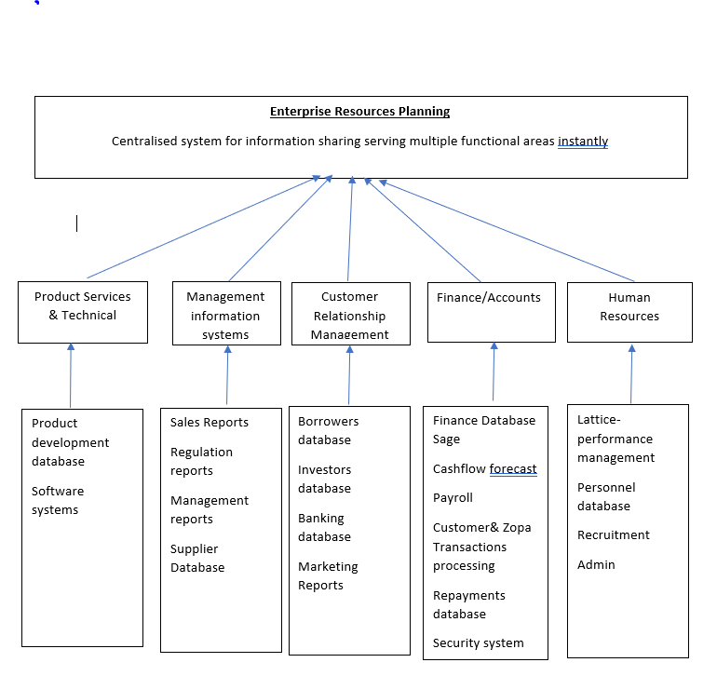

Conclusion

(Alkhafaji, 2014) research demonstrated that Information systems plays important role in ensuring data, information and knowledge makes a meaningful contribution to organisational performance.

Attaining meaningful value from information systems Zopa needs to boost technology funds include new business strategies and business process and support organisational culture.

Zopa can be more productive, profitable only if consistent management of business strategies, communication, finance and technology with effective information systems and employees and meeting customer needs.

Information systems empower Zopa to respond, satisfy, store, retrieve, distribute, and control invaluable asset being information and knowledge. For future growth vital Zopa concentrates on building effective information system that provides them with core information to use in determining success from knowledge derived effectively.

Appendix – research request, and two Zopa employees called me Sally Product Manager telephone interview and Lamene Customer Services Specialist
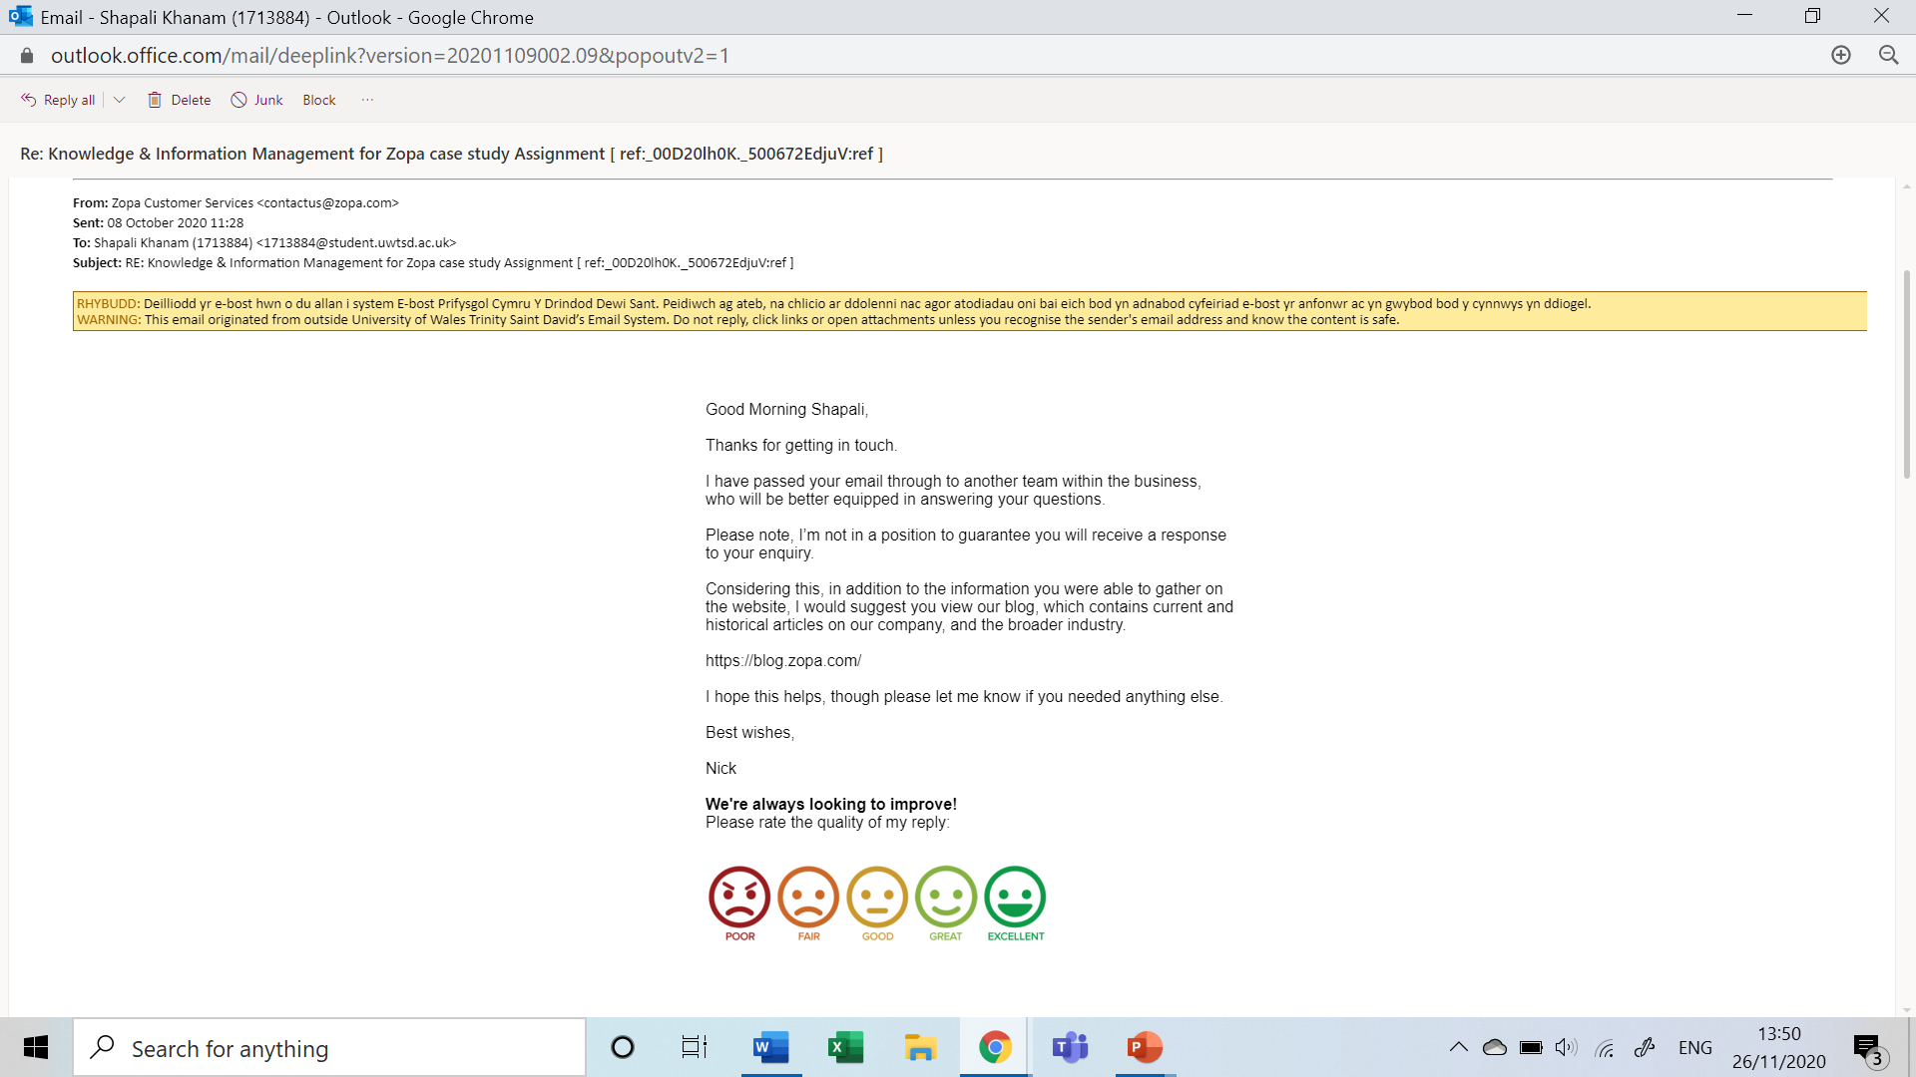

References

Alkhafaji, S. (2011) ‘Review of Information Systems and Business Challenges’. Review by Salah Al-Khafaji. International Journal of Management Rivulet 2(1). Available at: https://www.researchgate.net/publication/318528596_Review_of_Information_Systems_and_Business_Challenges. (Accessed 20 November 2020).

Anderson, J., Kupp, M. (2008) ‘Zopa.com — Innovation in the UK financial services industry’, Journal of Financial Transformation, 23, pp.51-59. Available at: https://www.researchgate.net/publication/46557712_Zopacom_-_innovation_in_the_uK_financial_services_industry (Accessed: 1 November 2020).

Baker, G. (2017) ‘Building a rule system in Ruby to evaluate loan applications’ Gregg Baker [blog]. 25 January. Available at: https://blog.zopa.com/2017/01/25/ruby-rules/ (Accessed: 5 November 2020).

Bhure, R. (2017) ‘A Categorization of Computer Based Information System’ International Journal on Future Revolution in Computer Science & Communication. 3(8),pp. 240-243. Available at: http://www.ijfrcsce.org/download/browse/Volume_3/August_17_Volume_3_Issue_8/1521006464_14-08-2017.pdf (Accessed: 13 November 2020).

Fricke, M. (2019) ‘The Knowledge Pyramid: the DIKW Hierarchy’, Knowledge Organisation, 46(1), pp.33-43.
Available at: https://www.ergon-verlag.de/isko_ko/downloads/ko_46_2019_1.pdf#page=33
(Accessed: 12 November 2020).

George (2020) ‘My Work Life’ George [blog].11 February. Available at:
https://blog.zopa.com/2020/02/11/my-work-life-george/ (Accessed: 5 November 2020).

Greiner, M. (2007) ‘A strategy for knowledge management’ Journal of Knowledge Management,11(6), pp. 3-15. Available at: http://dx.doi.org/10.1108/13673270710832127. (Accessed: 12 November 2020).

Indiatsy, C.M., Mwangi, M.C., Mandere, E.N., Bichanga, J.M., George, G.E. (2014) ‘The Application of Porter’s Five Forces Model on Organization Performance: A Case of Cooperative Bank of Kenya Ltd’, European Journal of Business and Management, 6(16), pp.75-85. Available at: https://core.ac.uk/download/pdf/234625548.pdf (Accessed: 9 November 2020).

Kathiravelu, S.R., Mansor, N.N., Ramayah, T., Idris, N. (2014) ‘Why Organisational Culture Drives Knowledge Sharing’,
Journal of Social and Behavioural Sciences, 129, pp. 119 – 126. Available at: https://www.sciencedirect.com/science/article/pii/S1877042814028389 (Accessed: 7 November 2020).

Lamene, L. (2020) Telephone interview Customer Services Specialist, 5 October.

Laundon, C.K. and Laundon, J.P. (2013) Management information systems 13th edn. Essex: Pearson Education Published.

Martina, E., Böhmann, T., Krcmar, H (2007) ‘A strategy for knowledge management’, Journal of Knowledge Management, 11(6), pp. 3-15.
Available at: http://dx.doi.org/10.1108/13673270710832127(Accessed: 10 November 2020).

Mc Kinsey & company (2020) AI-bank of the future: Can banks meet the AI challenge. Available at: https://www.mckinsey.com/industries/financial-services/our-insights/ai-bank-of-the-future-can-banks-meet-the-ai-challenge#(Accessed: 19 November 2020).

Megaw, N. (2019) ‘Zopa gets £140m investment amid pursuit of bank licence’, Financial Times Newspaper, 3rd December. Available at:https://www.ft.com/content/fc3833c0-15e4-11ea-8d73-6303645ac406 (Accessed: 10th November 2020).

Nonaka, K., Toyamo, R., Konno, N. (2000) ‘SECI, Ba and Leadership: Unified Model of Dynamic Knowledge Creation’, Journal of Long Range Planning,33(1), pp5-34. Available at:
https://www-sciencedirect-com.ezproxy.uwtsd.ac.uk/science/article/pii/S0024630199001156
(Accessed: 16 November 2020).

O’Neill, T. (2016) Data Democratization. What, why, and how?, Tamsin O’Neill [blog]. 2 December. Available at:
https://blog.zopa.com/2016/12/02/data-democratization/ (Accessed: 7 November 2020).

O’Neill, T. (2019) The Tech behind Borrowing Power, Tamsin O’Neill [blog]. 16 October. Available at:
https://blog.zopa.com/2019/10/16/the-tech-behind-borrowing-power/ (Accessed: 9 November 2020).

O’Neill, T. (2016) How Zopa uses data for informed decisions on risk, Tamsin O’Neill [blog]. 29 July. Available at: https://blog.zopa.com/2016/07/29/how-zopa-uses-data-for-informed-decisions-on-risk/(Accessed: 17 November 2020).

Paul, R. (2007) ‘Challenges to information systems: time to change’, European Journal of Information Systems, 16, pp.193–195. Available at:
https://doi.org/10.1057/palgrave.ejis.3000681 (Accessed: 10th November 2020).

Peppard, J. and Ward, J. (2016) The Strategic management of information systems. Chichester: John Whiley & Son.

Phillip, B. (2005) ‘Information systems management in practice: An empirical study of UK companies’, International Journal of Information Management, 25(4), pp. 287-302,
Available at:
http://www.sciencedirect.com/science/article/pii/S0268401205000198 (Accessed: 11 November 2020).

Sally, N. (2020) Telephone interview Product Manager , 21 October.

Skinners, C. (2020) ‘Will blockchain replace core banking?’, Chris Skinner [blog]. 23 November. Available at: https://thefinanser.com/2019/01/will-blockchain-replace-core-banking.html/ (Accessed: 12 November 2020).

Troicky, G. (2020) Machine Learning Applications for Assessing P2P Portfolio Default Risk. Unpublished PhD thesis. Copenhagen Business School. Available at:
https://research-api.cbs.dk/ws/portalfiles/portal/62182160/879666_ThesisTroickyG2020.pdf (Accessed: 17 November 2020

