Program: International Hotel Management (BA)
Module: International Meetings Management for the Hotel Industry
Module code: BMIH6007
Lecturer: Kathryn Flynn
Assignment Title: Event Strategic Planning and Delivery Considerations for an International Meeting
Student Name: Violeta- Ionela Necsoi
Student ID: 2212736

Table of Contents
1 Introduction 3
2 The Event Cycle 4
3 Event Concept 5
4 Aims and Objectives of the Event 6
5 Event Management 7
6 Event Budget 8
6.1 Breakdown of Income and Expenditure 8
6.2 Costs Analysis 9
7 Industry Trends, Issues, and Impact 10
8 Situational and Cultural Considerations 11
8.1 Linking with Event ( 11
8.2 SWOT Analysis 11
8.3 PESTEL Analysis 12
9 References 14

Introduction
The event reflects on the upcoming seasonal celebration named as Winter Food Festival presented by MICE (Meetings, Incentives, Conventions, and Exhibitions) industry. The event is designed to offer a definite experience for blending the activities like entertainment, educational facilities, and networking opportunities for all participants in the hospitality sector (Yeung et al., 2022). The event focuses on celebrating winter-themed cuisines while showcasing local chefs with their culinary experiences. The chefs are delighted through demonstrations and offer tastings to the visitors (Yeoman et al., 2021). It offers interactive elements that allows engagement of the attendees and providing rich culinary culture in the region. The event is planned professional connections with improving the collaboration of the people in the hospitality activities. The event is hosted at the selected venue to maintain the festive spirit. Yang et al. (2020) stated that the location is not only selected to facilitate the participants and visitors to gain easy access for participants but also offer inviting and welcoming atmosphere towards knowledge and learning of cooking and culinary. The event is planned to offer a direct platform for culinary experiences and make demonstrations and educational sessions based on all the winter dishes. Therefore, the event offers facilities based on informative and enjoyable services that are ultimately contributing towards the success of MICE tourism within the region (Wickham et al., 2021).
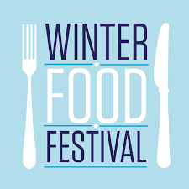
Figure 1: Winter Food Festival and management
Source: (Silvers and O'Toole, 2020)

The Event Cycle
The Event Cycle is said to be the structured framework that is helpful for the event planners to manage the services according to the essential stages based on organisation and execution of an event (Sealy, 2020). There are five significant stages in the event cycle that are applied in the services such as Plan, Organise, Measure, Analyse, and Share. The cyclical approach allows continuous improvement and achievement of the desired outcomes while increasing the participant experience in the event.
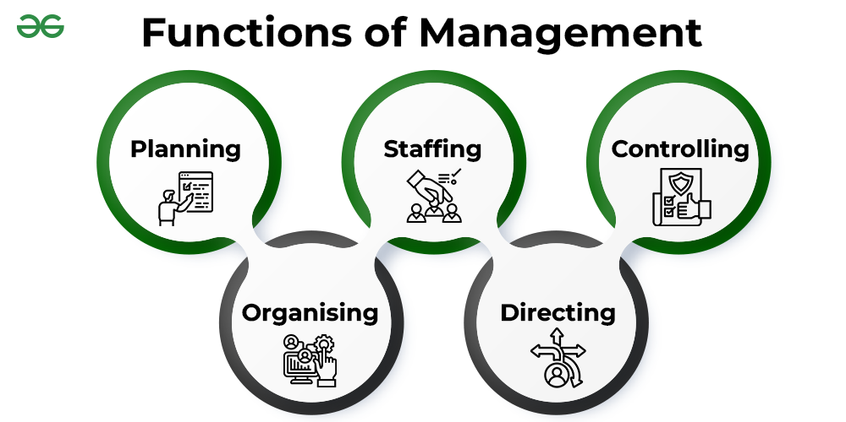
Figure 2: The Event Cycle
Source: (Salvador and Pedersen, 2022)
For the Winter Food Festival, the Event Cycle is elaborated as using the first stage of planning that offers clear objectives like showcasing of the arts of local chefs while improving the networking opportunities within the participants of the hospitality industry (Rossetti et al., 2023). It allows management of the budget for the suitable venue to maintain efficiency in the accommodation of culinary alignments tastings. The second stage of organising identifies the coordination of partners such as vendor working as food suppliers. It helps in scheduling the chef demonstrations, and promotion of the event using different advertisement resources (Pulh, 2022). The third stage define measurement that allows assessment to the activities and gaining level of satisfaction based on culinary experience. The fourth stage defines analysis that allows event planner like MICE to take feedback from visitors about the festival, and the last stage is sharing that helps in collecting feedback and make improvements in the future events (Orea-Giner et al., 2024).

Event Concept
The Winter Food Festival allows management of the immersive and delightful experience to define the services and activities for delegates and guests (Maguire, 2022). The event is centred with the celebration of winter seasonal cuisine and presentation of the culinary artistry. The day starts with the registration and offering a warm welcome, when the attendees are offered to receive festival passes with some direction of the program itinerary. The guests are offered with the keynote presentation by a renowned chef while sharing the insights to the services of the winter cooking techniques and providing importance to the use of the local ingredients. Koutrou and Berber (2023) elaborated that the festival is famous for unfolding the activities of participants by providing them several kind of opportunities to explore their interest in the culinary stations. It is representing different activities in the winter-themed cuisines from all over the world. The visitors are offered to make their engagement towards the interactive cooking demonstrations that is leading by the local chefs. The activities are showcasing different signature dishes and highlighting the seasonal ingredients by the chefs (Kesgin et al., 2022). The festival goes all the week from 10:00 am to 6:00 pm in the last of December.
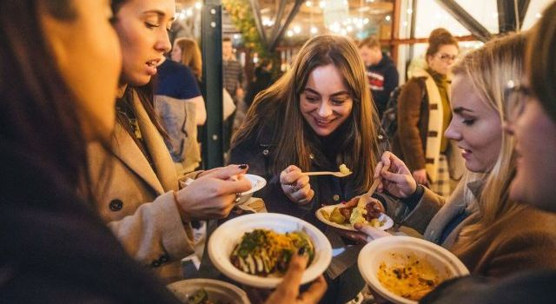
Figure 3: The Event
Source: (Gradinaru, 2021)
The festival allows designated processes for all the vulnerary activities that offers visitors to make relevant connection with industry peers and enjoying complimentary beverages and seasonal snacks at the entry (Fusté-Forné, 2022). Additionally, it offers a greater food experiences that is associated with some workshops on the related topics like food plating, pairing of the wines with winter dishes, and offering sustainable cooking activities. It is considered the gala festival for the winter season that offers a curated menu for the celebration of the best facilities in the winter cuisine followed by the live entertainment for the improvement in the event’s atmosphere (Frost and Frost, 2020).

Aims and Objectives of the Event
The aim of the event is:
To celebrate and enjoy winter culinary traditions with the collaboration of the professionals in the hospitality industry.
The objectives are given as below:
- To achieve participation of more than 500 visitors in all the week of event by using effective target marketing strategies.
- To obtain participation of almost 100 local chefs for presenting their skills in cooking and culinary experiences.
- To attain satisfaction of the visitors by 85%-90% on the collection of feedback after completion of the event.

Event Management
The event of Winter Food Festival is associated with effective event strategies providing a diverse set of skills and resources in all the process such as operational, planning, and marketing management (Fontefrancesco, 2022). The management (MICE) is responsible to offer efficiency in the operational skills that executes success of the festival. The management offers stronger organisational skills for different tasks at a same time. Event managers coordinate with the partners for managing venue setup, vendor management system, and catering services (Fontefrancesco and Zocchi, 2020). There is a proficiency in technology that manages the event using software and streamlining the operations, track registration system, and facilitation of the communication within the team members. Additionally, the effective vendor management skills helps in fulfilling the standards and timelines of the event. Elisa et al. (2022) illustrated that planning skills are applied by the event managers for applying stronger budgeting skills and allocation of the resources with potential costs. It offers creation of the comprehensive budget to gain unexpected expenses and management of the financial sustainability. Furthermore, Cain et al. (2021) presented that the event landscape offers knowledge of different culinary traditions and trends according to the expectations for the success of the program. The implication of effective organisational tools like provision of checklists and timelines helps the management to make efficiency in the planning process based on track and divisions.
Marketing plays a greater role for the attraction and satisfaction of the attendees and making a successful organisation of the Winter Food Festival (Bladen et al., 2022). MICE is responsible to implement excellent networking skills for building effective relationships with the stakeholders in the industry and promotion of the festival using different online channels. It leverages social media platforms, use of email campaigns, and partnerships with local hospitality for managing the wider audience. Crafting helps in providing the compelled messaging and highlighting the unique experiences like accuracy to the chef demonstrations and arrangements to the interactive workshops that make improvements in the interest and driving success to the attendance (Baldi et al., 2022). For the success of event management, flexibility is one of the definite skills that manages the unpredictable nature of live events. Managers of the event adapt the changing nature and circumstances within the festival. Stronger problem-solving are applied to address the emerging issues efficiently with providing a calm environment. Allen et al. (2022) reported that the adaptability is helpful for event managers to ensure that the festival is going smoothly. It offers efficiency in the services with memorable experience for all visitors and participants while achieving the desired aims and objectives of the event.

Event Budget

Breakdown of Income and Expenditure
Income Statement | Estimation(£)
Company Division | £15,000
Tickets (100 tickets @ £50 each) | £5,000
Sponsorships | £3,000
Other Charges and Auctions | £1,000
Gifts | £1,000
Total Income | £25,000

Expenditure Items | Estimated Cost (£)
Venue and Décor
Location for event | £3,000
Decoration for Culinary Arts | £4,000
Total Venue and Decoration | £7,000
Catering
Dinner (Three-course meal @ £50/person) | £5,000
Drinks (Welcome drinks and snacks) | £3,000
Total Catering | £8,000
Entertainment
DJ / Live Music | £1,000
Magician and Entertainer | £500
Photographer | £500
Total Entertainment | £2,000
Staffing and Logistics
Event Partners | £2,000
Logistics Partners | £1,000
Security Service Providers | £500
Total Staffing and Logistics | £3,500
Marketing and Promotion
Internal Marketing (online) | £300
Printed Materials (advertisements) | £500
Total Marketing and Promotion | £800
Miscellaneous Costs
Winter-themed Gift Bags @ £5/person | £1,000
Prizes and Gifts | £1,000
Total Miscellaneous Costs | £2,000
Contingency Fund (10%) | £2,000

Costs Analysis
For the successful management of the event named as Winter Food Festival, the overall income is estimated as £25,000 in which company divides £15,000, the tickets are offered at the overall price of £5,000, the sponsorships is estimated as £3,000, other charges and auctions are estimated as £1,000, and the gifts for the visitors are offered to almost £1,000 respectively. To define the expenditure items and the estimation of the overall costs, it seems that the venue and décor is estimated as £7,000, the catering services is estimated as £8,000 that offers free beverages at the welcome gate of the event. For the estimation of entertainment offered to the visitors in the event, there is a cost of £2,000 for the live music, fun activities, and photographer charges. The staff and partners in the event take almost £3,500 for their valuable services. The marketing activities are estimated to gain £800 for promotion and services. Therefore, all the miscellaneous costs is estimated as £2,000 respectively for the valuable event.

Industry Trends, Issues, and Impact
The services of MICE in the events industry is associated with different traditions and trends that impose issues and challenges in the successful future services (Akturk and Akbaba, 2021). The significant trends is increase in the hybrid event management systems that manages in-person and virtual factors at the same time. It allows management to reach a broader audience with providing efficiency and preferences to the participants and visitors. The Winter Food Festival offers leveraging trend with the provision of the live-streamed cooking demonstrations and implication of the interactive sessions for the remote participants. Akhundova (2021) defined that the process seems enhancing effective engagement and accessibility in the management services. The application of the hybrid model is not only applied to expand the reach but also make alignments with the changing expectations with the attendees while providing value to the flexibility and convenience setting.
Another issue that is facing by the industry is considering the increasing demand for sustainability. The management works on the consideration of the environmental concerns with the adaptation of the eco-friendly practices with the planning and execution levels. It is associated with the reduction of the waste, provision of resources for local ingredients based on the festival, and reduction of the carbon footprints using definite logistic practices (Yeung and Thomas, 2022). The Winter Food Festival addresses the trends with showcasing efficiency in the sustainable culinary experiences and practices with the promotion of the local chefs to maintain environmental-friendly options. It seems that the festival is not only meeting the needs of the attendee expectations but also make effective contribution in the positive manner to maintain efficiency in the community and overall environment. Yeoman et al. (2021) stated that the event management also adopts some definite resources of technological advancements that helps in transforming the event and make effectiveness in the planning and execution management. It uses different mobile event apps for the improvement of the attendee engagement while implementing the artificial intelligence tools and streamlining the system. It seems that technology plays a vital part to manage services in the modern event management. For the Winter Food Festival, it is helpful for MICE to integrate effectiveness in the technology and make improvements in the attendee experience using different features such as real-time updates, personalisation of the schedules, and interactive mapping system (Yang et al., 2020). Additionally, the use of data analytics is also helpful for the organisers to make a direct access to the attendee behaviour and overall preferences that manages the tailored experiences in the future events.

Situational and Cultural Considerations

Linking with Event (
The organisation of the Winter Food Festival is based on different situational and cultural factors that influences the success of the event. The management learns local customs and traditions while scheduling the event and using the type of cuisine served (Wickham et al., 2021). For example, the cultures may have different dietary restrictions and interest, therefore; for vegetarianism, it is essential to give preferences. Avoidance of the cultural beliefs may result in dissatisfaction of the visitors and overall progress of the event. Language barriers also arise to damage the effective communication within the participants. Silvers and O'Toole (2020) elaborated that English is easily be understood by all participants and attendees. It helps in enhancing the inclusivity and comfort for the management of non-native speakers. The situational factors impact on the timing of the event that is evaluated in appropriate manner. Scheduling the festival at the time of annual holidays in December is leading towards the attraction of more people and reduction of the challenges.

SWOT Analysis
Strengths | Weaknesses
Provision of unique culinary tradition and trends.  Offering relevant networking opportunities.  Offering of the diverse programming system for participants and visitors (Sealy, 2020). | Limitation of the applied resources to the successful completion.  Challenges form partners and suppliers of local ingredients.  Lack of dependency on local talents (Salvador and Pedersen, 2022).
Opportunities | Threats
Gaining the increase in interests in the culinary experiences and events.  Use of the sustainable options like eco-friendly practices.  Use of the digital engagement for the fulfilment of desired outcomes. | The implication of the economic instability and uncertainty in the services.  Difficulties in providing safety measures to health of chefs and workers.  Intense competition from other similar events.

PESTEL Analysis
Factors | Analysis
Political | Government regulations impact on the food safety and public health processes of the Winter Food Festival. The changes in the compliance management with local health codes is based on providing a smooth operation. Political stability manages the visitors and sponsorship opportunities and offers confidence in the participants and concerned stakeholders (Rossetti et al., 2023).
Economic | The economic climate impacts directly on the consumer spending power that make difficulties in the management of ticket sales and participation values. It allows higher attendance where the economic downturns lead towards the reduction in the participation (Pulh, 2022).
Social | There is a changing consumer preferences for the management of the local and sustainable food options in the festival. The consideration of the growing interest based on the culinary experiences helps in the promotion of the cultural diversity and overall innovation. It allows understanding of the demographic trends like age distribution and lifestyle choices to fulfil the desires of the people (Orea-Giner et al., 2024).
Technological | It uses advancements in technology for the improvements in the festival experience using mobile apps for making definite schedules, real-time system, and interactive measures. Social media platforms work as the powerful marketing tools for managing the attendees and creation of success in the event.
Environmental | The management offers increase in the awareness of environmental issues based on the sustainable practices in the festival. The implication of the waste reduction strategies like composting and recycling and learning of different ingredients helps in reducing the carbon footprints (Maguire, 2022).
Legal | There is a compliance to manage the legal regulations based on the food safety process, labour laws, and effective marketing practices for the success of the festival (Kesgin et al., 20220.

References
Akhundova, A., 2024. Role of Festivals in Stimulating the Development of Event Tourism. Theoretical And Practical Research In Economic Fields, 15(2), pp.277-287.
Akturk, H. and Akbaba, A., 2021. Local food festivals within the scope of destination branding. University of South Florida (USF) M3 Publishing, 5(2021), p.32.
Allen, J., Harris, R. and Jago, L., 2022. Festival & special event management. John Wiley & Sons.
Baldi, L., Peri, M., Baldi, G. and Trentinaglia, M.T., 2022. Economic Impact of an International Musical Event in a Small Destination: What Benefits For Local and Rural Development?. Event Management, 26(2), pp.419-436.
Bladen, C., Kennell, J., Abson, E. and Wilde, N., 2022. Events management: An introduction. Routledge.
Cain, L., Orlowski, M. and Kitterlin-Lynch, M., 2021. A holistic investigation of special event volunteer motivation. Event Management, 25(5), pp.473-487.
Elisa, S., Elena, C.M., Botella-Nicolás, A.M. and Isusi-Fagoaga, R., 2022. The importance of research on cultural festivals. International Journal of Arts Management, 24(2), pp.4-12.
Fontefrancesco, M.F. and Zocchi, D.M., 2020. Reviving traditional food knowledge through food Festivals. The case of the pink asparagus Festival in Mezzago, Italy. Frontiers in Sustainable Food Systems, 4, p.596028.
Fontefrancesco, M.F., 2022. Food festivals in Italy: a festive strategy against rural marginalization. Food, Culture & Society, 25(1), pp.3-17.
Frost, W. and Frost, J., 2020. Events and tourism. In The Routledge handbook of events (pp. 76-92). Routledge.
Fusté-Forné, F., 2022. Seasonality in food tourism: wild foods in peripheral areas. Tourism Geographies.
Gradinaru, C., 2021. Community, social capital and festivals. A pandemic perspective. Revista de Cercetare şi Intervenţie Socială, (73), pp.154-171.
Kesgin, M., Murthy, R. and Lagiewski, R., 2022. Profiling food festivals by type, name and descriptive content: a population level study. British Food Journal, 124(2), pp.530-549.
Koutrou, N. and Berber, S., 2023. The impact of role ambiguity on future volunteering: A case study of the 2017 European Youth Olympic Winter Festival. Journal of Policy Research in Tourism, Leisure and Events, 15(3), pp.298-317.
Maguire, K., 2022. An examination of the level of local authority sustainable planning for event management: a case study of Ireland. In Events and Sustainability (pp. 112-136). Routledge.
Orea-Giner, A., Fusté-Forné, F. and Todd, L., 2024. The origin story: Behind the scenes of food festivals. Event Management, 28(4), pp.585-598.
Pulh, M., 2022. Differentiation Through the Over-Experientialization of Cultural Offers: The Case of Contemporary Music Festivals. International Journal of Arts Management, 24(2).
Rossetti, G., Wyatt, B. and Ali-Knight, J. eds., 2023. Festivals and Edutainment. Taylor & Francis.
Salvador, E. and Pedersen, J.S. eds., 2022. Managing cultural festivals: tradition and innovation in Europe. Routledge.
Sealy, W.C., 2020. Managing the Risks: An Observation of Crowd Management and Other Risks Associated With Outdoor Music Festivals in the UK. In Legal, Safety, and Environmental Challenges for Event Management: Emerging Research and Opportunities (pp. 55-83). IGI Global.
Silvers, J.R. and O'Toole, W., 2020. Risk management for events. Routledge.
Wickham, M., Donnelly, T. and French, L., 2021. Strategic sustainability management in the event sector. Event Management, 25(3), pp.279-296.
Yang, F.X., Wong, I.A., Tan, X.S. and Wu, D.C.W., 2020. The role of food festivals in branding culinary destinations. Tourism Management Perspectives, 34, p.100671.
Yeoman, I., McMahon-Beattie, U., Findlay, K., Goh, S., Tieng, S. and Nhem, S., 2021. Future proofing the success of food festivals through determining the drivers of change: A case study of wellington on a plate. Tourism Analysis, 26(2-3), pp.167-193.
Yeung, E. and Thomas, R., 2022. The ‘long tail’of event management research: Evidence from the field’s main journals. Journal of Policy Research in Tourism, Leisure and Events, 14(2), pp.207-214.

