


APPLE iPhone
International Marketing Assignment
NAME: SUHAIB VELLIYATH
STUDENT ID: 2215786
NAME OF LECTURER: TUSHARA BALENDRAN
MODULE NAME: INTERNATIONAL MARKETING
MODULE CODE: LCM7006
ASSIGNMENT TITLE: ASSIGNMENT

Table of Contents
Introduction 2
Background Information: Apple Inc. in the UK and India 2
UK 2
INDIA……………………………………………………………………………………………………………………………………………..3
PESTLE Analysis 4
Cultural Differences and Effective Marketing Strategies- Hofstede’s cultural dimensions theory 5
Advantages and disadvantages 7
Similarities and Differences 8
Porters five force model 9
Similarities and Differences 15
SWOT analysis 16
Similarities and differences 20
Segmentation, targeting, and positioning (STP) 21
Similarities and differences 23
Marketing mix elements (7Ps) 24
Apple iPhone Market Entry Methods: 26
Directional Development Strategy 28
Recommendation 31
TOWS Matrix 31
Conclusion 33
Reference 35

Introduction
In today's rapidly evolving globalized economy, businesses encounter a myriad of complexities when it comes to marketing their products or brands across diverse cultural and economic environments. As the marketplace becomes increasingly interconnected, multinational corporations are continually challenged to tailor their strategies to suit the unique characteristics of each target country. Among these corporate giants, Apple Inc. stands out as a technological powerhouse, renowned for its innovation and cutting-edge products that have captured the imagination of consumers worldwide. This analysis focuses on one of Apple's flagship products, the iconic iPhone, which has redefined the way we communicate and interact with technology. With its global popularity and high level of consumer involvement, the iPhone's performance and success in different regions necessitate a deeper understanding of the local market dynamics and the marketing strategies employed.

Background Information: Apple Inc. in the UK and India

UK
In 1976, Steve Jobs, Steve Wozniak, and Ronald Wayne co-founded Apple Inc., a globally recognised technology company. Despite its origins in Cupertino, California, the company quickly expanded its operations globally, including establishing a presence in the United Kingdom. Apple's entry into the UK market began on November 9, 2007, with the official release of the first-generation iPhone. (Mickalowski et al., 2010).
Market Entry Method and Influence
Apple's market entry method into the UK was characterized by a product launch strategy, leveraging the high anticipation and buzz surrounding the first-generation iPhone. This strategic move allowed Apple to tap into the UK's tech-savvy consumer base and capitalize on the growing trend of smartphones. By directly introducing a groundbreaking product, Apple captured the attention of British consumers and established a strong initial presence in the UK market.
The influence of this market entry method was profound. The introduction of the iPhone revolutionized the mobile phone industry and reshaped consumer behaviours. The innovative features, design, and user experience of the iPhone set a new standard for smartphones, driving demand in the UK and creating a dedicated customer base. Apple's strategic decision to launch its product with a direct presence rather than relying solely on distributors or partners allowed the company to maintain control over its brand image, customer experience, and pricing strategies(Doole, Lowe and Kenyon, 2019).
Advantages
Brand Visibility: Apple's direct entry into the UK market through product launches garnered significant media attention, enhancing its brand visibility and recognition.
Control over Customer Experience: Operating multiple Apple Stores in the UK enabled the company to provide personalized customer experiences, fostering loyalty and strong customer relationships.
Quick Market Penetration: The launch of innovative products like the iPhone allowed Apple to rapidly penetrate the UK market and gain an early mover advantage.
Disadvantages
High Initial Investment: Setting up and operating multiple Apple Stores required substantial upfront investment, impacting the company's financial resources.
Limited Reach: While Apple Stores provided excellent customer experiences, they were limited in number and might not have reached all regions of the UK equally.

India
Apple's entry into the Indian market was gradual, with regulatory and pricing challenges initially limiting the iPhone's availability to a niche market. However, in 2016, Apple increased its efforts to capitalise on the vast potential of the Indian market, and its presence has grown significantly since then(Vliert, 2021).
To cater to the price-sensitive Indian market, Apple introduced financing options, trade-in programs, and attractive offers, further boosting iPhone sales. Moreover, the company expanded its distribution network by partnering with various retail chains and authorized resellers to reach customers in both urban and rural areas(Harvey, 2019). According to Aggarwal (2017),

PESTLE Analysis
Political Factors
In the United Kingdom, Apple's iPhone success can be attributed to the favourable political stability and regulatory environment. The UK's strong commitment to consumer protection laws ensures that iPhones adhere to high safety and quality standards, boosting customer confidence(Aggarwal, 2017).
In India, political factors like the 'Make in India' initiative have encouraged Apple to explore local manufacturing to cater to domestic demand. Nevertheless, India's complex and occasionally changing regulatory landscape poses challenges for the company's operations(Krishnan, 2022).
Economic Factors
In the UK, Apple's iPhone success benefits from a strong economy and high disposable income levels. iPhones are seen as status symbols, and the stability of the UK currency minimizes pricing fluctuations. The subscription model, exemplified by Apple's Upgrade Program, resonates well with consumers. These economic factors are favourable for iPhone sales(Nicolle, 2021).
In India, a growing middle class with increasing disposable income drives iPhone sales. However, the price sensitivity of the market remains a challenge. Apple's strategy of offering older models and financing options addresses this concern and caters to a broader market(Varshath and Kumaran, 2021).
Social Factors
In the UK, a tech-savvy population, strong consumer culture, and high demand for innovation create a favourable environment for iPhones. The cultural emphasis on individuality and status aligns seamlessly with Apple's branding strategy, contributing to the brand's success(Heywood, 2022).
In India, iPhones are associated with aspirational value and social status, which is a positive factor. However, the societal preference for value-driven purchases introduces competition into the market. Apple's approach to localization, including language support and features tailored for Indian users, reflects cultural sensitivity and is a favourable strategy(Apple Annual report, 2022).

Cultural Differences and Effective Marketing Strategies- Hofstede’s cultural dimensions theory
The technological landscape in the UK and India has witnessed rapid growth and transformation, with the Apple iPhone being one of the most iconic products of the era. The cultural dimensions theory proposed by Geert Hofstede offers a lens through which we can examine the differing cultural values in each country and their implications for Apple's presence and strategies(Hofstede, 2011).
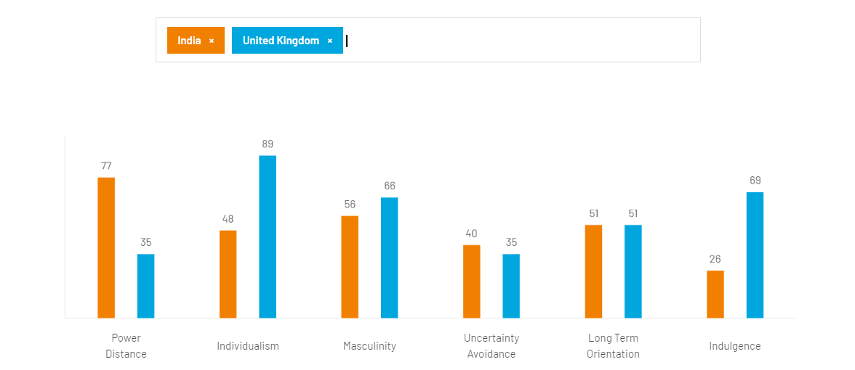
Source (hofstede insights, 2023)

Individualism vs Collectivism
The UK is characterized by a more individualistic culture, with an emphasis on personal achievements and independence. On the other hand, India tends to be more collectivist, valuing strong family ties and group harmony. This cultural difference can impact iPhone sales strategies, as marketing in the UK may focus on individual features and benefits, while in India, it may emphasize social connections and family-oriented uses(Alqarni, 2022).
Power Distance
India generally has a higher power distance, where hierarchy and authority are respected, while the UK scores lower in this dimension, promoting a flatter organizational structure. Apple's implementation of technology and growth strategies must adapt accordingly, considering the local acceptance of authority and decision-making processes in each country(Uzun, 2020).
Uncertainty Avoidance
The UK exhibits lower uncertainty avoidance, where risks are more tolerated, and flexibility is valued. India, on the other hand, has a higher uncertainty avoidance, leading to a preference for stability and risk aversion. This cultural variance can impact the acceptance of new iPhone features, with UK consumers being more open to innovation, while Indian consumers may be more cautious(Vasile and Nicolescu, 2016).
Long-term Orientation
The long-term orientation in the UK is evident by planning for the future and valuing perseverance, while India often displays a short-term orientation concerning traditions and immediate results. Apple's growth strategies should consider these varying time horizons, emphasizing the benefits of iPhone ownership in the long run for the UK market, and focusing on immediate gratification and convenience for the Indian market(Bashir and Usuro, 2018).

Advantages and disadvantages
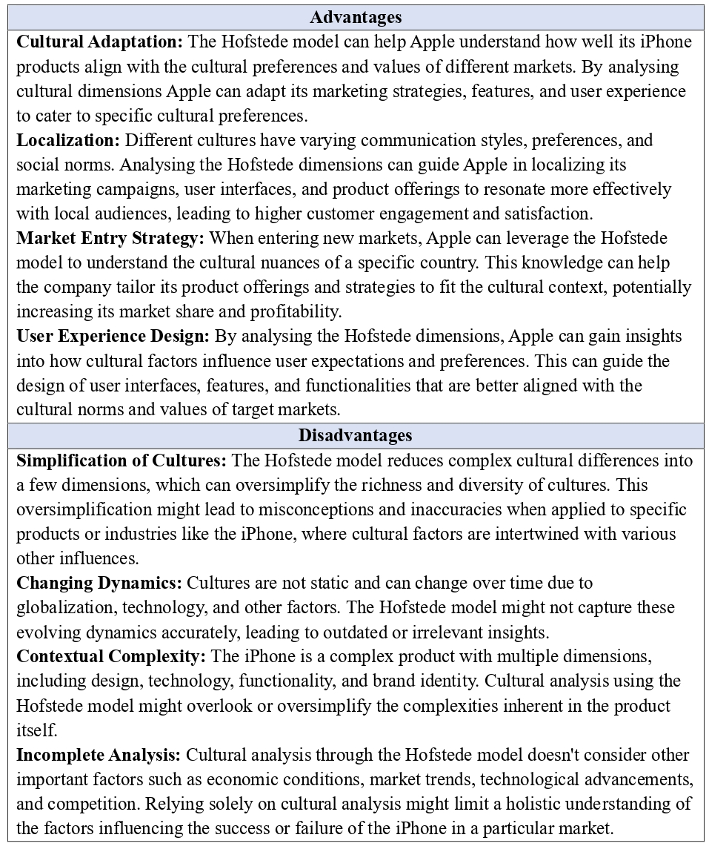

Environmental Factors
Both the UK and India are increasingly concerned about environmental issues, which aligns with Apple's focus on sustainability. In the UK, recycling regulations and efforts to reduce electronic waste Favor Apple's iPhone design and recycling programs. This aligns with favourable environmental trends.
In India, the push for sustainability resonates with Apple's initiatives, such as manufacturing iPhones using renewable energy and trade-in programs. However, challenges related to e-waste management and energy sources introduce unfavourable aspects that Apple needs to address(Singh, 2011).
Legal Factors
In the UK, stringent data protection laws like GDPR support Apple's commitment to privacy and security, positioning iPhones well in the market. However, legal battles surrounding taxation and market dominance could introduce unfavorable factors, impacting the company's operations(Husso, 2011).
In India, evolving data protection regulations require Apple to balance local laws with global standards, fostering consumer trust. Yet, legal complexities around intellectual property rights and taxation on digital services may impact iPhone pricing and profitability, representing unfavourable factors for the company(MOHAN, 2014).

Similarities and Differences
Both India and the UK hold crucial positions as markets for Apple's iPhone, yet each country possesses unique characteristics that play a pivotal role in shaping the company's operations and strategies.(Lockamy, 2017)&(Kaur and Arora, 2015) suggest the similarities and differences in both countries.
Similarities
Large Consumer Base: Both India and the UK boast substantial populations, making them highly appealing markets for smartphones, particularly the iconic iPhone.
Urban Centres: In both countries, densely populated urban areas exhibit strong demand for premium smartphones, including iPhones. The concentration of tech-savvy consumers in these urban centres creates a favourable market for Apple.
Tech-Savvy Consumers: Consumers in both India and the UK exhibit a tech-savvy nature, actively seeking out and embracing the latest technological innovations. This enthusiasm for cutting-edge technology contributes to the allure of iPhones in both markets.
Differences
Purchasing Power: One notable difference lies in the purchasing power of the two nations' populations. The UK generally enjoys a higher per capita income and greater purchasing power in comparison to India.
Market Maturity: The smartphone market in the UK has reached a more advanced and mature stage. Here, consumers often prioritize brand loyalty and value high-end features, creating a different set of expectations and preferences. In contrast, India's smartphone market is still evolving and experiencing rapid growth, with a substantial demand for more budget-friendly devices.
Distribution and Infrastructure: The distribution network and infrastructure exhibit marked differences between India and the UK. The UK benefits from a well-established and efficient distribution system, facilitating smoother market penetration for Apple's products. On the other hand, India might face challenges in reaching remote or rural areas due to infrastructural limitations, requiring tailored distribution strategies.

Porters five force model
According to Goyal (2020), The Five Forces model helps us understand the competitive forces that influence a company's profitability and attractiveness in a specific market(Goyal, 2020). We will assess the intensity of each force in both countries, highlighting similarities and differences between the two markets. Furthermore, we will explore how these forces impact the mobile technology sector, both supporting and non-supporting, and how they affect the overall market dynamics in each country.
Rivalry among Competitors
UK: High
The smartphone market in the UK is highly competitive, with several established players like Samsung, Huawei, and Google competing against Apple. According to market research data, Apple held a market share of approximately 30% in the UK smartphone market in the past year. The presence of strong competitors and relatively similar product offerings intensifies the rivalry in the UK(International data Corporation, 2020). The graph below depicts the number of mobile phones sold by various companies in the United Kingdom over the last two years.
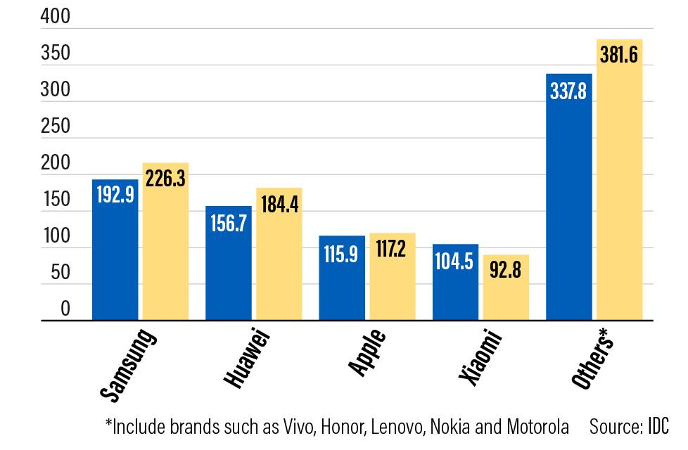
Source (International data Corporation, 2020)

India: Medium
In India, the rivalry among competitors is also notable, but the intensity is relatively lower compared to the UK. Apple faces competition from various domestic and international brands, such as Samsung, Xiaomi, and OnePlus. Apple's market share in India was around 2% due to its premium pricing and stiff competition from more affordable smartphones. The data below depicts the top five smartphone selling companies in India, with Apple missing out because it is so expensive in India.
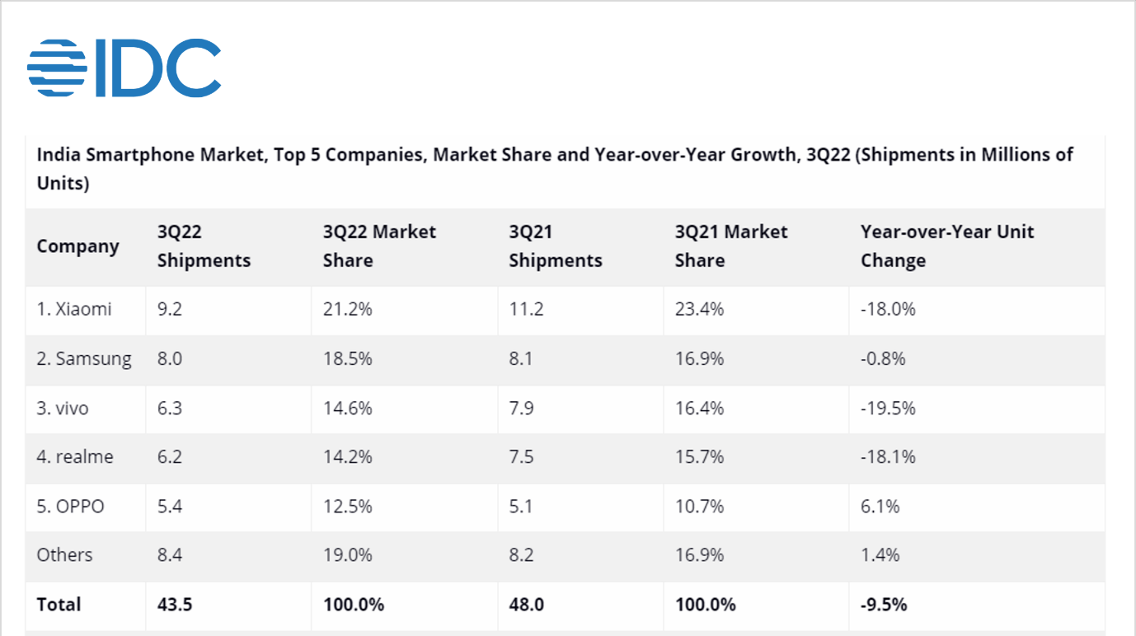
Source(International data Corporation, 2020)

High rivalry encourages companies to innovate and invest in technology to gain a competitive advantage. Both markets see significant investments in R&D and product enhancements to attract consumers. In the UK, this competition fosters technological advancements, leading to better mobile technology availability. In India, the moderate rivalry may somewhat slow down the influx of the latest technology but stimulates brands to offer budget-friendly options for the masses(Hooley et al., 2020).
Threat of New Entrants
UK: Low
The threat of new entrants in the UK is low, primarily due to high entry barriers, including strict regulations, brand loyalty, and substantial capital requirements. Apple's well-established brand reputation and customer loyalty act as significant deterrents for potential new entrants. The graph below shows the average price of iPhone and Android phones in UK(Cecere, Corrocher and Battaglia, 2014).
India: Medium
India presents a more moderate level of threat of new entrants due to its large and growing smartphone market. While there are some barriers to entry, such as distribution networks and brand recognition, the expanding middle class and increasing smartphone adoption rate attract new players to enter the Indian market. The graph below shows the average cost of an iPhone and an Android phone in India in 2020(Karunakar, 2017).
A low threat of new entrants in the UK allows Apple to focus on long-term technological innovations, ensuring a steady market presence. In India, the moderate threat keeps Apple on its toes, leading to continuous efforts to offer advanced technology at competitive prices.
Bargaining Power of Buyers
UK: Medium
Buyers in the UK possess a moderate level of bargaining power. There is a wide range of smartphone options available to consumers, enabling them to compare features and prices. As a result, buyers can exert some influence on prices and product offerings.
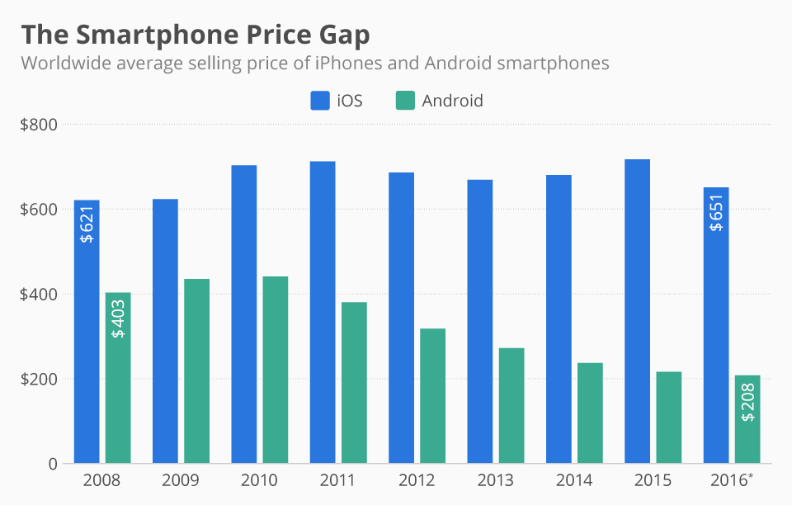
Source (Statista, 2022)

India: High
In India, the bargaining power of buyers is relatively high. The market is price-sensitive, and consumers have access to a plethora of affordable smartphone alternatives. This high bargaining power prompts companies to offer competitive prices and features to attract and retain customers(Singh, 2011).
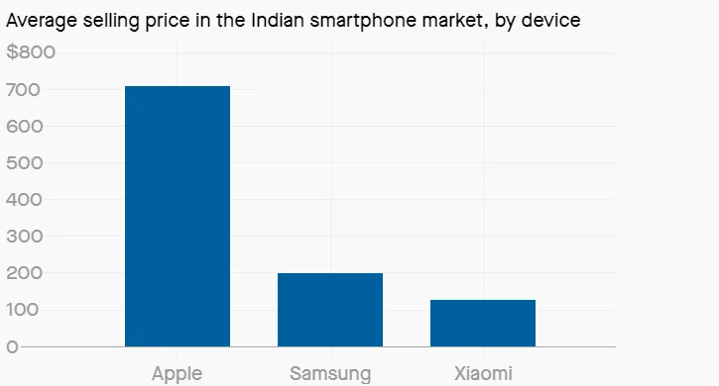
Source (Statista, 2022)
In both markets, the bargaining power of buyers emphasizes the importance of offering cutting-edge technology at reasonable prices. However, the Indian market's higher bargaining power necessitates a greater focus on cost-efficient technology solutions.
Bargaining Power of Suppliers
UK: Low
Apple's bargaining power of suppliers is low in the UK due to its strong brand presence and large-scale operations. The company's high sales volume allows it to negotiate favourable terms with suppliers, ensuring access to quality components at competitive prices(Heywood, 2022).
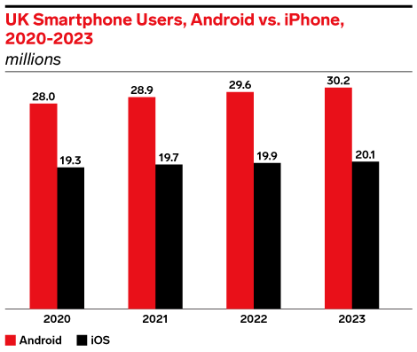
Source (International data Corporation, 2023)

India: Medium
In India, Apple's bargaining power of suppliers is moderate. While the company is a significant player in the market, it faces competition from other smartphone manufacturers, making suppliers less dependent on Apple's orders. the graph shows the demand for iPhone in India in previous years.
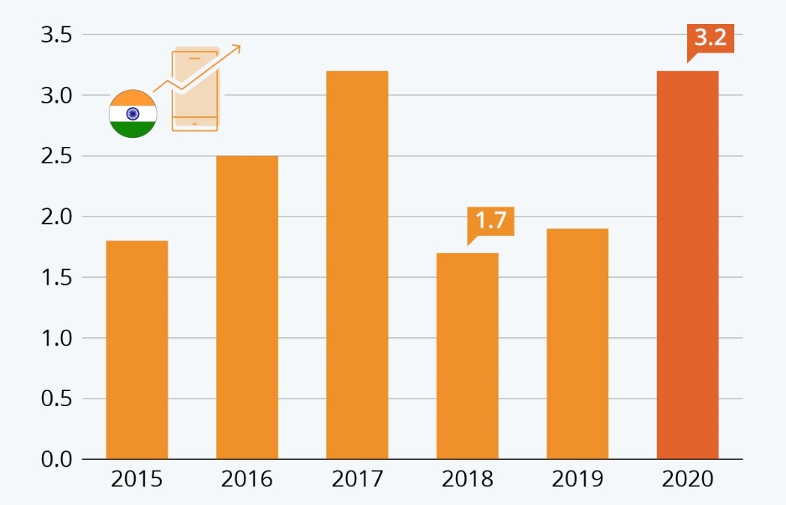
Source(Statista, 2020)
Both markets benefit from their respective bargaining power of suppliers, ensuring a stable supply of quality components for mobile technology. Apple's low bargaining power in the UK facilitates access to cutting-edge technology, while the moderate power in India demands a cautious approach to maintain the supply chain efficiency(Hooley et al., 2020).
Threat of Substitutes
UK: Low
The threat of substitutes for the Apple iPhone in the UK is low. The company's brand loyalty, ecosystem, and unique features reduce the likelihood of consumers switching to alternative smartphone brands(Husso, 2011).
India: Medium
In India, the threat of substitutes is moderate. While Apple's ecosystem is appealing to some, there are numerous local and international brands offering affordable and feature-rich smartphones, which can lure price-conscious consumers.
The low threat of substitutes in the UK encourages Apple to invest in cutting-edge technology and unique features, solidifying its market position. In India, the medium threat drives Apple to continuously innovate and introduce technology that can sway consumers from cheaper alternatives(MOHAN, 2014).

Similarities and Differences
Similarities
- Both countries have competitive mobile technology markets, with various players vying for market share.
- Both markets emphasize the need for continuous innovation to attract and retain customers.
- The bargaining power of buyers highlights the importance of offering advanced technology at reasonable prices in both countries.
- Both markets benefit from their respective bargaining power of suppliers to ensure a stable supply of quality components.
Differences
- The intensity of rivalry among competitors is higher in the UK compared to India due to the presence of more established players.
- The threat of new entrants is lower in the UK due to higher entry barriers, while it's moderate in India due to its expanding market.
- The bargaining power of buyers is higher in India, making competitive pricing and features more crucial.
- The bargaining power of suppliers is lower for Apple in the UK, enabling better access to cutting-edge technology.
- The threat of substitutes is lower in the UK due to Apple's strong brand loyalty and ecosystem, whereas it's higher in India due to affordability concerns.

SWOT analysis
Strength
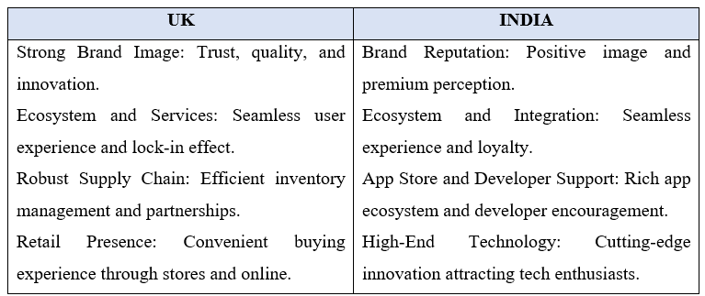
Facts
- As of 2021, Apple's brand value was estimated to be worth $263.4 billion, making it the most valuable brand globally (International data Corporation, 2023)
- In the third quarter of 2021, Apple's market share in India increased by 46%, driven by the popularity of the iPhone 12 series (International data Corporation, 2023)
The market share of leading mobile device vendors in the United Kingdom (UK) from 2012 to 2022 is shown below.
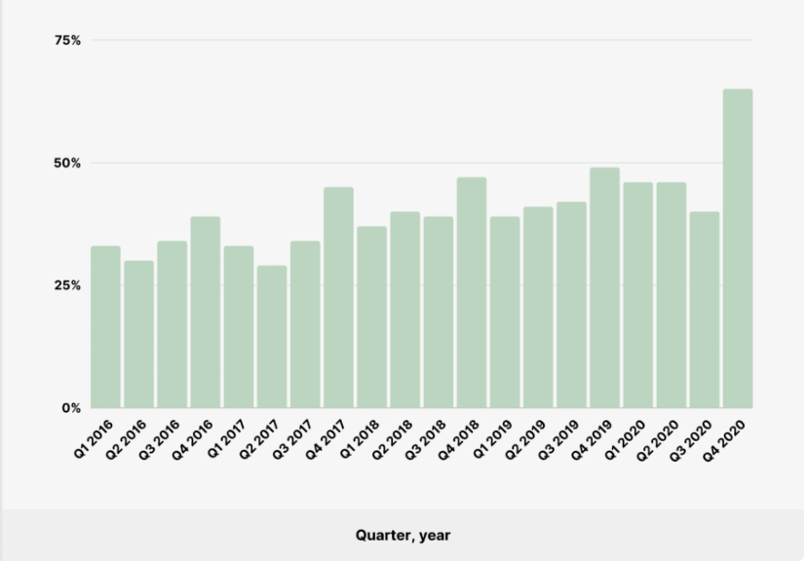
Source (Heywood, 2022)
Data demonstrating people's opinions on the security of the iPhone vs Android.
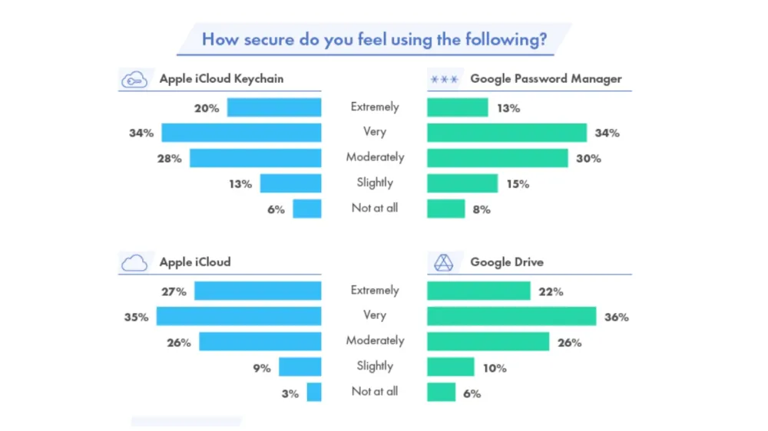
Source (Ye et al., 2023)

Weakness
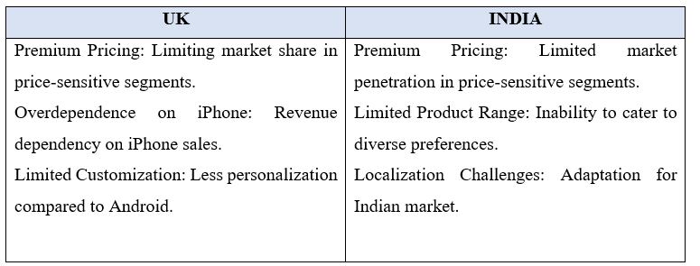
Facts
- The average selling price of an iPhone in the UK in 2021 was £775, significantly higher than many Android smartphones(Statista, 2021)
- In 2021, 15.7% of iPhone users in the UK considered switching to an Android device due to the desire for more customization options(Statista, 2021)
- As of 2021, iPhones accounted for less than 2% of the overall Indian smartphone market (Counter point Research, 2022)
- The iPhone SE, which was considered a more affordable option, constituted only about 2% of total iPhone sales in India in the first half of 2021 (Reuters, 2022)
Opportunities
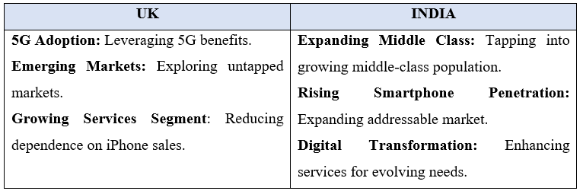
Facts
- India's middle-class population is projected to reach 547 million by 2025(Adlakha, 2020).
- The number of smartphone users in India is estimated to exceed 700 million by 2023 (International data Corporation, 2023)
The 5g map of the United Kingdom is shown below.
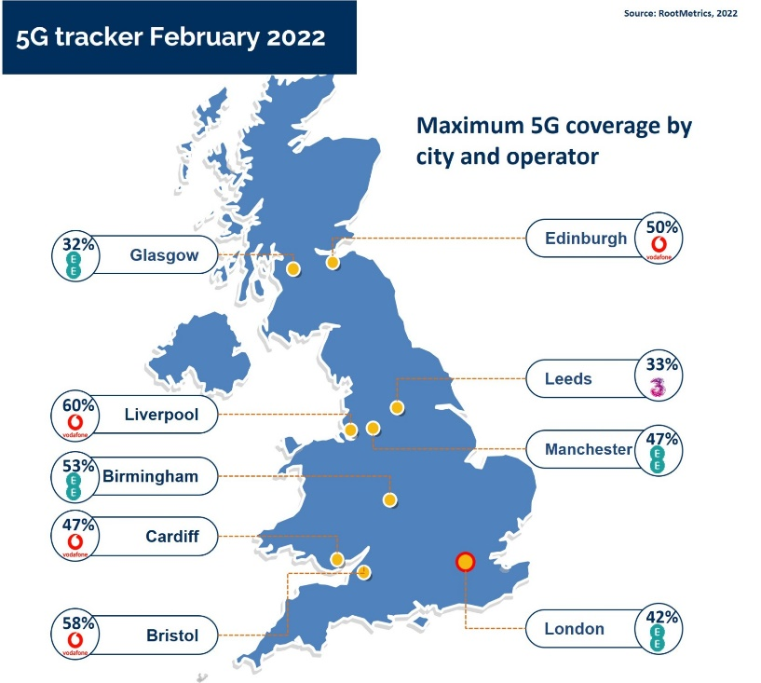
Source (Root matrix, 2022)
The graph below depicts iPhone users of various ages.
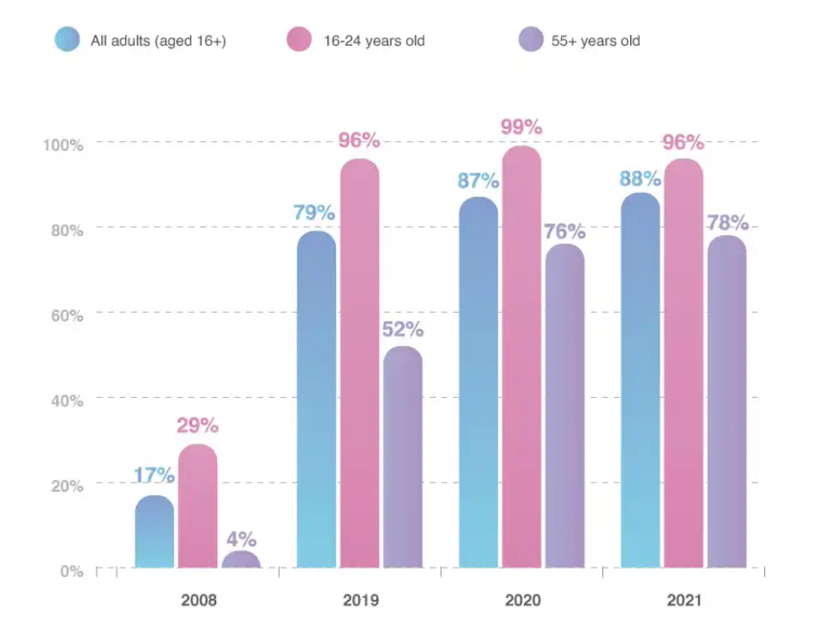
Source (Statista, 2021)
Threats
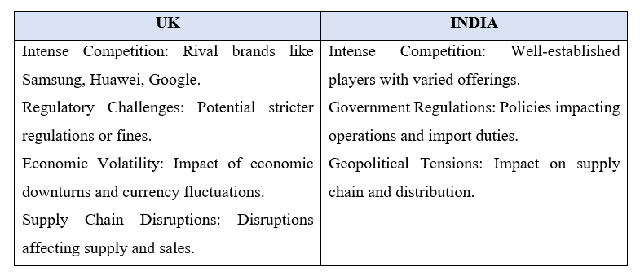
Facts
- In 2021, Samsung held a higher market share in the UK at 19.3%, indicating fierce competition for Apple(Statista, 2022)
- Apple faced a record £1.5 billion lawsuit in the UK over alleged anticompetitive practices related to its App Store(The Guardian, 2022)
- As of 2021, Xiaomi and Samsung were the leading smartphone brands in India, with market shares of around 28% and 21%, respectively(Counter point Research, 2022)
- In 2021, the Indian government introduced new import regulations for mobile phone components to encourage local manufacturing (Reuters, 2022).

Similarities and differences
Similarities
- Both UK and India identify the importance of brand reputation, trust, quality, and innovation for Apple's products.
- Both markets emphasize the significance of a seamless user experience and loyalty through the integration of Apple's products and services.
- Both countries see opportunities in exploring untapped or growing markets, whether it's through 5G adoption, rising smartphone penetration, or expanding middle-class populations.
- Both markets acknowledge the presence of strong competitors like Samsung and others that can challenge Apple's market position.
Differences
- While the UK focuses on a convenient buying experience through both physical stores and online platforms, India emphasizes Apple's positive image and premium perception.
- The UK identifies a robust supply chain and efficient inventory management as strengths, while India highlights Apple's limited product range as a weakness.
- The UK sees premium pricing and overdependence on iPhone sales as weaknesses, whereas India identifies limited market penetration in price-sensitive segments and localization challenges as weaknesses.
- While the UK values cutting-edge technology and a rich app ecosystem, India highlights Apple's developer encouragement and rich app ecosystem as strengths.
- The UK perceives limited customization as a weakness, whereas India combines limited product range and localization challenges as a weakness.

Segmentation, targeting, and positioning (STP)
According to Camilleri (2018), Segmentation, targeting, and positioning (STP) are fundamental marketing concepts that help companies identify and cater to specific customer segments effectively. Let's explore how these concepts can be applied to the iPhone in the UK and India, highlighting any similarities and differences(Camilleri, 2018).
Demographic Segmentation
India: In India, demographic segmentation for the iPhone can focus on factors such as age, income, education, and occupation. Apple could target young professionals and college students with disposable income, who are tech-savvy and value premium products(Camilleri, 2018).
UK: In the UK, demographic segmentation might involve targeting a wider age range but still focusing on the upper-middle to high-income segments, professionals, and individuals who place a premium on the latest technology and design.
Geographic Segmentation
India: India's vast geography and population density provide opportunities to segment by regions and urban/rural areas. Major metropolitan cities like Mumbai, Delhi, and Bangalore could be prime markets due to higher income levels and technology adoption. Tier 2 cities might represent a growing market as well.
UK: In the UK, geographic segmentation could focus on urban centres like London, Manchester, and Birmingham where a concentration of affluent and tech-oriented consumers resides. Suburban and rural areas could be secondary markets.
Psychographic Segmentation
India: Psychographic segmentation involves lifestyle, values, and interests. Apple could target individuals who value innovation, status, and being part of a global tech community. This might appeal to those who enjoy showcasing their social status through their possessions.
UK: In the UK, psychographic segmentation could involve targeting individuals who value aesthetics, cutting-edge technology, and seamless integration with other Apple products. The focus could be on users who appreciate the premium experience and are early adopters(Lupao, 2017)..
Target for iPhone in India and UK
India
Apple's target audience for the iPhone in India would likely include:
• Young professionals and students with disposable income.
• Tech enthusiasts who value innovation and premium products.
• Urban dwellers, especially in major cities, where incomes are higher and technology adoption is more common.
• Aspirational consumers who view owning an iPhone as a status symbol.
UK
Apple's target audience for the iPhone in the UK would likely include:
• Affluent professionals and executives with high disposable income.
• Technology enthusiasts who value cutting-edge features and design.
• Early adopters who seek the latest advancements in the tech world.
• Creative professionals who appreciate the ecosystem for multimedia and productivity.
• Consumers who are fashion-conscious and consider their smartphones as fashion accessories.
Positioning
Positioning is about creating a distinct image and value proposition for a product or brand in the minds of the target customers. It involves highlighting the unique benefits and attributes that set the product apart from competitors (Dibb and Simkin, 1991).
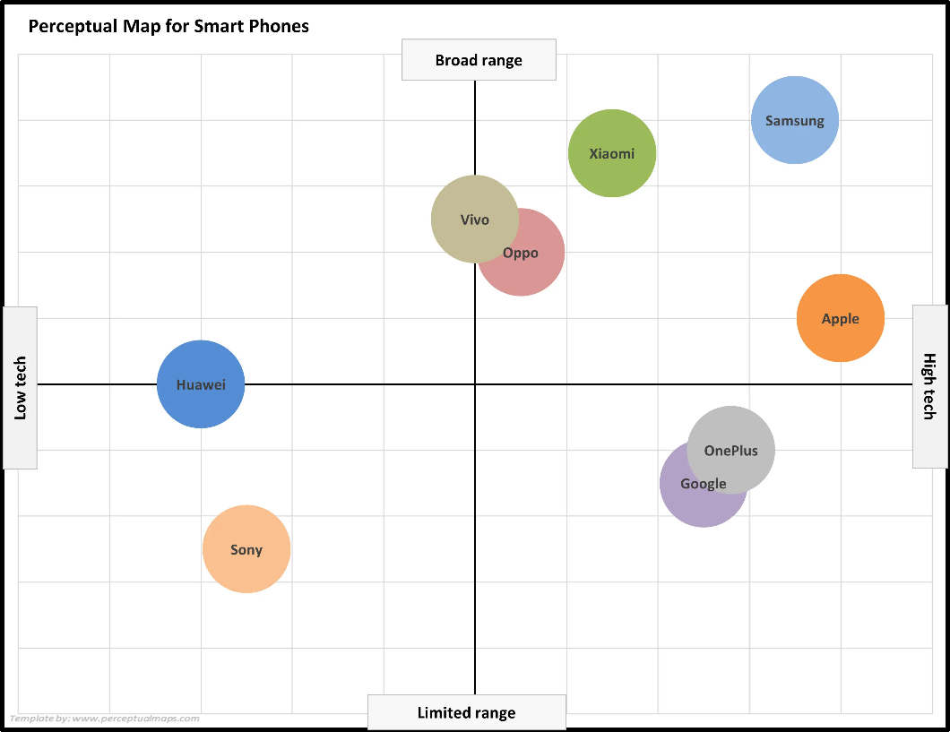
Diagram positioning map of smart phone worldwide source (Behl, 2022)

Similarities and differences
 | UK | India
Segmentation | - Tech-savvy professionals  - Affluent individuals  - Early adopters  - Students  - High-income professionals | - Tech-savvy professionals  - Growing middle-class  - Students and young professionals  - Early adopters
Targeting | High-income professionals and early adopters who appreciate premium technology products | Growing middle-class seeking aspirational Yet value-for-money smartphones
Positioning | - Cutting-edge technology  - Sleek design  - Premium status | - Reliability  - User friendly interface  - Integration with apple ecosystem

Marketing mix elements (7Ps)
In the analysis of the marketing strategy employed by Apple for the iPhone in both the UK and India, we will delve into the seven elements of the marketing mix, commonly known as the 7Ps: Product, Price, Place, Promotion, People, Process, and Physical evidence.
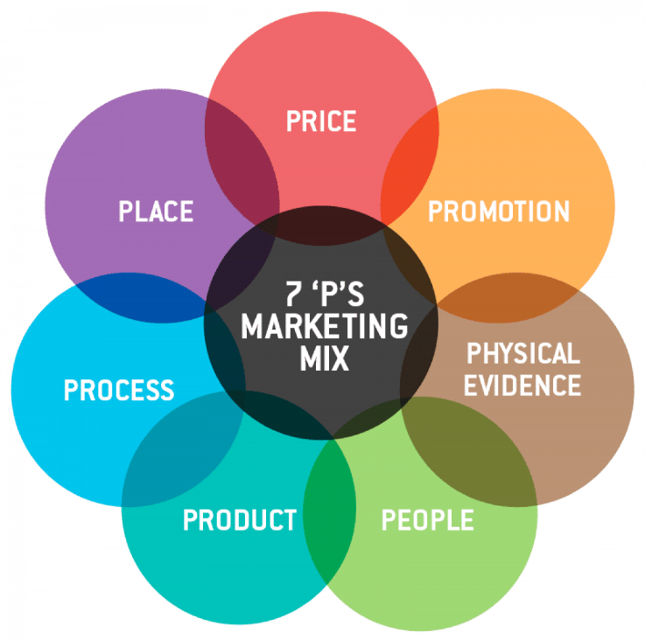
Source (self-made)
Product | Apple's iPhone, a premium smartphone, is the focal point of their marketing efforts in both the UK and India. The product is characterized by its cutting-edge technology, sleek design, and user-friendly interface. While the core features remain consistent between both countries, Apple may offer specific regional variations or localized software to cater to distinct consumer preferences and needs(Vliert, 2021).
Price | The pricing strategy for the iPhone differs between the UK and India due to variations in market dynamics, consumer purchasing power, and competitive landscape. In the UK, Apple may adopt a premium pricing strategy to emphasize the product's exclusivity and appeal to a more affluent segment of consumers. In contrast, in India, where price sensitivity is higher, Apple might implement more flexible pricing strategies, such as instalments plans or trade-in offers, to attract a broader customer base(Chavaglia and Filipe, 2015).
Place | Apple ensures widespread availability of the iPhone in both the UK and India. In the UK, the iPhone is sold through a combination of Apple's official retail stores, authorized resellers, and major carriers. In India, distribution channels might include exclusive Apple stores, authorized retail partners, and e-commerce platforms to reach customers across diverse geographical locations(Capatina and Draghescu, 2015).
Promotion | Apple employs a multi-faceted promotion strategy in both countries to create brand awareness and drive sales. In the UK, the company may focus on digital marketing, social media, and television advertisements to target the tech-savvy and urban population. In India, Apple may leverage a mix of digital advertising and traditional media while incorporating cultural and regional elements to resonate with the diverse population(Nicolle, 2021).
People | The people element refers to the personnel involved in the marketing and customer service processes. In both the UK and India, Apple ensures a well-trained and customer-centric workforce, including sales representatives and support staff. Additionally, Apple's customer service centres aim to offer consistent and exceptional service experiences in both countries(Ström, Vendel and Bredican, 2014a).
Process | Apple's marketing processes are designed to create a seamless customer journey in both the UK and India. This includes efficient order processing, product delivery, and after-sales support. The company may tailor certain processes, such as warranty and repair services, to adhere to specific regulations and cultural norms in each country(Ström, Vendel and Bredican, 2014b).
Physical Evidence | The physical evidence element pertains to the tangible aspects that customers interact with during their buying experience. In the UK and India, Apple's emphasis on sleek and visually appealing retail stores, packaging, and product displays contributes to the overall brand image and enhances the customer's perception of the iPhone's premium quality(Öztaş, 2015).

Similarities and difference
In the UK, Apple has historically adopted a well-established and sophisticated distribution network. The company capitalized on its strong brand reputation and consumer loyalty to collaborate with major telecom carriers, authorized retailers, and its own Apple Stores. By partnering with telecom carriers like O2, EE, and Vodafone, Apple ensured widespread availability of iPhones across various mobile plans, catering to a broad customer base. Simultaneously, the presence of Apple Stores in key cities provided a direct sales channel, fostering a personalized customer experience and showcasing the brand's premium image. The strategic utilization of online platforms, such as the official Apple website and renowned e-commerce portals, further amplified the reach of iPhones in the UK market(Ström, Vendel and Bredican, 2014b).
On the other hand, in India, Apple faced unique challenges given the country's diverse and price-sensitive market. To effectively penetrate this dynamic market, the company had to adjust its market entry strategy. Apple's initial approach involved partnering with local telecom carriers like Airtel and Reliance Jio, offering exclusive data plans and subsidies to make iPhones more affordable to Indian consumers. Additionally, the company expanded its distribution network by collaborating with prominent offline retailers to reach customers in various regions. Recognizing the significance of online channels in India's booming e-commerce sector, Apple also engaged with major online platforms like Amazon India and Flipkart to enhance product accessibility to a broader audience(Vliert, 2021).

Apple iPhone Market Entry Methods:
To expand its presence in various markets globally, Apple employs a variety of market entry strategies. The selection of a specific approach depends on factors such as the characteristics of the target market, competitive landscape, legal environment, and the company's strategic objectives.
Direct Sales and Distribution
Apple often enters new markets by establishing direct sales and distribution channels. This involves setting up Apple-owned retail stores, authorized resellers, and online platforms to sell and distribute its iPhones. This strategy allows Apple to maintain control over its brand image and customer experience.
Joint Ventures and Partnerships
Apple may form joint ventures or strategic partnerships with local technology companies or telecommunications providers. These partnerships can help Apple navigate local regulations, leverage local partners' knowledge, and expand its market reach by utilizing established distribution networks.
Licensing and Franchising
While Apple doesn't typically license its technology to third parties, it may engage in licensing agreements for certain components or technologies that are relevant to specific markets. Franchising, however, is less applicable to Apple's business model, as it focuses on maintaining consistent branding and customer experience across its retail stores.
Export
Apple exports iPhones from its manufacturing facilities to various markets around the world. This strategy is particularly effective in markets with strong demand for premium smartphones and where regulatory barriers are relatively low. Apple's strong brand recognition helps drive demand in these markets.
Direct Online Sales
Apple offers iPhones directly to consumers through its official online store. This strategy enables Apple to reach customers who prefer online shopping and provides a convenient way for customers to purchase its products without intermediaries.

Technology Transfer
Apple may engage in technology transfer agreements with local partners or governments to foster technological growth in certain markets. However, Apple is more known for tightly controlling its proprietary technology, making this strategy less common in comparison to other industries.
Strategic Alliances with Mobile Carriers
Apple often partners with mobile carriers in various markets to offer subsidized iPhones as part of mobile plans. These partnerships help drive sales and make iPhones more accessible to a wider range of consumers.
After-Sales Services and Support
Apple places a strong emphasis on after-sales services and support, including repairs, warranties, and customer service. This approach fosters customer loyalty and retention while ensuring the longevity of its products.

Directional Development Strategy
A directional development strategy is a collection of planned actions and initiatives undertaken by a company to expand its operations and market presence in specific regions or countries(Singh and Shah, 2012). In the context of Apple's iPhone business in India and the United Kingdom, the directional development strategy would include Apple's approaches and tactics for increasing market share, increasing sales, and strengthening its brand in these two distinct markets.
India
Market Penetration and Price Sensitivity: India is a price-sensitive market, and Apple recognized this challenge. To penetrate the Indian market, Apple focused on expanding its product range, including older iPhone models, to make its devices more affordable for a broader consumer base. This approach aimed to capture market share by targeting various income segments(Reuters, 2022).
Local Manufacturing: To reduce import costs and benefit from India's incentives for local production, Apple initiated local assembly of some iPhone models in India. This move helped lower prices, making iPhones more competitive and accessible to a larger audience.
Channel Expansion: Apple expanded its retail presence in India by increasing the number of authorized resellers and premium stores. This move aimed to reach customers in Tier II and Tier III cities and improve brand visibility.
Services Focus: Recognizing the potential of the Indian market for services, Apple put more emphasis on its services division, such as the App Store, Apple Music, and iCloud. This strategy aimed to enhance customer loyalty and generate additional revenue streams beyond hardware sales.
Investment in Research and Development: Apple also explored opportunities to invest in local research and development initiatives to align its products with the specific needs and preferences of Indian consumers.
UK
Brand and Premium Positioning: In the UK, Apple focused on maintaining its brand image as a premium and aspirational product. While the company offered various models, it retained its premium pricing strategy to cater to the more affluent segment of the market.
Flagship Stores and Customer Experience: Apple invested in flagship stores in prominent locations across major cities in the UK. These stores provided customers with a unique and immersive experience, reinforcing the brand's image and enhancing customer loyalty.
Online Presence: With a well-established e-commerce market in the UK, Apple also strengthened its online presence. The company provided a seamless online shopping experience through its website and collaborated with major e-commerce platforms to reach a wider audience.
Promotions and Marketing: Apple consistently used innovative marketing campaigns to create buzz around new product launches and create a sense of exclusivity. These efforts helped maintain strong demand and interest in Apple products.
Focus on Environment and Sustainability: In line with growing consumer demands for environmentally responsible products, Apple emphasized its commitment to sustainability in the UK market. This strategy aimed to attract eco-conscious consumers and bolster the company's reputation.
Overall, Apple's directional development strategies in India and the UK were adapted to the distinctive characteristics of each market, catering to local demands, preferences, and economic conditions. This approach allowed Apple to establish a strong presence in both regions and cater to a diverse range of consumers. However, it's essential to verify the current state of affairs and recent developments to gain a comprehensive understanding of Apple's ongoing strategies in these markets.
Similarities and differences
Similarities
- Market Adaptation: In both India and the UK, Apple recognized the importance of adapting its strategies to cater to the specific characteristics of each market. This included factors like consumer preferences, economic conditions, and cultural nuances.
- Retail Expansion: Apple expanded its retail presence in both markets, although the approach differed. In India, it focused on increasing the number of authorized resellers and premium stores to reach a broader audience, while in the UK, the emphasis was on creating flagship stores for an immersive customer experience.
- Brand Image: Apple maintained a strong brand image in both markets. In India, it adapted its pricing strategy to target various income segments while in the UK, it retained a premium pricing strategy to appeal to the more affluent segment.
- Online Presence: Apple strengthened its online presence in both markets. In the UK, where e-commerce was well-established, it leveraged online platforms to reach a wider audience. In India, it likely also used online channels to cater to urban consumers.
Differences:
- Price Sensitivity vs. Premium Positioning: In India, Apple faced a price-sensitive market and focused on affordability to penetrate the market. In contrast, in the UK, it maintained a premium image, catering to the affluent segment.
- Local Manufacturing vs. Flagship Stores: Apple initiated local manufacturing in India to reduce costs. In the UK, it invested in flagship stores for a high-end retail experience.
- Services Emphasis vs. Marketing Campaigns: In India, Apple emphasized services to generate additional revenue streams. In the UK, it used innovative marketing campaigns to maintain demand and exclusivity.
- Focus on Environment vs. Investment in R&D: In the UK, Apple emphasized sustainability to attract eco-conscious consumers. In India, it explored local research and development initiatives to align products with consumer preferences.
- Retail Expansion Strategy: In India, the focus was on increasing the number of resellers to improve accessibility, especially in Tier II and III cities. In the UK, Apple invested in flagship stores for a unique customer experience.
- Product Range Strategy: In India, Apple expanded its product range to include older models for affordability. In the UK, it likely offered a broader range of the latest models to maintain the premium positioning.
- Channel Strategy: In India, the focus was on authorized resellers and premium stores. In the UK, flagship stores played a significant role in customer experience.
- Target Audience: In India, Apple targeted a diverse income range due to the price-sensitive nature of the market. In the UK, the target was more on the affluent segment.
- Consumer Engagement: In the UK, Apple invested in flagship stores and online platforms for a unique shopping experience. In India, it likely focused on making products more accessible through various retail channels.

Recommendation

TOWS Matrix
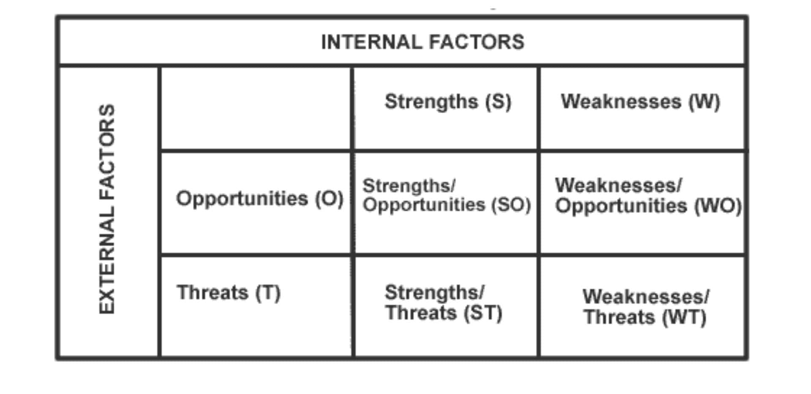
TOWS Matrix for Apple's iPhone Business in the UK
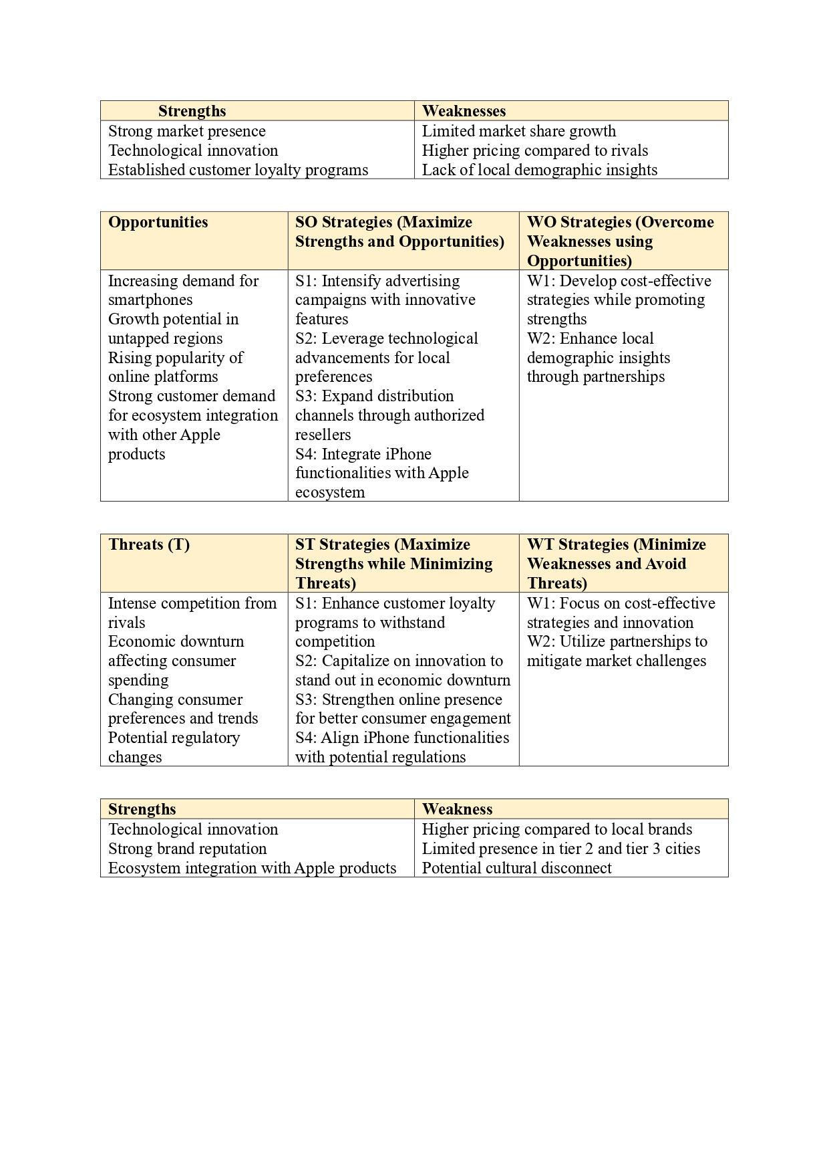
TOWS Matrix for Apple's iPhone Business in India
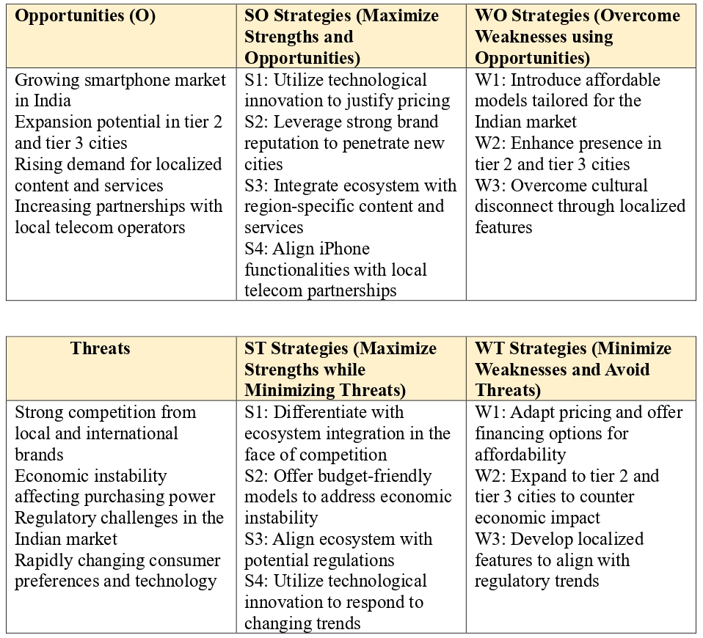

Conclusion
Apple Inc.'s iPhone business in the UK and India showcases the company's adaptability to diverse markets. The company's strategies align with the distinct consumer preferences, purchasing power, and market conditions in each country. In the UK, Apple maintains its premium positioning, leveraging its brand reputation and customer loyalty. On the other hand, in India, Apple focuses on affordability, local manufacturing, and services to appeal to the price-sensitive market. For critical analysis of the Apple iPhone, PESTLE, Hofstede's Cultural Dimensions, SWOT analysis, Porter's Five Forces, STP (Segmentation, Targeting, Positioning), Ansoff Matrix, and the 7Ps of the marketing mix are used. By understanding these market nuances and adopting appropriate directional development strategies, Apple can continue to thrive and expand its market presence in both the UK and India. As technological landscapes continue to evolve, Apple's ability to innovate and cater to the changing needs of consumers will be essential for sustained success in these regions.

Reference
Adlakha, A. (2020) ‘Population Trends: India’, International brief, p. 5.
Aggarwal, N. (2017) ‘A Study on Decline Trend in the Market Share of Apple Iphone’, International Journal of Engineering Research & Technology, 5(11), pp. 4–6.
Alqarni, A. M. (2022) ‘JOURNAL OF LANGUAGE AND LINGUISTIC STUDIES Hofstede’s cultural dimensions in relation to learning behaviours and learning styles: A critical analysis of studies under different cultural and language learning environments’, Alqarni / Journal of Language and Linguistic Studies, 18(1), pp. 721–739.
Anh, H. N. (2016) ‘SMARTPHONE INDUSTRY : THE NEW ERA OF COMPETITION AND STRATEGY’.
Apple Annual report (2022) ‘Apple (INDIA) Annual report’.
Bashir, S. and Usuro, A. (2018) ‘The relationship of long-term orientation with knowledge sharing in virtual community’, Communications of the IIMA, 15(2).
Behl, S. (2022) ‘Factors Affecting Consumer Choice of Mobile Phone Brands : an Empirical Study Using Multidimensional Scaling Techniques’, (March), p. 6.
Camilleri, M. A. (2018) ‘Market Segmentation, Targeting and Positioning’, Tourism, Hospitality and Event Management, pp. 69–83.
Capatina, G. and Draghescu, F. (2015) ‘Success Factors of New Product Launch: The Case of iPhone Launch’, International Journal of Economics and Finance, 7(5), pp. 61–70.
Cecere, G., Corrocher, N. and Battaglia, R. (2014) ‘Innovation and competition in the smartphone industry: Is there a dominant design?’, Telecommunications Policy, 39.
Chavaglia, J. and Filipe, J. (2015) ‘Consumers economic behavior and emotions: the case of iphone 6 in neuromarketing’, International Journal of Latest Trends in Finance and Economic Sciences, (4), pp. 1041–1047.
Counter point Research (2022) No Title.
Doole, I., Lowe, R. and Kenyon, A. J. (2019) International Marketing Strategy: Analysis, Development and Implementation. Cengage Learning. Available at: https://books.google.co.in/books?id=E0-5vAEACAAJ.
Goyal, A. (2020) ‘A Critical Analysis of Porter’s 5 Forces Model of Competitive Advantage’, Journal of Emerging Technologies and Innovative Research (JETIR), 7(7), pp. 149–152.
Harvey, J. N. K. (2019) Localizing Global Marketing Strategies: Emerging Research and Opportunities: Emerging Research and Opportunities. IGI Global (Advances in Marketing, Customer Relationship Management, and E-Services). Available at: https://books.google.co.in/books?id=eEHADwAAQBAJ.
Heywood, C. (2022) ‘Consumer purchasing behaviour in the UK smartphone market - CMA research report’, (2231083).
Hofstede, G. (2011) ‘Dimensionalizing Cultures’, Online Readings in Psychology and Culture, 2(1), pp. 1–26.
hofstede insights (2023) No Title.
Hooley, G. J. et al. (2020) Marketing Strategy and Competitive Positioning. Pearson. Available at: https://books.google.co.in/books?id=X6MEygEACAAJ.
Husso, M. (2011) ‘Analysis of Competition in the Mobile Phone Markets of the United States and Europe’, Department of Management and International business.
International data Corporation (2020) International data corporation.
International data Corporation (2023) ‘No Title’.
Karunakar (2017) ‘Smart Phone Industry in India: Changing Landscape with Entry of Chinese Players and Reliance Jio’, 06, pp. 1–10.
Kaur, S. and Arora, S. (2015) ‘Case Study of Supply Chain Management: Two foremost Smart phones Sumanpreet Kaur 1 Shilpa Arora 2’, International Journal of Business Management, 2(1), pp. 940–949.
Krishnan, D. (2022) ‘Employment Practices At Apple; Social and Legal Issues Disrupting India’S Industrial Relations Landscape’, Journal of the International Academy for Case Studies, 28(4), pp. 1–10.
Lockamy, A. (2017) ‘An examination of external risk factors in Apple Inc.’s supply chain’, Supply Chain Forum, 18, pp. 177–188.
Mickalowski, K. et al. (2010) ‘Apple’s iPhone Launch: A Case Study in Effective Marketing’, pp. 1–7.
MOHAN, A. (2014) ‘CONSUMER BEHAVIOUR TOWARDS SMARTPHONE INDUSTRY IN INDIAN MARKET’, Modeling and Simulation in Science, Engineering and Technology, 57(1779249), pp. 1–99.
Nicolle, A. (2021) ‘Strategic confusopoly : evidence from the UK mobile market’, (1).
Öztaş, Y. B. B. (2015) ‘The Increasing Importance of Mobile Marketing in the Light of the Improvement of Mobile Phones, Confronted Problems Encountered in Practice, Solution Offers and Expectations’, Procedia - Social and Behavioral Sciences, 195, pp. 1066–1073.
Reuters (2022) Reuters.
Root matrix (2022) No Title.
Singh, N. (2011) Emerging Indian Mobile Markets at the Bottom of the Pyramid.
Singh, R. and Shah, M. (2012) ‘Directional Strategies and Organizational Performance’, 3, pp. 57–69.
Statista (2020) No Title.
Statista (2021) e.
Statista (2022) No Title.
Ström, R., Vendel, M. and Bredican, J. (2014a) ‘Mobile marketing: A literature review on its value for consumers and retailers’, Journal of Retailing and Consumer Services, 21(6), pp. 1001–1012.
Ström, R., Vendel, M. and Bredican, J. (2014b) ‘The value of mobile marketing for consumers and retailers : a literature review’, Journal of retai, 21(6), pp. 1001–1011.
The Guardian (2022) No Title.
Uzun, T. (2020) ‘Relationships between Power Distance, Organizational Commitment, and Trust in Schools’, Educational Policy Analysis and Strategic Research, 15(3), pp. 359–371.
Varshath, B. and Kumaran, M. . (2021) ‘A study on Customer Satisfaction towards Asian paints with special reference to Coimbatore city’, International Journal of Creative Research Thoughts, 9(10), pp. 2320–2882. doi: 10.35629/5252-0310869874.
Vasile, A. C. and Nicolescu, L. (2016) ‘Hofstede’S Cultural Dimensions and Management in Corporations’, Cross-Cultural Management Journal Volume XVIII, 9(1), pp. 35–46.
Vliert, D. (2021) ‘Apple iPhone: A Market Case Study’, MacEwan University Student eJournal, 5.
Ye, Z. et al. (2023) ‘Mobile phone calls, genetic susceptibility, and new-onset hypertension: results from 212 046 UK Biobank participants’, European Heart Journal - Digital Health, 4(3), pp. 165–174.

