Kelly Ann Whitcombe
Submitted in partial fulfillment of the requirements for the degree of BA (Hons) University of Wales Trinity Saint David, Swansea
Lecturer: Harry Richmond
Word Count: 5030
12th December 2018

The act of persuasion
How Advertising Has Evolved Over Time
Table of Contents
Introduction 3
Chapter 1: Early Advertising
1.1 Pioneers of Persuasion 4
1.2 Distribution of Ideas 4
1.3 Persuasion of Copywriters 6
1.4 The Television 8
1.5 Brand Loyalty 10
Chapter 2: Advertising Today
2.1 Risky Business 12
2.2 The Internet 13
2.3 Social Media 13
Conclusion 16
References 22

The Act of Persuasion
Introduction
What is advertising? It is all around us; everywhere we go and even in our own homes. Advertising is how businesses, companies or other people captivate the public’s attention. This is typically to fulfill their main purpose of persuading people to buy their product or service. Advertising allows brands to directly connect with potential customers, as well as, existing customers. It is massively important for companies and brands to communicate to the public for several reasons:
- Awareness: Ensures people know that a company’s product or service exists.
- Persuasion: The product or service is a necessity in the consumer’s life that they desire.
- Brand identity: To boost the company’s image and reputation.
- Share values: Emphasize the brand’s message.
- Call to action: Persuades customers to proceed with the next step, whether that is obtaining more information, requesting samples, or even placing an order.
(Entrepreneur Media, 2018)

Over time, advertising has drastically shapeshifted and changed into what it is today. Starting off from just imagery advertising through carvings, to word of mouth, to type and press, to the invention of the television, and to the creation of the internet. Therefore, this dissertation is about advertisement’s’ journey throughout the years; how our culture and opinions have shifted overtime, but also, what direction brands are heading in with advertising and how they want to communicate to the public today. (Gallegos, 2016)
Chapter 1: Early Advertising
1.1 Pioneers of Persuasion
It is hard to say where and when advertising all began; however, some people consider prehistoric cave paintings and carvings as a type of advertising in their own way. It is recorded that the Romans used forms of advertising to pitch ideas to one another. Evidence of this was discovered in the ruins of Pompeii, where a sign was found promoting a brothel. (Tungate, 2013) Politicians of this era also required another profession at the time to advertise their campaigns. They had to promote and sell themselves to the people of Pompeii. Political statements and election notices can be seen painted all around the ruins of Pompeii and were hard to miss in black paint. The general idea was to tell people that they supported a certain politician and so should you. Nonetheless, if there have ever been a product or service to sell, people have tried to advertise it in any form they knew how to. Tools of awareness and persuasion were seen used in this era. (Gazur, 2017)

1.2 Distribution of Ideas
These principles were then applied in 1440, when Johannes Gutenberg introduced the printing press to the world. He used metal letter blocks instead of wood to create a movable type machine. The Gutenberg Bible was the very first printed book to be in production. The printing press caught on all around the world, especially in Europe. Consequently, thoughts and ideas could reach other people so fast and become so widespread, which threatened Europe’s unwavering power structures. (History.com Editors, 2018) The Roman Catholic Church was one of the most dominant and incredibly wealthy associations at the time. Not only was the church a religious institution, it influenced society's livelihood. During the 16th century, several people started communicating their opinions on the Roman Catholic Church, going against how they practiced. The most significant reformer was an Augustinian Monk, Martin Luther. The public paid money to the Church to pay off their sins or to lessen their time spent in purgatory after they passed away. The Church issued out indulgences which were pieces of paper confirming the amount paid into the Church and what sin had been pardoned; almost like an invoice. Through the innovation of the printing press, indulgences could be printed so rapid, it resulted in more money coming into the Church. Martin Luther caught on to the financial abuse that public were exposed to because of the Catholic Church. In protest, Luther created a list of objections that criticized how the Church controlled the people and put it up on his house door. The Church caught on to what was happening and even tried to create their own propaganda; however, Luther fought back with the idea of creating simple printed booklets that were cheap enough to produce in vast amounts. The booklets were easily spread across numerous cities and towns in Europe, sharing his views on the Catholic Church, sparking the idea of change. This whole situation could have remained a local dispute without the invention of the printing press and there would have been no Reformation. (Reading Manchester, 2011) The written word was a powerful tool that helped with the distribution of ideas. What did this mean for advertising? The invention of the newspaper was born in 1605 in Strasburg. Newspapers were soon printed and sold all over Europe, providing uniform information to everyone, as well as, help the spread of knowledge to educate common people. The more people that were literate, the more people you could advertise to. (History.com Editors, 2018)

One of the oldest surviving English printed advertisement dates from 1477. It promoted William Caxton’s newest religious book, Sarum Pie. (Figure 1) The advertisement told people where the shop was located, explained the quality of the book and it’s lettering, and most importantly how cheap it was for people to buy. It did the bare minimum as advertising goes to make people aware of his book. (Kwakkel, 2014)
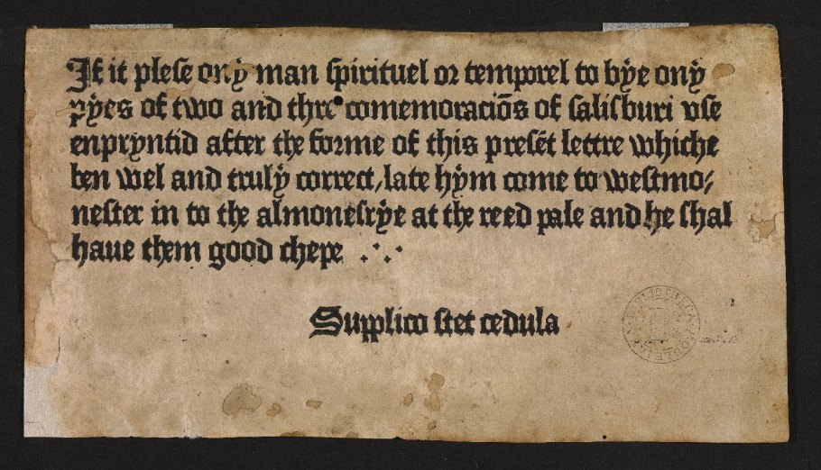
Figure 1 (Caxton, 1477)
1.3 Persuasion of Copywriters
During the industrial revolution in 1760, advertising rocketed with the benefit of the newspaper as a mass medium. Goods started to be produced and packaged at an unimaginable, or thought to be so, scale due to further advancements in technology. On that account, there were an abundance of products to go around. This pushed manufacturers who ran their businesses at home to pursue bigger and better goals in the new market and produce their goods. Manufacturers began to either set up new chains of retail outlets which consists of stores at several locations but share a common brand and management, or began to distribute their merchandise through wholesalers or retailers. (Tungate, 2013)

However, how were their goods going to stand out against everyone else’s goods? Thus, branding goods was an effective way to keep their products in their consumers’ minds. These brands were then able to be advertised to the mass to uplift sales. Where was the creativity? The most influential individual at the time was a copywriter named John E Powers. He is quoted as ‘the father of creative advertising’ according to Advertising Age. His backstory seems to be anonymous but by the late 1890s, he was earning 100 USD a day as a commercial writer. What made him so different from the rest of the copywriters at the time were his opinions and values. Powers believed in honesty and simple speaking, claiming that ‘fine writing is offensive.’ (Tungate, 2013)
He was once hired by a Pittsburgh clothing company that was on the verge of bankruptcy: ‘There is only one way out,’ Powers told his client, ‘tell the truth. The only way salvation lies in large and immediate sales.’ The resulting ad read: ‘We are bankrupt. This announcement will bring our creditors down on our necks. But if you come and buy tomorrow we shall have the money to meet them. If not we will go to the wall.’ Impressed by the directness of the ad, customers rushed to save the store. (Tungate, 2013)

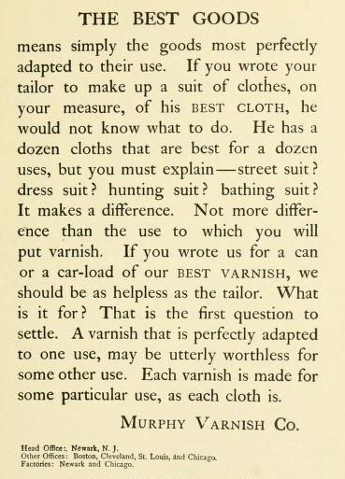
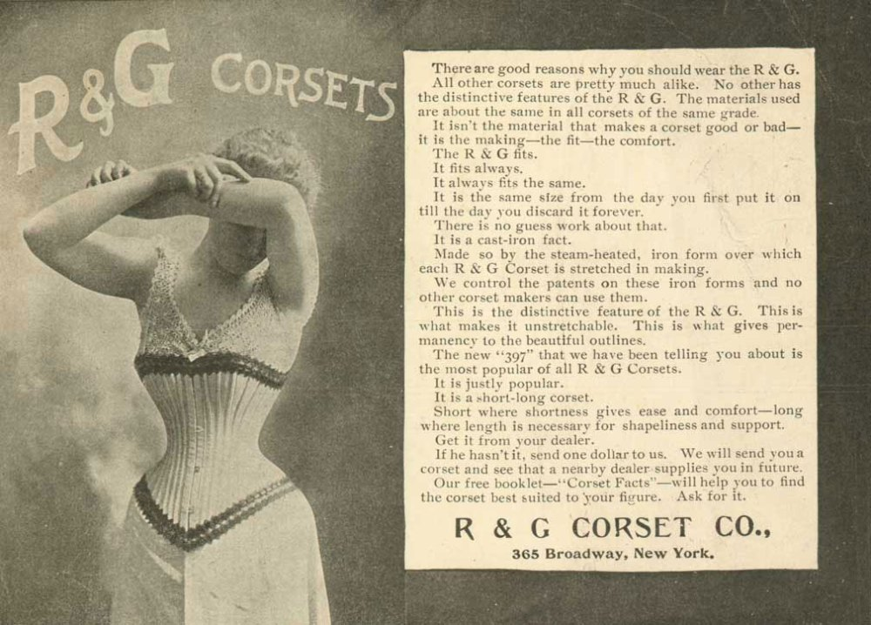
Many talented people rose to the occasion because of Powers such as, Charles Austin Bates. He was a remarkable copywriter who established his own company and gave himself the position of Ad-Smith. Bates became the first professional advertising critic and little did he know at the time, soon to be become one of the most important figure in the history of advertising. A copywriter emerged following Powers, Earnest Elmo Calkins, but he was not just any copywriter, Calkins’ creativity pushed the boundaries of advertising to a whole new level. As a child, he caught measles resulting in him losing his hearing. Being deaf did not stop Calkins from taking on the world with his heightened visual sense. In 1897, Bates held a copy writing competition in which Calkins competed in and won. Calkins was then recruited by Bates to work for the agency; yet, Calkins found himself and the company’s art department feuding and disagreeing over projects and ideas of how advertisements should be done. He wanted to change the way ads were presented to the public, steering away from the plain, boring to look at, copy. He learnt copy was not enough to entice people anymore. He came to the realization that consumers needed visuals to make them stop and stare. On the other hand, Bates was reluctant to change and did not want to give up the way he ran things. He did not allow Calkins to explore ideas that would be potentially costly for the company; therefore, Calkins ventured off to set up his own agency where he designed ads for clients (Figure 3) directly rather than just writing and pasting into articles. (Tungate, 2013)
Figure 3 (Powers, 1886)
Figure 3 (Calkins, 1899)

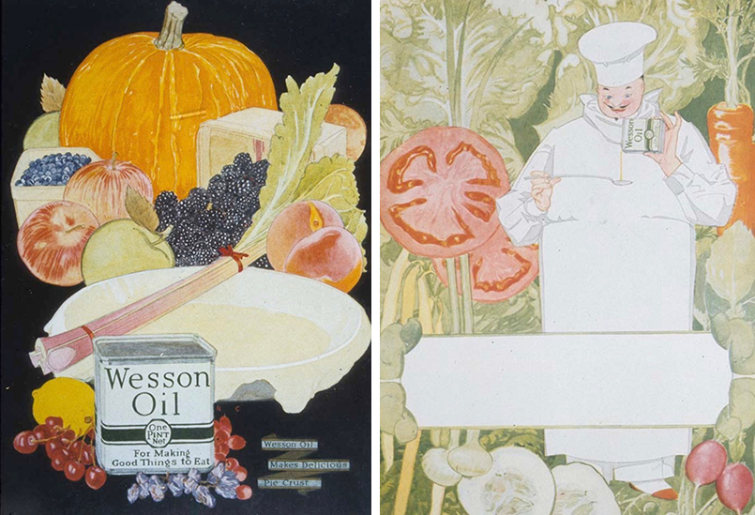
The progression of printing colour developed in the 1920s. Images, illustrations with an art-deco twist attracted consumers around the world. (Figure 4) Advertising was now very different to what it had been, steering away from the traditional black and white, line art style. Advert campaigns however, still used lengthy texts alongside their illustrations, but no matter how inspiring the text was, sales began to drop again and something new had to be done to capture the attention of their audience back. (Soler, 2013)
Figure 4 (Calkins, 1928)

1.4 The Television
The television was first introduced to the public in the mid 1930s. The machine was proposed worldwide by various thinkers and corporations; those who succeeded in producing silhouette images were acclaimed inventors of the television. Therefore, several people were thought to be the inventor in different countries. (BBC, 2018) “Thus, the French say both Belin and Barthelemy were the inventors of television; the Japanese believe it was Takayanagi; the Russians say Boris Rosing; the Germans either Nipkow or Karolus; the Hungarians von Mihaly; in the USA most people believe it was either Jenkins or Farnsworth; and in the UK we have the choice of Campbell-Swinton for the concept, or John Logie Baird for television's practical demonstration.” (BBC, 2018)

In 1941, the first television advert was broadcasted in America before American baseball teams, the Brooklyn Dodgers and the Philadelphia Phillies, played each other. The advert was for, Bulova, a clock and watch company. Fast forward to the 1960s, this is when the creative revolution changed how the world advertised products by playing with their consumers’ emotions. Up to the 60s, it was just finding a reason to buy a product. ‘Reason advertising’ was not effective for long and soon did not entice many people. What drives people to act on something? Is it emotion? Emotion may not always push the right action but action all the same. (Soler, 2013) Advertisers were now thinking how they can make their audience feel a certain way. Happy, sad, curious, brave, or even strong? A new standard was set in the world of advertising. (Gallegos, 2016) A popular advertising communicator, George Lois, known for his marketing miracles that stirred innovation and change, related advertising to some sort of poisonous gas.
Advertising is poison gas. The important thing is got to be that you implant an idea out there and everybody in a very human way understands it, grasps it, and is excited by it. If that end result doesn’t happen, I don’t care how beautiful I think something is, or how exciting the language is, if people don’t react, I’ve struck out. (George Lois, n.d.)

1.5 Brand Loyalty
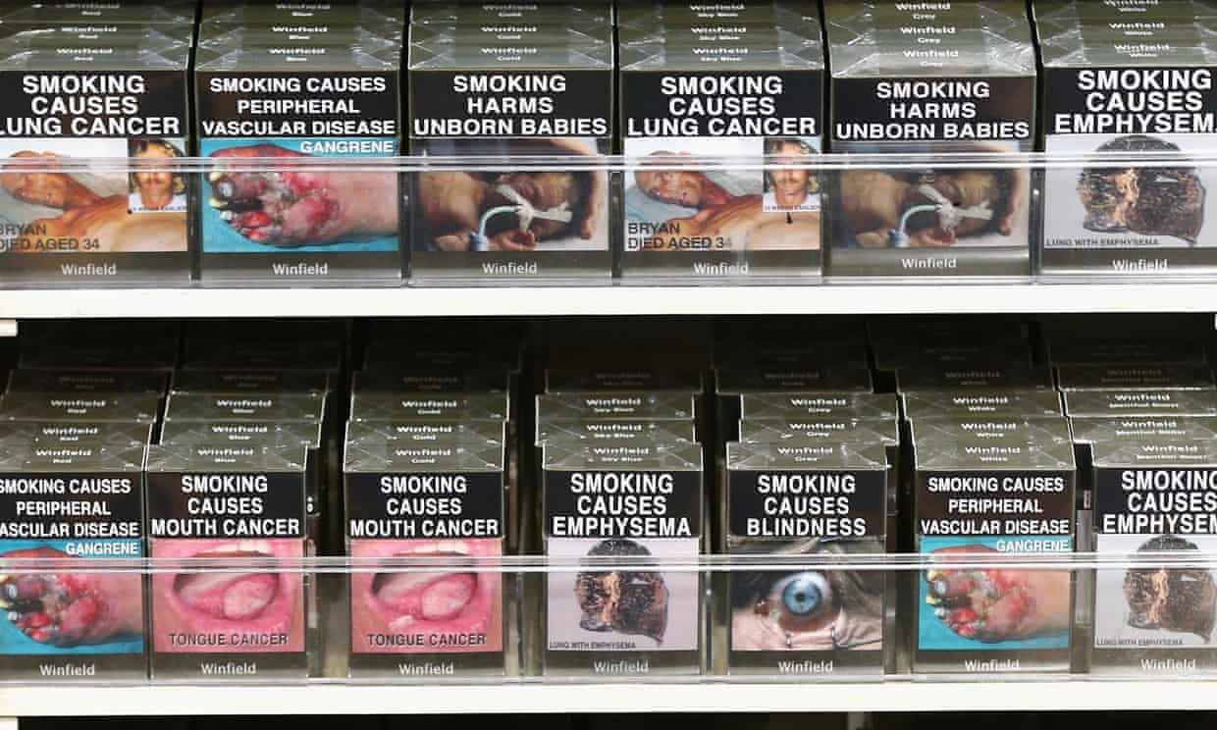

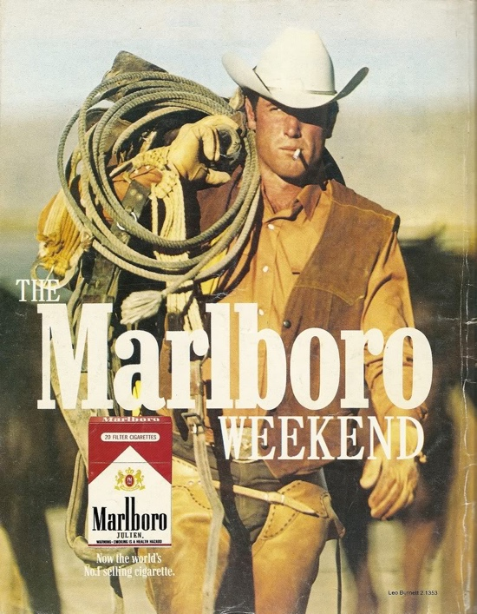
Advertising reached an all-time high due to the invention of the television. Brands wanted to establish a connection between them and their target audience. Thus, Characters were created and built around products to sell them. Mainly celebrities, that people looked up to, were used in adverts. (Gallegos, 2016) A good example would be Marlboro, a cigarette company, and their character, Marlboro Man. Brand loyalty was such a new concept, cigarette companies wanted to make sure they were the first ones you bought and smoked. Ever since the public found out cigarettes caused cancer in the 1950s, it was very important cigarette companies gained a connection with their target audience, distracting consumers from the obvious faustian bargain that eventually, their product could kill you. Companies struggled for survival, but nobody was better at the act of persuasion than Marlboro. (Coffee Break, 2016) Marlboro’s cigarette packaging and logo is so recognizable till today, even with the cigarette advert ban in 1970 and the standardized packaging legislation introduced in 2016. Cigarette companies now must package their cigarettes (Figure 5) in a pantone 448 C opaque couché color box with health risks and warnings covering the package. (Maynard, 2016) How did Marlboro do it? In 1847, Philip Morris started the company and aimed smoking towards women. It worked for a while, but that did not have as much of an effect on their sales in the long run. With talk of lung cancer and the risks of smoking came about in the 1950s, Marlboro scrapped the idea and focused on their brand loyalty. Switching the target audience to men, Marlboro made a key move that would change the advertising game forever. They became the first lifestyle advertisers. Most people are familiar with lifestyle advertising today, and might not even realize it. It is when a company tries to persuade their audience to buy into something for a reason more than just to have the product. This could be in the form of trying to sell a feeling, identity, characteristic, satisfaction, and the list goes on. For example, energy drinks like Red Bull try to sell athleticism, cameras like GoPro (Figure 6) try to sell a sense of adventure, soft drinks like Coke-Cola try to sell joy, Cars like Volkswagen try to sell love and security. This concept steered away from factual adverts that were originally just product orientated. So how did Marlboro achieve this? Targeting men, Marlboro created a character called Marlboro Man, a handsome cowboy who was manly, hardworking, and free. (Figure 7) The actual cigarette got less screen time and the focus was shifted to the feeling the cigarette gives you. They wanted men to feel like they could be Marlboro Man with a cigarette. Marlboro owned less than 1% of the market, and through this campaign, became the world’s 4th largest cigarette company in a year. Within 4 years, Marlboro became the world’s leading cigarette company and it has remained that way for several years. (Coffee Break, 2016)
Figure 5 (Spencer, 2016) Cigarettes in store
Figure 6 (Flanagan, 2012)
Figure 7 (Morris, 1968)

Chapter 2: Advertising Today
2.1 Risky Business

Products are no longer the centerpiece for advertisement. It is how a brand makes you feel and the connection you have with a brand. A popular example would be the chocolate brand, Cadbury’s 2007 advert called “Gorilla.” (Figure 8) It did not show the product once throughout the whole 90 second advert. There was no dialogue, just a man in an animatronic gorilla, some drums, and the song In the Air Tonight by Phil Collins. Imagine pitching that idea. Phil Rumbol, newly marketing director for Cadbury, said it was the hardest concept he’s ever had to sell. Despite almost not making it, Gorilla was aired and sales were increased by 10%. (Fleming, 2018) The brief was, get the love back, and Cadbury succeeded. Lee Rolston, part of Cadbury’s marketing team said, “We sensed from all the research we were doing that, although people were still talking about their love for Dairy Milk, it felt a bit passive. A bit like the comfy sweater you keep at the back of the wardrobe that you’ll never throw out but you start wearing less and less.” (D&AD, 2018) Cadbury wanted everyone to feel part of a brand that was cool, innovative, and humorous. The idea of a drum-playing gorilla was risky and unique. People were able to make their own responses to the advert through spoofs or parodies of it, which made it more interactive in a way, and was just more advertisement in itself. On the internet, there are over 300 different spoofs or parodies of the advert circulating today. (Gallegos, 2016)
Figure 8 (Cabral, 2007)

2.2 The Internet
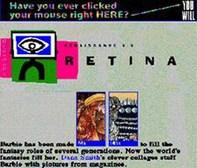
In 1994, it was just the beginning for advertising on the internet. Starting off from the first ever search engine, Yahoo!, and the first online magazine, HotWired, which included banner ads. (Figure 9) However, nowadays banner ads are an ineffective method of advertising on the internet. Most users tend to avoid and ignore banners. (Young, 2000)
Figure 9 (HotWired, 1994)
Our research suggests that the reason why click‐through rates are low is that surfers avoid looking at banner ads during their online activities. This implies that the larger part of a surfer's processing of banners will probably be done at the pre-attentive level. If such is the case, click-through rate is an ineffective measure of banner ad performance. (Drèze & Hussherr, 2003)

Advertisers and companies can target the right audience for a specific brand now through the internet. They have access to statistics and information that can measure responses instantly to an ad. Previously, advertising was all about reminding people this product exists and you can find it at this store. Now, with the use of the internet, potential customers go from awareness, to temptation, to transaction in a matter of seconds. For example, a jewelry company advert appears on a user’s screen, advertising the newest collection. The user can click on the advert and be directly transferred onto the brand’s website where they can be tempted by their products and hopefully make a purchase. The entire process could take up to just 5 minutes. (Young, 2000)

2.3 Social Media
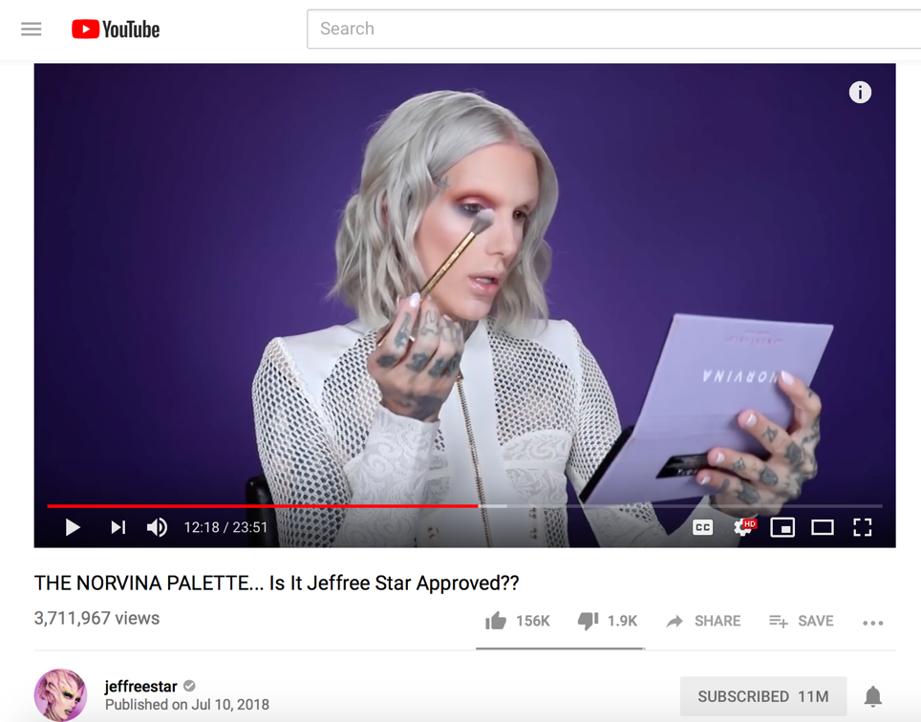
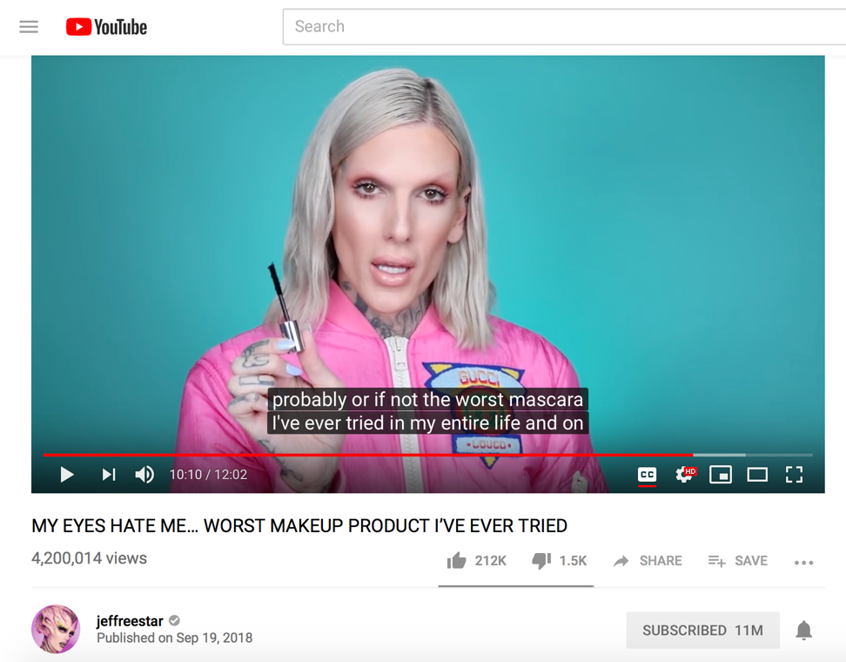
Today, plenty of advertisements and brands can be seen on social media, an online communication platform used for public input, interactions, and content sharing. Facebook, Twitter, LinkedIn, YouTube, and Instagram are a few examples. (Rouse, 2016) Ads can target users by personal, professional, behavioral, and demographic parameters. This is extremely helpful to know who the advertise to. Advertising to the right target audience can save companies some money because the other half of people who would usually ignore the ad, would not have it up on their feed. In 2012, Adobe’s study reported 68% of users found advertisements annoying and 51% found it distracting. (Lipschultz, 2018) Nowadays, a lot of us are influenced by people we follow on social media, such as, actors, comedians, you tubers, bloggers, and so on. Companies can send out PR (public relations) packages to people with a significant following, who then can promote and recommend the product to their followers. Not only is this advertising the product, it builds trust between the brand and the people, which is vital today. (Hatch, 2018) Some youtubers, people who make YouTube videos, rely heavily on making promotional videos as a career. For example, Jeffree Star has 11 million subscribers and counting on his channel. Most people trust his opinion and buy a product because he says to, or as he says, “Is it Jeffree Star approved?” (Figure 10)
Figure 10 ( (Jeffree Star, 2018)
Figure 11 (Jeffree Star, 2018)
Although this is great for exposure for brands to get their products out there in the world, it could also backfire. People with such a massive following, as Jeffree Star has, could impact a brand badly with just one bad review. (Figure 11) Anyone can post a review or make a comment about the product, but when someone does with a huge following it could damage a brand’s reputation in an instant. Consumer-to-Consumer communication limits how much a company can control in terms of what content and information is shared. (Mangold & Faulds, 2009)
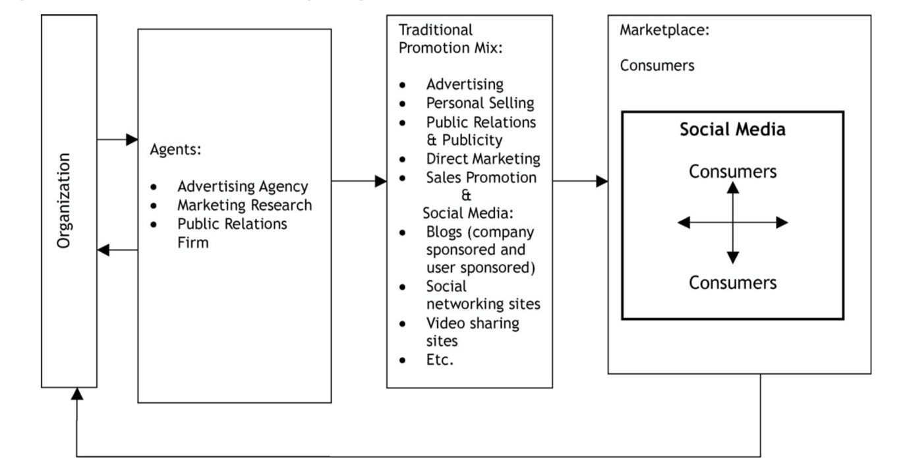
Figure 12 (Mangold & Faulds, 2009)
Kylie Cosmetics, a makeup brand created and owned by Kylie Jenner, shows what could be achieve with the use of social media as a marketing tool. In 2016, the traditional makeup market was down 1.3% whilst independent brands were up 42.7%, showing an obvious change in what consumers want today. Kylie saw an opportunity in the market to set up her own business in 2015. She was already popular on social media with 100 million Instagram followers, 24 million Twitter followers, and 20 million Facebook followers. Needless to say, Kylie has one of the biggest social following in the world. (Bova, 2018) She built her own makeup empire, with a net worth of 900 million dollars, in just 3 years. Kylie took advantage of her huge social media following and used it to advertise and promote her products rather than pay for advertisement space. There is no longer a need to pay for advertisement when you can just talk about your own brand to your millions of followers through social media in a matter of seconds. Her products are so desirable that they sell out within seconds on their release dates and because of that, it is almost like a challenge to acquire her products to tell everybody on social media you got it. The cycle continues through word of mouth then, and soon everyone is talking about it; which is where you want to be at today as a brand. In net profit, Kylie Cosmetics has made an estimated 230 million dollars. Kylie Jenner is on her way to becoming the next youngest self-made billionaire, a title once held by Bill Gates and Mark Zuckerberg. (Robehmed, 2018)

Conclusion
Brand identity has evolved so much as we have over the years. Brands are everywhere we look, all competing for the same thing, to be the most recognizable brand out there. We are so engrossed in brands it has almost become what defines us. We are searching deeper through the brand, past the logo, past the products. What brand supports my morals? What brand agrees with me? What brand gives me a satisfaction beyond a well-functioning product? We’ve started to ask questions; how, what, when, where? (Hatch, 2018)

So, what has advertising become? Brands are increasingly becoming part of culture to connect with the public rather than staying neutral as they normally would. Sharing opinions and values that not everyone agrees upon are uncharted territories with potential risks that could damage a brand severely. Advertising is starting to get controversial. Brands are willing to lose consumers for only consumers of the same opinions and value. In 2017, President of United States of America, Donald Trump voiced an immigration ban. Starbuck’s chairman and chief executive, Howard Schultz, took it upon himself to email his staff that he has set up a plan to hire 10,000 refugees over 5 years. He claimed he wanted to build bridges, not walls, with Mexico. (Kemp, 2017) Schultz wrote:
We are living in an unprecedented time, one in which we are witness to the conscience of our country, and the promise of the American Dream, being called into question. These uncertain times call for different measures and communication tools than we have used in the past.

It was a motion that got #BoycottStarbucks trending on social media platform, Twitter. However, numerous people backed Starbucks up for sharing their views on the situation. Chief executive, Brian Chesky, of Airbnb took it to Twitter to announce the brand is offering refugees free housing if they are not allowed into America. Google co-founder, Sergey Brin, also joined the conversation, protesting the ban, saying he is here because he is a refugee. Responses at such a personal and genuine magnitude highlights that brands seek something more than just selling a product now. Chief operating officer of global brand and innovation Safforn, David Perry, reckons brands are going to keep on getting involved in political issues occurring in the world: (Kemp, 2017)
As a brand, you have to ask yourself: 'Is this a fight you really want to take part in? Are you simply adding noise to an already saturated crowd or are you truly adding value?’

Social advertising runs along various topics such as, environmental issues, human rights, social injustice, and politics just to name a few. This form of advertising is used to spread awareness about an on-going problem happening around us. It highlights the consequences and future results of these problems if they keep going the way they are. The ads could go either way in terms of presentation; realistic and shocking, or light and humorous. (Bílá, 2011)

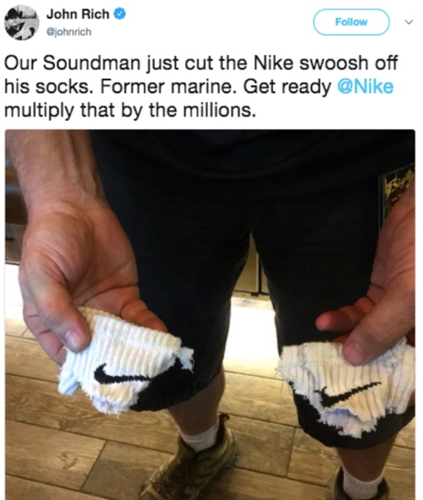
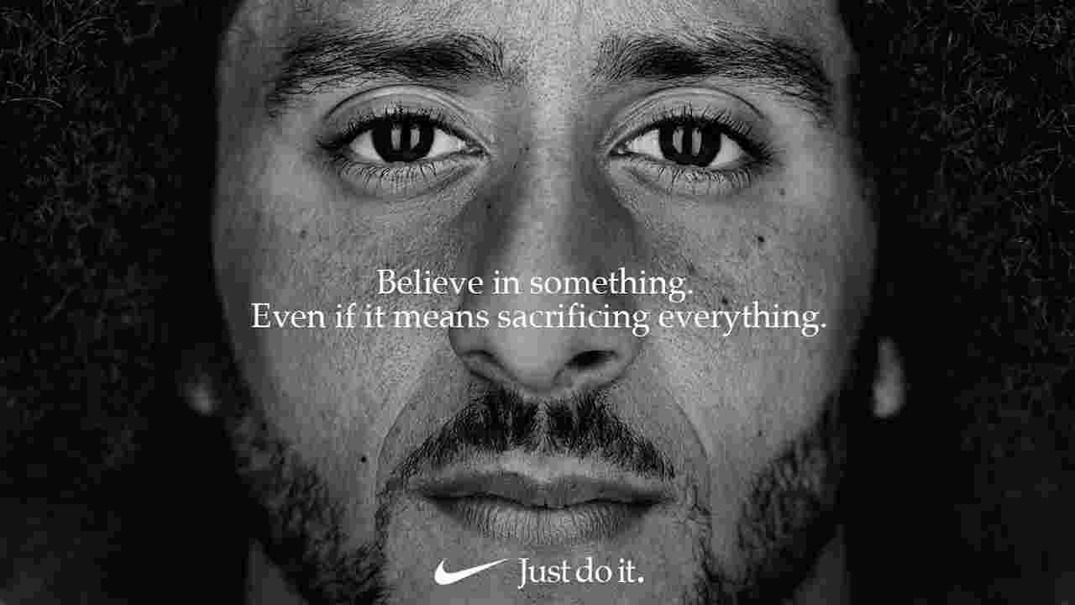
An example of a very controversial social ad campaign that split the public would be Nike’s recent 2018 Just Do It campaign celebrating 30 years of Just Do It campaigns. The 2018 campaign features former NFL player, Colin Kaepernick, who has been a polarizing figure since 2016. (Tyler, 2018) He lost his career for a silent protest he performed at one of his games. During the national anthem of the United States, Kaepernick refused to stand and kneeled instead. This protest was to bring awareness to police brutality, the recent killings of African Americans, Black Lives Matter, and other social injustices. Many have accused him of disrespecting the flag, country, and military. Therefore, Nike has taken a stand and has clearly made a social statement by featuring Kaepernick in their campaign. (Kelner, 2018) The ad displays various athletes with inspirational quotes to inspire people to push their boundaries to achieve greatness. However, the problem was Kaepernick’s featured quote: “Believe in something. Even if it means sacrificing everything.” This caused a divide in opinions on the campaign. Some people were so outraged with Nike, (Figure 14) they wanted to boycott the brand, going as far as burning their Nike trainers and posting it on social media for the public to witness. (Figure 15) (Tyler, 2018)
Figure 15 Video posted of someone burning their Nike trainers
Figure 14 Tweet posted
Figure 13 (Nike, 2018)

Despite the few disagreeing with the campaign, others backed Nike up, stating Kaepernick raised awareness for serious issues the world is dealing with today. Some people believe he was not disrespectful to the flag at all, in fact see the protest as respectful and powerful enough to spread the word without riots. Nike’s CEO, Mark Parker, claimed an up rise in sales since the campaign was launched. “Our brand strength is a key dimension that contributes to the ongoing momentum that we’re building across the Nike portfolio.” (Vizard, 2018)


Another example of a brand standing up for their values would be Iceland for their new Christmas ad campaign, No Palm Oil. The campaign has been announced the most powerful Christmas ad of 2018 by Kantar Millward Brown, a global leader in advertising development and market research. No Palm Oil raised awareness to deforestation due to palm oil plantations. The focus of the ad was an orangutan explaining he lost his home and family because the humans destroyed everything he holds dear. (Figure 16) This emotional ad is Iceland’s way of declaring they do no use palm oil in any of their products and will not sell products that do contain palm oil. The controversial ad campaign has been banned from being broadcasted on TV. The ad however, has been viewed online over 30 million times and counting. (Glenday, 2018) People are debating whether it should have been banned or whether the ad portrays Iceland’s values and should be able to reach consumers who have similar values, as well as, inform people of what they could be funding behind the scenes when buying certain products. A petition, with already 1 million signatures, has started so the ad can be broadcasted on TV in time for Christmas. (Doyle, 2018) Comments from the petition on Change.org: (Topps, 2018)
Figure 16 Screenshot from No Palm Oil advert (Iceland, 2018)
As a father of three who thinks this ad would help educate people about how their products are killing orangutans and their homes, I feel banning this advert is an injustice.

World issues like this should never be covered up from the public. There is nothing offensive or untrue in this advert and no good reason that I can see for banning it.

Because it's my planet. Because it's their planet. Because it's ours.

Brands are evolving into seemingly trustworthy businesses that are all wanting to win you over. Patagonia, an outdoor clothing and gear company, released an ad campaign called Worn Wear Stories in 2014. It won over the trust and loyalty to many consumers. The brand offers an unlimited warranty to their customers. Since it is an environmentally-friendly and resourceful brand, it made sense to fix repairs than replacing products in the long run. This campaign does not directly increase sales for Patagonia, but now consumers are choosing Patagonia over other brands because they built their brand identity. Why? Simply because the campaign holds true to what the brand values and willing to stand up for what they believe in. It is an act of courage that potential customers could also look up to. (Gallegos, 2016)

In conclusion, advertising and the way we communicate to one another has changed drastically over the years. Brands are constantly competing against one another to stay relevant in this world that is constantly evolving and changing. Advertising is the fuel used to keep our economy going by helping businesses to grow, but now advertising could be used for much more. We can tell a story, share opinions, agree, disagree, and even cause change. Brands are becoming so unpredictable; it is as if brands were almost robotic and now they are more human-like, with thoughts and opinions. A brand can represent who you are as a person in today’s society. Who do you wear? What does that represent? Where are you going? (Zhang, 2015) Emotional branding can be found in abundance nowadays. It has become an influential means of brand management. Emotional advertising is done to get a response, cause a reaction, change a mood, or establish consumer loyalty. The “buy, buy, buy” mentality has faded. (Gallegos, 2018)

List of Illustrations
Cabral, J., 2007. Gorilla. [Art] (Fallon London).
Calkins, E. E., 1899. R&G Corsets. [Art].
Calkins, E. E., 1928. Wesson Oil. [Art].
Caxton, W., 1477. Sarum Pie. [Art].
Jeffree Star, 2018. MY EYES HATE ME… WORST MAKEUP PRODUCT I’VE EVER TRIED. [Online]
Available at: https://www.youtube.com/watch?v=2rsXULPbAR0
[Accessed 09 December 2018].
Jeffree Star, 2018. THE NORVINA PALETTE... Is It Jeffree Star Approved??. [Online]
Available at: https://www.youtube.com/watch?v=pixA77hYteE&frags=pl%2Cwn
[Accessed 09 December 2018].
Morris, P., 1968. Marlboro Weekend. [Art] (Marlboro).
Nike, 2018. Just Do It. [Art] (Nike).
Powers, J. E., 1886. Murphy Varnish Co.. [Art].
Spencer, C., 2016. Standardised cigarette packs in Australia. [Art].

Bibliography
BBC, 2018. The Story of BBC Television. [Online]
Available at: https://www.bbc.co.uk/historyofthebbc/research/general/tvstory1
[Accessed 20 November 2018].
Bílá, Z., 2011. Social Advertising and its role in today’s Marketing Communications, s.l.: Tomas Bata University in Zlín.
Bova, T., 2018. Kylie Jenner. [Online]
Available at: https://www.entrepreneur.com/article/317001
[Accessed 09 December 2018].
Cabral, J., 2007. Gorilla. [Art] (Fallon London).
Calkins, E. E., 1899. R&G Corsets. [Art].
Calkins, E. E., 1928. Wesson Oil. [Art].
Caxton, W., 1477. Sarum Pie. [Art].
Coffee Break, 2016. How Marlboro Changed Advertising Forever. [Online]
Available at: https://www.youtube.com/watch?v=q3mlO2bzHV8
[Accessed 01 December 2018].
D&AD, 2018. Case Study: Cadbury Gorilla. [Online]
Available at: https://www.dandad.org/en/d-ad-cadbury-gorilla-case-study-insights/
[Accessed 03 December 2018].
Doyle, L., 2018. Iceland Christmas advert 2018 BANNED. [Online]
Available at: https://www.express.co.uk/news/uk/1043241/Iceland-Christmas-advert-2018-banned-palm-oil-why-was-Iceland-advert-banned
[Accessed 11 December 2018].
Drèze, X. & Hussherr, F., 2003. Internet advertising: Is anybody watching?. Wiley Periodicals, 31 October, 17(4), pp. 8-23.
Entrepreneur Media, 2018. Advertising. [Online]
Available at: https://www.entrepreneur.com/encyclopedia/advertising
[Accessed 20 September 2018].
Fleming, M., 2018. Cadbury Gorilla. [Online]
Available at: https://www.marketingweek.com/2018/06/14/cadbury-gorilla/
[Accessed 03 December 2018].
Gallegos, J. A., 2016. The History and Evolution of Advertising. [Online]
Available at: www.tintup.com/blog/history-evolution-advertising-marketing/
[Accessed 20 November 2018].
Gallegos, J. A., 2018. The Evolution and History of Content Marketing. [Online]
Available at: https://joseangelostudios.com/content-marketing-advertising-history/
[Accessed 11 December 2018].
Gazur, B., 2017. 10 Amazingly Ancient Advertisements. [Online]
Available at: http://listverse.com/2017/09/24/10-amazingly-ancient-advertisements/
[Accessed 22 September 2018].
George Lois, n.d. Biography. [Online]
Available at: www.georgelois.com/biography.html
[Accessed 20 November 2018].
Glenday, J., 2018. Iceland’s banned palm oil commercial named most ‘powerful’ Christmas ad. [Online]
Available at: https://www.thedrum.com/news/2018/12/04/iceland-s-banned-palm-oil-commercial-named-most-powerful-christmas-ad
[Accessed 11 December 2018].
Hatch, C., 2018. Understanding Internet Advertising. [Online]
Available at: https://www.disruptiveadvertising.com/marketing/internet-advertising/
[Accessed 09 December 2018].
History.com Editors, 2018. Printing Press. [Online]
Available at: https://www.history.com/topics/inventions/printing-press
[Accessed 02 October 2018].
Jeffree Star, 2018. MY EYES HATE ME… WORST MAKEUP PRODUCT I’VE EVER TRIED. [Online]
Available at: https://www.youtube.com/watch?v=2rsXULPbAR0
[Accessed 09 December 2018].
Jeffree Star, 2018. THE NORVINA PALETTE... Is It Jeffree Star Approved??. [Online]
Available at: https://www.youtube.com/watch?v=pixA77hYteE&frags=pl%2Cwn
[Accessed 09 December 2018].
Kelner, M., 2018. Colin Kaepernick. [Online]
Available at: https://www.theguardian.com/sport/2018/sep/04/nike-controversial-colin-kaepernick-campaign-divisive
[Accessed 10 December 2018].
Kemp, N., 2017. Why Brands Are Getting Political. [Online]
Available at: https://www.campaignlive.co.uk/article/why-brands-getting-political/1422951
[Accessed 09 December 2018].
Kwakkel, E., 2014. Medieval Spam. [Online]
Available at: https://medievalbooks.nl/2014/12/05/medieval-spam-the-oldest-advertisements-for-books/
[Accessed 02 October 2018].
Lipschultz, J. H., 2018. Social Media Communication. Second ed. New York: Routledge.
Mangold, W. G. & Faulds, D. J., 2009. Social media: The new hybrid element of the promotion mix. Business Horizons, August, 52(4), pp. 357-365 .
Maynard, O., 2016. Sifting The Evidence. [Online]
Available at: https://www.theguardian.com/science/sifting-the-evidence/2016/may/20/plain-standardised-cigarette-packaging-has-arrived-but-will-it-reduce-smoking
[Accessed 02 December 2018].
Morris, P., 1968. Marlboro Weekend. [Art] (Marlboro).
Nike, 2018. Just Do It. [Art] (Nike).
Powers, J. E., 1886. Murphy Varnish Co.. [Art].
Reading Manchester, 2011. From the Printing Revolution to the Reformation. [Online]
Available at: http://www.library.manchester.ac.uk/firstimpressions/From-Manuscript-to-Print/The-Explosion-of-Print/From-the-printing-revolution-to-the-Reformation/
[Accessed 05 11 2018].
Robehmed, N., 2018. How 20-Year-Old Kylie Jenner Built A $900 Million Fortune In Less Than 3 Years. [Online]
Available at: https://www.forbes.com/sites/forbesdigitalcovers/2018/07/11/how-20-year-old-kylie-jenner-built-a-900-million-fortune-in-less-than-3-years/#5519b3f3aa62
[Accessed 09 December 2018].
Rouse, M., 2016. Social Media. [Online]
Available at: https://whatis.techtarget.com/definition/social-media
[Accessed 06 December 2018].
Soler, M., 2013. Advertising's Past, Present and Future: A Viewpoint. [Online]
Available at: https://martinsoler.com/insights/advertisings-past-present-and-future-a-viewpoint
[Accessed 20 November 2018].
Spencer, C., 2016. Standardised cigarette packs in Australia. [Art].
Topps, M., 2018. Release Iceland’s banned Christmas advert on TV #NoPalmOilChristmas. [Online]
Available at: https://www.change.org/p/release-iceland-s-banned-christmas-advert-on-tv-nopalmoilchristmas/w?source_location=petition_show
[Accessed 11 December 2018].
Tungate, M., 2013. Adland: A Global History of Advertising. 2nd Edition ed. London: Kogan Page.
Tyler, J., 2018. Nike Ads Make Social Statements. [Online]
Available at: https://www.businessinsider.com/nike-ads-make-social-statements-2018-9?r=US&IR=T
[Accessed 10 December 2018].
Vizard, S., 2018. Nike ‘proud’ of Colin Kaepernick ad. [Online]
Available at: https://www.marketingweek.com/2018/09/26/nike-proud-of-colin-kaepernick-ad-campaign/
[Accessed 10 December 2018].
Young, S., 2000. Working Knowledge. [Online]
Available at: https://hbswk.hbs.edu/item/getting-the-message-how-the-internet-is-changing-advertising
[Accessed 06 December 2018].
Zhang, Y., 2015. The Impact of Brand Image on Consumer Behavior. Business and Management, 16 January, Volume 3, pp. 58-62.

