Zack Cleaver - 2502510
UWTSD

Exercise Training (Personal Trainer) Assignment

Client Profile & Needs Analysis
The focus of this report is a 57-year-old male client who participated in a personal training program designed to support long-term health goals and improve fitness. Preparing for a half-marathon charity walk in June 2026 was the client's main goal. Additionally, the client had lost quite a bit of weight, roughly 42 pounds and was hoping to keep it off while increasing their confidence and overall fitness.

Regarding health, the client underwent a total right knee replacement approximately 18 months prior to the session. Deeper knee flexion revealed multiple limitations, despite the client's high level of confidence and strong day-to-day activity. This showed how important it is to use a controlled, low-impact training strategy to reduce the risk of injury while encouraging progress.

The client had recently resumed exercising at the gym and was generally active, regularly participating in walking-based activities, including longer walks on weekends. This showed an acceptable base level of fitness, especially in cardiovascular endurance, but it also made clear that to meet the physical demands of the charity walk, muscular strength and joint stability needed improvement.

The development of cardiovascular endurance, lower-body strength, and general functional fitness was highlighted as a priority area by a requirements analysis. These elements were necessary to ensure the customer could complete the event safely and comfortably. A pre-exercise screening method was used to collect information, including completing a PAR-Q and a consultation form, and taking basic health measurements such as blood pressure, height, and weight (see Appendices A). These methods made it possible to create a training program that was safe, efficient, and customised.

Programme Design
The primary goals of the six-week training program were to increase the client's cardiovascular endurance in preparation for a half-marathon charity walk, sustain past weight loss, and improve general strength and knee stability. Age, prior knee replacement, current exercise levels, and personal preferences were all taken into consideration while creating the program.

The program was structured to include both supervised and independent training sessions, with a recommended frequency of two to three sessions per week (see Appendix B). This approach aligns with general exercise guidelines, which include regular participation in resistance and aerobic training in order to improve overall fitness and health (American College of Sports Medicine, n.d.). Proper recovery was also made possible by this structure, which is crucial given the client's age and injury history.

To ensure the training accurately matched the physical demands of the planned charity walk, exercises were selected using the principle of specificity. Low-impact cardiovascular exercises, including upright cycling, rowing, and inclined treadmill walking, were highlighted. The strength and conditioning literature supports these alternative training techniques, emphasising their ability to maintain cardiovascular fitness while reducing joint stress (Haff and Triplett, 2016). The client's previous knee replacement made this very essential.

To increase muscle strength and joint stability, resistance training was added to cardiovascular training. Fitness programming concepts, which emphasise the value of strength training in improving physical performance and reducing injury risk, support this method (Clayton et al., 2015). Exercises that promote lower-body strength while keeping joint safety include leg presses, step-ups, and glute bridges.

Furthermore, to ensure ongoing adaptation, the program employed the principle of progressive overload. At first, the client found the workouts suitably difficult; the training structure remained the same. The length of cardiovascular exercises, resistance, and repetitions were then progressively increased. This method ensured that fitness gains were achieved without too much stress on the knee joint. Each session also had a set structure, including a warm-up to prepare the body, a main phase with resistance and aerobic training, and a cool-down to promote recovery, all of which were safe, efficient, and aligned with the client's objectives.

Additionally, the program was tailored to each client's unique requirements and preferences. The client's age, prior knee replacement, and desire for low-impact cardiovascular training were taken into account. Exercises like cycling and incline walking were prioritised over high-impact sports like running to reduce joint stress. Moreover, the client was able to monitor and control exercise intensity during solo sessions using the Rating of Perceived Exertion (RPE), which improved both long-term program commitment and safety.

Due to unexpected circumstances, including obstacles to client availability and a personal ankle injury, my ability to provide practical sessions was severely hindered. This was a significant challenge to the entire training program, as face-to-face monitoring was less effective. As a result, changes were implemented to ensure continuous support for the clientele and growth. Programme cards with detailed instructions on how to properly progress exercises by adjusting repetitions, resistance, and duration were provided for independent training. Keep the client involved and confident in their ability to finish sessions on their own. Communication was maintained to provide direction and reassurance. Despite reduced control, this strategy allowed the customer to continue pursuing their objectives.

All things considered, the training program was designed around key training principles, including individualisation, progressive overload, and specificity. By using regulated-resistance exercises and low-impact aerobic workouts, the client improved their fitness without placing excessive stress on their knee joint. The client was encouraged to actively participate in their own growth, and commitment over time was encouraged by the combination of scheduled sessions and individual training.
Reflection
Introduction
This section analyses the personal training sessions that were conducted, emphasising the successes, difficulties, and solutions. Additionally, it evaluates how well the client was supported throughout the program.

What Went Well
As a whole, the first few sessions were successful in building a strong working relationship with the client and ensuring that the exercises were appropriate to their needs. Low-impact cardiovascular activities such as incline walking and cycling proved effective, as the client performed the exercises confidently while reducing stress on the knee joint. Resistance exercises, such as the leg press and glute bridges, were also useful in increasing strength and stability, both of which are required to support the knee. Clear communication and exercise demonstrations helped the client understand how to perform activities safely, increasing their confidence and participation.

Challenges Encountered
However, an important hurdle I faced during the program was an unexpected ankle injury that made it difficult for me to do in-person sessions. Additionally, the client's availability prevented them from committing to additional sessions. These difficulties affected the program's general structure and limited the number of supervised sessions that could be conducted. These adjustments were made to ensure the client's ongoing assistance. There were program cards with detailed instructions for completing and advancing workouts on one's own. To keep the client interested and confident enough to finish sessions without supervision, communication was kept open. According to Deci and Ryan (2000), this strategy encouraged the client's independence and motivation, which are crucial for sustained commitment to physical activity.

Adaptations and Support Strategies
Changes were also introduced in response to the client's performance and comments. Since the client initially thought the exercises were adequately hard, the program was not advanced too quickly. Instead, steady improvement was encouraged by increasing the number of repetitions and resistance as needed. This made it possible for the client to safely increase their exercise level without overstressing their knee joint, and movements within a safe and comfortable range. Workouts were also selected and tweaked to stop deep knee flexion.

Modifications to the Programme
Additionally, adjustments were made in response to the client's performance and comments. The program was not increased too quickly because the customer first felt the workouts were sufficiently challenging. Rather, increasing the amount of repetitions and resistance as necessary promoted consistent development. The client was able to safely increase their exercise level without putting excessive strain on their knee joint, thanks to this. Movements that are both safe and comfortable. Workouts were chosen and modified to avoid deep knee flexion.

Evaluation and Future Improvements
This experience made clear how important flexibility is in personal training, especially when handling unexpected challenges like client availability and injuries. It showed that training programs don't always go as planned and that it's key to maintain flexibility while still helping the client's development. One important lesson learned was how crucial it was to communicate regularly to keep the client engaged and confident throughout individual sessions.

In the future, I would like to improve emergency planning by developing an alternative session formats in advance, allowing training to continue more effectively during periods when face-to-face sessions are not possible. Ensure that improvements can continue to be used safely and effectively, I would like to further develop my online monitoring skills. This might include more organised feedback or regular meetings to ensure accountability.

Overall, this experience has helped me better understand client-centred practice by highlighting how important it is to prioritise safety, communication, and flexibility to promote long-term commitment and positive outcomes in personal training.

Word Count: 1432

References:

“Essentials of Strength Training and Conditioning.” Google Books, Human Kinetics, 2016, books.google.co.uk/books?hl=en&lr=&id=WxIxEAAAQBAJ&oi=fnd&pg=PR1&dq=Essentials+of+Strength+Training+and+Conditioning&ots=32B2EjnDSD&sig=kRW5gViyHvLgYidjZdPS9ocBep8#v=onepage&q=Essentials%20of%20Strength%20Training%20and%20Conditioning&f=false. [Accessed 29 Apr. 2026].

Clayton, N., Drake, J., Larkin, S., Linkul, R., Martino, M., Nutting, M. and Tumminello, N. (2015). FOUNDATIONS OF FITNESS PROGRAMMING. [online] National Strength and Conditioning Association (NSCA). USA: National Strength and Conditioning Association. Available at: https://www.nsca.com/contentassets/8323553f698a466a98220b21d9eb9a65/foundationsoffitnessprogramming_201508.pdf [Accessed 29 Apr. 2026].

American College of Sports Medicine. “Physical Activity Guidelines.” American College of Sports Medicine, American College of Sports Medicine, acsm.org/education-resources/trending-topics-resources/physical-activity-guidelines/. [Accessed 29 Apr. 2026].

Appendices:
Appendix A - Consultation Form / Health Screening
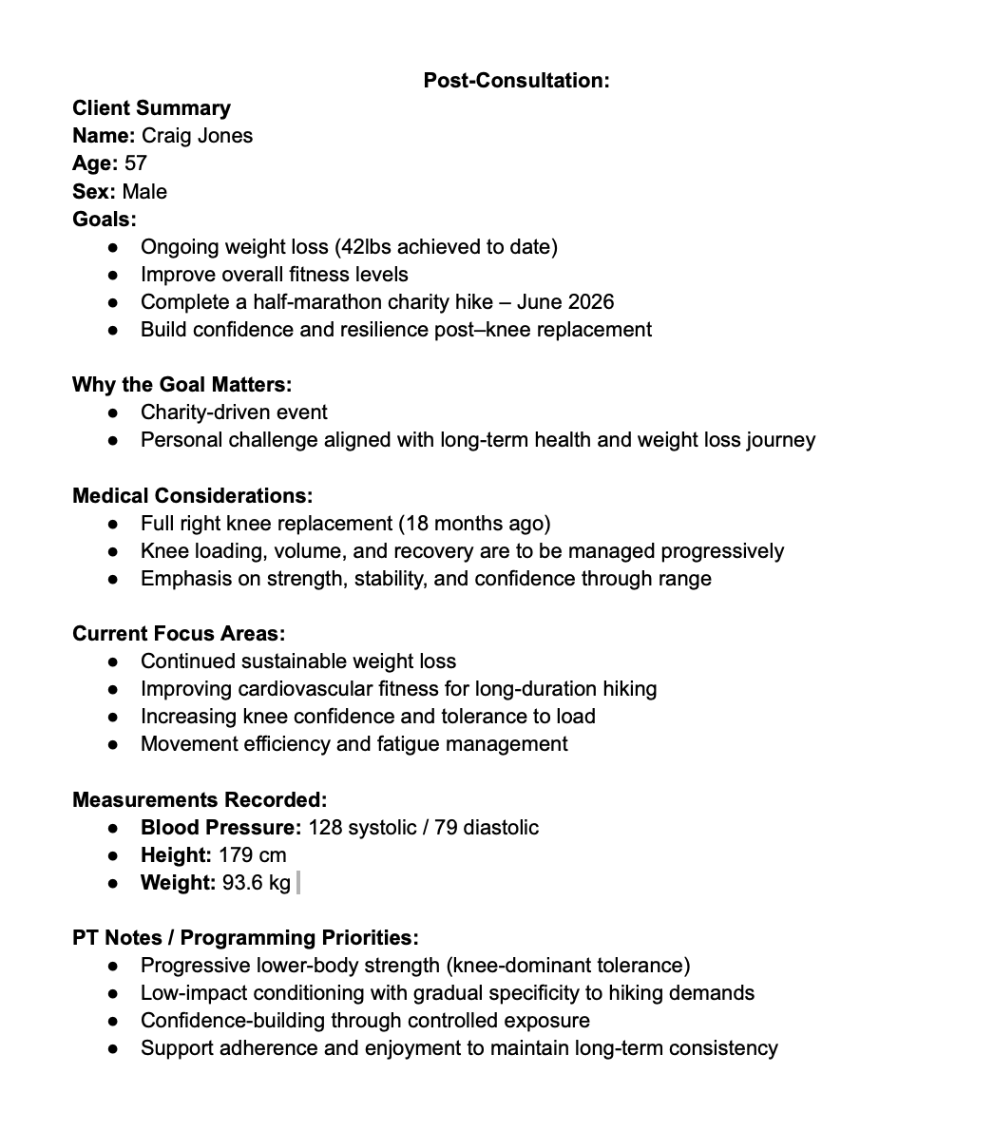
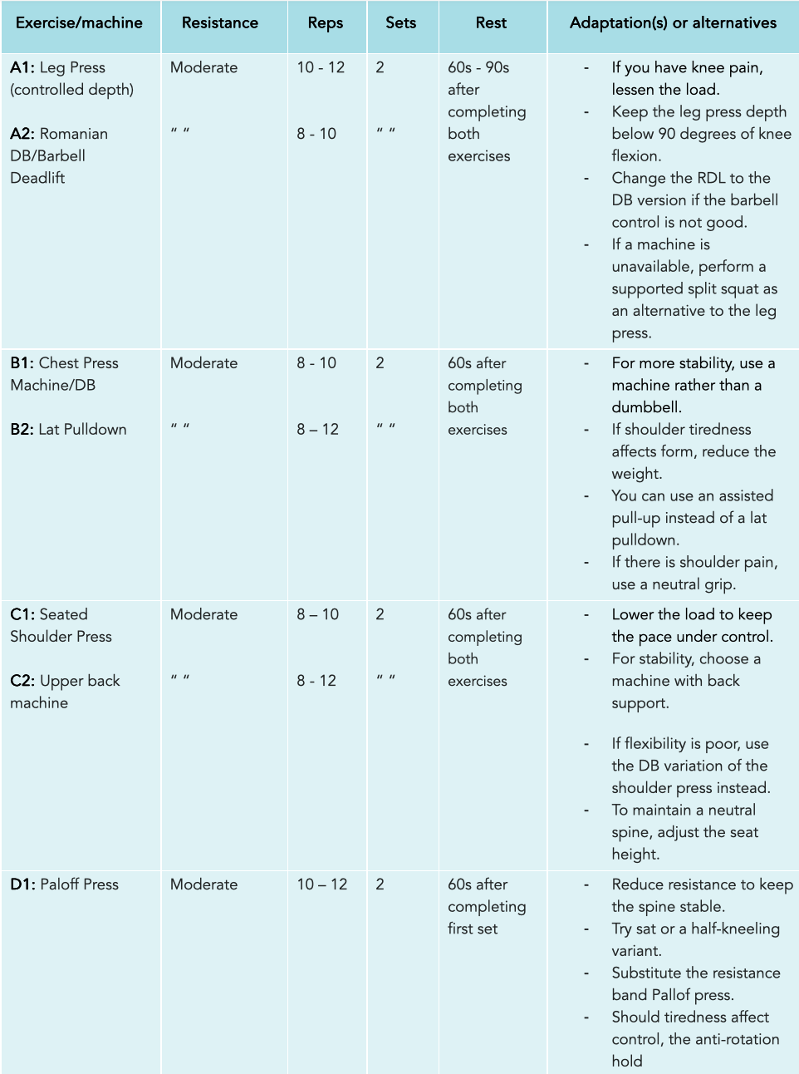
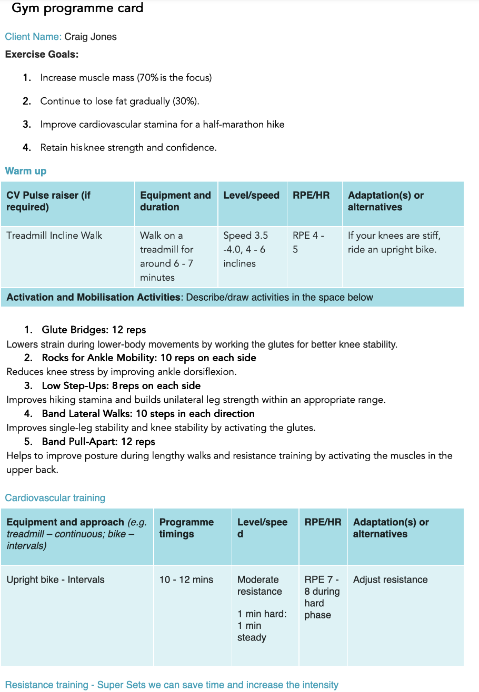
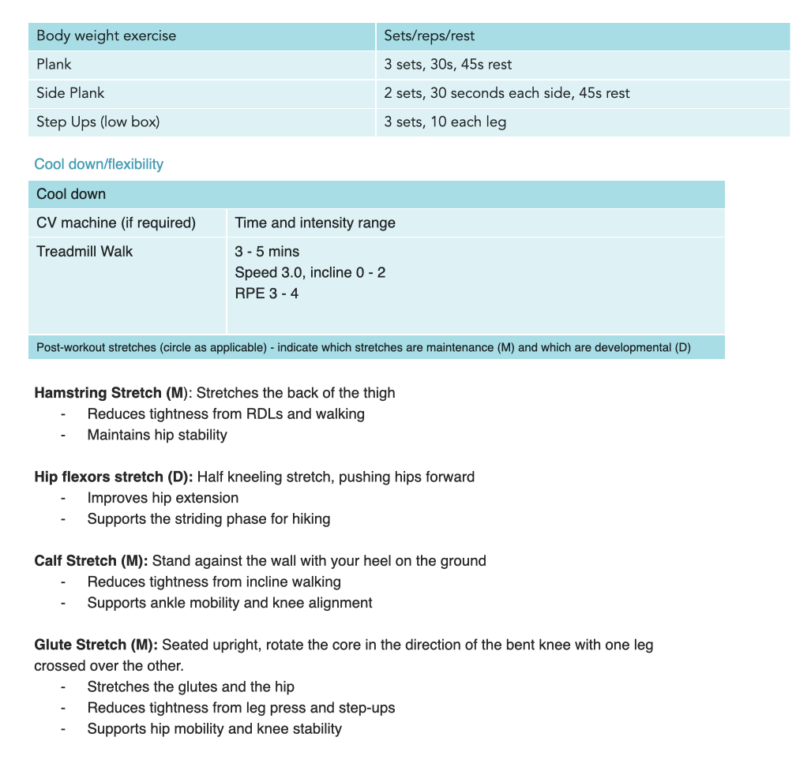
Appendix B - Example Programme Card (Week 1)

