Trials Design: Testing the Accuracy and Warhead Performance of an Enhanced Paveway II Bomb | July 1  2017
This paper discusses the possible conduct and safety implications of 2 none sequential trials activities to determine the accuracy and warhead performance of an Enhanced Paveway II on test ranges within the UK. The author has identified the potential risks and hazards of delivery, and discussed mitigation and control measures that could be introduced to protect the public.

Table of Contents
1. Introduction 2
1.1. Aims and Objectives 2
1.2. Background 2
1.3. General Specifications: UK Enhanced Paveway II (EPWII) 1000_{ib} Bomb 3
1.4. Command Systems and Guidance 3
1.5. Munition Specific Risks in the Test Range Environment 5
2. Trial Considerations 7
2.1. Test Location 7
2.2. Target Systems 8
2.3. Range Control and Trial Safety 10
2.4. Instrumentation and Data Capture 11
3. Conclusions 12
4. Bibliography and References 12

Introduction

Aims and Objectives
To consider the primary factors involved when evaluating the accuracy and warhead performance of the UK in-service Enhanced Paveway II Bomb. The author will provide the assessor with his opinions on designing and specifying a trials environment to meet the following criteria.
Testing must record the following observations:
- Recording of the laser spot positions on the selected target
- Measurement of the distance between the laser spot and the point of munition warhead detonation must be provided
- The fragmentation pattern of the detonated warhead must be provided.
When designing the trials activity the author will attempt through target system selection, localised geography and appropriate policy, procedure and control measures to minimise the effects of introduced laser hazards to both public and personnel.

Background
The UK test range environment offers a wide variety of large scale military testing with complex weapon systems. Ranges operated by QinetiQ are spread across the length and breadth of the nation. Each facility run on behalf of the MOD (Ministry of Defence) has unique geographical benefits and structural assets, which allow munitions and military equipment, on platforms of all sizes, to be tested throughout the life cycle process using the CADMID model implemented by MOD procurement and planners.
Evaluating the warhead performance and accuracy of a Paveway II bomb is too carried out by a stringent testing process known as a trial. Delivery of such an activity on a QinetiQ range is governed by the Hazardous Activity Management process (HAM) to ensure the safety and security of personnel (public and staff), equipment and environment while complying with all legal regulation introduced by from the HSE (Health and Safety Executive).
Guidance is also taken from the JSP (Joint Service Publication). The most pertinent to consider for an activity of this nature in the authors opinion being JSP’s 403 (Hand book of Defence Land Range Safety), 520 (Safety and Environmental Management of Ordnance, Munitions and Explosives over the Equipment Acquisition Cycle) and 392, (Military Laser Safety). (1)

General Specifications: UK Enhanced Paveway II (EPWII) 1000_{ib} Bomb
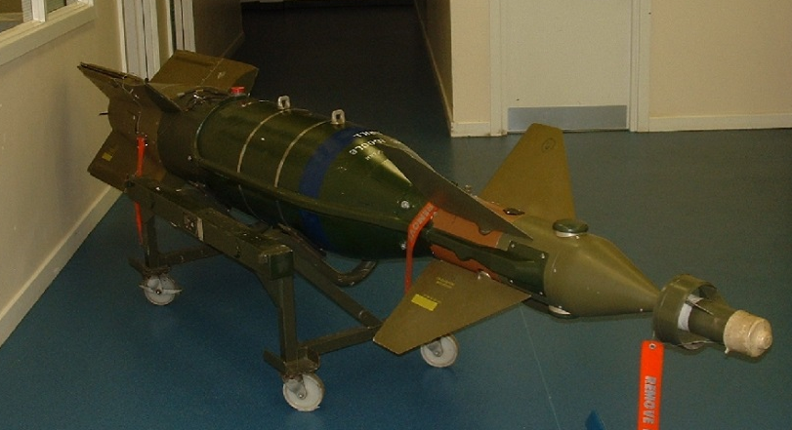

Fig 1: The image shown is an inert GBU-48 EPWII Bomb

Length | 3.68 m
Diameter/Width | 0.42 m
Fin Span | 1.6 m
Weight | 545 kg
Warhead | MK-83, 1000 lb, General Purpose Bomb
Explosive | PBX109 (RDX based)
Net Explosive Quantity | Approximately 200 Kg
Guidance System | Laser Seeker & GPS-Aided Inertial Navigation System (GAINS)
Data Source | https://www.raf.mod.uk/equipment/enhanced-paveway2-and-3.cfm

Raytheon’s business model when developing the Paveway range was to produce cost effective guidance systems for pre-existing bomb designs, effectively saving development and testing costs that would be associated by producing entirely new weapon. Logistically this allowed developed nations with pre-existing stockpiles of ordnance to retrofit their stores at a fraction of the cost and over a shorter time frame.

Command Systems and Guidance
The EPWII bomb was brought into service by the RAF in 2001 to overcome identified short comings with previous iterations of the weapon system. The lack of all-weather capability was identified by an MOD select committee and reported as severely damaging the operational effectiveness of the RAF in the conflict in Kosovo in 1999. Produced by Raytheon the EPWII was designed to strike static, mobile and armored targets accurately in all weathers and 24 hours a day. (2)
Based on the original Paveway II to supplement the laser guidance system an adapted and enhanced targeting module was introduced to the bomb, containing the Global Positioning System with Aided Inertial Navigation System (GAINS).
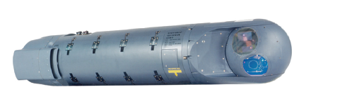
The semi active seeker used by the EPWII laser guidance system relies on the target being ‘painted’ by an outside source. Currently from the air this function is provided by the Rafael Litening III targeting pod. The target pod operates using a Class 4, Neodymium yttrium aluminium garnet laser. This will be an important safety consideration to consider in the test range environment.

Fig 2: The image shown is a Litening III targeting pod.g Pod

Below are the specifications of the Litening III designator pod sourced from Ultra Electronics promotional material (http://www.ultra-cis.com/resourses/Litening%20III%20-%20secured.pdf)
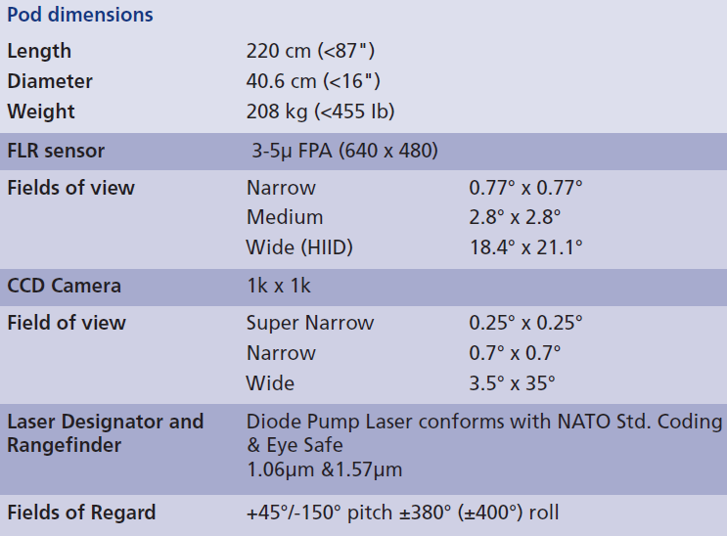

Laser light is emitted from the designator pod at a wavelength of 1.06μm; the seeker located on the EPWII bomb’s nose detects the reflected emission on approach to target. Using gas actuated canards located near the front of the bomb it adjusts its descent trajectory to align with the painted location. The cyclic nature of the internal computer will determine the rate at which the bomb can change its trajectory, sufficient internal processing power is required ensure accurate target impact.
This control type however is not infallible due to the requirement maintaining laser designation until final impact, potentially putting the designating platform at risk of return fire from ground based surface to air missiles or triple A. Another susceptibility of this control system as identified by the RAF in Kosovo is the potential of atmospheric interference due to increased moisture content in the air (rain). Reflection and refraction by the water droplets can scatter and disperse the laser emission causing the bomb to lose its acquisition of the target.
To compensate for this the GAINS system introduced as part of the Enhanced Paveway program can have target information pre-programmed or uploaded on route to the target and stored internally within the bomb. Using a combination of the global positioning system (GPS) and an inertia navigation system (INS), the weapon on launch can calculate its positional offset from its current location to the designated target co-ordinates. The GAINS system will then use this positional data to adjust the control surfaces (canards) in the same way as the laser designator to ensure an accurate target impact. At the release of EPWII military GPS is accurate to approximately 5 metres, used in combination with the INS system the envelope of target error was reduced to within 2 metres according to Raytheon’s marketing material.

Munition Specific Risks in the Test Range Environment
The following hazards have been identified as potential additional risks for consideration in the testing of the EPWII bomb in a trials environment; control measures must be introduced to mitigate these risks prior to the start of the activity.
    - Defects at Manufacture
Should any safety critical components fail to function due to a defect at manufacture as a consequence the safe conduct and viability of a trials activity could be put risk. Failures include inoperable/damaged seekers, control surfaces and/or guidance computer. Prior to the beginning of any operation a full systems check and inspection is to be run on the ordnance by a suitably qualified and experienced person.
To mitigate the potential consequences of such a failure the author proposes the trials activity is split into two non-sequential tests. One testing the accuracy of the weapon launched at altitude by an authorised platform but with an inert representative substitute replacing the explosive component. Should a failure occur resulting in the weapon leaving the authorised target envelope the resulting destructive effects would be limited compared against such a failure in a live system.
A second static test at ground level will be conducted to determine warhead performance, while not being entirely representative of detonation in an operational configuration; it will be possible to extrapolate fragmentary effects using the impact velocity and direction of the bomb gathered as part of the ‘accuracy’ portion of the activity to determine the beam angle of the resultant projectiles.

    - Laser Designator
The use of a class 4 laser designator introduces another element for consideration when introducing safety mitigation measures as part of a trials activity, should this testing be conducted on QinetiQ ranges it would be necessary to conduct an additional independent risk assessment specifically in relation to laser hazards. This would be required during the accuracy component of testing.
In order for an activity to take place the manufacturer or trials customer must provide the following information to satisfy QinetiQ’s safety management system:
- Maximum permissible exposure of the laser
- A laser risk assessment outlined in AORD or JSP 390
- The nominal ocular hazard distance
- Process instruction throughout laser operations from activation to shutdown
- Emergency cut off
- Specific assessed eye protection
- Incident reporting requirements
- List of authorised personnel
Public Health England recommends a 5 step risk assessment process to be carried out by a suitably qualified team. In order to prevent related incidents
- What are the laser characteristics?
- How is the beam delivered?
- What is the purpose or process of the laser?
- What environment will the system be working? ( Location, Utilities, Security)
- People? Who will be exposed and how will they be protected.

If the laser in use was continuous instead of the pulsed array used as part of the Litening III target pod, it would be possible to calculate the ‘Nominal Ocular Hazard Distance’ using the following formula:
$$NOHD=\frac{\sqrt{\frac{4 ×radiant power}{π ×MPE}}- initial beam diameter}{beam divergence}$$
Where by the radiant power is given in Watts, Initial beam diameter in Metres, maximum permissible exposure is provided by the manufacturer, and beam divergence is given in radians. (3)
To minimise the effects of beam reflection energy absorbing matt colouring will be applied to the accuracy target. There is potential for localised heating to occur at this location should the energy of the beam be sufficiently powerful. This however is unlikely with the distances involved. Understanding the material response of the target is key in producing an adequate safety case.

    - Transport

The transport of test assets for the dynamic accuracy and static warhead performance activities will require suitably robust ESTC (Explosives Storage and Transport Committee) approved packaging and ADR (European Agreement concerning the International Carriage of Dangerous Goods by Road) compliant delivery services to ensure the lawful transport of munitions across the UK. It may be necessary in the case of the warhead to seek a temporary ESTC classification of the asset due to the requirement to travel in component form. In both circumstances during transport hazard division signs must be displayed.

    - Storage
Any local magazine storing the munitions will require licencing afforded in the UK by the Health and Safety Executive. They will be required to produce an ‘Acquire and Keep’ certificate and demonstrate the facilities available do not breech the lawful boundaries set out as part of the Explosive Regulations 2014. Buildings must be licenced for an NEQ in excess of the items required for storage and must also be compliant with compatibility grouping and separation distances to prevent harm.

    - Environmental History
Prior to testing the supplier or manufacturer is to produce all records of the asset lifecycle including deployment history in terms of air carriage hours and storage conditions. The asset must be deemed to be within it serviceable operational range to ensure the validity of trials results. Extreme and prolonged temperature variance whether that is due to flight or storage conditions has the effect of chemically aging the explosive components of the munition, and could potentially increase the sensitivity or decrease performance. The dangers of increased sensitivity due to chemical aging cannot be overstated; lessons learned from resulting explosions in gun propellants due to autocatalytic decomposition highlight the need for a stringent product lifecycle. In less serious instances delamination of the explosive fill can result in cracking and void formation, while less significant in bombs than gun systems due to reduced setback forces limiting hot spot formation, potentially spurious fragmentation patterns could be produced due to uneven detonation characteristics. The author would recommend all test assets; especially if late in lifecycle undergo radiographic testing and approval prior to the conduct of a trials activity.

    - Blast and Fragmentation
In the conduct of both proposed activities personnel and equipment must be protected as far as reasonably practicable from blast and fragmentation, There is a requirement in the static warhead test to use pilgrim’s equations to calculate the maximum permissible distance fragmentation could travel. While blast is also a factor its affect are far more localised due to the attenuation of the wave front through the atmosphere. Staff will be protected within designated armoured buildings while within the safety trace. All unauthorised personnel and members of the public will be cleared from this designated area and secured prior to firing.

Trial Considerations

Test Location
In terms of location for the proposed activities, if testing were to be conducted on QinetiQ ranges the author would recommend splitting the assets between geographical locations and hosting activities at sites that specialise in the conduct of land and air based testing. The following factors determine the suitability of an area for test:
- Licencing and By-laws – Is the area authorised to conduct specialised military testing
- Population Density- Are test activities likely to attract un-necessary public attention of complaints. Should an incident occur and a safety trace be breeched in what area would the legal and public ramifications be least damaging to the business?
- Area-Is there sufficient space to conduct the activity within specified range boundaries, how is the test area to be secured, can the safety trace and cordon be contained and maintained?
- Storage Capacity- As stated in 1.5.4.
- Transport links- Can the assets be delivered to location safely?
- Control Systems- Are specialised communications and surveillance equipment in place to provide instruction, oversite and security to the personnel and equipment involved in the tests?
- Cost- Are the activities cost effective at the designated location? Cheaper alternative sites may require adaption to for fill the specified test aims.

Testing the accuracy of the weapon system would require the asset to be dropped in design configuration from a moving aircraft at altitude significantly increasing the complexity and safety requirements of the trial. Geographical constraints in the UK leave very few places trials of this nature could take place. One available location would be the MOD Hebrides range in northern Scotland, the low population, state of the art range control management system; extreme upper atmosphere air space bylaws and local technical expertise make it a unique and versatile asset in the UK’s trials infrastructure.
MOD Shoeburyness is well suited to deliver the warhead effects portion of testing due to its specialisation in large scale land based static testing. Trials batteries on site are authorised to detonate high NEQ warheads such as the Mk83 1000ib bomb found in EPWII. It should be noted however that due to noise constraints atmospheric conditions need to be ideal.

Target Systems

    - Accuracy Test

Target Specifications:
- Land based
- 4m by 4m square MDF witness pack with a thickness of 15cm
- Secured and angled at 45º in line the parabolic trajectory of the bomb drop to allowing high speed photography to acquire the painted target location.
- Target is to be scored with reference lines in both the X-Y axes. These lines are to drawn in 50 cm intervals to produce a reference grid. Location of the laser designator target is to be marked prior to lasing.
- Dark/Matt colouring to prevent laser reflection

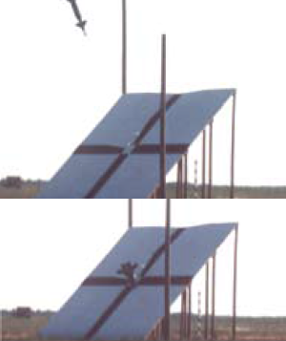

Fig 3: The image shown is an EPWII Accuracy Drop.g Pod

    - Warhead Performance Test.

- MDF (wooden) witness packs measuring 2 metres by 2metres are to be arranged in a hemispherical pattern around the warhead location at a distance of 20 metres to prevent obliteration by blast effects. Witness packs are to be secured and stacked to a height of 4metres.
- Warhead is to be orientated so it is representative of a standard approach trajectory and detonation height.
- Piezo electric blast gauges are to be placed at 5m intervals from the point of detonation on the opposite side of the war head to the witness packs.
- Splinter proofs to be placed in standoff locations 30 metres from the point of detonation. Splinter proofs to be orientated so the viewing aperture is protected from fragmentation.
- Mirror stands to be used to ensure high speed photography captures the detonation.

Witness Packs

Splinter proof

Not to Scale

Blast Gauges
Mirror Stand

Range Control and Trial Safety
The hazards generated by these tests can be addressed in numerous ways through the process of risk assessment, planning, effective work instructions, infrastructure and finally personal protective equipment. This however should be the last preventative measure to bring the risk to ALARP (As Low As Reasonably Practicable).
For any trial to take place the following documentation is required on QinetiQ ranges:
- Trials Specification
- Hazardous activity risk assessment (HARA)
- Trials Plan
- Safety Certification

For range control purposes ensuring the safety of the trials testing proposed in this report can be broken down into two primary areas.
- Control of airspace.
- Preventing ground based incursions into the applied safety trace.

Airspace will play the most significant factor when delivering the accuracy phase of testing, unlike land ranges such as Shoeburyness that are reliant on NOTAM’s (notice to airmen) and external airport controllers. The aerial testing conducted will require the direct support of an ATCO (air traffic control officer) to ensure that the bomb on release is at the correct altitude and position. Radar operators will be required to monitor the surrounding airspace and inform the trials conducting officer of any potential incursions. Communication at this point is key to provide an alert and adaptive system.

Land based incursions are to be prevented through the use of a ‘closing down’ procedure. At Shoeburyness this responsibility would lie with the range foreman. Around the perimeter of the range, red warning flags are to be raised to inform the public that the site is active. All access to routes areas that contain ‘public rights of way’ are to be closed. The range foreman through the use of static and mobile barriers will secure all local access routes that could compromise the weapon danger area established in the safety trace. A primary access route to the test battery will be established and manned by a sentry. If a sentry is unavailable a direct line of communication to range control will be provided through the use VHF radio system. The range foreman will inform range control that the area is closed and clear and seek permissions to go active. Range control through the use of strategically based CCTV and ground based radar will clear the local sea area should the safety trace extend seaward. When range control and range foreman satisfied that the weapon danger area is clear trials activity will begin. Two independent means of communication will be maintained at all times between range control and local battery operations.

Instrumentation and Data Capture
To capture viable data in a trials and testing environment, the suggested systems in use must have capable technical performance in the following areas:
- Speed- To be capable of capturing the event
- Resolution- To provide clear information
- Distance- To protect the equipment
Triggering- Accurate triggering reduces data file size in high speed photography by only capturing the event
    - Photography (Phantom 7.1 cameras)

Phantom high speed cameras will be used from protected enclosures known as splinter proofs in both test activities. To maximise the accuracy of this instrumentation method the operator must balance the necessary resolution to capture the shot, against the available memory capacity and camera shutter speed/refresh rate. The use of mirror stands in both instances is necessary to protect the equipment from fragmentation by allowing visual capture of both detonation and impact without the camera being in physical harm’s way. For accuracy testing the camera will capture the lased target position and point of impact. Images showing the impact on the target reference board will allow accurate analysis weapon accuracy. For the warhead performance testing the camera will be used to determine the detonation characteristics. Should the warhead deflagrate instead of detonate fragmentation velocity and therefore lethality will be reduced.

    - Blast Gauges (B12)

Piezo electric blast gauges used incidentally will confirm the impulse pressures generated by the explosive warhead at specified distances, it is expected that gauges within the first 10metres of the detonation will not be salvageable, like the high-speed photography analysis will confirm the type of detonation reaction produced by the warhead. Blast pressures crush the piezo crystal located in the gauge generating a voltage that when amplified can be converted into pressure. This requires the system to be calibrated prior to firing.

    - Hemispheric Witness Screen

Assuming a uniform detonation witness screens set up at 20 metres will survive the initial blast effects intact and be impacted by the munition casing in the form of fragmentation. Using an arduous technique known as pack analysis it is possible to map the spread of fragmentation produced in the detonation. This is the cheapest option currently available. Other alternatives include the FRAT system which can detect and map impacts electronically. Without a budget for this activity determining between the two systems is difficult.

3. Conclusions
- Conducting a large scale trial to test the EPWII is inherently difficult as it is a heavily regulated industry within the UK with a multitude of factors that must be taken into account to protect both the staff and public.
- Creating systems of work and integrating growing complexity is a significant challenge facing the test range environment.
- The author has attempted to the meet the requirements set out in the specification of work in the munition module while ensuring no restricted data is used in the construction of the works presented.

4. Bibliography and References
1. Defence, Ministry of. www.gov.uk. [Online] 2015. https://www.gov.uk/government/collections/joint-service-publication-jsp.
2. Adaptable Capability. Raf online. [Online] https://www.raf.mod.uk/equipment/enhancedpaveway.cfm.
3. https://www.essex.ac.uk. [Online] [Cited: 11 May 2016.] https://www.essex.ac.uk/health-safety/phys-agents/documents/calculating-nohd.docx.
4. Lasers: Properties, Hazards and Standards. Kersall-Joel, Julian. Farmbrough : QinetiQ, 2016.
5. http://www.wickedlasers.com. [Online] [Cited: 10 May 2016.] http://www.wickedlasers.com/laser-tech/blue_light_hazard.html.
6. Range Instrumentation. Horsfall, Ian. Cranfield : CranField University , 2015.
7. Range Safety. Ross, Charlie. Cranfield : Cranfield university, 2015.
8. MOD. JSP 403. JSP 403 Volume 1 Part 1. 2015, p. ii.
9. Deagel.com. LITENING III. Sensor Systems. [Online] 2017. http://www.deagel.com/Sensor-Systems/LITENING-III_a001563005.aspx.
10. Directory of Military Rockets and Missiles. Raytheon Paveway II. Appendix 5: Guided Bombs. [Online] 2008. http://www.designation-systems.net/dusrm/app5/paveway-2.html.
11. Ultra Electroncs Limited. Litening III Advanced Targeting/Recce Pod. 2010.
12. ttps://www.raf.mod.uk/equipment/enhancedpaveway.cfm. RAF - Enhanced Paveway II. Royal Air Force. [Online] 2006. https://www.raf.mod.uk/equipment/enhancedpaveway.cfm.
13. Act of Parliament. Health and Safety at Work etc. Act 1974. London : s.n., 1974.
14. Health and Safety Executive. Risk Management: ALARP at a glance. [Online] http://www.hse.gov.uk/risk/theory/alarpglance.htm.

