UNIVERSITY OF WALES TRINITY SAINT DAVID
Independent Project Dissertation Research Proposal
Researcher: Callum Rhys Samuel - ID : (1801402)
MA Criminal Justice and Policing
July 2020

Title
An Investigatory Insight Into the Pillars of Extremism: How Has Terrorism Evolved in Contemporary Times And What Are the Implications for the Future?

Research Questions / Areas That Will Be Covered

- How Should We Define Terrorism? – The Definitory Side of Terrorism

- How Has the Internet and Technology Been Utilised by Terrorists – The Digital and Technological Side of Terrorism

- How Have Terrorist Organisations Accumulated Large Quantities of Wealth? – The Financial Side of Terrorism

- What are the Mindset and Motivations of Terrorists and Radicalised Individuals with Regards to Their Goals? – The Psychological and Criminological Side of Terrorism

- How Do Terrorists Conduct Attacks in Contemporary Times, and What Will Future Attacks Look Like? – The Strategic Side of Terrorism

Table of Contents
Introduction 4
Objectives 6
Literature Review 7
The Definitory Side of Terrorism 7
The Digital and Technological Side of Terrorism 8
The Financial Side of Terrorism 8
The Psychological and Criminological Side of Terrorism 8
The Strategic Side of Terrorism 8

Research Techniques 9
Research Rationale 13
Research Timeline 14
Reference List 15

Introduction

The United Kingdom’s Strategy for Countering Terrorism - also known as CONTEST - which was published by HM’s Government (2018) four years ago in 2018, highlights Terrorism as one of the greatest threats regarding the national security of the United Kingdom. The publication of this strategy came at a time where terrorism was very much in the public eye due to the perpetual volume of incidents, particularly in 2017, with the publication of the strategy being in the wake of significant incidents such as Westminster, London Bridge, and of course, the Manchester Arena bombing.

At the time, the CONTEST strategy (HM Government, 2018) stated that between June 2013 and 2018, both MI5 and Counter-Terrorism Police were responsible for preventing 25 extremist attacks, with 12 of these attacks foiled in 2017 alone. Despite the period of 2013-2018 spanning five years, a Home Office publication in late 2021 revealed that between 2017-2021 – in a smaller period of four years - 32 late-stage terror attacks had been countered and foiled, with 7 of these planned attacks having been prevented since March 2020, a date which marked the beginning of the United Kingdom’s response to the COVID-19 pandemic (Counter Terrorism Policing, 2021). This figure - which surpasses the previous statistic established over a five-year period, and instead is overtaken in a period of four years - demonstrates a worrying potential rise in incidents, with not even mandatory and long periods of national lockdowns hindering the progress of would-be terrorists (Counter Terrorism Policing, 2021).

The organisational response to the COVID-19 pandemic by extremist and terrorist groups have been typical and not out of character, with Comerford (2020) observing that extremists often thrive off of crisis narratives. This is illustrated by Comerford (2020) when they note that extremists from every spectrum have attempted to opportunistically utilise the pandemic in a variety of ways, with far-right groups promoting conspiracy theories regarding the virus itself as well as any solution to it, as well as Islamic and Jihadist extremists attempting to legitimise their cause by pointing to the pandemic as proof of societal collapse in an effort to embolden groups, with an “accelerationist” mindsight often adopted by extremists to capitalise on disaster scenarios like the pandemic to further promote violence and social division (Comerford, 2020).

The capability of extremists to be able to plan and organise detailed terror attacks within the UK, despite living in a period where the country as a whole was at one point limited to “one walk out of the house a day”, represents a glimpse of contemporary terrorist strategy and its effectiveness of organisation, communication, and digital prowess, all of which will be analysed and expanded upon within this research project.

Objectives

The aim of this research project is: To explore and investigate the various avenues of terrorism to ultimately have an insight into the mindset and core strategic principles of a contemporary terrorist organisation. As well as: To look towards the future to ascertain the possible future directions of terrorist strategy, and potentially provide recommendations on how to minimise the implicated risks of such evolution.

These aims will be achieved by completing the following objectives:
- Critically analyse the meaning and definition behind the term “terrorism”, the misuse of the term, the need for the term, as well as the conflicting principle of “one man’s terrorist is another man’s freedom fighter”.
- Thoroughly research and understand the digital, technological, financial, psychological, criminological, and strategic sides of terrorism to establish how terrorist organisation’s function and behave.
- Gather and conduct primary research as well as analyse data that will be obtained through interviews of counter terrorism experts on the topic of terrorism and its evolution.
- Look at existing counter terrorism strategies and legislation, alongside the primary research provided by existing academic sources, as well as the data personally collected from qualitative interviews, to identify any pitfalls that may be utilised by terrorists in the future.

Literature Review - Small Preview (Draft was over 3,000 words for this one section alone)

The Definitory Side of Terrorism
Terrorism as an aggressive act of violence, an agenda to instil fear, or as a cause for freedom has been seen throughout history (Jenkins, 2020). Due to its varied appearances, scale and motivation, its inherent identity may seemingly shift from cause to cause, but fundamentally at its core and origin, it is ultimately and consistently the same in what it strives for, and that is religious, ideological, or political change.

The Terrorism Act (2000) provides the United Kingdom’s definition of terrorism as:

“The use or threat of action designed to influence the government or an international governmental organisation or to intimidate the public, or a section of the public; made for the purposes of advancing a political, religious, racial or ideological cause.”

Figure 1 - Definition of Terrorism (Source: Terrorism Act, 2000)

Although the UK operates on the same legal definition, conflicting definitions are more common internationally and the further you get from Europe. Baker (2019) and Chris (2014) demonstrates this, by observing the US’s attitude to defining terrorism, with the CIA (Central Intelligence Agency), DHS (Department of Homeland Security), FBI (Federal Bureau of Investigation), NCTC (National Counter-terrorism Centre), DoD (Department of Defence), and DoS (Department of State) all have differing definitions of the same word despite being in the same country and operating on the same legal system (Baker, 2019 and Chris, 2014).

Additional complications and misuse of the word according to Ganor (2013) can be found when looking at the World Muslim League’s definition of terrorism, with the organisation claiming; “if you insult someone’s intelligence you are committing an act of terrorism” (Ganor, 2013).

Ganor (2010) further addresses the importance of clear and internationally agreed upon definitions, as with the untangling of the term’s “terrorism” and “freedom fighters”, it enables authorities to label extremists who target civilians as “terrorists” so that they can no longer use the title of “freedom fighter” as a shield against being labelled in a manner that may deter support or sympathy.

The Digital and Technological Side of Terrorism - CUT

The Financial Side of Terrorism - CUT

The Psychological and Criminological Side of Terrorism – CUT

The Strategic Side of Terrorism - CUT

Research Techniques

Although there are various research techniques utilised in academic writing, this research project will follow “The Research Onion” created by Saunders (et al., 2016).

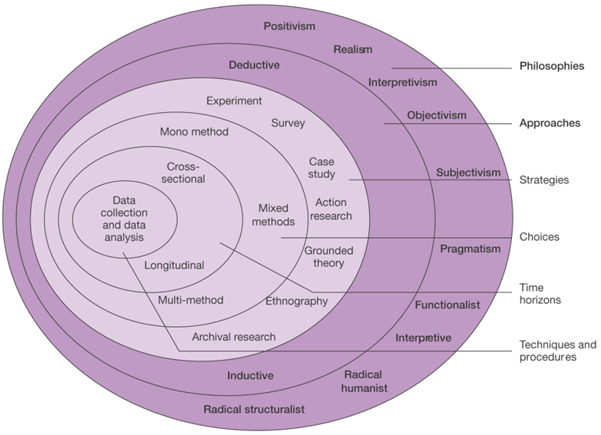
Figure 2 - The Research Onion (Source: Saunders et al., 2016)

The diagram shown in Figure 2 shows the research process, with each layer on the research onion demonstrating a specific research technique, with Figure 2 demonstrating the techniques that will be used for this research project.

The outer layer or “Research Philosophies” refers to the style or type of research angle a researcher might take when conducting a project, as well as what assumptions the research author may have about a specific field of study (Saunders et al., 2019). Interpretivism is the philosophical approach that will be taken for this research project as Saunders (et al., 2016) explains that this approach is used when either creating a new or enhancing an existing academic understanding, with this research project aiming to cover areas of social science as opposed to hard and fast concrete statistics or new definitive universal “laws” that may be seen in positivism approaches (Saunders et al., 2016).

Furthermore, an “Inductive” approach will be used for this research project, with Figure 3 by Bryman (2016) demonstrating the differences between Deductive and Inductive approaches.
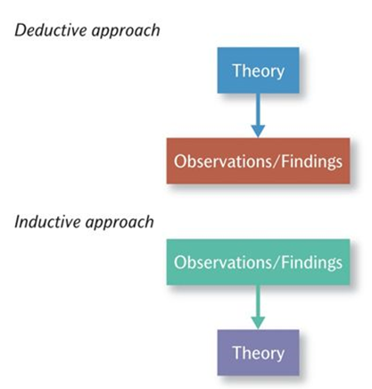

Figure 3 - Deductive and Inductive Approaches to the Relationship Between Theory and Research (Source: Bryman, 2016)

Qualitative research in the form of a series of interviews will be utilised for this project, with an inductive and interpretivist approach observed for the majority of the research project (Bryman, 2016).

The “Research Strategy” will be a “Mixed Method” approach as the research strategy that will be used will be a combination of both interviews with counter terrorism experts that have previously been contacted, as well both archival research and case study research informing the backbone of the project as a whole (Bryman, 2016).

Bryman (2016) states that self-administered interviews and questionnaires are useful data collection methods as they enable a researcher to collect data freely and quickly, and it enables participants to have the ability to respond whenever it is convenient to them. However, the main difficulty with a non-live interview is the possibility of a lack of participants responding, however, recorded, and live interviews will be attempted to reduce this possibility.

To make data analysis easier, a transcript of any interview conducted will be made, along with a spreadsheet compiled with responses to help find repeated terms.

The final aspect of the research onion that is important to note is “Time Horizons” (Saunders et al., 2016). For this particular project “Cross-sectional” research design will be employed as Bryman (2016) explains that cross-sectional research is more short form and appropriate as this design enables data to be collected on a small sample of cases at a specific single moment in time, as opposed to a “Longitudinal” project which takes many years to complete.

Research Rationale

Throughout the informative years of my life, terrorism has dominated the news, with many memories from 2017 revolving around such incidents that occurred. This led to the decision to further study in depth the topic of terrorism at every academic opportunity throughout my undergraduate and master’s degree. Following on from my undergraduate dissertation, there were many topics within terrorism that were not fully able to be explored, which is why there was a desire and need to return to this topic area and finally bring the four years of academic research to a close, in the form of deep analysis on contemporary terrorism, and bringing together the varying threads that are often discussed in isolation of each other.

A comprehensive analysis of the definitory, digital, technological, financial, psychological, criminological, and strategic aspects of terrorist behaviours is something that has not been seen as a single entity, with the desire to compile this research into a large volume leading towards the eventual possibility, of predicting the future direction of terrorism and the way in which extremists may one day attempt to operate.

Research Timeline

The following Gantt Chart seen in Figure 4 demonstrates the targeted timeline for the entirety of the research project.

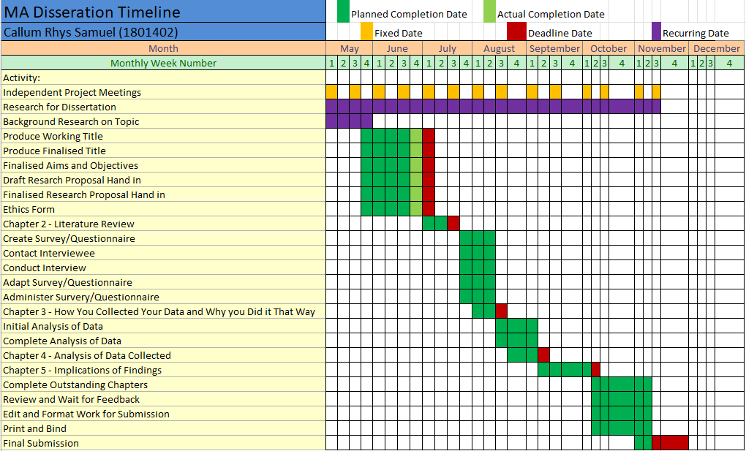
Figure 4 - Dissertation Timeline Gantt Chart

Reference List

- Alexander, D. and Klein, S. (2005). The Psychological Aspects of Terrorism: from Denial to Hyperbole. Journal of the Royal Society of Medicine, [online] 98(12). Available at: https://www.ncbi.nlm.nih.gov/pmc/articles/PMC1299349/ [Accessed 6 June 2022].
- Baker, C. (2019). We May Be Better Off Without a Clear Definition of Terrorism. [online] Fair Observer. Available at: https://www.fairobserver.com/region/north_america/terrorism-definitions-legislation-extremism-turkey-us-security-news-14231/ [Accessed 6 June 2022].
- Behr, I., Edwards, C., Gribbon, L. and Reding, A. (2013). Radicalisation In The Digital Era: The Use Of The Internet In 15 Cases Of Terrorism And Extremsim. [ebook] Brussels: RAND Europe. Available at: https://www.rand.org/content/dam/rand/pubs/research_reports/RR400/RR453/RAND_RR453.pdf [Accessed 6 June 2022].
- Binding, L. (2020). Coronavirus: IS Could Exploit COVID-19 Pandemic to Carry Out Terror Attacks, EU Warns. [online] Sky News. Available at: https://news.sky.com/story/coronavirus-is-could-exploit-covid-19-pandemicto-carry-out-terror-attacks-eu-warns-11987706 [Accessed 6 June 2022].

- Bryman, A. (2016). Social Research Methods. 5th ed. Oxford: Oxford University Press.
- Chris, C. (2014). Organisational Definitions of Terrorism. SecBrief, [online] Available at: https://www.secbrief.org/2014/04/definition-of-terrorism/ [Accessed 6 June 2022].
- CISAC. (2021). The Islamic State. [online] CISAC - Centre for International Security and Cooperation. Available at: https://cisac.fsi.stanford.edu/mappingmilitants/profiles/islamic-state [Accessed 6 June 2022].
- Clarke, C. (2018). ISIS's New Plans to Get Rich and Wreak Havoc. [online] Available at: https://www.rand.org/blog/2018/10/isiss-new-plans-to-get-rich-and-wreak-havoc.html [Accessed 6 June 2022].

- Comerford, M. (2020). How Have Terrorist Organisations Responded to COVID-19?. [online] Institute for Economics & Peace. Available at: https://www.visionofhumanity.org/how-have-terrorist-organisations-responded-to-covid-19/ [Accessed 6 June 2022].

- Counter Terrorism Policing. (2021). Latest Home Office Statistics Reveal 7 Late-stage Plots Foiled Since March 2020. [online] Counter Terrorism Policing. Available at: https://www.counterterrorism.police.uk/latest-home-office-statistics-reveal-7-late-stage-plots-foiled-since-march-2020/ [Accessed 6 June 2022].
- Ganor, B. (2010). Defining Terrorism - Is One Man’s Terrorist Another Man’s Freedom Fighter?. [online] International Institute for Counter-Terrorism. Available at: https://www.ict.org.il/Article/1123/Defining-Terrorism-Is-One-Mans-Terrorist-Another-Mans-Freedom-Fighter#gsc.tab=0 [Accessed 6 June 2022].
- Ganor, B. (2013). The Definition of Terrorism: A Fundamental Counter-Terrorism Measure. [video] Available at: https://youtu.be/lunQwBhzgxo [Accessed 6 June 2022].
- HM Government. (2018). CONTEST: The United Kingdom's Strategy For Countering Terrorism. [ebook] London: HM Government. Available at: https://assets.publishing.service.gov.uk/government/uploads/system/uploads/attachment_data/file/716907/140618_CCS207_CCS0218929798-1_CONTEST_3.0_WEB.pdf [Accessed 6 June 2022].
- Jenkins, J. (2020). Terrorism | Definition, History, & Facts. [online] Encyclopedia Britannica. Available at: https://www.britannica.com/topic/terrorism [Accessed 6 June 2022].
- Kydd, A. and Walter, B. (2006). The Strategies of Terrorism. International Security, [online] 31(1). Available at: https://www-jstor-org.ezproxy.uwtsd.ac.uk/stable/pdf/4137539.pdf?ab_segments=0%252Fbasic_phrase_search%252Fcontrol&refreqid=excelsior%3A67905db22fcc9edf0d79efa0905d6e5f [Accessed 6 June 2022].

- Saunders, M., Lewis, P. and Thornhill, A. (2007). Research Methods For Business Students. 6th ed. London: Pearson.
- Saunders, M., Lewis, P. and Thornhill, A. (2019). Research Methods For Business Students. 8th ed. [ebook] London: Pearson. Available at: https://www.researchgate.net/profile/Mark_Saunders4/publication/330760964_Research_Methods_for_Business_Students_Chapter_4_Understanding_research_philosophy_and_approaches_to_theory_development/links/5c53056f299bf12be3f0e2cf/Research-Methods-for-Business-Students-Chapter-4-Understanding-research-philosophy-and-approaches-to-theory-development.pdf [Accessed 13 November 2020].
- Terrorism Act 2000. Available at: https://www.legislation.gov.uk/ukpga/2000/11/contents [Accessed 6 June 2022].

