Dealing with Change – Welsh Water
Contents
Dealing with Change – Welsh Water 1
Introduction 2
Topic of change 2
Organisation 2
Change management 3
Internal and external change drivers 3
Force-Field Analysis 3
Theories and Strategies 4
Leadership / Management 5
Conclusion / Recommendations 7
Summary 7
Recommendations 7
Bibliography 8
Appendix 9

Introduction

Topic of change
For any organisations that are out to succeed, change is a crucial thing that any organisation must be doing at all times to continue to expand, improve, but most of all, make bigger profits. [1]Continuous improvement is a must, that’s what sets apart from good and back organisations. The real reason for most organisations to make change is cause of competitors, if change and improvements aren’t made, they may fall behind, thus losing more profit.
[2]Throughout history change is continues need to improve a pone what we already have, for example new technology to tackle more and more of are common problems like hospital equipment and are normal living standards. Due to this we have benefited greatly like improved living standards, attempted to lessen unemployment, longer life expectances and so on. Humanity as a whole have had great breakthroughs through the means of wanting change since the beginning, we have used a graph “Kondratieff” (See appendix “1” for an example) to show are biggest breakthroughs in change, currently we are sloping down but perhaps in a few years, we will invent things such as biotechnology, improved healthcare, environment impact and anything else that could be considered a big leap.

Organisation
The organisation I’ll be speaking about is a non-profit focus organisation but must continue to change to keep with always increasing demands, [3]“Welsh Water” is owned by “Glas Cymru” which is a single purpose company solely for the benefit of its customers, not saying they aren’t there to make profit, but its profits would be used to expand and improve on to improve service. Welsh water as a whole have a lot of changes being made all the time, but I’m going to focus on one big step they are deciding to take, which is the attempt to introduce [4]VR to further help design new [5]water works, it will allow those even far way to assist in the create on these facility’s, by being able to virtually see it, normally and internally, pipe layouts and so on, the possibilities with this could be limitless to how it could be used.
First of all, I have find a [6]case study to better understand how their business works, which done by a member of their organisation helps get the full detail of who, what and why their business works the way it does. In this case study it discusses the processes needed to provide water but also they speak about a previous change that was needed called “Geraint’s toolkit” which aimed to deal with the problems of blockage in the pipes that their current tools couldn’t deal with. In planning and adapting to change needed, he invented something that allowed him to reach more blockage, and in doing so save time and money spend digging up reads to get at pipes and so on. Part from mentioning how they dealt with change, they overall speak about “Innovation projects benefit all areas of our business, helping us to improve our technology, protect the environment and keep customers’ bills low.

Change management

Internal and external change drivers
All businesses have to deal with external changes by internally making changes to cope/adapt to such things, and this is always a continuance battle for any business, even for a non-profitable business such as welsh water this is a must, to keep up on changes. [7]Below are a list of possible external and internal forces for change.
External drivers could include:
- Change in demographic trends such as from post to email
- New technologies (from servers to cloud)
- Customer demands
Internal drivers could include:
- Outdated tech, machinery or product lines
- Declining team morale
- The need to earn more profit
Now below is a list of forces against change.
External factors might be:
- Already existing organizations (copy right problems)
- Fulfilling obligations towards your customers
- Government legislation

Force-Field Analysis
[8]First of force field analysis is a method created by “Kurt Lewin” to try to ensure that a business responds to the environment with the way it operates. (See appendix “2” for an example) Force field analysis shows change problems that need to be made by the business, showing for and against the changes (See appendix “3” for an example) I have done my version of “lewis’s FFA” to show the forces for and against change for welsh water introduction of VR. I have also score each force from 1 to 5, 5 being impotent/big obstacle to 1 being less important.

Theories and Strategies
Here are many other theories and strategies that can be used for example [9]“Kotter’s change management strategy” (See appendix “4” for an example) which is an 8 step strategy, here I will use this to demonstrate it used for my current case study of VR implementation for Welsh water:
Step 1 – Increase urgency of need of change (use of VR)
Step 2 – Build the Team
Step 3 – Get the right Vision (same end goal)
Step 4 – Communicate for buying into product
Step 5 – Act on actions
Step 6 – Create short term wins (such as getting one working first and fully function able)
Step 7 – Don’t let up
Step 8 – Make it stick (continues use, need VR e.g. no need for travel from a facility south to north, us VR to Simulate facility)
Of course using one of this strategy’s is easier said than done, there are always limitations and problems along he ways, such as resistance within the company its being the employs resistance to change, From stubborn old fools that don’t like change to the thought of need to learn everything again and or lose of job. So steps can be made to reduce the resistance to change and then to successfully implement change.
There are many strategies and theories on how his can be done, but generically this is what all most plan to achieve:
- Change produces anxiety and uncertainty
- Continues communication and input.
Most of all manages have a big role to play in this by doing the following (include my current change in welsh water)
- Own the changes made
- No biasedly or fractional support
- Create trusting and provide support to employees (especially those affected by it more)
- Continues communicate

Leadership / Management
First we need to try and define the difference from a leader and manager cause this are two very different things only one is suited based on the situation.

Leadership
[10]Leadership can be defined for most only in a few words, ether a motivationalist or a form of inspiration to people. It does very depending on the kind of leader, below are a few key defining leadership skills a leader would/could have: [11]
- Motivation/inspiration the leader channels the energy and professional potential of their employees, in order to achieve the objective
- Vision share your common goal towards which is to direct the effort and dedication of the entire team
- Serving by feeling supportive as a leader by for example providing the tools needed prevent incorrections
- Empathy or emotional intelligence which means putting themselves in the place of others, understanding and solving the problems
- Creativity leader encourages all the members of their team to develop their skills and imagination, by respecting the creativity of others and learn from them, their ideas will prove to be positive to the leader
- Thoroughness leader knows how to listen and provides the necessary time and resources for them/employees to do their job
- Taking risks is also a key part of a leader, they see opportunities which others don’t and know how to spread the enthusiasm for their vision to try to make it real
- Lastly improving is continuous in any leadership skill, for themselves or improving their team members with their influence as a leader
There are many ways a leader can be defined by, the easiest way to define a leader to a manager is for being more inspirational and a motivator.

Management
[12]Management is hard to define but the simplest way I can define it is by saying that a manager leads a team by keeping them on track, consisting of planning, organisation, actuating and controlling to achieve a pre-determined “objective”. [13]A few habits you can pick up on compared to a leader are that they are proactive, begin with the end in mind, first things first, think only win, seek understanding then understood, synergize and learn from previous experiences.

Differences / Comparing
[14]I believe a leader usually also manages from time to time based on situation but perhaps someone who knows how to manage would be better suited for a certain task more than a leader can and vis versa. A leader invents or innovates while a manager will organize, a leader will inspire trust while a manager relies on control, a leader has to ask what and why where a manager leans more towards the questions how and when.
[15]Using an Article “Three differences and between managers and leaders” and [16] “the three test” created from the article, you can determine in you’re a more of a leader or a manager (See appendix “5” for an example) if your more counting values, circle of influence, thus leading people makes you more of a leader, or creating value, circles of power, thus managing people, makes you a manger figure.
Here are a few more comparisons from a leader and a manager:
- Leader has visions while a manger has realistic expectations
- Leader uses intuition while manager is more practical
- Leader provides direction while a manager shows direction
- Leader seeks effectiveness while a manager seeks efficiency
- Leader identifies new opportunities while a manager archives objectives
- Leader empowers while managers informs people
- Leader works from the heart while managers works from the head
- Leader Has longer term goals while a manger usually has shorter term goals

Leadership vs management
[17] Use an article which create a Venn diagram (See appendix “6” for an example) to show their different characteristics and focuses. It shows and discuses more on the differences from a leader and a manager. So a Leader would be more appropriate for a situation that deal with mass amount of change due to their support and motivation, while a manager is great for setting a task for such date and for filling it as efficient as possible.
Leader Influences to challenge norms and guide innovation
Manager Ensures goals are carried out and are capable and responsible and their contribution to an organization is stickily by the book

Conclusion / Recommendations

Summary
For welsh water, [5]implementing VR as a core function across all, is going to be a big/huge step up on providing serveries to their customers, for allowing those to not have to leave their work environment and see a virtual example of key areas. But this being new is certainly going to be foreign in the eyes of all the employees so from my key findings I have a few recommendations that welsh water may want to consider when implementing this new system to all their branches.

Recommendations
First of all a strategy will be needed to carry out the changes made with the implementation of VR, there are main to choose from but for myself, I would recommend using Kotter’s strategy to pin point more of each stage with perhaps a few changes to imitate more for their changes for example:
Step 1/2 – Build the Teams
Step 3 – Ensure all installation members, aka teams know the goal
Step 4 – Communicate for buying into product
Step 5 – Act on actions
Step 6 – Create short term wins (such as getting one working first and fully function able)
Step 7 – Don’t let up
Step 8 – Make it stick (continues use, need VR e.g. no need for travel from a facility south to north, us VR to Simulate facility)
Removing step one as already this is being implemented and is known to be a good improvement, change to step 3 as its less of a “vision” and more of a “goal” and lastly for step 8 I would first ensure that it achieve its final goal, which is allow for facility’s to one be accessible virtually and secondly by anyone that needs access even from those other side of the country.
I feel Kurt’s strategy would also be effective but would not function well for the type of style “management or leadership” I have recommended next. Which on that point I would highly recommend those more management orientated to take the task of the teams as I feel their make sure to reach their goal with as much efficacy, state if capable and stick to the plan “by the book”
As a leader could also be effective, a leader is best dealing with big change with employees, and as this is only a new function being added already to their systems, the worry for employee thoughts and concerns will at most be minimal, so a straight path is needed to achieve this goal.
Perhaps after development, the use of leadership would be more apparent as future uses of VR would be limitless and inspiration and creativity would be useful to discover other uses for this new system.

Bibliography

[1] | Nexus, “Continuous improvement,” I-Nexus, ?? ?? ????. [Online]. Available: https://www.i-nexus.com/what-is-continuous-improvement?gclid=EAIaIQobChMI1ujC4P7s3QIVDbTtCh1h2gJqEAAYASAAEgKkc_D_BwE. [Accessed 06 12 2018].
[2] | M. Glynska, “Why do we Need change,” Huffpost, 29 08 2016. [Online]. Available: https://www.huffingtonpost.com/marianna-glynska/why-do-we-need-changes_b_11700296.html?guccounter=1. [Accessed 01 12 2018].
[3] | Welsh Water, “Infomation,” Comp Welsh Water, ?? ?? ????. [Online]. Available: https://www.dwrcymru.com/en/Company-Information.aspx. [Accessed 06 12 2018].
[4] | Vive, “Vive UK,” Vive VR, ?? ?? ????. [Online]. Available: https://www.vive.com/uk/. [Accessed 06 12 2018].
[5] | BBC, “Welsh Water uses virtual reality for water works design,” Welsh Water (VR), 08 01 2017. [Online]. Available: https://www.bbc.co.uk/news/av/uk-wales-40175124/welsh-water-uses-virtual-reality-for-water-works-design. [Accessed 06 12 2018].
[6] | Welsh water employee, “Benefit, Improve, protect the enviroment,” Welsh Water, ?? ?? ????. [Online]. Available: https://www.dwrcymru.com/en/Innovation/Case-Studies.aspx. [Accessed 09 01 2019].
[7] | Mindtool, “MForce field analysis,” Mindtool, ?? ?? ????. [Online]. Available: https://www.mindtools.com/pages/article/newTED_06.htm. [Accessed 18 12 2018].
[8] | Tutor2, “Lewins FFA,” Tutor, ?? ?? ????. [Online]. Available: https://www.tutor2u.net/business/reference/models-of-change-management-lewins-force-field-model. [Accessed 18 12 2018].
[9] | L. thoughts, “Kotters 8 step,” Leadershipthoughs, ?? ?? ????. [Online]. Available: https://www.leadershipthoughts.com/kotters-8-step-change-model/. [Accessed 18 12 2018].
[10] | MindTool, “What is leadership,” Mindtool, ?? ?? ????. [Online]. Available: https://www.mindtools.com/pages/article/newLDR_41.htm. [Accessed 09 01 2019].
[11] | Gamelearn, “What is a leader,” GameLearn, 12 01 2016. [Online]. Available: https://www.game-learn.com/what-is-leadership-ways-to-define/. [Accessed 09 01 2019].
[12] | Business Dictionary, “management,” BD, ?? ?? ????. [Online]. Available: http://www.businessdictionary.com/definition/management.html. [Accessed 09 01 2019].
[13] | G. m. scholars, “management definitions,” Whatishumanresource, ?? ?? ????. [Online]. Available: http://www.whatishumanresource.com/management-definitions-by-great-management-scholars. [Accessed 09 01 2019].
[14] | Go2HR, “UNDERSTANDING THE DIFFERENCES: LEADERSHIP VS. MANAGEMENT,” Go2HR, ?? ?? ????. [Online]. Available: https://www.go2hr.ca/management-leadership/understanding-the-differences-leadership-vs-management. [Accessed 01 09 2019].
[15] | V. Nayar, “Three differences between managers and leaders,” Medtronic, 02 08 2013. [Online]. Available: https://hbr.org/2013/08/tests-of-a-leadership-transiti. [Accessed 09 01 2019].
[16] | A. monnappa, “What’s the Difference Between Leadership and Management?,” Simplilearn, 03 10 2018. [Online]. Available: https://www.simplilearn.com/leadership-vs-management-difference-article. [Accessed 09 01 2019].
[17] | L. Ho, “Leadership vs Management: Is One Better Than the Other?,” Lifehack, 20 03 2018. [Online]. Available: https://www.lifehack.org/674254/leadership-vs-management-is-one-better-than-the-other. [Accessed 09 01 2019].

Appendix

1.
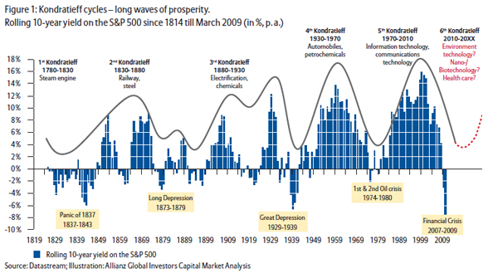
https://makewealthhistory.org/2012/06/18/green-tech-the-6th-kondratieff/

2.
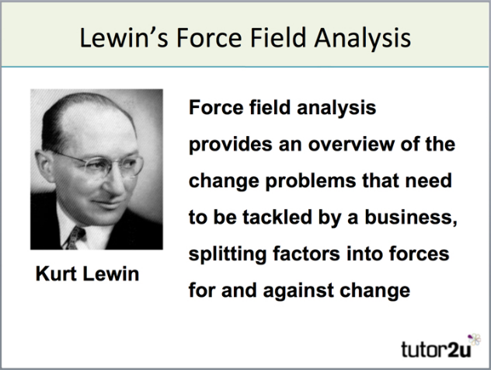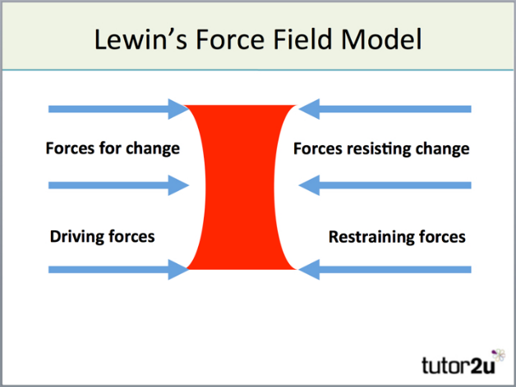
https://www.tutor2u.net/business/reference/models-of-change-management-lewins-force-field-model

3.
Here is my FFA using Kurin Lewis’s stratergy:
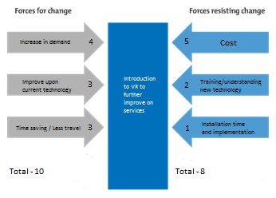
4.
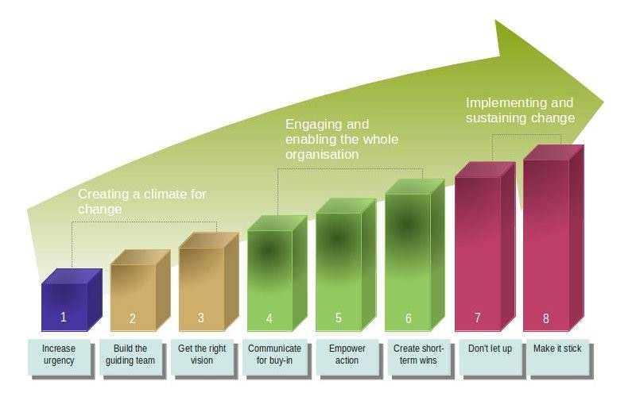

5.
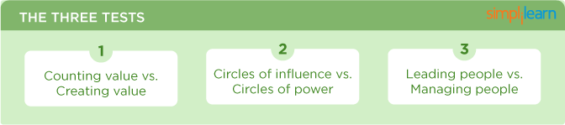
https://www.simplilearn.com/leadership-vs-management-difference-article
6.
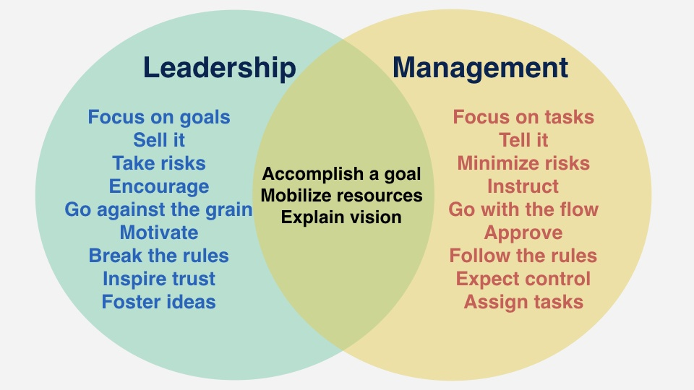
https://www.lifehack.org/674254/leadership-vs-management-is-one-better-than-the-other

