Academic Film Review on “Selma” by Ava Duvernay.
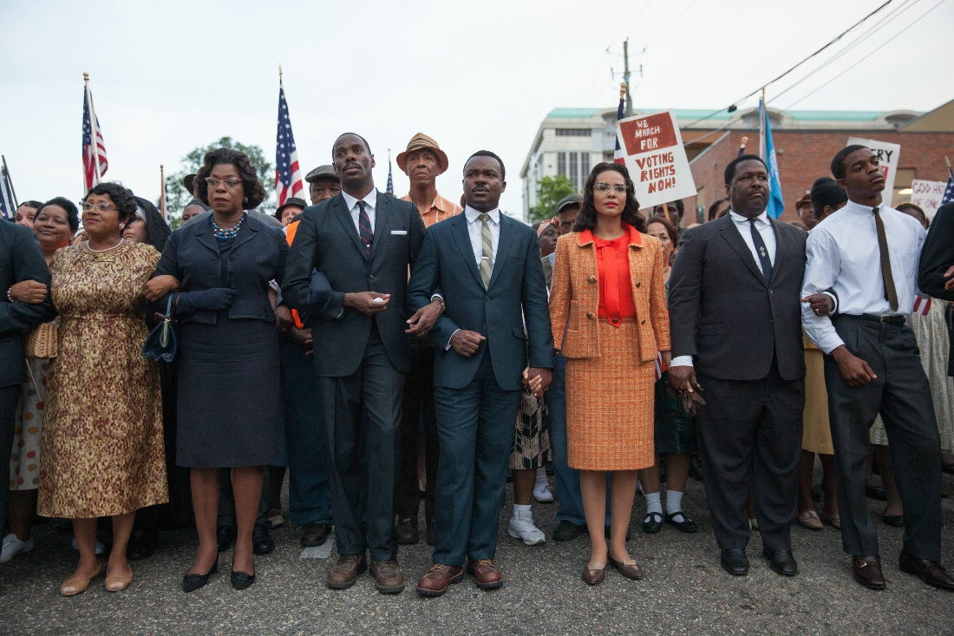

Name: Dru Sutherland
Module: Contemporary Challenges: Making a Difference
Assignment: # (1) one- Film Review
Lecturer: Ann Bevan
Date: 30th May 2023

(Reggaeville 2016. Nesbeth) “Make me start da one yah, Like how Martin Luther King woulda start it, My dream, my dream, My dream, my dream, my dream, Tell you, my dream is, fi live my dream, Hail di Most, High inna mi sleep when mi see him, Tell you, my goal, my goal, my goal, All of my goal is fi reach my goal, Live a happy life, put it pon mi headstone, Nobody nuh fi cry over mi dead ... Look at me now, Weh them treat me less than gold, Put mi inna box, like a rectangle, Oh ohh, Look at me now, oh!, Look at me now, oh oh!, Look at me now, oh!, And mi a tell you, my life!, Weh dem use to go roun' me, go roun', No one use to come roun' me, My life was so lonely, oh ohh! Look at me now, oh! Look at me now, oh oh!, Look at me now, oh!”. ‘My Dream’ is a popular Reggae song, sang by Nesbeth who grew up in Trench Town, West Kingston, Jamaica. The song is about "the manifestation of one's thoughts, dreams, goal, and aspiration — in other words, the vibration that you send out is what you receive," the lyrics say. The singer continued, (Staff 2016) "While it's important to have a dream, it's more important to live the dream."
One of my favorite ways to pass the time is to watch a good movie, especially after a long day. It is crucial to remember that making a fantastic movie requires a lot of effort and commitment. Selma stands out to me because of its impeccable features and historical significance. While the movie might be lengthy, it is worth watching because of the considerable effort that went into its creation. Therefore, I have decided to write my film review on Selma.
Personally, I find it enjoyable when I can vividly imagine what will happen next and when I can relate to the characters. There are various specific qualities that contribute to a movie being great, but one of the most important is quality acting. This brings the movie to life and affects our belief in it. Powerful messages also help to give the movie direction and coherence. However, the most crucial aspect of a good movie is when the cast proves their passion for the plot. Selma is a splendid example of a movie that embodies these qualities.
The extraordinary and correct narrative describes the difficult three months in 1965, When Dr. Martin Luther King Jr. Valiantly overcame violent opposition to lead a drive to guarantee equal voting rights. The culmination of the trek from Selma to Montgomery came when President Johnson signed the voting rights act of 1965, which was a huge victory for the civil rights movement. Ava Duvernay’s film “Selma,” tells the tale of Dr. Martin Luther King Jr. and other civil rights leaders, to show how they sparked change that changed history forever. In the film Selma, Dr. Martin Luther King Jr. fights for the right of African Americans to vote. From Selma in Alabama to Montgomery in Alabama, he had a long walk to make. Even though there is considerable fighting and foul language, the film is admirable and holds some useful teachings.
In October 1964 Dr. Martin Luther King Jr. received the Nobel peace prize. Even though a law was passed to make sure everyone was treated fairly, some people in one state still were not allowed to vote. When Annie Lee Cooper (Characterized by Oprah Winfrey) tried to register to vote, she was denied her rights. She was assaulted by the sheriff, where she then fought back and got arrested. Dr. Martin Luther King Jr. wanted everyone to be able to vote, But President Lyndon Johnson was too busy to help people to vote. Dr. Martin Luther King Jr. wanted everyone to have the right to vote, but some people did not agree. So, he talked in Brown Chapel in Selma, where a group called (SCLC) Southern Christian Leadership Conference was present and gave a speech about how God made everyone equal. Some people who were fighting for the right to vote were there too. Dr. Martin Luther King Jr. told them they had to keep working hard to make a difference.
After the preacher talked, Dr. Martin Luther King Jr. the SCLC and the (SNCC) Student Nonviolent Coordinating Committee talked about how they could show that everyone should be able to vote, they decided to walk a long way from Selma to the capital of Alabama in March 1965. The people were walking together to ask for their rights, but the police brutal attacked them. Lots of people heard about it on TV and the news. The leader had to think about whether they should try again. Dr. Martin Luther King Jr.’s family was having some problems too. Before the second march, King’s wife got upset because he was being unfaithful to her with another woman. Dr. Martin Luther King Jr. tries to fix things with his family while the march is getting ready. During the march, the police stopped them again, but King told everyone to go back to where they started. There, he gave a great speech. By this point, the treatment has angered the entire country.
To defend the marches on their journey to the state capital, where Dr. Martin Luther King Jr. delivers another stirring speech. President Johnson issued an order to the army and the national guard. The voting rights act was also sponsored by Johnson at the same time, and it was soon passed. The most impressive aspect of Selma is how convincingly it illustrates how nonviolent action may lead to social transformation. When priests, nuns, ministries, and rabbis’ join the Selma community on the March from Selma to Montgomery, unified in their pursuit of freedom, equality, and Justice, it was an empowering moment. Hence, we can see the significant roles that prayer, bible quotes, hymns, and group cohesiveness play. We look back to the civil rights struggle with appreciation and the utmost respect in these days when political leaders appear all too eager to use violence against their deemed adversaries and people all too often turn to guns to resolve disputes. The kind of leaders we require today are like those of Selma.
Selma's end credits are fascinating to see since they reveal the destinies of the characters we have traveled with. We discovered this spiritual principle while letting the movie stew in our minds, which Dr. Martin Luther King used to direct the civil rights movement's peaceful demonstrations. Keep in mind how relevant these ethical principles are as you reflect on them. (From Soul Feast: An Invitation to the Christian Spiritual Life by Marjorie J. Thompson) "Meditate daily on the teachings and life of Jesus. (January 18, S.V.H. and 2016) “Remember always that the nonviolent movement in Birmingham seeks justice and reconciliation, not victory. Walk and talk in the manner of love, for God is love. Pray daily to be used by God in order that all might be free.” (Twitter n.d.) “Seek to perform regular service for others and the world.” Refrain from violence of fist, tongue, or heart. (Thompson M.J. n.d.) “Strive to be in good spiritual and bodily health. Follow the directions of the movement and the captains of a demonstration."
‘Selma’ is a tribute to the power of art in times of social turmoil despite issues with historical authenticity. Selma tries to rip the underpinnings of ignorance and intolerance that still affect American society today by exposing the anguish of innocent people and their struggle through moments of doubt and uncertainty. Selma, is a difficult movie by Ava Duvernay, is bogged down in conflict and the past. With the Selma to Montgomery march acting as its focal point, the battle to ensure full voting rights for African Americans is at its core. This movie caught my attention because of its outstanding performance and historical accuracy.
King and other members of the Southern Christian Leadership Conference battle with the young members of the Student Nonviolent Coordinating Committee over the best course of action to win the support of most Americans to their cause, and these complex struggles are vividly depicted in Selma's incisive screenplay by Paul Webb. Coretta King watches as Malcolm X (Nigel Thatch) confesses that he and her husband disagree on the use of nonviolence but pledges to support the Selma protests in a powerful scene. King and his wife, who are growing increasingly fearful of "the constant closeness of death," are bothered by the pressure of death threats and hate mail. The portrayal of the violent police attack on the protesters on the Edmond Pettus Bridge is the most captivating element of this gripping drama. As the 82-year-old father of one of the young men who had been slain in an earlier demonstration, Henry G. Sanders gives a heartfelt performance in this scene. We are additionally inspired by the zeal of the other leaders on the team, such as John Lewis (Stefan James) and Rev. Hosea Williams (Wendell Pierce).
King urges President Johnson to bring a voting rights bill to Congress in several sessions at the White House. He queries how the President can finance the Vietnam War while declining to take up arms against the atrocities committed against his people. A crusade of hatred by Governor George Wallace (Tim Roth) and J. Edgard Hoover's (Dylan Baker) covert effort to undermine King also saps King's energies.
No matter where on the globe or when it occurs, there is always someone who is subjected to oppression, abuse, or discrimination in some way. People's fundamental rights have been violated or judged throughout history. Movies like Selma are crucial because they shed light on these incidents and wrongdoings, which must be brought to people's notice. Regarding the events that took place during the Civil Rights movement of the 1960s, the movie Selma was a true revelation. Many of its points were made in ways that no other successful rendition of the narrative had. Many of the actors' depictions of historical individuals were so correct that the characters were enacting the storyline themselves. The overarching ideas of the film were also quite clear, and if not easy to relate to, at least easy to grasp and empathize with the characters. Things like the music or the way the film is put together and structured to affect the emotions of the audience may make a movie engaging and emotionally moving beyond just the conversation or purely what you see being represented on screen.
The film, which centers on the leadership and efforts of Martin and Coretta King as well as the hundreds who joined them in Selma and across the nation, is a delicate, restrained picture of a time of the most extreme American violence against black people. It also proves how difficult life was for African Americans in the early 1960s because of the prejudice and hatred directed to them at the time. Because of their racial hues, some White People treated Black People in a deplorable and cruel manner. But despite all the pain and mistreatment, one man eventually changed the country as we know it by giving one of the most well-known speeches in American history. He helped people come together to oppose this injustice by teaching them how to fight with words rather than fists. To prove their solidarity and the fact that they could achieve anything as a group, he also taught them how to march. Martin Luther King Jr. was the name of that person.
King speaks in the distinctive Southern gospel manner in "Selma," where he gives addresses. The actor who played King, David Oyelowo, was a master at capturing the melody and southern inflections that made Dr. Martin Luther King's speeches so moving. King's speeches could not be quoted in the movie because of copyright regulations. Paul Webb, the author, rewrites the speeches while keeping the preacher's rhythms and cadences that powerfully affected King's audience and stoked their zeal for the cause. Even in his script, Webb employs King's call-and-response method. A tradition that West African slaves introduced to the Americas is call and response. As a result, it serves to remind King's black audience of their beginnings and how far they have come, as well as to remind a contemporary audience of the persecution of African Americans, which is supposed to be outdated but still exists in contemporary society. The altered speeches lose a lot of the religious overtones that were essential to King's message, despite Webb's elegant scriptwriting. This turns the attention to the crucial issue of black rights and broadens the appeal of the film to a 2015 audience that might not be aware of all the religious overtones.
But this adjustment downplays the significance of religious peacemaking. Maria Pilar Aquino does, highlight the importance of a faith-based bottom-up peace building method, which King employed by incorporating moral and spiritual principles into his justifications for black rights. King gained power and attention that sparked political change by keeping the moral high ground through nonviolent protests and incorporating religious allegory into his talks to make his actions and words morally justifiable. As a result, by altering King's speeches to exclude most references to religion, the film downplays the significance of religious peacebuilding in the civil rights campaign.
In conclusion, 'Selma' succeeds most in making an impression on the spectator of today even though it may not accurately portray the genuinely religious character of King's speeches and may hold certain historical mistakes. One is forced to consider the challenges that people of all races confront in the battle for equality in contemporary society as it serves as a reminder of earlier brutality. (Pinterest n.d. Martin Luther King Jr.) “I say to you today my friends, that in spite of the difficulties and frustrations, of the moment, I still have a dream!”

Reference List
ClickView. (n.d.). Making Waves: Assignment 1 Film Review. [online] Available at: https://online.clickview.co.uk/playlists/share/d9cf74c7/videos/4048257 [Accessed 19 May 2023].
January 18, S.V.H. and 2016 (2016). Why does Martin Luther King’s pledge of nonviolence matter today? [online] Waging Nonviolence. Available at: https://wagingnonviolence.org/2016/01/why-martin-luther-kings-pledge-of-nonviolence-matters-today/.
Love Out Loud. (2019). MLK Commitment Card. [online] Available at: http://www.loveoutloudws.com/union-blog/2019/2/14/mlk-commitment-card [Accessed 18 May 2023].
Meditate daily on the teachings and life of Jesus. (n.d.). Available at: https://static1.squarespace.com/static/5ba261f81aef1d93d6cbcbc5/t/5f3d65c0ad23bb41af49c65d/1597859269795/Carey+Casey%27s+10+Principles+of+Championship+Fathering.pdf [Accessed 18 May 2023].
Patriotic Moms. (n.d.). Martin Luther King Jr. [online] Available at: https://www.patrioticmoms.com/home/a-pledge-of-peace5772603 [Accessed 18 May 2023].
Pinterest. (n.d.). I still have a dream... #MartinLuther King Jr. | Martin Luther king Jr quotes, Dr martin Luther king jr quotes, King quotes. [online] Available at: https://www.pinterest.com/pin/3799980927619803/ [Accessed 19 May 2023].
Reggaeville (2016). Nesbeth - My Dream [Official Video 2016]. YouTube. Available at: https://www.youtube.com/watch?v=RrmWlIp4CvQ [Accessed 6 Aug. 2020].
Spacious Faith. (2014). Martin Luther King Jr.’s Rule of Life. [online] Available at: https://spaciousfaith.com/2014/01/20/martin-luther-king-jr-s-rule-of-life [Accessed 18 May 2023].
Staff (2016). ‘My Dream’ By Nesbeth to Become the First Hit of 2016. [online] I AM A JAMAICAN. Available at: https://iamajamaican.net/music/2016/01/nesbeth-my-dream/ [Accessed 18 May 2023].
Thompson, M.J. (n.d.). Soul Feast by Marjorie J. Thompson | Review | Spirituality & Practice. [online] www.spiritualityandpractice.com. Available at: https://www.spiritualityandpractice.com/book-reviews/view/9888/soul-feast [Accessed 18 May 2023].
Twitter. (n.d.). https://twitter.com/aoc/status/952958429957709824. [online] Available at: https://twitter.com/aoc/status/952958429957709824 [Accessed 18 May 2023].

