Can graphic design save your life?
Exploring the relationship between design, happiness, and personal growth.

The books “The Courage to Be Disliked” and “The Courage to Be Happy” serve as theoretical foundations. Both books are centered on the ideas of psychologist Alfred Adler, exploring the importance of having the courage to be disliked through a dialogue between a young person and a philosopher. They argue that this courage is key to achieving true ha


I will explore this article from three perspectives: 1. Emotional Resonance in Design; 2. Self-Growth in Creation; 3. Design Can Make Society a Community.

three main arguments in the article
1.Emotional Resonance in Design
Design is not just "visual communication" or "commercial communication"; it can also influence people's psychological state, allowing them to find works that express their inner voice.

2.Self-Growth in Creation
The design practice process (creation, communication, expression) is itself a form of "self-growth" (suggestions from others can also help people think from different angles.

3. Design Can Make Society a Community
Good design can bring meaning, promote happiness, and even help people understand life. (Helping others love life, and even society—the world is a community.)
1.Opening context（开篇语境）
In a fast-paced world filled with visual noise people are constantly searching for meaning, comfort, and connection. Beyond its commercial functions, graphic design has emerged as a form of visual communication that can influence how we think, feel, and relate to others.

2.Thesis statement（论文陈述）
This essay argues that graphic design can ‘save’ our lives by improving emotional well-being, enhancing self-growth through creative practice, and connecting us with others through shared meaning.

3.Examples of the three main arguments

(1) Emotional well-being（情绪幸福感）
Graphic design can influence how we perceive and process emotions. The thoughtful use of colors, typography, and composition can evoke calmness, positivity, and empowerment. By creating visually soothing and meaningful experiences, design can help reduce anxiety and improve daily emotional balance.
Therapeutic Design（疗愈性设计）
- Designer: Emily Coxhead, British independent designer
She founded a newspaper, *The Happy Newspaper*, which publishes only positive, warm, and hopeful news. The entire visual system is centered around soft, bright colors, and an illustration style .
Website: https://thehappynewspaper.com/about/?v=7885444af42e
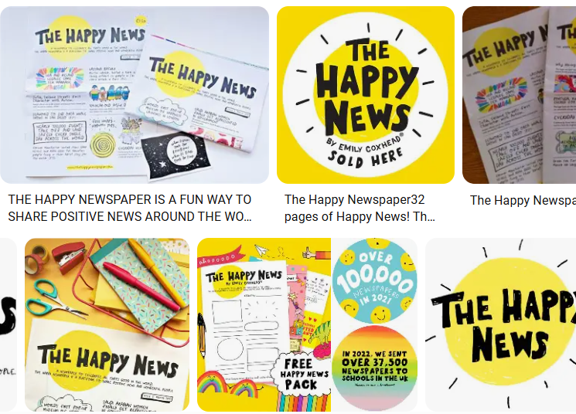
- Organization: A mental health advocacy project initiated by the British Royal Family.
The posters and promotional materials use an open, bright blue color scheme and an inclusive font to encourage the public to "Talk about mental health."
Website: https://www.headstogether.org.uk
Purpose: To encourage open discussion of mental health, allowing people to express their thoughts and feelings without reservation. Mental health should be equal, open, and supportive, not treated as a treatment service, but as a normal topic of conversation.
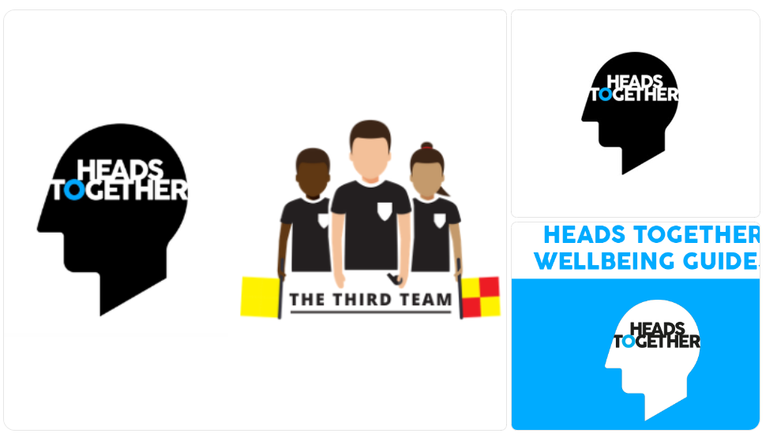
Design for Joy and Playfulness（为“快乐”而设计）
1.The poster "You are enough" by British illustrator Lisa Condon.
These designs, through playful typography and inclusive language, allow viewers to feel "seen/recognized/encouraged" in their everyday spaces.
Website:https://lisacongdon.com/products/you-belong-here-art-print?utm_source=chatgpt.com
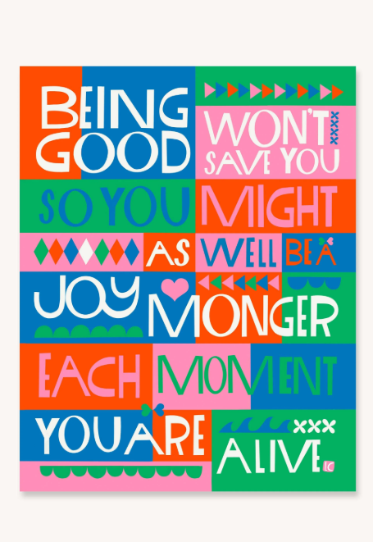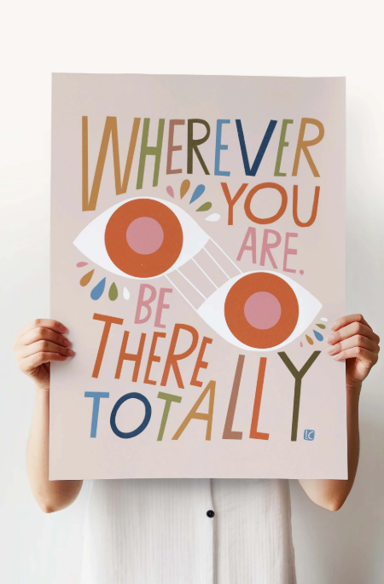
2.Airbnb emphasizes that "no matter where you are, you can find a sense of belonging, psychological security and belonging."
网址：https://design.studio/work/airbnb
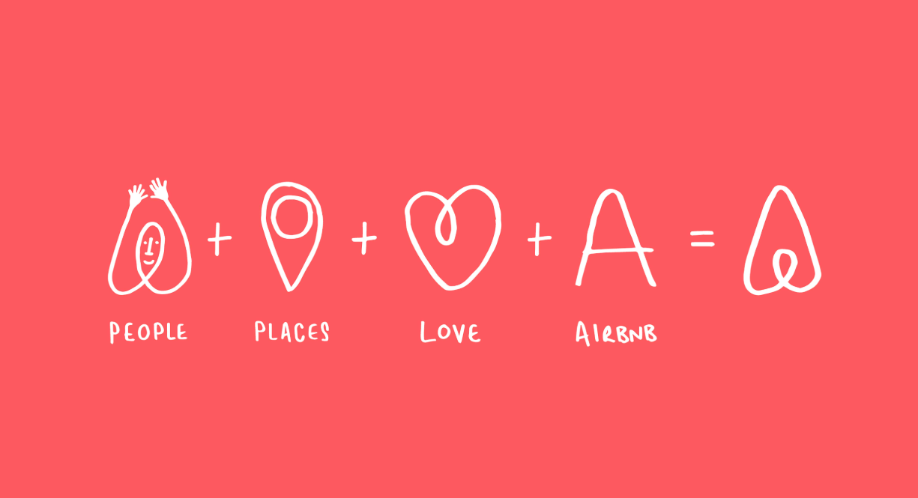
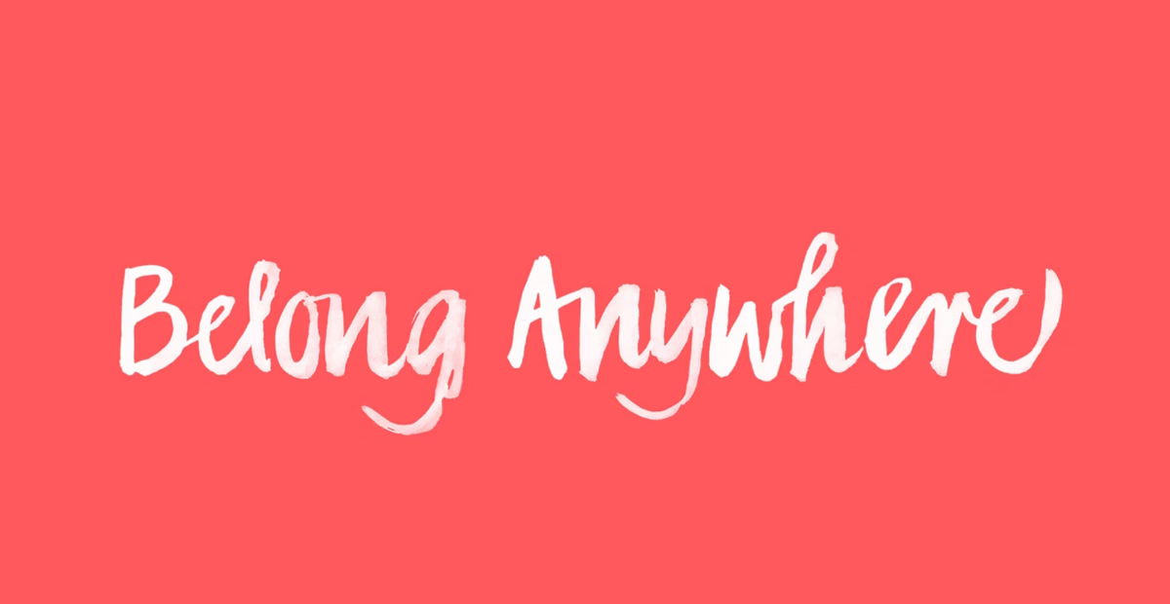
Airbnb’s visual identity has been redesigned around “Belong Anywhere,” shifting the focus to the warmth of belonging and demonstrating how fun and inclusive design can help create a sense of security, welcome, and social connection.

(2) Self-growth through creative practice（通过创造性实践促进自我成长）
Engaging in the process of design is also a journey of self-discovery. Through visual creation, individuals can express identity, explore ideas, and build confidence. The iterative process of experimentation and problem-solving, creativity, and a deeper understanding of the self.
“Through repeated revisions and feedback, I realized that design is not about proving one’s talent but about communication and understanding. This shift in mindset helped me embrace uncertainty with courage.”

Clients' needs are sometimes vague, so designers need to learn to listen, ask questions, and understand their emotions. The theory in "The Courage to Be Happy": "Freedom is not about pleasing others, but about understanding others and still being yourself."

Example：
Case Study: Paula Scher (renowned graphic designer) mentioned in her TED Talk that her "Mapping" series was a way for her to escape commercial constraints and rediscover herself.

"Making mistakes, experimentation, and play are ways I grow the work. My painting is all about mistakes." (These mistakes aren't real mistakes, but rather explorations through playful experimentation with new painting techniques.)

Social connection through shared meaning（共同意义建立社会连接）
Graphic design also serves as a universal language that connects people. Visual symbols, public campaigns, and collaborative projects create shared meaning. When people encounter designs that reflect their values or emotions, they feel a sense of belonging and connection to a larger community.
Example：
1. The Refugee Nation Flag (Yara Said, 2016)
Website：https://yara-said.com/The-Refugee-Nation-Flag?utm_source=chatgpt.com
The flag was designed for the Refugee Olympic team. The orange and black color scheme comes from the colors of life jackets and the ocean, symbolizing hope and survival.
为难民奥运代表队设计的旗帜。橙色和黑色的配色来自救生衣与海洋的颜色，象征希望与生存。
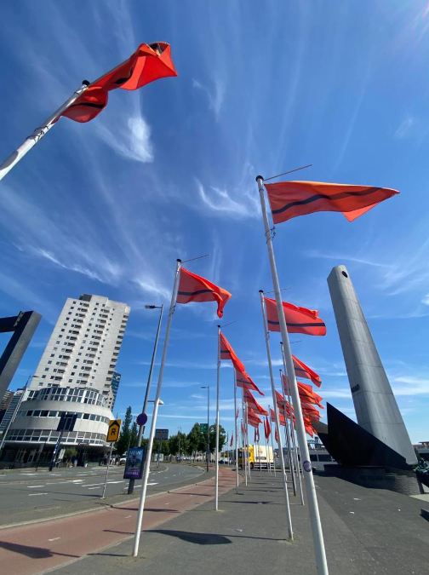
Graphic design has become a "language without borders," allowing the world to understand the plight of refugees. Even without a common language, people can empathize through graphics.
2. Love Has No Labels Campaign (Ad Council, 2015–)
网址：https://lovehasnolabels.com

An American public service advertisement uses X-ray images to show people hugging, kissing, and interacting, revealing that behind the labels of "race/gender/religion" are all the same people, and that people are not distinguished or discriminated against based on appearance, skin color, etc.

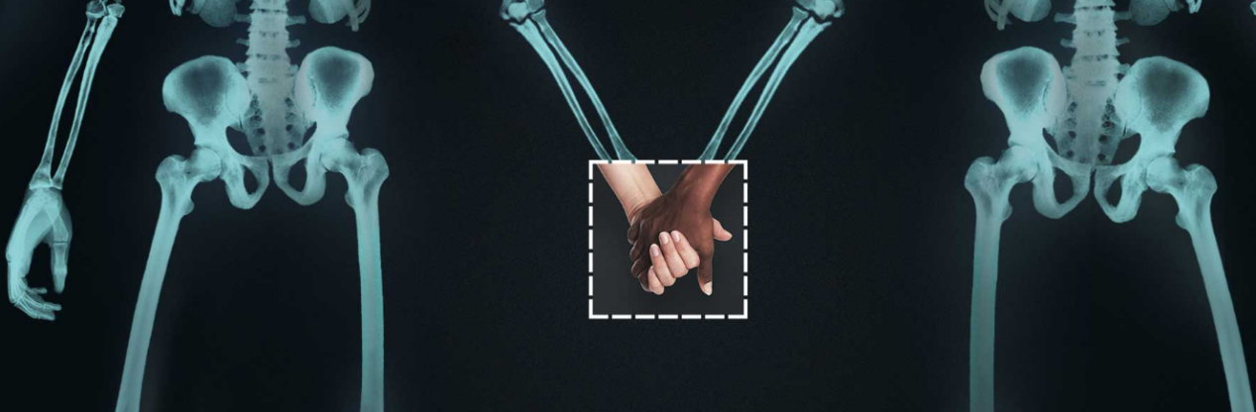2. Cultural understanding and visual commonality

The Noun Project (Ongoing, since 2010)

网站：https://thenounproject.com
A globally collaborative icon library that uses a unified graphic language to express common concepts worldwide.

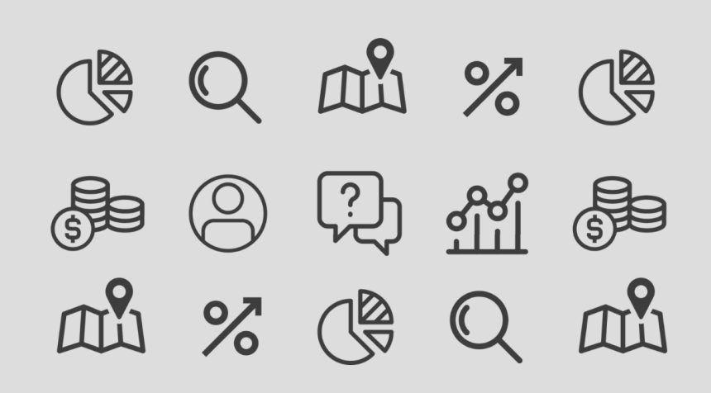

Graphic design serves as a "universal language," promoting cross-cultural communication and inclusion. It breaks down barriers between the hearing impaired and the general population, eliminating the need for sign language.

Community belonging and identity
Sephora “We Belong to Something Beautiful”活動 (2019)
Website：
https://www.prnewswire.com/apac/news-releases/sephora-adopts-a-global-brand-signature--we-belong-to-something-beautiful--302080996.html?utm_source=chatgpt.com
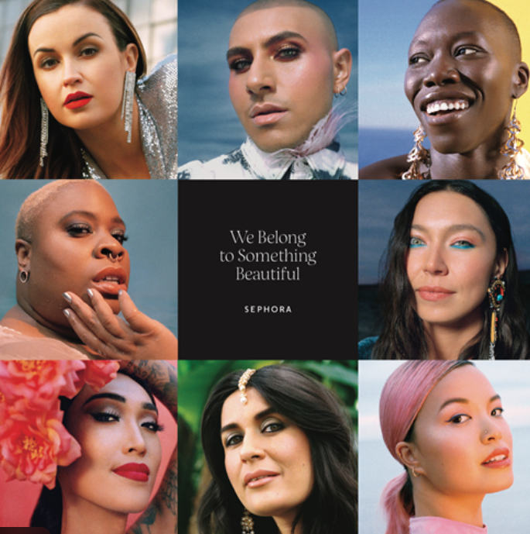
A person's identity partly stems from group affiliation. The event uses visual storytelling to present individuals of different ethnicities, genders, body types, and ages, conveying the idea that "beauty is diverse and universal."
“By showing real people instead of idealized models, Sephora created a sense of shared beauty and empathy across cultures.”

5. Concluding transition（结尾过渡句）
Ultimately, graphic design’s potential lies not only in shaping what we see, but also in transforming how we live — emotionally, personally, and socially.
While graphic design may not literally save a life, it has the profound power to save our sense of life — by bringing meaning, joy, and human connection into everyday experience.

