Aquarelle Cafe Business Plan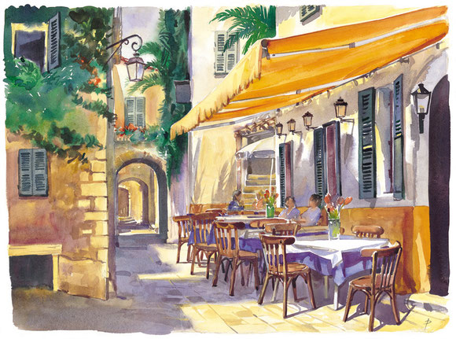

Madalina Petre(198822)
Course: Managing Enterprise in the 21st Century with Melanie Squire

University of Wales Trinity Saint David
2021

Table of contents

- Introduction
About the business………………………………………………………………………………………………………………………….1
Legal identity………………………………………………………………………………………………………………….3
Objective………………………………………………………………………………………………………………………..4

2. External and Internal Analysis……………………………………………………………………………………… 5
Products…………………………………………………………………………………………………………………………6
Physical location…………………………………………………………………………………………………………….7
Competition……………………………………………………………………………………………………………………8
Human resources at Aquarelle Café………………………………………………………………………………..9

3. Commercial Aspects
Marketing and PR Plan…………………………………………………………………………………………………12

4. SWOT analysis of Aquarelle Café………………………………………………………………………………….15

5. Financial Plans(appendix 1)…………………………………………………………………………………………. 16
12 months Cash Flow Forecast

6. References …………………………………………………………………………………………………………………..17

- Introduction
- About the Aquarelle Cafe

Our Aquarelle Cafe is a perfect escape for moms or grandparents who want to enjoy coffee, tea, hot chocolate or other snacks while their children or grandchildren are safe and constantly watched for half hour, time when they listen to stories and songs being encouraged to enable their imagination. We offer a large game of products perfect for you and for your child breakfast or afternoon snack. . We will also maintain a friendly, fair, and creative work environment, which respects diversity in case our client want to work or read while they enjoy a good cup of coffee.
Our mission is to make you relax and take a break from everyday worries, from taking care of preparing breakfast, snack for your child or from taking care to entertain him for an hour.
- Magic Room of Fairy Tales
The Magic Room of Fairy Tales will be the part of our store where children will enjoy of the fantastic atmosphere of the fairy tale world, they will be able to sing and put into practice beautiful passages from stories.
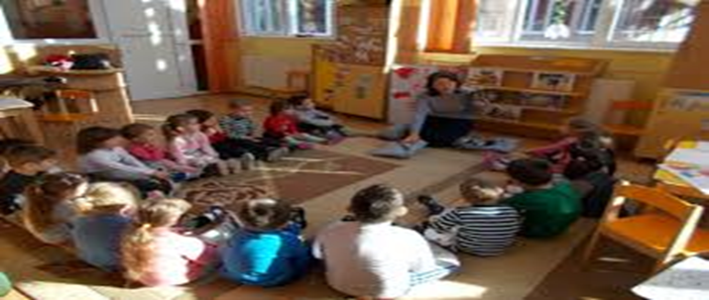

Our motto is’ Start the day with a break’.

- Legal identity
I started this business in a partnership with my best friend. This partnership is the relationship of me and my friend where we will carry out this business with a view to making a profit.
As compared to a sole proprietorship, which is essentially the same business form but with only one owner, a partnership offers the advantage of allowing the owners to draw on the resources and expertise of the co-partners. Running a business on your own, while simpler, can also be a constant struggle. This partnership for me means:
Joanne Cox says in her book Business Law that a partnership may offer many benefits for your particular business.
- More Cash
- Cost Savings
- More Business Opportunities
- Better Work/Life Balance
- Moral Support
- New Perspective
Also she said that partnership can have disadvantage:
- disagreements
- agreement
- the liability of the partners for the debts of the business is unlimited
- taxation
- profit sharing
We will bring an investment of 50,000 pounds, 50% me and 50% my partner money from our savings account.

- Our objective
Anne M. Wenzel in The Entrepreneur, Guide to Market Research make me know Cardiff coffee market still has huge potential as the current number of cafes and bars is insufficient for the existing population. In Cardiff there is a wide variety of cafes from internationally renowned to local cafes with a more or less known reputation. Most cafes charge fairly high prices even those oriented to the middle segment. The applied margin is considered higher for a premium cafe. Our company aims to open a cafe that offers quality products and services at average prices, thus managing to create a stable clientele that will recommend the cafe to other customers.
Also Molly Elodie Rose in How to Make Business Plan Outline speaks about purpose, objectives and how to do an internal and external analysis of a business and I conclude that:
- Purpose of the cafe is to offer a special menu of coffee, tea and chocolate of the highest quality in a cheerful and relaxing atmosphere.
- Our objectives are:
-permanent adaptation to the business environment in Cardiff by offering new products and ways to spend free time
-An initial number of 100 clients per day in the first business year
-developing a trusting relationship with customers, so that the promotion of the cafe is achieved primarily through recommendations from mom to mom.
-hiring qualified people (barista, manager or acting students for children's stories) to form a top team
-Create a PR and marketing plan that targets every parents and grandparents from our town
-to include our children's programs in educational programs

- External and Internal Analysis
- Products
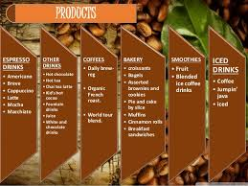

In ‘The Journal of Small Business and Entrepreneurship’ it is write how important is to choose your product and how important products, location and human resources are for my business
Aquarelle Café will have a large game of products because when selling products in a cafe, you should realize that the most profitable for sale are products that can be sold the fastest. Coffee shops usually have a smaller average sale per person. Customers often stand in a queue and usually order a drink and some small snack. The sooner we provide our customers with the ordered products, the sooner we will be able to serve subsequent customers. Therefore, in the case of café with heavy traffic it is important to sell ready or very quick to prepare or reheat products to maximize profits. We will offer the following products:
1. CAKES
2. COOKIES AND MUFFINS
3. SANDWICHES
4. SALADS
5. YOGHURTS, GRANOLAS AND OATMEALS
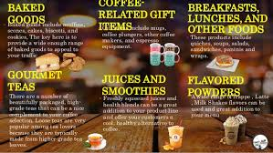
6. CROISSANTS

7. WRAPS
8. COFFEE AND TEA MUGS
9. THERMOSES AND FLASKS FOR COFFEE AND TEA
10. FRUIT INFUSER WATER BOTTLES
11. BULK COFFEE GRAINS
12. SMOOTHIES
13. MACARONS

14. TOASTIES OR FRENCH TOASTS
15. FRESH FRUIT JUICE
16. TEA
17. BAGELS
18. YERBA MATE
19. SOUPS
20. HOT CHOCOLATE
21. LEMONADE


-Espresso
-Drip coffee
-Cappuccino
-Cafe latte
-Caramel macchiato
-White chocolate mocha
-Cafe frappe
-Iced coffee
-Decaffeinated coffee (and tea if possible)
EXTRAS: syrup, honey, steamed milk soy / almond / coconut milk
To these products is added our main service, namely an hour in which we will take care of your children, an hour in which they will listen to beautiful stories and happy songs.

- Physical Location
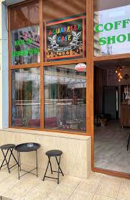

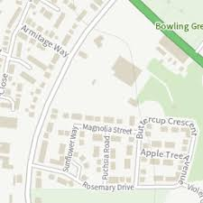

The Aquarelle Café will be located on 47 Magnolia Street in Cardiff. It is a street next to the main street in the city central. It is a busy street along which are located at least 30 offices. The location is located near two nurseries: Ladybirds and Buttercups as well as a school: St David School. Access to the site can be easily accessed by public transport, but there is also the possibility to park nearby. Representing a critical detail in this type of business! Great attention was paid to the optimal location
The space will be rented and has an area of ​​120sqm and includes: main room with bar and serving space, a toilet, lockers room for employees, room for children and a small office of the manager. In fact, there will be a storage room where we will have two refrigerators and shelves for stock products.
The service room will have 8 tables with 4 chairs, 6 tables with two chairs, 3 sofas with 3 seats, chairs for children, two mini bookcases with books and a water stand, glasses and sugar with coffee sticks and tissues.
The necessary equipment (for the preparation of products based on coffee, tea and chocolate and for the storage of beverages and pastries) will be obtained directly from suppliers based on a leasing contract in which I will pay a monthly rates. In this way the shop owns new and quality equipment. In addition, the company offers training services for employees at no additional cost.

There is a list with the essential equipment from my coffee shop:
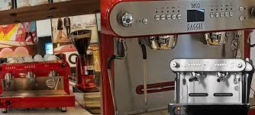
-Automatic Drip Coffee Makers (£ 1500)
-A High-Quality Espresso Machine (£ 3500)
-An Industrial Coffee Grinder (£800)
-POS System and Website (£1000)
-Industrial Blenders (£300)
-Ovens and Toasters (£300)
-Refrigerators and Freezers (£3000)
-Shelving (£500)
-Containers, Pumps, and Storage (£1000)
-A Security System (£200)
-Dishwasher with mugs, glasses and plates (£1200)
Most of the equipment will be bought in a system of monthly rates from Industrial Coffee Suppliers an international brand .First we will pay an advance of the invoice in the amount of £ 1000 and then every month we will pay a rate.
- Competition.
Close to our location is Nero Café and Costa Cafe

- Human Resources Aquarelle Café
- Recruiting
All the jobs will be posted on profile sites and all employees will go through a mandatory interview and a two-hour test
For my business I need:
- Two baristas to prepare the coffee professionally.
Our baristas perform several job duties and provide customer service. Baristas take orders and make coffee, tea, and other drinks to customer specifications. Our baristas may also operate cash registers and credit card machines. Like additional duties I must mention that baristas may field customer complaints or questions, as well. Baristas at Aquarelle Café also must often clean coffee machines, restaurant areas, restrooms, and preparation areas during a normal shift. Baristas work to maintain good customer relations and speedy delivery of all beverages as well as complete assigned tasks from management every day.
A barista at Aquarelle Café typically enjoys competitive pay as well as a variety of employment benefits. Starbucks barista starting salary rates typically fall between minimum wage and 10.00 per hour, depending on experience and location. Baristas may also take advantage of several job benefits. Qualified baristas receive health benefits, such as medical, dental, vision, and life insurance plans. Eligible baristas at may also enjoy 401(k) retirement programs and paid vacation time.
- Four waiters
The Waiter/Waitress will take orders and serve food and beverages to our customers in our cafe. Always be aware of customer satisfaction to deliver the perfect service experience. Ensure high quality of food and beverages to our clients. Duties and responsibilities include, but are not limited to: servicing the customers in a friendly, efficient manner while maintaining a clean and safe work environment. They will be paid with £ 11/h and £15/h if they do overtime.
Their main responsibilities will be:
-Ensure hot food is hot and cold food is cold
-Adhere to timing standards for products and services
-Look for ways to consolidate service and increase table turns
-Present menu, answer questions and make suggestions regarding food and beverage
-Serve in an accommodating manner
-Pre-bus tables; maintain table cleanliness, bus tables
-Looks for ways to avoid waste and limit costs
-Assist in keeping the restaurant clean and safe

- Two cleaners who will work in shifts and will take care of the shop to be always clean. Also they will have the following duties:
-Cleans restrooms, including restocking dispensers, emptying trash, cleaning and sanitizing fixtures, cleaning mirrors, spot cleaning partition doors and walls, sweeping and mopping tile floors, and cleaning toilets and urinals.
- A person who will take care of the children. This person would have to love children, to be patience and have storytelling talent.

- Café manager oversee the day-to-day running of cafés
The store will have a person in charge of the cafe who will supervise everything, make the stocks, inventory, orders and appointments for the children's program. Main duties are:
-Recruiting, training, and supervising café staff.
-Preparing weekly work schedules for staff and finding suitable replacements in cases of staff absence.
-Ensuring that all café expenses are within budget and identifying ways to decrease operational costs.
-Resolving customer complaints regarding food quality and customer service.
-Suggesting new menu items based on customers' preferences and feedback.
-Identifying strategies to retain and attract customers.
The jobs will be posted on the profile sites. All staff will participate in job interviews and will require at least 2 years of experience in the field.

Employees will be paid based on their experience and salaries in the profile market, therefore I will give my employees the opportunity to negotiate their salaries just to make sure that they will be satisfied and will return to their jobs.
My employees will be paid from the profit of the café but in the first three months they will be paid from the investment that my partner and I will bring.

- Commercial Aspects
- Marketing and PR Plan
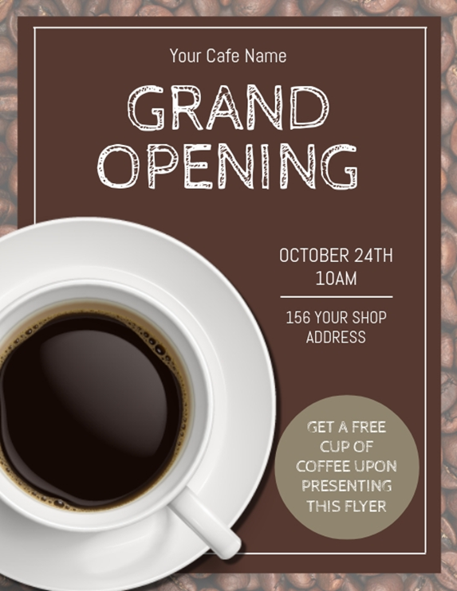

My target market will generally be made up of parents or grandparents but not only, people who want to relax, read a book or work are always welcome, we will also have a take away service so the employees of the surrounding companies who appreciate good coffee they are also a target.
In all cases I will spread flyer, I will go to nearby nurseries and schools with brochures.
I will make my café known by inviting a great actor to read stories to children on a day that I will promote in my commercials. In fact, in a month every week I will invite a personality: singer, actor, painter or writer to spend an hour with children to make sure that people will know about my cafe.
I will offer the possibility to accumulate loyalty points in exchange for a free coffee.
I will have as breakfast products for children and snacks to encourage mothers to come
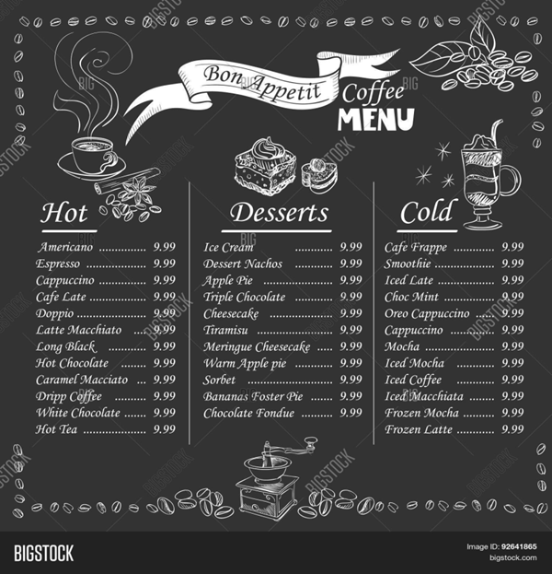
Also I will give free samples are one of the oldest marketing tricks around; that's because it works. Free samples are like discounts; they attract customers and encourage them to make purchases. Offer free samples on and offline; these can be new treats and coffee flavors.
I will start running Facebook ads or uploading images on Instagram, people need to understand that our coffee shop isn't just a store or a company name. It's a brand. And defining your brand is setting the tone of who you market to so our coffee from Honduras it is a brand and the coffee lovers will be delighted .However, it's still one of the best platforms to convert followers into shoppers with ads, not to mention it's seen as one of the most comprehensive online directories for local businesses. Next to Google, customers will check your coffee shops Facebook's page for opening hours, a menu, reviews, and check-ins when they visit in person.

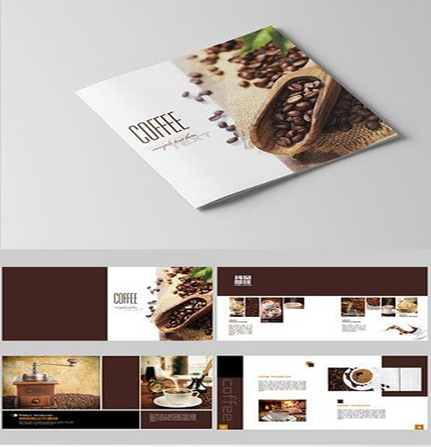
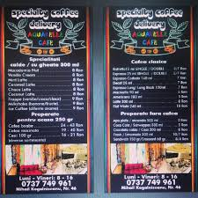
Then I will host a giveaway or Coffee Lovers Contest
Hosting giveaways can increase our brand awareness by up to 30% when compared to previous marketing tactics because:
- Increase brand awareness and product purchases
- In the future we plan to host coffee events.

- SWOT analysis of Aquarelle Café
Christopher Seth in ‘SWOT Analysis, Management and Marketing’ notes the importance of a Swot Analysis in the future of a business.
- Strengths
- increasing daily coffee consumption (more than a cup - the tastes of coffee consumers have evolved
-association with a well-known coffee producer: Lavazza and Honduras
-our originality
-the loyalty programs, related services
-the experience our baristas
-Quality of products and service
- The area and location has heavy drive by traffic and will lead to more sales when proper signage is placed on the real estate and it is close to the bus stations
-the equipment is of the latest generation and allows us to cope with the morning crowd without problems
- Weaknesses
-Poor consumer confidence, uncertainty and pessimism in new start-ups.
-Established coffee shops can take away or limit our potential customer given their goodwill and customer rapport.
-As a newer café and/or coffee shop, potential consumers and customers have not heard of our delicious exotic coffee beans, espresso and lattes; so proper marketing will need to be established to assure our target demographic knows and understands our products.
-owners lack of experience
-Our financial resources, such as funding, sources of income and investment opportunities limit our reach and impact in the market.
- Opportunities
-we know that going out to a restaurant with children can be more expensive and tiring for parents
-the coffee tastes are more extravagant and more pretentious now
-coffee consumption is constantly increasing
-We can develop the programs we have with the kids: karaoke, painting or paper crafts and we will have more diversity to attract the customers
-the session with your kids in story or singing time will last 30min so the estimate time spent in our shop by a customer is 30 min which allow us to have more people in in one day

- Threats
- Rent Prices may be high (future rent increases, caused by progressing community development
-Other cafes in the area
- Government regulations, requirements – high administrative costs, experts might be needed
-Varying prices for resources (food, electricity, gas, oil, water)
- Issues with the popularisation of the cafe business - the theme might be too common

- References

1. www.cardiffwalesmap.com
2. www.costa.co.uk
3. www.webrestaurantstore.com
4. onlineshop.caffenero.com
5. www.coffeeshopsstartups.com
6. Rob Dransfield, Catherine Richards, Philip Guy, David Dooley, Business, Heinneman Educational Publisher,2004,UK
7. John E. Doerr, Measure what Matters, Portfolio, 2018
8. Anne M. Wenzel, The Entrepreneur’ Guide to Market Research, Praeger, 2012, California
9. The Journal of Small Business and Entrepreneurship, Vol.1, 2003,Canada
10. Clive Rich, Law for Small Business for Dummies, John Wiley& Sons Ltd, 2016,West Sussex, UK
11. Joanne Cox, Business Law, Oxford University Press,2009,UK
12. Christopher Seth , SWOT Analysis, Management and Marketing, 2010,US
13. Timothy Jury , Cash Flow Analysis and Forecasting, Wiley Publisher, 2012,UK
14. Molly Elodie Rose , Business Plan Cash Flow Forecast Template, Independently Publisher , 2020
15. Molly Elodie Rose, How To Make Business Plan Outline, Independently Publisher, 2020

- Financial Plans (Appendix 1)
- 12 months Cash Flow Forecast
In order to see if my business is profitable I did a 12 months cash flow forecast
How I write before me and my partner will bring 25.000 pounds each like an investment
Regarding the rent, I must mention that I signed a 2-year contract with the landlord, so in the next 12 months the rent will be exact, namely 600 pounds per month will be passed as a fixed expense.
The monthly income listed in the table refers to the income from the sale of our products: coffee, food, etc. cumulated with the income from our services, for each child who goes to the Magic Room of Fairy Tales we will charge a fee of 4.5 pounds.
In the first 3 months I will take care of children from the Magic Room of Fairy Tales and my partner will take over the position of cafe manager and the payment for our services will be 0 pounds following a collaboration contract, after 3 months the initial salaries will be added the salary of our storyteller and in the 8th month we will allow ourselves the promotion of one of our employees for the position of cafe manager and another for the position of stock manager.
The utility bill will contain the consumption of water, gas and also in the section of utilities we have accumulated the telephone and internet bill. All these votes had an estimated amount of 300 pounds per month.
In the first three months our cafe will be promoted on a local radio for the amount of 200 pounds per month, in addition to the brochures and flyers that we will spread in the first 6 months. In December we will have a special guest in the Magic Room of Fairy Tales who will have a fee of 150 pounds.
Stocks with raw materials: drinks, sandwiches, cookies, snacks, fruits, porridge, etc. will be renewed weekly and will cost 400 pounds per month.
Stocks with napkins, coffee sticks, sugar, coffee, tea, etc. will be renewed once every month, the first payment will be 600 pounds in June and the next another 3 months.
Another monthly expense in the first year will be the equipment rate. After an advance of 1,000 pounds to the supplier we signed a contract with him in which we will undertake to pay a monthly rate of 120 pounds.
Also in the first month we will redecorate the store, we will buy chairs and sofas for the dining room. The bar will also be included in the decoration expense with a value of 4500 pounds.
Until August, the employees will have the locker room and the manager of the arranged office.
In August we will buy shelves with books worth 1200 pounds and in July we will invest 2000 pounds in the Magic Room of Fairy Tales.

