Module: LCDB7009

Critical Literature Review by QURATULAIN
Dr. Gareth Hughes
Spring 2023

PART 1

What is a Literature review?

For practically all research projects, a literature evaluation is a crucial step. As stated by Webster and Watson (2002), it provides the framework for knowledge advancement, promotes the development of theories, concludes mature research, and identifies new study opportunities. A literature review, which analyses and synthesizes earlier material, is referred to as a "knowledge map" by Frank and Hatak (2014). A comprehensive summary of past studies on a particular topic is what a literature review essentially is. An academic examination of a certain field of study is known as an analysis of literature. In addition to summarizing the sources, a strong study of literature evaluates, synthesis, and assesses them to present a thorough picture of the state of the field's knowledge (Cooper, 2010).

The development of a study topic, the consolidation of what is already known, the identification of knowledge gaps, and the identification of ways in which you might contribute to knowledge are all facilitated by conducting a literature review. It is a skill that is required of researchers, students, and professional managers alike to determine what is at present understood and, therefore, what is still unknown regarding a topic. This is what academics refer to as studying literature since it helps you understand the status of a discipline, identify deficiencies in knowledge and tie it to existing research (Lim et al.,2022).
A review of the literature can bring an argument to a close, highlight areas in need of further study, and establish an area of interest (Anastasiadis et al.,2015). A review of the literature is often included in research manuals to show why the study must be conducted. The problem statement, which makes the argument for the significance of the paper's purpose by using the literature to support claims, expresses this necessity. The key concepts in the problem statement and purpose are supported by the literature that comes after the purpose. The literature review, which is a component of the introduction section, serves three purposes,
- Determining if a topic is researchable.
- Reporting the findings of closely related studies.
- Establishing the significance of the current study relative to earlier studies (Creswell, 2003).

A literature review is, in the words of Fink (2005),

A framework that is "systematic, stated, and reliable for the recognition, evaluations, and combination of the most recent body of published and archived work generated by investigators, academics, and professionals."

An unbiased, comprehensive investigation and critical examination of significant research and non-research literature on the subject under study represents a review of the prior research (Hart, 1998). Its objectives include educating the reader about the state of the literature in the field and laying the foundation for further objectives like arguing for the need for greater field research. A good literature review gathers information from several sources on a certain topic. It's well-written and doesn't contain many if any, personal prejudices. It is important to have a clear search and selection method. A solid framework is necessary for the review to flow better and be easier to read. The correct use of language and jargon should be practiced (Cornwell and Daly, 2001).

The research topic serves as the foundation of a synthetic literature review, which then proceeds to data gathering and data analysis. The data analysis aids the researcher in formulating judgments and suggestions (Scott and Bruce, 1994).

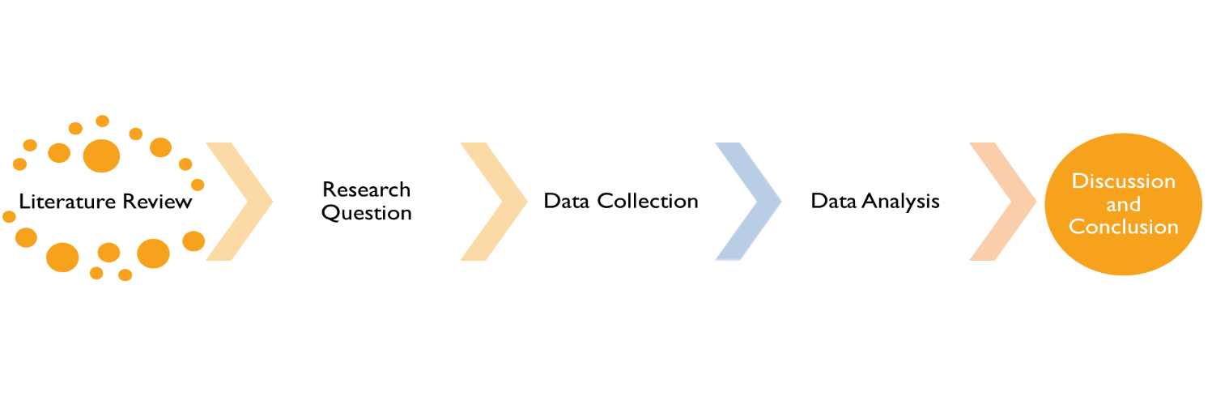
By highlighting gaps in the body of current knowledge, a literature review—a crucial step in the research process—can help define a study question. It can also create a greater understanding of a subject while advancing new research discoveries and ideas. It may provide a novice researcher with knowledge of tools for data collection and analysis as well as insight into relevant study designs. The method of approach—qualitative or quantitative—often determines when and how something is done. Numerous sorts of literature reviews might be employed, depending on the purpose and objectives of the research in addition to the motivations behind the review (Kraus et al., 2020).

An evidence-based, in-depth investigation of a topic is what a literature study is. A significant evaluation of the current corpus of information on a topic is what a literature review is. There are many reasons to write one, and each will have a different impact on the length and writing style of your review. Instead of just listing every publication that has been made, a literature review should offer a fair overview of the information. It should consider both known and new concepts, as well as conflicting data and conflicts (Lim et al., 2022).
According to Booth, (2016) there are four types of literature reviews: critical, integrative, mapping, and literary. The literature review will be the main topic of this study.

2. Critical Literature Review
A front-line critical evaluation of the literature explains what has been done, how it was done, why it was done, what it means, and what should be done next (Torraco,2005).
Front-line Literature Genres Four Categories,

- Theory
- Research
- practice and
- policy.

Theory
By employing data to spot patterns, theoretical literature models how things are (or should be). The proof need not be original research from the theorists; it might be experiments, observations, experiences, or thoughts. Once the patterns have been formalized into a model, researchers may be able to forecast what would occur in hypothetical future circumstances.

Research
Research writing, or data-driven literature, presents observations about the outside world and frequently connects them to a model-derived forecast or hypothesis. Though there is considerable overlap, data come in two primary forms: observational and experimental. If the researcher manipulates the situation or not, there is a significant difference.

Practice
Practice literature includes descriptions of how things are done and is frequently published by skilled practitioners who believe that others might profit from knowing how they conduct their business. This genre of writing is especially prevalent in applied disciplines of investigation that concentrate on a sphere of practical social activity, like nursing.

Policy
Change to improve practice by values is stressed in policy literature, which is also most prominent in applied disciplines. Most authors of this genre are policymakers, people who work for them, or people whose main goal is to persuade policymakers.
(Torraco,2005).

Creswell (1997, pp. 20, 21) states that the literature in a research study serves several purposes, including the following:
- It updates the reader on the findings of other closely similar studies to the one being presented. It connects a study to a more extensive, ongoing conversation in literature.
- It builds upon and connects to past investigations.
- It provides a framework for figuring out the importance of the study. (Marshall & Rossman, 2011).
A literature review is an objective, thorough summary and
critical analysis of the relevant available research and no

Types of Literature Review

A literature review is central to the research process and can
help refine a research question by determining
inconsistencies in a body of knowledge. Similarly, it can help
inspire new research innovations and ideas while creating
a greater understanding of a topic. It can enable a novice
There are 2 types of literature reviews,

1. A traditional or narrative review of the literature
2. A non-traditional or systematic review of the literature

3.1. Traditional Literature Review

A traditional or narrative literature review's primary objective is to assess and summarize the body of text. To do this, a thorough study of the pertinent literature is conducted with the goal of highlighting fresh lines of inquiry, identifying knowledge gaps, or highlighting inconsistencies. This form of literature review, according to Coughlan et al. (2007), can help with the development of the refinement, determination, and classification of research themes, as well as the conceptual and theoretical frameworks. A conventional social science and business management literature review is beneficial at revealing knowledge deficiencies, while the systematic review is focused on advancing research understanding. Snyder, 2019 offers an ongoing process of the numerous techniques used for both literature evaluations.

story perspective systematic evaluation

range of aesthetics structured methods.

undefined technique rigorous approach

Without a specific analysis Meta-analysis and synthesis

Traditional literature mixes together pertinent literature based on the critical judgments and (subjective) choices of the author(s) through a process of discovery and critique (such as pointing out errors and disputing assertions or views). The exposure, expertise, and experience (often referred to as the "3Es") in judgment calls of the author(s) have an impact on these decisions. Non-SLRs are hence literary critiques (Lim and Weissmann, 2023).

3.2 Non- Traditional/ Systematic Literature Review

Systematic literature reviews, on the other hand, usually because they are employed to respond to incredibly precise and well-structured research questions, adopt a more thorough strategy while analyzing the literature. Specifically, SLRs are systematic reviews that follow a protocol or procedure that has been adopted or modified to direct data curation and analysis, allowing for open disclosure and replicable results (Kraus et al. 2020). As a result, an SLR is essentially any review nomenclature that is informed by a systematic approach. This kind of literature evaluation has its roots in the early 1990s evidence-based medicine movement, which sought to address the problem of conflicting results in research for medical treatments (Boell and Cecez-Kecmanovic, 2015).

4.PURPOSE AND CONTENT OF LITERATURE REVIEW:

Before forming an argument or justification, one should familiarize themselves with the subject and the literature by conducting a literature review. This thesis's key chapter's goals are to define the situation and provide evidence for the study's findings. (Bruce and Scott,1994).

As stated by Lieta et al., 2019 the author " creates an " identifying and integrating the essential ideas, challenges, conclusions, and research approaches that emerge from an in-depth investigation of the readings, it also contributes to the structure of additional research. (Rudestam and Newton, 2001).

The evaluation of research serves several functions. The reader is made aware of the conclusions of nearby, similar research that is being done. completing the gaps and extending earlier inquiries, it connects a study to the larger, continuing dialogue in literature (Cooper, 2010). It is an approach to gauge the significance of the research project and a yardstick for contrasting the findings with other findings. All or some of these justifications could serve as the basis for incorporating academic literature into a study (Marshall & Rossman, 2011).
Cooper (2010) talked about four different kinds of literature reviews,

1. Consider what others have said and done.
2. Critiquing earlier academic works.
3. create connections between related topics, and
4. pinpoint the key problems in a certain area.

A literature review does at least three things at once:

1) It is, above all else, a defense of the aim and significance of your research for the field.
2) It boosts your authority as a specialist in the field.
3) It enables you to explain and explain the significance of your technical results to the reader.

Process of Literature Review
The three primary processes in a successful review are planning, conducting, and reporting.
(Kitchenham,2007).
Researchers determine the study topics, create the review procedure, and decide whether a review is required during the preparation stage. The primary studies are chosen and identified, and the researchers then take the data from those studies and synthesize it. The researchers report their review to communicate their conclusions from the literature analysis. The following eight processes can be used to finish any review, even if different types of literature reviews use various methodologies (Denney and Tewksbury,2013).

1. defining the research problem is step one.
2. creating and approving the protocol for the review.
3. looking through the literature.
4. Choosing participants.
5. Evaluating quality.
6. Data extraction.
7. Examining
8. Conclusion

The literature review procedure can be iterative, it should be highlighted. Unexpected issues may develop while completing the review and need modifying the research question or review process. The research question was too wide, which requires the researchers to focus their attention and modify the inclusion criteria. To contextualize research findings, conducting a literature review includes acquiring knowledge on a topic or evidence to support a theory. These days, we have access to knowledge at our fingertips and can easily find online resources using sophisticated search engines like Google without ever having to set foot inside a library. The first step is to choose wide, pertinent keywords for your topic. Given that they are accountable, these call for serious examination (Kazakova,2022).

Fundamental elements of the literature review

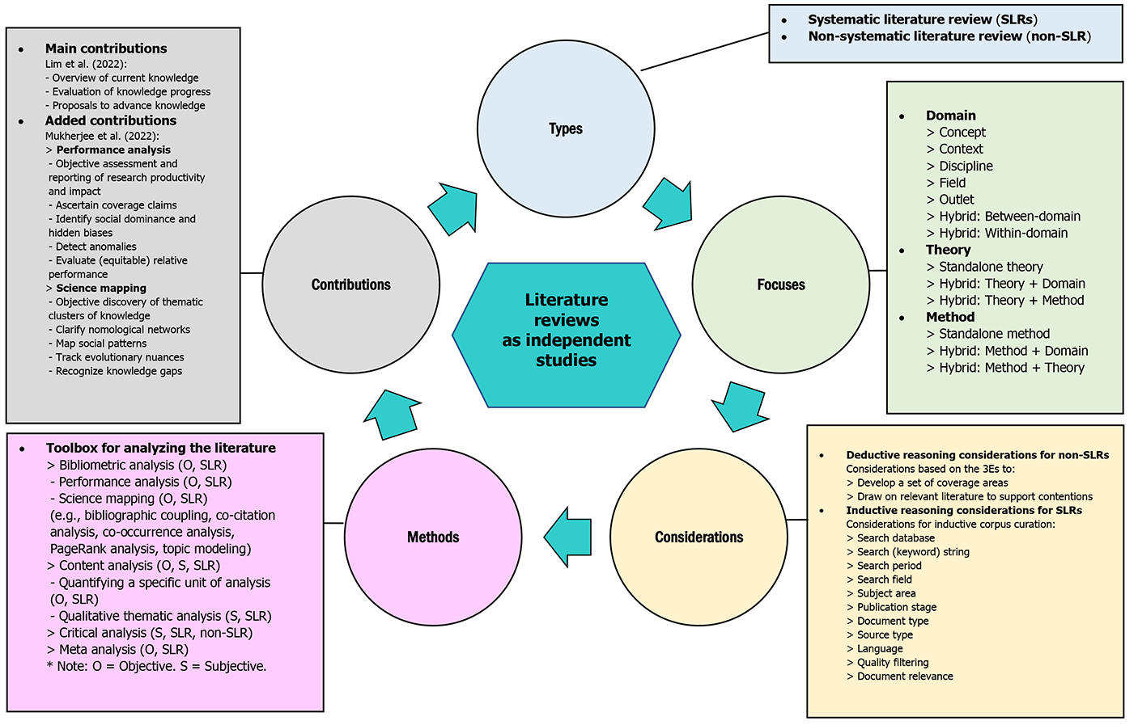

CONCLUSION
As a result, the literature review is crucial and essential to the research project because it analyses and synthesizes the current literature to identify gaps and direct the study toward addressing them. The literature review enables the researcher to situate their research about previous studies that have been done on the issue. It enables the researcher to gather the most pertinent data and determine which kind of evidence to use effectively in their study. The examination of the various perspectives, discourses, theories, and conceptions regarding the subject of interest that are presented rationally and by specific standards constitutes the substance of the literature review. Therefore, conducting a solid literature evaluation gives the research a solid foundation.

REFERENCES
Anastasiadis, E., Rajan, P. and Winchester, C. L. (2015) “Framing a research question: The first and most vital step in planning research,” Journal of clinical urology, 8(6), pp. 409–411. doi 10.1177/2051415815612049.
Boell, S. K. and Cecez-Kecmanovic, D. (2015) “On being ‘Systematic’ in Literature Reviews in IS,” Journal of information technology, 30(2), pp. 161–173. doi: 10.1057/jit.2014.26.
Booth, A. (2016) “Searching for qualitative research for inclusion in systematic reviews: a structured methodological review,” Systematic reviews, 5(1), p. 74. doi: 10.1186/s13643-016-0249-x.
Cornwell, R. and Daly, W. (2001) “Strategies for the construction of a critical review of the literature,” Nurse education in practice, 1(2), pp. 57–63. doi: 10.1054/nepr.2001.0008.
Cooper, H. (2010) Research synthesis and meta-analysis: A step-by-step approach. Thousand Oaks, CA: Sage.
Coughlan, M., Cronin, P. and Ryan, F. (2007) Step-by-step guide to critiquing research. Part 1: quantitative research. PLACE AND PUBLISHER.
Creswell, J. W. (1997) “Research Design: Qualitative and Quantitative Approaches,” Modern Language Journal, 81(2), p. 256. doi 10.2307/328794.
Creswell, (2003) “Systematic Reviews: Rationale for systematic reviews,” BMJ, 309(6954), pp. 597–599. doi 10.1136/bmj.309.6954.597.
Denney, A. S. and Tewksbury, R. (2013) “How to write a literature review,” Journal of criminal justice education, 24(2), pp. 218–234. doi: 10.1080/10511253.2012.730617.
Fink, A. (2005) Conducting Research Literature Reviews: From the Internet to Paper. London: Sage.
Frank, H. and Hatak, I. (2014) “Doing a research literature review,” in Fayolle, A. and Wright, M. (eds.) How to get published in the best entrepreneurship journals. Cheltenham, pp. 94–117.
Hart, C. (1998) Doing a Literature Review: Releasing the Social Science Research Imagination. London: Sage.
Kazakova, M. (2022) “Writing a literature review,” An International Multidisciplinary Research Journal, 12(5), pp. 1136–1139. doi: 10.5958/2249-7137.2022.00526.2.
Kitchenham, B. (2007) Guidelines for performing Systematic Literature Reviews in Software Engineering. Barbara Kitchenham.
Kraus, S., Breier, M. and Dasí-Rodríguez, S. (2020) “The art of crafting a systematic literature review in entrepreneurship research,” International entrepreneurship and management journal, 16(3), pp. 1023–1042. doi 10.1007/s11365-020-00635-4.
Leite, D. F. B., Padilha, M. A. S. and Cecatti, J. G. (2019) “Approaching literature review for academic purposes: The Literature Review Checklist,” Clinics (Sao Paulo, Brazil), 74(e1403), p. e1403. doi: 10.6061/clinics/2019/e1403.
Lim, W. M., Kumar, S. and Ali, F. (2022) “Advancing knowledge through literature reviews: ‘what’, ‘why’, and ‘how to contribute,’” Service industries journal, 42(7–8), pp. 481–513. doi 10.1080/02642069.2022.2047941.
Lim, W. M. and Weissmann, M. A. (2023) “Toward a theory of behavioral control,” Journal of strategic marketing, 31(1), pp. 185–211. doi: 10.1080/0965254x.2021.1890190.
Marshall, C. and Rossman, G. B. (2011) “Designing Qualitative Research,” Modern Language Journal, 80(3), p. 403. doi 10.2307/329453.
Rudestam, K. E. and Newton, R. R. (2001) “Surviving your dissertation: A comprehensive guide to content and process,” JMR, Journal of marketing research, 30(2), p. 265. doi 10.2307/3172836
Scott, S. G. and Bruce, R. A. (1994) “Determinants of innovative behavior: A path model of individual innovation in the workplace,” Academy of Management Journal, 37(3), pp. 580–607. doi 10.2307/256701.
Snyder, H. (2019) “Literature review as a research methodology: An overview and guidelines,” Journal of business research, 104, pp. 333–339. doi: 10.1016/j.jbusres.2019.07.039.
Torraco, R. J. (2005) “Writing integrative literature reviews: Guidelines and examples,” Human resource development review, 4(3), pp. 356–367. doi: 10.1177/1534484305278283.
Webster, J. and Watson, R. T. (2002) “Analyzing the past to prepare for the future: writing a literature review,” MIS Q, 26(2).

PART 2 LITERATURE REVIEW ASSIGNMENT

BASE PAPERS
PAPERS DIGITAL ENTREPRENEURSHIP
PAPERS DIGITAL INNOVATION
PAPERS IIOT INDUSTRY
PAPERS DIGITAL HEALTH INDUSTRY

PART 3

PART 3 LITERATURE REVIEW OF TOPIC

Through the mediation role of the IIOT 5.0 Industry, case study research will look at the interaction between digital entrepreneurship and digital radical innovation, ultimately resulting in the sustainability of an economy.

EXECUTIVE SUMMARY
The goal of the contemplate is to gauge whether the concept of "industry 5.0" can be used to describe the connections between fifth-generation characteristics and digital innovation, entrepreneurship, and the healthcare sector. The distinctive characteristics of Industry 5.0 are contrasted with those of prior industrial evolutions. It also discusses how digital technology can be used to create and make applications for industry 5.0, such as those in the healthcare sector. This paper goes into detail about the foundational Industry 5.0 innovation, including blockchain, The World Wide Web of Things, robots, and digital triumphs. "Industry 5.0," forthcoming, innovations from prior eras are designed for efficient and inventive machines. The goal of the study is to shed light on how leveraging digital tools makes it more difficult to know the challenges in the medical field. Finally, the study seeks to shed light on how using electronic equipment in the healthcare sector could promote long-term economic growth and viability. However, Industry 5.0 stands out from all other possibilities because humans are now at the center of industrial operations. The production process and supply networks for manufacturing will be drastically changed by intelligent robots, which will promote well-being and ensure economic sustainability.

Word Count: 3550
keyword research: digital entrepreneurship, radical innovation in the digital sphere, IIOT 5.0, sustainability, digital devices, health care sector.

1.1 Digital Entrepreneurs and Digital Entrepreneurship
In the words of Hull et al.'s definition of "digital entrepreneurship" from 2007, it is “the harmonization of vintage with some or all the following: "Entrepreneurship with the novel method of developing and operating enterprises in the digital era," some or all the tangible elements that typically are included in a traditional company have been converted to digital form. Davidson and Vaast (2010) offer somewhat interpretations of digital entrepreneurship that vary, referring to it as " the procedure of determining enterprise potential while leveraging digital media and other forms of communication and information technology."
Digital entrepreneurship activity is a general term for any entrepreneurial effort that brings a crucial good, service, or aspect of the company online. Traditional business owners and internet entrepreneurs share a few essential traits, according to a 2007 study by Hull et al. The main differences between entrepreneurs who operate in the digital arena and those who don't are their products, marketing strategies, and working environments. By recognizing and taking advantage of opportunities to enhance organizational performance, and find creative solutions to problems, entrepreneurs advise companies that employ policies that support the environment of organizational creation and make efficient and effective utilization of the resources of other businesses (Rae, 2016).
Entrepreneurs are those who see chances to add value for their businesses, stakeholders, and society at large and who take action to control other people and the conditions of the workplace, according to Greenberg et al., (2013). Chen et al., (2022), who recognized that this construct lies at the crossroads of entrepreneurship, claimed that an entrepreneur is a person who combines initiative, creativity, and risk-taking. Gupta et al., 2004 theoretical underpinnings for this type of digital entrepreneurship are congruent with this point of view. By creating a vision, anticipating, and visualizing change, and maintaining flexibility, entrepreneurial leaders foster innovation and the identification of opportunities in medium-sized and small enterprises (Bagheri, 2017, Renko et al., 2015; Cogliser & Brigham, 2004).
The world has greatly benefited from digital entrepreneurs' inventive business techniques, especially in the last ten years. Google, Facebook, Microsoft, and Apple all had a big impact on how people interact daily in addition to fundamentally transforming business. We now inhabit a world that has undergone a digital transformation, where artificial intelligence is possibly used to enhance the standards of decisions, and where our perception of fact may be enhanced in a variety of ways to broaden our vantage point (Kraus et al., 2019).
Dinh et al., (2018) state that technical Internet, ICT, and other related terms are to blame for the phenomenon known as "digital entrepreneurship." The phrase "digital entrepreneurship" refers to any entrepreneurial activity that puts the main product, service, or element of a business online. Traditional and digital business owners diverge in several ways. According to Hull et al., (2007), the main distinctions between digital and non-digital entrepreneurs may be found in the products, marketing plans, and work settings they use.
Entrepreneurs inspire and enable businesses to embrace practices that foster a business attitude of innovation by identifying and leveraging possibilities to enhance company efficiency, find unique approaches to issues, and make optimum use of the resources available to the business (Rae, 2016). According to Greenberg et al., (2013), entrepreneurs are individuals who identify possibilities and add value for their companies, stakeholders, and society at large and who take the initiative to control other people and the working environment. A composite formulation of determination, creativeness, and risk-taking builds up an entrepreneur, according to Chen et al., (2022), who reiterated that the concept exists at the pinnacle of entrepreneurship. This perspective is consistent with how Gupta et al., (2004) conceptualized entrepreneurship in the digital age.
Unquestionably, the theoretical cornerstone of entrepreneurship study is Schumpeter's theories from 1997. Entrepreneurship is the capacity as well as the readiness of individuals to discover and cultivate novel economic possibilities (processes, organizations, and product arrangements) and to market their theories in light of absurdity alongside other difficulties whether acting alone or in groups, inside or outside of well-established organizations.
Strategic decision-making based on accurate future estimates is made possible by future orientation. By creating a vision, anticipating, and visualizing change, and maintaining flexibility, entrepreneurs foster innovation and the recognition of opportunities in small and medium-sized enterprises (Bagheri, 2017; Renko et al., 2015).
Compact and moderately sized technologies in Iran, Bagheri (2017) investigated the effects of entrepreneurs' innovative behavior on employees' capacity to recognize opportunities. In that study, 39 high-tech SMEs with 310 employees were examined.
Any of the following, as well as others, may take on a digital form in an entrepreneurial enterprise. The list of " Giones and Brem's (2017) article, "Modern Services and Goods Based on the Internet," offers a more methodological perspective. Acknowledge that "The use of technology is an input factor" and limit your use of examples of digital entrepreneurship to those that are cloud-based, big data-based, or AI-based. Acs and Sussan assert that this understanding of digital entrepreneurship is expanded (2017, p. 66).
Acs and Susan (2017) improve our comprehension of digital entrepreneurship by incorporating the user component. A more specific definition of digital entrepreneurship is provided by It has been described by Davidson and Vaast (2010) as an exploration of the potential benefits of using internet-based media and other interpersonal and informational tools technology. According to the knowledge spillover hypothesis of entrepreneurship, inventive activities enable entrepreneurial organizations to recognize and seize opportunities brought about by knowledge spillovers, hence establishing a link between innovation and entrepreneurship (Paul et al., 2023).

1.2 Digital Radical Innovation
Innovation, as stated by (Caceres et al., 2011), is an ongoing procedure for creating beneficial resources that are then used to make goods and technological items more accessible and of greater quality. Ilori et al., (2017) described innovation in a similar manner, defining it as the incorporation of new information into procedures, goods, and services. In the words of Peter Drucker (1998), innovative thinking is the cornerstone of all entrepreneurial activity and is the reason why so many business owners are successful. When a company is strategically extended, as well as when entrepreneurship is promoted, innovation is one of the variables considered (Hund et al., 2021).
Even further, Stein (2018) claims that a company's strategy's originality is the most crucial element. Entrepreneurs have, through technological improvements, the ability to explore opportunities. Entrepreneurship in corporations includes both the development of new organizations by (or the inside out) a currently operating business and emerging companies by (or within) a current enterprise, in addition to the creation of original concepts, services, frameworks for corporate operations, and methods for producing goods. In other words, entrepreneurial innovation encourages other businesspeople to take part in their endeavors (Caceres et al., 2011, De Cleyn and Braet, 2012, Zortea-Johnston et al., 2012).
The foundation of the digital revolution is invention and creativity, which are essential to the globalization of entrepreneurship and the continuation of this transformation. It is a process of ongoing improvement to enhance human welfare through methods of economic growth (Mason et al., 2014).
Innovation was categorized using developments in technology, marketing strategies, as well as institutional traits. In accordance with the definitions provided, innovation is a logic-driven process that initiates with the identification of following the realization of a problem or the generation of a novel concept, problem-solving, and the actualization of an operational capacity for bringing creative goods and services in the market (Macher and Richman, 2004).
Inventiveness fails to happen on its own. This is so that organizational authorities can coordinate, assist, and decide to be inventive considering the intense competitiveness in a global setting. Innovation requires effective multi-functional connectivity. This coordination necessitates the formation of clusters and the division of tasks, obligations, and authority in order to meet the innovation challenge.

1.3 Internet of Things Industry IIOT 5.0

Machine learning (AI), big data statistical analysis, 5G, the Industrial Internet of Things (IIOT), and blockchains, such as technological advancements are just a few of the ones that Arnold et al., (2016) claim the Industrial Revolution encourages the creation of novel manufacturing processes and services. A development of the Internet of Things that involves production digitization is the Industrial Internet of Things (IIOT) idea (Chen et al., 2022).
Three fundamental characteristics—context, omnipresence, and optimization—distinguish the Internet of Things, according to Gubbi et al., (2013). The Internet of Things has opened new opportunities for performance studies. For instance, host regulations may automatically control cars used for road transportation. As a result, the vehicles will be able to run at a constant pace and at predetermined intervals, improving their fuel efficiency and reducing their impact on the environment.
For an array of businesses, including the public and private sectors, healthcare, transportation, and the environment, the World Wide Web (WWW) of Things (IKIT) offers a multi-modal perspective. Different scholars have provided various IoT explanations for various topics and aspects. An IoT system is made up of a huge number of interconnected gadgets and sensors. Due to the broad expansion and growth of IoT networks, the number of these sensors and devices is rapidly increasing. These devices converse and exchange information with one another online. This data may be referred to as big data due to its quantity and continuous stream (Kiel et al., 2019).

1.4 From Industry 1.0 to Industry 5.0, the industry has evolved.

1.4.1 Industry 1.0
Industry 1.0, or the First Industrial which took place between roughly 1760 and 1840, is defined by the utilization of steam power and the mechanization of industry. Steam power and water were crucial to the development of Total Quality Management & Business Excellence. 1.0 Mechanized production replaced manual labor as the first step in the era of the revolutionary economy (Vinitha et al., 2020).

1.4.2 Industry 2.0,
A combination of technology, management strategies, and the usage of electricity in early 20th-century mass manufacturing are what define the Second Industrial Revolution. Physicist, engineer, and statistician Walter Shewhart suggested utilizing control charts as a statistical tool to oversee industrial processes. By reducing the need for inspection through process control charts, time and money were saved while quality was increased. The inspection was no longer the primary focus of data analysis; instead, it was the effectiveness of the procedure and the need to comprehend the variation. As a result, probability and statistical models became to be extremely important instruments for evaluating quality (Zonnenshain & Kenett, 2020).

1.4.3 Industry 3.0
The 3rd Industrial Revolution (Industry 3.0), which was inspired by the partial automation of numerous sectors, began in the 1970s using algorithmic learning. Technology made it feasible to "mass customize." In its most basic form, mass customization combines job shops' flexibility with the capacity of substantial, systems of production with continuous flow. The automation industry is developing in the manufacturing sector during this time of revolutionary change. Within the manufacturing industry, engineering has grown astronomically. Industries are currently automating their entire production process so that no workers are needed. Hardware that can be controlled by computers and electronics is vital to the operation of automation. The industrial system has increased dependability and efficiency (Rifkin, 2011).

1.4.4. Industry 4.0
The phrase "Industry 4.0" was first used in 2011 by the German National Association of Humanities and Technology. Industry 4.0 marked the start of the 4th Industrial Revolution, which was triggered by the deployment of digital-physical systems (CPS), the Internet of Things, and services. the development of innovative services that, among other things, make it possible for things to be operated, maintained, and diagnosed via the Internet was made feasible by the development of cyber technologies which connect devices to the Internet. With over 20 years of professional experience under its belt, Germany is a leader in the field of CPS (Jazdi 2014).

1.4.5 Industry 5.0
Even while Industry 5.0 is beginning to take shape, it still needs to pick up speed to mature fully. Industry 5.0, or the fifth technological advancement, is a brand-new and in-progress stage of industrialization in which people work with cutting-edge equipment and robots that are powered by AI to enhance work processes. Along with this, there is also a greater focus on meeting human needs, increased resilience, and a deeper knowledge of sustainability (Javaid et al., 2020).

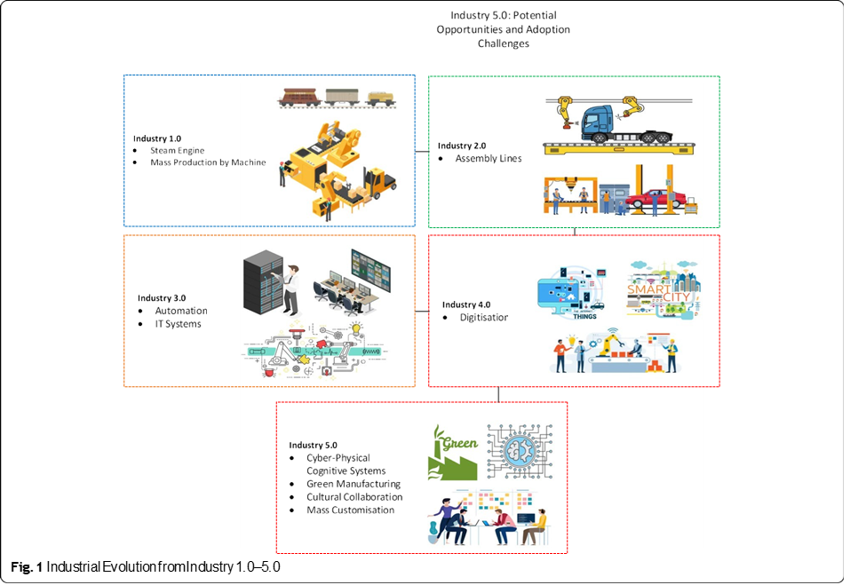

1.5 Sustainable Development of an Economy
Digital entrepreneurship's capacity to assist businesses in achieving their business goals acts as a representation of its relevance. Organizations with leaders and managers who have entrepreneurial digital skills are more successful by raising employee productivity and overall business performance. The most recent craze in academia is digital entrepreneurship, which is a necessity for companies. However, business managers who just have entrepreneurial tendencies won't be able to thrive in the current business climate. In other words, to achieve the development and sustainability objectives and strategies of their organizations, managers need more than just entrepreneurial or technological skills. Competitive managers, however, should possess technology and enterprise skills to be imaginative, and take chances, opportunity-seekers, who ultimately succeed (Esmer, 2016).
Leveraging Industry 5.0 has made a commitment to exploiting commodities that have experienced alterations to fulfill the challenges of the twentieth century's industrial revolution. sector today. Human-technology collaboration produces adaptable business models. Regulation is also necessary to reduce waste from overproduction. Local production helps to support economies along with creative endeavors (Saraswat et al., 2021).
Entrepreneurial advancements have altered the trend with Sector 5.0. As a result, sustainable policies are created that can boost an organization's productivity, such as better waste generation and management. Industry 5.0, which places itself at the forefront of evolution with a useful design, deliberately prioritizes information and emphasizes cutting-edge research. It is believed that what sets it apart is a resolve that extends beyond simply producing items for profit. Industry 5.0's three are resilience, human centricity, and durability. Workplace productivity and efficiency are increasing because of modern technologies (Longo F et al., 2020).

1.6 With Industry 5.0, smart hospitals are possibly the future.

Industry 5.0 wants to create an instantaneous, autonomous hospital. Technology can provide solutions for remote monitoring (Phuyal et al., 2020) in the medical field. It is critical for improving the lives of practitioners. Practitioners may emphasize infected patients and offer essential details throughout the COVID-19 pandemic, for better treatment by utilizing this intelligent healthcare technology (Lima et al., 2019).
The COVID-19 epidemic demonstrates significant instruction for new doctors. Genetic data, natural language processing, and medical imaging all use machine learning (ML), according to Vandi (2019). It is focused on identifying, detecting, and predicting diseases. In 2020, Abu Bakar et al. claimed that by adapting to client demands, Industry5.0 enables the proper production of personalized smart implants. Medical professionals are increasingly using artificial intelligence technologies to track various conditions, such as blood glucose levels. Mass personalization is made possible by manufacturing the necessary orthopedic implants per patent match (Lutz et al., 2019).
Even if the traditional method of making implants for patients evolves, it can still be used to enhance a variety of medical devices and apparatus. The surgery uses technology because it allows for precise execution (Abid and Javaid, 2019 & Pereira et al., 2020).
Better teaching, learning, research, and expansion techniques are favorable for medical students (Saxena et al., 2020). The orthopedic Industry 5.0 demands long-lasting, high-quality, individualized implants. Issues like excessive production, poor tool selection, and a lack of transparency are resolved with its help, claims Tosh et al., (2000) and Sherburne, (2000).

2.0 Research Purpose
The purpose of this study is to compare in an experimental setting the connection between digital entrepreneurship and radical innovation, as well as how both affect long-term economic growth. The goal of the study is to inquire about the difficulties and barriers that digital devices in the healthcare sector face. We combine industry intermediaries of things with other components to encourage the growth of sustainable businesses.
Corporate leaders must actively prepare their strategies going forward because of the corporate environment's continual link to data and considerable transformation. The economic landscape of the twenty-first century shows how the economy is growing more and more global since new information and communication technologies are constantly being developed and the digitalization process. The essential tenets of the value of the digital economy in the twenty-first century and the part that digital innovation plays in international trade are all examined in this article.
This research offers a methodology based on significant research methodologies to clarify the importance of digitizing global business. The research being conducted will illustrate the connection between innovative technology and online enterprises as well as strategies for developing effective Internet of Things approaches in order to aid entrepreneurs in succeeding in today's competitive business environment. The globalization theme, which also makes clear the goals of international trade, summarizes the business opportunity assessment. The digitization of business provides an environment that allows for creativity to keep tabs on emerging technological developments and market trends. According to Carayannis et al., (2022), the digital factory's cutting-edge technology is Industry 5.0, interacting and communicating with both humans and robots. Social networks promote communication between human and electronic components. The industrial revolution introduced strong, practical, and human-centric principles by Industry 5.0. By liberating human labor from monotonous activities, it will revolutionize production techniques across the world (Broo et al., 2022). Both the manufacturing supply chains and the production workflow will be significantly altered by intelligent robots.

3.1 Research Objectives
To fulfill the research goal, the following objectives are listed:
- To investigate the difficulties and restrictions that digital entrepreneurs may run into when putting digital gadgets into the healthcare sector.
- To comprehend how the usage of digital technologies in the healthcare sector can enhance well-being and ensure the economy's viability.
- To investigate the connection between digital radical innovation and entrepreneurship?
- To assess the state of the Internet of Things Industry What role does 5.0 play in mediating the connection between digital entrepreneurship and radical digital innovation?

4.1 Research Questions
The precise research questions in my study are therefore presented as follows in accordance with the research aims.
- What obstacles and problems will digital entrepreneurs face when introducing digital technologies to the healthcare sector?
- What connection exists between the usage of digital devices in the healthcare sector and the enhancement of well-being and economic viability?
- What connection exists between digital radical innovation and entrepreneurship?
- How do digital entrepreneurship and digital radical innovation interact when mediated by the Internet of Things Industry 5.0?

Summary and Research Contribution
The present investigation compares the empirical relationship between revolutionary technological advancements for business survival and digital entrepreneurs. To promote the sustainable growth of current and future healthcare businesses, we use the Internet of Things industry mediators between various elements. Industry 5.0 has excelled to the point where it is displacing prior inventions. Because machine work requires less time and effort from human labor, this procedure is successful (Adadi A, Berrada M., 2018).
The report highlighted the strategy utilized by commercial organizations ought to additionally deploy 5.0 in addition to the challenges. On creating a synthetic pancreas, specialists are working with the aid of the medical sector. This project has not yet been finished. A monitoring device that detects blood sugar levels has been given to patients who have been diagnosed with Type-1 diabetes. This one is attached to the apparatus with which the body can receive insulin. One of the most modern innovations is this one. One of the most cutting-edge technologies created specifically for patients, it offers the patient a reputable and valuable management system. By empowering professionals to generate exposure to electronic devices for their client’s apps that they can utilize to monitor the progress of their daily activities and lifestyles and create a customized medical care strategy for them, Industry 5.0 is raising this level of personification. Since the systems' foundation is artificial intelligence (AI), systems, they may completely transform life for those who have Type-1 diabetes. These AI systems have the capacity to identify and interpret a variety of body responses and respond appropriately.

REFERENCES

Abid, H. and Javaid, M. (2019) “Industry 5.0 and its applications in Haleem orthopedics,” J Clin Orthro Trauma, 10(4), pp. 807–808.
Abubakr, M. et al. (2020) “Sustainable and smart manufacturing: An integrated approach,” Sustainability, 12(6), p. 2280. doi: 10.3390/su12062280.
Acs, Z. J. and Sussan, F. (2017) “The digital entrepreneurial ecosystem,” SSRN Electronic Journal. doi: 10.2139/ssrn.2918535
Arnold, C., Kiel, D. and Voigt, K.-I. (2016) “How the Industrial Internet of Things changes business models in different manufacturing industries,” International Journal of innovation management, 20(08), p. 1640015. doi 10.1142/s1363919616400156.
Bagheri, A. (2017) “The impact of entrepreneurial leadership on innovative work behavior and opportunity recognition in high-technology SMEs,” The Journal of High Technology Management Research, 28(2), pp. 159–166.
Broo, D. G., Kaynak, O. and Sait, M. (2022) “Rethinking engineering education at the age of industry 5.0,” Journal of industrial information. Integration, 25.
Caceres, R., Guzman, J. and Rekowski, M. (2011) “Firms as a source of variety in innovation: influence of size and sector”,” International Entrepreneurship and Management Journal, 7(3), pp. 357–372.
Carayannis, E. G. et al. (2022) “Known unknowns in an era of technological and viral disruptions—implications for theory, policy, and practice,” Journal of the knowledge economy, 13(1), pp. 587–610. doi 10.1007/s13132-020-00719-0.
Chen, L. et al. (2022) “IIoT talent cultivating mechanism in line with industrial internet,” Procedia computer science, 199, pp. 377–383. doi: 10.1016/j.procs.2022.01.046.
Cogliser, C. C. and Brigham, K. H. (2004) “The intersection of leadership and entrepreneurship: Mutual lessons to be learned,” The leadership quarterly, 15(6), pp. 771–799. doi: 10.1016/j.leaqua.2004.09.004.
Davidson, E. and Vaast, E. (2010) “Digital entrepreneurship and its socio-material enactment,” in Proceedings of the Annual Hawaii International Conference on System Sciences. IEEE, pp. 1–10.
De Cleyn, S. H. and Braet, J. (2012) “Do board composition and investor type influence innovativeness in SMEs?”,” International Entrepreneurship and Management Journal, 8(3), pp. 285–308.
Dinh, T. (2018) “Towards a living lab for promoting the digital entrepreneurship process,” International Journal of Entrepreneurship
Drucker, P. F. (1998) “The discipline of innovation”,” Harvard Business Review, 76(6).
Esmer, Y. (2016) “A New Paradigm In Management: Ethical Leadership,” Akademik Bakis Uluslararasi Hakemli Sosyal Bilimler Dergisi, 57, pp. 38–54.
Giones, F. and Brem, A. (2017) “Digital technology entrepreneurship: A definition and research agenda,” Technology innovation management review, 7(5), pp. 44–51. doi: 10.22215/timreview1076.
Greenberg, D., McKone-Sweet, K. and Wilson, H. J. (2013) “Entrepreneurial leaders: Creating opportunity in an unknowable world,” Leader to leader, 2013(67), pp. 56–62. doi 10.1002/ltl.20063.
Gubbi, J. et al. (2013) “Internet of Things (IoT): A vision, architectural elements, and future directions,” Future generations computer systems: FGCS, 29(7), pp. 1645–1660. doi 10.1016/j.future.2013.01.010.
Gupta, V., MacMillan, I. C. and Surie, G. (2004) “Entrepreneurial leadership: developing and measuring a cross-cultural construct,” Journal of business venturing, 19(2), pp. 241–260. doi: 10.1016/s0883-9026(03)00040-5.
Hund, A. et al. (2021) “Digital innovation: Review and novel perspective,” Journal of strategic information systems, 30(4), p. 101695. doi: 10.1016/j.jsis.2021.101695.
Hull, C. E. et al. (2007) “Taking advantage of digital opportunities: a typology of digital entrepreneurship,” International Journal of Networking and virtual organizations, 4(3), p. 290. doi: 10.1504/ijnvo.2007.015166.
Ilori, A. B., Lawal, A. and Simeon-Oke, O. O. (2017) “Innovations and innovation capability in palm kernel processing industry in southwestern Nigeria,” International Journal of innovation science, 9(1), pp. 102–114. doi: 10.1108/ijis-10-2016-0045.
Javaid, M. et al. (2020) “Industry 5.0: Potential applications in COVID-19,” Journal of Industrial Integration and Management, 05(04), pp. 507–530. doi 10.1142/s2424862220500220.
Jazdi, N. (2014) “Cyber-physical systems in the context of Industry 4.0,” in Proceedings of 2014 IEEE International Conference on Automation, Quality, and Testing. Robotics, AQTR.
Kiel, D. et al. (2019) “Sustainable industrial value creation: Benefits and challenges of industry 4.0,” in Digital Disruptive Innovation. WORLD SCIENTIFIC (EUROPE), pp. 231–270.
Kraus, S. et al. (2019) “Digital entrepreneurship: a research agenda on new business models for the twenty-ﬁrst century,” Int J Entrep Behav Res, 25, pp. 353–375.
Lima, F. et al. (2019) “Digital manufacturing tools in the simulation of collaborative robots: Towards Industry 4.0,” Brazilian Journal of Operations & Production Management, 16(2), pp. 261–280. doi 10.14488/bpm. 2019.v16.n2.a8.
Longo, F., Padovano, A. and Umbrello, S. (2020) “Value-oriented and ethical technology engineering in industry 5.0: A human-centric perspective for the design of the Factory of the Future,” Applied sciences (Basel, Switzerland), 10(12), p. 4182. doi 10.3390/app10124182.
Lutz, J. et al. (2019) “Wearables for integrative performance and tactic analyses: Opportunities, challenges, and future directions,” International Journal of environmental research and public health, 17(1), p. 59. doi 10.3390/ijerph17010059.
Macher, J. T. and Richman, B. D. (2004) “Organizational Responses to Discontinuous Innovation: A Case Study Approach,” International Journal of Innovation Management, 8(1), pp. 87–114.
Mason, C. and Brown, R. (2014) “Entrepreneurial ecosystem and growth-oriented entrepreneurship,” 40, pp. 211–225.
Nagano, M. S., Stefanovic, J. P. and Vick, T. E. (2014) “Innovation management processes, their internal organizational elements, and contextual factors: An investigation in Brazil,” Journal of Engineering and Technology Management, 33, pp. 63–92.
Paul, J. et al. (2023) “Digital entrepreneurship research: A systematic review,” Journal of business research, 156(113507), p. 113507. doi: 10.1016/j.jbusres.2022.113507.
Pereira, A. G., Lima, T. M. and Santos, F. C. (2020) “Industry 4.0 and society 5.0: opportunities and threats,” Int J Recent Technol Eng, 8(5), pp. 3305–3308.
Phuyal, S., Bista, D. and Bista, R. (2020) “Challenges, opportunities and future directions of smart manufacturing: A state of the art review,” Sustainable Futures, 2(100023), p. 100023. doi 10.1016/j.sftr.2020.100023.
Rae, D. (2016) “Developing entrepreneurial leadership: the challenge for sustainable organizations,” International Journal of Work Innovation, 2(1), pp. 76–100.
Renko, M. et al. (2015) “Understanding and measuring entrepreneurial leadership style,” Journal of small business management, 53(1), pp. 54–74. doi: 10.1111/jsbm.12086.
Rifkin, J. (2011) The Third Industrial Revolution: How Lateral Power is Transforming Energy, the Economy, and the World.
Saraswat, V., Jacobberger, R. M. and Arnold, M. S. (2021) “Materials science challenges to graphene nanoribbon electronics,” ACS Nano, 15(3), pp. 3674–3708. doi: 10.1021/acsnano.0c07835.
Saxena, A. et al. (2020) “Emergence of educators for industry 5.0: an Indological perspective,” Int J Innov Technol Explore Eng, 9(12), pp. 359–363.
Schumpeter, J. A. (1997) “Economic theory of leadership, innovation, and entrepreneurial history,” Explorations in Enterprise, pp. 45–64.
Sherburne, C. (2020) “Textile Industry 5.0? Fiber computing coming soon to a fabric near you,” AATCC Review, 20(6), pp. 25–30. doi: 10.14504/ar.20.6.2.
Stein, G. (2018) “, leading the revolution, Harvard business school press, Boston,” Revista Empresa y Humanismo, pp. 205–208. doi: 10.15581/015.3.34682.
Tosh, D. et al. (2020) “Towards security of cyber-physical systems using quantum computing algorithms,” in 2020 IEEE 15th International Conference of System of Systems Engineering, IEEE.
Vandi, N. (2019) “Industry 5.0-a human-centric solution,” Sustainability, 11(16).
Vinitha, K. et al. (2020) “Review on industrial mathematics and materials at Industry 1.0 to Industry 4.0,” Materials Today: Proceedings, 33, pp. 3956–3960. doi: 10.1016/j.matpr.2020.06.331.
Zonnenshain, A. and Kenett, R. S. (2020) “Quality 4.0—the challenging future of quality engineering,” Quality Engineering, pp. 1–13. doi 10.1080/08982112.2019.1706744.
Zortea-Johnston, E., Darroch, J. and Matear, S. (2012) “Business orientations and innovation in small and medium-sized enterprises”,” International Entrepreneurship and Management Journal, 8(2), pp. 145–165.

