BA (Hons) Business Management
Academic Year: 2024/2025
Student Name: Ileana Lupu
Student Number: 2231908
Lecturer Name: Dr Seyed Nasirpour
LCBB6004_BIRM
Strategic Management and Sustainability
Component 1: Written Report

Executive Summary
‘Jaguar Land Rover (JLR)’, a subsidiary of ‘Tata Motors’, is a leading UK automotive company specializing in premium vehicles and engineering innovation. JLR has recently faced several industry changes in the form of increased market demand for ‘electric vehicles (EVs)’, increasing environmental sustainability regulations, and changing consumer preferences. Strategic analysis of JLR indicates a company continuously operating under a highly competitive and politically charged environment. A strategic analysis of JLR indicates that JLR is affected by several issues, including Brexit, global emission targets, and economic uncertainty, and a ‘Porter's five forces analysis’ indicates competitors' intense industry rivalry and changes driven by technological developments.

Table of Contents
1. Introduction 3
2. Strategy Analysis 4
2.1. External Environment Audit 4
• PESTLE Analysis 4
• Porter’s Five Forces Analysis 6
2.2. Internal Environment Audit 8
• Value Chain 8
• Resource-Based View (RBV) 9
• VRIO Framework 10
2.3. SWOT Analysis 11
3. Strategy Formulation 12
4. Conclusion and Recommendations 13
4.1. Conclusion 13
4.2 Recommendations 13
5. References 14

1. Introduction
The UK automobile sector is experiencing rapid transformation due to the global emissions targets, electric mobility, and varied change policies. Domestic sales and exports 2003-2023. In 2023, domestic sales of UK-built cars reached around 905,100 units, which represented a 16.8% increase compared to the previous year.
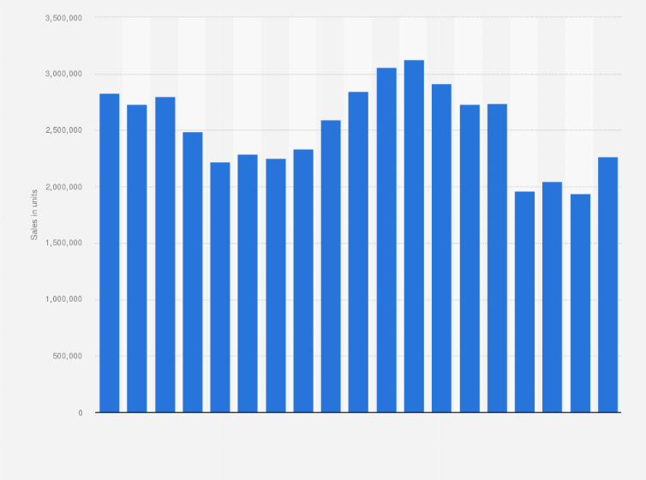
Figure 1: The UK automobile sector
(Source: Statista, 2023)
In this landscape, strategic management is a key element that can be illustrated by companies like Jaguar Land Rover in managing the uncertain situation, reacting to pressure from external factors, and exploiting potential opportunities (JLR, 2025). It offers a wide range of products, including the ‘Range Rover, Defender, Discovery, F-PACE, and the electrified Jaguar I-PACE’. The main idea of the JLR`s vision is to create contemporary luxury by using sustainable design.
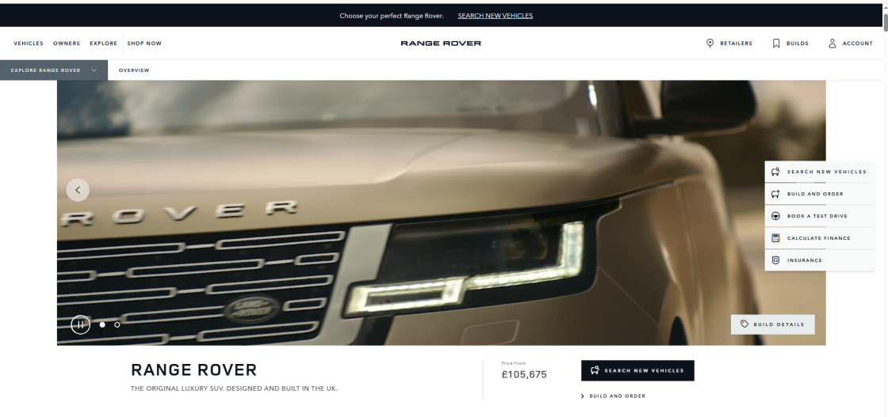
Figure 2: The Official Website of the Company
(Source: JLR, 2025)
The project lies in the development of high-quality experiences that correspond to the environmental responsibility of the company. Moreover, the main focus is on sustainability in the manner of becoming carbon net-zero across the supply chain, products, and operations by 2039 and thus achieving sustainable economic performance.

2. Strategy Analysis

2.1. External Environment Audit

PESTLE Analysis
Factor | Key Insight
Political | Brexit impact on trade, UK EV policy incentives (Bown, 2024)
Economic | Inflation, global slowdown, currency volatility (Carriero et al., 2022)
Social | Shift to sustainability and luxury personalization
Technological | EV innovation, AI in vehicles, and autonomous driving
Legal | Emission laws, GDPR, evolving labour standards
Environmental | Climate change regulation, EV battery recycling mandates
Table 1: PESTLE Analysis
(Source: Self-Created)
- Political Factors:
Jaguar Land Rover trades in a politically touchy environment, now no longer least because of its robust production presence in the UK and its reliance on international trade. Post-Brexit alternative regulations have damaged supply chains and introduced costs because of customs duties and border delays. Furthermore, converting ‘UK government Legislations’ and incentives (UK ZEV mandate and Gigafactory construction) additionally affect the JLR method route simultaneously (Bown, 2024).
- Economic Factors:
Economic instability, inflation, up-and-down fuel prices, and interest rate hikes have consequences for consumers shopping for electricity and car financing. International downturn in monetary and neighboring countries calls for asymmetries, which include China and, within the EU, specifically an effect on the profitability and manufacturing planning of JLR Carriero et al., 2022). Changes in alternate rates, especially among the ‘GBP and USD’ and the GBP and EUR, additionally in addition complicate export marketplace pricing strategies.
- Social Factors:
Consumer alternatives are moving to sustainability, generation, and individualization in cars. Younger, extra eco-aware clients take electric mobility, digital interfaces, and subscription-based vehicle usage models. JLR is stopping decrease lower back through repositioning itself as a modern luxurious brand targeted on ethical format and virtual comfort.
- Technological Factors:
Disruption of technology, within the automobile zone, becomes a relevant pressure. JLR has poured resources into electric powertrains, self-sustaining tech, and digital cockpit advancements. Strategic working relationship with ‘NVIDIA for AI-driven software program’ platforms is evidence of its readiness to lead towards smart mobility (Hennigh et al., 2021). The rapid pace of innovation presents challenging scale and integration issues, however.
- Legal Factors:
JLR should comply with strict legislation in more than two jurisdictions. The ‘United Kingdom and EU emissions’ requirements, information safety (GDPR), highbrow belongings laws, and developing labour regulations require continuous tracking (Wolford, 2025). Legal investigations of product recalls and ethical sourcing practices also affect brand perception.
- Environmental Factors:
JLR’s long-term agenda is replete with environmental concerns. The automotive sector has come under increasing pressure to cut emissions, improve fuel efficiency, and adopt green manufacturing techniques. JLR’s commitment to becoming net zero by 2039 requires steady investment in innovative technologies, carbon offsetting, and round manufacturing methods. The environmental audit also includes responsibility for battery sourcing and the recycling of EV components.

Porter’s Five Forces Analysis
Force | Pressure Level | Strategic Insight
Competitive Rivalry | High | Strong luxury EV competition (BMW, Tesla, Mercedes)
Threat of New Entrants | Moderate | Tech startups entering with asset-light EV models
Supplier Power | Moderate–High | Chip and battery suppliers dominate pricing
Buyer Power | Moderate | Increasing demand for value and customisation
Threat of Substitutes | Moderate | Urban mobility alternatives, car subscription models
Table 2: Porter’s Five Forces
(Source: Self-Created)
Competitive Rivalry (High):
The highest echelon of the automobile business is a place where only the toughest players can compete. JLR is in a fierce race with BMW, Mercedes-Benz, Audi, Volvo, and Tesla, each of which is making an increase in electric vehicle line-up. Product innovation life cycles are getting shorter, which means the company needs to be more adaptable and innovative at the same time to keep up with the trend.
Threat of New Entrants (Moderate to Low):
Only a few very large companies dominate the market because of the heavy capital requirements. The expenses of covering the R&D process, the customer loyalty to the brand, and the regulatory adherence serve as a big constraint for newcomers. There is a new wave of startups that have chosen a digital-first business model (Pangarkar and Prabhudesai, 2024).
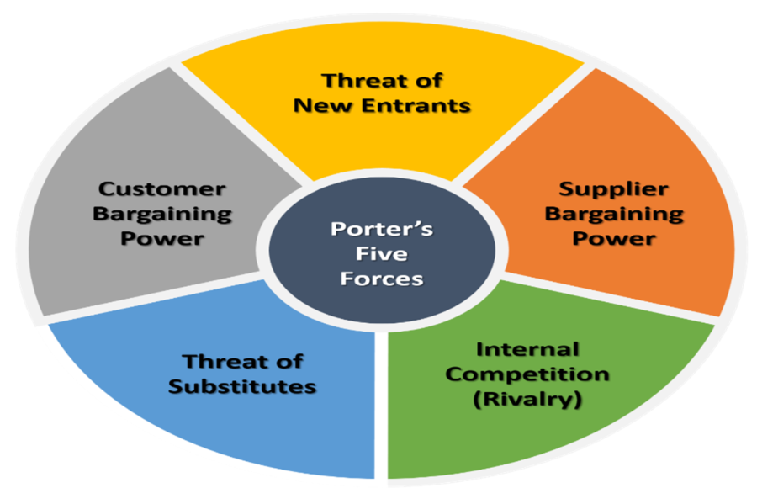
Figure 3: Porter’s Five Forces
(Source: Singh et al., 2022)

Bargaining Power of Suppliers (Moderate to High):
JLR is supplied with high-quality components such as semiconductors, lithium-ion batteries, and infotainment systems by the global automotive suppliers. The global chips and raw materials (cobalt, rare earths) shortage has led to supplier bargaining power. Cooperating with partners or being backward integrated will also mitigate the reliance.
Bargaining Power of Buyers (Moderate):
Customers have restricted power, the upward push of EV comparisons, online configurators, and international reviews empower clients to call for excessive value (Ndzabukelwako et al., 2024). Fleet buyers, leasing companies, and dealerships exert more strain on pricing and servicing agreements.
Threat of Substitutes (Moderate):
Alternative shipping modes, together with ride-sharing, e-bikes, and public transit, mainly in city areas, task conventional automobile ownership. In addition, regulatory constraints on diesel and petrol engines act as oblique substitutes via way of means of accelerating the shift to EVs.

2.2. Internal Environment Audit

Value Chain
Activity | Strategic Role in JLR
Inbound Logistics | Global sourcing: recent disruptions post-Brexit
Operations | Lean production; EV platform integration (Modular Longitudinal)
Outbound Logistics | Export-heavy model; complex EV distribution (Antràs and Chor, 2022)
Marketing & Sales | Digital branding and high-end positioning
Service | Connected tech, predictive maintenance for customer retention
Table 3: Value Chain
(Source: Self-Created)
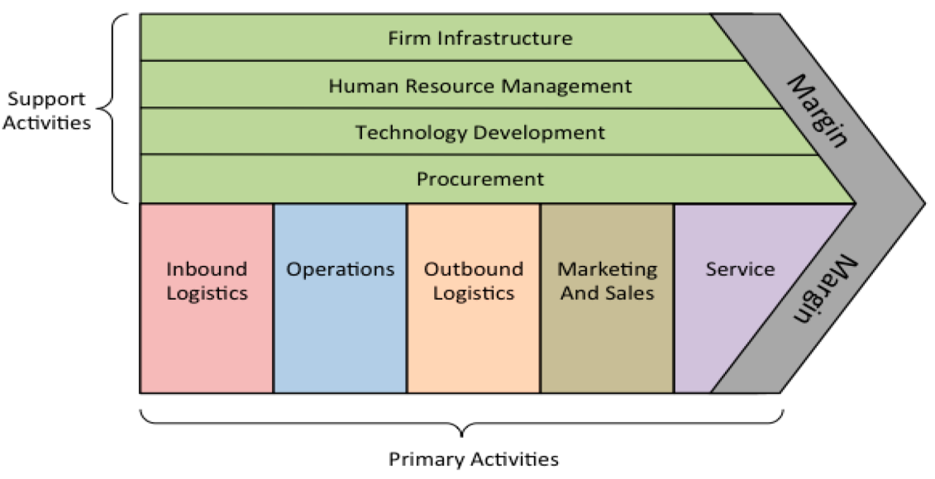
Figure 4: Value Chain Analysis
(Source: Yun and Yigitcanlar, 2022)

- Primary Activities:
Inbound Logistics: JLR has complex international sourcing arms, including European and Asian components. Issues with present provide chains, including those after Brexit and during the COVID-19 pandemic, showed up vulnerabilities. There are already efforts to localize and diversify suppliers.
Operations: JLR has world-class manufacturing facilities in the ‘UK (Solihull, Halewood), Slovakia & India’. This foliage has lean production and are getting re-tooled for EV manufacturing.
Outbound Logistics: JLR transports cars all over the world through local dealers and export centers. The logistics will become more complicated due to the need for either electric vehicle-specific handling, to include shipping regulations for batteries, and infrastructure compatibility (Antràs and Chor, 2022).
Marketing and Sales: JLR identifies itself as a state-of-the-art luxury brand. Storytelling, immersive digital experiences, and influencer partnerships enhance logo engagement. It must balance exclusivity with a greater embrace of green mobility.
Service: Post-sale products are changing with connected car diagnostics, predictive maintenance, and extended warranties (Ambos et al., 2021). The new digital services featuring the InControl Remote app strengthen customer retention.
- Support Activities:
Procurement: Sustainability, value-based competitiveness, and excellent assurance are central to JLR's sourcing. The agency is one of many that are increasingly adopting ethical sourcing policies, especially for EV battery materials.
Technology Development: R&D is a strategic priority for JLR, with level funding for more than one billion pounds yearly. Innovations non-exclusively include electrified powertrains, self-sustaining vehicle trials, and lightweight aluminum platforms.
Human Resource Management: JLR's workforce of 30,000+ humans specialize in developing talent in electric-powered and software program engineering capabilities (da Silva et al., 2022). The company provides internal training academies and partners with universities to facilitate capability development.
Firm Infrastructure: Tata Motors' centralized decision-making allows for synergies in strategy development, investments, and market entry opportunities. The company has a strong focus on ESG compliance, digital transformation, and agile development in innovation.

Resource-Based View (RBV)
The ‘RBV model’ focuses on how to develop competitive advantages through internal capabilities and resources. The array of rare or valuable resources qualifies for the RBV's value and rarity elements (Lubis, 2022). These resources include a strong brand heritage across the luxury market, exemplified by Land Rover with off-road and Jaguar with luxury/performance, with a global high-income, high-end consumer.
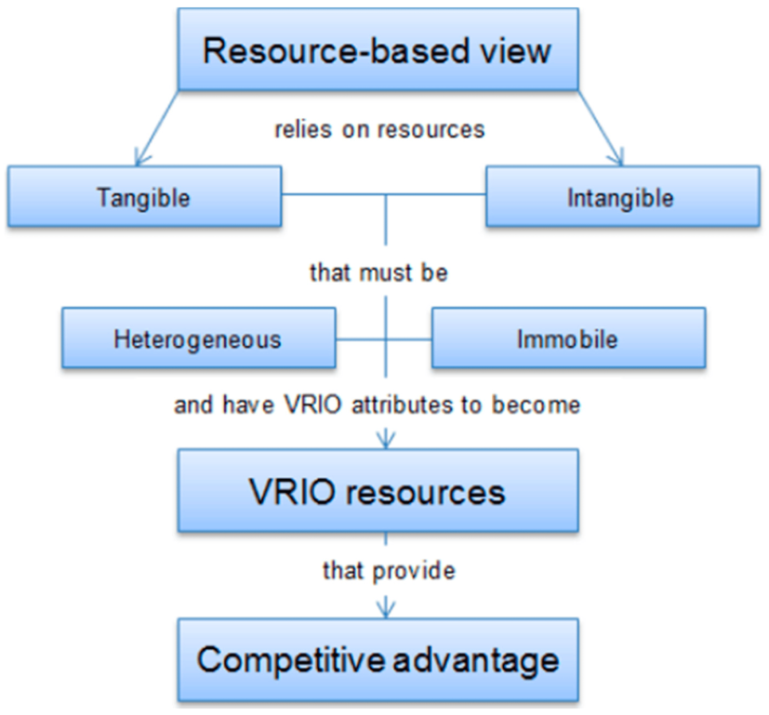
Figure 5: Resource-Based View
(Source: Haseeb et al., 2020)
In addition to the rights to its brand characteristics and sophistication, JLR has Tata Motors' financial and strategic support over the long term, with the infrastructure it needs to operate and access to run through economic cycles (Ferreira and Ferreira, 2024). JLR's engineering, service design, product design, and service development teams work collaboratively across roles and processes to allow for greater flexibility in capital and capability shaping into products and experience as market trends change.

VRIO Framework
Resource/Capability | Valuable | Rare | Inimitable | Organised | Competitive Outcome
EV platform tech | Yes | Yes | Moderate | Yes | Temporary advantage
Heritage & brand equity | Yes | Yes | Yes | Yes | Sustainable advantage
Tata Group support | Yes | No | No | Yes | Support capability
AI-driven infotainment | Yes | Yes | Yes | Yes | Sustainable advantage
Skilled R&D talent | Yes | Yes | Moderate | Yes | Temporary advantage
Table 4: VRIO Framework
(Source: Self-Created)
The factor of JLR`s aggressive advantage that is attributed to resources that are valuable, rare, inimitable, and organizationally embedded (VRIO) can be explained as follows:
Valuable Resources: JLR is big on the topic of the brand character it has created over the years, the engineering magic it has been working with, and the strong R&D body (Renato Lopes et al., 2024). In addition, the use of the modular platform and its own hybrid/electric power drivetrains allows rapid innovation.
Rare Resources: The design identity and the unique in-class off-road luxury segment residing in JLR (Land Rover) do not have counterparts in the industry. The history of JLR in the automotive sector has been incredibly beneficial.
Inimitable Resources: Good vendor relations in the long run, the vehicle architecture that is proprietary, and having the mix of British luxury history are the factors that make JLR capable of being the most difficult competitor to the others (Amaya et al., 2022).
Organizational Support: Tata Group`s support provides the necessary funding, its centralized strategic framework allows for the swift international implementation of innovations and green transition plans.

2.3. SWOT Analysis
Strengths | Weaknesses
- Globally recognised premium brands  - Tata Group's strategic and financial backing  - EV and AI innovation leadership  - Strong R&D infrastructure and IP portfolio | - High production and R&D costs  - Supply chain complexity (esp. Brexit and chips)  - Lower EV model range vs. top EV competitors  - Legacy issues with diesel and emissions recalls
Opportunities | Threats
- Growth of EV demand and government subsidies (Li et al., 2023)  - Expansion in Asia-Pacific and Gulf markets  - AI partnerships (NVIDIA, Waymo)  - Carbon neutrality and green manufacturing | - Intense EV competition (Tesla, BYD, Lucid)  - Regulatory volatility and compliance costs  - Supply disruptions, particularly semiconductors and metals (Xiong et al., 2024)  - Recession risks and shifting consumer preferences
Table 5: SWOT
(Source: Self-Created)
J.L.R.'s major advantages are its global brand stature, luxury image, and solid research and development. The company's management of independent businesses and electrification, with Tata Motors' support, gives it the capacity to grow sustainable technologies.
However, weaknesses that must be resolved include limited EV range and supply chain weaknesses, which have been amplified by Brexit political and other geopolitical circumstances, that may dampen performance (Li et al., 2023). There are opportunities, particularly in markets including India, China, and the UAE, where premium EV adoption is growing (Xiong et al., 2024). The company has added tech collaboration for extending competitiveness to the supply chain and manages sustainability road maps that fit with global regulatory evolution.
However, threats include competitive EV-first competition, and the rising costs of raw materials, plus increasingly climate-aware regulation that can affect JLR's market position if not addressed proactively. Economic slowdowns in key markets could further erode consumer spending in the luxury auto sector.

3. Strategy Formulation
- Expansion of Electric Vehicle Portfolio
An important strategic route for JLR is a deep product offensive in the field of electric vehicles. The I-PACE represents a promising first foray into full EV territory. JLR next needs to be able to offer full electrification across its entire showroom, like the Range Rover, Defender, and Discovery on down. The growth is also necessary to ensure conformity with global emission norms and to cater to the increasing sustainable mobility requirements among luxury consumers.
- Strengthening Technological Alliances
Partnerships with major technology firms are key to JLR's future-proofing its business. The company’s partnership with NVIDIA serves as a prime example of how AI and software integration are making way for smarter infotainment systems and self-driving technologies. Other potential partnerships with companies like ‘Intel, Waymo, and Microsoft’ might offer users access to ‘edge computing, 5G connections, and cloud-based vehicle applications’ (Anand et al., 2021). These alliances will enable JLR to keep up with ever-evolving digital luxury experiences and accelerate the time it takes to bring new features to market.
- Market Expansion in Emerging Economies
JLR should enhance its marketplace position in emerging markets like ‘China, India’, and the ‘Gulf Cooperation Council (GCC)’ countries. These emerging markets are developing an appetite for premium vehicles, particularly in the electric category (Ediagbonya and Tioluwani, 2022). Setting up local assembly plants or joint ventures will not only mitigate tariffs and logistics costs but also allow the company to respond to local consumer preferences.
- Circular Economy and Sustainability Integration
In order to achieve its 2039 net-zero goal, JLR must embed sustainability throughout its supply chain, including the use of recyclable materials (Dunant and Allwood, 2024). The closed-loop battery systems and waste reduction in manufacturing to circular economy approaches, which are also popular with luxury consumers who are increasingly valuing ethical production.
- Strategic Alignment with Vision
Strategic options must complement JLR's "Reimagine" strategy and its goal to lead in the luxury electric and sustainable automotive space. These strategies, if implemented successfully, will help future-proof JLR's marketplace position while fostering responsible innovation.

4. Conclusion and Recommendations

4.1. Conclusion
The company is also planning to completely retool a manufacturing site in Castle Bromwich in the English Midlands that makes more expensive models of the Jaguar saloon for electric vehicle production. From a strategic audit, it is clear that the company has considerable brand equity, technological aspiration, and reflects strong access to key resources through Tata Motors. However, it will need to deal with operational inefficiencies, supply chain risk, and the narrow EV product line-up. The accelerating pace of market disruption and competition requires responsive and future-focused policies that are not set in stone.

4.2 Recommendations
Accelerate Electric Vehicle Rollout: JLR must try to have a greater variety of EVs throughout the Jaguars and the Land Rovers. Accelerating the introduction of electric vehicles will allow JLR to meet its carbon neutrality goals and tap ballooning demand in the luxury green vehicle market.
Strengthen Technology Alliances: To address the increasingly crowded digital mobility market, JLR will need to strengthen its existing partnerships and explore potential new ones with vendors such as ‘NVIDIA’, and others with expertise in ‘AI, cloud, and 5G’ to leverage in-vehicle intelligence and differentiation of experience for customers (Boudi et al., 2021).
Diversify Supply Chain: The company needs to lessen its dependence on risky suppliers by having the ability to purchase vital components such as semiconductors and lithium batteries from various parts of the world.
Expand in Emerging Markets: JLR needs to create a stronger local footprint in faster-growing emerging markets like ‘India, China, and the Middle East’, enhancing regional production hubs and product lines to improve affordability, ability to pay tariffs, and better respond to demand in real time.

5. References
Amaya, N., Bernal-Torres, C.A., Nicolás-Rojas, Y.W. and Pando-Ezcurra, T.T. (2022). Role of internal resources on the competitive advantage building in a knowledge-intensive organisation in an emerging market. VINE Journal of Information and Knowledge Management Systems, [online] 54(5), pp.1–17.
Ambos, B., Brandl, K., Perri, A., Scalera, V.G. and Van Assche, A. (2021). The nature of innovation in global value chains. Journal of World Business, [online] 56(4), pp.101–221.
Anand, J., McDermott, G., Mudambi, R. and Narula, R. (2021). Innovation in and from emerging economies: New insights and lessons for international business research. Journal of International Business Studies, [online] 52(4), pp.545–559.
Antràs, P. and Chor, D. (2022). Chapter 5 - Global value chains. [online] ScienceDirect. Available at: https://www.sciencedirect.com/science/article/abs/pii/S1573440422000053 [Accessed 09 June 2025]
Boudi, A., Bagaa, M., Poyhonen, P., Taleb, T. and Flinck, H. (2021). AI-Based Resource Management in Beyond 5G Cloud Native Environment. IEEE Network, 35(2), pp.128–135.
Bown, C.P. (2024). Trade Policy, Industrial Policy, and the Economic Security of the European Union. Social Science Research Network.
Carriero, A., Corsello, F. and Marcellino, M. (2022). The global component of inflation volatility. Journal of Applied Econometrics, 37(4), pp.700–721.
da Silva, L.B.P., Soltovski, R., Pontes, J., Treinta, F.T., Leitão, P., Mosconi, E., de Resende, L.M.M. and Yoshino, R.T. (2022). Human Resources Management 4.0: Literature Review and Trends. Computers & Industrial Engineering, [online] 168(108111), p.108111.
Dunant, C.F. and Allwood, J.M. (2024). What investments in material production are needed to achieve net-zero construction in the UK by 2050? Journal of Cleaner Production, [online] 464, pp.142709–142709.
Ediagbonya, V. and Tioluwani, C. (2022). The role of fintech in driving financial inclusion in developing and emerging markets: issues, challenges and prospects. Technological Sustainability, 2(1).
Ferreira, N.C.M.Q.F. and Ferreira, J.J.M. (2024). The field of resource-based view research: mapping past, present and future trends. Management Decision, 63(4).
Haseeb, M., Hussain, H.I., Kot, S., Androniceanu, A. and Jermsittiparsert, K. (2020). Role of social and technological challenges in achieving a sustainable competitive advantage and sustainable business performance. Sustainability, [online] 11(14), p.3811.
Hennigh, O., Narasimhan, S., Nabian, M.A., Subramaniam, A., Tangsali, K., Fang, Z., Rietmann, M., Byeon, W. and Choudhry, S. (2021). NVIDIA SimNetTM: An AI-Accelerated Multi-Physics Simulation Framework. Computational Science – ICCS 2021, pp.447–461.
JLR (2025). JLR Corporate Website. [online] Jlr.com. Available at: https://www.jlr.com/ [Accessed 09 June 2025]
Li, Y., Liang, C., Ye, F. and Zhao, X. (2023). Designing government subsidy schemes to promote the electric vehicle industry: A system dynamics model perspective. Transportation Research Part A: Policy and Practice, 167(103558), p.103558.
Lubis, N.W. (2022). Resource Based View (RBV) in Improving Company Strategic Capacity. Research Horizon, 2(6), pp.587–596.
Ndzabukelwako, Z., Mereko, O., Sambo, T. and Thango, B. (2024). The Impact of Porter’s Five Forces Model on SMEs Performance: A Systematic Review. The Impact of Porter’s Five Forces Model on SMEs Performance: A Systematic Review.
Pangarkar, N. and Prabhudesai, R. (2024). Using Porter’s Five Forces Analysis to Drive Strategy. Global Business and Organizational Excellence, [online] 43(5), pp.1–11.
Renato Lopes d, Costa, a, Geraldes, R., Pereira, L., Dias, Á., Rui Gonçalves, N.A. João and Geraldes (2024). Creating sustainable competitive advantages through dynamic capabilities. International Journal of Business Excellence, 32(2), pp.214–235.
Singh, A., Gill, A.C., Lim, D.J., Kasmaruddin, A., Miri, T., Chakrabarty, A., Chai, H., Anurita Selvarajoo, Festo Massawe, Yousif Abdalla Abakr, Kumbirai Ivyne Mateva, Ng, W., Serifi, O., Mackenzie, C., Mohamad, M., Hooi Siang Kang, Pei Sean Goh, Jun Hyung Lim and Wing Yi Chan (2022). Feasibility of Bio-Coal Production from Hydrothermal Carbonization (HTC) Technology Using Food Waste in Malaysia. Sustainability, 14(8), pp.4534–4534.
Statista (2023). Topic: Automotive manufacturing industry in the United Kingdom. [online] Statista. Available at: https://www.statista.com/topics/5457/automotive-manufacturing-industry-in-the-uk/ [Accessed 09 June 2025]
Wolford, B. (2025). What is GDPR, the EU’s new data protection law? [online] GDPR.eu. Available at: https://gdpr.eu/what-is-gdpr/ [Accessed 09 June 2025]
Xiong, W., Wu, D.D. and Yeung, J. (2024). Semiconductor supply chain resilience and disruption: insights, mitigation, and future directions. International Journal of Production Research, pp.1–24.
Yun, J.J. and Yigitcanlar, T. (2022). Open Innovation in Value Chain for Sustainability of Firms. Sustainability, 9(5), p.811.

