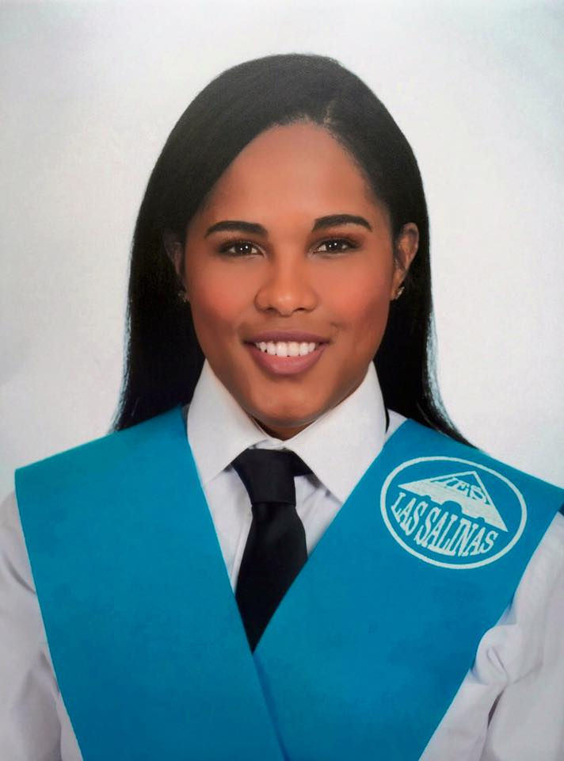
ID NUMBER:1916655
Lecturae Name: Dr Alfred Mensah
Module Name/Code:ACE
Word Count: 2404

Academic and employability skilss
Introduction
In this assessment I will talk about how you can sort it out your problems and difficulties those you can go through at your work or at your new experiences that you want to grow up in the future. In this assessment it’s going to be pretty interesting which will show you all the steps you need to fallow to do what you want to be on this life.
2. Employability skills
Experience is no longer the only thing that matters. The most valued skills and competencies are a combination of acquired knowledge and experiences, added to the personality and attitude of everyone. Employers today are interested not only in technical knowledge or "hard skills," but also in what is known as "soft skills," and “transferrable skills” that is, the ability to solve problems or the creativity to do so.
2.1. SOFT SKILLS
Are those attributes or characteristics of a person that allow him to interact with others effectively, which generally focuses on work, certain aspects of it, or even daily life. They are not just a ingredient, but are the result of a combination of social skills, of communication, way of being, of approach to others and other factors that make a given person relate and communicate effectively with others
- Teamwork, it is necessary that the collaborators understand that their contributions must add up to achieve a goal.
- Leadership, every group requires a person who knows how to guide them, but the leader does not impose ideas, but proposes them and debates them for the benefit of the results.
- Communication, people who work in a company must know how to explain their ideas at any level.
- Persuasion, this is a very useful skill when negotiating
- Motivation, collaborators must understand that things will not always go well, but it is important to know how to get up and lift colleagues from adversity. At the time of applying

2.2. HARD SKILLS
Hard skills are related to formal and technical requirements to carry out a certain activity. For example, know the procedures and mode of operation of a machine in a factory is part of a person's hard skills. It is also important not to idealize the different capacities or each person's abilities; for some tasks or functions soft skills are of great importance (for example for those jobs where there is a direct relationship with the public, or where a lot of interaction with other entities, departments or people), while other works focus their requirements rather on candidate's "hard" skills (for example, a computer programmer). Each person, according to its characteristics and preferences, it will be more comfortable in a position according to your skill set.

- Mastery of a foreign language that helps improve the chances of being hired. The person who is fluent in English or other languages will have more opportunities to travel to close businesses.
- A title that allows the professional to demonstrate their skills for a specific task. This is frequently seen in companies that provide outsourcing services.
- The certificate indicating the handling of a certain type of operating machinery. The most common cases would be in companies dedicated to the mining, oil, fishing, and other sectors.
- Use of computer programs that allow you to perform better at work. It is essential that, in these times, all professionals master Office and design tools

What Is a Learning Curve?

‘’A learning curve is a concept that graphically depicts the relationship between the cost and output over a defined period, normally to represent the repetitive task of an employee or worker. The learning curve was first described by psychologist Hermann Ebbinghaus in 1885 and is used to measure production efficiency and to forecast cost’’.
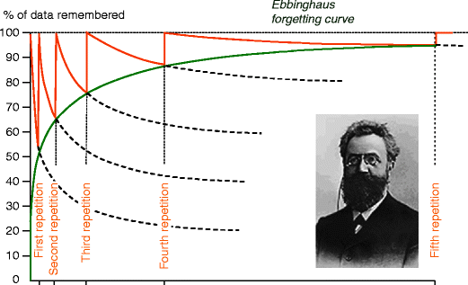

2.3. Transferable Skills
These are generic skills that can be transferred from one situation to another and that can improve your academic and personal profile. For example, learning the importance of teamwork while playing soccer and trying to hear everyone idea or put yourself into your plans and give the best of you will help you and if you have to do group work at university.
- Communication skills, any skill you have developed in communicating with others is transferable to any career. Examples include knowledge of other languages, knowing how to listen, write well and speak in front of an audience (speech).
- Interpersonal skills, interpersonal skills are developed to relate to other people and are valuable in helping others, resolving conflicts, delegating and negotiating. Interpersonal skills also include motivating people, delegating responsibilities, and empathizing with others.
- Research and analytical skills, knowing how to find information quickly and analyse data can be very valuable in many degrees; researching an essay, for example. Discerning between good sources of information and poor is an additional research skill.
- Organizational skills, being able to multitask, manage and coordinate both work and extracurricular activities is important in order to start a college career without getting overwhelmed. Working autonomously with little supervision, time management, and the ability to prioritize are valuable organizational skills.

3. Academic skills
So now we going to talk about my personal skills and academic skills and how I work with others. However, I going to explain a bit some skills we get at school or university to improve ourselves:
- Construction of knowledge, it is essential that knowledge be interdisciplinary to apply it in different contexts. Feedback from peers allows building solid and integrated knowledge that can be mentally reviewed for use.
- Collaboration involves sharing responsibilities and making important decisions collectively to carry out a task. Fostering interdependence among students is essential to ensure their academic and professional success.
- Communication skills, the ability to provide an opinion, explain a concept or make an oral presentation, is another essential item to enter a university or work.
- ICT involvement, information and communication technologies should be actively used by teachers and students to broaden the horizons of learning. In addition to using them, it is convenient for students to design their own ICT aimed at a real audience.
- Innovative solutions to real problems, connecting concepts and abstractions with the real world is necessary to train people capable of solving everyday problems. Theory must be explicitly linked to practice, appealing to creativity to achieve innovative solutions.
- Self-evaluation, reviewing the work itself is a guarantee to fix knowledge in the long term, since the student must strengthen his neural connections to recover knowledge that he stored in his memory.
- Questioning, Fostering the ability to ask key questions is central to comprehensive training, since the ability to question a given reality appropriately allows it to be transformed.

3.3. My own academic employability skills

SWOT Analysis is an effective process for interpreting my Strengths and Weaknesses, and for describing the Opportunities available to me and the Threats hindering me. In order to be productive when learning study skills must be acquired.

Strengths | weaknesses
- Good communication skills  - Negotiation skills  - Persuasion skills  - Organization skills  - Motivated  - Ability to work under pressure  - Time management  - Confident in what I will offer  - Problem solver  - Computer and technology skills  - Initiative  - Flexibility  - Hard worker  - Friendly  - Perfectionist | - Emotional  - Can get stressed easily  - Impatient  - Can appear Infront of large groups  - Perfectionist
Opportunities | Threats
- Bet working  - Receiving clients through personal relationships  - Regular customers  - Recommendations by customers  - Broaden as I build both experience and portfolio  - Opportunity of taking on assistant and teaching them  - Work and personal skills such as communication and people skills | - Existing photographers  - Rejection  - Introduction of new photographers  - Illegal use and production of images  - Increasing technology (will have to adapt)  - Nonprofessional photographers-increase ease of taking own photographs or professional level through technology and software being widely available

3.1 Team Working
Being able to work as a team is one of the ubiquitous qualities in job offers and CVs of candidates. And it is true that, in an environment in which many people are involved with many different characteristics and different forms to sort it out the problems or to act. So for this reason is very important to know and be able to understand, be flexible.

In my own experience to work with a team I first place was little bit difficult or hard to understand others and l have different view of everything. However, while growing more and working in different sectors and with different kind of person I learn many things which helped me to be a great potential candidate to get a job.

Nowadays, me skills they have grown a lot also I can say, How to empathize and be assertive or be able to put the good of the task before personal interest and I know how to work as team and individual, respect other and do a god job together.

"This is the question asked by Chidiebere Ogbonnaya, Senior Lecturer in Organizational Behaviour and Human Resources Management at the University of Sussex, England, who has conducted research into the effects that teamwork has on employees who make up the groups. "While it can generate innovative ideas and solid performance, it can also be stressful," explains Ogbonnaya. "

3.2. Communication verbal and nonverbal
3.3. Verbal:
Try to keep a balanced tone of voice, not too much low or too high, and watch the pronunciation. Adapt it to context in which you find yourself and your interlocutor. See that be firm and determined to transmit security and that you control the situation.
- Prepare the answers and the way to express them, avoiding the monosyllables, vocabulary too colloquial or too elaborate.
- Preparing the answers will also help you to be consistent in the message, avoiding errors when transmitting it, and expressing it in natural way.
- Speak the “same language” as the interviewer, the important thing is that you connect with them and understand and retain what are you telling him. For example, if you have a technical profile and your interlocutor also, you can use it and understand yourself at a level more specific than if you were talking to a psychologist which you probably couldn't understand certain technicalities.

3.4. Non-verbal communication
- Punctuality: Make sure you arrive in advance at the place where the interview is going to take place. It has a very negative impact reaching late, but be careful, you also have to arrive too early. The recommendation would be 5 or 10 minutes in advance.
- Clothing: It is important to wear appropriate clothing and sometimes not it's easy to hit. Take into account the type of company and job you will occupy. It is not the same to work in a law firm or in a company that designs video games. Some ways to getting information can be getting to know the company through its website, or your workers on social networks and see what image they transmit, look for the person who is going to interview you on social networks to know something about their style. If possible, too you could go to the company to see it. In the case of not having clear what clothing is appropriate, opt for something neutral with basic colours, a moderate style. Of course, clean and properly cared for.
- Hygiene: Take care of your hygiene, it is also not necessary to abuse the perfume. Keep your hair and hands cared for.
- Shaking hands: the way of shaking hands predisposes the attitude of the interviewer generating trust; avoid shaking hands loose to avoid giving the image of lack of energy or decision.
- Facial expression: The face is said to be the mirror of the soul.
- Smile: Entering the interview with a smile will help you create a pleasant space of trust, to connect with the person interviewer.
- Eye contact: look at the face of the person you are talking to and show interest in what they are telling you, it is the best procedure to show sincerity and that you are someone in which
- you can trust.
- Body language: sit up straight, showing confidence, neither leaning back (can show disinterest) or very incorporated forward (may show nervousness and restlessness).
- Gesture of the hands: during the conversation it is correct that we support our explanations with the gestures of the hands, but never, this gesticulation must be excessive. The language gestural will help us to emphasize our verbal communication, to put an image on it.
4.Team Management
When it comes to leading a team, you have to be clear about some aspects that can make the difference between good and bad management .Not everyone can lead a team, it takes a left hand and a lot of eye for the small details. They are the ones that make a difference. No matter how you want to lead your team, what really makes you a good boss or manager is having empathy with the rest of your team.
Here I left some tips how to manage:
- Change focus
- Learn and Listen
- Be very clear with everything
- Be a model to fallow
- Do not ignored the problems
- Don’t listen the stress
- Ask others
- Celebrate the successes
- Be open to changes
- Positive thinks
- Go beyond administrative
- Clear speech
- act decisively
- make questions
- do don’t do everything by yourself
- know yours campaign workers

5.In my personal development I want to add that in all these years I have grown as much as a person as professionally given that I have had several jobs in which I have acquired different types of skills that help me in every position that I develop, I do it in the best way. For example, my last two jobs were as a waitress in which I learned how to treat the client and know their needs or what they need, speed, kindness.
Nowadays, I can say that I have a better position, Sales Assistant, Inditex, Oxford Street, London. In this company I can grow up and go very high. And now more, with this year of university I will acquire a better level of English and more skills which will help me go very far.

6.Conclusion
In conclusion, to have good skills at work, you need many skills and tips to acquire all of these. Also, all these steps must be trained one by one, assimilated and studied.
You must learn to cope with hard skills and softs skills as well as "verbal" and "non-verbal communication". As well as being able to acquire skills from other of your colleagues, either at work, at home with family members, etc.
learn from your past failures and know how to deal with them and learn from mistakes (your career).
Here we can also see a bit how to manage a team, of your own university achievements.
I have also added a SWOT talking about me, and my career.
6.References:
- M. Victoria S. Nadal, 2019, El Pais Economia. Available on https://retina.elpais.com/retina/2019/11/28/talento/1574943402_436874.html
- Author Grow mw, 2017, Available on https://growme.es/wp-content/uploads/2017/05/lenguaje-verbal-y-no-verbal.pdf
- Copyright © 2020 Elsevier B.V. or its licensors or contributors. ScienceDirect ® is a registered trademark of Elsevier B.V.ScienceDirect ® is a registered trademark of Elsevier B.V. Available on https://www.sciencedirect.com/bookseries/advances-in-experimental-social-psychology/vol/14/suppl/C

