Introduction
This assignment is splatted 4 tasks aimed to report, evaluate and illustrate on various Essential Academical and Employment Skills for future career path. Collaborative Mind Map and individual Poster, Virtual Collaboration and RefWorks, lastly task 4 will be looking at E-Portfolio Creation and Evaluation.

TASK1
Academic and career skills are essential learning activities which reflects on careers and goals in life. Skills boost confident in any chosen career majoring. These skills are everyday tools used at work it gives abilities to achieved training rather than lack of achieving through training. Chances on reasonably secured when performing an equivalent task showing skills learned.[1]
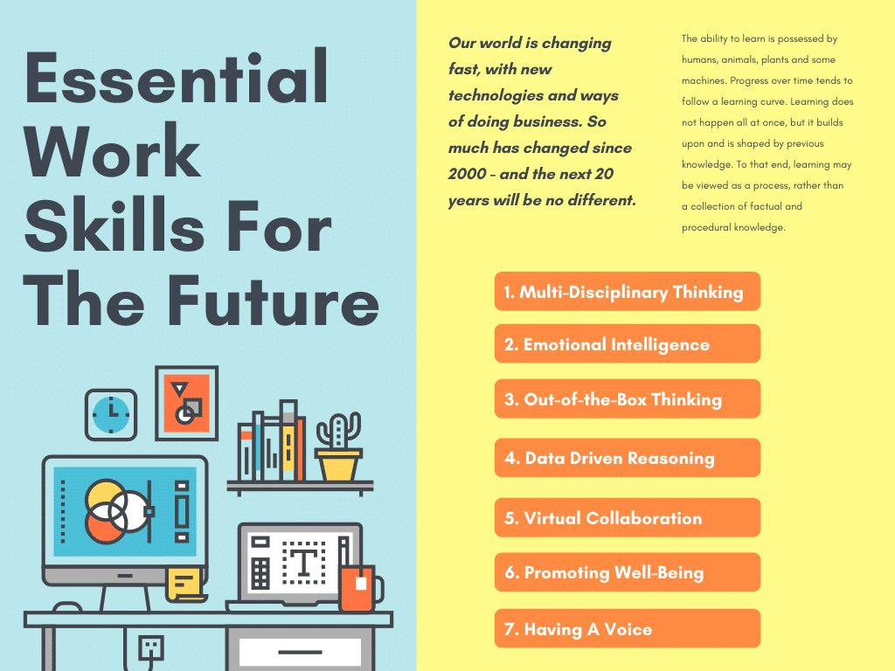

[2]
The importance of educational skills
which include reading, writing, critical thinking, research, analysis and problem-solving are generally all essential employable study skills. For example, Software engineering provides specialist knowledge of variety programming languages. These are professional skills gained studying Software design, Information systems, Databases, Software architecture. It can be further to higher level of study up to postgraduate qualification in software engineering, computer security, forensic computing, data science or another IT-related field to develop specialist knowledge further.[3]
Further to employability
It's also possible to be employed within a range of sectors in an in-house IT role, such as software engineer/developer. This can be for any company that has a need to develop and maintain its own software systems. A few examples of the types of organisations you could work for include financial services, government, healthcare and many more.
according to job website like prospect professional career job in Software engineering graduates showing percentages of their area of jobs career. For example,
- Programmers and software development professionals (33%),
- cyber security professionals (19%),
- IT user support technicians (7%),
- IT business analysts, architects and systems designers (4%),
- IT operations technicians (4%),
- information technology professionals (3%),
- IT network professionals and IT (2%). [3]
references:
[1]
S. Cottrell, The Study Skills Handbook, 5th ed. London: Bloomsbury Academic, 2024.
[2]
Sumit, “7 Essential Work Skills For The Future – The 2020s And 2030s Deploy Yourself School of Leadership - Sumit Gupta,” Deploy Yourself School of Leadership - Sumit Gupta | Helping the best leaders get better and do the work of their lives, Dec. 27, 2020. https://www.deployyourself.com/life/essential-work-skills-future-2020s/ (accessed Mar. 24, 2025).
[3]
“What can I do with a software engineering degree? | Prospects.ac.uk,” www.prospects.ac.uk. https://www.prospects.ac.uk/careers-advice/what-can-i-do-with-my-degree/software-engineering

