

A Study of Air quality
And development of an Air Quality sensor

By
Ryan O’Sullivan
Supervisor: DR. Gary Jones
Second Marker: Stephen Mosey

Project submitted as part of the requirements for the award of
BEng (Hons) Computer Systems and Electronics
April 2018

Abstract

Every year millions of people around the world, die prematurely due to the bad air quality[1].
The World Health Organisation recognizes[2] this and states that more action is needed, with little knowledge of the true extent of the situation. The daily routine of a human being can not only lead to drastic effects on the atmosphere, but also the health of the human body. Just a small amount of CO2 absorbed into the body over a period of years can lead to implications. Unfortunately, CO2 is on the rise with the rising population. This sees major cities and condensed areas to be some of the major contributors.

This project outlines the principle of a portable air quality sensor, commonly used professional researchers, industrial companies and public safety teams. This project will, however, focus from the public consumer point of view, with them being the primary user and interpreter of information. The device will allow the user to detect CO2 and VOCs (volatile organic compounds) levels in the atmosphere during their daily routine, enabling them to make better decisions to avoid hazardous air pollutants. The device involves Inferred detection and the micromachined metal oxide semiconductor

The main task of the project is to program a microcontroller that will enable CO2 and VOC level readings to be accessed from a system readily and easily, via the use of a simple user interface. The cost of the project is of the utmost importance as it is to compete with industrial and medical company prices. The report entails the development of the IAQ core to allow the device to measure CO2 and VOC levels, displaying the digital readings and display them on LCD Screen.

Table of Content

Contents
Abstract 2
Table of Content 3
CHAPTER 1. INTRODUCTION TO PROJECT 8
Introduction 8
The Idea/Inspiration 9
Projects Aims and Objective 9
Introduction to the project 10
CHAPTER 2. PROJECT OUTLINE 11
Types of devices 11
CO2Mini Indoor Air Quality Monitor 12
Extech Portable Indoor Air Quality CO2 Meter 13
Series 500 – Portable Air Quality Monitor 14
Atmotube 14
E Instruments AQ VOC Indoor Air Quality Monitor for the IAQ Professional 15
Differences 15
Development 16
Extra Development of Function 17
Target Audience 17
CHAPTER 3. BACKGROUND RESEARCH (CO2&VOCs) 18
Introduce to Research into CO2 18
Introduction 18
Methods of reducing CO2 19
Policy and International Agreements Regarding CO2 Emissions 20
CO2 Outdoor Pollutant 21
CO2 Indoor Pollutant 22
CO2e 24
Volatile organic compound (VOC) 25
Introduction 25
Sources of VOCs 26
Health Effects 27
Steps to Reduce Exposure 28
TVOC 30
The Effect of Temperature and Pressure on CO2Measurement 31
CHAPTER 4. Research Methodology 32
The Research Onion 32
Summary 32
Research Philosophy 33
Methodical choice 33
Strategies 33
Time Horizon 34
Technique and procedures 34
Hardware and software 34
CHAPTER 5. Component selection and research 35
Introduction 35
Gas detection Techniques 35
IR techniques 36
micromachined metal oxide semiconductor 36
Techniques selection 37
CO2 Sensors selection 37
CozIR LP 37
IAQ-Core sensor 38
MISIR 5,000ppm CO2 Sensor 38
VOC sensor selection 39
Figaro TGS2602-B00 Air Contaminants Gas Sensor 39
IAQ-2000 Indoor Air Quality (VOC) Sensor 39
WSP2110 40
Humidity/Temperature/pressure Sensors 41
MS8607 41
DHT-22 41
BME280 42
Future Components 43
SD Card 43
Molex 104642 Series 8 Way Micro SIM, MicroSD Memory Card Connector with Solder Termination [60] 43
USB 43
Power calculation 43
Battery 44
Screen 44
Voltage regulator 3.3v 44
Product Casing 45
Microcontroller 45
Pic16f1455 46
Pic16f1459 46
PIC18f14k50 47
Pic18f24l50 47
Pic18lf25k50 48
Pic18f45k50 48
Final sensors choice 49
IAQ-Core 49
BME260 50
The MOD1023 51
Pic18Lf25k50 52
How IAQ-core works 53
Factors that could influence air quality changes and produce anomalies in results and errors. 54
CHAPTER 6. Design & Design Research 55
Introduction 55
Simulation 55
Final simulation design 56
MOD-1023 57
Screen 57
PIC18lf25k50 58
Switch 58
I2c Simulation with 24LC08N EEPROM 59
LED 59
I2C Debug 60
Data in 24LC08N 60
Calling the I2c 61
USB/SD 61
Voltage regulator 62
Operations of simulation 62
Design Block 63
The design parts 64
Analysis of Simulation 65
Background knowledge of simulation 65
I2c 65
Pic18f45k50 66
ADC Configuration 67
Ergonomics 67
Calculation 68
Humidity I2c calculation (convert to 16 bit value) 68
Pressure I2c calculation (convert to 16 bit value) 68
Temperature I2c calculation (convert to 16 bit value) 68
CO2 I2c calculation (convert to 16 bit value) 68
VOC I2c calculation (convert to 16 bit value) 68
Composite calculation of temperature and Pressure. 68
CHAPTER 7. Implementation 69
Introduction 69
Implementation design 69
Problems with Implementation 69
Testing 70
Testing the IAQ core 71
Results of testing 74
Evaluation Board 75
Prototype simulation 75
Prototype Board 75
Expenses and Parts 76
CHAPTER 8. Programming 77
Code discussion 77
Outline of further programming. 77
Current flow chart 78
Programmed Safety levels LEDs 79
How the I2c is called 79
CHAPTER 9. Evaluation 80
Project Evaluation 80
Further development 81
Project management (Time management) 82
CHAPTER 10. Conclusion 83
Project Conclusion 83
Project recommendation 84
Reflection 84
Referencing 86
Bibliography 91
Books 91
Online articles 91
Appendices 92
Coding 95

CHAPTER 1. INTRODUCTION TO PROJECT

Introduction
This report will focus on addressing the problem of air quality in outdoor, and Indoor environments, giving a simple response to the user, to show the danger limits of harmful CO2 levels surrounding them. The report will contain background research into the dangers of VOC and CO2 along with design decisions that have been implanted to improve other user functions. This report shall also contain a parts lists with all the disadvantages and advantages, and implantation issues.
An evaluation of all proceedings in this project will show the development and further advancement that could be added. Combining environmental electronics with consumer electronics, with a vast business field of medical use to common such as fitness and city environment exposure.

- A wearable air quality sensor will be created to help people in heavy air pollution countries where there is no way of measuring the quality of the air easily, this is due to portability and price.
- This would then allow for users of the product to know when it is necessary to wear protective masks or ventilating a room.
- Minimising the potential risks associated with air pollution. The product will be made wearable by putting it into a small casing and be able to last 24 hours.

There are many articles, journals, textbooks and scholarly reports in this assignment all can be found in the Reference section

The Idea/Inspiration
The world is developing at an explosive rate, producing more CO2 lever in an urban environment than ever before. Some house near the busy road can suffer from over expositor of a CO2 levels or VOC levels every day. Research shows that people surrounded with a large amount of CO2 levels or VOC levels can suffer from many ailments (Ref. Chapter 3).
Giving people the ability to measure air quality levels in a portable device gives the user control of the air they breathe and the health impact that could have an impact on their lives. Recent studies show that VOCs in cleaning products can be as bad as smoking 20 cigarettes a day.[3]

Projects Aims and Objective
The overall aim of this project is to design and prototype a product that can detect CO2 in a local environment, like homes or busy city streets, and advice user on potentially dangerous levels. Use a metal oxide semiconductor sensor contained in a small package. An added feature of VOC, temperature, pressure and humidity will be added to help with outdoor factors. VOCs will be added to help with home and indoor quality.
The steps need to complete these objectives are.
- Research into dangers CO2 levels and VOCs (To advice user)
- Research into how a metal oxide semiconductor sensor react in outdoor environments
- Select a sensor that provides useful results
- Simulate circuit Connected to a Microcontroller, screen, sensor
- Built prototype
- Test product
- Apply molecular density of gas laws to make portable

Introduction to the project
To succeed in obtaining all the set-out aims and objects, the final design must be capable of detecting unsafe zones of hazardous air partials, and interacting with the user to display useful data, so precisions can be taken. Using a metal oxide semiconductor sensor to detect CO2 and VOCs can cause issues when working in an outdoor and indoor environment, the project will review ways to stop outdoor factors affecting results.
The report will show the development of a system that would create the interfacing of a metal oxide semiconductor sensor (CO2/VOC) to a microcontroller. These results will be tested against predetermine levels of Dangerous (Red), potently dangerous (Yellow) and safe (Green), these levels have been taken from research of health levels of CO2e and TVOC (chapter 3)
To control outdoor factors on CO2 readings A BME280[4] sensor has been integrated, this sensor is able to give a reading of pressure temperature and humidity, all these factors can affect CO2 and VOC results.
This report will show research in how outdoor/indoor factors affect the sensors. And, how much air flow is required to get best results. Testing is done to show that all sensor can show a changing in results when CO2 or VOC pass over, and how much of an area space effective reading can be taken for.
When the choosing a sensor, it was determined that an I2c interface would be used create the connection to the microcontroller from the semiconductor sensor, this will allow for fast interfacing speed and multiple connections.
The final prototype is much larger and missing some of the extra features, but the final simulated design proves the concept in full, with the simulated design containing all extra features, and being able to be broken down into a much smaller circuit if PCBed.

CHAPTER 2. PROJECT OUTLINE

Types of devices

An in-depth investigation into the CO2 device was carried out though researching components and to create an advanced understanding of them. This was acheved by researching other air quality devices used in health care, industry and consumer fields, these categories create the full spectrum of manufactory for air quality devices.
Industrial devices are very bulky, but are highly accurate, yet have the downside of high power consumption. But sometimes the level of accuracy does not need to be applied when creating more of a consumer-based device, some of the specifications can change to create a more rounded device with lower power consumption, but, lacking in reading range.
Creating an idea of how other company’s design there air quality sensors, and to see their advantages and disadvantages, this data then played a role in the final design, trying to avoid the disadvantages and build on the advantages of other product. While researching various suppliers were considered, this was done to better understand how to form ideas and build from original air quality device.
This project investigated certain medical conditions, such as; asthma, respiratory problems, and heightened sensitivity to chemicals, to see if any other factors such as humidity, temperature, CO2, VOCs could be a problem for people suffering from these conditions
Also, researching into medical supplier of air control and quality. A lot of information on equipment was: http://www.novairmedical.com/medical-air/quality-standards-and-regulations/ [5]was very helpful

CO2Mini Indoor Air Quality Monitor
This low-priced CO2 monitor is used as a desktop air quality monitor, the device can only measure CO2 and temperature, and it is not an industrial standard device, this device is also not able to tell the user when bad air quality is being exposed to them, it only shows the current readings. Used in a most basic environment like meeting rooms offices buildings, schools and homes. This device is powered by USB, which hinders it portability and positioning in the property. To get best results, this product is self-calibrating [6]
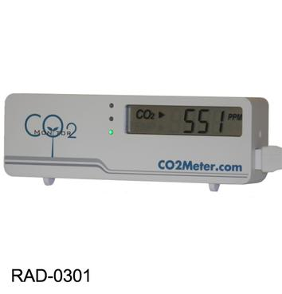
This product is very user-friendly and is firmly placed in the consumer market. Built in a small package, it would really have help if it was also portable, and not stuck at USB points

Extech Portable Indoor Air Quality CO2 Meter
Industrial standard portable indoor CO2 products are used in schools, office buildings, greenhouses and factories. This device has
- programmable audible alarm,
- Backlit LCD RS-232 interface.
- 8-hour runtime
Temperature measurements from -14 to 140°F (-10 to 60°C)
Alarms for STEL (15-minute short term exposure limit).
CO2 measurements from 0 to 5000ppm[7]
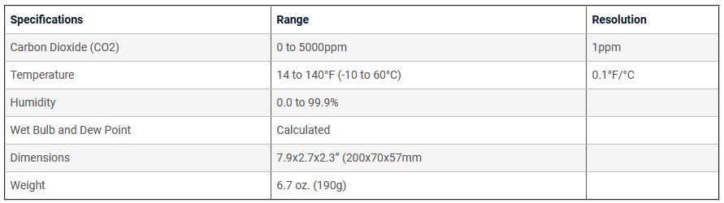
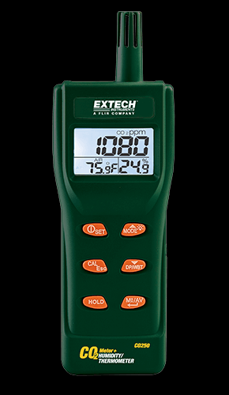

Series 500 – Portable Air Quality Monitor
This advance device is able to measure a large array of gasses, it is able to be used as a data logger storing all its data on internal SD card, and it can also connect to external control systems such as air conditioning. This device is used a lot in the medical industry for people who need to control loads of different gasses in their homes, or hospitals, below is the list of gases that this device can detect and log.
“Ammonia (NH3), Carbon Dioxide (CO2), Carbon Monoxide (CO), Chlorine (Cl2), Dual - CO, CO2, Formaldehyde (CH2O), Hydrogen (H2), Hydrogen Sulphide (H2S), Methane (CH4), Nitrogen Dioxide (NO2), NMHC, Ozone (O3), Perc (C2Cl4), Sulphur Dioxide (SO2), Triple, CO, CO2, VOC, VOC”[8]
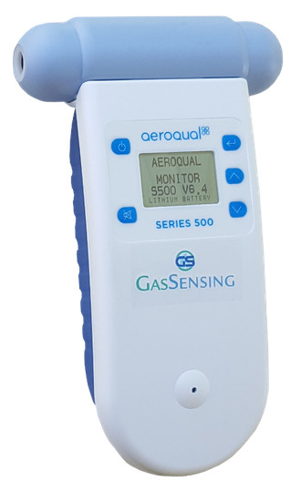[8]

Atmotube
This device is probably the nearest device to being like the final product in this assignment, there are a lot of things this product is missing from that are final project has achieved. This device is also still not on the market it stopped development, with only one was created.
But this product measures CO2/VOC levels in real-world environments. All the data for the Atmotube is sent to a phone through Bluetooth, this collects all the data and sets alerts when the air quality gets dangerous high, it uses ultra-low power and was funded through Indiegogo[9]
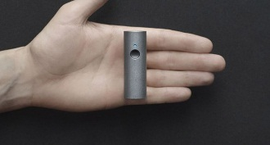

E Instruments AQ VOC Indoor Air Quality Monitor for the IAQ Professional
AMS has created an IAQX sensor that is able to measure 400 different VOC gases this sensor is used in this E Instruments air quality monitor. This device provides VOC indoor air quality testing for professionals and is able to measure 0-20000ppb 0-200ppm. It’s able to be used as data logger using an sd card and USB connections this device includes temperature, pressure and humidity [10]
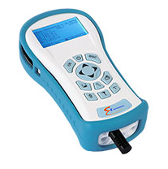
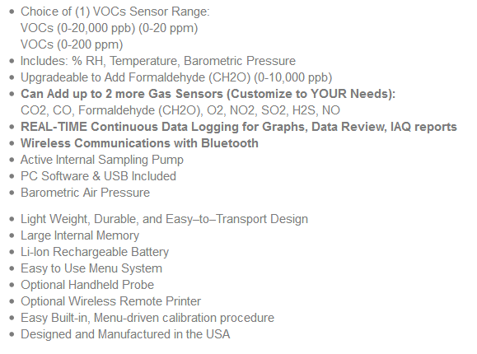

Differences
Being able to set the product apart from others, by giving it something different, for example, by making it portable with such a compact sensor build into the core of the device, which will make this product standout from the common market. A lot of devices don’t measure such a large range of variables that can calibrate with bad air quality. Humidity, temperature, and pressure can all play a part in bad air quality combining these with CO2 sensor and VOC (volatile organic components)
Making this device wearable would be one of the final goals after testing concept and prototyping, this would involve making this device as small as possible to fit in acceptable wearables package.

Development
After reviewing different sensors and their ability to gather different data types, such as CO levels and Particle Counter. The data that seems to be the most in line with the product was VOC levels and CO2 levels. A sensor must be chosen for this project that’s able to measure both levels needed for this project, while only need a lower power supply, and come in a tiny package. This will allow for the device to be compact and allow for better portability and will give it a better chance to be added in to daily life, without any inconvenience.
Giving the user the ability to collect their data and analysis later has given the need for the use of an SD card and USB slot for this device. Adding these to the development process will consist of using simulators and breadboard this device will also have a simulation of the PCB product ready for distributions.
- An SD card will be added to this product to collect data.
- A USB will also be used for Transferring data.
- One button with 3 modes will be added it will be holed for 8 seconds to turn on the device. Pressed once to show embedded readings. 8 seconds to turn off.
- This device will measure a range of things from temperature to humidity, CO2 and VOCs, these can all play a factor in air quality and was needing to give the user more accrete data.
- Some functions for this device is to be able to collect data save it to the SD card. And use the USB slot to transmit its data to PC
- This device will also come with one button and four LED these will show the danger zone levels of your environment.
- The button will have three modes hold down mode will turn the device off and on 1 push will pause the device.
- It will read all data such as temperate, humidity, VOC, CO2 to screen for the user.

Extra Development of Function
Making the device display a live reading of air quality is one of the fundaments of this project and will be the basis of showing the concept, but there are extra functions that have been planned into the design.
Some development functions for this device allow the user to be able to collect data without any need for the external device, being able to transfer all data to an SD card or be able to view it through the USB.
This device will also come with 1 button and 4 LED, these will show the danger zone levels of your environment.
The button will have 3 modes, hold down mode will turn the device off and on, and 1 push will pause the device.

Target Audience
With many countries suffering from heavy pollution in their homes and in their outdoor environment, lots of the populations unknowingly inhaling polluted air, which has caused premature death, this has created a demand for information on the air quality from millions of people.
This product can be used also in an industrial environment, for uses such as that of miner or people working in high-density VOC or CO2 areas.
With people wanting to know more information on their health and wellbeing, more and more people are turning to electronic devices that can provide information on their health, with this market booming bring in the highest revenue this year than ever before. This product would work well with letting people know if they're out running with a lot of pollution in the air, which can cause more damage in long-term.
- This product has a wide range of audience type, such as sports where people want to know what type of environment there pushing their body to their limits too.
- Health experts, so this product could be used by people who like to monitor all of their health, by collecting it data and reviewing it later on.
- Industry, in the factory's where CO2 and VOC are rampant, in this case, this product could save lives
- The common consumer living in large cities, such as London, New York and Hong Kong
- Medical, so that people could control their environments better.

CHAPTER 3. BACKGROUND RESEARCH (CO2&VOCs)

Introduce to Research into CO2
Due to the high levels of atmospheric CO2 levels within the past decade, with a growth rate, for the years 2015 and 2016, of double that between 1990 -2000[11]. Due to this fact, there have been many proposed and implemented developments which aim to reduce our impact on the environment and hence humanity, with regards to CO2, and in some cases, the reduction the current CO2 levels. This section shall explore methods that have been proposed and implemented as well as policies and international agreements such as the Paris Agreement.

Introduction
For over a 100 year, CO2 has been a hazard, (Carbon Dioxide) which is naturally present in the air. This scales to about 0.037% of breathable air within the atmosphere.
This small amount of CO2 is considered to not be harmful. But at high concentrations, it can be extremely dangerous and can have health implications.
CO2 is an odourless, colourless gas, therefore, is unidentifiable, so naturally, it goes undetected.
At high concentrations, CO2 can cause loss of consciousness, headaches, and, confusion at very high concentrations, and, it can even cause fatalities over a long period (a decreased lifespan). CO2 is a low-lying gas and can be at its highest in vales or ditches. In the UK, CO2 is ranked as a substance hazardous to health (Control of Substances Hazardous to Health Regulations 2002 (COSHH))
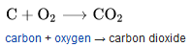
Carbon + Oxygen = Carbon Dioxide
Made from one carbon atom and two oxygen atoms

Methods of reducing CO2
The Netherlands has been regarded as revolutionary when it comes to climate change, and the government’s actions to prevent it (Euro news.)[12]. The Netherlands, as stated by the Dutch Government, has chosen to work to both adapt to and prevent further climate change[13], the government aim to reduce greenhouse gas emissions with regards to energy[14] usage, transport, construction and house, and agriculture and horticulture. A notable example of this being seen through Dutch transport, with a focus on electric trains, whereby all Dutch electric trains are, as of 2017, powered by wind energy, this goal was reached 8 years early, which is significant with over 600,000 daily passengers, on 5,500 train journeys per day(Guardian, 2017[15]). A further development from the Netherlands is carbon dioxide removal, whereby carbon dioxide is captured and stored, long-term, the diagrams below show this such process (Zeman, 2007)[16], which would have a positive impact on atmospheric CO2 levels(IEAGHG, 2011), if these technologies were to be successfully deployed, the IEAGHG have estimated that a potential removal between 3.5 and 10 Gt of CO2 from the atmosphere per year.
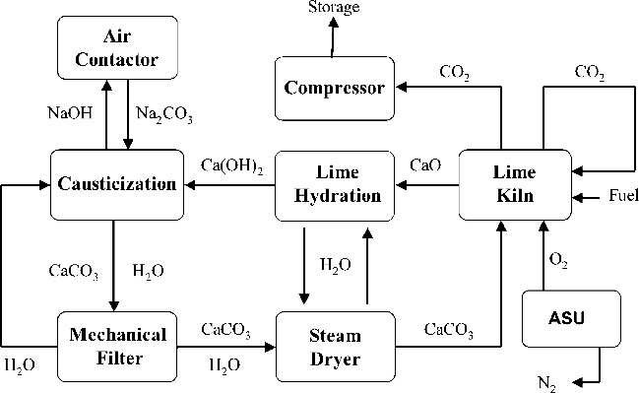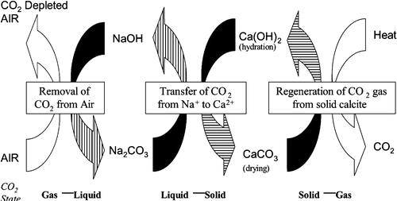

A further means of reducing CO2 levels can be seen through photosynthesis, Zhang et al, 2017 [16]stated that this method can be used to show that through the use of plants, it is possible to reduce carbon emissions, where a system they call plant factory carbon reduction, they estimated that with a growth area of 1,00,000 Square meters, 10,000 tons of carbon dioxide can be removed from the atmosphere, hence supporting the large-scale use of such methods. These methods have been introduced in places such as Mexico City, whereby vertical city gardens have been installed to filter the air of pollutants and greenhouse gases (The New York Times, 2012)[17], these such vertical gardens have been installed within the city area, either as walls or sculptures, and additionally these vertical gardens have also been installed on highways as vertical walls.

Policy and International Agreements Regarding CO2 Emissions
In 2015, the United Nations Framework Convention on Climate Change adopted the Paris Agreement, which has been signed by 195 Signatories, under Article 20[18] of the agreement. The agreement recognised that “climate change represents an urgent and potentially irreversible[19] threat to human societies and the planet”, the decision also acknowledged that climate change is an issue in which all countries must co-operate effectively, with an aim of reducing greenhouse [18]gas emissions (Article 2). Under article 10[18] of the agreement, countries must create “long-term” aims and targets regarding climate change and greenhouse emissions.
The United Kingdom ratified the Paris Agreement in November of 2016[20], Nick Hurd MP, the Minister of State for Climate Change and Industry of the time, stated that intends on using the Paris Agreement as an opportunity to transform aspirations into implementations, stating that the UK has provided “secure, affordable and clean energy” to both businesses and British families. The Energy and Climate Intelligence Unit, a UK not-for-profit organisation[21], claims that the Paris agreement will have a wider impact upon 14 mains areas, these being; policy, energy, business, investors, weather, nature, security, international politics, civil society, faith, international development, farming, the media and more-so health.

CO2 Outdoor Pollutant
Cyclists are exposed to Large Amounts of CO2 while bike riding behind cars[22]. City Lab has done extensive research in how CO2 effect cyclists - The study shows Bikers inhale black carbon than pedestrians do. A study led by Professor Jonathan Grigg from Bart’s and the London School of Medicine “bicycle commuters had 2.3 times more black carbon in their lungs”. Some People who go running in city climates with heavy car usage will also see an increase of Carbon levels in their lungs[22]
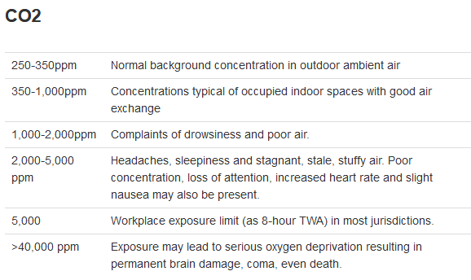

[23]

CO2 Indoor Pollutant
Indoor CO2 levels have been increasing inside buildings, this is attributed to high-rise housing and poor air ventilation in homes. The high concentration of CO2 can impair performance of the Health of the Occupants.
Sick Building Syndrome is on the increases in most counters. This syndrome is caused when the air quality within a building is dangerous or causes sickness. The NHS Online[24] state that “symptoms of sick building syndrome get worse the longer you're in a particular building and get better after you leave”
This shows that the longer the exposer, the more dangerous the effects, meaning people need to be alerted to their current air quality immediately.
Some of the symptoms and Causes as stated by the NHS include[24]:
- headaches
- blocked or a runny nose
- dry, itchy skin
- dry, sore eyes
- rashes
- tiredness and difficulty concentrating
Causes of
- poor ventilation or poorly maintained air conditioning systems
- dust, smoke, fumes or fabric fibres in the air,
If Sick Building Syndrome is detected, it's easy to resolve.
- Opening a window,
- Checking Air conditioning Filters
- Put more plant in the Room effected,
- Lowering Temperature to 19C.

This shows the percentage of the CO2 present in the atmosphere, and the health effect associated if the level rose [25]. 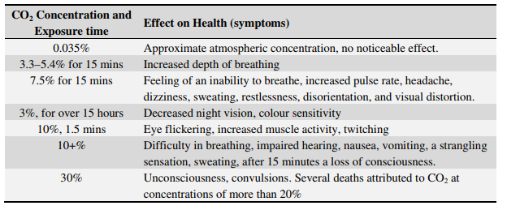
The Mauna Loa Observatory have been measuring CO2 levels since 1960, these observations show the steady increases of CO2 present. To date, this chart has reached the 450ppm limit in 2018, which shows a dramatic increase since 1960, of only 320ppm[26].
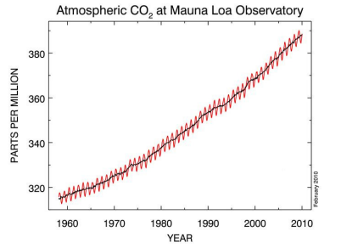[26]
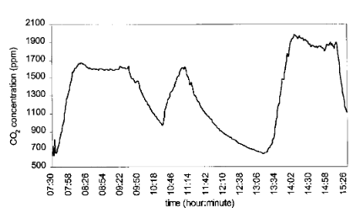
Indoor air quality investigations by S.C. LEE* AND MAUREENCHANG [27]show that some indoor classroom in China, had CO2 levels that reached1900ppm. This investigation also show that the size of the room and number of occupants play a factor of CO2 levels. 1900ppm of CO2 is very unsafe and can cause headaches and sleepiness, creating a bad learning and working environment [27]
[27]

Sick building syndrome is given to building with High CO2 levels this creates the building inhibitors to start feeling sick and unwell From S.C. LEE* AND MAUREENCHANG finding it is possible to observe that the area of space and occupant of the room and length of stay in the room can play a massive factor in this Sick building syndrome[28].
These are provided by the National Centre for Biotechnology Information, U.S. National Library of Medicine[29]
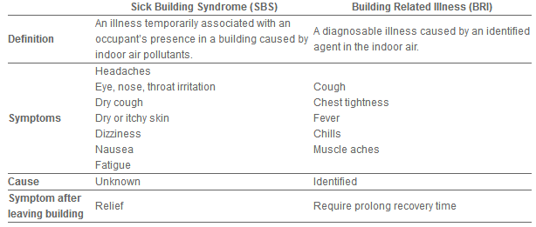

CO2e
CO2e (carbon dioxide equivalent) measures not just CO2 but other minute particles, that are also harmful to global warming, these other gases are also harmful to humans, methane, nitrous oxide and F-gases are included in these measurement, this can be used to calculate the impact of greenhouse gas in your homes or local environment.
CO2e can be used to measure your carbon footprints as this measurements take in to consideration the global warming damming Another way to look at it is to think of methane this scours 25 this means that in every 25 tons of CO2e 1 tone of methane does the same global warming damage.[30]
These shows need data on CO2e reading and health effect this research was needed to build safety light in the project to Allows novice users to also be aware of dangers
According to research done by Wisconsin Department of Health Services[23].
350-1,000ppm CO2e | These reading should not cause alarm as this shows average CO2e readings
1,000-2,000ppm CO2e | The possible danger this level should cause drowsiness and poor air.
2,000-5,000 ppm CO2e | Danger High this can cause a range of ailments Headaches, sleepiness asthma attacks, etc.

Volatile organic compound (VOC)

Introduction
Volatile organic compounds or VOCs contain a variety of chemicals, that are emitted from solids or liquids, these chemicals in the air can be very dangerous in long term or short-term exposure, VOC are at their highest indoors, as many products contain VOCs, this combined with low airflow can create an unhealthy or deadly situation.
These Organic chemicals are used in a lot of household product, vanishes and pain, etc.
EPA's Office of Research and Development's "Total Exposure Assessment Methodology (TEAM) Study" (Volumes I through IV, completed in 1985) found levels of about a dozen common organic pollutants to be 2 to 5 times higher inside homes than outside, regardless of whether the homes were in rural or highly industrial areas. TEAM studies indicated that while people are using products containing organic chemicals, they can expose themselves and others to very high pollutant levels, and elevated concentrations can persist in the air long after the activity is completed.[31]
Whether the homes were located in rural or highly industrial areas. TEAM studies indicated that while people are using products containing organic chemicals, they can expose themselves and others to very high pollutant levels, and elevated concentrations can persist in the air long after the activity is completed.[31]

Sources of VOCs
Household products containing VOCs | Others containing VOCs | Activities containing VOCs
paints, paint strippers and other solvents | building materials and furnishings | Smoking
wood preservatives | office equipment such as copiers and printers, | Cooking, hobbies
aerosol sprays | Photographic solutions. | Burning wood
cleansers and disinfectants | graphics and craft materials including glues
moth repellents and air fresheners | permanent marker
stored fuels and automotive products | adhesives,
hobby supplies | carbonless copy paper
dry-cleaned clothing | correction fluids
Pesticide
Many products have cut out as much VOC as possible but there still some VOCs, we cannot get away from, this list shows all products used in a household, and other products such as workplace hazards as carbonless copy paper or building material[31][32]

Household Products Database Containing VOCs producing products https://hpd.nlm.nih.gov

Health Effects
The health risks of inhaling VOC chemical depend on how much one person consumes, over a period of time. If low levels of VOCs are inhaled over a long period of time it will increase health problems studies such as Minnesota Department of Health[33] claim that the longer you're exposed to VOCs , the worse the symptoms can manifest. People who are sensitive to chemicals, such as asthmatics will find an increase in irritations from any levels of VOC.
VOCs are a collection of chemicals such as benzene, ethylene glycol, formaldehyde, methylene chloride, tetrachloroethylene, toluene, xylene, and 1, 3-butadiene. Each chemical can have its own health effects. The symptoms of exposure to these chemicals can cause many different health problems. The chart shows some of the symptoms that are supported by Minnesota Department of Health[33][34]

Over exposure to VOC can have very dangerous effect some of these effect supported by Minnesota Department of Health[33][34]
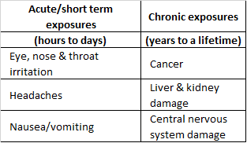

Steps to Reduce Exposure
[35]
If people follow the instruction on their product, which most potentially hazardous products have, such as warning labels and instruction, on how to handle a product that contains VOCs, such as opening windows or using in the well-ventilated room.
All product that contains VOC should be kept in a sealed container, when you have finished with the product check to see if your local government has a day or a place to dispose of your chemical waste safely.

Methylene chloride and benzene are the two chemicals contained a lot of products and in a lot of human activities, like smoking, this person should try and keep exposure to this at a minimal,this is one of the most used VOC in product and can still cause harm at long exposures or at high intensity [34]
methylene chloride | Benzene
paint strippers | tobacco smoke
adhesive removers | stored fuels
Aerosol spray paints. | paint supplies
Both these chemicals have been studied to increases the chance of cancer in dogs and have long-term help issues of humans
There is a range of people who are at a higher risk of irritation and illness from breathing in VOCs, Such as People with.[36]
- respiratory problems
- asthma
- young children
- elderly
- heightened sensitivity to chemicals

TVOC
TVOC (total volatile organic compounds) is often the name give VOC that are indoors. Having an idea of the health and risks related to the measurement of this element was needing to be able to convey to the user of this product. Many different organizations have sent their own limits and health-related to them this table shows some of the originations and agency own results[37]
All results are related to the same measurements taken in this project TVOC parts per billion.

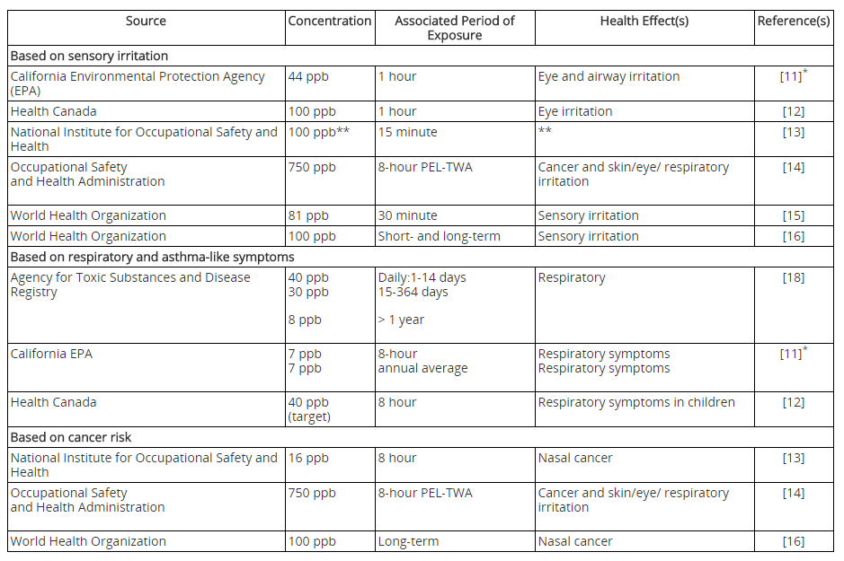

The Effect of Temperature and Pressure on CO2Measurement
Temperature and pressure can cause false reading when measuring given gas but the ideal gas law or molecular density of gas laws can be used to stop this affecting reading. First, you must be able to read temperature and pressure and gas from this you can take results from temperature and pressure and predict the effect they will have on CO2 readings to compensate [38]

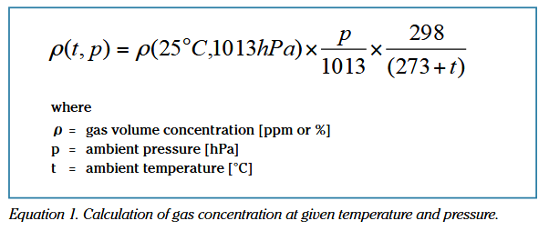
This density formula will be used to calculate the CO2 readings and change reading as the need for temperature and pressure.
From the below table it shows the observation of CO2 sensor measurement changing with pressure and temperature. [38]
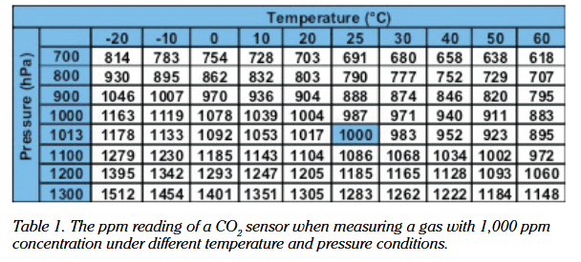[39]
Without these calculations, this product will not be able to perform well when being used in a portable environment, this is why molecular density of gas laws need to be implement.

CHAPTER 4. Research Methodology

The Research Onion

Summary

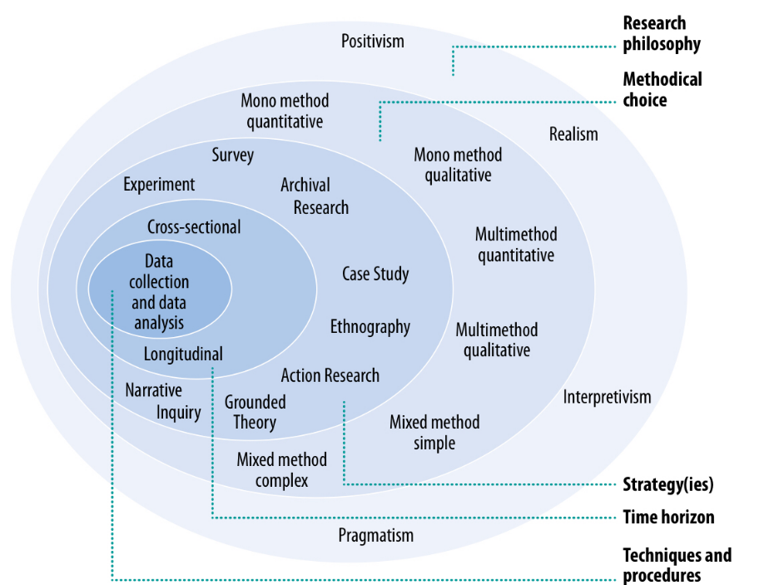
The metaphor of the Research Onion is used in order to understand the complex processes of research and its related decisions, this metaphor takes a layered approach, hence its name of Onion, these layers, in according order, being; research philosophy, methodical choice, strategies, time horizon and technique and procedures. These layers then have within them, associated words and phrases, as seen in the diagram below, (Saunders and Tosey, 2013[40], cited Saunders et al, 2012[41]) which shall be explored further within this section.
This method, as suggested by Saunders and Tosey, ensures that research conducted and the procedures in which it was conducted, are both sufficiently “coherent” and sufficiently “appropriate”, hence why this method has been chosen. They state that “Most researchers design a piece of research to answer a question or address a problem”, by doing this they have less of a focus on the outer layers of the onion, which in this case in focused on data collection and analysis, due to this, Saunders and Tosey argue that researchers using his method have a less complete understanding due to the fact that they do not consider the outer layers and more so, the implications that these layers have on the rest of the onion.

Research Philosophy
Research Philosophy is the outermost layer of the onion, this layer concerns itself with the philosophical standpoint for the researcher, Saunders and Tosey argue that one’s own philosophies affect the way in which we understand and conduct research. There are four main philosophies to consider for this layer, these are positivism, which is focused on scientific observation and predictions, this philosophy tends to allow for research replicability and is favoured as a scientific approach, realism, being related to observed experience which are viewed to be as an “accurate interpretation” of the world, this methods is similarly to a positivism approach is viewed to scientific, interpretivism, which is focused upon interpreting research that has been conducted previously, this approach is focused more on the analysis and reviewing of previous research, and pragmatism, being an approach that collects a variety of data, with the aims to ensure that their the research is “credible, reliable and relevant”. For this report, a pragmatism approach has been taken, to focus on the complexity of air quality and the impact that this has upon health.

Methodical choice
With regards to methods, there are three main types, these being qualitative, quantitative and mixed. With regards to qualitative and quantitative, there are two subgroups, these being mono-method, and multi-methods. However, with regards to mixed, there are simple and complex methods. In this sense, mono-methods are singular use such as interviews, observations, case studies, or questionnaire, whereby multi-methods are the use of a variety of methods. Additionally, mixed refers to the combination of both qualitative and quantitative methods, simple being a combination of methods and complex being the quantitative methods to evaluate qualitative methods. Within the project, mixed method simple was chosen allowing for the research of the qualitative impact upon health and related legislation, as well as quantitative research regarding co2 levels and VOC levels.

Strategies
The third layer of the research onion is related to the ways in which data for the report is collected and analysed, these methods include experiments, surveys, archival research, case studies, ethnography, action research, grounded theory and narrative enquiry. With this layer, a variety of methods, for the report the main strategy was archival research, whereby journals, report and legislations are used, amongst others.

Time Horizon
Time-horizon refers to the types of strategies with regards to times, in the sense that a method that uses short term studies which is defined as cross-sectional, whereby longer-term studies are classed as longitudinal, in the sense of the research onion. This project focuses on a combination of long-term and short-term studies, hence has a both cross-sectional and longitudinal strategies.

Technique and procedures
This section, the core of the onion, the most critical part, focuses itself upon the means of collecting and analysing data, with reference to the previous layers (Derby.ac.uk[42]). This layer must consider all of the other layer, and the decisions in this must correlate to them.

Hardware and software
To develop an air quality device there was a few hardware devices and software applications need to implement the final design they are as follows.
Software | Hardwar
- Microsoft office  - MPLAB  - Proteus 8  - CCS C compiler | - Soldering iron  - Breadboard  - Digital Multimeter  - Sensors  - Microcontroller  - General electronic components (LEDs, Resistors, voltage regulator)

CHAPTER 5. Component selection and research

Introduction
Researching different components for this project was vital to creating a device with a good degree of functionality this report will keep to the specification choices of VOC/CO2. Other combination sensors are reviewed such as humidity, pressure and temperature to developing the project. This section will discuss and evaluate possible components there are two major sensors needed for the success of this project; a CO2 sensor and a VOC sensor.
Humidity, pressure and temperature Sensor are added to stop the effect that these ellement have on readings from the CO2 sensor and VOC readings. These will be used in line with molecular density gas laws.
From this research, it will be possible to determine which components are suitable for this project to have best efficiency and effectiveness keeping down power consumption and size.

Gas detection Techniques
This report will look deeply in to two types of gas detection methods; metal oxide semiconductor (MOS) and IR techniques. Both these methods use two very different techniques one uses inferred light this gives the ability for the IR sensor to have the CO2 Gas absorbing light at 4.3 am this give the possible measurement of CO2 from inferred sensors. Metal oxide semiconductor uses a controlled oxidation to get a voltage reading which allows measurement of CO2.

IR techniques
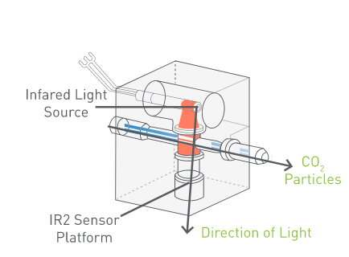[43]
A small amount of Inferred is absorbed by light whilst CO2 gas also absorbs light at 4.3 am it is possible to get a measurement of CO2. This works by directing Inferred light through the gas that needs to be measured, a filter will be used to prevent other wavelengths to be measured this will make sure that only CO2 detected. The higher the CO2 levels the less inferred light will pass through the air. The inferred sensor needs to be calibrated when the device is used in a Different light source, if these sensors are not calibrated it will cause a drift in reading over time. This device would need a pump and a lot of airflow within the sensor to get accurate readings.[44]

micromachined metal oxide semiconductor *
Metal-oxide-semiconductors (MOS) use a controlled oxidation to give a change in voltage output. These sensors utilize porous polycrystalline resistors made of semiconducting oxides. When creating a MOS to detect gasses 3 factors are taking in to effect insulator grain boundary (semiconductor material) and fabrication (metal). MOS is designed to only adsorb/react at a target gas.[45]
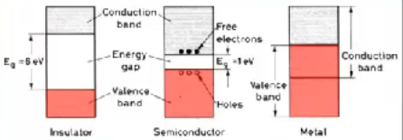 [46]
From here you can see how the 3 factors creating a metal oxide semiconductor (Band theory).
When the target gas hit the MOS there is a chemical reaction within in and this reaction will give a change in the output, this will be shown as a voltage change and this device would come with a table to calculate the target gas [46]

Techniques selection
The technique that was needed for this project must use very little space. It did not have to be very accurate just giving a baseline of local CO2 and VOC levels. After researching and comparing both techniques the metal oxide semiconductor technique is most applicable to this project, but IR techniques are very useful when possession is a need but the need to pump air through the IR sensor makes it lacking for this project.

CO2 Sensors selection

CozIR LP
This IR technique show a baseline of inferred sensor. These have a massive measuring range from 0 to 50000ppm this is able to measure the whole spectrum of CO2 levels. First reading from this device is 1.2s after power on. This must have an operating pressure of 950mbars to 1050mbars to get a correct readings response time of 2-3 minute but is able to also give a reading twice per second. Operating on 3.3vs ultra-low power[47][48]
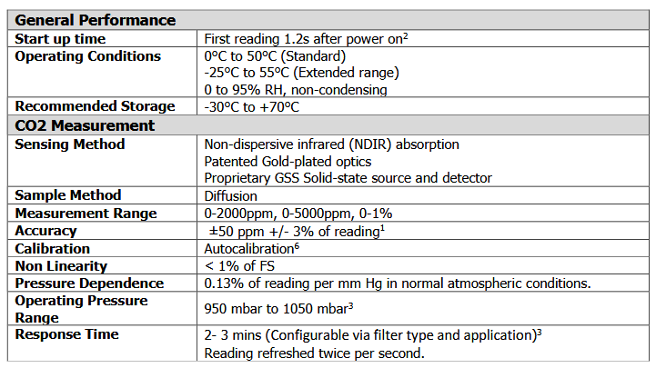
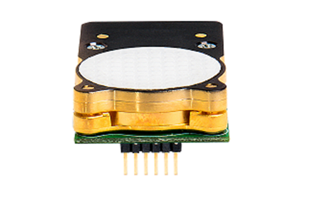

IAQ-Core sensor
The IAQ-Core is one of the only devices that combined VOC (volatile organic components) and CO2 measurement. This device is the smallest out of all reviewed items in this category. Run at 3.3v, 25ma, 67 mW power consumption. Operating on i2c made this device desirable for this project as it would use a very low amount of pin and could contain multiple sensor on one data bus.
This technology use micro machined metal oxide semiconductor High sensitivity and fast response time. Measuring 450 to 2.000 ppm CO2 equivalents 125 - 600ppb TVOC [49][48]
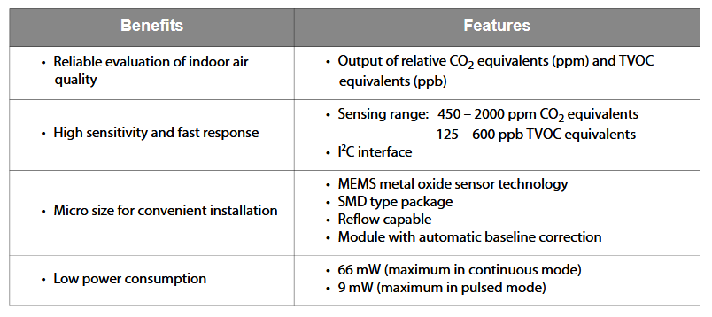
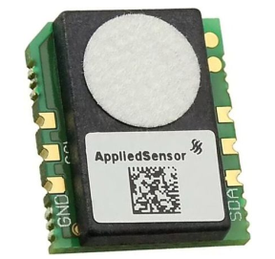

MISIR 5,000ppm CO2 Sensor
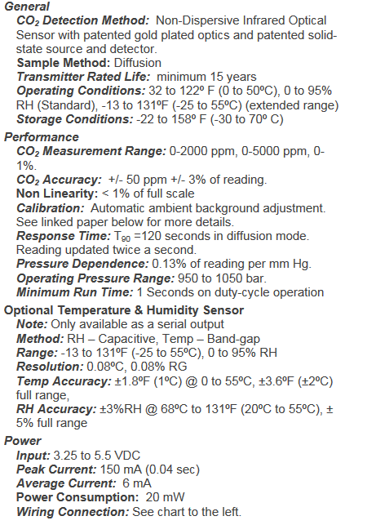
This device uses NDIR with gold-plated optics IR sensor technology with dual beam to detect CO2 particles the air. This device is much larger than the other device and operates on 3.3v with 20mw power consumption It takes the 20s to warm up but can Measurement range of 0-5,000 ppm CO2, this device would have been chosen for this project but as of it large size It would not have worked effectively if this project wanted to be used in industry standards environment where more wider spectrum of readings. [50][48]
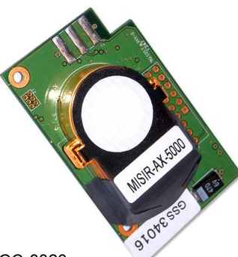[48]

[48]

VOC sensor selection

Figaro TGS2602-B00 Air Contaminants Gas Sensor
This metal oxide semiconductor device is able to measure Air contaminants (VOCs, ammonia, H2S, etc.) Working only in one state no sleep mode operating at 56mA 5V this device has a high-power consumption compared to other sensor on the market. There is a circuit that converts conductivity on the metal oxide semiconductor to an output signal which corresponds to the gas. Having a high sensitivity to low concentrations of odorous gases H2S can contain more data on air quality housed in a standard TO-5 package[51][52]
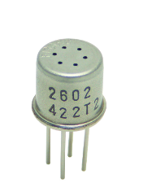[51]

IAQ-2000 Indoor Air Quality (VOC) Sensor
This VOC has a very wide response rate being able to measure a spectrum of chemicals in the air things such as bio-effluence, cooking odors, smoke, alcohols, organic acids, etc. Having such a wide range give this device the ability to be used in a lot of aspect like detecting alcohol on the breath of drivers. This device has the ability to send data to air conditioning
Systems to remove bad odours like burnt cooking, or smelly feet. IAQ2000 measure concentration VOC particles Running on 5vs 22-30ma this device comes with a sleep mode and operates on RS232TTL, SPI, I2c creating a wide change of data buses to use.[53][54]
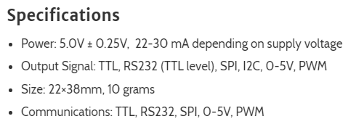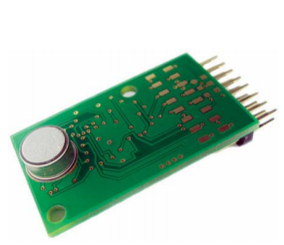
[54]

WSP2110
The WSP2110 semiconductor VOC Sensor adopts multilayer film manufacturing technology This Metal oxide semiconductor Technique Explain in Gas Detection Techniques having the ability to detect gases whose concentration is up to 1ppm to 50ppm this is quite low but still able to measure toluene, acetone, benzene, alcohol, methanol, etc. One of the biggest issues with this sensor it has a warm-up time of over 120 hours this would not be suitable for this project running on 5V 300MW.[55]
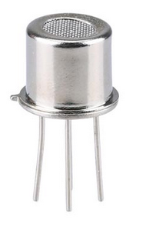
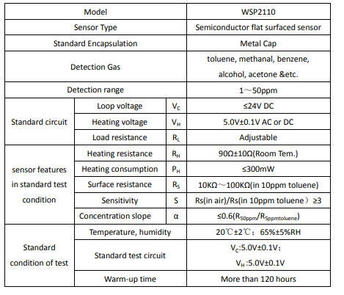[55]

Humidity/Temperature/pressure Sensors

MS8607
This environment sensor is able to measure a wide range such as pressure, temperature & humidity (10 to 2000 mbar, -40 to +85 °C, 0% RH to 100% RH) with such a wide range this sensor. This device work with ultra-low power Supply voltage 1.8 to 3.6 V. All data from this device is sent through I2C Interface. High-resolution module supplies fast response rate for accrete data [56]

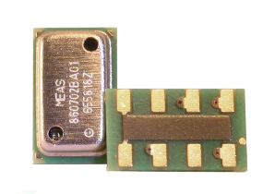 [56]

DHT-22
This low-cost temperature and humidity sensor give a digital output, it determines the level of CO2, and measures for any disturbances. The signal is received digitally via data pin (analogue isn’t required).
The product itself is a very simple design, which makes it easier to use, however, it relies on precision timing to retrieve data. The main issue with this sensor is the memory of the sensor reading can be as old as two seconds and can impede true data. Running on 3-5v 2.5mA max current use with a wide reading range of for -40 to 80°C temperature readings and 0-100% humidity readings[57].
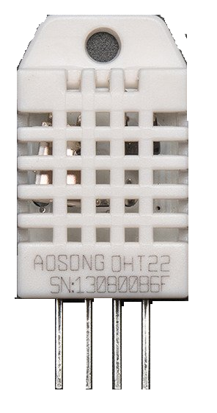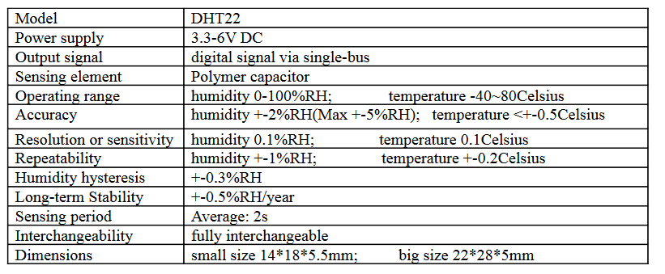[58]

BME280
The BME 280 is one of the most powerful devices as it able to reading all 3 senses of humidity/temperature/pressure, all these come built in to a very small page of a 2.5 x 2.5 x 0.93 mm³³ LGA package This ultra-low size creates the ability to utile this product with no loss of function this device specifically designed for mobile applications this device is very rugged with very long-term stability and high EMC robustness.[4][59]

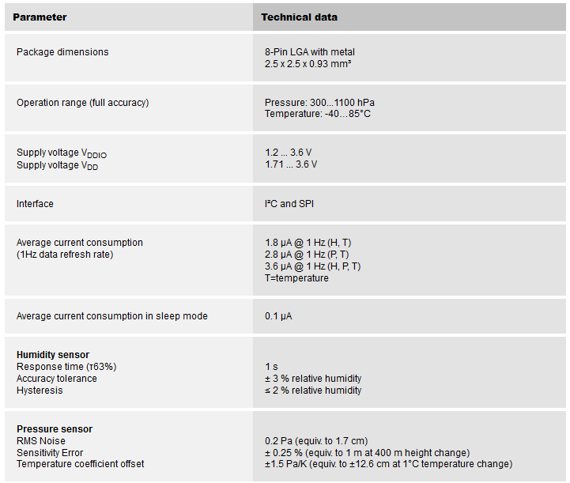
This sensor has the lowest power consumption within the review. 3.3v 3.6 μA this low power combined with low small size and flexibility in readings such humidity, temperature and pressure which makes this sensor one the best for small product environment sensor around. Optimized for very low noise and high resolution.
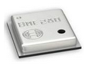[4]

[4]

Future Components
These components were not implemented in this report due to time restraints and limited coding knowledge, but these components have been simulated for later expansion of the product after prototyping and proof of concept.

SD Card

Molex 104642 Series 8 Way Micro SIM, MicroSD Memory Card Connector with Solder Termination [60]
0.88

USB
ASSMANN WSW Right Angle Through Hole Type A USB Connector, Receptacle[61]
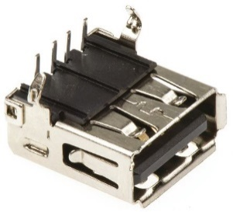

Power calculation
Calculating the power required needed by all components within the design from these calculations it is possible to find a battery that ensure this device run for a full day. 30Mah are need for this project I battery over 3000Mah and above will be chosen for this project to help with portability and run time.
Device | power
PIC | 3.3v 5mA
Screen | 5v 4mA
Humidity/Temp/Pressure/CO2/VOCs | 3.3v 21mA
Total | 30mAh lowest input voltage of 5 volts 150 watts
Watts
P(watts)=(V)x(I)
Watt hours
(W)*(h) = (Wh)
(Wh)*1000/(V) =(mAh)

Battery
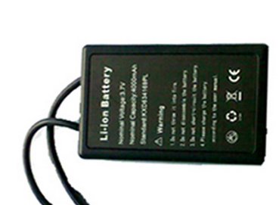
The KXD-5v-4000mah battery is running at 5vs with 4000mah. When researching battery first the power calculation would be needed from are results we have calculated that are prototype device would run on 30mAh the chosen battery will give over 3 days’ worth of run time plenty for this project. the chosen battery is also rechargeable this is too keep wastage of battery’s low and usability of this project more desirable [62]
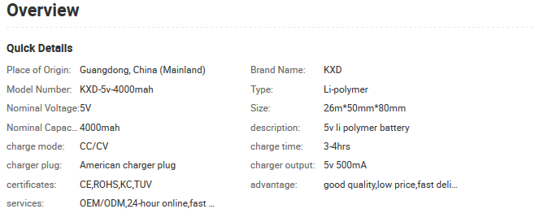

Screen
GDM1602K-Basic 16x2 Character LCD - Black on Green 5V 4mA[63]
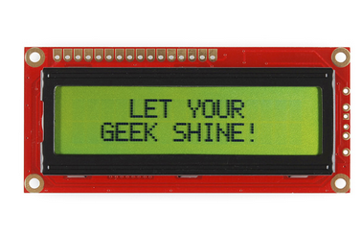

Voltage regulator 3.3v
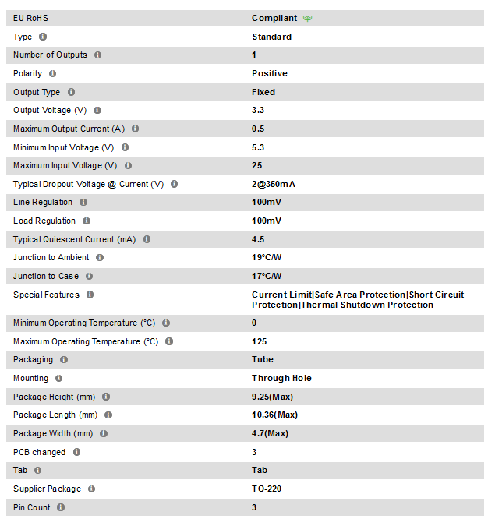
The voltage regulator takes the 5 volts input from the battery and steps it down to 3.3 volts this need for all component apart from the screen in this project. Using a UA78M33CKS this device works just like the LM7080 that is used in simulation. [64]

Product Casing
The final product will be made out of an ip65 light plastic casing that can withstand weather effecting and erosion a solid/light container is needed for the portability of this product there could also be a simpler product made without the screen only using the LED danger levels.

Microcontroller
This microcontroller for this project has a lot of requirements needing to be able to handle many different Digital Communication Peripherals. Such a large range of communication need to work with extra features and the base product.
From picking the sensors and component need for this project after reviewing all their datasheet it was possible to use Microchip.com [65]to find the most effective and efficient Chip for this project

The below table shows the parameters, this have been placing into microchip.com to filer possible PIC controllers these sensors are all somewhat suitable for this project.

Pins | Operating Voltage Range (V) | Clock speed | Digital inputs | Analogue inputs | Ram | Program Memory  Flash | Analogue to digital | Data bus | Digital Communication Peripherals
15+ | 0-3.3v | 12-16megs | 3 | 4 | 160bit | 16k | 10ch+  10-bit | 8bits | 1-UART,  1-SPI  1-usb  I2C1

From the data take from Microchip.com it was possible to review 6 chips not all are suitable for this project but could be suitable if a smaller device was made without a screen. All PICs have been Thurley reviewed their data sheets. The PIC18 family is one of the most advanced chipsets this project will overview over 4 Pics from this family as it is the most suitable for this project.

Pic16f1455

This chip offers a lot of power in a small 14 pin containing Flash Program Memory with self-read/write capability with 2x Standalone PWM Modules 10 Channel 10-bit ADC with Voltage Reference 2 Analog Comparators 5-bit Digital to Analog Converter (DAC) Enhanced Power-On/Off-Reset Extreme Low Power (XLP) ‘LF’ Variant (1.8V – 3.6V) These features allow for many uses.[66][48]
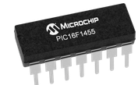
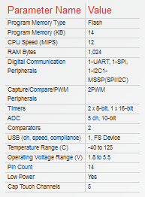

Pic16f1459
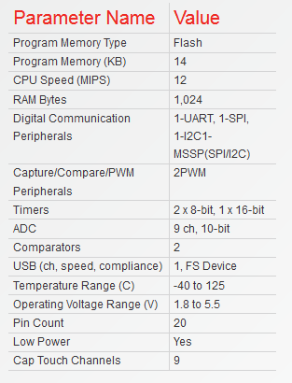
The 16f14 family contains a lot of small devices that pack a punch in power bosting a 12MIPS CPU with on board Flash of memory of 14kb with 9 analogy to digital channels allowing for a variety of I/O options Some features are High Endurance Flash Memory (HEF) 128 B of Non-volatile Data Storage Universal Serial Bus 2.0 Module with clock recovery from USB host 2x Standalone PWM Modules 10 Channel 10-bit ADC with Voltage Reference 2 Analog Comparators 5-bit Digital to Analog Converter (DAC) MI2C / SPI Module Wide Operation Voltage Variant ‘F’ (1.8V – 5.5V) [67][48].

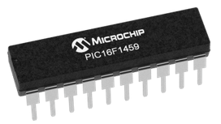

PIC18f14k50
The smallest of the PIC18f family but still have all the ease of use as with a C Compiler optimized architecture Allowing use of USB with the USB v2.0 compliant interface Supports. Containing I2C/SPI Interface I²C™ ports 10-bit, 9-channel ADC Module Rail to Rail operation 1.8 to 5.6V operating[68][48].

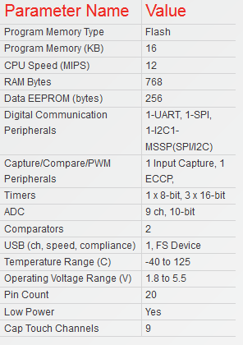
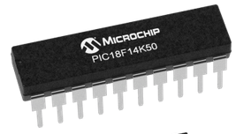

Pic18f24l50
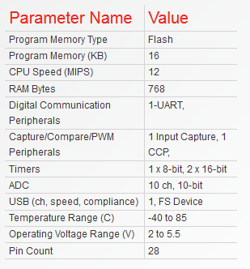
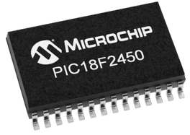
The 28 pin Pic18f2450 contains 1-UART, Program Memory (KB) 16 ADC 10 ch, 10-bit this chip is compact Full Speed USB applications (12Mbit/s). The Enhanced Flash program memory allows operation when disconnected from the bus and easy field upgrades via the USB port.[69][48]

Pic18lf25k50
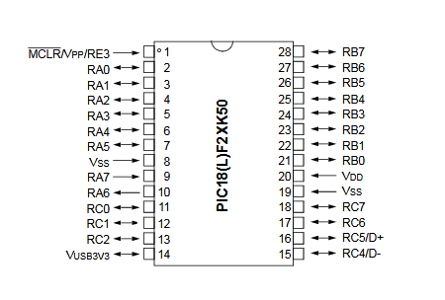
This chip would have been perfect for the project contain 32 (KB) Program Memory 28-pint USB capability 14chanels of 10 bits Analog-digital conversion. 2048bytes of ram would have been plenty as SPI ports allow an external SD card that will be added. With an operating voltage range of 1.8v to 5.5v. A low price range of £1.84 per 1-25 this chip would be useful for many projects. [5] Reviewing this Pic from the perverse project as it suited both projects. [70][48]
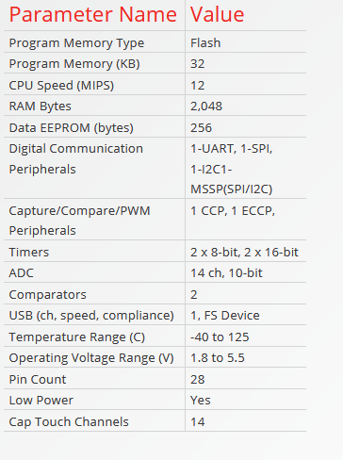

Pic18f45k50
This 40-pin chip is perfect for a future aspect of the device. Allowing more sensors to be added for more accurate readings. This chip would be able to handle most projects and it contains High-performance PIC18 core these family of chips are powerful chips being able to work at a fast rate and not losing on ports and power consumption.
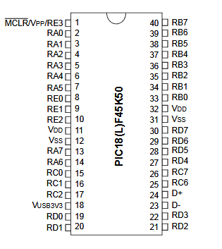
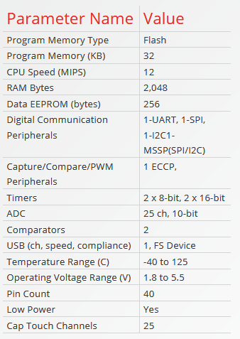
The Enhanced Addressable USART Module will allow for faster data transfer. Working on a low power consumption reviewing this Pic from the perverse project as it suited both projects.[71][48]

Final sensors choice
The IAQ sensor was chosen for this project as it fit the needed categories very easily with low power usage running on 3.3v and being able to measure the total CO2 levees and VOC levels give this sensor and step up from its competitors.
When looking for a mounted version of the IAQ core Though research another device seem very suitable it came with an IAQ CORE sensor and a BME260 this gives the device the ability to get all reading need for this project all mounted to one simple bored it allowed for the ability to read CO2 VOCs Humidity Pressure and temperature all these things can have an effect on air quality and should be monitored in areas where people are at most risk.

IAQ-Core
After researching gas detection techniques a micro machined metal oxide semiconductor technique was chosen there were few devices on the market that was able to measure VOC and CO2 in such a compact device from the other sensor reviewed this was chosen for the reason of size, to measure VOC and CO2 working on ultra-low power consumption these are the main task for this project. This device has a narrow reading rang but when safety levels past 2000ppm being very dangerous the product did not need to detect to the full range on 5000ppm Sensor that uses IR absorption can be costly and bulky this device does not contain any of the issues. CO2 equivalent and TVOC are measured with a fast response time but has a 5-minute startup. With all data send through i2c this device did not need a lot of pins to function. IAQ core is the ultracompact solution for detecting poor air quality detection.[72][73]
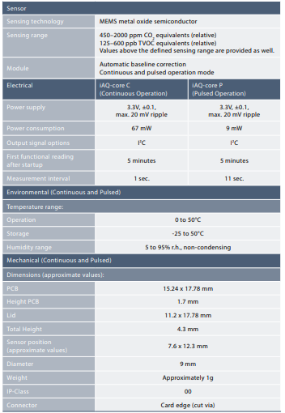
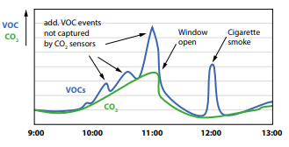
The below diagrams shows the levels of CO2 and VOC in the Classroom and the effects it has on the room.

BME260
The BME260 sensor is an environmental sensor able to detect temperature, pressure, humidity this type of data is needing to calibrate the MOS sensor these types of sensor can have their data altered by the effects of Temperature and Pressure on CO2/VOC Measurement in chapter 3. This sensor was chosen for its tiny size and multiple choices of environmental factors. It was originally designed to be used in phones, so it has a very low operating power 3.3v at 3.6uA. This sensor has an in-build sleep mode to also control power consumption no other device reviewed could beat any of the specifications of this sensor.

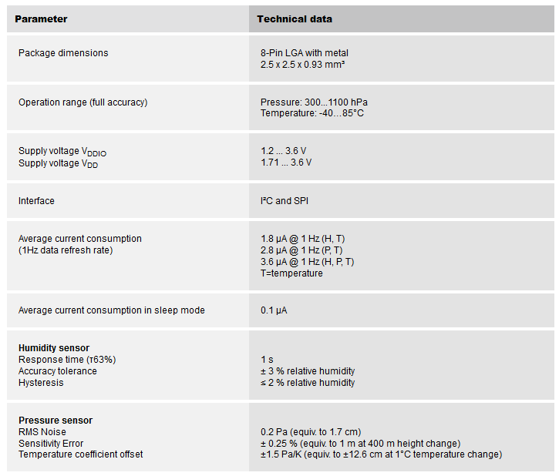[59]

The MOD1023
The MOD board is the pre-mounted PCB bored contains the two sensors that are used in this project. The IAQ core and the BME280 both work of i2c so no need extra pins were needed for the PIC18f. Running on 3.3v created by embedded adventures.
The MOD chip is able to measure a vast range of both its sensor perfect for environment monuments.
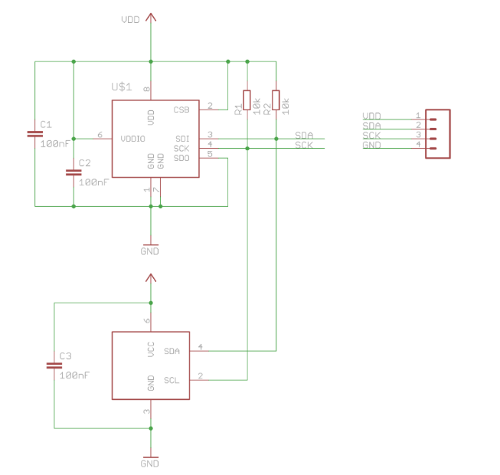
The MOD bored is able to measure pressure sensor, temperature sensor, humidity sensor and CO2 and VOC these are all the senses need for this project this would work best for Prototyping Nothing would change if the items the IAQ and BME sensor was mounted separately to a PCB Creating smaller product. [72][73][4]

[4]

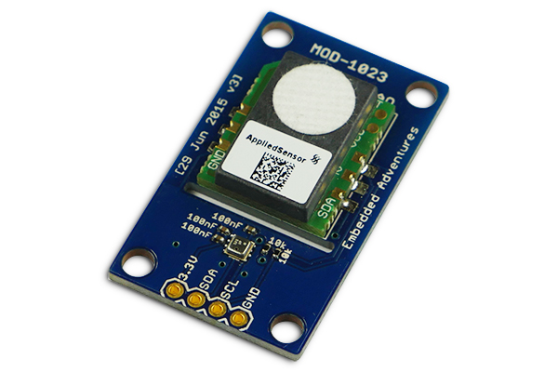
[73]

Pic18Lf25k50
The chosen microcontroller had to have be able to handle all communication need for all components in this project doing this ultra-low power the Pic18Lf25k50 this had all the communication need for this project such as i2c, SPI, analogy ,rs232 and digital with 28 pin O/I this PIC would allow for the fitting of extra components . The 18FL was able to operate at a 1.8 to 3.6v this was perfect for the 3.3v operation voltage chosen for the project. [74]
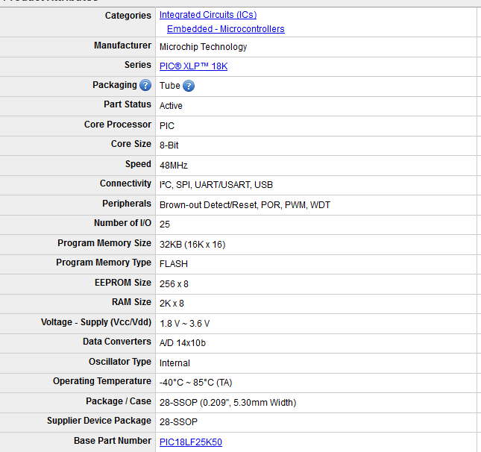

How IAQ-core works
MEMS metal oxide sensor is used in the IAQ-core these Conductometric semiconducting metal oxide gas sensors have been widely used and investigated in the detection of gases. Investigations have indicated that the gas sensing process is strongly related to surface reactions, so one of the [73][75][49]
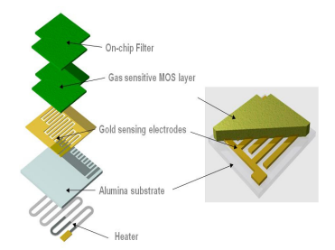
Important parameters of gas sensors, the sensitivity of the metal oxide-based materials, will change with the factors influencing the surface reactions.[76]
[76]

Factors that could influence air quality changes and produce anomalies in results and errors.
Semiconducting metal oxide gas chemical sensors like the ones chosen in this project can have a cross-response to outdoor factors these factors can cause fault reading. as stated in this project the Results for CO2 and VOC will be taken from a Semiconducting metal oxide gas sensor so presentment of these fails reading was needed the factor that can cause fault readings are;[37][46]
Pressure
Temperature
Humidity fluctuations
These are all known to fluctuate reading as researched shows in chapter 3
This response to temperature and humidity can be corrected by research showed in Chapter 3
These use results were taken by The BME sensor such as Temperature and humidity and use a calculator to correct the VOC/CO2 readings.
Wind can cause an error in response reading a light film is used over the IAQ sensor to stop excessive air flow the allows a controlled amount of air through the film but does not hinder reading when creating a case for this project air flow was one of the main gales to help control air flow.

CHAPTER 6. Design & Design Research

Introduction
In the section, there will be an overview of some of the design and design research used within in this product, subject contained within this section will be modules in within the PIC18f Background need research on I2c, SPI and Rs232.
From research, this section will create a simulation of the final product using Proteus to create circuit design, this involves understanding all of the datasheets, and background methods, to develop a working simulation, including simulation coding.

Simulation
Using simulation software, such as Proteus, can greatly increase the understanding of the final design, this is able to be done by creating schematics to go alongside programming. Programming could have been done in CCS, but this would not have proved the same level of knowledge and understand the final design. Having a knowledge of all components used, is needing to effetely connect these parts to PIC microcontroller.
The sensors and PIC operate on a 3.3v this has been stepped down with a voltage regulator from 5vs is need for the screen only in this project.

Final simulation design
This shows the final design in Proteus, with all additional components added, for later use. The below schematics was created in Proteus after reviewing all datasheets of device used in simulation and implantation.
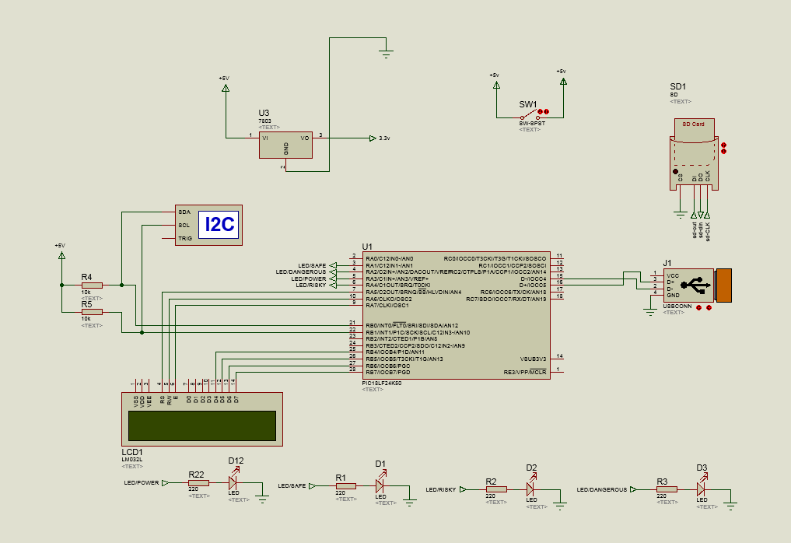

MOD-1023
The MOD-1023 contains all the vital sensor need for this project. The IAQ core giving readings on VOC and CO2, and BME280 giving reading on temperature, pressure, humidity. This device was not in the Proteus library so it had to be simulated the below diagram shows what the simulation would look like if the MOD-1023 Chip was in the Proteus library. This shows what the final design will look like if the MOD-1023 was in the Proteus library.
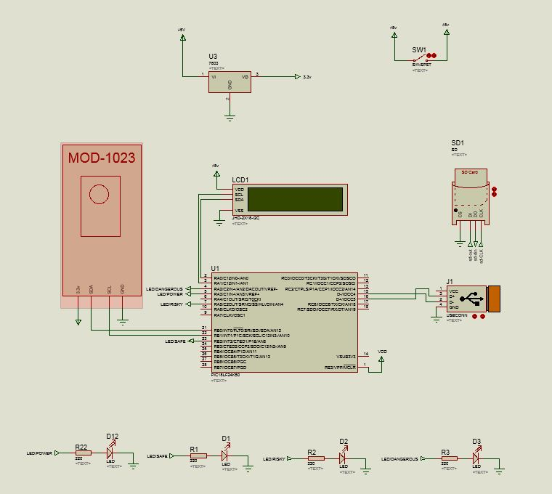

Screen
The LED screen created the user interface being able to show relevant vales running on 5v this is the only thing in this project running on 5v.
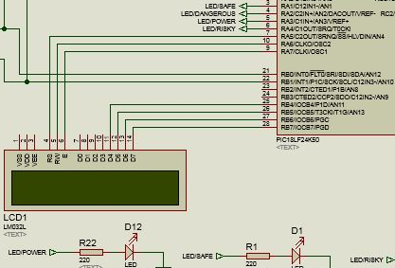

PIC18lf25k50
This PIC18lf25k50 has all required connections for this project all most all data coming into the device is being revived via I2c on pin 21, 22. It is possible to observe the LED safety and power lights connections on pin 3,4,5,6. The power connection is used as Vdd pin 20 Vss pin 8,19 these all run on 3.3vs from the voltage regulator, the screen was using pins7,10,9,25,26,27,28 running on the input voltage of 5vs this creates the base of the device extra features such as USB and SD cards are added for late expansion. A slow clock speed was need on the pic18 to function with the i2c.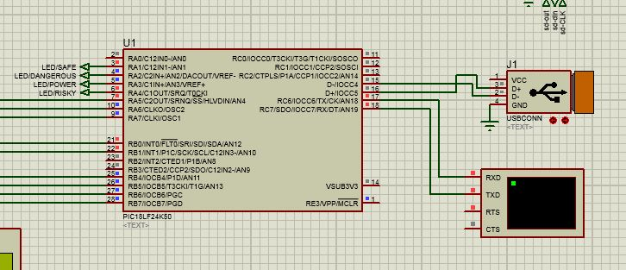

Switch
On and off switches at the input voltage will give the ability for the device to power down to save battery. This will be created with a toggle switch.
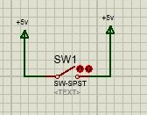

I2c Simulation with 24LC08N EEPROM
As Proteus did not contain the simulation components BME280 and the IAQ core, this EEPROM electrically erasable programmable read-only within coding Hex values, these were written to the 24LC08N these hex values represented the same addresses at the BME280 and the IAQ.
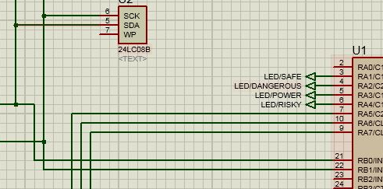

LED
LED are connected to Microcontroller 3 are used as a safe light to alert the user and one is a power of light to show the Microcontroller is powered and running code.
Green LED
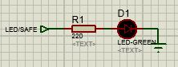
Yellow LED
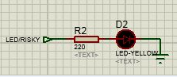

Red LED
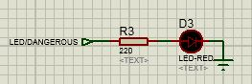
Blue LED
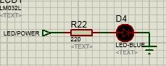

These led will light up if CO2e or TVOCs go over the recommended limit,
Red LED High: levels of CO2e 1800ppm and above
Red LED High: levels of TVOC 1500ppb and above
Yellow LED Mid-levels: of CO2e 1000ppm and above
Yellow LED Mid-levels: of TVOC 500ppb and above

I2C Debug
The in-built Proteus I2c debug give the ability to show the data transmission on the I2c data line. Being able to see these transmissions give an idea on if the code was talking to the I2c device correctly and able to observe any errors having a better understanding of the I2c transmission
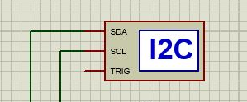

Data in 24LC08N
Simulating the MOD device involved putting simulated data in to the 24LC08N this was in line to where the data is located and called from i2c on the MOD1023. Blue shows the IAQ data stored with in the 24LC08N black shows the BME280 data.
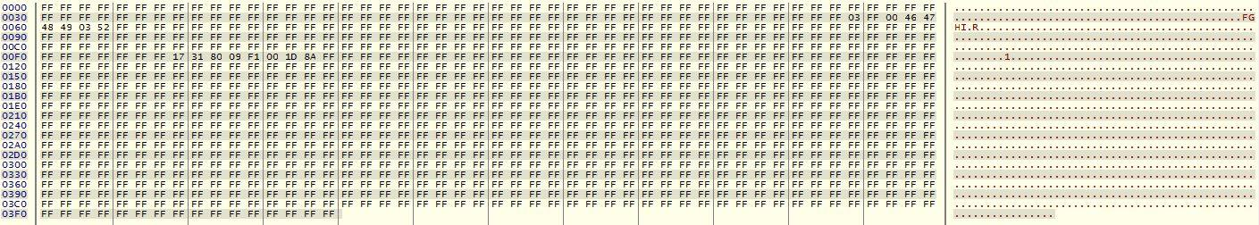

Calling the I2c
This show the outline coding for i2c used in conjunction with CCS compiler used in Proteus for simulation for more in-depth coding instructions please refer to chapter 8.

i2c_start (); this start the I2C with a start condition
i2c_write (0xB5); This Calls the IAQ core
i2c_read (1); reading i2c data on address 0xB5 this is sent with an acknowledgement
i2c_read (0); reading i2c data on address 0xB5 this is sent with a not acknowledgement
i2c_stop (); ending the i2c transmission

USB/SD
Extra features such as SD card slot and USB slot for data transfer to pc have been added to the simulation but have not been programmed for lack of time. But give this project to the ability to be a fully functioning product.
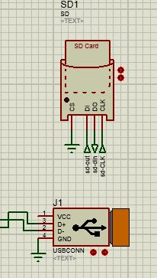

Voltage regulator
3.3v voltage regulator controller power thought this design power all aspects apart from the screen that is powered by 5vs this was aimed to keep power consumption low this protects all components from not being overloaded. This project is using UA78M33CKS that work just like an LM7803.
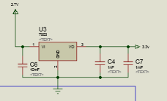

Operations of simulation
Stepping though the functions of the simulation will show how the simulated code interacts with components.
- The code will start by first Showing the user a start-up screen and setting the power LED to on.
- It call data from the Simulated 24LC08N EEPROM component via i2c (where data has been input in correct locations to correlate with both the IAQ and BME sensor datasheets)
- This data is converted from bits to CO2data = byte0 *2^8+ byte1
- The device checks to see if the IAQ is sending true data (this device take 5 minutes to start up) if true or false it will show the user.
- All converted data is shown, and the user is told if IAQ data is true or false.
- This program repeats from step 2

Design Block
A simple diagram setting out the basic set up schematic of how the product will look when in the implantation stage this shows the 5v input from the battery is used by the screen and then is being regulated down to 3.3 v powering the PIC and the MOD chip the arrows out of the bme280 represents the i2c data.
The screen is receiving all data from the PIC and will display it for the user.
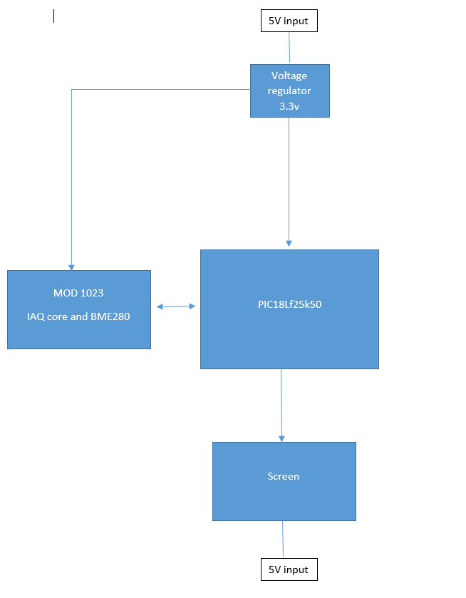

The design parts
Having an exact understanding of all parts need in this project gave the ability to fully understand the simulated design. Creating a list of all part and sensor need for this report before simulation allowed for research in to the respected datasheets and find simulated part that represented the final parts choices.

Analysis of Simulation
The simulation schematic shows all needed components for this project even adding extra features Such as SD, USB. This simulation was Programmed to Represent the final product Prototype this prototype did not include the SD, USB.
The simulation was able to Call I2c Results from the 24LC08N EEPROM that represented the MOD sensor chip. These results were saved into arrays this was to help with calling the I2c. These results were then Put though calculations and displayed on the LCD screen.
The Pic18lf25k50 worked very well in simulation able to easily handle the tasks needed for this report, with fast response time and multiple ports with many uses this Chip would be suitable for the most project and performed well through this project.
The warning LED and Power LED was also programmed into simulation and was tested by changing the inputted data from the 24LC08N these results were taken from the search in Chapter 3.
It was hard to Fully simulate this project as Proteus did not contain the BME280 and the IAQ core this made programming and finding the I2c Addresses of these devices quite difficult
Overall the Simulation shows that the core printable of this project would work in a simulated environment.

Background knowledge of simulation

I2c
The Figure below shows the I2C interface module in both modes master mode and slave mode these diagrams explain in greater detail of the all the processes that are contained in i2c interfacing
I2c normally supports up to 7 to 10 bits addressing with interrupts Start and Stop function
I2c Send read and write data from master to slave and from the slave to the master this ability to talk to each other give the control over data and device function. Being able to talk and call commands allows i2c to have multiple devices on one data bus. [77][78][48]
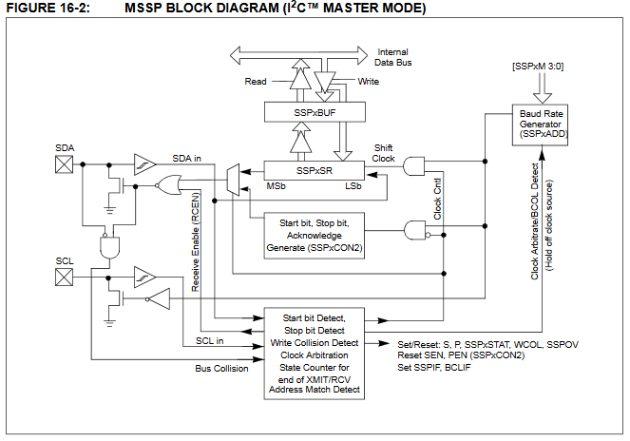
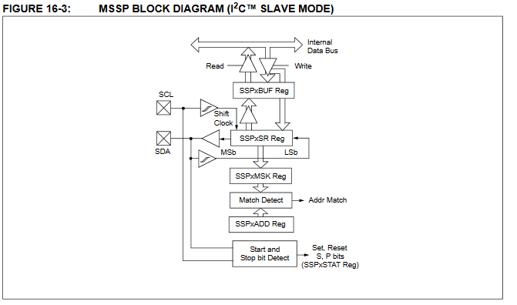

Pic18f45k50
This diagram shows the general design of the pic18(l)45k50 in block diagram format this makes it a lot easier to see all the function contained in this device and how they correlate with each other.[78][48]
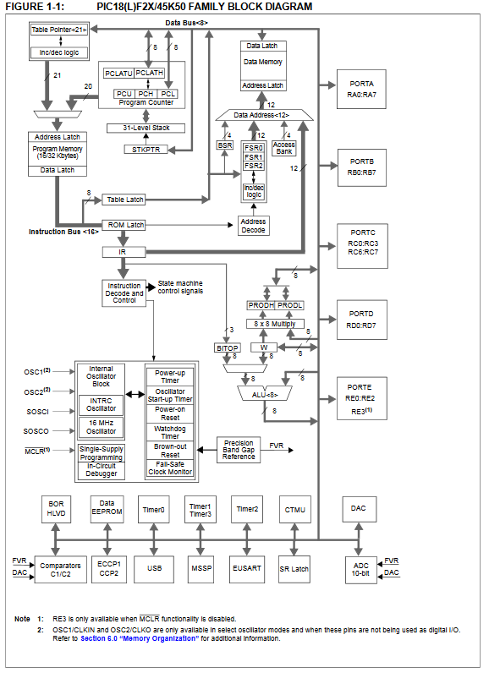 [78]
This Pic contains a lot of advance feature and is using the advance universal bus for fast operations. Some of the features that are used in this Pic for this project is SPI, I2c, Digital-to-Analog Converter (DAC), 10-Bit Analog-to-Digital (A/D), USB2.0, RS-232, operating voltage 3V to 5.5V, Flash Program Memory of 10,000 Erase/Write Cycles Minimum and 20-year Data Retention [4].

ADC Configuration
Analog to Digital Converter (ADC) Take an analogue input signal such as a current or voltage than that model t converts that Analog signal into a digital code(binary) and So that data can be used by The Microcontroller.
The diagram below shows a 10-bit A/D converter within a PIC18 it is possible to see the Switching effect of each pin to activate the A/D and show that input goes into the A/D Vain. [79], [80] [48]

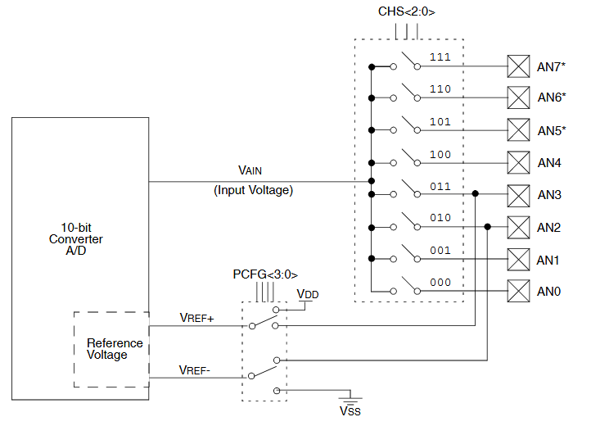[80]

Ergonomics
Keeping the device Portable and small would allow the device to be worn as a necklace, wristband and broach this would make the product easier to blend into everyday life. Making, sure enough, air to get the sensor is vital to the product is not to be cover by clothing it should be open to the elements.
The product would come with a dock to hold the device when in a home environment this would allow it to charge and collect data from the home environment assisted by a small fan to keep airflow over the sensor.
- Keeping the device Portable and small would allow the device to be worn as a necklace, wristband and broach this would make the product easier to blend into everyday life. Making, sure enough, air to get the sensor is vital to the product is not to be cover by clothing it should be open to the elements.
- The product would come with a dock to hold the device when in a home environment this would allow it to charge and collect data from the home environment assisted by a small fan to keep airflow over the sensor.

Calculation
I2c Calculation are used to break down the many bits data is received in and change them to relevant vales

Humidity I2c calculation (convert to 16 bit value)
Humidity = (Databit6) x 256 + (Databit7) = FinalHumidityVaue

Pressure I2c calculation (convert to 16 bit value)
(Databit0) x 256 + (Databit1) x16 = pressureX
(Databit6) /16 = pressureZ
pressureX + pressureZ = FinalPressureVaue

Temperature I2c calculation (convert to 16 bit value)
(Databit0) x 256 + (Databit1) x16 = Temperature X
(Databit6) /16 = Temperature Z
Temperature X + Temperature Z = FinalTemperatureVaue

CO2 I2c calculation (convert to 16 bit value)
CO2 = (Databit0) x 256 + (Databit1) = FinalCO2eVaue

VOC I2c calculation (convert to 16 bit value)
TVOC = (Databit7) x 256 + (Databit8) = FinalTVOCVaue

Composite calculation of temperature and Pressure.
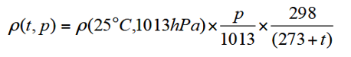

CHAPTER 7. Implementation

Introduction
After simulating the final design correctly and have the code running efficiently it was possible to move on to implementations and testing the final circuit with real components. The Pic18 was programmed in Proteus with the assistance of CCS compiler then Transferred to the PIC18 though PICkit this transfers coding to the PIC allowing for it to run simulated code in implementation environment. Figure 3 shows the final implemented design without the MOD 1023 connect though the SDA SCL Pin on the I2c.

Implementation design

Problems with Implementation
After reviewing all data sheet and simulated this project with it working when implementing this simulation Code. Issues arose with false data being read or no data at all be shown on LCD all other Bit of code seemed to be run as simulated When researching the IAQ core issues There was a small post about how problem with the original data sheet IAQ core Could mean the I2c address could not be as Stated 00x5A. The addresses that were needed for this project was the 00xB5. This resolved issues with the IAQ Data.
Another issue that was only found out in implantation was the need for a slow clock speed on the Pic18 this was needed to function with the i2c this was found out from reading back though the iAQ date sheets.
Invalid BME280 Data readings was an issue once loading simulated program to the microcontroller All other functions worked such as the IAQ core after changing addresses and slowing the clock speed but there was not getting any readings from the BME280 When finding issues with the BME sensor from research the I2c started up in a sleep mode it was give the data 00 80 00 00 80 00 00 this was the sleep mode data coming though this showed that the BME sensor was work correctly but was just set in a sleep mode this was not able to be programmed as a time restraint if this report if the BME280 was in the Proteus library this issues would have been found out in the simulation stage leave more time for testing and implementation. So, the bme280 issues were identified and could have been resolved.

Testing
Testing the final prototype was needed to prove that the IAQ sensor was able to measure a change in CO2 and VOCs. All aspect Of the Sensor chosen were planned to be tested but with the BME280 not functioning Humidity pressure and humidity was not able to be tested at the beginning of the project goals was set for testing that was as following

- All the sensors used in this device will be tested.
- The humidity and heat will be cross-referenced with another device that already been calibrated.
- VOC is a bit harder to test and this will be tested by using a board mark that contains VOC being blown over the sensor
- For CO2 I will hold my breath creating more CO2 and breath over the device this will show a spike reading of CO2.

Factors of Errors were investigated though research and by using the prototype in a different environment some factors of errors as following.
- Factors that could influence air quality changes and produce anomalies in results and errors.
Semiconducting metal oxide sensor has many issues when used in a portable device in the outdoor environment some cross-response to outdoor factors are caused by
- humidity fluctuations
- airflow (e.g., wind)
- Temperature
To avoid this, we investigate the effect of airflow and other effects on the sensor reading once calibrated. This is also coved in the stability and control of a metal oxide gas sensor.

Testing the IAQ core
When testing the IAQ core, there was need to see a change in VOC and CO2, which was relevant to the project.
At a base line the IAQ sowed reading of CO2e 450 TVOC125
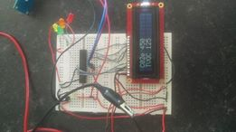
When leaving the product by a window that was allowing fresh air in the base line reading of the IAQ core was CO2e 450ppm and TVOC 125ppb the are the lowest results being able to be taken from this product and shows that there is excellent air quality.
Next, it was planned to move the IAQ core in to the middle of a room close all windows and wait an hour for CO2 and VOC build up.
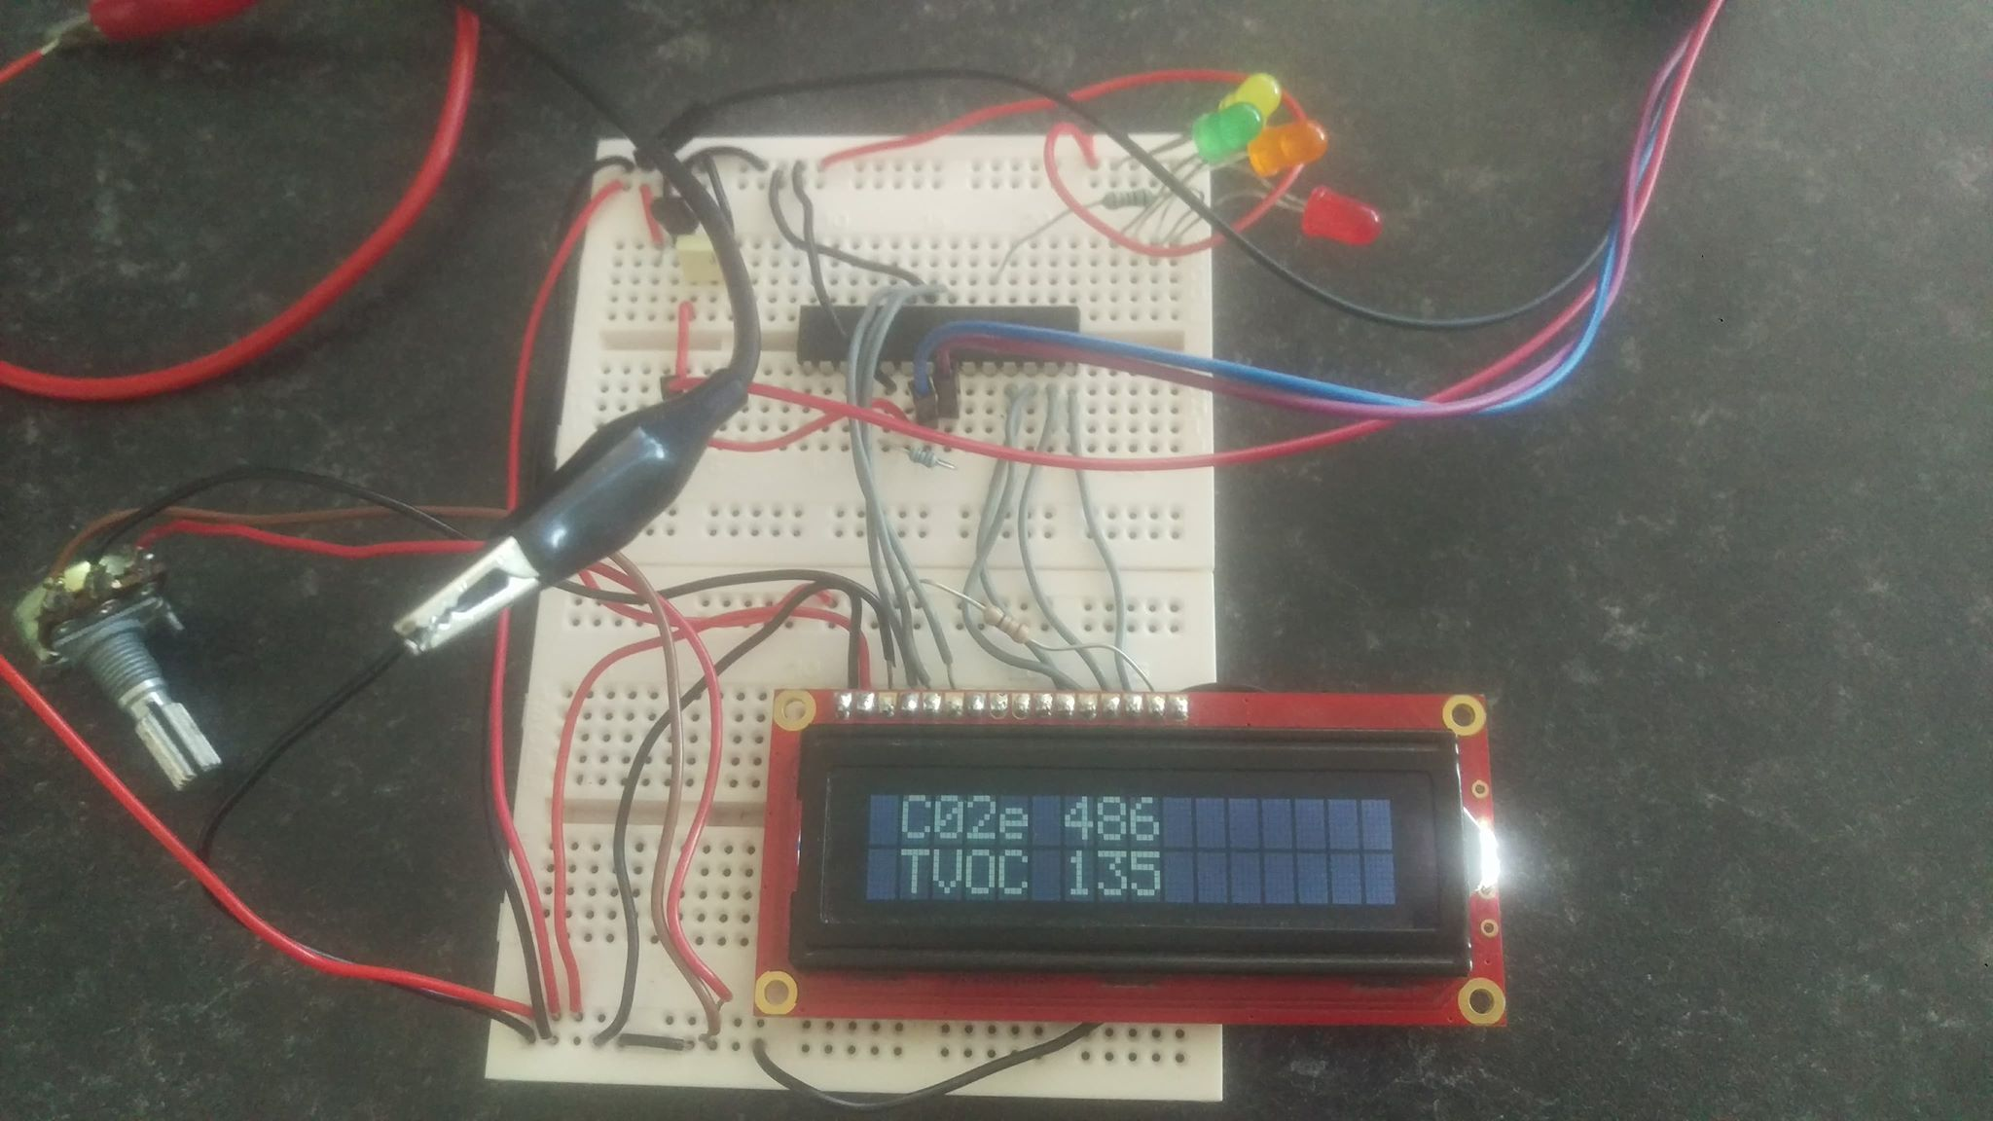
Showed here is a change in CO2 and VOC relevant to the readings wait an hour for reading to build up in the room shows that CO2e has increased to 486ppm and TVOC to 135ppb still at a safe level.

Next it the project it was vital test if the project could handle large amount of CO2 and V0Cs.
After having a cigarette, I then blew on the IAQ filter directly this gave large reading
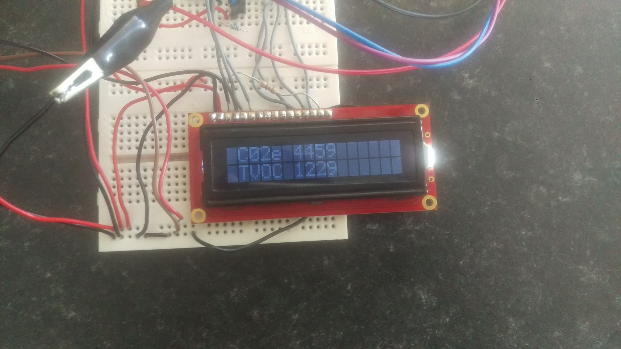
This shows a dangerous level of both CO2e at 4459ppm and 1229ppb TVOCs, these results come from the CO2 from my breath and the benzene from smoking on the VOCs. After waiting 50 seconds, the next reading on the IAQ showed a dissipation of both VOC and CO2, over time bring results to CO2 2358ppm and TVOC 651ppb.
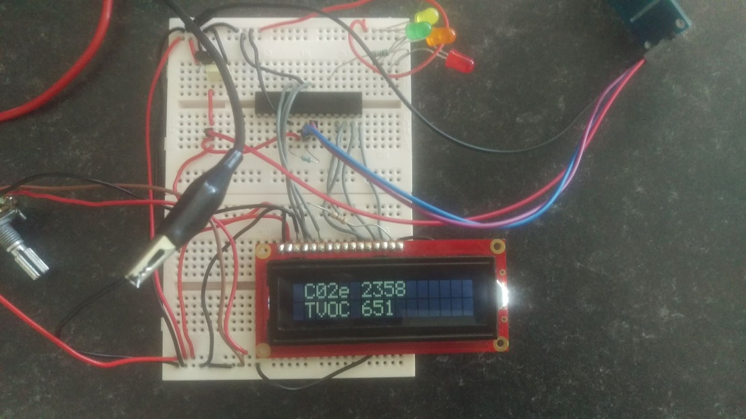

Testing the BME sensor was not possible as it was not functioning, it was possible to see the device in sleep mode showing it’s just the bme280 being in sleep mode stopping this project from meeting its full goals when BME280 is in sleep mode it transmits 808000008000800 this is shown in figure 1,2,3,4 in appendices.
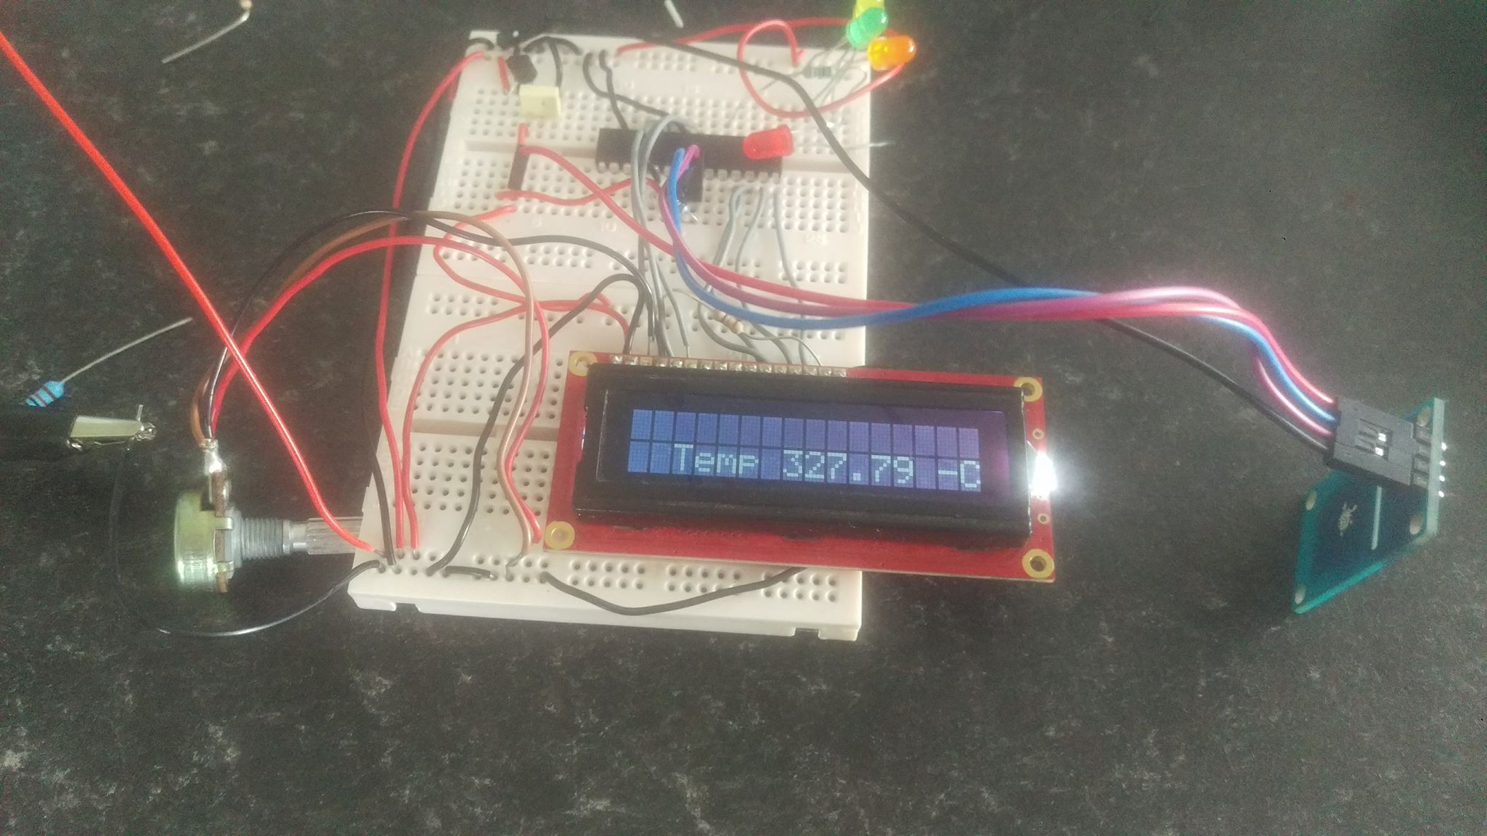
This is showing the BME transmitting false data
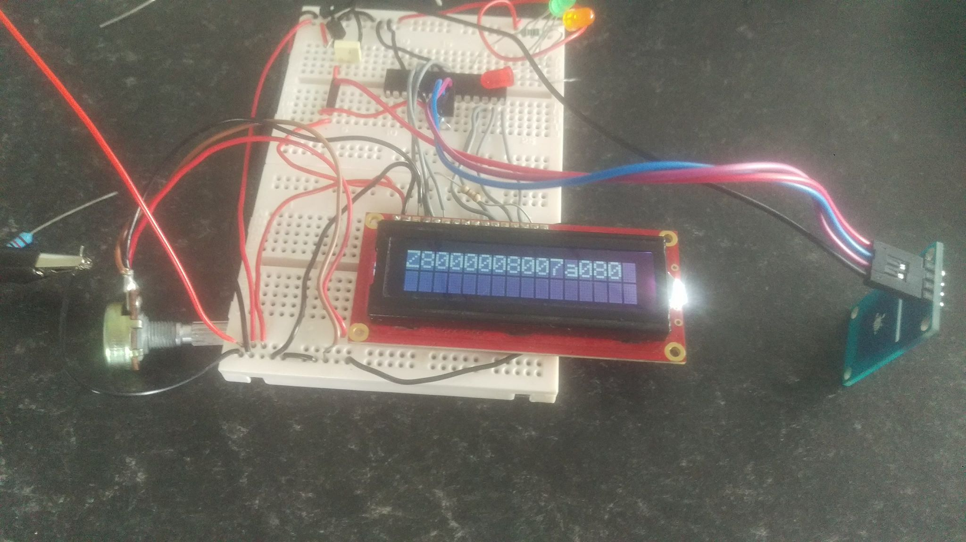
This proves that data is being read from the bme280 but is sending only sleep mode data back.

Results of testing
From testing the IAQ in different environments and focusing high reading it simple to confirm that all results do relate to CO2 and VOC levs in line with the IAQ core Data sheet. Without testing, these results we would have no data to confirm that they are related the specified Values.
Without the BME280 sensor, it would not be possible to use this product in an outdoor environment, as molecular density of gas laws were not implant, this would of brought down the factors of errors caused when air quality sensor are use outdoors.
The IAQ core tested as expected give good results on related vales caused by indoor factors, this device would be able to measure dangerous CO2 and VOC levels as showed when large amount of these gasses are directed at the sensor.
The LED light that are there for safety levels were then tested to their vales all these correlated to programmed vales this was not shown in Photos as it was implemented on the second testing stage.
Red LED High levels of CO2e 1800ppm and above
Red LED High levels of TVOC 1500ppb and above
Yellow LED Mid-levels of CO2e 1000ppm and above
Yellow LED Mid-levels of TVOC 500ppb and above
Low levels are anything under these values and will show as green

Testing results over the hour ever 20 minute
time | C02e | TVOC | Concisions
0 | 450ppm | 125ppb | Room was aired then windows closed
20 | 562ppm | 136ppb | 3 people in the room after 20 minute
40 | 591ppm | 152ppb | 3 people in the room after 40 minute
60 | 650ppm | 159ppb | 3 people in the room 60 minute

All door was keep closed for the experiment to work this showed an increase of Both VOC and CO2 over time.
A smaller room was then chosen without windows for testing the door for this room was left open for hour before testing to make sure results are fair.
3 people stayed in the smaller room for an hour to show the effect a smaller area space and less ventilation on results this is shown in figure 5 in appendices.

Evaluation Board

Prototype simulation
The simulation of this project was able to give a better understanding of how all component interacts and behaved. The final simulation was able to read all data from the I2c devices and display it effectively all indicator responds to change in results with a clean program flow with data being updated every second. The simulation shows that this project can effectively read i2c results from an I2c device having the knowledge to understand how i2c interacts and addresses itself is fundamental to this report. Effective aids such as an I2c debugger and I2c registry reader advanced the observation of I2c infecting without being able to simulate these Responses it would have been impossible to creed the final porotype bored. The downside to simulation was it not having the BME280 and IAQ core device already build within Proteus if this was in the liberty of Proteus we could say simulation matches prototyping. But a chip called the 24LC08N was used to simulate the reading from the sensors this caused errors in prototyping stage of I2c not being interfaced correctly in prototyping.

Prototype Board
The final board achieved basic implantations by being able to detect VOC/CO2, this was the fundamental outline for this report. Not achieved activation of the BME280 to show any data did affect the final devices performance as molecular density of gas laws could not be implemented, to correct errors. Thus, this device did not the ability to be portability used as a chance in pressure or CO2 could affect reading dramatically. If this device worked as planned this device would be able to handle this portability aspect.
The final schematics for this project show the achievement of low power consumption and a small confirmation this was made to interlink with portability the screen was the bulkiest item in the final prototype and would be replaced with a smaller screen when fully developed.
After building the simulation components on a Breadboard Prototyping Board it was possible to observe the prototype using a 5v power supply at first all simulated code seemed to be working well apart from false data results from the I2c components of the device after further investigation the address for IAQ core and BME280 was not correct after entering new addresses and uploading them to the pic the IAQ core and BME280 was able to show data accurately.
The prototype board was a fundament stage to this report, giving insight to how a finished product could help people suffering in harsh VOC/CO2 areas. With a few issues of human error that was corrected the final prototype was able to show VOC and CO2 results informing the user of levels with screen and indicators.

Expenses and Parts

CHAPTER 8. Programming

Code discussion
This project has made all coding in Proteus with the assistance of CCS compiler this project was aiming to display all data from Chosen sensors on an LCD screen. Background research was done on how I2c Coding practices and using CCS compilers help files.
When calling i2c there a few steps to be taken depending on the product being used datasheet may vary.
First, a Start bit is sent
Second, the Device address is call
Third Read sensor data
Fourth send the last reading without Acknowledgment
Fifth send a stop bit
This combined with LCD display, Warning light and composite calculations build are a coding structure.

Outline of further programming.
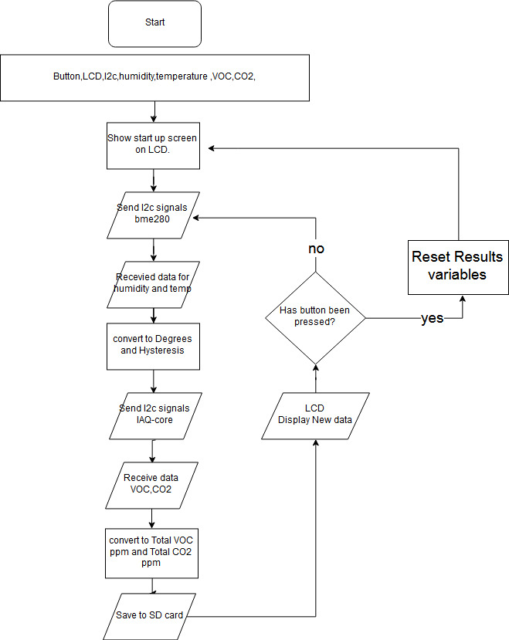
Planning for further development for this project is need by time restraint of Committed Deadlines These show further features that can be implemented such as SD card, saving data and Button Reset, Implmenting the BME sensor.

Current flow chart
The current flow chart shows how the code flows in the final prototype without the extra features that could be implanted by following the steps above.
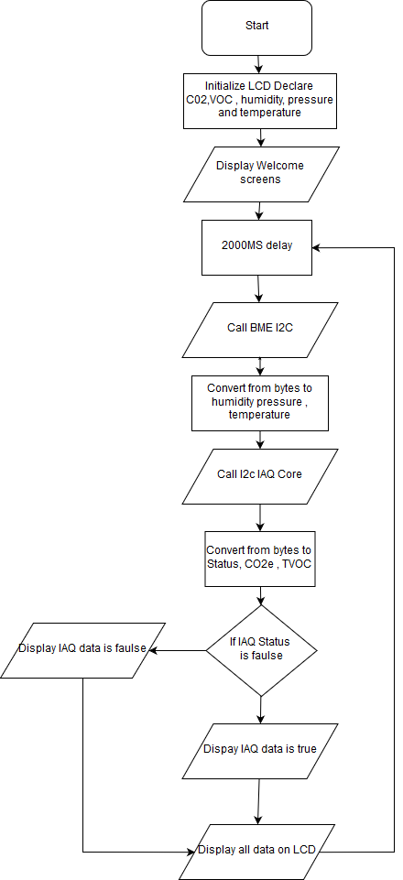

All code can be found in the Appendices with annotation of how the programming code interact with the PIC18LF25k50 and corresponding sensors. This will show in detail how the I2c operated and interacts with the chosen microcontroller converting all data to 16 bits after reading the i2c data. And displaying air quality data.

Programmed Safety levels LEDs
There are hard set levels in programming, setting out basic safety levels they provide an outline of how damaging the air quality around us, these come in different colours of LEDs, for the user interaction.
RED (Dangerous Within (under an hour))
Yellow (Dangerous Within (5 hours+) avoid heavy air intake)
Green (Breath Safe)
These predetermined levels taken from research are to give someone who has limited knowledge of safe levels of VOCs or CO2 the ability to take control of their Air Quality conditions.

How the I2c is called
This shows how the I2c data is being called in the programming. Showing all conditions (start/I2C write/ i2c read / stop)
i2c_start(); // send start condition
i2c_write(0x5B); // point to first address
for (q=0;q<7;q++)
{
data[q]=i2c_read(TRUE); // read sequential bytes with acknowledge
}
data[q]=i2c_read(FALSE); // read final byte without acknowledge
i2c_stop();

CHAPTER 9. Evaluation

Project Evaluation
This project was created for initial from research in to how CO2 can kill people premature like in London, which estimated that 9,416 premature deaths were caused by air pollution in London alone. This report chose to informed people on air quality and from this research create a detect device.
The objective set-out in this report was not full achieved but the basic outline was informing people and developing a CO2/VOC detection device. The BME 280 was not integrated fulling having issues with its communication though I2c.
Overcoming the difficulties of working with I2c was one of the biggest challenges for this project. This challenge was overcome through researching, simulation and implementation the way I2c transmits its data can be difficult to program without background knowledge of datasheets and I2c techniques. The project is on the right path to it final development stage of PCBing without time constraints this report could outlay the creating of a final consumer product. Getting to the prototype stage was the goal of this report not to create a final product just to outlay its fundaments aspects and workings. This project could help saves with its detection and interacting methods of informing the user of Dangerous levels the prototype succeeded in this by being able to read any change in CO2 and V0C. The BME280 sensor is not calibrated to the CO2 and V0C yet so the device only works effectively within indoor areas and no case for the project has been built to protect for wind tempura and peruse changes this would also minimize outside factors giving fault readings
Testing the VOC/CO2 went as planned this was needed to show that a response was being made to alteration of these items in the air. Testing went as expected showing both fluctuations in CO2 with by breathing on the IAQ sensor and blowing a marker containing VOC over the device These response cross referenced with datasheets and air quality research show that this device would be able to protect from over exposure to high amount of CO2 and VOC when exposing the sensor to test methods hazard light work as expecting informing the user bad air quality been detected.
However, reading from the IAQ core were stable creating the outline of air quality device this established the goal of developing an air quality detection device. Although the full operations of the Humidity, pressure and temperature was not completely implemented the project did archive its goal.

Further development
Further development of this device is can create a longer lasting more impacting device. Removing the power-heavy screen from this design and developed a smaller more efficient device one the device could create that missing link of a screen. through Bluetooth or WIFI wirelessly transmitting its data to a phone. Giving a wireless ability was given it could see this product controlling smart homes or air conditioning within buildings.
When this product is left in a home on a table it might not be getting effective air flow to give correct reading being able to use this device on the go and at home give people more place they can be testing their environmental data lowing risks.
Using a pump or fan with this design could help with stagnant air gathering around the device and the ability to have a more wider range of detection.
Making sure this project Fits in a case that is best for it reading, ruggedness, portability is one of the further deployments that would be needed if it was to be used in the outdoors.
this project could add many more environmental sensors with more wider ranges of industry standard product, but this product is based on a broader understanding of CO2 not exacts measurements if this product was created for more industry standard the IAQ chips would have to be changed to the IR technique used in the CozIR LP sensor in Chapter 5 this would increase size and power consumption.
Making this device into a smaller package can help with it portability and functionality this can be done by using Application Specific Integrated Circuit (ASIC) This can lower cost in the long run but increases prototype cost.

Project management (Time management)
Good time management give the ability to keep this project on task, there were a few variations due to coming across more difficult coding error and implantation delays with code not being able to be fully simulated in Proteus, which did put this project a little behind but, this project was able to catch up as planned error time that was taken in account in preparing for this project

The above Gantt chart show the final timings of this project Showing, with testing/coding being only at 90% complete as the BME sensor is stuck in sleep mode. All other sections have been completed on schedule, with the poster and viva to be finished after report has been hand-in so only 50% complete.

CHAPTER 10. Conclusion

Project Conclusion
In conclusion, the main requirement for an air quality detection device was achieved in this project. As programming for the BME280 is still an ongoing problem that needs to be resolved, apart from this, the project meet the basic specification that was planned and has worked effectively.
This report has overviewed many areas of CO2 levels and VOCs. From the beginning of this report, one of the fundament aspects was to create a device that would be able to help people acknowledge and act on dangerous levels of CO2 and VOC exposure. This has been set out through researching, design, simulating and protyping. From this, the report has set out the full potential of a potable air quality device. From research, it had been easy to observer and understand the risk of CO2 and VOC, this knowledge has been implanted in LEDs, which show hazardous air quality levels, which have been deeply investigated, and are up held by many agencies.
The IAQ and BME 280 both utilize I2c, this sends read and write data from master to slave, and from the slave to the master, this ability to talk to each other gives the control over data and device function.
The ability to code I2c was one of the biggest challenges faced when designing, simulating and developing this project. Issues caused with reading data from I2c in the implantation section was a large obstacle to overcome, postponing the testing and PCB stages.
The IAQ datasheet being wrong gave unseen set-backs throughout the entirety of the project. The IAQ datasheet had set the I2c address wrong, after further research in to issues with IAQ core the answer of I2c address was found 00xB5.
Learning idle air laws, and how pressure and temperature can cause errors when dealing with air quality gave this project the ability to make this device portable, without these laws this device would not be precise at reading CO2 and VOC with fluxing pressure and temperature.
The final prototype device created in this project did not fit its full role of portability, it was able to measure VOC and CO2, but not with assistance of idle laws as the BME280 device would not seem to function after testing the device with Arduino, it was observed that this issue occurred due to a lack of knowledge with regards to imbedded C.

Project recommendation
Many extra features can be achieved in this air quality device, some features have already been added to simulation but not activated by programming, which are as following;
- Adding an SD card programming and implantation could give the device the ability to save environmental data.
- Adding a USB port would allow for the transferal of saved data from the SD card to PC
- Wirelessly transmitting data to a smart phone device, which would allow for user accessibility and the ability to share the data that you have collected with others.
- A sensor with a wider range would mean that the device would be more suited for industry, however this would make the device bulkier.
- Implementing composite calculation to correct errors created by temperature and pressure.
- Intergrading a smaller screen making the product more portable, hence more appealing to users.

Reflection
Researching CO2 and VOC levels around the world and their health effect that are related to these dangerous gasses progressed understand and outlined the need for air quality sensors system. The objectives set out at the start of this project was to be able to inform people about their air quality and give them a device that would be able to detect these gasses
When advancing though the designing of this project keeping to the full objectives of this report seem to be challenging. But after research many other design and gas detection techniques, applying these basic fundamental of the set-out objectives as quite straight forward. At the beginning of this project, there was no understanding on the functions of air detection devices but after researching inferred techniques and micromachined metal oxide semiconductor techniques and understanding on how these devices could detect particles in the such as CO2 and VOCs.
Dealing with I2c communications had its issues as never previously working with this data bus in much detailed before created gap in knowledge. From this report, a larger understanding about i2c and how communication from the slave to the master or from the master to the salve functions. Knowledge of coding in I2c has drastically improved in the last few months.
Progression on the knowledge of programming language used in conjunction with Proteus assisted by CCs C compiler, giving this project the ability to simulate many function and coding before implantation.
If the needed components are present within Proteus then there are massive advantage, this is as most implantation issues will be spotted in simulation. But as some components that are used in this project are not contained in the library other relevant simulation parts had to be used in place of the BME280 and the IAQ core this caused issues with implantation.
Simulation worked reaching all objectives for this project being able to apply molecular density of gas laws with data being reived from the BME280 giving results more stable results and the ability to be portable as the device would not be affected by a change in pressure and temperature
Solving issues with the I2c communication involved creating a program in Arduino which would identify the addresses for the BME280 and the IAQ core this confirmed that the I2c addresses were correct. The solution to solving these issues was found out to be the clock speed of the PIC18LF25k50, which was set to high, and had to be changed to low, after this the IAQ function as expected but the BME280 was stuck in sleep mode.
The final prototype was able to measure a change in VOC and C02 levels, these functions were tested to best of possibilities. If more funding was available, this project would have been tested more intensely to check accuracy. All identification lights functions showing a range of air quality levels and a power light to show that the device is operating this all-in conjunction with a screen reach the object to create a device that would display air quality and give the user an understanding of the air quality in simple, user friendly way.
Creating this report has given a clearer understand of how air quality can have major life effects. Goal one of this project was to advice people on what good and bad air quality was and how to reduce their effect, this was a success in this project laid out in chapter 3.
Creating a device that would be able to detect air quality was goal two, this was a success with the IAQ core providing reading of VOC and CO2. Without these reading from the IAQ, none of this project would have correlated, as there would be no way to detect air quality.
Making the device portable was near implementation that would have created the success of last objective in the report, as reading was need from the bme280 to keep the IAQ core results stable when changing environments this device was stuck in sleep mode, more coding was need for full functions giving the ability apply molecular density of gas laws.
This report has been very insightful with regards to developing existing skills, such as schematic design and MOS sensors, as well as gaining knowledge on such as embedded programming and I2C. Furtherly, the project has provided awareness of current CO2 and VOC levels, and the impact of these upon health. The project has been successful, with a majority of its goals being met, however time constraint was problematic, which lead to issues with the BME280 being stuck in sleep mode. Overall, this study has been stimulating and has given the interest to develop further health related products.

Referencing
[1] “Polluted air causes 5.5 million deaths a year new research says - BBC News.” [Online]. Available: http://www.bbc.co.uk/news/science-environment-35568249. [Accessed: 02-Oct-2017].
[2] “WHO | WHO releases country estimates on air pollution exposure and health impact,” WHO, 2017.
[3] Josh Gabbatiss Science Correspondent, “Cleaning products as bad for lungs as smoking 20 cigarettes a day, scientists warn | The Independent,” independent, 2018. [Online]. Available: https://www.independent.co.uk/news/health/cleaning-products-lungs-damage-cigarettes-smoking-20-day-scientists-warning-a8214051.html. [Accessed: 19-Apr-2018].
[4] “BME280.” [Online]. Available: https://www.bosch-sensortec.com/bst/products/all_products/bme280. [Accessed: 19-Apr-2018].
[5] Novair Medical, “Quality standards and regulations - Medical air.” [Online]. Available: http://www.novairmedical.com/medical-air/quality-standards-and-regulations/. [Accessed: 19-Apr-2018].
[6] co2meter, “CO2 Meter - CO2mini CO2 Indoor Air Quality Monitor - CO2 Meter by CO2Meter.” [Online]. Available: https://www.co2meter.com/products/co2mini-co2-indoor-air-quality-monitor. [Accessed: 19-Sep-2017].
[7] “Extech CO250 Indoor Air Quality Meter - Carbon Dioxide Tester.” [Online]. Available: https://www.test-meter.co.uk/extech-co250-indoor-air-quality-meter/. [Accessed: 19-Aug-2017].
[8] “Gas Sensors Aeroqual Series 500 Monitor with Sensor Head - Gas-Sensing.com.” [Online]. Available: http://www.gas-sensing.com/aeroqual-series-500.html. [Accessed: 02-Apr-2018].
[9] “Atmotube Is A Tiny Pollution Sensor That Clears Up What’s In The Air You Breathe | TechCrunch.” [Online]. Available: https://techcrunch.com/2015/11/16/atmotube-is-a-tiny-pollution-sensor-that-clears-up-whats-in-the-air-you-breathe/. [Accessed: 19-Aug-2017].
[10] “E Instruments AQ VOC Indoor Air Quality Monitor for the IAQ Professional | OneTemp.” [Online]. Available: https://www.onetemp.com.au/aq-voc. [Accessed: 02-Apr-2018].
[11] Matt McGrath Environment correspondent, “Record surge in atmospheric CO2 seen in 2016 - BBC News.” [Online]. Available: http://www.bbc.co.uk/news/science-environment-41778089. [Accessed: 19-Apr-2018].
[12] Elena Cavallone, “Dutch show the way to deal with climate change | Euronews.” [Online]. Available: http://www.euronews.com/2017/11/16/dutch-show-the-way-to-deal-with-rising-sea-levels. [Accessed: 19-Jul-2017].
[13] Government of Netherlands, “climate-agenda-resilient-prosperous-and-green.” [Online]. Available: https://www.government.nl/binaries/government/documents/reports/2014/09/24/climate-agenda-resilient-prosperous-and-green-summary/climate-agenda-resilient-prosperous-and-green.pdf. [Accessed: 19-Apr-2018].
[14] “Measures to reduce greenhouse gas emissions | Climate change | Government.nl.” [Online]. Available: https://www.government.nl/topics/climate-change/national-measures. [Accessed: 19-Apr-2018].
[15] “Dutch electric trains become 100% powered by wind energy | World news | The Guardian.” [Online]. Available: https://www.theguardian.com/world/2017/jan/10/dutch-trains-100-percent-wind-powered-ns. [Accessed: 19-Jul-2017].
[16] F. Zeman*, “Energy and Material Balance of CO2 Capture from Ambient Air,” 2007.
[17] “Vertical Gardens in Mexico a Symbol of Progress - The New York Times.” [Online]. Available: https://www.nytimes.com/2012/04/10/world/americas/vertical-gardens-in-mexico-a-symbol-of-progress.html. [Accessed: 19-May-2017].
[18] Unfccc, “ADOPTION OF THE PARIS AGREEMENT - Paris Agreement text English.”
[19] “ADOPTION OF THE PARIS AGREEMENT,” 2015.
[20] “UK ratifies the Paris Agreement - GOV.UK.” [Online]. Available: https://www.gov.uk/government/news/uk-ratifies-the-paris-agreement. [Accessed: 19-Jul-2017].
[21] “The UN Climate Change Summit What does the Paris Agreement mean for the UK?”
[22] “City cyclists are at increased risk from lung injury from inhaled soot, study finds -- ScienceDaily.” [Online]. Available: https://www.sciencedaily.com/releases/2011/09/110925125145.htm. [Accessed: 19-Apr-2018].
[23] “Carbon Dioxide | Wisconsin Department of Health Services.” [Online]. Available: https://www.dhs.wisconsin.gov/chemical/carbondioxide.htm. [Accessed: 19-Apr-2018].
[24] “Sick building syndrome - NHS.UK,” NHS.UK. [Online]. Available: https://www.nhs.uk/conditions/Sick-building-syndrome/. [Accessed: 19-Apr-2018].
[25] S. A. Rice, “HEALTH EFFECTS OF ACUTE AND PROLONGED CO 2 EXPOSURE IN NORMAL AND SENSITIVE POPULATIONS *.”
[26] “Climate Change: Vital Signs of the Planet: Record annual increase of carbon dioxide observed at Mauna Loa for 2015.” [Online]. Available: https://climate.nasa.gov/news/2413/record-annual-increase-of-carbon-dioxide-observed-at-mauna-loa-for-2015/. [Accessed: 19-Jul-2017].
[27] S. C. Lee and M. Chang, “Indoor Air Quality Investigations at Five Classrooms,” Indoor Air, vol. 9, no. 2, pp. 134–138, Jun. 1999.
[28] J. Al-Hubail and A.-S. Al-Temeemi, “Assessment of school building air quality in a desert climate,” Build. Environ., vol. 94, pp. 569–579, Dec. 2015.
[29] P. Hunter, “The impact of CO2. The global rise in the levels of CO2 is good for trees, bad for grasses and terrible for corals.,” EMBO Rep., vol. 8, no. 12, pp. 1104–6, Dec. 2007.
[30] M. Brander, “Greenhouse Gases, CO 2 , CO 2 e, and Carbon: What Do All These Terms Mean?”
[31] O. US EPA, “Volatile Organic Compounds’ Impact on Indoor Air Quality.”
[32] Young Min Kim, * and Stuart Harrad, and R. M. Harrison, “Concentrations and Sources of VOCs in Urban Domestic and Public Microenvironments,” 2001.
[33] K. Smeltzer, “Volatile Organic Compounds (VOCs) in Indoor Air Health effects of VOC exposure.”
[34] S. S. Jamieson, S. Dimitroulopoulou, V. M. Brown, H. M. ApSimon, and R. N. Colvile, “Levels of Indoor VOCs in Workplaces in a Polluted Urban Area of London,” Indoor Built Environ., vol. 14, no. 3–4, pp. 259–268, Jun. 2005.
[35] “6 Easy Ways to Reduce VOC Exposure in the Workplace | Health and Safety News.” [Online]. Available: http://healthsafetynews.co.uk/entries/guidance/6-easy-ways-to-reduce-voc-exposure-in-the-workplace. [Accessed: 19-Apr-2018].
[36] “Volatile Organic Compounds (VOCs) in Your Home - EH: Minnesota Department of Health,” 2013. [Online]. Available: http://www.health.state.mn.us/divs/eh/indoorair/voc/. [Accessed: 25-Oct-2017].
[37] Ľ. Mečiarová, S. Vilčeková, E. K. Burdová, and J. Kiselák, “Factors Effecting the Total Volatile Organic Compound (TVOC) Concentrations in Slovak Households,” Int. J. Environ. Res. Public Health, vol. 14, no. 12, 2017.
[38] Nasa, “Gas Density.” [Online]. Available: https://www.grc.nasa.gov/www/k-12/airplane/fluden.html. [Accessed: 19-Sep-2017].
[39] “Density of Gases and Physical Property.” [Online]. Available: http://chemistry.elmhurst.edu/vchembook/123Adensitygas.html. [Accessed: 20-Apr-2018].
[40] P. Saunders,Mark and Tosey, “The Layers of Research Design,” 2012.
[41] M. Saunders, P. Lewis, and A. Thornhill, Research Methods for Business Students, 6th editio. Pearson, 2012.
[42] J. Phillimore and L. Goodson, “Outside of the Onion,” 2004.
[43] “SI1145 Digital UV Index / IR / Visible Light Sensor ID: 1777 - $9.95 : Adafruit Industries, Unique &amp; fun DIY electronics and kits.” [Online]. Available: https://www.adafruit.com/product/1777. [Accessed: 05-Jan-2018].
[44] “How infrared gas detectors work - EnggCyclopedia.” [Online]. Available: http://www.enggcyclopedia.com/2011/11/infrared-gas-detectors/. [Accessed: 19-Jul-2017].
[45] A. Dey, “Semiconductor metal oxide gas sensors: A review,” Mater. Sci. Eng. B, vol. 229, pp. 206–217, Mar. 2018.
[46] C. Wang, L. Yin, L. Zhang, D. Xiang, and R. Gao, “Metal oxide gas sensors: sensitivity and influencing factors.,” Sensors (Basel)., vol. 10, no. 3, pp. 2088–106, 2010.
[47] www.gassensing.co.uk, “CozIR LP ambient CO2 sensor.” [Online]. Available: https://www.gassensing.co.uk/products/ambient-air-sensors/cozir-lp-ambient-air-co2-sensor/. [Accessed: 27-Mar-2018].
[48] Ryan O’sullivan, “Ryan O’sullivan Past Research from other assignments.” .
[49] ams AG, “iAQ-core C.”
[50] “CO2 Meter - MISIR 5,000ppm CO2 Sensor - CO2 Sensor by GSS.” [Online]. Available: https://www.co2meter.com/products/misir-5000ppm-co2-sensor. [Accessed: 27-Mar-2018].
[51] “Figaro TGS 2602 -for the detection of Air Contaminants.”
[52] “TGS 2602 -for the detection of Air Contaminants.”
[53] “CO2 Meter - VOC Sensor Measures Paint Fumes, Smoke, other Odors - VOC - Volatile Organic Compounds by AppliedSensor.” [Online]. Available: https://www.co2meter.com/products/iaq-2000-indoor-air-quality-sensor. [Accessed: 19-Apr-2018].
[54] “Datasheet: iAQ‐2000 Sensor Energy savings.”
[55] “VOC Gas Sensor, air quality monitoring sensor, VOC Sensor- Winsen Electronics.” [Online]. Available: http://www.winsen-sensor.com/products/flat-surfaced-gas-sensor/wsp2110.html. [Accessed: 19-Apr-2018].
[56] “MS8607-02BA01.”
[57] “DHT22 temperature-humidity sensor + extras ID: 385 - $9.95 : Adafruit Industries, Unique &amp; fun DIY electronics and kits.” [Online]. Available: https://www.adafruit.com/product/385. [Accessed: 19-Apr-2018].
[58] L. Aosong ELectronics Co, “Dht22 (Am2302),” vol. 22, pp. 1–10, 2015.
[59] B. Sensortec, “BME280: Final data sheet BME280 Combined humidity and pressure sensor BME280 DIGITAL HUMIDITY, PRESSURE AND TEMPERATURE SENSOR,” 2014.
[60] “104642-1610 | Molex 104642 Series 8 Way Micro SIM, MicroSD Memory Card Connector with Solder Termination | Molex.” [Online]. Available: https://uk.rs-online.com/web/p/memory-sim-card-connectors/1213817/. [Accessed: 19-Apr-2018].
[61] “A-USBSA | ASSMANN WSW Right Angle Through Hole Type A USB Connector, Receptacle | ASSMANN WSW.” [Online]. Available: https://uk.rs-online.com/web/p/type-a-usb-connectors/6741325/. [Accessed: 19-Apr-2018].
[62] “2017 4-20ma / 0-5v / 0-10v Output Particle Counter Indoor And Outdoor Air Quality Monitor - Buy Air Quality Monitor,Pm2.5 Detector,4-20ma Air Quality Detector Product on Alibaba.com.” [Online]. Available: https://www.alibaba.com/product-detail/2017-4-20mA-0-5V-0_60640841816.html. [Accessed: 29-Dec-2017].
[63] “Basic 16x2 Character LCD - White on Black 5V - LCD-00709 - SparkFun Electronics.” [Online]. Available: https://www.sparkfun.com/products/709. [Accessed: 19-Apr-2018].
[64] “UA78M33CKC Datasheet(PDF) - Texas Instruments.” [Online]. Available: http://www.alldatasheet.com/datasheet-pdf/pdf/82058/TI/UA78M33CKC.html. [Accessed: 19-Apr-2018].
[65] “Home | Microchip Technology.” [Online]. Available: http://www.microchip.com/. [Accessed: 20-Apr-2018].
[66] “PIC16F1455 - Microcontrollers and Processors - Microcontrollers and Processors.” [Online]. Available: https://www.microchip.com/wwwproducts/en/PIC16F1455. [Accessed: 06-Apr-2018].
[67] “PIC16(L)F1454/5/9,” PIC16(L)F1454/5/9.
[68] “PIC18F14K50 - Microcontrollers and Processors.” [Online]. Available: http://www.microchip.com/wwwproducts/en/PIC18F14K50. [Accessed: 05-Jan-2018].
[69] “PIC18F2450/4450 Data Sheet.”
[70] “PIC18F25K50 - Microcontrollers and Processors.” [Online]. Available: http://www.microchip.com/wwwproducts/en/PIC18F25K50. [Accessed: 14-Nov-2017].
[71] “PIC18F45K50 - Microcontrollers and Processors.” [Online]. Available: http://www.microchip.com/wwwproducts/en/PIC18F45K50. [Accessed: 05-Jan-2018].
[72] “Embedded Adventures - Products - MOD-1023 BME280 AMS IAQ weather multi-sensor module.” [Online]. Available: https://www.embeddedadventures.com/bme280_AMS-IAQ_multi_sensor_mod-1023.html. [Accessed: 19-Apr-2018].
[73] ams AG, “iAQ-core.”
[74] “PIC18LF25K50-I/SS Microchip Technology | Integrated Circuits (ICs) | DigiKey.” [Online]. Available: https://www.digikey.com/product-detail/en/microchip-technology/PIC18LF25K50-I-SS/PIC18LF25K50-I-SS-ND/3671514. [Accessed: 20-Apr-2018].
[75] “Embedded Adventures - Products - MOD-1023 BME280 AMS IAQ weather multi-sensor module.” [Online]. Available: https://www.embeddedadventures.com/bme280_AMS-IAQ_multi_sensor_mod-1023.html. [Accessed: 06-Apr-2018].
[76] “IAQ-CORE C | ams IAQ-CORE C, Air Quality Sensor, I2C Maximum of 3.3 V dc 6-Pin | ams.” [Online]. Available: http://uk.rs-online.com/web/p/colour-light-sensors/1024162/. [Accessed: 28-Oct-2017].
[77] F. Leens, “An introduction to I2C and SPI protocols,” IEEE Instrum. Meas. Mag., vol. 12, no. 1, pp. 8–13, Feb. 2009.
[78] Microchip, “PIC18(L)F2X/45K50.”
[79] R. H. Walden, “Analog-to-digital converter survey and analysis,” IEEE J. Sel. Areas Commun., vol. 17, no. 4, pp. 539–550, Apr. 1999.
[80] D. Johns and K. W. (Kenneth W. Martin, Analog integrated circuit design. John Wiley & Sons, 1997.

Bibliography

Books
The Art of Electronics Third Edition by Paul Horowitz, Winfield Hill
Mastering the I2C Bus: LabWorX 1 Publisher: Elektor Electronics Publishing (15 Aug. 2011)
Practical Electronics for InventorsBook by Paul Scherz published: 2000
Nicollian, E.H., Brews, J.R. and Nicollian, E.H., 1982. MOS (metal oxide semiconductor) physics and technology (Vol. 1987). New York et al.: Wiley.
M. Siegesmund, Embedded C programming : techniques and applications of C and PICMCUS. .
N. Gardner and Custom Computer Services., PICmicro MCUC : an introduction to programming the microchip PIC in CCS C. Bluebird Technical Press, 2002.

Online articles
Bernstein, J.A., Alexis, N., Barnes, C., Bernstein, I.L., Nel, A., Peden, D., Diaz-Sanchez, D., Tarlo, S.M. and Williams, P.B., 2004. Health effects of air pollution. Journal of allergy and clinical immunology, 114(5), pp.1116-1123.
Boden, T.A., Marland, G. and Andres, R.J., 2009. Global, regional, and national CO2 emissions.
Kim, Y.M., Harrad, S. and Harrison, R.M., 2001. Concentrations and sources of VOCs in urban domestic and public microenvironments. Environmental science & technology, 35(6), pp.997-1004.
Daisey, J.M., Hodgson, A.T., Fisk, W.J., Mendell, M.J. and Ten Brinke, J., 1994. Volatile organic compounds in twelve California office buildings: classes, concentrations and sources. Atmospheric Environment, 28(22), pp.3557-3562.

Appendices

Figure 1
This shows the BME280 is in sleep mode this is shown by the retuned data of 800000800080 from the I2C communications
Figure 2
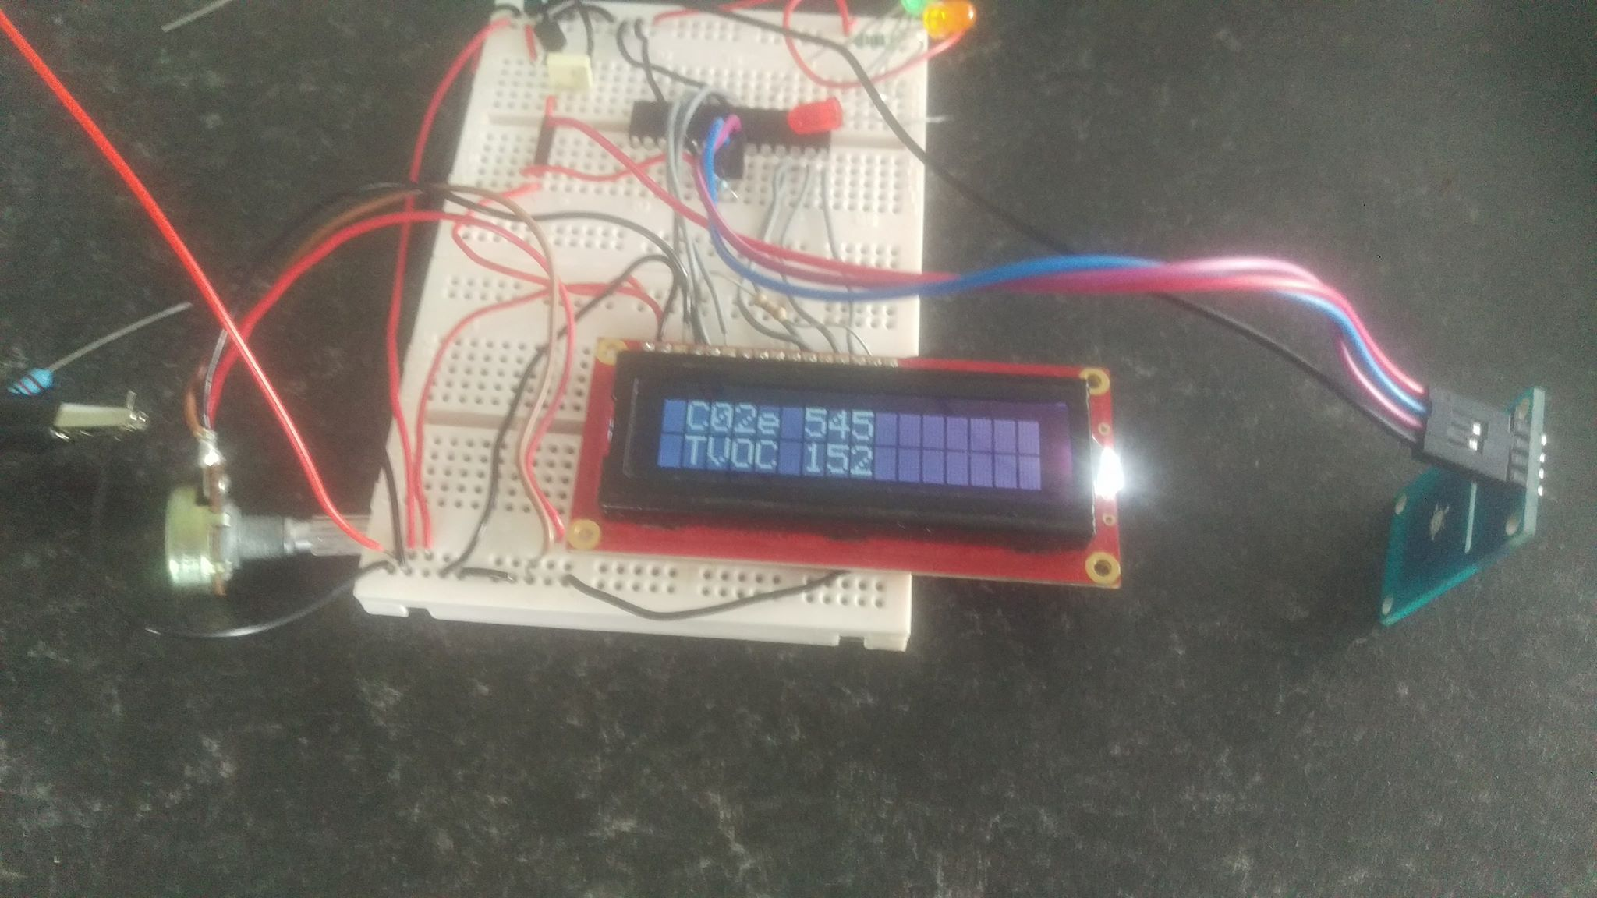
This shows the IAQ function as planned.
Figure 3

This show how the effect of the BME280 being in sleep mode had on readings giving false results

Figure 4
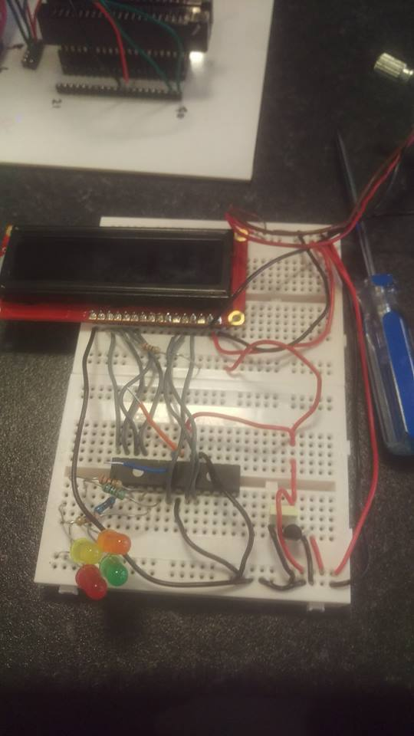
This show the final implement design without the MOD 1023 sensors connected.

SDA I2C
SCL I2C
PIC18fl25k50
Voltage regulator 3.3v
Screen I2C
Safety / power lights

Figure 5
This show the increase in C02 and VOC while there is little ventilation and small area space.
Smaller room with no ventilation test
time | C02e | TVOC | Condition
0 | 450ppm | 125ppb | Room was aired before use
20 | 605ppm | 139ppb | 3 people in the room after 20 minute
40 | 688ppm | 168ppb | 3 people in the room after 40 minute
60 | 752ppm | 187ppb | 3 people in the room 60 minute

Coding

#include <main.h>
#define LCD_ENABLE_PIN PIN_A7
#define LCD_RS_PIN PIN_A5
#define LCD_RW_PIN PIN_A6
#define LCD_DATA4 PIN_B4
#define LCD_DATA5 PIN_B5
#define LCD_DATA6 PIN_B6
#define LCD_DATA7 PIN_B7

#include <lcd.c>

#define CHIP_ADDR 0xB5 // define IAQ I2C address
#define READ_OK 0 // Define status ok for iaq
#define COLD 0x10 // Define status cold for iaq
#define BUSY 0x1 // Define status busy for iaq
#define ERROR 0x80 // Define status error for iaq
#define NOT_FOUND 0xA0v // Define status not found for iaq

void read_temp_device(void); // define subroutines
void read_C02VOC(void); // define subroutines
void status(void); // define subroutines
Void BMEreadings(void); // define subroutines

unsigned int data[10]; // sequential data from BME280 read from device
int Co2VOCdata[10]; // sequential data from IAQ read from device
long int q=0; // while loop variables
long int i=0; // while loop variables
long int x=0; // while loop variables
unsigned long int tvoc ; //IAQ TVOC Data
unsigned long int prediction; //IAQ C02 Data
char flag=3; //Flag variable
long long Humid=0; //BME280 Humidity
long long Temp=0; //BME280Tempture
long long Temp2=0; //used in calculation
long long presure=0; //BME280 presure
long long presure2=0; //used in callulation

void main() //Main Start

//The first section of Programing was used to Input the need data for the IAQ and BME in to a Simulated compnet.
//This section was not used in implenation.
//*************************************************************************
{
// BME350
/* i2c_start(); // send start condition
i2c_write(0xa0); // select and write to chip zero control
i2c_write(0xf7); // point to first address byte

i2c_write(0x60); // write to chip
i2c_write(0x00
); // write to chip
i2c_write(0x25); // write to chip
i2c_write(0x26); // write to chip
i2c_write(0x35); // write to chip
i2c_write(0x28); // write to chip
i2c_write(0x29); // write to chip
i2c_write(0x2a); // write to chip
i2c_stop();
delay_ms(50);

//*************************************************************************
/* IAQ simulation data input
i2c_start(); // send start condition
i2c_write(0xa0); // select and write to chip zero control
i2c_write(0x5b); // point to first address byte

i2c_write(0x43); // write to chip
i2c_write(0x44); // write to chip
i2c_write(0x45); // write to chip
i2c_write(0x46); // write to chip
i2c_write(0x47); // write to chip
i2c_stop();

delay_ms(50);

i2c_start(); // send start condition
i2c_write(0xa0); // select and write to chip zero control
i2c_write(0x60); // point to first address byte

i2c_write(0x48); // write to chip
i2c_write(0x49); // write to chip
i2c_write(0x4a); // write to chip
i2c_write(0x4b);

i2c_stop();

*/
//MAIN PROGRAM STARTS
//**************************************************************************

lcd_init(); //Start LCD screen
printf(lcd_putc,"\fPortable Air tester Start up"); // on LCD
delay_ms(500); //Delay
printf(lcd_putc,"\fConfigering settings"); // on LCD
delay_ms(1000); //Delay
printf(lcd_putc,"\f Co2e levels and TVOC"); // on LCD
lcd_gotoxy(2,2); //LCD Position
printf(lcd_putc,"valid after 5 mins"); // on LCD

delay_ms(1000); //Delay

//*******************************************************************************************

while(TRUE) //call Humidity Temp and Pressure from the BME280
{
read_temp_device(); // Go to read_temp_device
for(q=0;q<8;q++) // Do this for 9 readings
{
printf("%x ",data[q]); // Print results in on RX,TX for diagnostic reasons
}
printf("\n\r")

//********************************************************************************************

read_C02VOC();
for(q=0;q<9;q++)
{
printf("%x ",Co2VOCdata[q]);
}
printf("\n\r");
//*************************************************************************************
BMEreadings(); // do data calculations for BME

printf(lcd_putc, "\f");
lcd_gotoxy(0, 0); //First line of LCD reading Humidity
printf(lcd_putc," Humidity %Ld%% RH ",Humid);
delay_ms(2000);

lcd_gotoxy(1, 0); //Second line of LCD reading pressure
printf(lcd_putc," Presure %Ld hPa ",presure);

delay_ms(2000);

lcd_gotoxy(2, 0); //Third line of LCD read temp
printf(lcd_putc," Temp %Ld °C ",Temp);

delay_ms(1000); //Delay 1000ms
printf(lcd_putc, "\f"); //Delay 1s Clear screen
status(); //call IAQ core status

lcd_gotoxy(0, 0); //First line of LCD read C02
printf(lcd_putc,"\f C02e %Lu ",prediction);

lcd_gotoxy(1, 0); //Second line of LCD read TVOC
printf(lcd_putc," TVOC %Lu ",tvoc);
delay_ms(2000); //Delay 2000ms

//Light warnings
//******************************************************************
if (prediction>=1800) // C02 high risk
{
output_high(PIN_A2);
}
else
{
output_low(PIN_A2);
output_high(PIN_A1);
}

//Light warnings
//******************************************************************
if (tvoc>=1500) // TVOC high risk
{
output_high(PIN_A2);
}
else
{
output_low(PIN_A2);
output_high(PIN_A1);
}

//Light warnings
//*********************************************************************
if (prediction>=1000) //mid risk CO2
{
output_high(PIN_A4);
}
else
{
output_low(PIN_A4);
output_high(PIN_A1);
}

//Light warnings
//********************************************************
if (tvoc>=500) // mid risk TVOC
{
output_high(PIN_A4);
}
else
{
output_low(PIN_A4);
output_high(PIN_A1);
}

}
} //END of main void

//This section will Get the needed data from the BME280 Core though I2C
//****************************************************************************
void read_temp_device(void)
{
i2c_start(); // send start condition
i2c_write(0xec); // select and write to chip
// i2c_write(0xa0); // select and write to chip zero control (used in simulation testing line )
i2c_write(0xf7); // point to first address
i2c_start(); // send start condition
i2c_write(0xed); // select and read to chip
// i2c_write(0xa1); // select and write to chip zero control (used in simulation testing line )
for (q=0;q<7;q++)
{
data[q]=i2c_read(TRUE); // read sequential bytes with acknowledge
}
data[q]=i2c_read(FALSE); // read final byte without acknowledge
i2c_stop();

}

//This section will Get the needed data from the IAQ Core though I2C
//*********************************************************************************************************

void read_C02VOC(void)
{

i2c_start(); // send start condition
// i2c_write(0xa0); // select and write to chip zero control (used in simulation testing line
i2c_write(0x5B); // point to first address
// i2c_start(); // send start condition
// i2c_write (0xB5); // This was in reading out data in simluation (used in simulation testing line )
// i2c_write(0xa1); // select and write to chip zero control (used in simulation testing line )
for (i=0;i<8;i++)
{
Co2VOCdata[i]=i2c_read(1); // read sequential bytes with acknowledge
}
Co2VOCdata[8]=i2c_read(0); // read byte without acknowledge
i2c_stop(); //stop condition

prediction = Co2VOCdata[0]*256+Co2VOCdata[1]; //information structure C02 (convert to 16 bit value)
tvoc = Co2VOCdata[7] * 256 + Co2VOCdata[8]; //information structure V oc (convert to 16 bit value)

}
//*********************************************************************************************************
void status(void)
{
if (!Co2VOCdata[3]) // IAQ status comes back READ_OK
{
if(bit_test(flag,0))
{
printf(lcd_putc,"\f Air data is true");
flag=0;
delay_ms(2000);
}
}
else
{
if(bit_test(flag,1)) // IAQ Status in Valid state.
{
printf(lcd_putc,"\f Air data is false"); // LCD PRINT DATA FALSE
flag=1;
delay_ms(2000);
}
}

}

// Convert BME readings to 16 bit values
//********************************************************************************
Void BMEreadings(void)
{
//information Humidity structure C02 (convert to 16 bit value)
//*******************************************************************************
Humid = data[0]*256+data[1];
//information Temp structure C02 (convert to 16 bit value)
//*******************************************************************************
Temp = Data[4]; // get value of msb - 1st byte
Temp*=256;
Temp+=Data[3]; // get lsb
Temp*=256; // shift left
Temp2 = Data[2];
Temp2/=16;
Temp+=temp2;
//information Pressure structure C02 (convert to 16 bit value)
//********************************************************************************
//Pressure
presure = Data[7]; // get value of msb - 1st byte
presure*=256;
presure+=Data[6]; // get lsb
presure*=256; // shift left
presure2 = Data[5];
presure2/=16;
presure+=presure2;
}
//**********************************************************************************************************

