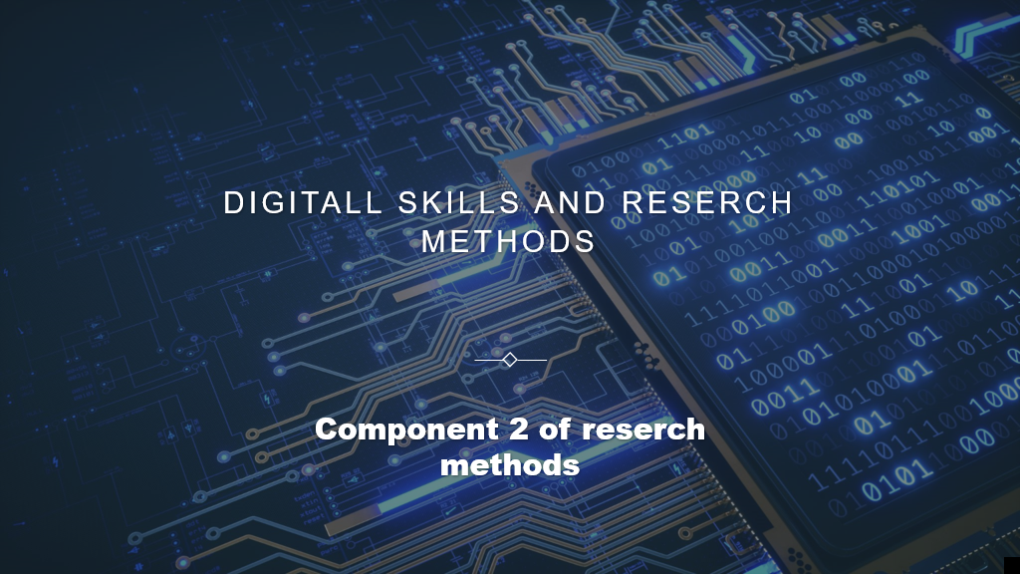

How I can use the DIKW and CRAAP frameworks to confirm or refute my collected Academic GRIT test result (Primary Data) compared to the UWTSD GRIT Result (secondary Data) based on the work of Angela Duckworth TED Talk lecture”.

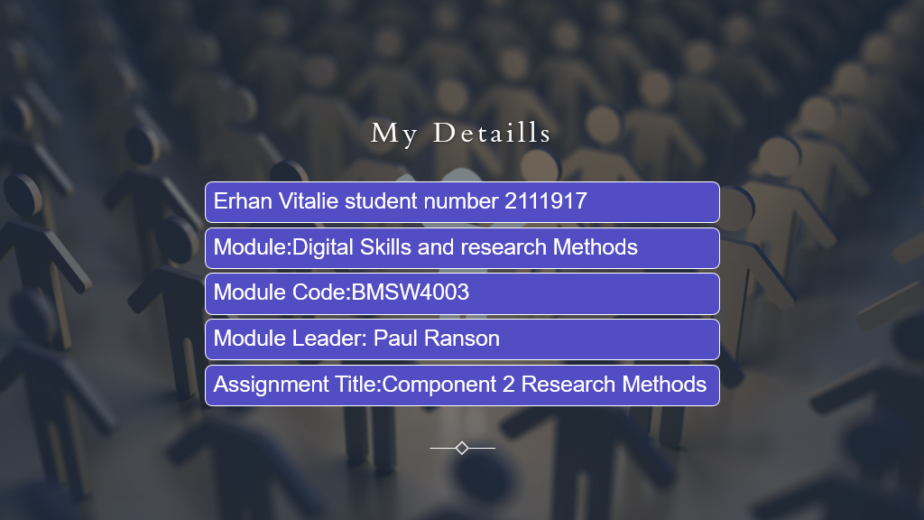

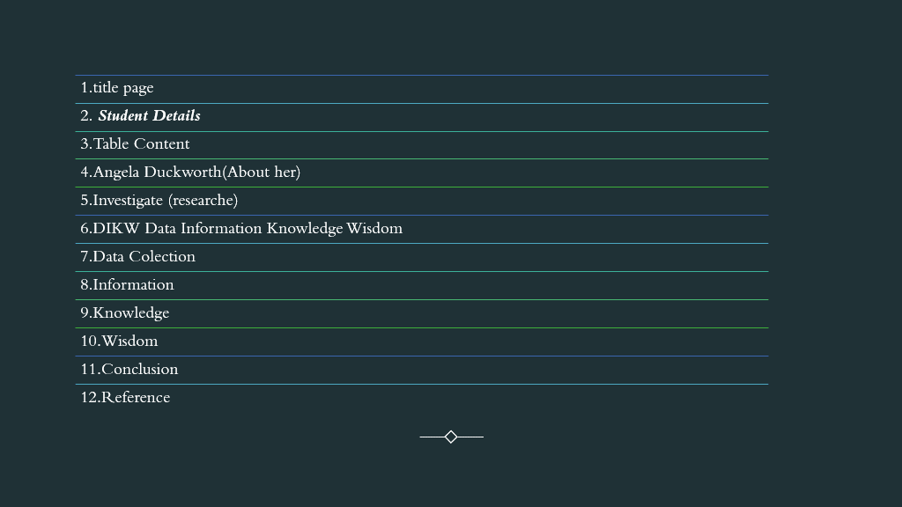



Angela Lee Duckworth graduated from Harvard University with a BA in Neuroscience and a Ph.D. in Psychology from the University of Pennsylvania. She won a MacArthur Foundation scholarship in 2013.At the age of 27, Angela decided to leave a rather difficult and responsible job in management consulting in order to switch to an even more difficult area - teaching. Duckworth began working in New York public schools.
Everything went according to a predetermined program. However, over time, Angela clearly realized that it is not only the IQ that distinguishes the successful and the lagging students. Those who performed better on assignments did not at all have exorbitant IQ levels. At the same time, some of the smartest schoolchildren could not master Duckworth's problems. After several years of teaching and observing, Angela was convinced that at the school desk, in addition to being able to quickly and easily learn, students need to have some other qualities. Not wanting to leave the research she had begin, Duckworth left school and went to graduate school to study psychology. She became interested in the study of the behavior of adults and children in various difficult situations. On a case-by-case basis, Duckworth tried to determine who was successful and how, and in the end, Duckworth came to a startling conclusion. The main component of success is not at all IQ level, not developed social skills, not external attractiveness and not health. Duckworth said the main key to success in all areas is strength of character. This trait implies passionate and persistent actions aimed at achieving even the most long-term goals.[Reference website]

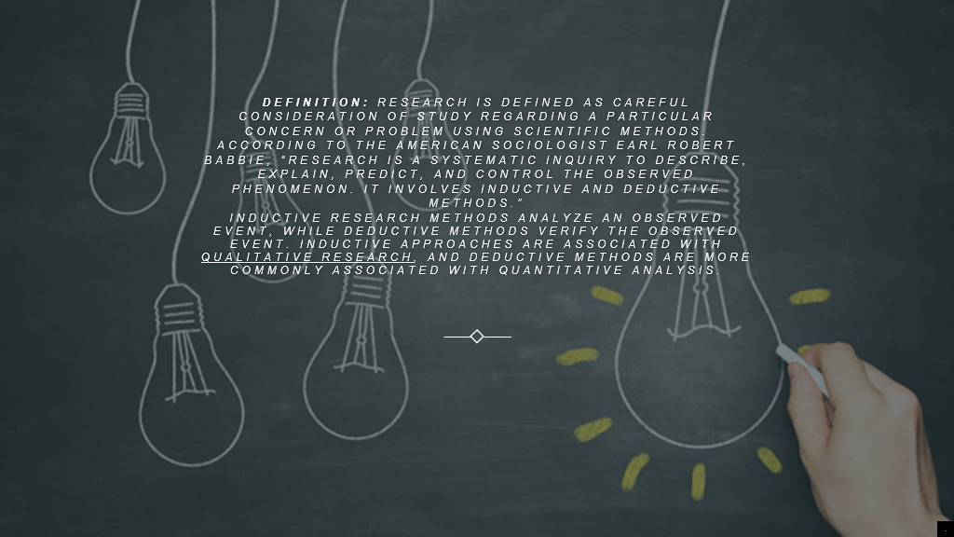

Inductive research methods analyze an observed event, while deductive methods verify the observed event. Inductive approaches are associated with qualitative research, and deductive methods are more commonly associated with quantitative analysis.
Research is conducted with a purpose to:
- Identify potential and new customers
- Understand existing customers
- Set pragmatic goals
- Develop productive market strategies
- Address business challenges
- Put together a business expansion plan
- Identify new business opportunities
- 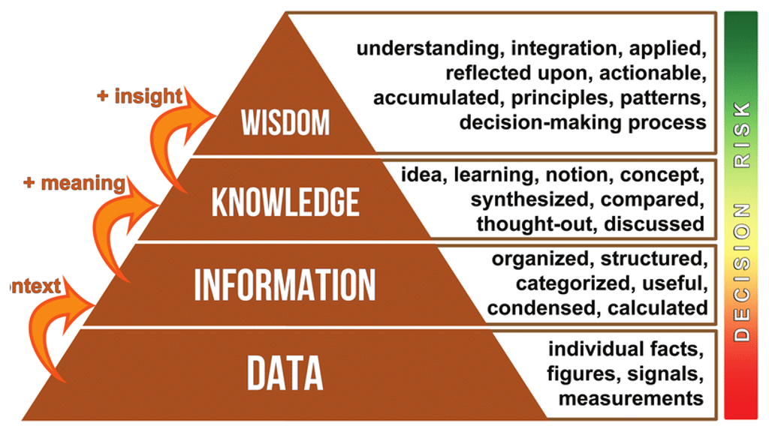

The general idea is to explain the functional relationship between Data, Information, Knowledge, and Wisdom. If we start with “Data”, we may have a lot of facts and observations, but they are likely unorganized and difficult to make any sense of. Only after we really think about the “Data” and what it means does it turn into “Information”. We’ve now made connections between the data points and know which ones are important. “Information” gives “Data” meaning, but if you only provide nurses and doctors with more “Information”, what will they actually take away? We need to take that “Information” and turn it into “Knowledge”. To get to Knowledge, we start to connect those information points and see associations between them. Some may connect well, with a logical sequence, whereas others don’t at all. “Knowledge” is very instructive, and can be a good baseline for learning. However, where you can make a difference as an association, is to offer learning opportunities that categorize as “Wisdom”.
The DIKW model "is often quoted, or used implicitly, in definitions of data, information and knowledge in the information management, information systems and knowledge management literatures, but there has been limited direct discussion of the hierarchy".^{[1]} Reviews of textbooks^{[1]} and a survey of scholars in relevant fields^{[2]} indicate that there is not a consensus as to definitions used in the model, and even less "in the description of the processes that transform elements lower in the hierarchy into those above them".^{[1][27]}
This has led Israeli researcher Chaim Zins to suggest that the data–information–knowledge components of DIKW refer to a class of no less than five models, as a function of whether data, information, and knowledge are each conceived of as subjective, objective (what Zins terms, "universal" or "collective") or both. In Zins's usage, subjective and objective "are not related to arbitrariness and truthfulness, which are usually attached to the concepts of subjective knowledge and objective knowledge". Information science, Zins argues, studies data and information, but not knowledge, as knowledge is an internal (subjective) rather than an external (universal–collective) phenomenon.^{[2]}



Therefore, Data is processed in the Information stage of the hierarchy. Relationships in the data are revealed, and analysis is done to find an answer to Who, What, When and Where questions.​
If we come back to our scenario, the following is more meaningful if 1 million SMS service users are analyzed. Eight hundred thousand users using this service are in the 15-25 age range. 80% of these users use this service from seven pm to eleven pm in the evening. And 90% of these users use SMS service when there is not internet connection on their cell phone. As you see, this analyzed data become an information and answers Who, What, When and Where questions. And this is the result of the Information step in the DIKW hierarchy. Boulding's version of DIKW explicitly named the level below the information tier message, distinguishing it from an underlying signal tier.^{[9][12]} Debons and colleagues reverse this relationship, identifying an explicit symbol tier as one of several levels underlying data.^{[9][22]}
Zins determined that, for most of those surveyed, data "are characterized as phenomena in the universal domain". "Apparently," clarifies Zins, "it is more useful to relate to the data, information, and knowledge as sets of signs rather than as meaning and its building blocks".^{[2]}

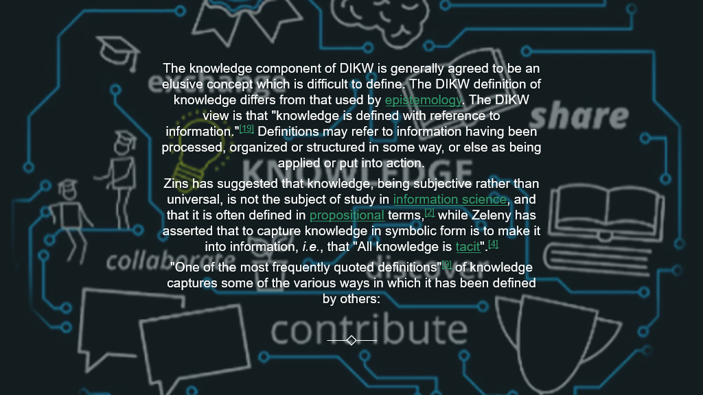

Knowledge as processed Mirroring the description of information as "organized or structured data", knowledge is sometimes described as:
- "synthesis of multiple sources of information over time"
- "organization and processing to convey understanding, experience [and] accumulated learning"
- "a mix of contextual information, values, experience and rules"^{[19]}
One of Boulding's definitions for knowledge had been "a mental structure"^{[9][12]} and Cleveland described knowledge as "the result of somebody applying the refiner's fire to [information], selecting and organizing what is useful to somebody".^{[9][14]} A recent text describes knowledge as "information connected in relationships".^{[9][28]}
The distinction here between subjective knowledge and subjective information is that subjective knowledge is characterized by justifiable belief, where subjective information is a type of knowledge concerning the meaning of data.
Boiko implied that knowledge was both open to rational discourse and justification, when he defined knowledge as "a matter of dispute".^{[9][29]}

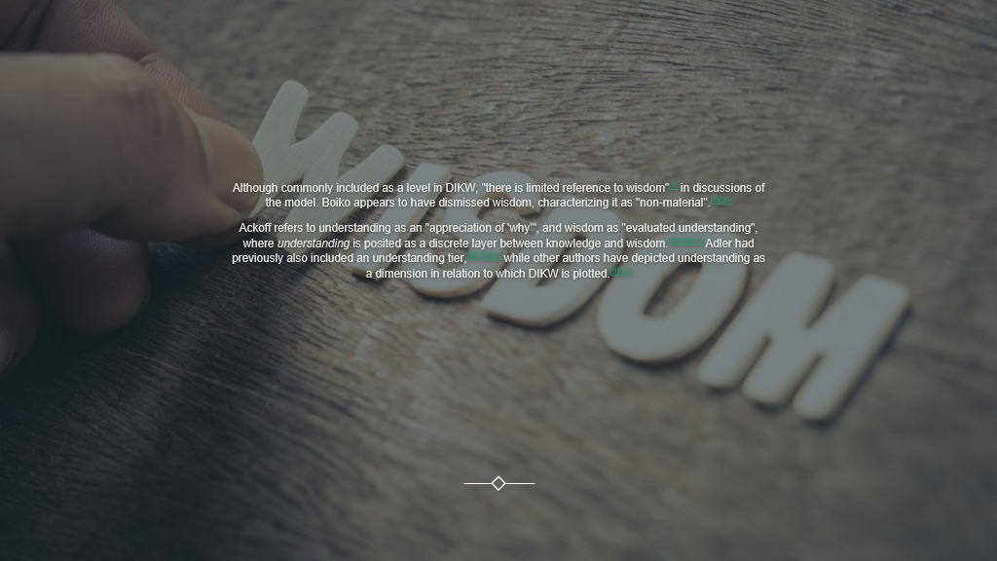

Ackoff refers to understanding as an "appreciation of 'why'", and wisdom as "evaluated understanding", where understanding is posited as a discrete layer between knowledge and wisdom.^{[9][18][31]} Adler had previously also included an understanding tier,^{[9][20][21]} while other authors have depicted understanding as a dimension in relation to which DIKW is plotted.^{[6][31]}
Cleveland described wisdom simply as "integrated knowledge—information made super-useful".^{[9][14]} Other authors have characterized wisdom as "knowing the right things to do"^{[6]} and "the ability to make sound judgments and decisions apparently without thought".^{[9][28]} Wisdom involves using knowledge for the greater good. Because of this, wisdom is deeper and more uniquely human. It requires a sense of good and bad, right and wrong, ethical and unethical.
Zeleny described wisdom as "know-why",^{[17]} but later refined his definitions, so as to differentiate "why do" (wisdom) from "why is" (information), and expanding his definition to include a form of know-what ("what to do, act or carry out").^{[4]} According to Nikhil Sharma, Zeleny has argued for a tier to the model beyond wisdom, termed "enlightenment".^{[15]}

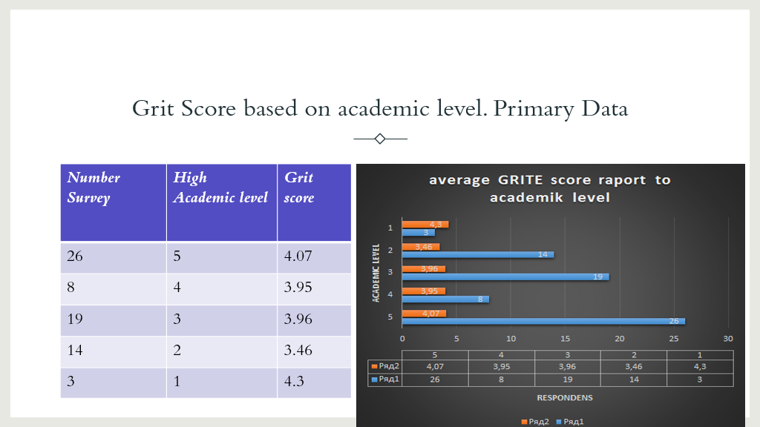

The total number of respondents in the survey is 70 according to the above-mentioned class survey. The highest academic level of 19 respondents is 3, while the highest academic level of another respondents is also 4, indicating a medium level of education. However, 26 out of 70 respondents in the study have an academic level of 5, which is a high level. This demonstrates that their digital skills are excellent and assist them in meeting their planned goals and objectives. These 19 respondents have an excellent score of 4.8, which is likewise good when compared to the other respondents. As a result, it may be concluded that the above-mentioned table and graph include reliable information on respondents' grid scores.

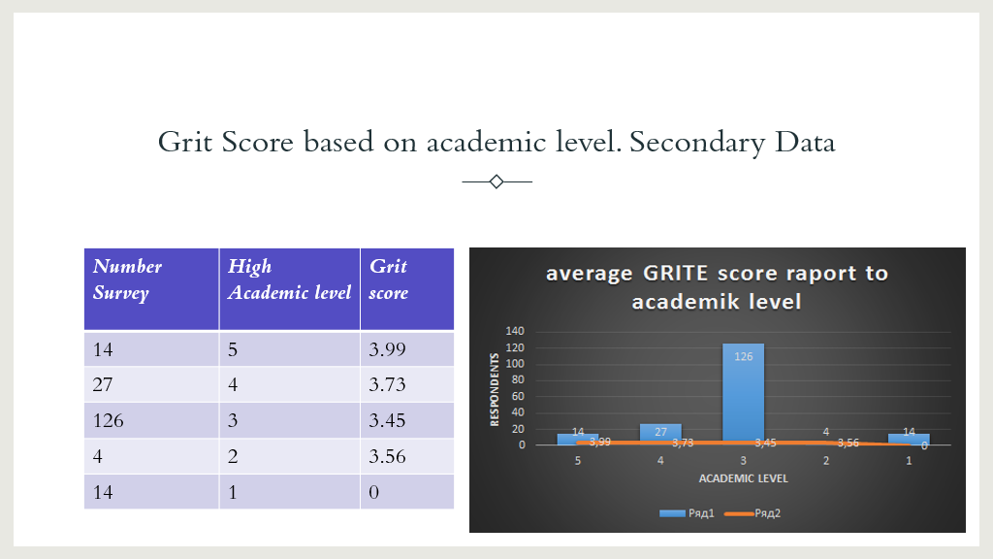

Grid score is particularly beneficial in determining the degree to which a person is interested in and focused on achieving long-term goals.
Apart from that, this score aids in determining the difference between talents and the causes for it, allowing for the application of relevant approaches to close the gap.
Another advantage of grid score is that it aids in determining an individual's internal skills level.
The comparison of grid score with other classes and their interpretation is obvious from the supplied tables and graphs.
According to the graph of grid score of school and class shown above, the respondents of class are very focused on their interests and ambitions and have excellent digital abilities. A high grid score indicates that an individual is dedicated to achieving his or her objectives. The high level of abilities and knowledge among the pupils in class is the key cause for their high grid score level. They have advanced digital abilities such as problem solving, communication, and information management. These abilities enable them to place a greater emphasis on information and education, distinguishing them from the rest of the kids in the school.
Hi academic level is 5 lowest one is one let’s see how grit score influents on academic level. From de graphic we see that is not big deferens of average grit score for hi level 3.99 and lowest 0 academic level. But progress of respondents that start with academic level 2 and grit score is 3.56 to academic level 5 grit score is 3.99 its clearly if respondent have target to progress his grit score becoming bigger and result is satisfaction and level 5 step.

conclusion
In recent years, grit has become something of a buzzword among entrepreneurs and personal development gurus. If you follow any aspiring entrepreneurs on social media, you've probably seen them post something like this...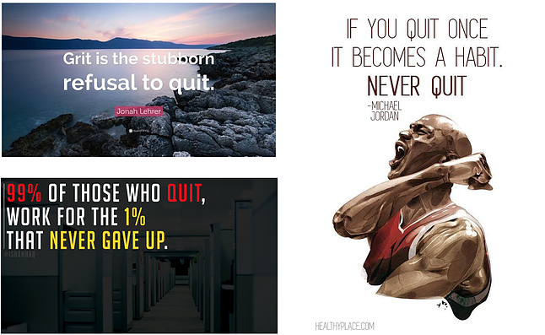
Inspiring? - Yes. Realistic? - Perhaps not.

The idea of enduring in the face of adversity has a romantic ring to it. Most romantic ideals, on the other hand, are unduly simplistic. I find the concept of love at first sight to be incredibly alluring. I, on the other hand, have fallen in love at first sight with dozens of Victoria Secret models, and no one has accepted to date me so far, no matter how many acrostic poems I send them.

Angela Duckworth, a psychology professor at the University of Pennsylvania, popularised the notion of grit, which she defined as "perseverance and passion for long-term goals." According to her findings, "grittier" people are more likely to succeed in school and in the long run.
This quote seems to summarize the true relevance of grit to innovation. “Grit works when you’re pursuing a big opportunity. It can help you bounce back from setbacks, deal with challenges and overcome seemingly insurmountable obstacles. However, grit will not help turn your “Tinder for pets” app idea into a successful business. For that you’ll need a healthy dose of creativity to help you pivot to a new direction or generate new ideas altogether”.
So the next time you see a motivational post on social media about refusing to give up, bare in mind that sometimes giving up on an idea is the best option.

About Angela

https://angeladuckworth.com/

Information of DIKWW
https://en.wikipedia.org/wiki/DIKW_pyramid

Rowley, Jennifer; Richard Hartley (2006). Organizing Knowledge: An Introduction to Managing Access to Information. Ashgate Publishing, Ltd. pp. 5–6. ISBN 978-0-7546-4431-6.

Boiko, Bob (2005). Content Management Bible(2nd ed.). Indianapolis: Wiley. p. 57. ISBN 978-0-7645-4862-8.

Liew, Anthony (June 2007). "Understanding Data, Information, Knowledge And Their Inter-Relationships". Journal of Knowledge Management Practice. 8 (2). Retrieved 7 January 2009.

Rowley, Jennifer (2007). "The wisdom hierarchy: representations of the DIKW hierarchy". Journal of Information and Communication Science. 33 (2): 163–180. doi:10.1177/0165551506070706. S2CID 17000089.

Wallace, Danny P. (2007). Knowledge Management: Historical and Cross-Disciplinary Themes. Libraries Unlimited. pp. 1–14. ISBN 978-1-59158-502-2.

Zins, Chaim (22 January 2007). "Conceptual Approaches for Defining Data, Information, and Knowledge" (PDF). Journal of the American Society for Information Science and Technology. 58 (4): 479–493. doi:10.1002/asi.20508. Retrieved 7 January 2009.

Rowley, Jennifer (2007). "The wisdom hierarchy: representations of the DIKW hierarchy". Journal of Information and Communication Science. 33 (2): 163–180.

Future minds lab 29.10.2018 joel davies blog
https://www.futuremindslab.com/blog/2018/10/29/when-grit-is-not-good-why-sometimes-you-should-just-give-up

