Understanding and Engaging in the Customer Experience

Programme: BA (Hons) Leadership and Management Skills for the Workplace.
Module: Understanding and Engaging in the Customer Experience.
Module code: BMSW 5103
Student Name : LOUAY ALSAYED-OMAR
Student Number: 1922056
Level 5 Term 2 Group 2.
Module lecturer: Joy Botu
Assignment Title: Organisation’s quality systems and customer relationship management.

1

Organisation’s Quality Systems and Customer Relationship Management.
Executive Summary.
Purpose:
This report is an academic demonstration of the changes and challenges that has recently obligated all organizations in this current century 21st twenty-first to improve and develop a new modern strategy for the customer relationship management CRM including the quality systems and controls for excellent customers services maintaining successful business market share part and a long term of sustainability with customer relationships, because of the recent crisis caused by the pandemic disease of COVID-19 organizations highly demanded to emphasizing on customers services specifically on customers touchpoints service and customers segmentations.
Methodology:
The Importance of quality processes and CRM excellent customer experience CRM and benefits of excellent customer experience and total quality management TQM ,CRM relation with customers management models.
Findings:
Importance of quality processes and CRM and benefits of excellent customer experience, Morrisons PLC UK context, Internal and external factors influence including COVID19.
Practical Implications:
Evidence of a critical understanding of quality process in the workplace, application CRM Value Chain Model on Morrisons PLC UK ,critical analytical selection and justification for CRM Value Chain model and models review and covering the relevance Morrisons PLC UK.
Value:
CRM understanding and engaging in the customer experience within quality systems and controls for customers.

2

Table of contents:
1.0.Introduction……………………………………………………………………………..…4.
2.0.The Importance of quality processes and CRM excellent customer experience.
2.1. The importance of quality processes………………………………….…..…4.5.6.
2.2. CRM and benefits of excellent customer experience……………………......…7.
2.3.Outlining report contents in the following sections…………………….…..….…8.
3.0. Morrisons PLC UK context.
3.1. Morrisons PLC brief description……………………………………………..…...9.
3.2.Internal and external factors influence including COVID19.
SWOT analyses……………………………………………………...10. 11.12.13.
PESTLE analysis………………………………………………….……....…14.15.
4.0. Models review and covering the relevance.
4.1. Payne’s Five Process model……………………………………….……..…...16.
4.2. Marketing Mix 7Ps Model……………………………………………....…..17.18.
4.3. Stakeholder Map theory………………………………………………………..19.
5.0. Model Selection.
5.1. CRM Value Chain Model………………………………………...20.21.22.23.24.
6.0.Recommendations……………………………………………………………………25.
7.0.Conclusion………………………………………………………………….………….26.
References.

3

1.0.Introduction.
Morrisons Supermarkets PLC applying modern concept of quality systems processes to control the recent customers experience challenges and changes in marketing requirements during and post pandemic crisis of coronavirus diseases (COVID-19),that obligated the organization to adapt modern academic customer relationship management (CRM) Model, method’s and theorise to develop and to maintain an excellent advanced wide strategies which provide to Morrisons PLC the ability to face UK marketing competitors in the retail sector (coursehero.com). Morrisons PLC understood completely the actual century conflict of marketing business challenges and how to deal with marketing competition through various marketing strategies with wide stages that determine the successful methods of marketing connection and customers interaction, ultimately these factors and wide strategies stages established and improved Morrisons customers loyalty, customer value, data security and privacy ,customers ecosystem, by providing a good customer quality service and CRM customer experience, this wide strategy starts with two stages the stages of importance quality processes and the stage of the CRM benefits of excellent customer experience which will be demonstrated at the next section as the Importance of quality processes and CRM excellent customer experience.

2.0.The Importance of quality processes and CRM excellent customer experience.
2.1. The importance of quality processes.
Morrisons PLC strategy highly gives the importance for quality of services processes because its form the method of selling and relationship marketing (RM) Payne and Frow (2017).This sales method develop and establish a long-term of relationship between the organization and customers, achieving both parts benefit (coursehero.com). Morrisons PLC quality of services processes create a large platform for development customer engagement, customer loyalty and a powerful mutual targets interaction, Information provided from quality of services processes platform can help directly to meet customers’ needs, customers’ expectations, customers satisfaction, customer relationship management (CRM) specified as a strategic tools to manage and develop relationships between existing customers and the new attracted customers achieving high sales level. suppling products with a high-quality service process it can reduce the coast also it presents the organization in market competitions as an especial distinctive brand from the other organizations or from the other competitors (Sehat et al. 2012).
service process is a set of activities intangible usually it takes place and interact between customers and the organization staff, products and services systems must provide solutions relating to customer problems practically it is intangible and doesn’t have an ownership. (Monavarian & Amiri 2005). the common factor of service quality is estimated after provide service in fact product is what the customers gain from organization (arabianjbmr.com).

4

Service contact point where customer and service provider interacting, and service quality is predictable Its quality is perceived from offered services (academicsolvers.org).
The five variables of quality service are:
1.Tangibles. (clean uniform as a physical proof, tidy customers reception or office).
2.Reliability.( emphasizing on right technology CDW.).
3.Responsiveness.( ready to serve in any time).
4.Assurance. (trust communication by the service providers).
5.Empathy.(service provider understands customers’ needs and ready to satisfy them).
Total quality management (TQM).
Morrison Hershfield’s Quality Management System is ISO 9001:2015 certified:

Figure 1.(morrisonhershfield.com).
Quality processes is a wide concept that include unlimited Modules, theories, methods quality processes start from defining the creation of create customer value, which is the fundamental advantage in marketing relationship, customer value has two meninges:
1.Value of the company that provides customer receives.
2. Value enterprise receives from customers of the company.

5

Quality processes all the time struggling to achieve customers’ expectations of a good product quality with competitive prices in a short time services, Morrisons PLC apply the concept of the market competition this competition make a big deference especially in online shopping, that request from the organization to ensure customers ‘data protection which are related with customers touchpoints, shops with F2F meetings, phone numbers, email address, fidelity shopping cards, fax, these are marketing method’s and techniques that can affect customer’s loyalty negatively or positively also has influence’s and effect on customer’s quality of modern expectations, satisfaction, requirements, perceptions, needs.

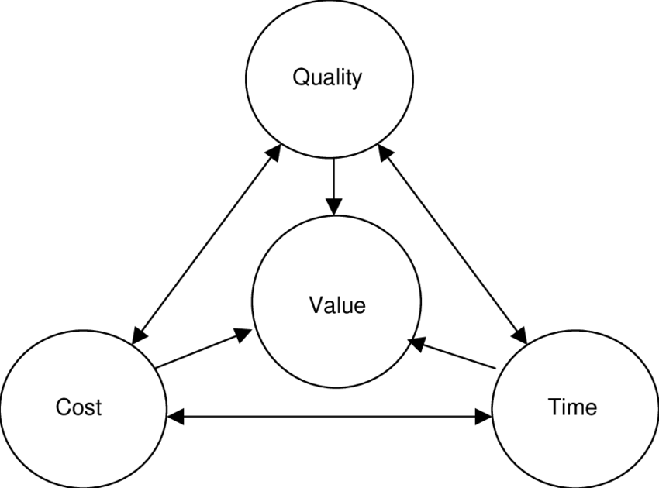
Figure 2. (researchgate.net).

One of the main factors that influencing customer satisfaction is service quality that can be obtained from customer’s verdict about their level of staffing from services expectation dose it meets their services expectation or no this can help us to understand the customer experience.
Managers and organization seeking in the industrial field apply SERVQUAL Model to measure gap of service quality this model aim to recognize gaps between the customer expectation and the recent service in many stages of service delivery for managing customer experience but in CRM business markets managers and organizations has more than one model that begin with external environment of the customer’s it is QCI model, Morrisons PLC motto is to deliver more loyalty by applying intelligent customer relationship management (CRM) strategy (edit.co.uk).

6

2.2. CRM and benefits of excellent customer experience:
Morrisons PLC UK made a new modern strategy that include applying customer relationship management CRM strength in multi-channel supported by Capgemini UK plc. For over than 490 stores that provide weekly services to 11 million customers (capgemini.com). this new modern strategy multi-channel CRM qualify Morrisons to establish a powerful customers relationship that wins customer’s satisfaction and authorize Morrisons to target customers’ with more personals offers, making a new path for the products in advanced marketing digital technologies that reinforce products services for the existing customers and the new market customers those will be related to multi-channel services as a CRM modern solution for sale forces by App. #1 CRM as a digital implementation also these data will be attached with customers touchpoints, by this methods Morrisons PLC understand customers needs more clearly and interact customer relationship management CRM ,this new IT applications created a new digital marketing team considerate as a very important milestone that focuses on customer’s business strategy.

7

2.3.Outlining report contents in the following sections.
For outlining and clarifying what will this report covers out of the first part which was number one the following sections are:
(Company context) that include the following sections:
3.0. Morrisons PLC UK context.
3.1. Morrisons PLC brief description.
3.2. Internal and external factors influencing including COVID19.
SWOT analyses.
PESTLE analysis.
(Models Review) that include the following sections:
4.0. Models Review.
4.1. Payne’s Five Process model.
4.2. Marketing Mix 7Ps Model.
4.3. Stakeholder Map theory.
(Model Selection) that include the following sections:
5.0. Model Selection.
5.1. CRM Value Chain Model.

-Then the following sections:
6.0.Recommendations.
7.0.Conclusion.
References.

8

3.0. Morrisons PLC UK context.
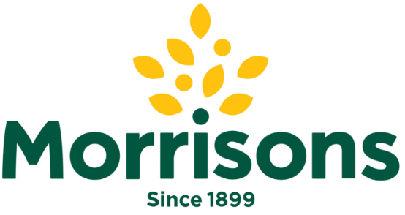
Figure 3. free imagen (logos-download.com).
3.1. Morrisons PLC brief description.
Established by William Morrison in Bradford 1899 from a stall to the fourth largest supermarket chain in UK (morrisons-corporate.com). in 1961 first supermarket in Bradford, Victoria, Sir Ken opens selling fresh meat, fruit, and vegetables.
Morrisons boasting of a new customer relationship management (CRM) strategy which remind customers of the value that fully integrated with CRM communications, and customers touch points achieving all stages of the customer lifecycle, Morrisons increasing more effective activity of CRM, Morrisons its first principle is teaching and training all Morrison's staff by intensive human resource management training courses from HR. inside the organization about delivering more loyalty with a smart customer relationship management (CRM) strategy which is the first main target of Morrisons organization this reflect on 500 retail stores and online home delivery services that include over of 110,000 Morrisons staff that serve 11 million people who visit the stores every week (edit.co.uk).
Morrisons possess a high-quality management system (QMS) and a good product services the evidence is in the last invention of Help Hub – Morrison website supported by IT department and Morrisons HR department, Help Hub – Morrisons is evidence of a new invention in customers services that practically meet the customer expectations, perceptions, requirements, and customers satisfaction (Help Hub - Morrisons).

9

3.2. Internal and external factors influence including COVID19.
To identifying the internal factors for Morrisons PLC including COVID 19 ,after researches and investigations with relevant resources internal factors for Morrisons PLC can be understood by SWOT analyses model and for the external factors including COVID 19 of Morrisons PLC can be understood by PESTLE analysis as a strategic management tool for analysing the Macro environment.
SWOT analyses for internal factors that influencing quality system of Morrisons PLC :
Strengths of Morrisons PLC:
Strong distribution:
Morrisons logistics service chain supported by RDC’s remote deposit capture (supplychainsolution.co.uk) as a logistics service chain solution network in UK and international manufactures, supplier’s, distributors, these methods allow the products to be available in large numbers as a factor for customers baying process that signify a good quality system during and post Coronavirus disease COVID 19.
Low-cost structure:
Morrisons selling products in a low-price to attract customer’s and achieving marketing target that played a fundamental roll to increases the salles during and post COVID 19 Morrisons diversity products support comes from suppliers
Financial situation:
Morrisons reported a strong financial record for the half year till 1 August 2021.total revenue with fuel up 3.7% to £9.05bn (2020/21: £8.73bn) the results are according to (morrisons-corporate.com). this financial situation preparing for a good strong future in capital expenditure and a successful generating capital return factor in post Coronavirus disease COVID 19 also there are other factors that participate to this success such as employees training skills and the strength of social media

10

Weaknesses of Morrisons PLC:
R&D. Research and development:
Morrisons expense in R&D are less than a few markets competitors average in present (morrisons-corporate.com) this factor is a disadvantage in marketing after successful new products it influences new entrance in market, this factor affect buying process.
Letting property:
Morrisons rent property rather than owns the property as a landlord paying a huge amount of money this factor increases the cost which has a negative financial impact.
Financial ratio:
Morrisons in the present has low financial ratio even the organization could have the ability to pay the financial obligations.

Lower budget for quality control:
Morrisons has a lower budget for quality control compering with other markets competitions according to annual report and financial statements 2020/21 (morrisons-corporate.com) Morrisons corporate this factor has a negative impact that possibly can damage other quality’s across the entire organization and influences the organization functional performance.

11

Opportunities of Morrisons PLC:
Customers touchpoint:
Morrisons can highly achieve customers touchpoint using the new internet Apps which are available in online internet connections this factor is an opportunity for a good interaction with customers.
Opportunity of E-commerce:
Morrisons increased sales demands during COVID 19, currently e-commerce after or post COVID 19 has sales growth in online purchasing Morrisons online digital shopping has an opportunity to provide more revenue incomes in the other side economic Inflation provide another opportunity because Morrisons applying low-cost strategy this factor includes dimensions of customer value also customer experience.
The government tax reduction:
Tax reduction is a financial benefit for Morrisons low tax during and post COVID 19 not only for Morrisons but also for the other market competitors represent a positive factor for organizations to focus on their CRM responsibility.
Consumers satisfaction:
Morrisons during and post COVID 19 accumulated accurate experience about consumers needs of health products Morrisons can achieve more opportunities by including health products this consumer segmentation can be applied from now on as an opportunity that has a positive effect on consumers loyalty and food safety.

12

Threats of Morrisons PLC:
Challenges of technology:
Competitors developments of advanced technology is a threat for Morrisons because customers have their own individual perceptions if they cannot found their wants and needs they will changes their behaviour because the competitors offer them their accurate services of quality and achievement of customer satisfaction and minimizing customer gap.
Changes of CRM consumer behaviour:
Morrisons should be aware about the threats of modern CRM consumer behaviour and changes per-sale and post-sale.
Threat of substitute products:
Currently a huge variety of products are obtainable for customers in market this factor provides for customers a large advantages as an available substitute products for them, Morrisons is under the threat of manufacturers cost increase because post COVID 19 competitor’s start with product promotions.

Threat of product lifecycle:
Morrisons suppliers and manufacturers have limitation and shortage in row materials resources they cannot keep on with market demands sometimes manufacturers take decisions to cancel some products.

13

PESTLE analysis for external factors that influencing quality system of Morrisons PLC :
Political factors:
The external political factors have a strong influence on Morrisons PLC the government released a set of legislation during and post COVID 19 emphasized on food quality also the healthy food ingredients Morrisons is an international organization that faced and facing unlimited challenges with international new law after Brexit especially at the entrance in UK with customs new transportation legislation influenced arrival goods to the warehouses.
Economic factors:
Macro environment factors influences by new inflation rate such as the mandatory employees taxation benefits rates had been increased and other rates currency exchange rate interest rate, economy cycle changes relating to investment economy legislation.
Micro environment factors influences are in the competition rules, and it is an advantage for Morrisons because Morrisons can benefits from the other international countries economic systems factors such as industrial inflation and UK retail industry growth rate in this level Morrisons doesn’t need to rase up the capital in UK local market.
Social factors:
Morrisons influenced with the society culture that determine and control pre-sale also the process of post-sale factors formed from customers have a big influence on Morrisons marketers how do they can understand the customers wants and needs in the retail marketing of broader nature in the society entrepreneurial mindset also individual’s beliefs attitudes adding the factor of personal entertainment interests in official holidays.
Technological factors:
Fast technology development influencing Morrisons in marketing computations the appearances of new competitors with new technologies that understand online shopping as one shop store as a new marketing player relaying on advanced technological factors that provide products promotion this delivering factor has a huge impact on Morrisons products coast in the retail industry also it influences consumer services and the organization value chain structure.

14

Environmental factors:
Morrisons facing factor of recycling plastic products as a results currently 82% of the plastic products are recyclable chief executive of Morrisons David Potts wants to achieve his target of plastic reduction products to be 100% biodegradable (The UK Plastic PACT | Morrisons). Goods has waste Morrisons facing factor of environment law as a challenge because Morrisons take a big responsibility of waste management that caused by consumers services department, Morrisons adopted a new plastic pollution policy.

Legal factors:
Legal factors that form legal Morrisons acting in the market under legislation of intellectual property and customers data protection, health and safety, e-commerce law for consumer protection these legal factors influence by its legal limitation operational system of CRM and quality services some customers don’t understand it this could create as a result unsatisfied customers after that they do make legal complaint which affect TQM total quality management.

15

4.0. Models review and covering the relevance.
4.1. Porter’s 5 forces Model.
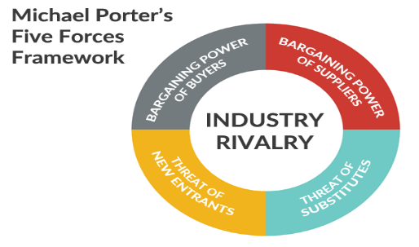
Figure 4. (fernfortuniversity.com).
Threat of new entrants: Morrisons rivalry as an international brand it is in a high-level as market requests are extending for Morrisons retail products organization the threat of new entrants is innovation of new a marking method by acceptable pricing strategy the reduces products cost that provide a new value for customers expectation by this way Morrisons can managing the challenges and effectively put an end to defence its rivalry.
Bargaining power of suppliers: Majority of organization goods are from their suppliers they dominate and control this stage Morrisons can win more in the market when apply assertive commercial negotiations by these commercial negotiations as consumer services Morrisons can decrease the suppliers power
Bargaining power of buyers: All time buyers seeking for best offers and promotions in a small price as much as possible this situation create in long term a huge pressure on Morrison profits to run the business organization must not stop on only what products it has currently but must display and provide new goods to limited and control the buyers bargaining power ability.
Threat from substitute products: In industry rivalry marketing and services is a competition when any substitute products or any advanced services meet customers wants and customers’ needs threat from substitute products became so high practically when other competitors provide customer’s value and a good quality services Morrisons should search new unique products and services to avoid products similarity in market with other competitors mitigating the threat from substitute products.
Rivalry among the existing players: Market players seek to hold the biggest market share here the competition is so powerful it takes place in many business aspects practically it is the product quality and cost competition Morrisons can be rivalry among the existing players when organization achieve the 4Is of customer engagement and apply CRM business strategy for customer satisfaction and customer quality perspective raising by to concept of modern expectation.
16

4.2. Marketing Mix 7Ps Model.
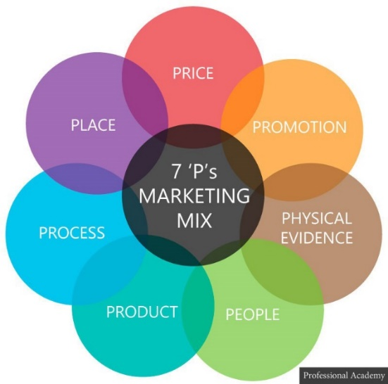
Figure 5. (weebly.com)
Product:
Morrisons are the owner and partnership of some products as a fresh food with high quality in which play as a key of success in business such as M Kitchen' frozen range, M NuMe natural yogurt (groceries.morrisons.com).these products are served in factories and shops this strategy is marketing mix model and product lifecycle.
Price:
Price is one of the reasons that customer chooses shopping in Morrison, prices in Morrisons shops are very competitive and pricing strategy emphasizes on CRM customer experience.
Place:
Morrisons have wide geographic services all over UK with more than 660 stores and 117,000 staff members’ (mbaskool.com). the organization as a manufacturer of fresh food take the second place in the UK by its distribution this leads to strategy of marketing mix and Morrisons have British geographic farming program as an operation system.

17

Promotions:
Promotional strategy in marketing presented in online and offline promotions by advertisements, Morrisons is so proud as basic belief to offer products with low prices and a good quality for its customer and rewarding customers by match and more cards as a CRM implementing.

People:
Morrisons people working with intensely they make efforts in marketing they have techniques and skills gained from continuous HR. training also the people in customer service they show respects for their customers they try with all possibility to apply problems solving related with many issues like customers satisfactions they have a powerful impact on customers maintaining a good customers relationship achieving Morrisons customer expectations, they improve the quality of service’s online and offline to meet customer’s needs.

Process:
Morrisons strategy try its best to ensure that all their retail products to customers are available all the time employees when they receive buying orders is related with a computer system that not only send the buying orders information’s to Morrisons employees but also reply to customer when this buying order will be delivered including the option of home services delivery Morrisons do researching related to develop and understanding customers needs organization active in online shopping Facebook, Instagram, Twitter and in mass media.

Physical evidence:
Morrisons make customers shopping so easy to identify the products places there are signs and indicators that help customer to find the items so easy in the store also online products online and offline has high standards view.

18

4.3. Stakeholder Map theory.
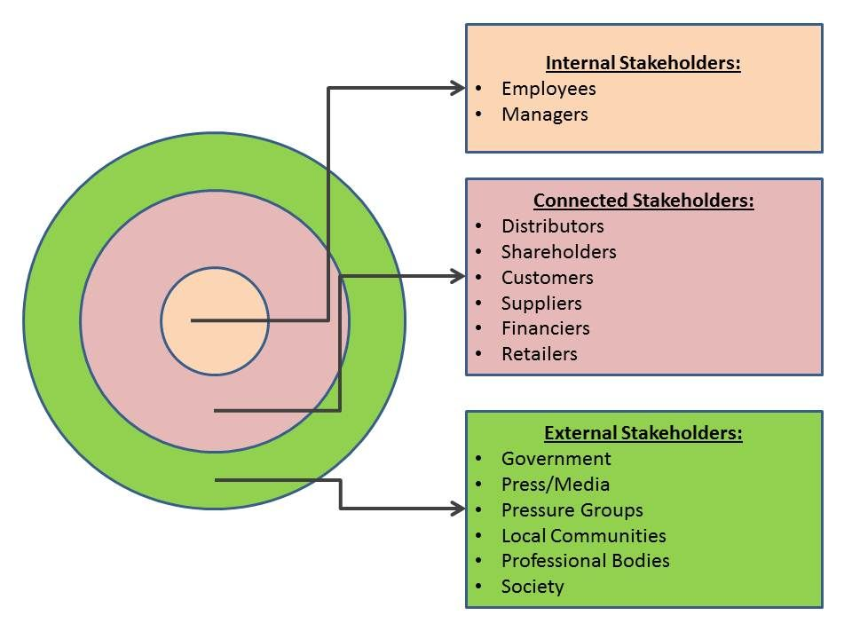
Figure 6. Free image Stakeholder Mapping – Marketing Theories (Bing images).

Internal stakeholders:
Morrisons internal stakeholders formed from groups of directors that are appointed from shareholders to manage daily issues Morrisons directors act with organization board, managers planning controlling organization activity’s leading the employees.
Connected stakeholders:
Morrisons connected stakeholders at meeting they are voting solutions and they are allowed to control the organization they have the right of design making for any problems related to customers and distributors
External stakeholders:
Morrisons commercial activities act are under the government’s law and its leaders, the interest and pressure groups effect some of organization operational system such as manufactured products, Morrisons gives big importance to mass media and interacting with local communities with different local projects and donations.

19

5.0. Model Selection.
5.1.The customer relationship management CRM Value Chain Model.
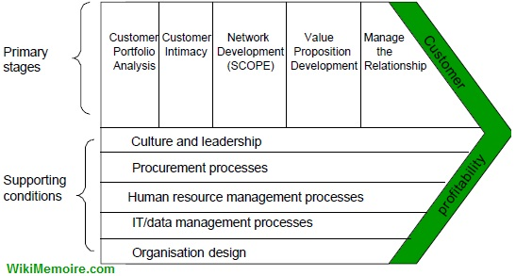
Figure 6. Images of Free Image CRM Value Chain Model (wikimemoires.net).
The stages of CRM Value Chain Model.
1. Primary stages for implementation CRM Value Chain Model:
-Customer portfolio analysis.
-Customer intimacy.
-Network development.
-Value proposition development.
-Manage customer lifecycle.
2. Supporting conditions stages for CRM Value Chain Model:
-Culture and leadership.
-Procurement processes.
-Human resource management processes.
-IT/Data management processes.
-Organization design.

20

Analytical selection and justification for CRM Value Chain model:
Customer relationship management CRM is a wide broader concept with vast content of academic Models, theories, tools and methods as an overview for this academic basis of CRM we can understand that it is fundamental comprehensive base in infrastructure of any successful organization that open the door to a large world of business trading, organizations seeking to obtain reasons of success even they possess a big capital but without implementing an academic basic criteria failure is defiantly eminent. CRM strategy is a plan of actions highly organizing peoples ,processes, technology achieving customers related goals (Buttle 2009).
CRM Value Chain model utilizing to implement and developing a plan created for customer relationship management CRM Morrisons apply the concepts of CRM Value Chain model as a management approach (coursehero.com). achieving integral success in marketing strategy maintaining an advanced advantage to face the challenges provided from other market competitors by interacting with customers in high level in internal and external business environments creating customers value as a market target it is B2B business to business and B2C business to customers for all businesses sizes (Gummesson 2015) CRM Value Chain model can control customer management cycle (Chen & Myagmarsuren 2011).
CRM Value Chain model in long term help Morrisons to understanding and documenting customers data by IT processes to approach the concept of customers’ needs with good relationship with peoples (Ernst et al. 2011).CRM Value Chain model is so appropriate for Morrisons to implement better performance with customers relationship CRM Value Chain model is a competitive model for Morrisons to face business challenge’s and problems compering with analyses of the three models review and covering the relevance at the above stage it so difficult to stop at one model to face the market challenges and to interact positively with customers problems every model have a specific process to solve specific station but all these models aim to create a value for the organizations, it is so beneficial at the practical level applying the value chain model compering with the above three modules because this model process has the ability to provide high level of CRM and it is so compatible and well matched with Morrisons CRM goals, there are many reasons for selecting CRM Value Chain model the first reason Morrisons facing customers segmentations problem caused by post COVID-19 pandemic station customers segmentation became so ambiguous Morrisons deal with customers as if they are in one customer data level, indications for tracking customers’ needs as a target became so difficult to be specified and to be identified Morrisons work hardly to regather data that analysis customer portfolio to define effective new strategy implementation which leads to interacting with customers’ needs to create high CRM value.

21

The second reason is Morrisons after gathering and obtaining customer portfolio analysis by different channels organization can start to element the problem of retaining customers’ by interacting with the most important value of retaining customers’ as an asset in Morrisons CRM value and creating great customer intimacy eliminating by this method the intensity of competitors strength, by understanding customers’ expectations also wining marketing competition.

The third reason is Morrisons solving big challenges of strategic partnerships CRM value, via interacting and planning to develop network with consumers, staff ,suppliers, stakeholder’s providing a good services quality that can be represented also in essential part of CRM customers touchpoints.
The fourth reason is Morrisons can mitigate problems with customers services complaining by developing a new policy with an extensive customer’s experiences that maximizing factors of customers loyalties, customers satisfaction’s, this strategy can meet customers’ requirements and their expectations it is so profitable for Morrisons because it reducing customers complaining of refund tangible products problems by providing a high level of TQM total quality management and enhancing market position by maximizing profit from products life cycle stages.
Supporting conditions stages for CRM Value Chain Model:
Morrisons can create effective culture and leadership marketing value when completing CRM process supported from HR for all organization departments by modern software IT data because it interacts with all CRM value that are a model of operation for all organization departments.

22

Application CRM Value Chain Model:

Morrisons is an international organization with large numbers of products and employees including organization wide customers numbers and different cultures this do make strong obstacle’s to applying all models at the same time but there are an academics criterion that indicate and signify standards of the appropriate model after the organization strategy, after Morrisons hierarchical structure CRM Value Chain Model competency is the most appropriate model that is related to the modern organization strategy (academia.edu). CRM Value Chain Model characterize internal and external organization activity that create a product a service (Johnson, Sholes, and Whittington, 2008. p.110).
Customer portfolio analysis:
In this stage CRM Value Chain Model request from Morrisons to defining customers segmentation after customers annual profitably according to customer's buying process patterns and those how can bring a value to the organization business (projectguru.in).Morrisons customers segmentation strategy depend on customer’s buying process interacting with customers in a long term with excellent relationship (Buttle 2004).
Customer intimacy:
In this stage CRM Value Chain Model request from Morrisons to learn more about the existing segmented customer so Morrisons can clarify target market achieving customers’ expectations assessing customers’ level of touchpoints with the organization Morrisons highly gives importance for data management and customers feedback about services, products satisfaction for effective customers retaining.
Network development:
In this stage CRM Value Chain Model request from Morrisons to develop interacting with customers extensively for well understanding of customers’ needs building up sustainability in per-sale and post-sale stage.
Value proposition development:
In this stage CRM Value Chain Model help Morrisons to develop value proposition based on target market segmentation including delivering value of services and products tangible and intangible, value proposition is the basic strategy that influence Morrisons in decision making regarding market target and the implementation of customers expectation obtained from customers feedback about products and quality services.

23

Manage customer lifecycle:
In this stage CRM Value Chain Model request from Morrisons to apply software outcomes of the above three stages to start with accuracy predicting existing customer delivery requests of services and products this will help the organization to clarify how it will obtain customer lifecycle management CLM that include customer loyalty, acquisition, retention, development

Supporting conditions stages of CRM Value Chain Model are supportive stages conditions that will help organization in primary performance functions (Kapooria 2017).

24

6.0.Recommendations.

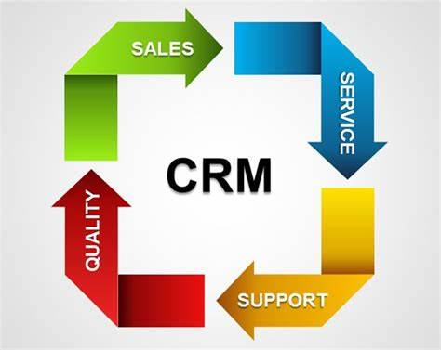
Figure 7. free imagen (slidehunter.com).

Morrison’s CRM based on the above application can apply the following recommendation:

- Morrison’s CRM should create and generate appropriate analyses based on CRM Value Chain Model stages before and after model applications.
-Human resource HR can improve its practices by applying relating model stages concepts on practical training structures also by explaining to all organization employees what targets we can achieve by applying this model concept and stages, why this model is useful to mitigate and minimize our internal and external organization challenge’s.
-Morrison’s CRM must have in consideration that Porter's value chain model is flexible can be applied with confidence in the organization departments activity to element and manage a big part of customer’s daily problems, so this model provides customers value.
- Porter's value chain model is so dynamic in managing customers relationship Morrison’s CRM tasks must be related to the suitable stage so it can be considerate a problem-solving method.

25

7.0.Conclusion.
This report covers the academic and the practical applications of organisational quality systems importance and fundamental benefit’s from the concept of CRM that controls customers excellent services experience applied on Morrisons organization as a factor of success and standards forms extracts from core the concept of understanding and engaging in the customer experience in CRM also dynamic CRM Value Chain model that provide basic value of CRM process that support organization to control macro and micro environment in CRM.

26

References.
Morrisons CRM.docx - Morrisons CRM Value Chain1 …[online] available at: https://www.coursehero.com/file/71908626/Morrisons-CRMdocx (Accessed: 27 MAR 2022).
THE QUALITY OF SERVICE AND ITS IMPORTANCE IN SERVICE ... [online] available at: https://www.arabianjbmr.com/pdfs/OM_VOL_3_(3)/4.pdf · PDF file (Accessed: 27 MAR 2022).
Five variables of service quality – Academic Solvers [online] available at: https://academicsolvers.org/five-variables-of-service-quality (Accessed: 28 MAR 2022).
Morrison Hershfield’s Quality Management System is ISO ... [online] available at: blog.morrisonhershfield.com/quality-management-system-iso-9001-2015...(Accessed: 28 MAR 2022).
Builders' Perceptions of Lowest Cost Procurement and Its ... [online] available at: https://www.researchgate.net/publication/287513186_Builders (Accessed: 29 MAR 2022).
Case study: Increasing Morrison’s More activity via CRM | …[online] available at: https://edit.co.uk/work/morrisons (Accessed: 29 MAR 2022).
Morrisons strengthens customer focus with advanced CRM ... [online] available at: www.capgemini.com/gb-en/news/morrisons-strengthens-customer-focus-with-a(Accessed: 29 MAR 2022).
Morrisons vector logo – Download for free[online] available at: https://worldlogohub.com/6418-morrisons-logo-download.html (Accessed: 29 MAR 2022).
Company History - Morrisons Corporate [online] available at: https://www.morrisons-corporate.com/about-us/company-history Accessed: 30 MAR 2022).
Case study: Increasing Morrison’s More activity via CRM | … [online] available at: https://edit.co.uk/work/morrisons (Accessed: 30 MAR 2022).
Help Hub – Morrisons [online] available at: https://www.morrisons.com/help (Accessed: 30 MAR 2022).
Logistics services for suppliers to Morrisons Supermarket ... [online] available at: https://supplychainsolution.co.uk/morrison-logistics (Accessed: 29 MAR 2022).
Financial Reports - Morrisons Corporate [online] available at:https://www.morrisons-corporate.com/investor-centre/financial-reports(Accessed: 29 MAR 2022).
Annual Report 2020/21 - Morrisons Corporate https://www.morrisons-corporate.com/investor-centre/annual-re…[online] available at: https://www.morrisons-corporate.com/investor-centre/annual-report/?msclkid=81a71f56af6711ec84d0faa8b02ab345 (Accessed: 29 MAR 2022).

The UK Plastic PACT | Morrisons my.morrisons.com/uk-plastics-pact/ [online] available at: The UK Plastic PACT | Morrisons (Accessed: 30 MAR 2022).
Morrison (Wm) Supermarkets Plc Porter Five (5) Forces ... [online] available at: fernfortuniversity.com/term-papers/porter5/lse/434-morrison--wm--supermarkets-pl…(Accessed: 30 MAR 2022).
Images of Morrisons Marketing Mix 7Ps Model Free bing.com/images [online] available at: 7Ps Marketing Mix - Bloomsbury Business (weebly.com) (Accessed: 30 MAR 2022).
Images of Free Image Customers Distribution Products Pricing Ma…bing.com/images[online] available at: free image customers distribution products pricing marketing promotional mix - Bing images (Accessed: 30 MAR 2022).
Family & Kids Meal: Ready Meals: Fresh: Morrisons Shop https://groceries.morrisons.com/.../family-kids-meal-177471 [online] available at: https://groceries.morrisons.com/browse/fresh-176739/ready-meals-176768/family-kids-meal-177471?msclkid=d8a3a2c9b06811eca55b39463ece82fb (Accessed: 30 MAR 2022).
Morrisons Marketing Strategy & Marketing Mix (4Ps) | MBA Skool www.mbaskool.com/marketing-mix/services/16798-morrisons.html [online] available at: Morrisons Marketing Strategy & Marketing Mix (4Ps) | MBA Skool (Accessed: 30 MAR 2022).
Free image Stakeholder Mapping – Marketing Theories [online] available at: Free image Stakeholder Mapping – Marketing Theories - Bing images (Accessed: 30 MAR 2022).
CRMFrameworks&CRMModels:IDICmodel,QCI,Value…https://wikimemoires.net/2011/06/the-customer-relationship-ma…[online] available at: CRM Frameworks & CRM Models : IDIC model, QCI, Value Chain (wikimemoires.net) (Accessed: 30 MAR 2022).
Morrisons CRM.docx - Morrisons CRM Value Chain1 MORRISONS CRM VALUE CHAIN By Course Professor’s Name Institution Location of Institution Data Morrisons | Course Hero [online] available at: Morrisons CRM.docx - Morrisons CRM Value Chain1 MORRISONS CRM VALUE CHAIN By Course Professor’s Name Institution Location of Institution Data Morrisons | Course Hero [online] available at: (7) Strategic Management Practices by Morrison PLC, UK. Analysis, Lessons and Implications | IJMSBR Open Access Journal - Academia.edu (Accessed: 1 APR 2022).
Understanding the importance of Buttle's CRM value …https://www.projectguru.in/buttles-crm-value-chain-model [online] available at: Understanding the importance of Buttle's CRM value chain model (projectguru.in) (Accessed: 1 APR 2022).
CRM Model diagram [online] available at: CRM Circular Squared PowerPoint Diagram with Arrows (slidehunter.com) (Accessed: 2 APR 2022).

