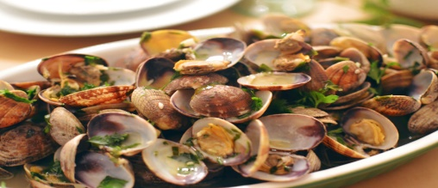

TAKEWAY MENU
24-26 oakfield street, swansea, sa14 2by Tel: 02920797920, home delivery service available, opening hours: Monday -Friday, 12am-11pm, open on bank holidays. eMAIL: trinityhotelswansea@gmail.com
STARTERS |  |  | 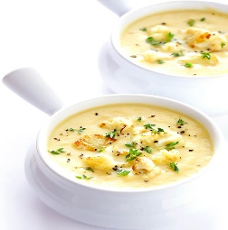  SALADS & SOUPS  IF YOU HAVE A FOOD ALLERGY OR A SPECIAL DIETARY REQUIREMENT PLEASE INFORM US BEFORE YOU PLACE AN ORDER
GLAMORGAN SAUSAGE  Traditional Welsh vegetarian sausage served with apple sauce | 6.99 |  | GREEN SALAD  Fresh lettuce, tomatoes,  Cucumbers, onions with special dressing | 5.99
STREAMER CLAMS  Fresh Welsh steamers cooked with garlic and fresh herbs | 8.99 |  | SHRIMP LOUIS  Iceberg lettuce, tomatoes, cucumbers, onions & choice of dressing | 11.99
CALAMARI  Breaded calamari rings and tentacles with cocktail sauce and lime tartar sauce | 9.99 |  | CAESAR SALAD  Crisp romaine with shaved parmesan cheese and classic dressing | 5.99
CHICKEN WINGS  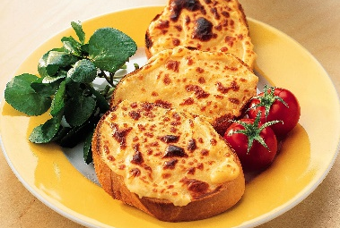  Naked wings tossed with root beer, BBQ, or red hot sauce | 6.99 |  | FETA CHEESE CHERRY SALAD  Fresh baby spinach with canned cherry and feta cheese | 6.99
CHIPS AND SALSA | 3.99 |  | CAULIFLOWER SOUP | 4.99
CHICKEN TENDERS  Served with Chips | 6.99 |  | CRAB MEAT & SWEET CORN SOUP | 5.99
COCKLES AND LAVERBREAD  mollusk with traditional Welsh bread | 6.99 |  | 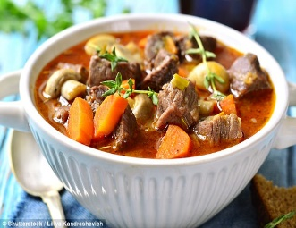  WELSH LAMB CAWL  Traditional lamb stew with local veg | 8.99
WELSH RAREBIT  Cheese sauce on toast | 5.99 |  | LEEK SOUP | 4.99
ON THE BUN |  |  | HOUSE SPECIALTIES
OPEN FACE CHILI BURGER  Flame-broiled & smothered with house chili, cheddar, and onions with curly fries | 8.99 |  | STEAK & FRIES  8 oz New York topped with a jalapeno, and cucumber and served with seasoned fries | 15.99
QUINAULT BURGER  Flame-broiled topped with cheddar cheese with tomatoes, onions, and fries | 8.99 |  | FISH & CHIPS  Delicious cod fried in our house beer batter served with chips, coleslaw, and tartar sauce | 12.99
BLACK JACK BURGER  With your choice of chicken breasts or beef patty, topped with pepper jack cheese, guacamole placed with a ciabatta bun, served with tomatoes, onions, and lettuce | 9.99 |  | FAGGOTS  Traditional pork meatballs served with mushy peas, mashed potatoes, and special onion gravy. | 13.99
JAMBO DOG  ½ lb gourmet all-beef foot-long hotdog, garnished with radish, mustard, and fried onions served with chips | 7.99 |  | SALMON TACOS  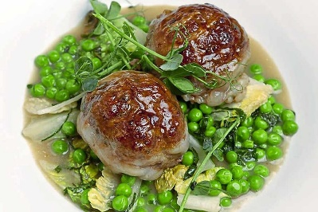  Seasoned salmon filets stuffed in a warm flour tortilla and topped with cabbage, pico de Gallo, caper lime aioli served with fresh salsa and tortilla chips | 15.99
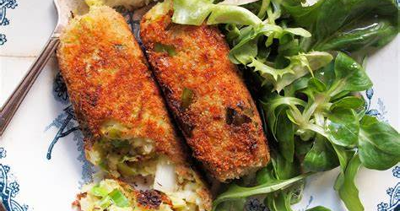
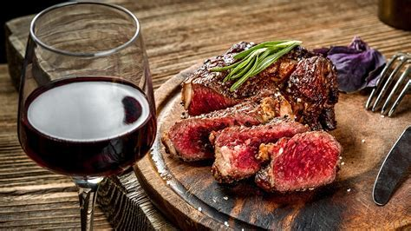
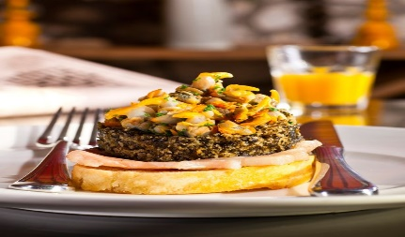
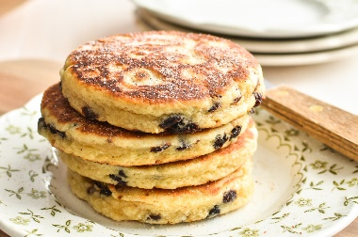
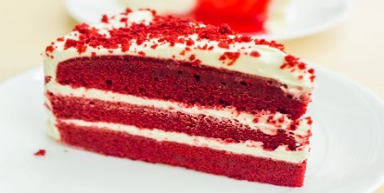
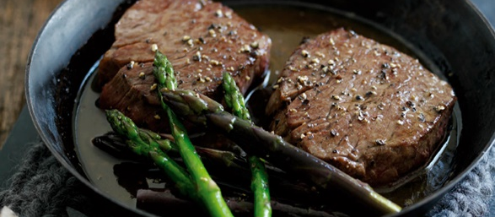
SPECIAL COMBO |  |  |  | KIDS MENU
WELSH BLACK BEEF STEAK  With special dressed salad, grilled tomatoes & Peri wedges/ Aromatic Rice  with  Domaine des Vigneaux – Syrah – Libation  ( 75cl, 2020) | 34.50 |  |  | CHICKEN NUGGETS & FRIES | 6.90
 | 34.50 |  |  | NACHOS WITH BEEF | 7.90
 | 34.50 |  |  | MINI HOT DOG WITH CHIPS | 6.90
 | 34.50 |  |  | CHEESE QUESADILLA WITH CHIPS | 6.90
LOBSTER THERMIDOR  Signature creamy sauce, with green beans and baby spinach  With  Edouard Delaunay ‘Septembre’ Chardonnay  (75cl, 2019) | 39.50 |  |  | DELIGHTFUL DESSERTS
 | 39.50 |  |  | BARA BRITH (Welsh Traditional Fruit Cake) | 4.90
 | 39.50 |  |  | RED VELVET CAKE | 4.90
 | 39.50 |  |  | FERRERO ROCHER CHEESECAKE | 4.90
 | 39.50 |  |  | CHOCOLATE FUDGE CAKE | 4.90
DRINKS
WINES (all 75cl bottles)
SPARKLING  Prosecco Montresor Santa Dorotea (1.1%) | 16.95 |  |  | RED
SPARKLING  Prosecco Montresor Santa Dorotea (1.1%) | 16.95 |  |  | Nero D Avola, marchese della torre Sicilia  (13%) | 13.95
WHITE |  |  |  | Bonarda, calvi Oltrepò pavese effervescente (12.5%) | 16.95
Grillo marchese della torre Sicilla (13%) | 14.95 |  |  | Bonarda, calvi Oltrepò pavese effervescente (12.5%) | 16.95
Pinot nero bianco, calvi, Oltrepò pavese (13%) | 16.25 |  |  | Syrah, Montalto, Sicilia (14%) | 15.95
Riesling Guarini, Oltrepò pavese (12.5%) | 17.50 |  |  | Montepulciano, Epicuro, Abruzzo (13%) | 15.25
BEER |  |  |  | SOFT DRINKS
Moretti, golden larger, medium hops (4.6%, 330ml) | 2.75 |  |  | Still Water (500ml) | 1.95
Menebrea, medium hops (4.8%, 330ml) | 2.95 |  |  | Sparkling Water (500ml) | 2.95
Mela Rosa, dry cider (5%, 330ml) | 3.25 |  |  | COKE (Original/Diet, 330ml) | 1.50
Peronilibera 0% (non-alchololic, 330ml) | 2.50 |  |  | Sprite (330ml) | 1.50
HOT DRINKS
Espresso/ Macchiato/ Americano (Regular) | 2.50 |  |  | Strong breakfast Tea | 2.00
Latte/ Cappuccino/ Flat White (Regular) | 2.95 |  |  | Green Tea | 2.00
Hot Chocolate/ Mocha (Regular) | 3.20 |  |  | Camomille Tea | 2.00
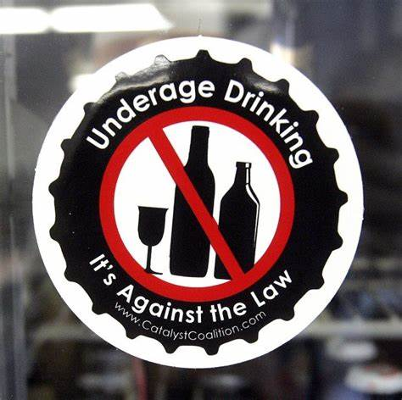
We are also on…..
Follow us on…..



@TrinityHotelSwansea@ @TrinityHotelSwansea@ @TrinityHotelSwansea@

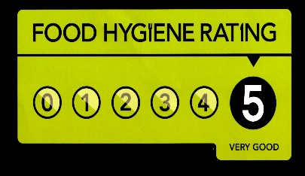

ANNISA SATHI (2119261)
REFERENCE LIST

Bici Café (2020) TAKEAWAY DRINKS MENU SEP 2020 - Bici Café Available at: https://www.bici-cafe.co.uk/takeaway-drinks-menu-sep-2020/?full-site=true (Accessed: 10 June 2022)
Food Standards Agency (2022) Food allergy and intolerance. Available at: https://www.food.gov.uk/safety-hygiene/food-allergy-and-intolerance (Accessed: 10 June 2022).
Food Standards Agency (2022) Food Hygiene Rating Scheme. Available at: https://www.food.gov.uk/safety-hygiene/food-hygiene-rating-scheme (Accessed: 10 June 2022).
GOV.UK (2022) Alcohol and young people. Available at: https://www.gov.uk/alcohol-young-people-law (Accessed: 10 June 2022).
Mercer, C. (2021) Wine with beef: A food pairing guide with expert advice - Decanter. Decanter. Available at: https://www.decanter.com/learn/food/christmas-beef-wine-pairing-tips-351001/ (Accessed: 10 June 2022).
Welsh Food & Drink (2022) Traditional Welsh Food and Drink. Welsh Food and Drink. Available at: https://www.welshfoodanddrink.wales/ (Accessed: 10 June 2022)
Zmenu.com (2018) Online Menu of Image Restaurant, Kaukauna, Wisconsin, 54130 - Zmenu. Available at: <https://www.zmenu.com/image-kaukauna-online-menu/ (Accessed: 10 June 2022).

