Academic and Employability Skills

Report

Student Name: | Julia Silva
Student Number: | 2130195
Module Title: | Academic And Employability Skills
Module Code: | BMSW4001
Term: | Term 1
Lecturer Name: | Peter Allen

Table of Contents

Introduction

More than defining, it is convenient to conceptualize from different angles the importance of putting into practice what was learned in the classroom, especially for those who want to continue their studies in this report we will discourse about: Time management, Organising study, Academic Writing and Public speaking and presentations. How these tools will be convenient for the future and how to place into practice. and lastly, the expectation I has for this module was related. Its importance lies in the fact that employability is made up of the employee's professional, behavioral and relational skills, as mentioned above. And all these skills are essential for the company's growth and development.

Time management

As the name suggests, effective time management means having the right balance between my homework and college life work. Organizing days takes the stress out and ensures you are productive. Most people avoid taking the time to plan their priorities. This will help stay on track and stay organized while studying and working and private life.” The time management is worthy goal of many human activities. It concerns variety problems related to goals definition, assessment of available resources, control of management policies, scheduling of decisions” (stoilov, 2012).

Having an efficient and productive study routine largely depends on good time management. For those who work or need to enjoy moments of intense studies for this, it is necessary to divide leisure and study periods well, avoid procrastination and organize my to-do lists well, among other measures. But how to put this into practice?
Organize is the verb that commands personal time management. However, I don't need to be the most methodical person in the world to succeed in your personal time management, but on the other hand, I need to create your own organizational logic. Stop to think about the best way to organize my routine and create rules.

The first step for those who want to manage their time well for their studies is to know their current situation of available time. How many hours work per day, what are the unavoidable commitments with family and friends, avoid moments of procrastination and low productivity. Think about what distracts I most from my studies, Tv and mobile phone social networks “emoving such duplicates is an essential task to ensure systematic reviewers do not waste time screening the same citation multiple times” (John, Carter, Hoffmann, & Glasziou, Systematic reviews, 2015, Vol.4 (1), p.6-6).
In addition to a weekly study calendar, some people use an agenda to better organize their tasks and appointments. Having an agenda is a way to maintain productivity at work, carry out all the tasks and not leave any pending issues that can get in your way when you review what you saw in class. (Petre DRUCKER, 1967), known as the father of modern administration, said: “Time is the scarcest resource, and unless managed, nothing else can be managed." This thought demonstrates how time can drain through our fingers and prevent us from acting efficiently if we do not know how to use it in a planned way. Technology is a powerful ally of personal organization and time management. So, how about taking advantage of it to make a personal and very effective time management? Discover some apps that will help you in this endeavor, nominated by the British newspaper The Guardian as one of the best organization apps available, Todoist – Task List has 4 million users around the world. The application helps to remember everyday tasks, such as everyday life

By bringing this reality into an organization, where the use of time is vital, we can understand why it is so important to strategically use time management. Without it, it is not possible to meet deadlines or achieve goals. I can only manage time if you track it right – Spica’s team, with this quote, the author means how much important it is to know how to manage our time. Most of the world’s population cancels special events or does not set goals with the excuse that there is no time when in fact time was not taken advantage of, which ended up unslinging the goals to be completed during your day. When we stimulate our time, we are contributing to a very frequent current problem in our society PROCRASTINATION. Current technology is one of the main cases of this phenomenon ,more present in the young population that very easily acquired technological devices and abdicated from the outside world to venture into the virtual world to venture into the virtual world ,indirectly ruining their social life.40% of young people spend more than two hours on social networks and most of the population spends about seven hours a day on technological instruments ,which proves to be a great distraction ,many times we do not. examples and suggestions for a better life, have a diary to write down the events make a plan for your day wake up early, organize your work or university stuff the day before.

Organising study

The University routine includes several tasks and a rhythm that sometimes causes confusion. When he loses, he exchanges data or finds out about late deliveries. However, understanding how to organize studies is essential to avoid these moments. the relief necessary to enjoy the course in the right way arises. Want to discover the best tips for organizing my studies?
To control schedules, the first step is to understand the routine. Recognizing how my day-to-day works is the first step to fitting responsibilities and leaving nothing behind.
By following the previous steps, I have already started creating a calendar. However, to be successful in the organization of studies, it is necessary to take it seriously and have everything well defined. With a complete schedule, it is easier to fulfill all responsibilities. Faced with so many obligations, however, it can seem difficult to know how to prepare. running away from social networks are among the main villains when it comes to distraction. Get off my profiles while studying and resist the temptation to check my feed all the time. take notes
One of the ways to not give in to distractions is to keep a sheet of paper by your side, where you should write down everything that comes to mind. Write about what you should buy at the supermarket and other things you need to work out after studying. With a clear mind, it is easy to concentrate. Respect the limits of your body and mind, being able to “handle” the subjects and prepare is important. But even more relevant is your well-being, the way you feel and face everyday life. So, don't neglect yourself. It is essential to take some breaks throughout the study, such as to play with your pet or stretch the skeleton. Take a deep breath and enjoy a few minutes between one battery and another of studies. Also try to deal with stress. Try to stay calm and be sure that, with planning, it will be possible to learn everything. The more you respect your limits, the better the result.

Keep an eye on my habits in addition to knowing how to rest, it is important to pay attention to your daily life. Not sleeping, exercising or eating right is not good for the body or brain. Try to create a routine with good habits to reach your goals. With a good organization of studies, I will have an above-average performance that helps you achieve your goals. Put these tips into practice and see how they make a difference. make summaries
Each day, summarize the material given in each subject. Start with the most difficult subjects and finish with the easiest ones. Be rigorous in your daily study but take short 15-minute breaks for every hour of study. Learn comprehension and memorization techniques
Some subjects need understanding, others need memorization, so it's important to research techniques and master both. Putting ideas in your own words or using visual aids, such as diagrams or tables, are good allies to better understand and memorize the material.
Follow our tips to organize your study and give priority to university but don't make it a military regime. Rest on Sunday and have time for friends, family and myself. No matter how small your study time is, study. “Don’t be afraid to grow slowly, just be afraid to stand” (still-Chinese proverbs) With this proverb the author meant that it does not matter the hours of study as long as the methods you use work with yourself. If you are a persistent and dedicated person, you will get good result.

Academic Writing

In this first unit, from the Academic Writing classes, I had chance for reflections and learning on the basic principle’s competence relating to textual production at the university. To this end, it is necessary to understand that the language with which we write, is our main instrument of expression and/or communication for the formation and scientific literacy.
But what happens when we study in a language that is not my first language? basis and have self-confidence read more and put into practice everything I learned in class the way and longer but not impossible. nor in my dreams can imagine that there are so many tricks I'm talking about in-text citations, remains my biggest headache references where it finds how to reference all this contributed to the great in what I have in the head.
Academic writing is characterized by evidence-based arguments, precise word choice, logical organization, and an impersonal tone Though sometimes considered wordy or inaccessible, strong scholarly writing is just the opposite, it informs, analyzes and persuades in a straightforward way and allows the reader to critically engage in scholarly dialogue.
Academic writing is, of course, any formal written work produced in an academic setting. While academic writing comes in many forms, the following are some of the most common. Most academic disciplines employ their own stylistic conventions. However, all academic writing shares certain characteristics. The focus of an academic paper – the research argument or question – is established in advance by the thesis statement. Every paragraph and sentence in the article connect back to that main focus. While the article may include background or contextual information, all content serves the purpose of supporting the thesis statement.
Logical structure. All academic writing follows a logical and straightforward structure. In its simplest form, academic writing includes an introduction, body paragraphs, and a conclusion. The introduction provides background information, establishes the scope and direction of the essay, and states the thesis. The body paragraphs support the thesis statement, with each body paragraph elaborating a fulcrum. The conclusion refers to the thesis, summarizes the main points and highlights the implications of the article's findings. Each sentence and paragraph logically connect to the next to present a clear argument. Evidence-based arguments. Academic writing requires well-informed arguments. Statements must be supported by evidence, whether from academic sources (as in a research article), results of a study or experiment, or citations from a primary text (as in a literary analysis essay). The use of evidence lends credibility to an argument.
Impersonal tone. The purpose of academic writing is to convey a logical argument from an objective point of view. Academic writing avoids emotional, inflammatory, or biased language. Whether you personally agree or disagree with an idea, it must be presented accurately and objectively in your article.

Conclusion

Time Management the tactics listed throughout the report are powerful and can contribute a lot to my productivity. Consequently, I saw these minutes poring over the content as an investment. are put into practice, some advantages can be noted. However, the larger achievements take time to appear. So, turn the techniques into a rule do not follow them for a short period.
Study Organization is important to be very efficient and achieve the best results, the organization of studies is essential. Trust me, spending some time on planning makes a big difference in performance. You will notice that it will be simple to handle all the obligations and learn more and more.

How significant is Academic Writing? See that there are good magazines where the author is free to tell his story. Academic writing is a sector of human communication and as such requires respect for language, science and creativity. As language, science, and creativity are subject to change over time, so is academic writing.

Public speaking and presentations

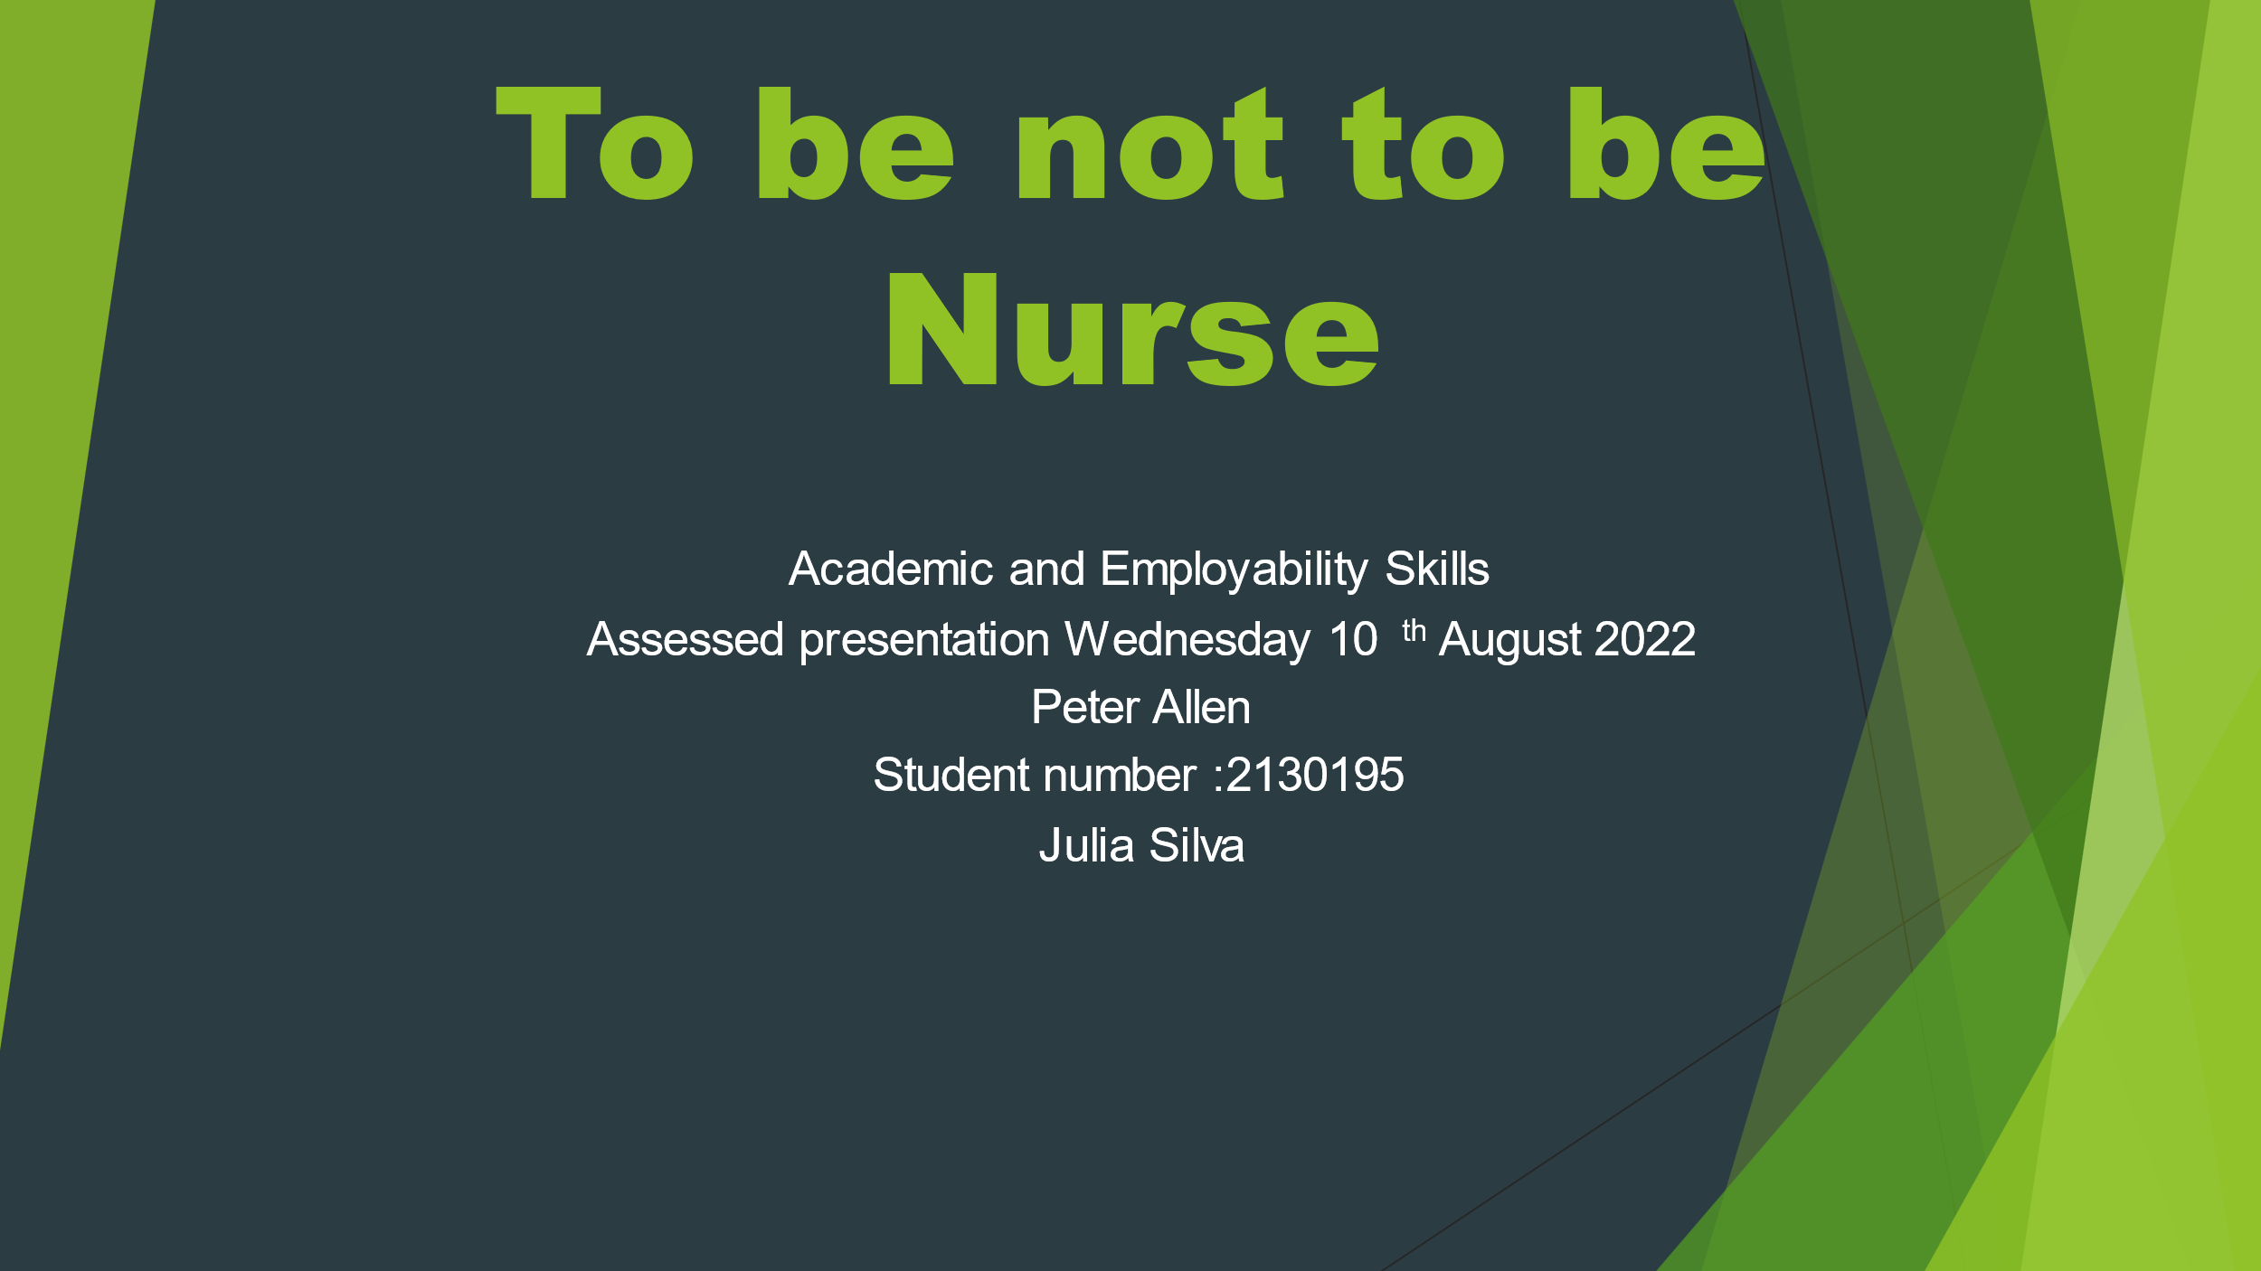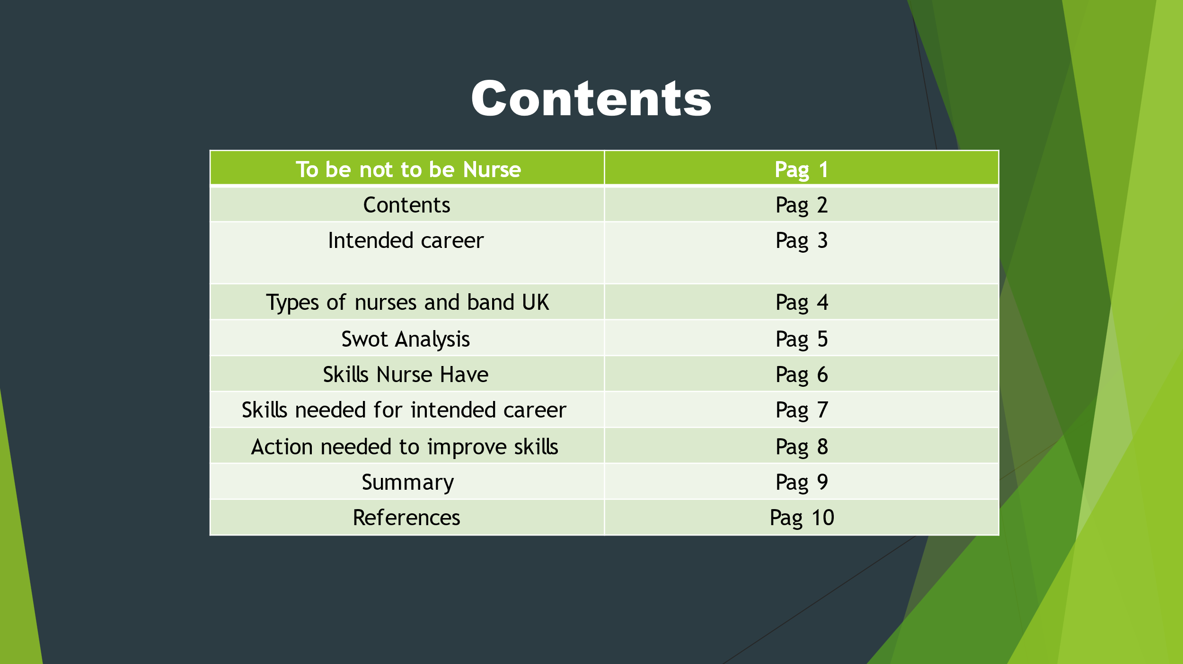
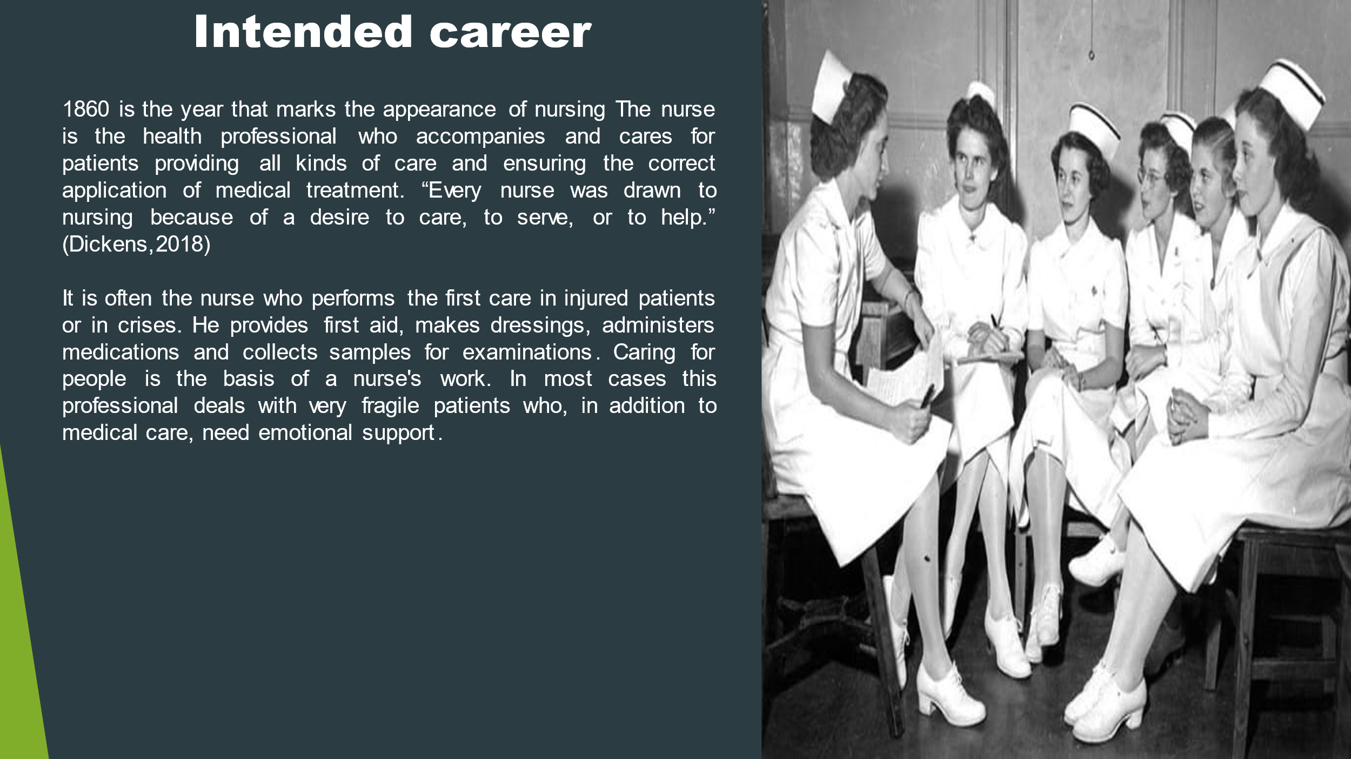
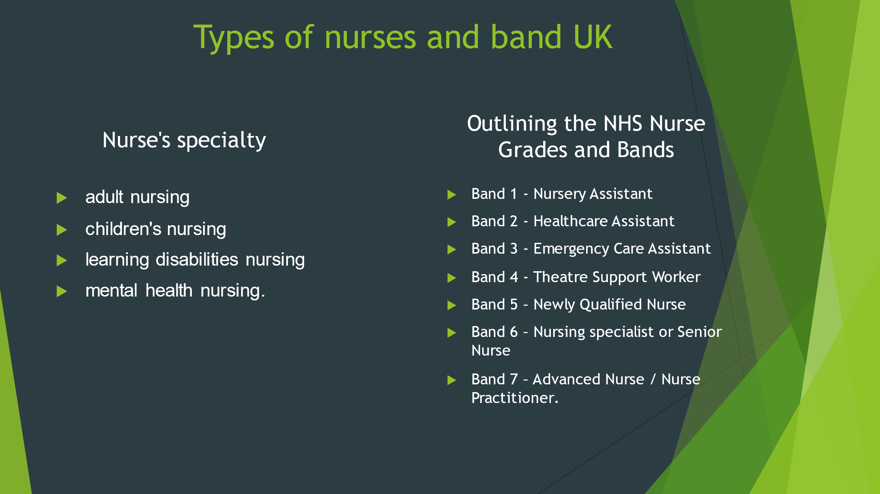
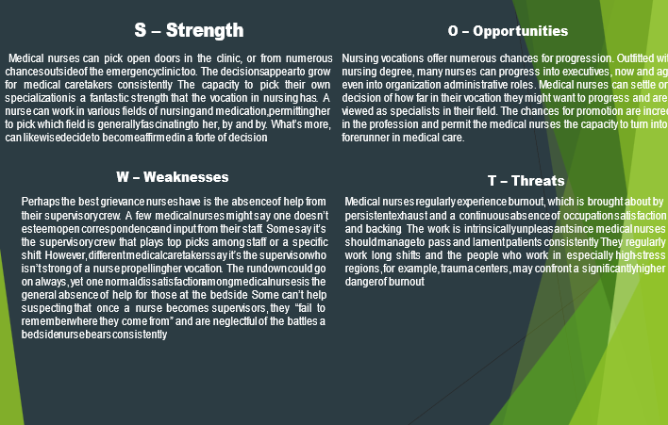
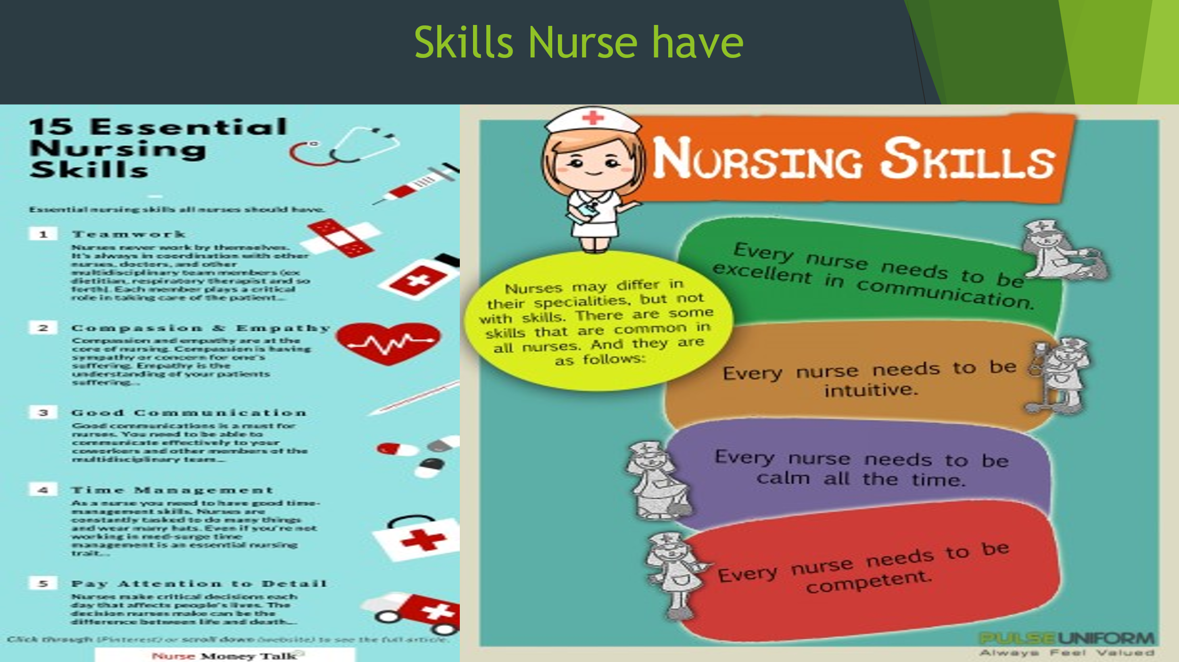
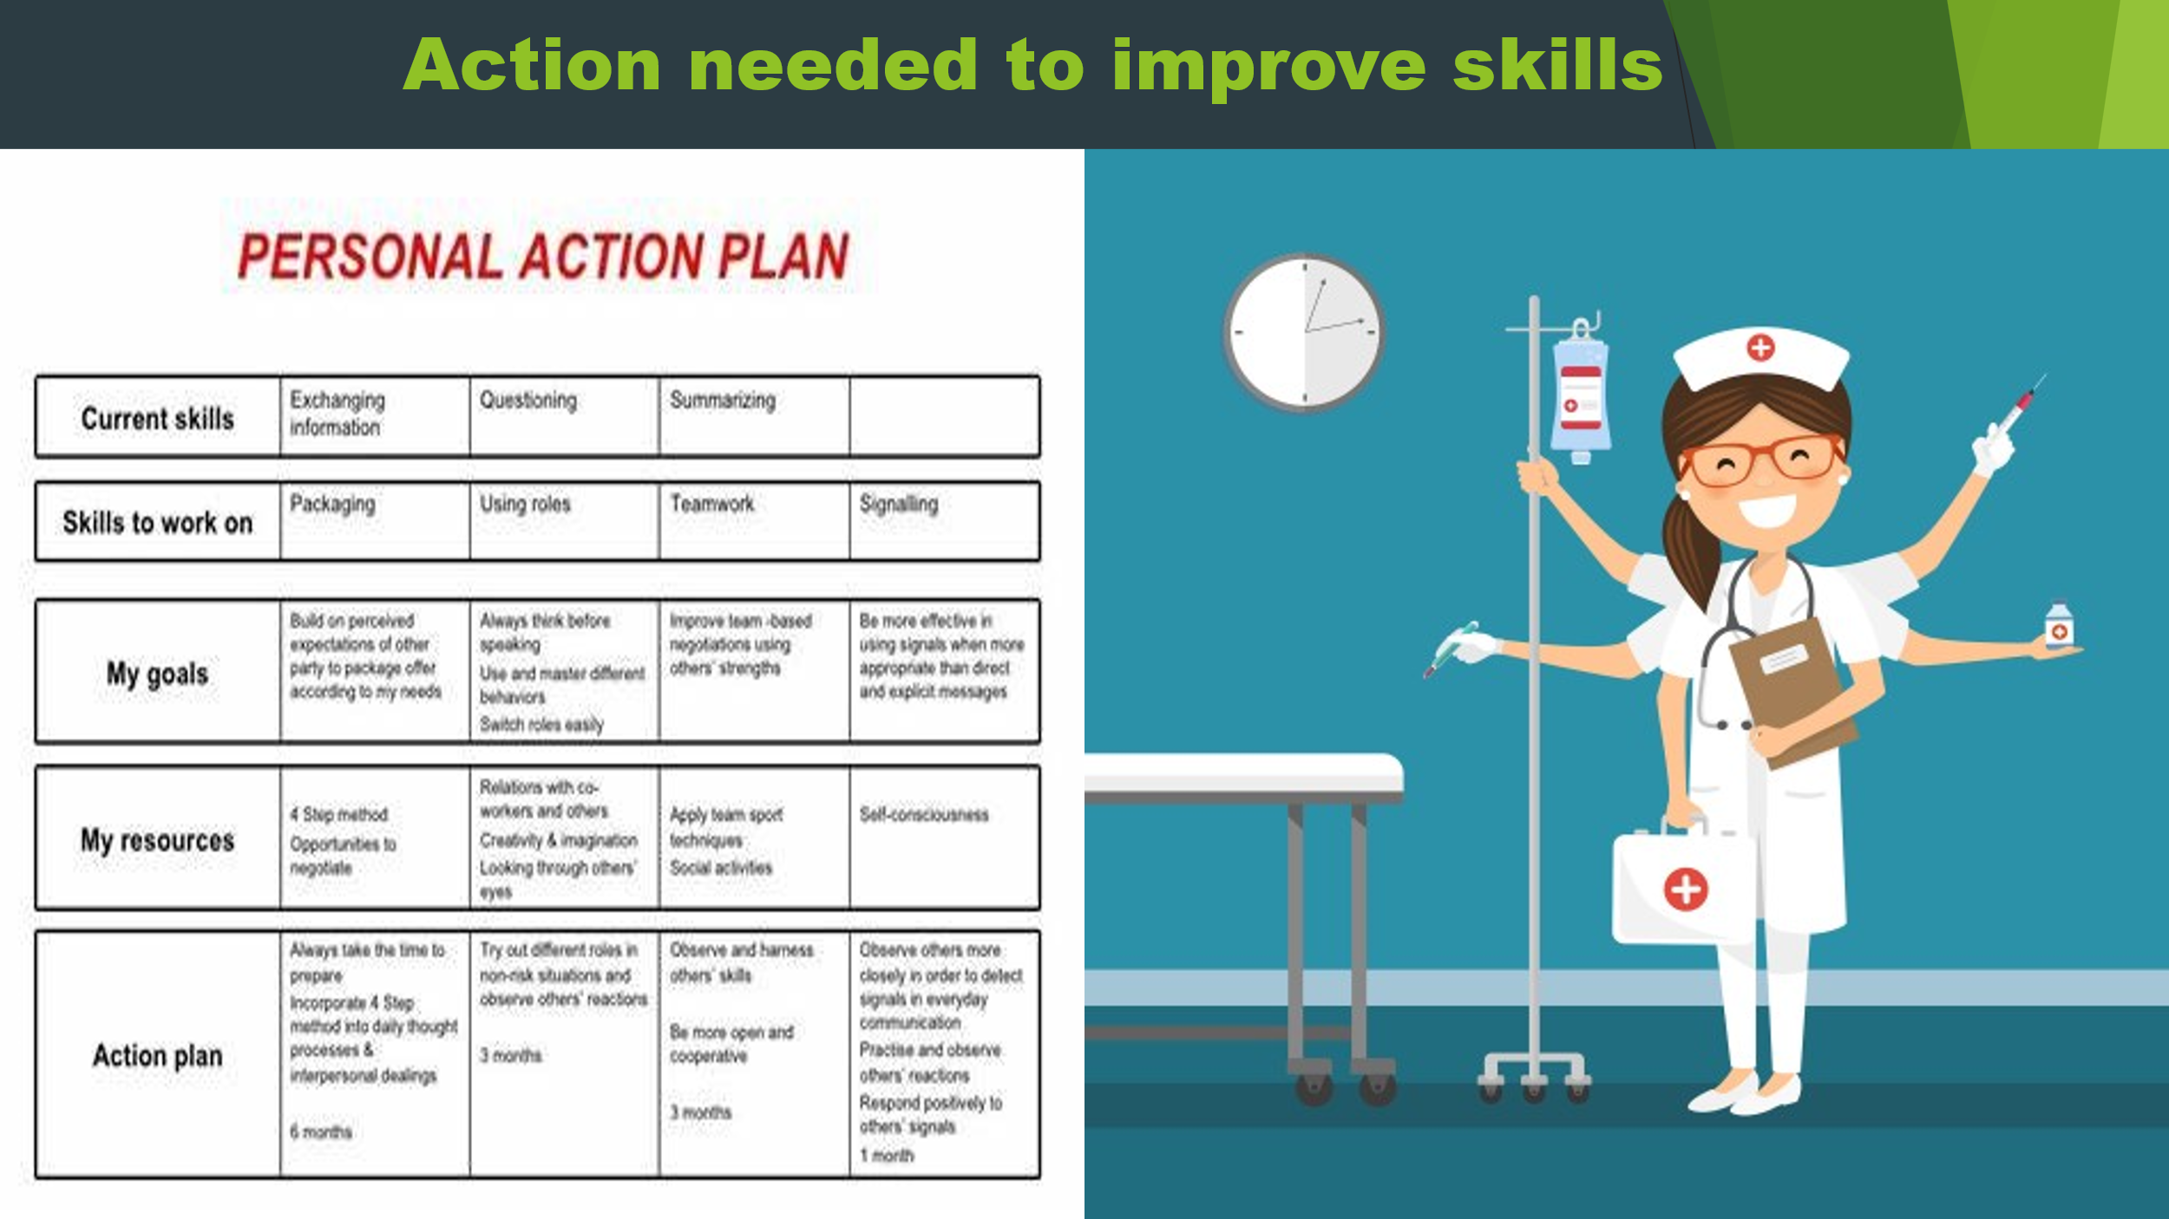
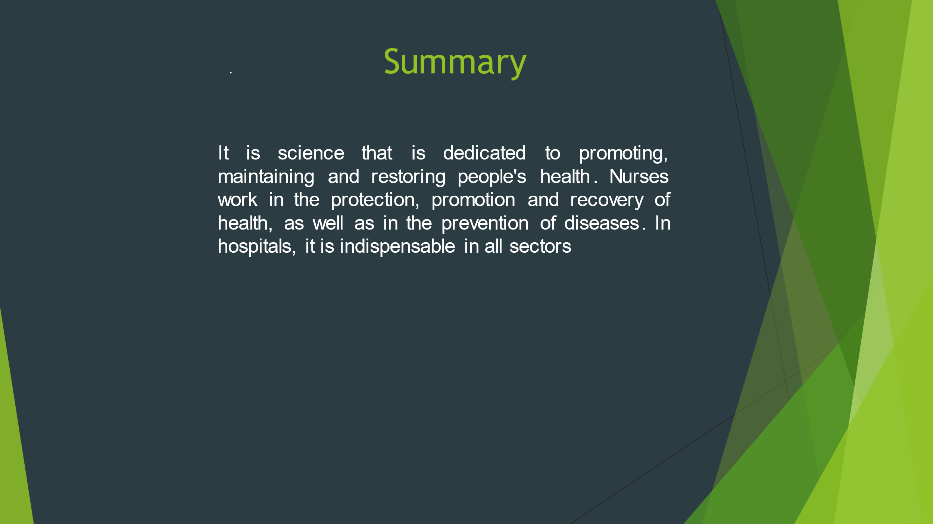
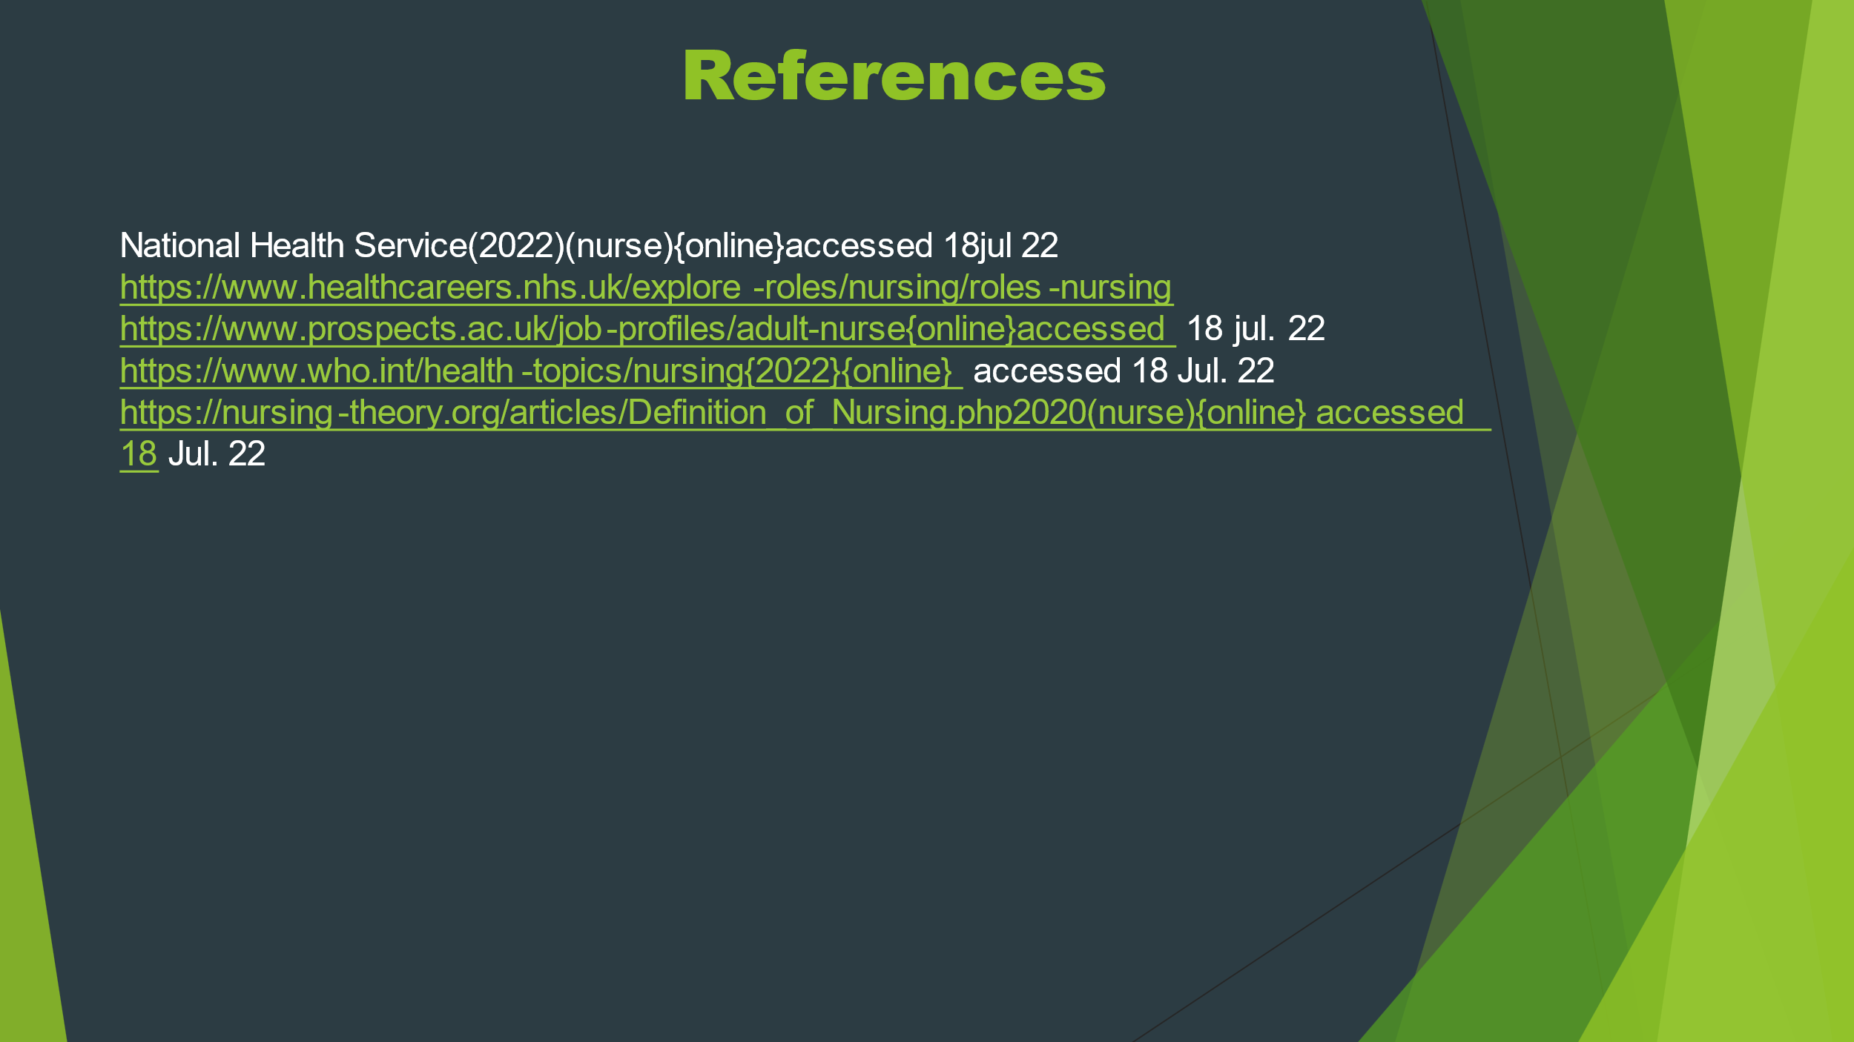
Making a presentation in front of an audience, regardless of the size of this, is a task that causes cold belly in anyone, whether experienced or novice. However, it is possible to decrease anxiety and control nervousness when preparing well before the occasion. After all, knowing how to communicate in front of an audience is indispensable. (Lincoln.)"It often takes more courage to dare to do right than to fear doing wrong." it was essential to study and know well the subject on which I intended to discuss. Before train in front of the mirror, (I’ll be crazy??).
it seems easy but as the English is not and my first language so made my presentation (lack of self-confidence) I'm very afraid to express myself to show my feelings. As Nobel Peace Prize Laureate Nelson Mandela would say, "the brave man is not the one who is not afraid, but the one who can overcome it." we can define communication in public as the transmission of a message to a receiver or more, in general, done in person. That is, public speaking does not mean speaking to a crowd, but rather exposing their ideas convincingly. To communicate in public efficiently, it is essential to remember that not only words, but everything we do conveys a message. the importance of attention to verbal and nonverbal communication our posture, tone of voice, gestures and expressions. even with all my fears and with such limited time. I was able to convey the message so desired, better than it was, never and late to reach the dream, age does not matter, have a career is significant, As Nobel Peace Prize Martin Luther King Jr would say “Climb the first step in faith. It is not necessary for you to see the whole ladder. Just take the first step”.
the first step I've already proved this and the beginning of this university course seems little but the doors are opening from me. continuing spoken of the experience of the present can show the defence in working to pay the bills or choose a career where I can make the difference where I’ll leave my mark here four years. I succeeded to enjoy the five minutes I’ll be given me, transmitted what had to convey the dream and passion of being a nurse. consciously or unconsciously the title of my presentation already showed what would be the mission was accomplished successfully not by clapping yes by the complements and expressions of my colleagues.

Conclusion

Learning how to speak in public is important for activities developed in various segments of professional and personal life. Acquiring knowledge and techniques in a practical and experiential way, self-confidence grow. Public speaking or presentation is the best way to develop communication and leadership skills, besides assisting in the development of self-esteem and convincing skills. Another benefit is to see also improve personal image, which results in being more socially accepted and recognized, not to mention that all this is very important for professional development and that it significantly, exponentially increases employability.
It is everyone's knowledge that one of the reasons for success in the professional field is the ability to speak well, to sell projects and ideas, to convince others of their way of thinking. In the academic world it is also noted how important it is and how it evolves better the one who improves the ability to speak well, also improving himself, improving his personality.

References

John, Carter, M., Hoffmann, T., & Glasziou, P. (Systematic reviews, 2015, Vol.4 (1), p.6-6). Better duplicate detection for systematic reviewers: evaluation of Systematic Review Assistant-Deduplication Module. England: BioMed Central.
Lincoln., U. S. 16 President of United States (n.d.).
Petre DRUCKER. (1967). The Effective Executive. New York: Harper & Row.
stoilov, T. (2012). Time Management. March 23rd, 2012.

