Academic And Employability Skills
BMSW4001
Chirea Cristina Elena
2026624
Module Leader: Sylvia Hoffmann

Task I
Introduction
Employability skills refer to the traits and core skills that are required to enhance the chances of employability in the current job market (Aliu et al., 2021). Therefore, these general skills are significant for an individual to get a job efficiently and perform excellently in the position concurrently. In this assignment will discuss the current skills of the author and the areas of development to increase the chances of employability rapidly. For that reason, the task will utilise SWOT, time management tool and PDP to analyse the strengths and weaknesses of the learner. This assignment will even represent the scenario of the world of work in the context of an HR manager.

SWOT
Strengths-
After attending a learning module, I have understood that adaptability, confidentiality, and organisation skills are my strengths. Since an HR manager needs to have the adaptability to work efficiently with employees from any background, my strong flexibility will make me the perfect fit for the HR manager profile. In addition to it, an HRM needs to keep the personal information of an employee confidential to maintain the privacy of the candidate. Therefore, my strong adaptability will make me appropriate to work in an organisation as an HRM and keep the privacy of the employees intact concurrently. My organisation skill is another strength that will help me leverage time and concentrate on multiple tasks simultaneously.
Weakness-
According to the feedback received from my peers, my communication, time management and team working skills are weak. As I will work as an HRM in a future organisation, poor communication kill can hinder me from establishing a robust connection with the employees. In addition to it, poor communication ability can even hinder me from getting the best employee for the company as well. An HRM must manage multiple tasks concurrently, and the activities even include finding the right candidate, screening the individual, training the person and so on. Therefore, poor time management skills will prevent me from performing multiple tasks concurrently. Moreover, my poor team working skills can hinder me from working efficiently with the team members.
Opportunities-
My good awareness of technology, and data-driven and analytical skills can be the opportunities to work as an HRM in the future workplace. Since HRM activities have become more technology-dependent, strong knowledge regarding technology will help me work efficiently as an HRM in the organisation. Moreover, efficiency in the technology field will even increase my adaptability to work in the organisation proficiently. Moreover, my data-driven skill will offer me a scope to work proficiently as an HRM in my future workplace. As my analytical skill is robust enough to work efficiently as an HRM, it can be another opportunity for me as well.
Threats-
According to the feedback received from my peers and senior authorities, my poor leadership, active listening and coaching skills can threaten my chances of employability. My poor communication and team working skills have threatened my leadership ability, and it will decrease my employability chances as an HRM. Moreover, my poor active listening skill will prevent me from listening to the positive and negative feedback from the employees. Moreover, my poor coaching skill will decrease my chances of employability as an HRM, since I will fail to guide the employees efficiently.
PDP
Specific | Measurable | Attainable | Reasonable | Time-bound
To improve communication skill | The constructive feedbacks from peers and higher authorities are the best way to measure the improvement of this skill. | Staying concise and clear regarding the speech can help an individual improve their communication skill efficiently (Coffelt et al., 2019). In addition to it, I will stay prepared before time while participating in a meeting or lecture, so that I can communicate with others efficiently. | Since I am preparing to work as an HR manager in the future, communication skill is important for me to establish a robust connection with the employees. | 3 months
To develop time management ability | I will measure my time-management skill by assigning myself multiple tasks and trying to complete all the work on time. | Avoiding distractions can be the optimal way to develop time-management skills (Sainz et al., 2019). Moreover, the utilisation of several time-management applications can be helpful for me to develop time-management skills. | Time-management skill is important for an HR manager as the person needs to handle multiple tasks concurrently (Augustine et al., 2018). From finding an appropriate candidate to train the employees, everything is the responsibility of the HR manager. | 5 months
To enhance team working skill | I will measure the improvement of this skill by comparing my team working performance with the pre-set goals. | I will attain the team working skills by establishing a positive mindset toward overall performance and productivity. Moreover, I will try to establish an enthusiastic environment so that every team member can perform efficiently. | As an HR manager, I need to develop team working skills so that I can work with the employees proficiently. | 7 months
To develop leadership skill | The best way to measure leadership skills is by performing as a leader in a real-time situation. | Practising discipline is the best way to attain leadership skills (Raghubir, 2018). Moreover, I will develop situational awareness and create an inspiring environment to help other employees work efficiently. | Leadership skill is significant for the HRM to enhance their performance and productivity simultaneously. Therefore, I will improve this skill to enhance my employability chances as an HRM. | 12 months
Table 1: Personal Development Plan
Time management tools
Time management skills are one of the most important abilities that was learned by me. To manage time, several tools were used by me which are designed to track and maintain time. I used a dairy planner to schedule the daily tasks that were assigned to me. I used the dairy schedule to plan my every day’s work efficiently. This tool was useful to maintain and helped me to keep a track of my personal time management skill development. I also ensured that each task was given a time limit. This is because putting a time limit to the tasks made me conscious about the deadline. Establishing a routine was essential as it put me in the habit of checking my dairy before the day started. I would tick off the tasks from the dairy that were completed. After finishing the task, I would ensure to re-check the dairy to ensure that my routine was correctly maintained. I was able to submit my assignments and homework on time. It also benefitted my overall performance in class. Calender was used as another effective tool.
It is a tool that I used to mark the dates and plan future tasks accordingly. Planning tasks for the future was extremely helpful as it kept me prepared for the upcoming tasks. This was useful as I could also plan vacations and fun activities since I already had information about class tasks. It was important to block out distractions as time management requires focus and patience. I also learned about note-taking software which was a beneficial tool to manage time. This tool was used to automatically take a note of daily tasks and align them with the time taken to complete each task. It helped me to track my speed and I could enhance my academic performance with this time management tool. This was an expensive software, and I did not use it for a long time. In my experience, the other tools were more affordable.
A time-tracker stopwatch was used by me as it enabled me to record the amount of work I did throughout the day. It was essential to record the energy I invest each day which was collected through the time tracker. Tracking the time is an important part of managing time as it provides information about the entire amount of time I utilise in a day. This tool was used for not just my academic lessons but also for any extracurricular activities I had in class. Time management was essential for the entire day including all the activities and group discussions that used to take place in class. A reminder notification alarm was useful for me to remember the deadlines for everyday assignments. I ensured to setup reminders in the alarm clock so that I do not miss out on important assignments. In my experience I found that this reminder alarm was highly advantageous as it helped me to stay focused and prepared for the upcoming tasks. I could also schedule my next tasks as I already set reminder for the previous ones.

Show an understanding of the world of work in the chosen sector by citing relevant articles or advice from recruitment agencies, job centres
Human resource management (HRM) is the chosen sector for understanding its application in the world of work. Modern business organisations put emphasis on the role of HRM as it the tool to recruit skilled human resource which is essential for the firms. In the view of Chinnappa and Karunakaran (2021), globalisation, privatisation and liberalisation have been the main reasons for organisations taking the approach of efficient hiring. Globalisation leads to internationalism that requires the HR management team to operate in an efficient manner. Businesses go beyond the domestic markets and requires hiring talented labours across the globe. The role of HR managing skills is necessary to ensure that talented individuals are recruited for increasing organisational performance. Productivity is enhanced by practicing the HR management process in a way that caters to both organisational and employee needs. On the other hand, according to Immaneni et al. (2021), HR practices are useful to measure organisational performance in relation to turnover. Profitability of an organisation is an important duty performed by the HRM team. It enables the firms to enhance employee performance and upscale business profitability.
The growth and expansion of an organisation is highly dependent on the HR management skills of the team. However, according to Szyjewski (2020), one of the fundamental responsibilities of the HR management team is decision making. This is because key decisions are often required to be made by the HR team. A leadership quality and communication skills are essential to possess by the HR to ensure that right decisions are made. The requirement of decision-making skills becomes more effective during critical situations. Making decisions that affect organisational structure and innovative plans is a critical task that the HRM needs to carry out with efficiency. Impact of decision-making skills is visible in the future performance of the business. it is essential to keep a focused mind to make right decisions that would not hamper the staff or organisation. On the contrary, in the opinion of Pandya (2019), mobile HR is the new trend in the organisational sectors. Several mobile applications like HRO mobile and HR Intouch are useful for the HR management team to provide easy access to the employees. It is necessary for the HR to ensure that employee issues and queries are answered.
Feedbacks from employees can be responded by using mobile applications. The HR management team can enhance the employee relations by integrating these applications that bring the staff closer to the HR team. This is because the HR management team is an important body in a firm that has the duty to resolve internal conflicts and maintain the work balance. As per, Mazurchenko and Maršíková (2019), HR is also essential as the team can help employees with their career growth. This is because a competent HR can retain star performers and ensure that company operations are executed with efficiency. The productivity level and customer services can be enhanced as HR can create a coordination between departments and motivate the staff to work towards organisational welfare.

Conclusion
The assignment has discussed the academic and employability skill of the author in the context of an HR manager. Moreover, the task has analysed the current skills and the areas of development of the writer to increase the future employability chances as an HRM. The assignment has even discussed the skills of the student through SWOT, PDP, and time management tools. The understanding of the world of work in the context of HRM has even been discussed here. The assignment has found that the student has strong adaptability, confidentiality, and organisation skill. However, poor communication and time management skill can prevent the student from getting employed in an organisation.
Academic And Employability Skills
BMSW4001
Chirea Cistina Elena
2026624
Module Leader: Sylvia Hoffmann

TABLE OF CONTENT:
- Introduction
- SWOT
- PDP
- Time Management Tools
- Show An Understanding of the World of Work
- Conclusion
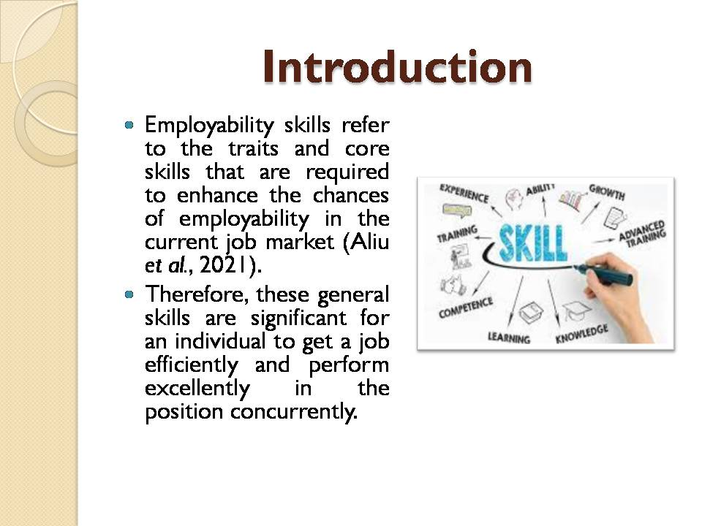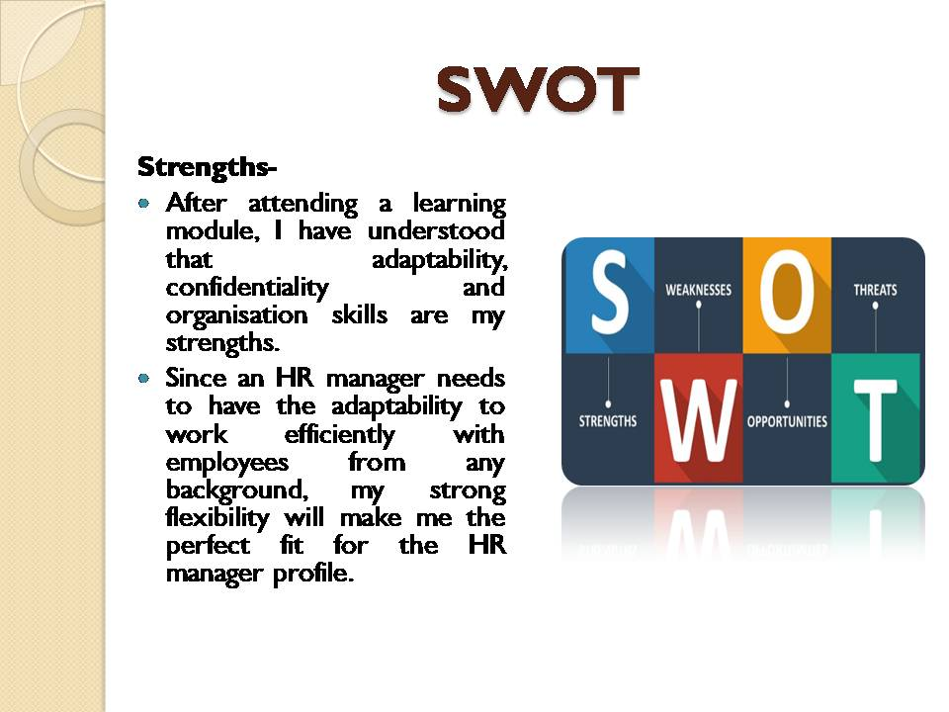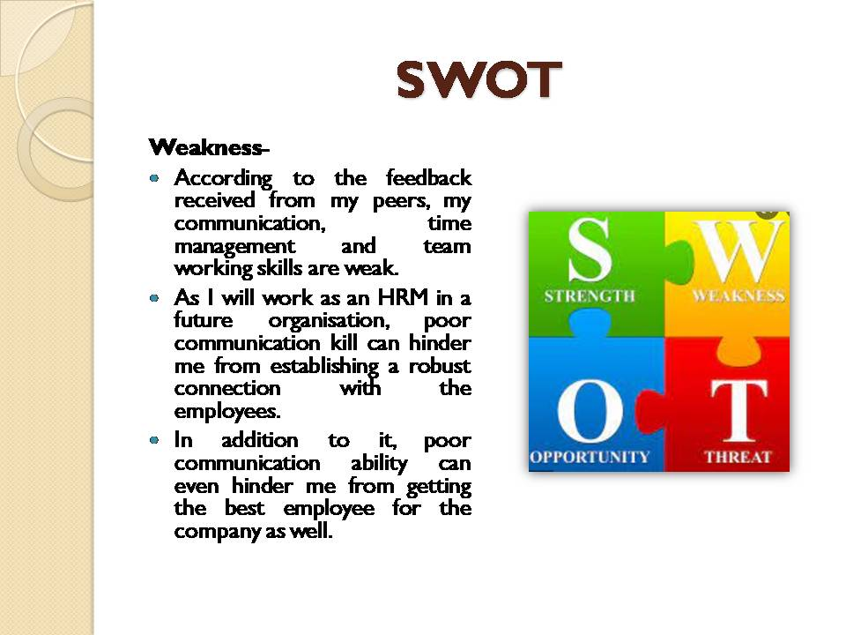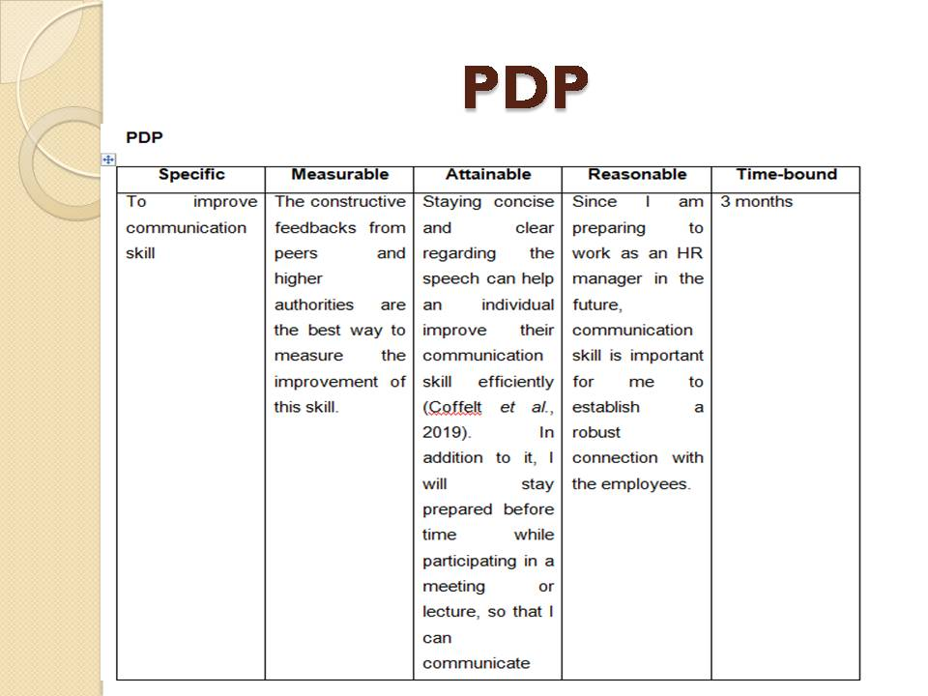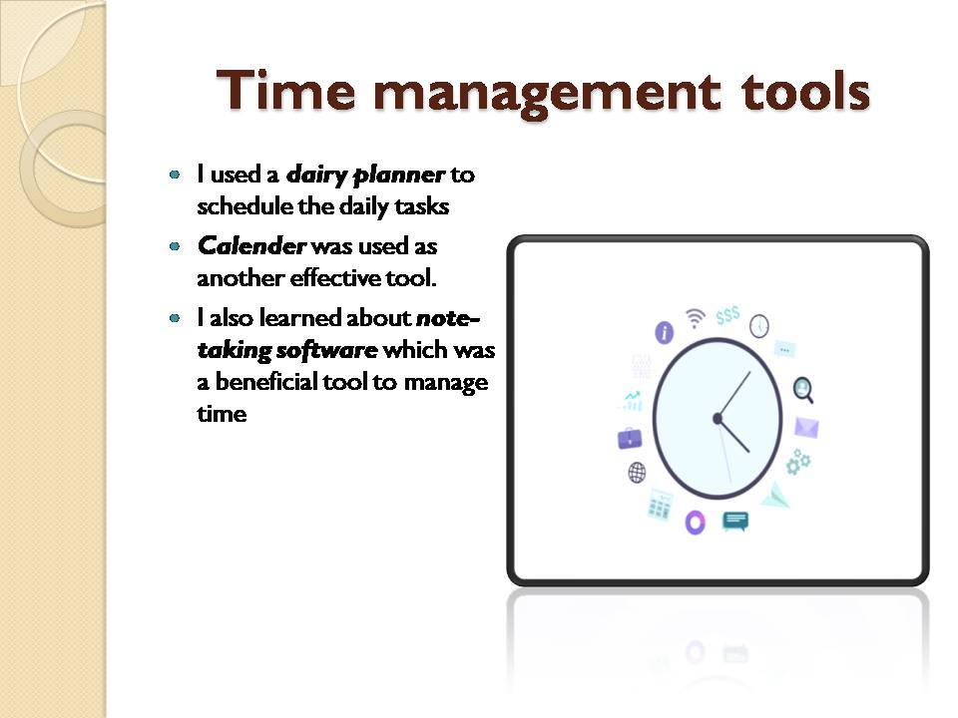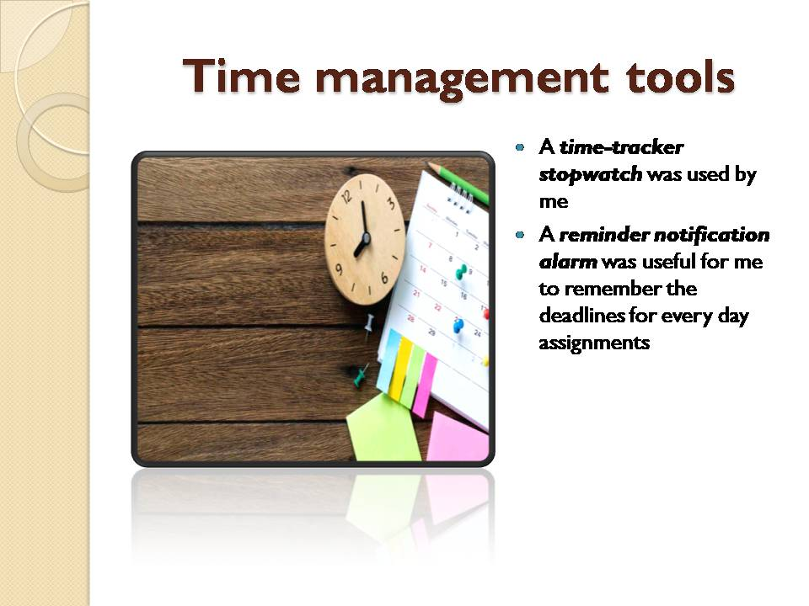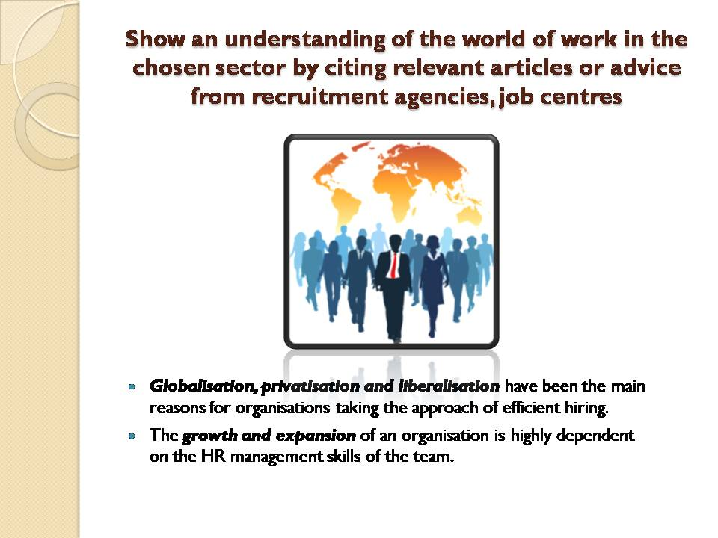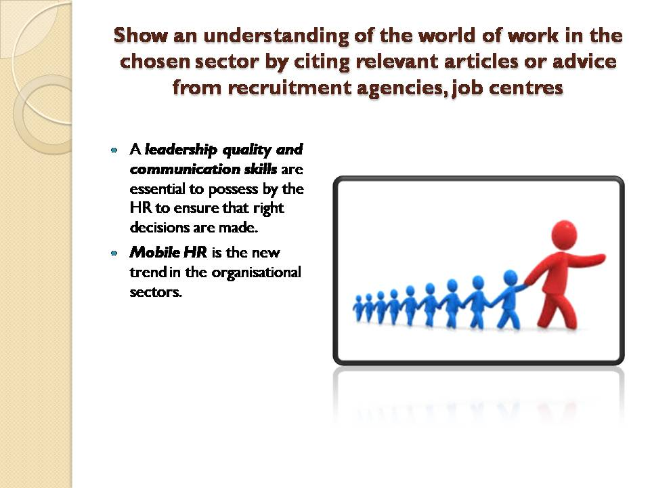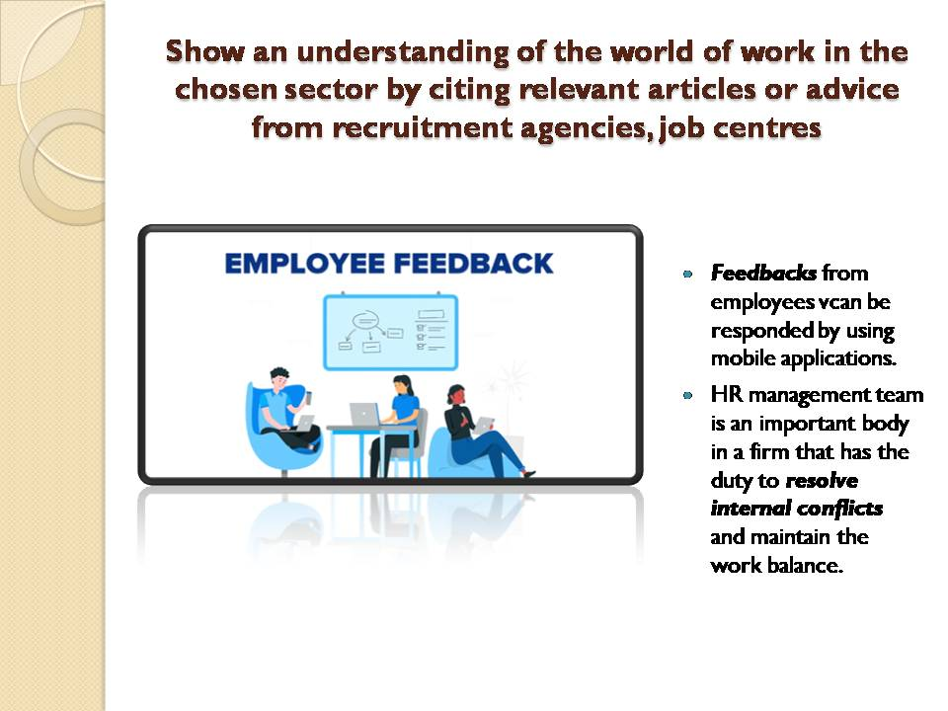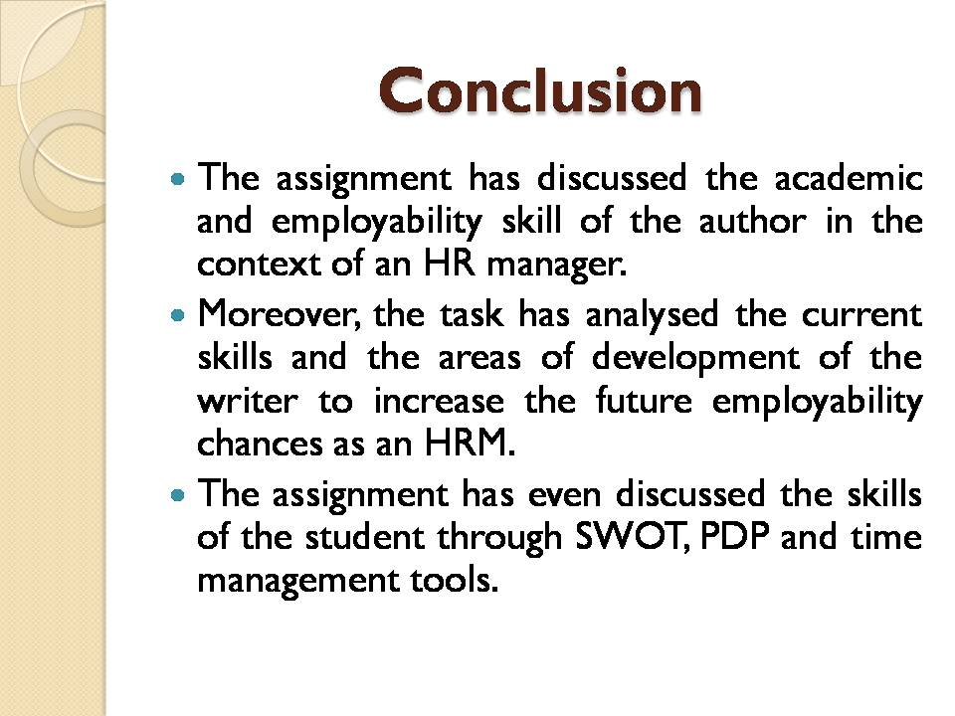
Reference list
Aliu, J., Aigbavboa, C. and Thwala, W., 2021. A 21st century employability skills improvement framework for the construction industry. Routledge.
Chinnappa, T.B. and Karunakaran, N., 2021. Global hr skills and competencies. 8(2), pp.75–77
Coffelt, T.A., Grauman, D. and Smith, F.L., 2019. Employers’ perspectives on workplace communication skills: The meaning of communication skills. Business and Professional Communication Quarterly, 82(4), pp.418-439.
Mazurchenko, A. and Maršíková, K., 2019. Digitally-powered human resource management: Skills and roles in the digital era. Acta Informatica Pragensia, 8(2), pp.72-87.
Pandya, B., 2019, April. A competency framework for virtual HR professionals in an artificial intelligence age. In Proceedings of the International Conference on Applied Research in Management, Business and Economics (pp. 27-48).
Raghubir, A.E., 2018. Emotional intelligence in professional nursing practice: A concept review using Rodgers's evolutionary analysis approach. International journal of nursing sciences, 5(2), pp.126-130.
Sainz, M.A., Ferrero, A.M. and Ugidos, A., 2019. Time management: skills to learn and put into practice. Education+ Training.
Szyjewski, G., 2020. A rapid preliminary skills diagnostics for supporting the decisionmaking process, on HR management example. Procedia Computer Science, 176, pp.2423-2433.

Task 2

Personal reflection
Executive summary
In this reflective report, a reflection has been drawn on 4 skills. Time management, cover letter writing, CV writing and public speaking skills have been reflected upon. Gibb's reflective model is used to draw the reflection for each skill. A detailed description, evaluation, analysis and improvement steps are given in the reflective report. The issues faced during learning these skills have been identified. Literary evidence has been used to support the usefulness of the skills. The personality development process has also been discussed by reflecting on each skill. The report aims to reflect on the learning of the student in the recent module. The purpose of this assignment is to analyse how the student can take the learning in the future for increasing employability chances. The report has found that CV writing skill is important for a learner to stand out from the crowd in the case of getting a job.

Introduction
Personal development skills are beneficial for class performance. It helps one to identify the progress of learning personality skills and can improve one’s ability to communicate and manage tasks efficiently. A personal reflection is drawn by using the Gibbs reflective model. This is one of the most efficient models for reflection. In this model, there are 6 steps namely, description, feeling, evaluation, analysis, conclusion, and action plan (Adeani et al., 2020). Each of the 4 skills is reflected upon by using this model. The 4 skills chosen are time management skills, CV writing skills, cover letter writing skills and public speaking skills.

Time management
Description
During the class performance, I observed that time management was one of the most important skills. Time management skills helped me to complete tasks within deadlines. It enabled me to save time for myself as the lessons and homework were completed sufficiently. I also observed that time management skills were gradually developing as I progressed more with my lessons.
Feeling
Practicing time management skills made me feel highly encouraged and motivated. I was performing tasks in class with efficiency. It made me stand out from my peers and provided me with more self-confidence. Managing time felt like a useful skill for not just class work but overall life. I realised that time management skills help us to multitask without compromising on quality. It was a learning experience while practicing and developing my time management skills.
Evaluation
Time management skills were initially difficult to practice. This was because I was unable to manage time to finish daily class lessons. I learned that using a personal timetable and mental calculation were useful tools. Time management is dependent on both cognitive and daily life aspects (Afsaneh et al., 2019). I provided deadlines for each task to ensure that I can complete my lessons on time. Mental calculation helped to accelerate the process of tracking time. Each task was tracked based on the individual time it took me to complete them. This was useful as I could understand my speed of managing time.
Analysis
I used a personal timetable that was a useful tool to identify my progress in learning time management skills. In my observation, I found that time can be managed efficiently when the mind runs faster in time than the actual real-time. For instance, when it was 15 minutes to 2 pm, my mind was thinking it was 5 minutes to 2 pm. This helped me to manage my time according to 5 minutes and not 15 minutes. I found out that I finished the task before the deadline and saved extra time for myself to do other tasks. The skills of time management were extremely beneficial for me as they enhanced my academic performance and personal growth.
Conclusion
I can conclude that time management skills take time to develop. It is a long process as one learns the skill along the way. Applying time management skills was highly advantageous to speeding up my daily assignments and saving time to complete more work. I could perform better in class and stand out from my classmates.
Action plan
Time management skills can be improved for my future performance in a class by implementing some action plans. I would maintain a schedule right from the beginning of a new session in class. This would help me to plan my timetable from day one. I would also start putting extra useful tasks in the places where I save extra time. It would enable me to complete the next day's tasks earlier and later, I can have time for relaxation and fun.
CV writing
Description
As a student, I attended the learning module with my friends and professor. In the classroom, there were 20 students along with our professor and everyone was excited to learn about the CV writing procedure. Since the CV writing skill is an important ability to enhance an individual's chances of employability, the overall outcome of the learning session was successful and significant for us to achieve our academic milestone. As per my expectation, I wanted to become this learning module a successful one as the CV writing skill can enhance my ability to work as an HR manager in the future. Moreover, this skill will even escalate my performance and productivity in the future workplace.
Feelings
During the learning module, I was excited and thrilled to know about the CV writing technique from the experienced professor. Since an excellent CV helps an individual stand out from the crowd due to the efficient illustration of the education, work experience, strengths, and passion, it is an important academic and employability skill for a learner. However, my excitement even increased massively after the completion of the learning module as I became able to craft excellent CVs efficiently. Even now, whenever I think of the outcome of the learning module, I feel satisfied to learn CV writing proficiently.
Evaluation
CV writing skill is complicated employability and academic skill as the first impression of a job aspirant depends on his CV (Derous and Ryan, 2019). Therefore, a person needs to have the proper analytical skill to write down an excellent CV that makes the candidate look appropriate for the job. However, my poor analytical skill primarily hampered me from writing down an excellent CV that makes me look perfect for the HR manager role. However, with the assistance of constructive feedback from my peers and professor, I overcame this weakness and started writing a perfect CV following modern guidelines.
Analysis
Analytical skill is significant for an individual to write down an appropriate CV (Menggo, 2018). If a person has poor analytical skills, the individual cannot decide what to put on the CV and how to present the Curriculum Vitae to attract the attention of employers. Therefore, due to my poor analytical skill, I struggled for the first few days to learn CV writing proficiently. However, my fast-learning ability made me learn this skill proficiently.
Conclusion
After receiving constructive feedback from my peers and professor, I comprehended that my analytical and communication skills are poor to develop my CV writing skill efficiently. Therefore, if I would have improved these abilities, the overall experience of learning CV writing could be better as well.
Action plan
After the completion of this learning module, I understood that I need to improve my analytical and communication skill to enhance my CV writing skill smoothly. Therefore, I will start analysing a project or framework before starting it. in addition to it, I will take the help of some analytical tools that will assist me in improving my analytical and CV writing skills concurrently.
Cover letter writing
Description
Cover letter writing was taught to us in class as an important skill for the professional field. There were 20 of my peers along with me and the teacher who participated in this lesson. Having the skills of cover letter writing was new learning as it was something I did not know about in the past. Cover letters are essential in the pursuit of professional achievement(Phan and Socciarello, 2020). In my experience of learning about cover letter writing skills, I observed that the key feature of a good cover letter is that there should be authenticity and logic involved in it. This helps a cover letter stand out from others.
Feeling
Learning the skills of cover letter writing was a fun experience for me. This was because my peers and I exchanged our initial attempts at writing our first cover letters. I learned from my peer's works about the drawbacks in my letter. The cover letters written by my peers also highlighted the strong points in my cover letter. My cover letter was appreciated by the teacher that made me feel happy and inspired me to excel in this skill. Writing cover letters made me feel more aware of myself as I had to analyse my qualities to write an efficient cover letter.
Evaluation
Cover letter writing skills is extremely useful as it helps to make a normal CV stand out from competitors. I noticed that there were key terms like mentioning my quality that aligns with the job role I might be applying for, which was essential. This is because every job has different requirements that the recruiter looks for in candidates. I observed that a cover letter needs to highlight the best quality of the individual by showing a valid relationship with the job requirements.
Analysis
The skills of writing a good cover letter developed smoothly in me. My teacher informed me that my language was of high quality which made my letter meaningful and effective. I also noticed that writing a cover letter required a good level of personal awareness and analysis. This is because covering key points about oneself required one to have the utmost knowledge about oneself.
Conclusion
It can be concluded that my experience of cover letter writing skills was good. I enjoyed practicing this skill as it made me learn about myself. It also helped me to identify my drawbacks that can be enhanced. I also learned that a cover letter is essential and needs to be provided with a CV as it can increase the chances of getting selected for the job.
Action plan
To improve my future implication cover letter writing skills, I will read more books. This is because it would increase my knowledge about good language and vocabulary which are important to writing an efficient cover letter. I would also practice writing more letters for various job roles and get it checked by the teacher to improve my ability to write a cover letter for any job role.
Public speaking and giving presentations
Description
Public speaking and giving presentation skills were learned by myself. I had to present various projects and PowerPoint presentations in class. It helped me to build confidence in public speaking. I was able to speak with confidence and clarity during presentations or group discussions.
Feeling
I felt nervous at first as initially, I had stage fear. Although, as time progressed, I began to push myself and my peers were supportive in this process. I felt motivated and appreciated as my skills in public speaking were excelling.
Evaluation
Practicing public speaking, I gained more recognition and was known for being a good speaker. Public speaking is an important language and communication skill that influences personal and professional life areas (Kinasih and Olivia, 2022). The ability to speak and present publically shed light on my inner strength and I did not have the stage fear anymore.
Analysis
The skills of public speaking enabled me to communicate with articulation and effectiveness. It made my presentations score high marks. I could also represent my class in various Intra speaking competitions. I learned that public speaking is a highly useful skill that every individual needs to possess.
Conclusion
I can state that in my experience public speaking was one of the most beneficial skills that I learned. It is a skill that I use in the professional field as well. The skills of holding the confidence in front of the public make me more confident and competent at my work.
Action plan
I would like to improve my stage fears by ensuring to meditate daily. Meditation can help me to stay more focused and calmer. I would take part in debates and quizzes to enhance my public speaking and giving presentation skills.

Conclusion
It can be concluded that time management, cover letter writing, CV writing and public speaking are important and beneficial skills. Time management skills can be improved by maintaining a timetable. While I would work on my language and vocabulary to enhance my cover and CV writing skills. To improve public speaking skills meditation is useful. I would also continue to take part in competitions for public speaking skills. These skills helped me to enhance my class performance and grow my personality. Skills are also useful for my professional practices. I can utilise these skills for future performance in class and professional fields.

References
Adeani, I.S., Febriani, R.B. and Syafryadin, S., 2020. USING GIBBS’REFLECTIVE CYCLE IN MAKING REFLECTIONS OF LITERARY ANALYSIS. Indonesian EFL Journal, 6(2), pp.139-148.
Afsaneh, H.R., Gunnel, J., Suzanne, W. and Kajsa, L.H., 2019. Time management skills in relation to general self-efficacy and parental sense of competence in individuals with and without cognitive disabilities. Cogent Psychology, 6(1), p.1655981.
Derous, E. and Ryan, A.M., 2019. When your resume is (not) turning you down: Modelling ethnic bias in resume screening. Human Resource Management Journal, 29(2), pp.113-130.
Menggo, S., 2018. English learning motivation and speaking ability. Journal of Psychology and Instruction, 2(2), pp.70-76.
Phan, N.H. and Socciarello, M., 2020. Using Corpus Analysis to Teach Cover Letter Writing through Data Driven Learning in EFL/ESL Classrooms (Vol. 18), pp.1-36. TESOL Working Paper Series.

