

APPENDIX QE1a

MODULE REVIEW

MODULE TUTOR - REPORT FORM

The review of a module is carried out initially by the Module Tutor. When the module review is completed, its findings are considered by the Head of School or Programme Director and noted at the School’s Annual Programme Review. Module feedback and what changes will be made as a result of the feedback given are also discussed at Staff Student Consultative meetings. This form is not compulsory but is provided to support the module review process.

Academic Session: 2018-2019

Module Title: Major Project

Module Code: TBA

Student Feedback

Number of students registered and eligible to complete the questionnaire: 11

Number of returns: 10

Legitimate issues/ positive comments raised by a significant number of students (Please note number of students).
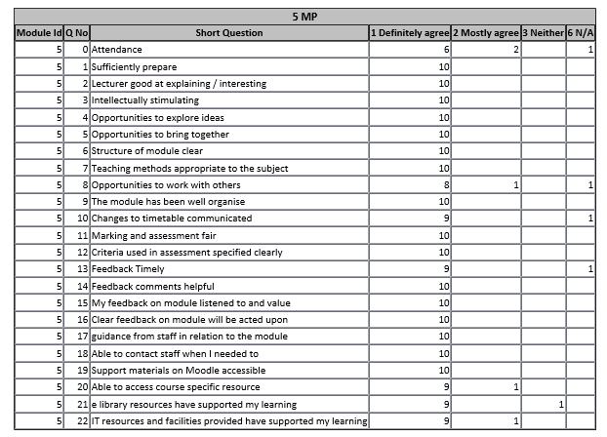

Are there any sections or questions where the majority of students indicate that they ‘mostly or definitely disagree’ or where the results are well below the scores for other sections?

No

Module Tutor’s response to feedback given by students

18 out of 23 questions were answered as “Definitely Agree” or “N/A”
2 out of 23 questions were answered as “Definitely Agree” or “Mostly Agree”

2 questions - “Opportunities to Work with Others” and “Attendance” do not apply to this module so can be ignored

Only 1 student answered “E library resources have supported my learning” as “Neither” – I believe this is an error by the student, since the resources available are excellent.

Tutor Self-Reflection

In what way might the module be improved in terms of content, delivery and assessment as a result of the feedback given? What (if any) changes will be made?

I have taught this module for 4 years and despite my efforts, I have noticed some students are producing excellent Literature Reviews, but poor Evaluations and Conclusions. I am therefore going to spend more time on the delivery of these skills in the Project Management and Research Methods Module. I will also continue to encourage students to follow their time plans in order to have the time required to complete these sections.

How will any changes made to the module as a result of feedback be communicated to all the students that took this module?

I have already communicated the changes I will be making to the module with the students as it was discussed in their final session

Module Tutor: J Adams Date: 15/5/2019

Head of School/
Programme Director: ……………………………………… Date: ……………………

