
11/18/2025

Trinity saint david University of Wales (London Campus)
IWD : Database Design and Development
Assignment 01
Module NaMe: Introduction to Web and Database Concepts
Module Code: ACCA 4023
Lecturer: Suneth Fernando
sTUDENT nAME: ODIRLEI COTRIM RIBEIRO
STUDENT ID: 2442401
group: 2

Table of content

Introduction to the case study
To meet the request of the local authority, a robust database solution will be developed and implemented for the management of an alternative ecological transportation system called EcoRide.
This system will be based on the rental of electric bicycles, a means of transport that aims to reduce the use of internal combustion engines, thus decreasing air pollution and improving the quality of life of users. This project will include quick and practical bicycle rental and return at designated stations, as well as geolocation management, maintenance, usage control, and improved project efficiency, providing accurate reports on system utilization.
All of this addresses the current manual and imprecise methods, which lead to incorrect management of the enterprise. The new system will be able to generate accurate reports in real time and consequently improve company management.

Task 1 — Practical Implementation

1.1 SCENARIO ANALYSIS
The EcoRide service connects riders, electric bikes, staff members, and various operational processes. Although the current paper-based workflow allows the system to function at a basic level, it introduces several complications that limit the effectiveness and visibility of the scheme.
A structured database is needed not only to standardise data entry but also to organise how the different parts of the system relate to one another. To design such a system, it is necessary to identify the core entities and the attributes that describe them. Riders, bikes, staff, rentals, and maintenance actions represent independent components of the EcoRide ecosystem, yet they are tightly connected through daily operations. By treating each component as a separate entity, the database can support clear relationships that reflect how the service works.
Riders are essential because they initiate most system interactions by renting bikes. Their identifying information (such as ID number, contact details, and name) allows the system to match users to their rental activity. Bikes, on the other hand, represent physical assets that move through different states available, rented, or under repair. Recording details such as bike type, current condition, and location allows staff to understand fleet performance and predict maintenance needs.
The Rental entity links riders to bikes and provides a timeline for each hire. It captures when the rental started and ended, where the bike was picked up, where it was returned, and the cost or duration associated with that rental.
The Maintenance record entity stores information about inspections, faults, repairs, and future service requirements. This ensures the team can track which bikes have unresolved issues and which ones are safe to use. To ensure accountability, Staff members who carry out these tasks are also represented as an entity. This allows the system to log who performed each check or repair, which is important for operational transparency and organisational planning.
Understanding how these entities interact also helps identify potential bottlenecks.
Overall, the analysis shows that a well structured database improves efficiency by consolidating scattered information into a single, consistent system. This enables EcoRide’s management to monitor the service more effectively, reduce errors caused by manual processes, and generate meaningful reports on usage, fleet condition, and maintenance workloads.

Entity Relationship Diagram (ERD):

The ERD provides a visual representation of how data flows through the EcoRide system. Its purpose is not only to map the entities and their key attributes but also to clarify how each entity interacts with the others during day to day operations. A well designed ERD forms the blueprint for the database structure and ensures that the system can support accurate, consistent data handling.
The EcoRide system revolves around five central entities—Rider, Bike, Rental, Maintenance Record, Station and Staff. Each entity represents a distinct area of activity within the operation:
- Rider captures user information and plays a crucial role because every rental transaction begins with a rider.
- Bike represents the core assets of the service; each bike must be tracked carefully to avoid double bookings or availability confusion.
- Rental acts as the linking mechanism between riders and bikes. It documents each rental event and helps the organisation monitor usage patterns and system performance.
- Maintenance Record ensures operational safety and service quality by tracking inspections, repairs, and technical issues.
- Stations of EcoRide are displayed the postcode, address, and location point. Every rental has a beginning and an end.
- Staff members are directly linked to maintenance activities, providing accountability and transparency in the workflow.
The relationships between these entities use standard cardinalities:
- One Rider → Many Rentals
- One Bike → Many Rentals
- One Bike → Many Maintenance Records
- One Staff Member → Many Maintenance Records
- One Station → Many Bikes
This structure allows the database to handle common operational tasks such as checking which bikes are available, retrieving the full rental history of a rider, or determining which staff member performed a particular repair. The ERD provides the foundation for constructing a properly normalised relational database that reduces redundancy and allows efficient, accurate querying.
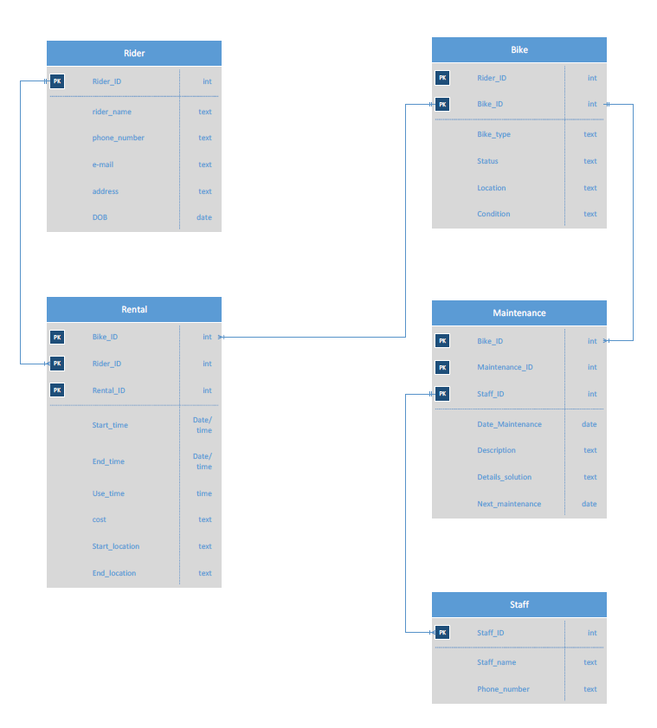
Figure 1.2 – ERD Diagram (Visio)

Data Structure Development
Based on the ERD, each entity becomes a database table with carefully selected attributes, data types, and constraints. The purpose of this stage is to transform the conceptual design into a practical structure suitable for implementation in a relational database system.

Rider
RiderID | INT
Name | TEXT
PhoneNumber | TEXT
Email | TEXT
Address | TEXT
DOB | DATE

Bike
BikeID | INT
BikeType | TEXT
Status | TEXT
Location | TEXT
Condition | TEXT

Rental
RentalID | INT
RiderID | INT
BikeID | INT
StartTime | DATETIME
EndTime | DATETIME
UseTime | INT
Cost | TEXT
StartLocation | TEXT
EndLocation | TEXT

Maintenance
MaintenanceID | INT
BikeID | INT
StaffID | INT
Date | DATE
Description | TEXT
Details | TEXT
NextMaintenance | DATE

Staff
StaffID | INT
StaffName | TEXT
ContactNumber | TEXT

Station
StaffID | INT
StaffName | TEXT
Role | TEXT
ContactNumber | TEXT

This structured layout ensures controlled data entry, consistency across operations, and reliable relational links between entities.

Type of Relationship between Entities (please explain each relationship with appropriate examples from the case study.)
When a single record in one table is connected to a single record in another table, this is known as a one-to-one relationship. Its happening in a Rent table.
In the EcoRide database, the “one-to-many” relationship is the most prevalent. For instance, over time, a single rider may have numerous rentals.
The final database does not contain a direct many-to-many relationship. Rather, linked tables are used to solve it. It would be many-to-many, for instance, if riders could join several locations and locations could have numerous riders. In this instance, the Rent table, which is located in the centre, resolves the issue.

Entities interact within the database
The entire bike rental process is supported by the interactions between the entities in the EcoRide database. Although each entity holds a distinct kind of data, they are linked by primary and foreign keys. The system may function as a single, cohesive structure thanks to these linkages.
Because each rental needs to be associated with a particular rider, the Rider entity communicates with the Rent entity. This makes it easier for the system to maintain a complete record of who used particular bike and when. Since a rental cannot take place without a bike, the Bike entity also communicates with the Rent entity. The system is able to monitor each bike's usage through this contact.
Because each rental has a single payment record, the Rent entity communicates with the Payment entity. This enables the business to verify whether and how much the rental was paid. Additionally, the Bike entity communicates with the Maintenance entity. A maintenance record is made and connected to a bike whenever it needs maintenance or repairs.
Lastly, since a staff member completes every maintenance task, the Staff entity communicates with Maintenance. These interactions demonstrate the system's data flow and the interdependence of the entities.

1.3. DATA STRUCTURE DEVELOPMENT

The ERD served as the primary guidance for the creation of the EcoRide system's data structure. In Microsoft Access, each entity from the diagram was created as a separate table. Each table includes a primary key that aids in the identification of every record. To provide the proper connections between tables, foreign keys were inserted. The database functions more clearly and systematically thanks to this structure. Information on service users is kept in the Rider table. RiderID, first and last names, phone number, email address, and ID number are among the fields it contains. The primary key is RiderID.
Every electric bike is detailed in the Bike table. BikeID, kind, model, condition, availability, and notes are all included. The primary key is BikeID.
The rental point data is kept in the Location table. LocationID, place name, address, and postcode are all included.
Every rental operation is documented in the Rent table. RentID, RiderID, BikeID, start and finish locations, rental date and time, and hours are all included. To link this table to Rider, Bike, and Location, RiderID, BikeID, and LocationID function as Foreign Keys.
The rental fee information is stored in the Payment table. PaymentID, RentID, hours worked, total cost, and payment status are all included. The foreign key that links payments to rentals is called RentID.
Information regarding maintenance and repairs is kept in the Maintenance table. MaintenanceID, BikeID, StaffID, service date, service type, and fee are all included. Information on the employees who inspect and fix the bikes is included in the Staff table. First name, last name, position, and StaffID are all stored there. This structure facilitates accurate linkages between all components of the system, keeps the database clear, and minimises errors.

1.5 — SAMPLE DATA POPULATION
After creating the tables and setting all Primary and Foreign Keys, I added sample data to the database. The sample data is based on the EcoRide scenario and shows how the system works in real life. Each table contains at least five records. This helps to test the relationships, queries and reports in Microsoft Access.
Several users with names, phone numbers, and ID documents are shown in the Rider table. A variety of electric bikes in various sorts and states are displayed in the bike table.
The system's rental points are shown in the Location table. Examples of bike rentals made by riders are listed in the Rent table. Each rental's cost and if the payment has been made are displayed in the payment table. Sample service records for the motorcycles can be seen in the Maintenance table. The employees who inspect and fix the bikes are included in the Staff table.

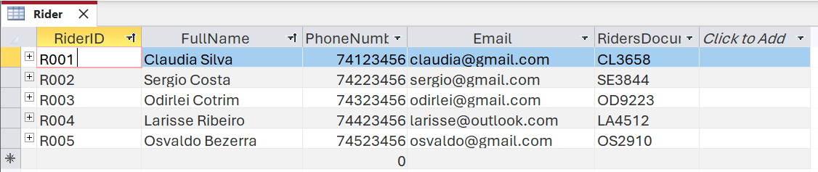
Figure 1.5.1 – Rider Table

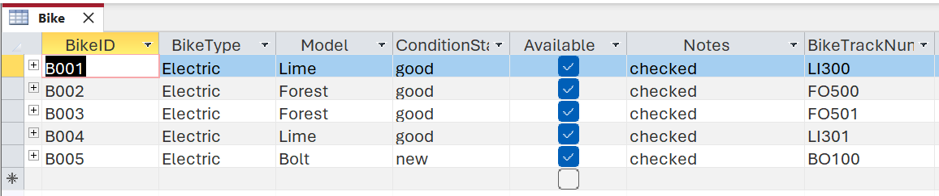
Figure 1.5.2 – Bike Table

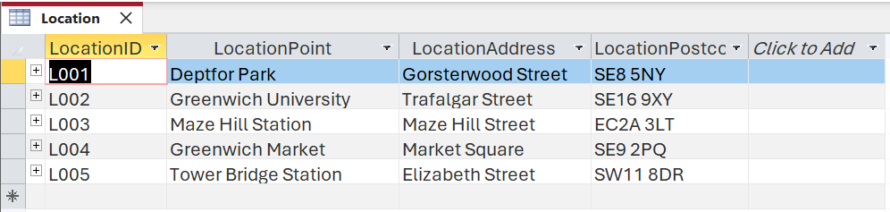
Figure 1.5.3 – Location Table

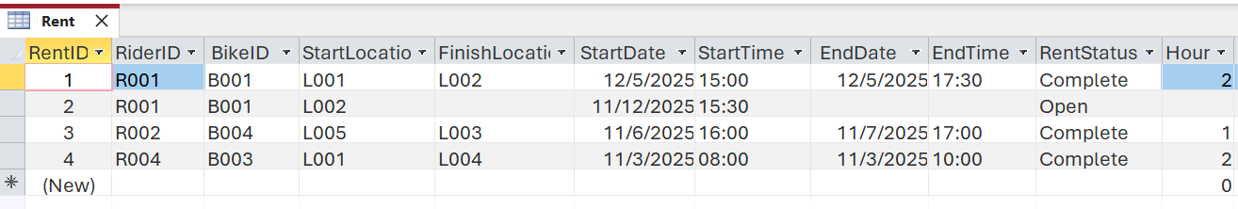
Figure 1.5.4 – Rent Table

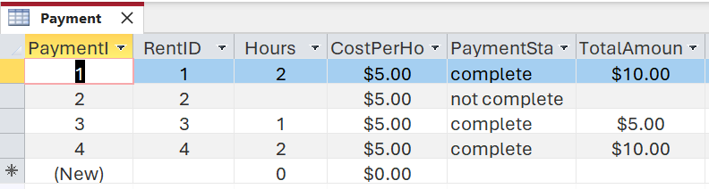
Figure 1.5.5– Payment Table

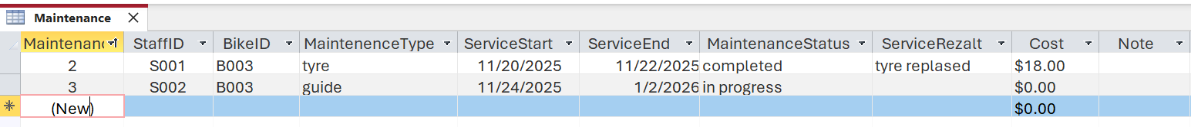
Figure 1.5.6 – Maintenance Table

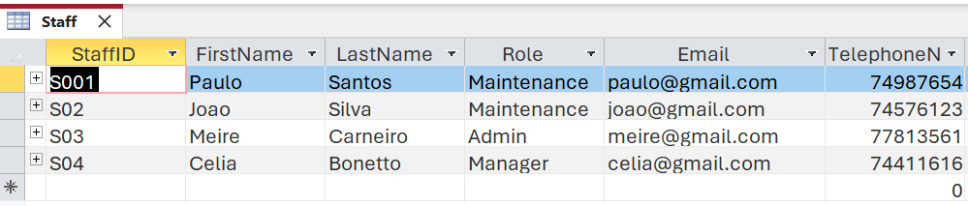
Figure 1.5.7 – Staff Table

1.6 — QUERY DEVELOPMENT

Microsoft Access uses queries to locate and arrange data within the database. They assist the user in rapidly verifying crucial data, including current rentals, payments, or bike usage. I developed a number of queries for the EcoRide system to demonstrate how the database might assist with day-to-day tasks.
A list of riders is displayed by the initial query. Staff can easily view all registered riders with their contact information by using this query. When beginning a new rental or verifying customer information, it is helpful.
A different query displays rentals that a certain rider has completed. I used RiderID (e.g., RI0001) to filter the Rent table in this query. This enables the business to examine any previous rental history and determine how frequently a rider utilises the service.
Additionally, was made a query that displays rental payments. Checking which rentals have been paid and which are still outstanding is simple with this query. It assists the group in controlling revenue and preventing late payments.
These enquiries show how the system can assist with practical activities like monitoring riders, verifying rental records, and managing payments. For EcoRide employees, queries make the database more useful and user-friendly.

Logical Design
Table Creation in MS – Access (take screenshots of each table (Datasheet view and design view) and paste it here and annotate each screenshot.
Customer Details table (Design view and datasheet view)
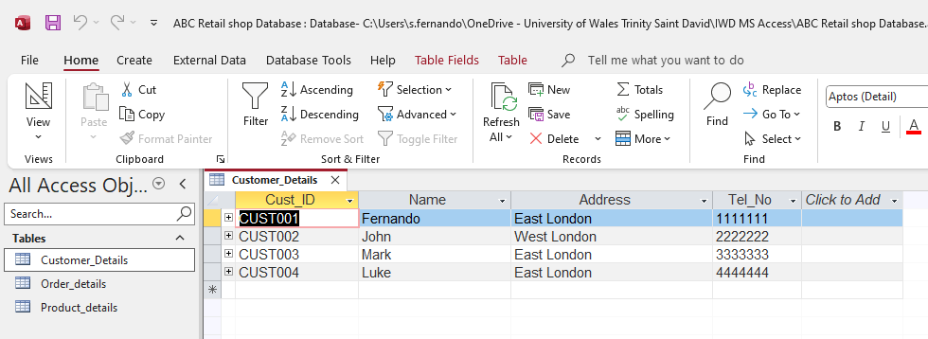

Relationships between tables
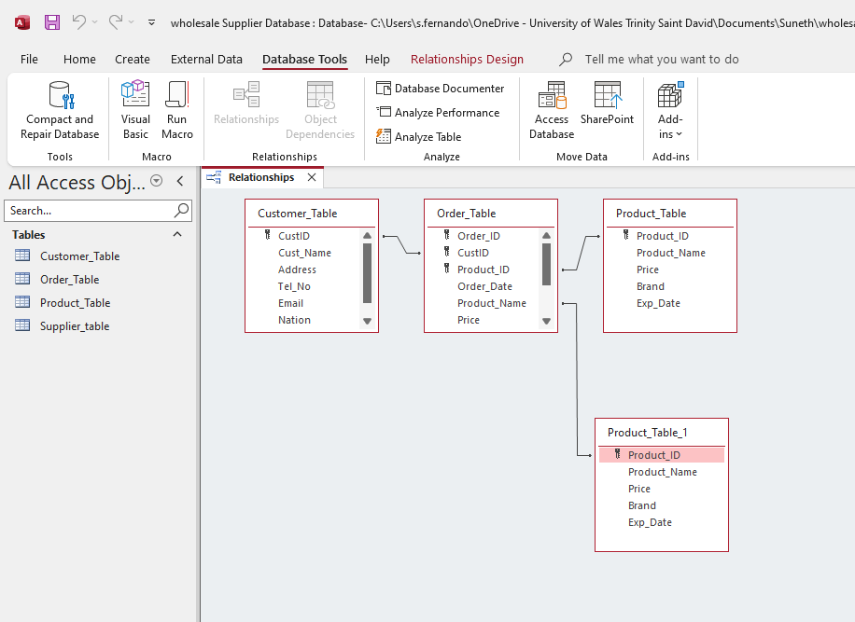
Explain what type of key attributes (each table) used to create relationships between tables.

Testing and Validation
Requirements of the case study
- Manage an inventory : in this case a table called, “product” has been designed and developed to maintain inventory of all the products.
- Customer Information : A table called "Customer” has been designed and developed……..

Test Cases | Expected Results | Actual Results | Any Discrepancies
Manage an Inventory | It is expected to manage an inventory for all the products of the shop | A table has been design and developed to maintain an inventory of the products. | No

Normalization Process
Take screenshots of 3rd Normal form from MS-Excel and Paste here and annotate each table.

MS- Access

Forms Creation (take screenshots of all the forms and annotate them)

Queries Creation (take screenshots of the design view, datasheet view and SQL view of each query and annotate them)
Based on your critical thinking, create at least two – three queries
SQL view
SELECT
Customer_Details.Cust_ID,
Customer_Details.Name,
Customer_Details.Address
FROM
Customer_Details
WHERE
(((Customer_Details.Address) = "East London"));

Report Creation (create reports from each query and annotate them)

Calculations (show how you implement calculation ( if any) and take screenshots)

Dashboard Creation (show how to navigate from dashboard to forms and forms to dashboard)

1.6 — QUERY DEVELOPMENT
Microsoft Access uses queries to locate and arrange data within the database. They assist the user in rapidly verifying crucial data, including current rentals, payments, or bike usage. I developed a number of queries for the EcoRide system to demonstrate how the database might assist with day-to-day tasks.
A list of riders is displayed by the initial query. Staff can easily view all registered riders with their contact information by using this query. When beginning a new rental or verifying customer information, it is helpful. A different query displays rentals that a certain rider has completed. I used RiderID (e.g., RI0001) to filter the Rent table in this query. This enables the business to examine any previous rental history and determine how frequently a rider utilises the service.
Additionally, I made a query that displays rental payments. Checking which rentals have been paid and which are still outstanding is simple with this query. It assists the group in controlling revenue and preventing late payments. These enquiries show how the system can assist with practical activities like monitoring riders, verifying rental records, and managing payments. For EcoRide employees, queries make the database more useful and user-friendly.

