

Module Code: EGCE5002P/C
  - Assessment: CHANGEMAKERS: BUILDING YOUR PERSONAL BRAND FOR SUSTAINABLE EMPLOYMENT
Name: A.Richards​
Student No: 2015583​
Assessment 1: Part A: CV (Equivalent to 700 words)
Cover Letter (Equivalent to 700 words)
Part B: Zander Letter (Equivalent to 600 words)
Assessment 2: Reflective Account
(Equivalent to 2,000 words)
Foundation Degree Inclusive Education​
Sue Ainsworth
University of Wales Trinity Saint David
Swansea – Wales​
30.10.2022​
Assessment 1 Part A: CV
Amanda Jayne
Richards
OBJECTIVE  “Every child has the right to quality education and learning” www.unicef.org  This quote summarises my beliefs and passion.  ADDRESS  630Carmarthen Road  Gendros  Swansea SA5 8JT  PHONE  07849437606  WORK EMAIL  Richardsa224@hwbcymru.net  PERSONAL EMAIL  tomatoketchup2002@icloud.com  SUMMARY OF SKILLS…  - Creativity  - Persuasion  - Collaboration  - Adaptability  - Emotional intelligence  - Diplomacy  - Initiative  - Organisation  - Reliability  - Team Work  - Time Management  - Planning |  |  | EXPERIENCE
– 2012 to present
- Dylan Thomas Community School • Swansea Cynnydd/TIDE/LAC Learning Coach
– 2011 to 2012
- Clase Primary School • Swansea – Volunteer Teaching Assistant Nursery
– 1994 to 2004
- First Choice Holidays • Various Countries Europe to Long Haul –Overseas Manager

(Full work history available on request)

PERSONAL STATEMENT
I look forward to discussing further skills that I am able to bring to the job role.
Such as working with SEMH, LAC, and ALN pupils.
I have included my role overseas to highlight education and training come in many forms and those years abroad fetch their own skill sets worthy of the role.
 |  |  | EDUCATION
- UWTSD – Swansea - Foundation Degree Inclusive Education (Due to complete 2024)
- Gower College, Gorseinon Campus – Levels 2 & 3 Diploma in Supporting Teaching and Learning in Schools.
- London College of Furniture, East London –OND & HND in Interior Architecture and Furniture.
- Glanmor Annexe Swansea Art College – Foundation Year in Art and Design.
- Mynnddybach Comprehensive, Swansea – O’ Levels – 8 passes varying from B’s to C’s in core subjects, Arts, and Humanities. A’ Level Art.
 |  |  | COMMUNICATION
- Writing skills - Proficient in Microsoft Office, including Excel and PowerPoint. Emails. Creating lesson plans, mentoring, and research, developing materials, marking and delivering Princes Trust, invigilating, reader scriber ALN pupils. Writing Personal Education Plans for LAC reviews. Reports for multi-agency meetings. Cynnydd Reporting. Safeguarding reporting
- Verbal skills – Strong professional and parent relationships formed through regular phone calls and meetings. In times of crisis and celebrations. Emotionally available adult, for pupils through trauma-informed training. Persuasive skills and catalytic leadership brought from previous employment in sales and customer service.
- In-person skills - Public speaking delivered through presentations. Networking through discussions and connecting with industry peers both online and in person.
- Listening skills - Taking detailed notes and following all instructions at LAC meetings and Person Centred Reviews. Empathic pupil relationships.

 |  |  | LEADERSHIP
- Lead Volunteer Coach and Swim teacher – Swansea Stingray Disability Swimming Team.
- Committee Volunteer - Junior Rising Stars Disability Drama Group. We won the Queens award QAVS during the lockdown in 2020.
- Overseas Manager First Choice Holidays.
 |  |  | REFERENCES
- Paul Davies - Head Teacher
Dylan Thomas Community School, Swansea
DaviesP151@Hwbcymru.net
Telephone No: 01792 6103000
- Ashley Payne – Deputy Head Teacher and Child Protection
Dylan Thomas Community School, Swansea
PayneA32@Hwbcymru.net
Telephone No: 01792 6103000
Assessment 1 Part A: Cover Letter
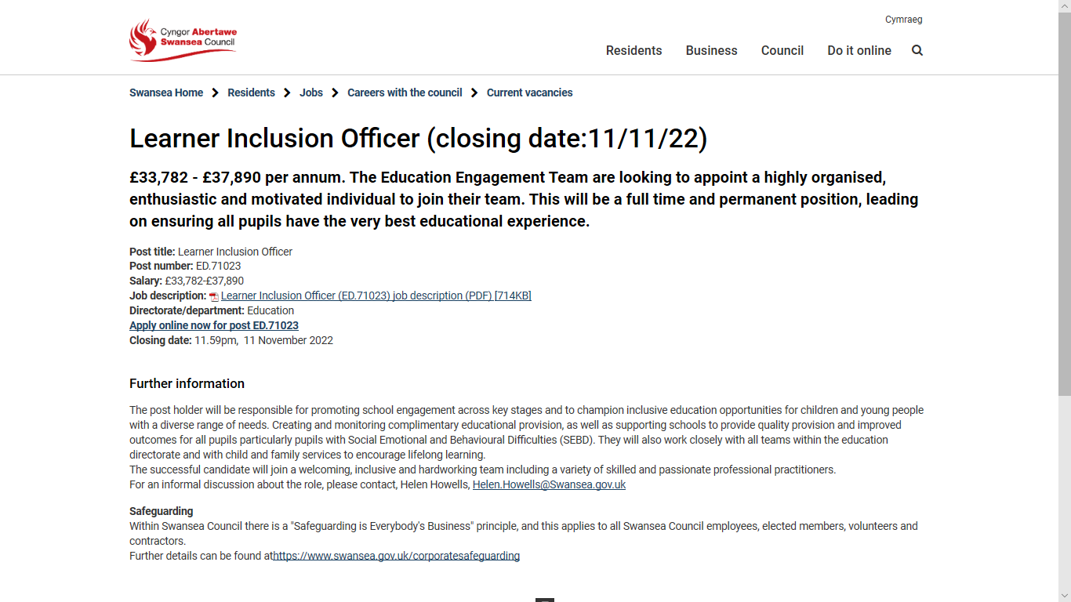

SCREEN SHOT OF JOB THAT CV AND COVER LETTER
IS REFERRING TO AS A POTENTIAL JOB OPPORTUNITY….

Amanda Richards
630 Carmarthen Road,
Gendros,
Swansea,
SA5 8JT

30th October 2022
Ms. Helen Howells
Team Manager for Pupil Support
Swansea Council
Helen.Howells@abertawe.gov.uk

Dear Ms. Howells,
I am a Learning Coach with ten years of experience. After reading your job posting for a Learner Inclusion Officer, I knew that I had the necessary skills and qualifications, to immediately, bring value to Swansea Council in this position. As a candidate who is experienced in the responsibilities associated with this role, I believe that I will perform effectively and go beyond the expectations listed in the job description.

While working as a Learning Coach I have developed my expertise in time management, Communication, and adaptability. While growing these skills, I stood out due to my resilience and empathic nature. I am also completing a degree in Inclusive Education at the University of Wales Trinity and Saint David's, through which I am successfully evolving into a critical thinker who is now able to demonstrate this in my daily professional life. My objective is to; apply these abilities as a Learning Inclusion Officer, while simultaneously learning new capabilities within the area of Inclusive Education.

After reviewing my personal profile and CV, I hope that you are able to observe my qualifications and my potential as a candidate for this role. I am excited to further, elaborate, on how my specific skills and professional experiences will benefit your organisation.

Please contact me to organise a convenient meeting date and time. If you require additional information; or would like references from my employers, do not hesitate to get in contact with me.
Thank you for your time and consideration.

Yours sincerely

Amanda Richards

Referencing:
Web pages and Journals:
- Attaway, W.C. (2022) Catalytic Leadership: 12 keys to becoming an intentional leader who makes a difference. Washington D.C.: Eriall Press
- Canva Software for CV writing (2022) Available at: https://www.canva.com [Accessed 23rd October 2022]
- Jobseeker (2022) Available at: https://www.jobseeker.com/cover/letter [Accessed 23rd October 2022]
- Swansea Council (2022) Available at:
https://www.swansea.gov.uk/article/19395/Learner-Inclusion-Officer-closing-date111122
[Accessed 23rd October 2022]
Unicef Official Website (2022) Available at: https://www.unicef.org.uk/?sisearchengine=377&siproduct=Campaign_%2A%2ABrand-Unicef-Exact-G631906975
[Accessed 23rd October 2022]

Assessment 1 Part B: Zander letter
July 2024
Dear Amanda
Congratulations on passing your BA Honours Degree you did it; you gained a First-Class in Inclusive Education. In September 2020 after losing your father and during the lockdown from COVID. You decided it was time to honour his memory and complete your education journey. After taking a break from your self-development journey in education and looking after your father and family, you started again with the University of Wales Trinity Saint David (UWTSD, ND). Having not academically studied since your level three in 2014. You were nervous and apprehensive and started with doubt in your heart that you would ever reach this day. However, here you are four years on and you have reached your goal and achieved a first, the highest you could achieve. This journey has been driven and shaped by your thoughts and actions formed in extreme situations, which have provided you with a new understanding of who you are and whom you want to be. (Dexter, 2017)
Your academic journey has not been straightforward. Driven by need over desire. (Bates 2019, pp 66- 67) your aspirations have always been high and your competitive nature with yourself has motivated your accomplishments. Your academic journey on occasion been stonewalled by the effects of childhood experiences (ACES) (TIS, 2022). Not reaching your predicted grades at sixteen due to your Mother leaving the family home the night before your mocks and then causing mayhem for the next few years affected your learning and results. Only now do you truly understand the impact that had on your outcome. (ACES) (TIS, 2022). However, you always dreamed that you would one day achieve a degree and here you are you have. Resilience is what helped you achieve this and that was, learned from your years of competitive sports such as swimming and gymnastics. Hockey and dance drama, this is, proven in the four domains proposed in the Circle of Courage model. (Trang 2011, pp 71-77) This tenacity has been effective in your journey and self-efficacy (Bates 2019, pp 52-53)
Banduras states that observation and judgments of our own capabilities are, affected by observing others. (Bates 2019, pp 52-53)
Therefore, you knew it was vital to set a good example for your children. For that reason, you walk the stage, and accepting a degree today is empowering for their educational journeys. (Bates 2019, pp 52-53)
Your change of career and the drive to educate, support, and help develop young minds was born out of the birth of your daughter who was born with Down Syndrome. Her early years allowed you to develop skills and be educated in the inclusion of young minds. Through networking and classes educated to help your daughter’s deficit in her development. You started volunteering and using your skills to good use in Clase Primary School. It was here you noticed that whilst in Primary Education. Inclusion was, being, achieved and they were safe. (Ainscow et al. 2006) It was then that you turned your attention to Comprehensive education as you saw that was where there were the possibilities of pupils falling through the cracks, as did you. You felt that was where you could make a difference. Being the type of human who is nurturing (Dexter, 2017, pp 429-495) you knew you could make a difference. It was here you started your journey of formally educating yourself by completing your level two in support and teaching and level three alongside your extensive courses on INSET days. (School A, 2020) which has brought you to your success today.
Yes, there was a gap of eight years in formal education but you never stopped empowering yourself and your mind by reading and developing skills. Having a growth mindset (Dweck, 2017) and Networking (Bridgstock, 2017, pp 339 – 358) within the ALN community within Swansea has equipped you today to achieve. Also ensuring your network of support allowed you to use their strength when your weakness raised its ugly head has brought you this far. You have learned to ask for help, which before these four years was something you found difficult. You have learned that trying and failing is never a failure it is just merely an opportunity to learn. You had preached this to your pupils but never been able to go through this emotion prior to these four years. So congratulations on achieving this hurdle. Your growth mindset got you here. (Dweck, 2017) Here walking the stage and accepting your First Class Honours Degree.
Congratulations Amanda you are here because of you and all the skills you have brought to the table and the backup and support of friends and lecturers who told you, you could. You can, you did, and you have.
Yours with good wishes and good fortune, your future self,
Amanda

Referencing:
Books:
- Bates, B. (2019) Second Edition. Learning Theories Simplified. SAGE Publications Ltd.
- Dexter, D. (2017) The TEN TYPES of HUMAN. Windmill Books.
- Dweck, C.S. (2017) Changing the way you think to fulfill your potential. (6th EDN.) London: Robinson.
- Zander, R.S. and Zander, B. (2000) The Art of Possibility: Transforming Professional and Personal Life (1st Edn.) Massachusetts: Harvard Business School Press.
Web pages:
- Bensinger, K. (2020). Adverse Childhood Experiences. Chicago. Available at: https://www.pacesconnection.com/fileSendAction/fcType/5/fcOid/406624864726144615/fodoid/406624864726144614/C4%27s%20ACE%20booklet%2011-14.pdf [Accessed 22nd October 2022]
- Trauma-Informed UK Schools (TISUK) (2022) Available at: https://www.traumainformedschools.co.uk [Accessed 22nd October 2022]
- UWTSD. (ND). Education (MA, PgDip, PgCert). Available at: https://www.uwtsd.ac.uk/ma-education [Accessed 22nd October 2022]
Journals:
- Ainscow, M., Booth, T. and Dyson, A., (2006) Improving schools, developing inclusion. Routledge. [Accessed 22nd October 2022]
- Bridgstock, R., (2017) The university and the knowledge network: A new educational model for twenty-first-century learning and employability. In Graduate employability in context (pp. 339-358). Palgrave Macmillan, London. [Accessed 22nd October 2022]
- Trang, V.T., (2011) The effect of sports on youth resilience and well-being. Beyond Social Services, 8 (2), pp.71-77.
Unpublished Papers: [School A] (2022) [School A] Staff Training. Swansea: [School A]. Unpublished
Videos/YouTube:
- Benjamin Zander – Give Yourself an A (2016) YouTube video, [Online] Available at: https://www.youtube.com/watch?v=M1ANV5BQnJA
[Accessed 23rd October 2022]

