DIGITAL SKILLS AND RESEARCH METHODS

Table of Contents
Introduction 3
The organization 4
The Usefulness at the technology at the EKELS Software Company 4
Use of Social media at ELEKS Software 7
Creating own professional online presence 8
Conclusion 8
Reference 9

Introduction
The companies today are getting inclined towards the use of digital technology, this is the technology that has been used by the companies to bring ease to the working process of the organization and the digital technologies involved changing the overall working process of the companies. This report has focused on the use of digital technology by the company ELEKS and how the company has been involved using digital technologies to make the organizational process faster and how it will also make the companies life easier to cater for the consumer’s demands efficiently. The following report has provided these discussions in a detailed manner.

The organization
Prior to proceeding with the main discussion, this is important for me to introduce the business operations that are carried out by the selected company ELEKS. This is a UK based software company and the company has been involved in providing the European and various companies in UK with software solutions and this includes; providing software solutions for the companies which include highly efficient end-to-end software engineering. As the partner in technology, the company has been involved in promoting software as the compound for the efficacy and the expansion of the business organizations. The company also does not hurl in to solutions, rather the company uses more gradual approach with the clients and also creating various points so that they can lead the market at which they are operating the organization. As of 2018, the company has been involved in providing effective software solutions to the companies that are situated all across United Kingdom.

The Usefulness at the technology at the EKELS Software Company

The digital technology has helped to shape the way companies such as ELEKS Software, have been using various available software to provide the consumers with the best of services and in accordance to their needs. With the introduction and upgrading of new technologies every year, companies such as the EKELS Software are becoming more competent at providing the best form of services to the client base of the organization (Oztekin, et al, 2014). In this part of the report I have discussed the usefulness of certain technologies and software applications that have made it easier for us to cater to the needs of the clients instantly.
Scanner
This device has been very useful for our employees and the reason is that, we are required to send the blueprints of the software along with other documents associated with the hardware of the devices. Due to this reason, the scanner is a very helpful asset for us to send these documents without wasting any time. Some examples of these scanners are; the flatbed scanners and the sheet-fed canners, both are helpful to send the documents to the project managers at various locations.
The laptops and computers
Our company, ELEKS Software, has provided me and others with laptops which are upgraded with new versions of windows and this software is also compatible with the software used by the clients and the companies (Ahmed et al, 2014). The newest upgrades are allowing me to save time over possible system crashes and other hardware problems and I can also work more flexibly when a project is underway.
Webcam
This has been one of the most useful devices that are used by the employees of our organization and this device is preferred mainly by the project managers. The webcam is allowing us the solve problems or even to bring ideas by using the video conferencing where we can talk to the team members at anywhere at any moment. On the other hand, the video conferencing and its frequent usage is helping the company to stay constantly connected to the other project leaders that are working for the company in other parts of Europe.
Email
This has been seen as one of the important means of communication process as we are capable of communicating with the clients that are from other parts of Europe and United Kingdom. The process of manual documentation makes it vulnerable for us to store the steps and the design of the project in a safer manner, since, there are various hazards that we might face and this includes; the probability of fire hazards, various water leakages and even losing the documents unintentionally (Morgan, 2016). The email process, such as the facilities that are provided by the company Gmail and yahoo, are providing the options for drafting that helps us to save the documents that are associated with the project and hence saving the documents from any vulnerability of loss. At my organization we use emails to communicate with our clients on a daily basis and also with our co- workers. The orders are delivered through emails so that there is a written trail of communication also as the communication in this case is in written form the instructions are generally clear and easy for us to follow and the manager is able to send the same message to everyone in a single click.

Cloud computing
The process of cloud computing has been very useful for us since, we sometimes work on various projects and with the help of cloud technology we are capable of using our desktops and laptops to save the projects. Furthermore, we are capable of dragging and dropping files to the created folders and this also includes using the carrying process in a faster manner. The cloud computing is also allowing the company to save finances, as our company uses almost three cents per gigabyte for the purpose of storing the data by the use of internal process and the additional cost savings can be also done since our organization also does not have to use their internal power for the purpose of storing the data (Baden-Fuller, et al., 2013). At our organization the use of cloud computing has made the operations process smoother as this allows us to use office documents from any part of the office premises and even from home as the uploaded information can be modified and referred to by us whenever needed. The software designs and the layouts too can be shared with the clients with the help of cloud technology.
Video conferencing
The video conferencing and the web conferencing has very useful for our company as this allows us to talk to the clients and the other project managers as this allows them to understand the requirement of our clients and provide us the briefing that are related to the ongoing projects (Iglesias-Pradas et al, 2013). The video conferencing has increased our competency as we are not required to attend any client meetings in person and we can use the time that we have saved, to work more efficiently over the projects that are provided to us by the clients and the project managers. At our organization the video conferencing is used for pitching to our clients who are in other far away locations in the country or even abroad. We communicate with our partners using this technology on regular basis.

Use of Social media at ELEKS Software

Facebook
Social media has become very popular in the last decade and as a result millions of people use it on regular basis. In the past business relied on mass media advertisement to boost sales but now social media is the new popular platform to conduct advertisement in as it can reach the target customers in a considerably cheaper way (Poynter, 2010). Our organization also makes use of this social media on a regular basis. Through the use of Facebook profiles we are able to learn about our potential clients and send them messages about what sort of software that can be used and the deals they may have. The clients are also able to see our profile and learn about our packages and through const communication we are also able to provide them tailor made products. We conduct advertising on Facebook on a daily basis so that the potential customers are able to know about us and contact us form any part of the world. Communication among the co-workers through Facebook is also very convenient as it allows office groups to receive messages all together and the voice call option has driven down the communication costs in our organization considerably.
LinkedIn
Similarly, LinkedIn is also a platform that can help companies or an individual build connection. This platform is a professional networking site and this has helped our company considerably with conducting our business (Oztekin, et al., 2014). This site has helped us to get in touch with clients who have provided us with a lot of work after checking our capabilities. This site has also helped us gain experienced coders and programmers some of whom we have hired and some of whom work as freelancers from abroad at considerably low rates. Advertisement on this platform has helped us generate a lot of leads to new customer base and with the right information about these customers we were able to create packages to their liking and sell them a variety of products. With millions of professionals present through this site we were also able to outsource work from abroad which we were incapable of handling.

Creating own professional online presence

Figure: Personal Facebook
As seen in the case of organizations social media can also help build personal profiles that can be helpful to obtain better jobs through better linkups (Morgan, 2016). My business page is quite different from my professional page as it contains all my skills and experiences and this will help companies to notice my capabilities and hire me as per their need. This Facebook page is easy to access for companies or third parties like head hunters who will help me obtain better careers. This page will act as my own advertisement tool that can be updated as and when needed and with additional experience more and more employers will be likely to be interested in me as a potential employee.
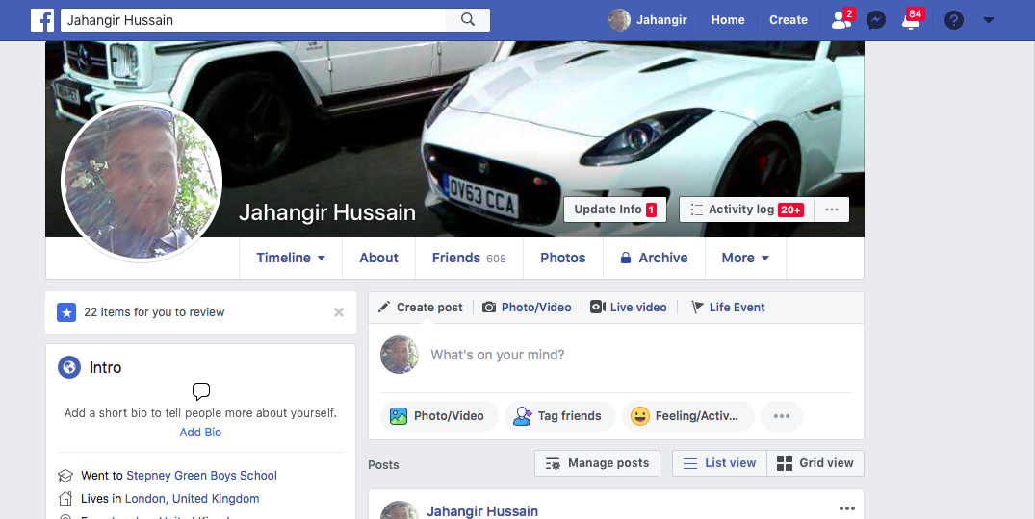

Figure: Personal LinkedIn
LinkedIn unlike Facebook also does the same task for me. My LinkedIn profile contains all my attributes in a very organized and elaborate manner and this has helped me gain many offers. The professionals and companies on LinkedIn are able to see my qualification as per their requirement and are able to communicate with me and express their needs allowing me to secure better job and better salary in the process. It exposes my CV to all the potential employers who may need be on fulltime or part time basis.
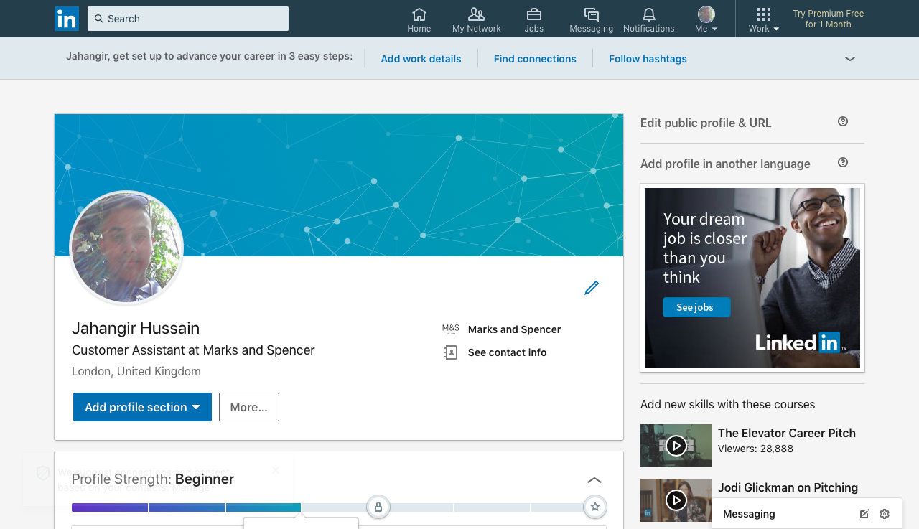

Conclusion
The overall report has provided the discussion for the use of the digital technology in the workplace and the way this technology has made changes to the working process at the selected company. The report has reflected over the use of the digital technology from the point of view of the employee of the organization and this process is also effective to depict the problems since the first account of an employee is included in the report for the employee of the company ELEKS. The report has also given more detailed form of discussion for the aspects that are included in the digital technology and this include various forms of functions of the software.

Reference

Ahmed, N. and Matuleviius, R., (2014). Securing business processes using security risk-oriented patterns. Computer Standards & Interfaces, 36(4), pp.723-733.
Baden-Fuller, C. and Haefliger, S., (2013). Business models and technological innovation. Long range planning, 46(6), pp.419-426.
Iglesias-Pradas, S., Pascual-Miguel, F., HernáNdez-GarcíA, Á. and Chaparro-PeláEz, J., (2013). Barriers and drivers for non-shoppers in B2C e-commerce: A latent class exploratory analysis. Computers in Human Behavior, 29(2), pp.314-322.
Maund, A. Schriek, M. and Tinkler, P. (2017). Certificate in Higher Education: Skills for the Workplace Student Yearbook. Sage Publications
Morgan, P. (2016). The Business Student’s Guide to Study and Employability. Sage Publications
Oztekin, B.U., Antonova, D., Dhamdhere, K., Southey, F. and Mao, Z., Google Inc., (2014). Reordering search query results in accordance with search context specific predicted performance functions. U.S. Patent 8,645,390.
Poynter, R. (2010) The handbook of online and social media research: Tools and techniques for market researchers. United Kingdom: Wiley.

