REPORT

Name: Bruma Daniela Ionela
Student Number: 2128799
Module Title: Sustainable Hospitality
Module Code:BMIH5006
Lecturer’s Name: Huw Thomas

Table of Contents

Introduction: 3
Has the hotel been accused of greenwashing? 4
Are there areas where it could be construed that they are greenwashing? 6
Do they self-evaluate? 8
Why do companies self-evaluate? 10
Is ‘Green’ technology being used and is it more sustainable? 12
What could they do instead of self-evaluating? 13
Conclusion: 14
Reference: 15

Introduction:
This assignment report will be focusing on the hospitality industry sector. The assignment will completely concentrate on the hospitality organisation in the United Kingdom (UK) TUI Group. TUI group is one of the leading travel and restaurant companies which has also established its network all across the world. The company is the largest company working in the hospitality industry sector. The company is well known for operating under Touristik Union International (TUI). The TUI Group consist of a number of different travel agencies, hotel chains and airlines within it. The global business that works within more than 400 hotels all across the world. The company is offering high-quality accommodations and food services in holiday locations. Therefore, this assignment will be based on the analysis of the hospitality industry's claims about their hospitality industry regarding greenwashing (which.co.uk, 2023). Greenwashing is a concern in the travel industry sector which is considered an important aspect.

TUI Logo
(Source: Tui.co.uk, 2024)

Has the hotel been accused of greenwashing?
TUI is one of the major international travel hospitality businesses and also the company has experienced accusations of Greenwashing, especially regarding their marketing of ecohotel collections. When the TUI expects them to meet the higher standards set by the standardized Global Sustainable Tourism Council (GSTC). It is observed the company TUI has been explaining their holiday packages in the tag of “Green and fair” holidays (Bbc.com, 2016). For these green practices, the company has been making use of paper straws and other measures which were seen as marginal as compared to the carbon dioxide emissions from flights to reach the particular destination.
The chosen organisation TUI has taken several steps to decrease their carbon footprint which also include providing climate-friendly holidays and vacations from the year 2012 (bbc.com, 2012). TUI’s many hotels decreasing their carbon footprint through different measures and offsetting unavoidable emissions through certified climate protection projects. On the other hand, the chosen organization TUI has been completely dependent on the carbon offsetting schemes which will help them to appear more sustainable as a point of concern as it does not address the actual cause of emission.
The sustainability aspect of the chosen organisation TUI Has been significantly increased. The company started making a significant number of efforts towards sustainability for sustainable development. This has outlined the organization’s commitment to decrease carbon emissions schemes to appear more sustainable which has been the point of concern.
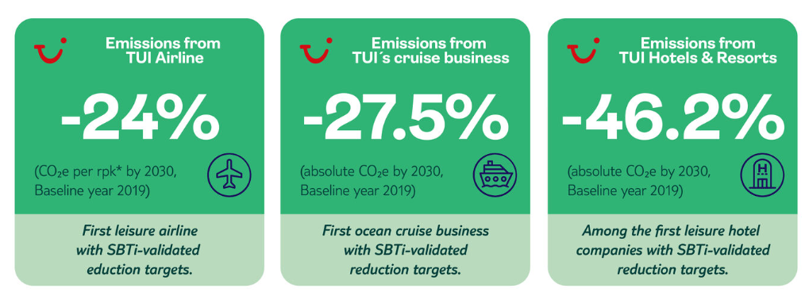
Figure 1: Target Initiatives by TUI
(Source: tuigroup.com, 2024)
The efforts of the TUI for sustainability have shown their commitment towards decreasing energy and water consumption. Apart from that it also showcased that the company tries to recycle the materials and implement environmental management systems. Even though the organizational implementation of the sustainability concerns they have faced several criticism as they exaggerate their environmental credential in order to improve their sales (telegraph.co.uk, 2024).
The competition and market authority have showcased their concerns regarding greenwashing and the travel industry sector. In addition to this, the advertising Standards Authority has also banned that attachment for airlines that misleads customers regarding their sustainability efforts.
So overall TUI has taken several steps to decrease its carbon emissions and improve its sustainability efforts. However, their marketing efforts for the green and fair holiday have been criticized as greenwashing as the TUI companies are completely dependent on carbon offsetting schemes (‌Tuigroup.com, 2023).

Are there areas where it could be construed that they are greenwashing?
The organization TUI has experienced fewer accusations of greenwashing in different areas not only focusing on eco-hotel marketing campaigns (cabidigitallibrary.org, 2018). The sustainability efforts of the chosen organisation TUI have been criticized for their greenwashing aspect. Apart from that, a few different areas where Greenwashing could be constructed for TUI mainly include:
Marketing of dream and fair holidays:
The TUI has been criticized for its marketing campaigns for Green and Fair Holidays (tui.co.uk, 2024). However, TUI’s eco hotels meet high sustainability standards and their marketing has been seen as quite exaggerated when it’s compared to the emission of carbon dioxide from flights to reach a particular destination.
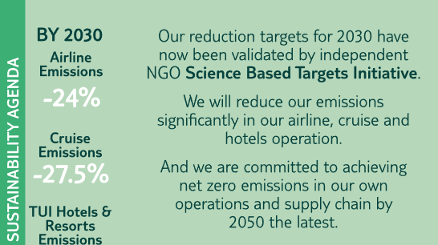
Figure 2: Sustainability targets as per marketing on website
(Source: tuigroup.com, 2024)
Dependency on carbon offsetting:
The chosen organisations' dependency on the carbon offsetting schemes has been seen as more sustainable and the point of concern which does not assist the root cause of carbon emission. This has increased questions regarding the commitment of TUI to actually decreasing the carbon footprint and emissions.
Sustainability messaging:
TUI has started using paper straws and other measures which have been seen as useful for the sustainability aspect and marginal as compared to the carbon dioxide emissions from flights to reach to particular destination. This has resulted in increasing concerns that TUI sustainability claims are more inclined toward their marketing approach than their preferences for environmental impact sustainability.
The factor of transparency:
While TUI's sustainable development focuses on the company’s commitment towards decreasing energy and water consumption, this also increased recycling rates and implementation of environmental management systems. The company TUI has been criticized for potential greenwashing when they exaggerated their marketing campaign for environmental credentials and increasing sales.
Ultimately, the organisation TUI has faced accusations of greenwashing in different areas by including different marketing of green and fair holidays, their dependency on carbon offsetting, Sustainability messaging and the factor of transparency. These kinds of concerns have been increased instead of companies' detailed sustainable reports. These ultimately showcase that there is a potential divergence between their marketing plans and actual environmental impact.

Do they self-evaluate?
The chosen organization TUI have not self-evaluated and analyzed for the greenwashing aspect. In other terms, the company’s sustainable development report focuses on its efforts to decrease energy and water consumption. The sustainability report also showcased that they are working towards increasing the recycling rates and implementation of environmental management systems as per the standards.
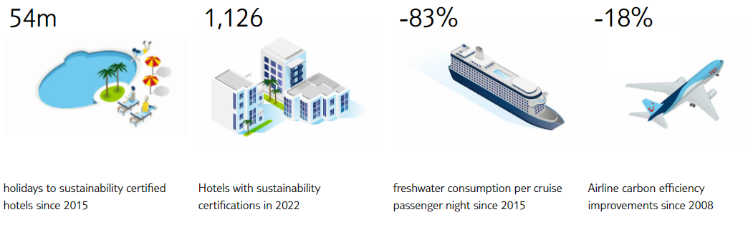
Figure 3: Sustainability in numbers
(Source: tuigroup.com, 2024)
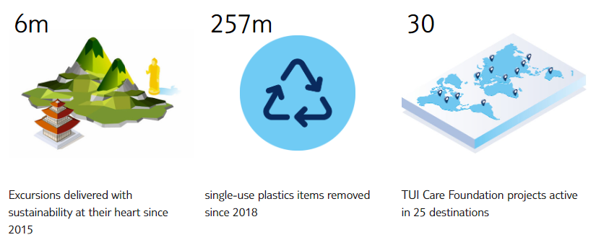
Figure 4: Sustainability in numbers
(Source: tuigroup.com, 2024)
Instead of such kinds of efforts, the organization Tui has faced several accusations of greenwashing especially regarding their marketing of eco-hotel collection which is completely based on carbon offsetting schemes to appear more sustainable to the consumer base.
To overcome the issue of greenwashing the chosen organization needs to conduct self-evaluation by simply taking into account the aspects which are described below:
- Assessing and analysing the company Tui’s marketing claims against their environmental impact
- Making sure that sustainability efforts taken by the chosen organisation TUI a transparent in a way and verifiable
- Decreasing the dependency on carbon offsetting schemes
- Focusing more towards decreasing carbon emission
- Engaging with independent 3rd party organisations and companies to validate the sustainability claims of TUI
- Making sure that the sustainability efforts taken by the chosen organisation TUI are constant and with their marketing claims
Therefore, these are Some of the methods by which tui will be able to evaluate themselves. By conducting the self-evaluation the chosen organization TUI Demonstrate their commitment towards sustainability and addressing the concerns regarding greenwashing.

Why do companies self-evaluate?
Businesses like TUI should self-evaluate themselves for greenwashing to understand their commitment towards sustainability efforts and address concerns regarding greenwashing. TUI has not made any specific reports on self-evaluation for greenwashing however the company’s sustainable development report showcases their efforts for decreasing energy and water consumption. From their sustainable development report, it is also observed that they are trying to increase the recycling rates and implementing varied environmental management systems as stated by the standards (tuigroup.com, 2018).
On the other hand, the organisation TUI has also experienced a few accusations and criticisms regarding their greenwashing specifically for their marketing campaign of ecohotel and their dependency on the carbon of setting schemes which are more connected to the sustainability aspect. In order to overcome these concerns and criticism effectively, the organization TUI Could conduct a self-evaluation. Certain reasons behind conducting the valuation by companies for greenwashing are described below:
Reputation management:
Businesses might make use of greenwashing or improving their public image and getting the loyalty of consumers towards the brand. By effectively promoting her initiatives that will be focusing on the sustainability aspect the company like ty working with the Internet travel industry segment can attract the attention of consumers who are environmentally conscious and we want to prioritize the sustainability aspect.
Competitive benefit:
In this highly competitive industrial segment, businesses like Tui working within the travel industry sector may make use of Greenwashing as a method through which they can easily stand up from the other competitors and differentiate themselves. They are trying to impression of protecting the environment and conducting sustainability initiatives can be seen as a method to gain a competitive benefit. In addition to this, it will be more appealing for environment-conscious consumer segments.
Demand of customers:
As Consumer awareness of environmental issues increases there are increasing requirements for sustainable products and services. Businesses may engage in greenwashing to align their branding with this demand even if their actual environmental practices are not as required rigid.

Is ‘Green’ technology being used and is it more sustainable?
The organisation TUI has implemented different Green technologies for the ultimate aim of decreasing the environmental impact and becoming more environment friendly. The company has taken several steps to avoid and decrease carbon dioxide emissions which mainly include decreasing energy consumption, decreasing water consumption, Improving the recycling rate and starting sustainability initiatives. Considering all these there are also other things that that TUI have implemented for decreasing the environmental impact. The organization tui has introduced environmental management systems as per the standards along with different certifications for improving the transparency of their targets and achievements aligning with the environmental performance. However, the efforts taken by the TUI to implement green technologies are specific and significant. Even after experiencing accusations and criticism for greenwashing regarding their marketing of eco-hotel collections, the company has become stable for the same and dependent on carbon offsetting schemes through which they have been seen as a sustainable friendly organisation (mirror.co.uk, 2022). That is the reason why, it is extremely significant for the chosen organization TUI work in the travel industry sector to ensure that their efforts towards sustainability are transparent for their consumers. Along with this, it is also important that their initiatives should be verifiable and their marketing campaigns and claims should be constantly aligned with the sustainability goals.

What could they do instead of self-evaluating?
As far as the TUI organisation has been taken into account, instead of self-evaluating businesses working in the travel industry they should take action to demonstrate their commitment towards sustainability goals. A few alternatives for self-evaluating for greenwashing will include, 3rd party certifications, Transparent and verifiable reports, stakeholder engagement, Investment in renewable energy, creating a sustainable supply chain system, and Increasing awareness and consistent improvement. By adopting these practices businesses like TUI will be able to demonstrate their commitment towards sustainability and build trust among stakeholders.

Conclusion:
This assignment was completely based on the aspect of sustainability for the hospitality industry sector focusing on the organization TUI. TUI is one of the prominent Hotel chains operating in several countries. In this assignment, the sector was discussed thoroughly. In addition to this how the organisation has implemented the green technology was also discussed in detail.

Reference:
bbc.com (2012). Can hotels be truly carbon neutral? [online] Bbc.com. Available at: https://www.bbc.com/travel/article/20121023-can-hotels-be-truly-carbon-neutral [Accessed 17 Feb. 2024].
Bbc.com (2016). Tui Group hit by 40% fall in Turkish holiday bookings. [online] BBC News. Available at: https://www.bbc.com/news/business-35530116 [Accessed 17 Feb. 2024].
cabidigitallibrary.org (2018). Green certification – helpful, confusing, or just ‘greenwashing’? [online] Available at: https://www.cabidigitallibrary.org/do/10.5555/collection-news-23461/full/ [Accessed 17 Feb. 2024].
mirror.co.uk (2022). TUI launches new scheme to make it easier to find eco-friendly hotels. [online] The Mirror. Available at: https://www.mirror.co.uk/travel/news/tui-launches-new-scheme-make-28515881 [Accessed 17 Feb. 2024].
telegraph.co.uk (2024). Businesses ‘greenstalling’ on net zero policies over concerns around criticism for doing wrong thing. [online] The Telegraph. Available at: https://www.telegraph.co.uk/news/2024/02/05/businesses-greenstalling-net-zero-policies-concerns/ [Accessed 17 Feb. 2024].
tui.co.uk (2024). Green and Fair | Sustainable Hotels | TUI.co.uk. [online] Available at: https://www.tui.co.uk/holidays/green-and-fair [Accessed 17 Feb. 2024].
tuigroup.com (2018) ‌D E ST I N AT I O N S U STA I N A B I L I T Y Sustainable Development Report 2011/2012 Aktiengesellschaft Visiting Remembering Society Planning Travelling Profi le Responsible Governance Products Environment Our People. Available at: https://www.tuigroup.com/damfiles/default/ir/28_nachhaltigkeitsbericht/NB_2011_12_EN-1626bde74bc3396308b45b189f43ee3f.pdf [Accessed 17 Feb. 2024].
‌Tuigroup.com. (2023). TUI expands the number of hotels with the ‘Green & Fair’ label by nearly 50%, to enable customers to make more sustainable choices. [online] Available at: https://www.tuigroup.com/en-en/media/press-releases/2023/2023-05-30-green-and-fair-expansion-uk-press-release [Accessed 17 Feb. 2024].
which.co.uk (2023). Which? Travel research uncovers greenwashing from major UK holiday companies. [online] Which? Available at: https://www.which.co.uk/news/article/which-travel-uncovers-greenwashing-from-major-uk-holiday-companies-aWk7C9s9RLJr [Accessed 17 Feb. 2024].
‌

